Lithology and facies development of ODP Site U1464
The GDGT indices exhibit patterns indicative of changing environmental conditions at IODP site U1464. To better understand how the lithology and the GDGT biomarker proxies relate, we examined the changes in different lithologic/seismic sections. The sabkha related algal mats were used as a starting point for our interpretation, since they formed in the shallowest depositional environment (intertidal) and are characterized by a typical GDGT composition unsuitable for SST reconstructions (Petrick et al., 2019). In the sabkhas, we found some proxies were high (%GDGT-0, MI, BIT, 2/3 index) and others were low (#Rings_{tetra}, RI) (Petrick et al., 2019). Below, we discuss how these changes can be reconciled with sedimentary and seismic facies analysis.
At the bottom of the succession, we have samples between 831.95-706 mbsf downcore (~17.4 -15.4 Ma), which can be tied seismically to the first coral reef build-ups MioR-0 (Fig. 2, (McCaffrey et al., 2025)). At IODP site U1464, the seismic record reflects a marginal slope environment shallowing upward into a shallow subtidal platform environment (Fig. 2). The seismic section also shows that the developing reef was located landward (~20 km) of the core site. The shipboard analysis indicated the presence of the green algae Halimeda as well as the large benthic foraminifer Cycloclypeus, and even a sample with coral in this section (Gallagher et al., 2017). Thin-section analysis shows samples rich in large benthic foraminifera (LBF), coralline algae (CA), and locally bryozoa (Fig. 6 g-j). All the GDGT biomarker proxies are below the cutoff values for elimination throughout this entire section, except for one sample that had an enhanced but acceptable BIT and a high #ring_{tetra} value above 0.8 (Fig. S1). This means that the changes in GDGTs in this section are ideal for reconstructing thermal changes (Fig. S2). Therefore, the highest reconstructed temperatures occur in relatively shallow water, but in the open ocean environment seaward of the reef front. It is unlikely that there is any local heating effect due to an enclosed environment for these TEX₈₆ ^{H} SSTs. Yet while the core site is in an open ocean environment, there are indications of shallowing. The few planktonic foraminifera only occur at the base of this section, while the upper part of the section is barren, suggesting an upward shallowing of the depositional environment (Gallagher et al., 2017). Finally, although many of the GDGT indices are stable, the BIT index is increasing. Given that high BIT is associated with more terrestrial input (Schouten et al., 2013) and was reported as high in the sabkha sediments (Petrick et al., 2019), it indicates that the platform progradation resulted in a more proximal position in the uppermost part of this interval. Therefore, while still in the open ocean, the depositional environment at Site U1464 is shallowing as the first coral reef build-ups (Mi-0) are developing on the NWS.
The core interval between 695-631 mbsf (15-14.4 Ma) is bracketed between seismic horizons H3 and H4 (Figs. 2,3). This interval is associated with reef generation MioR-1 (McCaffrey et al., 2025), corresponding to the initial development of the barrier reef on the NWS (Fig. 3). The seismic data indicates that the reef prograded to a position seaward of Site U1464 (Fig.3) and developed into a barrier reef system (Fig. 3). The sediments at the site, therefore, were deposited in a shallow subtidal environment within a lagoon. In the GDGT biomarker data, BIT continues to increase. The #Ring_{tetra} values record a decrease across this boundary and are below 0.5 by the end (Fig. S2). BIT indices indicate more influence of terrestrial material or algal mats. In contrast, low #Ring_{tetra} values are associated with shallow waters (Sinninghe Damsté, 2016). The drop in #Ring_{tetra} values, therefore, suggests a change from an open shelf environment to a much shallower environment characterized by higher input of terrestrial or algal mats. Finally, there are also minor increases recorded in the GDGT0% and MI indices (Figs. S2). High values in both indices, especially GDGT0%, were found in modern and ancient sabkhas (Petrick et al., 2019). This suggests that, by the end of the period, sediment from sabkhas may have started reaching the site. However, the changes in other biomarkers are either minor or non-existent, indicating that the influence of GDGTs from the sabkha environment was still limited.
The following section covers 631-524 mbsf (14.4-12.3 Ma), between seismic horizon H4 and the transition between lithologic units IV and V (Figs. 2, 3) (McCaffrey et al., 2025). This stage corresponds to a further progradation of the reef to its most seaward position (MioR-2) and maximum extent (Fig. 3). Three microbial mats associated with sabkha facies have been identified in this interval in the core (Fig. S4) and characterized with biomarkers, XRD, thin section, and core description (Petrick et al., 2019) (Fig. 2). These intertidal microbial mats associated with the sabkhas have extremely high values in the various GDGT indices (BIT, %GDGT0, and MI) and low values in other indices (#Ring_{tetra,} RI). The GDGT values with these characteristics either match or are near the three identified sabkha facies. In these samples, SST could not be reconstructed due to contamination by the microbial mats (Petrick et al., 2019b). The non-thermal GDGTs would lead to a cold bias in reconstructed SSTs (avg. 25.87 °C) (Fig. S2). Furthermore, all the GDGT proxies in this interval show a much higher variability than in any other section, indicating that the input of non-thermal GDGTs and likely distance from shore were variable during this time (Fig. S1). However, some samples within this period have GDGT index values considered suitable for climate reconstructions, such as those from the “brown layers” in (Petrick et al., 2019). These have acceptable normal values on all the TEX₈₆ indexes, indicating minimal sabkha influence (Petrick et al., 2019) (Fig. S1). However, given the dynamics of all the GDGT indices in this period, some caution is warranted for the SSTs in this section, especially since these are among the coldest values in the entire record. Therefore, from both the GDGTs and the facies indicators, there is a shallowing of the depositional environment likely associated with the eustatic sea-level drop associated with the MMCT (Fig. 5) (Miller et al., 2020). Seismic data from other parts of the barrier reef system indicate that this sea-level drop led to karstification in the inner carbonate platform environment during the same time (Rosleff-Soerensen et al., 2012).
The section between the unit V/IV boundary and seismic horizon H5 (522-413 mbsf, 12.56-9.4 Ma) corresponds to a retrogradation of the MioR-2 reef system (Fig. 5). The reef front is stepping back to a position similar to the former MioR-1 reef (Fig. 5). As a result, the biomarkers are very similar to the lagoonal interval predating the sabkha interval (MioR-1) with mainly stable GDGT indices not high enough to reject the SST values. This interval is devoid of intertidal mats but contains, for the first time, more abundant corals. Therefore, there is an overall deepening from intertidal to shallow subtidal conditions in a lagoonal depositional environment. The corals (Fig. S4) include the zooxanthellate genera Porites, Acropora, Montipora, and Faviidae (Gallagher et al., 2017), indicating deposition within the photic zone. This is consistent with the abundance of large benthic foraminifera, confirming deposition in an inner to middle shelf environment (Fig. S3). It is worth noting that the low core recovery, combined with the presence of corals, made sampling for biomarkers challenging at the upper part of this interval (Fig. S4).
The following section, between horizons H5 and the top of the sampled section of the core (413-266 mbsf), is in the lower part characterized by low core recovery and, therefore, limited sampling. This results in almost no biomarker data for the lower part of the section. It is known that this period saw further backstepping of the reef front and the disintegration of the barrier reef into atolls (MioR-3). This is reflected in an increase in #ring_{tetra}, and a decrease in BIT and GTGT-0% values compared to the section below, indicating more open water conditions (Figs. 2,3).
Then, starting at 327 mbsf (6.4 Ma), the preserved sediment and therefore sampling increases. At the same time there is a first increase in the abundance of planktonic foraminifera and nannofossils preserved in the sediment (Gallagher et al., 2017) (Fig. 6b). Benthic foraminifera assemblages suggested a sudden transition to deeper water sediment at a depth of 308 mbsf, with a further prominent increase in nannofossils and planktonic foraminifera at ~6 Ma (Karatsolis et al., 2020). This is associated with an increase in the Th+K values in the NGRL (Fig. 3). These higher values are not related to a reduction in the sedimentation rate (Karatsolis et al., 2020). This suggests an increase in siliciclastic input to the core site, rather than a reduction in carbonate accumulation. There is further evidence of other changes. While below the reject value, MI increases at 312 mbsf, indicating the presence of methanogenic archaea, perhaps due to increased organic content in the sediments. Anoxic porewater conditions are also indicated by an increase in pyrite contents in the same interval (Gallagher et al., 2017). There is a simultaneous peak in U in the NGRL at 310 mbsf (Fig. 3) (Gallagher et al., 2017), indicating increased organic burial. Finally, the thin sections show increased glauconite in this section with typical pelagic foraminifera species, indicating reducing conditions (Fig. S3a,b). All of this occurs relatively rapidly between 327-307 mbsf (6.4-6.0 Ma), indicating a change in the depositional environment from a shallow lagoon to a “pelagic” sedimentary system with an increased amount of siliciclastic input. Interestingly, this occurred below the H6 seismic horizon located at 276 mbsf (4.28 Ma), which suggests the end of the barrier reef system and the transition to more isolated atolls (McCaffrey et al., 2025, 2020). We will investigate this transition in more detail below.

SST seasonality
We decided to use the TEX₈₆^{H} ratio to compare to the work that has been done before in this region. We have also attached the raw data to enable the recalculation of data if necessary. The low GDGT 2/3 ratio (Fig. S1) suggests that the archaea used to calculate the TEX₈₆^{H} ratio thrived in the surface ocean (Rattanasriampaipong et al., 2022). Previous TEX₈₆^{H} SST reconstructions on cores from the Australian shelf have shown that TEX₈₆^{H} SST most likely represents summer SSTs (De Vleeschouwer et al., 2022; Petrick et al., 2024, 2023, 2025) However, Modern average summer (January-March) temperatures on the NW Australian shelf range from 28-31 °C. This is ~3 °C warmer compared to the modern annual average SSTs (Reagan et al., 2023). A similar difference is also seen when the TEX₈₆^{H} SST record from IODP Site U1464 is compared to the nearby Mg/Ca SST record from ODP Site 761 (Sosdian et al., 2020; Sosdian and Lear, 2020) (Figs. 1, 5). Depending on the calibration of the Mg/Ca record, SSTs from IODP Site U1464 reconstructed by TEX₈₆^{H} SSTs are about 1-4 degrees warmer than Mg/Ca-SSTs from ODP Site 761 during the MCO (Fig. 5) (Sosdian and Lear, 2020). If Mg/Ca represents annual average SST, this difference would be comparable to the modern situation on the NW Australian shelf, where summer temperatures are ~3°C warmer than annual average SSTs (Reagan et al., 2023). The Miocene summer SSTs reconstructed here are ~2-3 °C higher than modern summer SSTs during the MCO, ~1 °C higher in the early Late Miocene (11-10 Ma), and in a similar range as modern summer SSTs during the MMCT and LMC. In the Late Miocene part of the record, SSTs are similar to the summer TEX₈₆^{H} derived SSTs at other sites from northern Australia, such as ODP Site 811 (Petrick et al., 2023, 2025) (Fig. 5), indicating all the TEX₈₆^{H} SSTs are reflecting similar temperatures.
The one exception is the MMCT, where the TEX₈₆^{H} SSTs at IODP site 1464 are nearly identical to the Mg/Ca values at ODP Site 761 (Fig. 5) (Sosdian et al., 2020; Sosdian and Lear, 2020). As shown above, the MMCT at site 1464 is characterized by the presence of extensive sabkhas in the record. It has been demonstrated that algal mats from sabkhas have a characteristic GDGT signature, which is unsuitable for temperature reconstructions using established calibrations due to an artificial cold bias (Petrick et al., 2019). Most of the samples removed from the SST calculation were in the MMCT part of the record, and many of the samples that were retained were on the borderline for several of the GDGT indices (Fig. S2, S1). It is therefore likely that some of the GDGTs in this section are sourced from sabkha sediments (Fig. 3), which could have resulted in a cold bias of the calculated SSTs in this interval. Further work should be focused on understanding the nature of this contamination and on developing a “sabkha index.” For now, however, it is likely that the cooling during the MMCT is exaggerated.
The one caveat is that low-nutrient environments have been suggested to increase TEX₈₆^{H} SSTs (Rattanasriampaipong et al., 2025). This is recent work, so it is not clear whether this is on top of a seasonal signal or whether the two are linked (i.e., lower-nutrient environments exhibit greater GDGT production during the summer). We also lack a nutrient proxy for the site, so we are unable to quantify nutrient changes. However, coral reefs tend to develop in low but not very low nutrient conditions (Bell et al., 2013). There may be some magnification of the SST data during the period of our record, leading to higher SSTs. This does not appear to exceed the seasonal SST difference shown above. It may be that some of the highest SST data is unreliable. Still, it does not alter our overall conclusion that the TEX₈₆^{H} SSTs are above the modern coral growth window.
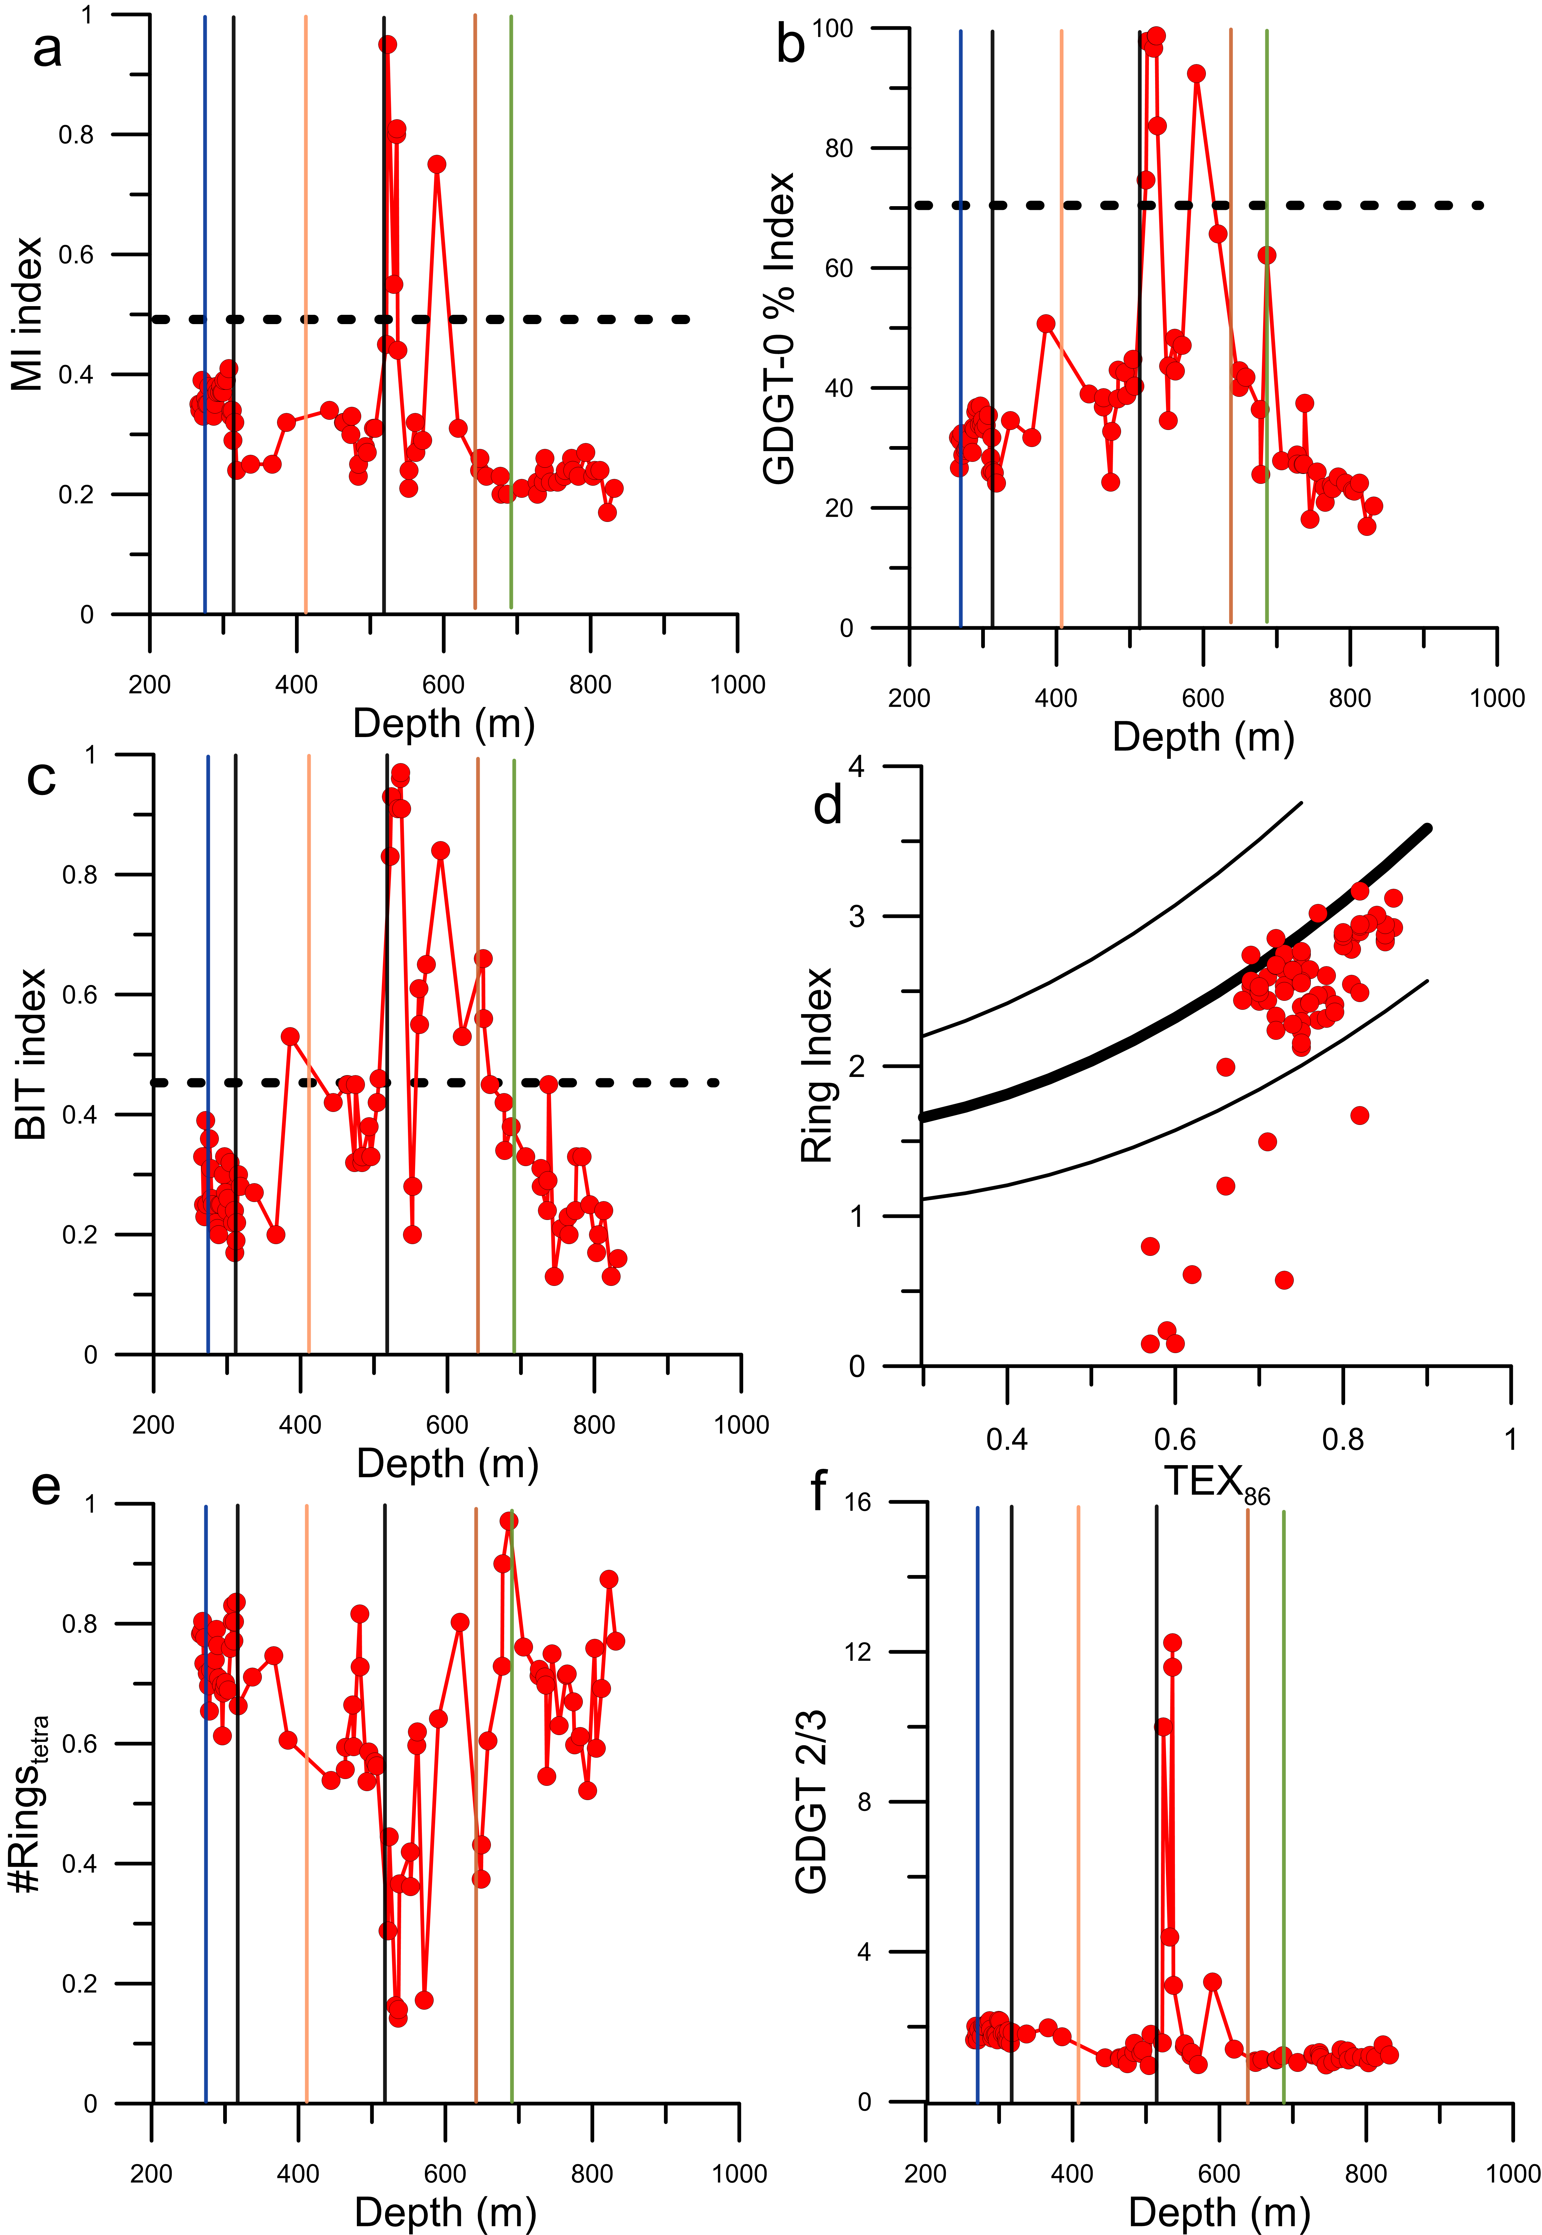
Figure S1: GDGT indexes used in this study. Seismic horizons H3 to H6 (McCaffrey et al., 2025)) and Unit III to V (Gallagher et al., 2017a) boundaries are shown as described in Figure 3. Note the specific biomolecular signals of sabkha sediments positioned between 510-630 m. Dashed lines represent the rejection value used in this study. Quality criteria shown are the (a) methane index with a reject value >0.5 (MI, after (Zhang et al., 2011)), (b) %GDGT-0 index with a reject value > 70% (after (Sinninghe Damsté et al., 2012)), (c) branched vs. isoprenoid index with a reject value >0.45 (BIT, proposed by (Schouten et al., 2002)), (d) ring index (RI, proposed by (Zhang et al., 2016)), e) #Ring_{tetra} (as proposed by (Sinninghe Damsté, 2016)) f) GDGT 2/3 (proposed by (Hernández-Sánchez et al., 2014; Taylor et al., 2013)).

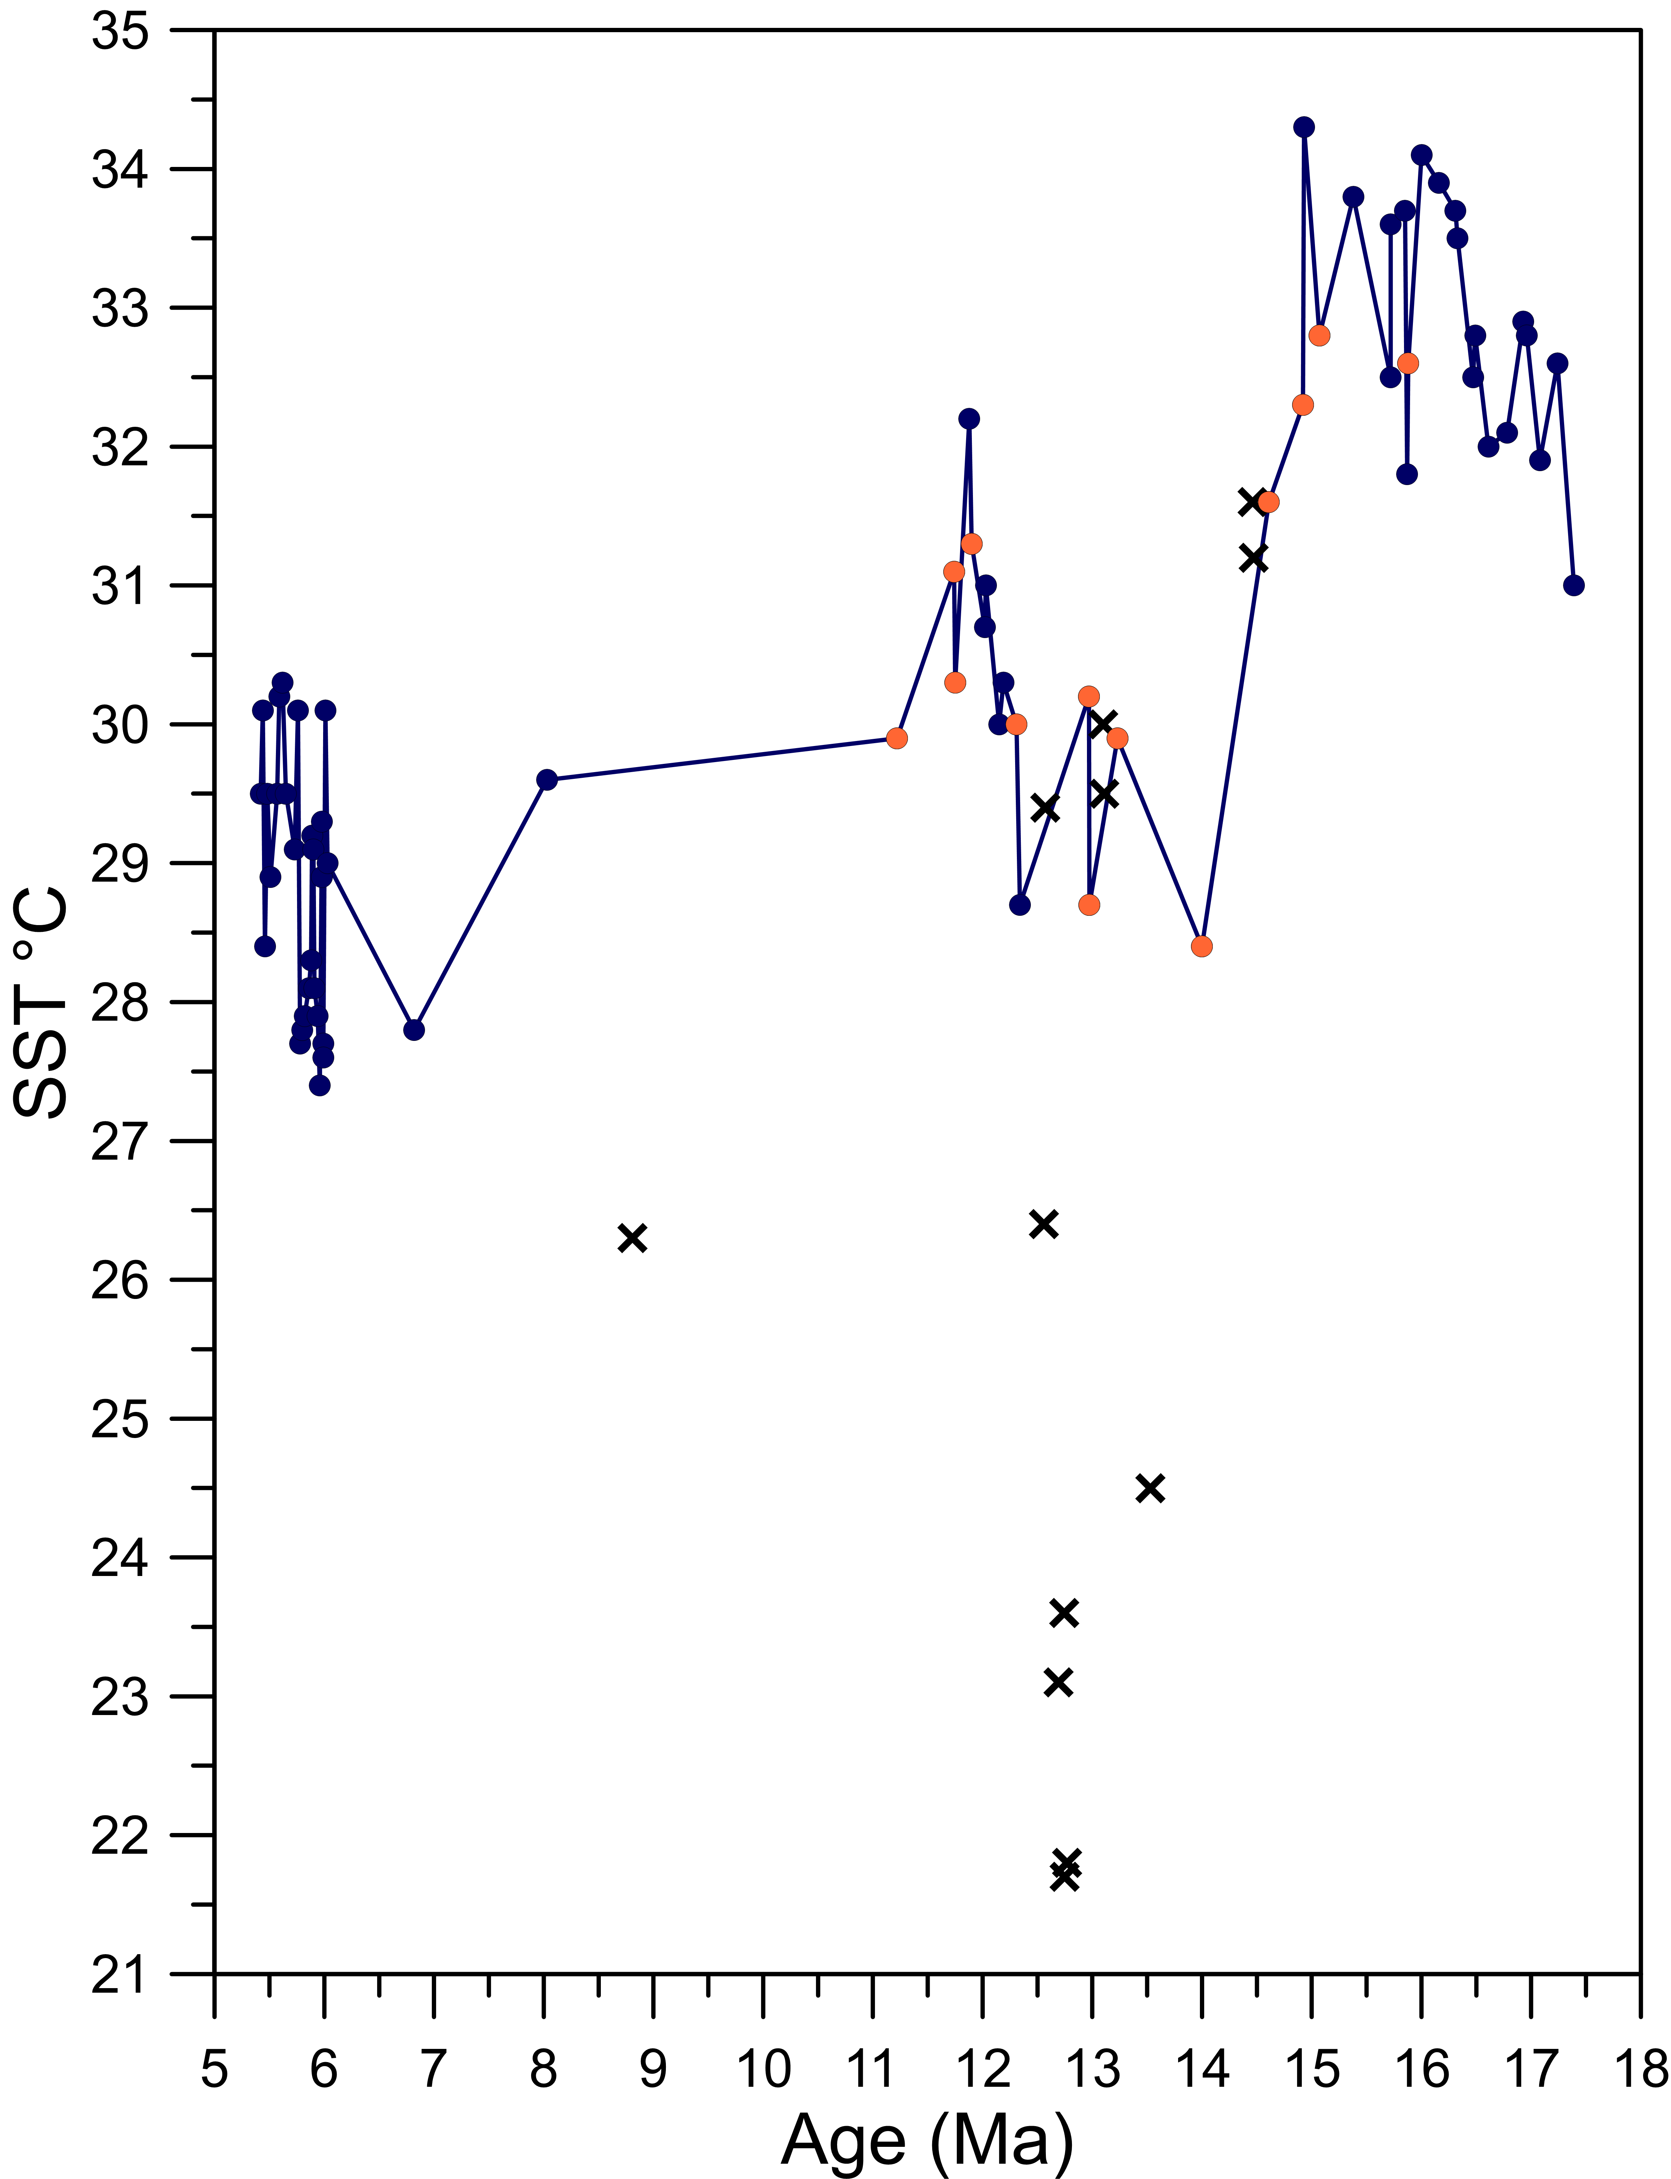

Figure S2: Data removed from interpretation due to non-thermal influence on GDGT-derived SST proxies. Data points in orange exhibit higher BIT values but are just below the chosen cut-off for BIT or reveal #Ring_{tetra} values above the threshold.

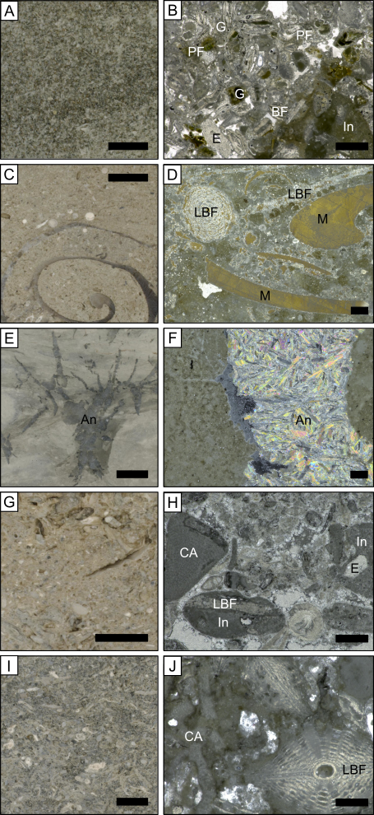

Figure S3: Core photographs and thin-section images from IODP Hole U1464C. Sample positions are indicated on Figure 2. The scale bar is 1 cm on core and 500 μm on thin section photos. A and B: Lithofacies of the platform drowning sequence (MioR-3). Glauconitic (G) packstone with a mix of neritic (e.g., benthic foraminifera (BF), echinoderm fragments (E)) and pelagic components (planktic foraminifera (PF)) and intraclasts (In). C and D: Wackestone to packstone from the lagoonal facies (MioR-2) contain abundant large benthic foraminifera (LBF) and mollusk fragments (M), including bivalves and gastropods. Most previously aragonitic bioclasts have been partially or completely replaced by gypsum. E and F: Mud to wackestone from the sabkha facies (MioR-2) characterized by large anhydrite (An) crystals. Note that the matrix in F shows a peloidal texture. G and H: Bioclastic pack- to grainstone with intraclasts (In) (MioR-0). Bioclasts include Larger benthic foraminifera (LBF), coralline algae (CA), and echinoderm fragments. I and J: Bioclastic packstone of the slope margin facies (MioR-0), rich in large benthic foraminifera (LBF) and coralline algae (CA).

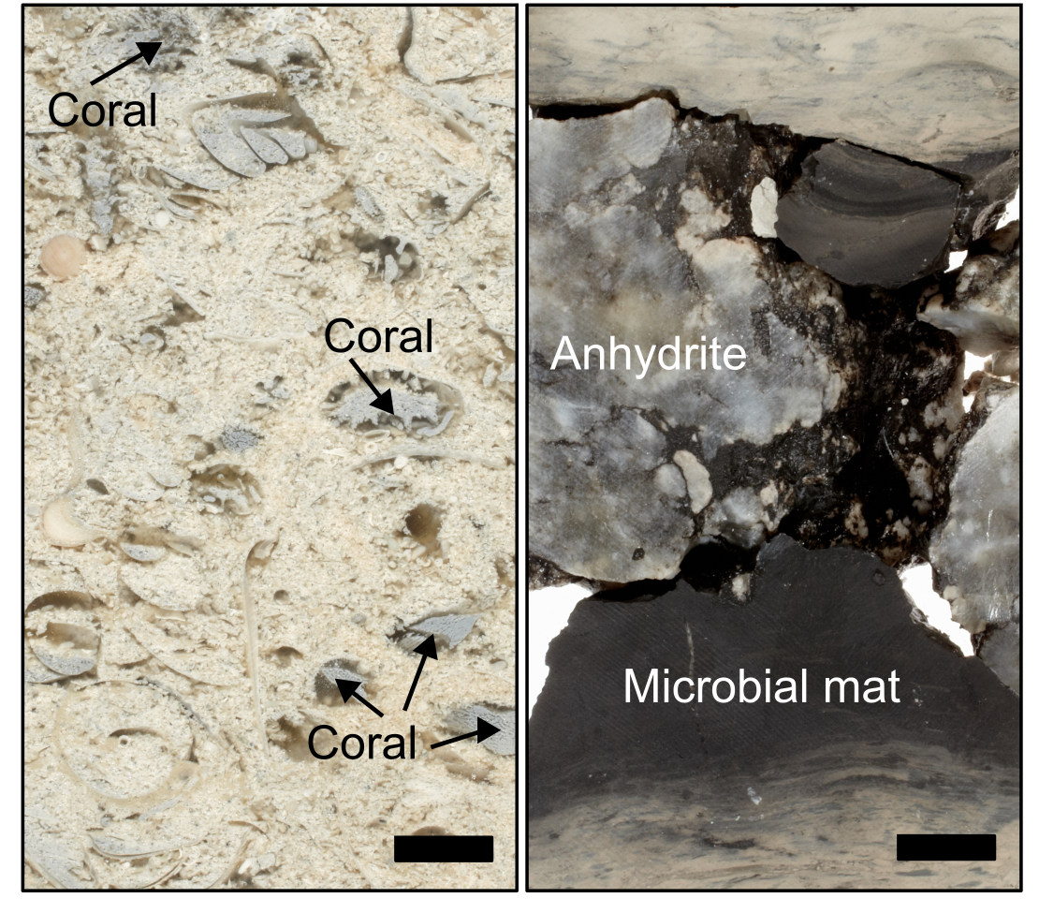
Figure S4: Core photos from IODP Hole U1464C showing a microbial mat associated with the sabkha (right) and coral fragments, partly or completely replaced by gypsum (left). Both were deposited during the phase of maximum reef progradation (MioR-2). Locations shown in Figure 2. The scale bar is 1 cm.

Bell, P.R.F., Elmetri, I., Lapointe, B.E., 2013. Evidence of Large-Scale Chronic Eutrophication in the Great Barrier Reef: Quantification of Chlorophyll a Thresholds for Sustaining Coral Reef Communities. AMBIO 2013 43:3 43, 361–376. https://doi.org/10.1007/S13280-013-0443-1
De Vleeschouwer, D., Peral, M., Marchegiano, M., Fullberg, A., Meinicke, N., Palike, H., Auer, G., Petrick, B., Snoeck, C., Goderis, S., Claeys, P., 2022. Plio-Pleistocene Perth Basin water temperatures and Leeuwin Current dynamics (Indian Ocean) derived from oxygen and clumped-isotope paleothermometry. Climate of the Past 18, 1231–1253. https://doi.org/10.5194/cp-18-1231-2022
Gallagher, S.J., Fulthorpe, C.S., Bogus, K., Auer, G., Baranwal, S., Castañeda, I.S., Christensen, B.A., De Vleeschouwer, D., Franco, D.R., Groeneveld, J., Gurnis, M., Haller, C., He, Y., Henderiks, J., Himmler, T., Ishiwa, T., Iwatani, H., Jatiningrum, R.S., Kominz, M.A., Korpanty, C.A., Lee, E.Y., Levin, E., Mamo, B.L., McGregor, H.V., McHugh, C.M., Petrick, B.F., Potts, D.C., Rastegar Lari, A., Renema, W., Reuning, L., Takayanagi, H., Zhang, W., 2017. Site U1464. https://doi.org/10.14379/iodp.proc.356.109.2017
Karatsolis, B. ‐Th., De Vleeschouwer, D., Groeneveld, J., Christensen, B., Henderiks, J., 2020. The Late Miocene to Early Pliocene “Humid Interval” on the NW Australian Shelf: Disentangling Climate Forcing From Regional Basin Evolution. Paleoceanogr Paleoclimatol 35. https://doi.org/10.1029/2019PA003780
McCaffrey, J.C., Gallagher, S.J., Wallace, M.W., Averes, T., Fabian, S.G., Lindhorst, K., Reuning, L., Krastel, S., 2025. The Rowley Shoals atolls: Remnants of a Miocene great barrier reef on the north-west Australian margin. Glob Planet Change 245, 104688. https://doi.org/10.1016/J.GLOPLACHA.2024.104688
McCaffrey, J.C., Wallace, M.W., Gallagher, S.J., 2020. A Cenozoic Great Barrier Reef on Australia’s North West shelf. Glob Planet Change 184, 103048. https://doi.org/10.1016/j.gloplacha.2019.103048
Petrick, B., Reuning, L., Auderset, A., Pfeiffer, M., Auer, G., Schwark, L., 2024. High sea surface temperatures were a prerequisite for the development and expansion of the Great Barrier Reef. Sci Adv 10, eado2058. https://doi.org/10.1126/SCIADV.ADO2058/SUPPL_FILE/SCIADV.ADO2058_DATA_S1.ZIP
Petrick, B., Reuning, L., Auer, G., Zhang, Y., Pfeiffer, M., Schwark, L., 2023. Warm, not cold temperatures contributed to a Late Miocene reef decline in the Coral Sea. Sci Rep 13, 4015. https://doi.org/10.1038/s41598-023-31034-8
Petrick, B., Reuning, L., Martínez-García, A., 2019. Distribution of Glycerol Dialkyl Glycerol Tetraethers (GDGTs) in Microbial Mats From Holocene and Miocene Sabkha Sediments. Front Earth Sci (Lausanne) 7, 310. https://doi.org/10.3389/feart.2019.00310
Petrick, B.F., Reuning, L., Pfeiffer, M., Auer, G., Schwark, L., 2025. Impact of the Late Miocene Cooling on the loss of coral reefs in the Central Indo-Pacific. Climate of the Past 21, 405–417. https://doi.org/10.5194/CP-21-405-2025
Rattanasriampaipong, R., Tierney, J.E., Abell, J.T., Gilmore, L.D., 2025. A Nutrient Effect on the TEX86 Paleotemperature Proxy. Geophys Res Lett 52, e2025GL115237. https://doi.org/10.1029/2025GL115237;ISSUE:ISSUE:DOI
Rattanasriampaipong, R., Zhang, Y.G., Pearson, A., Hedlund, B.P., Zhang, S., 2022. Archaeal lipids trace ecology and evolution of marine ammonia-oxidizing archaea. Proceedings of the National Academy of Sciences 119, e2123193119. https://doi.org/10.1073/PNAS.2123193119
Reagan, J.R., Boyer, T.P., García, H.E., Locarnini, R.A., Baranova, O.K., Bouchard, C., Cross, S.L., Mishonov, A. V., Paver, C.R., Seidov, D., Wang, Z., Dukhovskoy, D., 2023. World Ocean Atlas 2023.
Rosleff-Soerensen, B., Reuning, L., Back, S., Kukla, P., 2012. Seismic geomorphology and growth architecture of a Miocene barrier reef, Browse Basin, NW-Australia. Mar Pet Geol 29, 233–254. https://doi.org/10.1016/j.marpetgeo.2010.11.001
Schouten, S., Hopmans, E.C., Rosell-Melé, A., Pearson, A., Adam, P., Bauersachs, T., Bard, E., Bernasconi, S.M., Bianchi, T.S., Brocks, J.J., Carlson, L.T., Castañeda, I.S., Derenne, S., Selver, A.D., Dutta, K., Eglinton, T., Fosse, C., Galy, V., Grice, K., Hinrichs, K.-U., Huang, Y., Huguet, A., Huguet, C., Hurley, S., Ingalls, A., Jia, G., Keely, B., Knappy, C., Kondo, M., Krishnan, S., Lincoln, S., Lipp, J., Mangelsdorf, K., Martínez-García, A., Ménot, G., Mets, A., Mollenhauer, G., Ohkouchi, N., Ossebaar, J., Pagani, M., Pancost, R.D., Pearson, E.J., Peterse, F., Reichart, G.-J., Schaeffer, P., Schmitt, G., Schwark, L., Shah, S.R., Smith, R.W., Smittenberg, R.H., Summons, R.E., Takano, Y., Talbot, H.M., Taylor, K.W.R., Tarozo, R., Uchida, M., van Dongen, B.E., Van Mooy, B.A.S., Wang, J., Warren, C., Weijers, J.W.H., Werne, J.P., Woltering, M., Xie, S., Yamamoto, M., Yang, H., Zhang, C.L., Zhang, Y., Zhao, M., Damsté, J.S.S., 2013. An interlaboratory study of TEX 86 and BIT analysis of sediments, extracts, and standard mixtures. Geochemistry, Geophysics, Geosystems 14, 5263–5285. https://doi.org/10.1002/2013GC004904
Schouten, S., Hopmans, E.C., Schefuss, E., Sinninghe Damsté, J.S., 2002. Distributional variations in marine crenarchaeotal membrane lipids: a new tool for reconstructing ancient sea water temperatures? Earth Planet Sci Lett 204, 265–274.
Sinninghe Damsté, J.S., 2016. Spatial heterogeneity of sources of branched tetraethers in shelf systems: The geochemistry of tetraethers in the Berau River delta (Kalimantan, Indonesia). Geochim Cosmochim Acta 186, 13–31. https://doi.org/10.1016/J.GCA.2016.04.033
Sinninghe Damsté, J.S., Ossebaar, J., Schouten, S., Verschuren, D., 2012. Distribution of tetraether lipids in the 25-ka sedimentary record of Lake Challa: extracting reliable TEX86 and MBT/CBT palaeotemperatures from an equatorial African lake. Quat Sci Rev 50, 43–54. https://doi.org/10.1016/j.quascirev.2012.07.001
Sosdian, S.M., Babila, T.L., Greenop, R., Foster, G.L., Lear, C.H., 2020. Ocean Carbon Storage across the middle Miocene: a new interpretation for the Monterey Event. Nature Communications 2020 11:1 11, 1–11. https://doi.org/10.1038/s41467-019-13792-0
Sosdian, S.M., Lear, C.H., 2020. Initiation of the Western Pacific Warm Pool at the Middle Miocene Climate Transition? Paleoceanogr Paleoclimatol 35, e2020PA003920. https://doi.org/10.1029/2020PA003920
Zhang, Y.G., Pagani, M., Wang, Z., 2016. Ring Index: A new strategy to evaluate the integrity of TEX 86 paleothermometry. Paleoceanography 31, 220–232. https://doi.org/10.1002/2015PA002848
Zhang, Y.G., Zhang, C.L., Liu, X.-L., Li, L., Hinrichs, K.-U., Noakes, J.E., 2011. Methane Index: A tetraether archaeal lipid biomarker indicator for detecting the instability of marine gas hydrates. Earth Planet Sci Lett 307, 525–534. https://doi.org/10.1016/J.EPSL.2011.05.031

