Supplementary Material for
Hund’s physics-driven strong correlation in the altermagnet CaCrO₃
Zhenfeng Ouyang,¹ Peng-Jie Guo^{,2,*}, Rong-Qiang He^{,2,*}, and Zhong-Yi Lu^{2,3,*}
¹Department of Physics, School of Physical Science and Technology, Ningbo University, Ningbo 315211, China
²School of Physics and Key Laboratory of Quantum State Construction and Manipulation (Ministry of Education), Renmin University of China, Beijing 100872, China
³Hefei National Laboratory, Hefei 230088, China
e-mail: guopengjie@ruc.edu.cn; rqhe@ruc.edu.cn; zlu@ruc.edu.cn

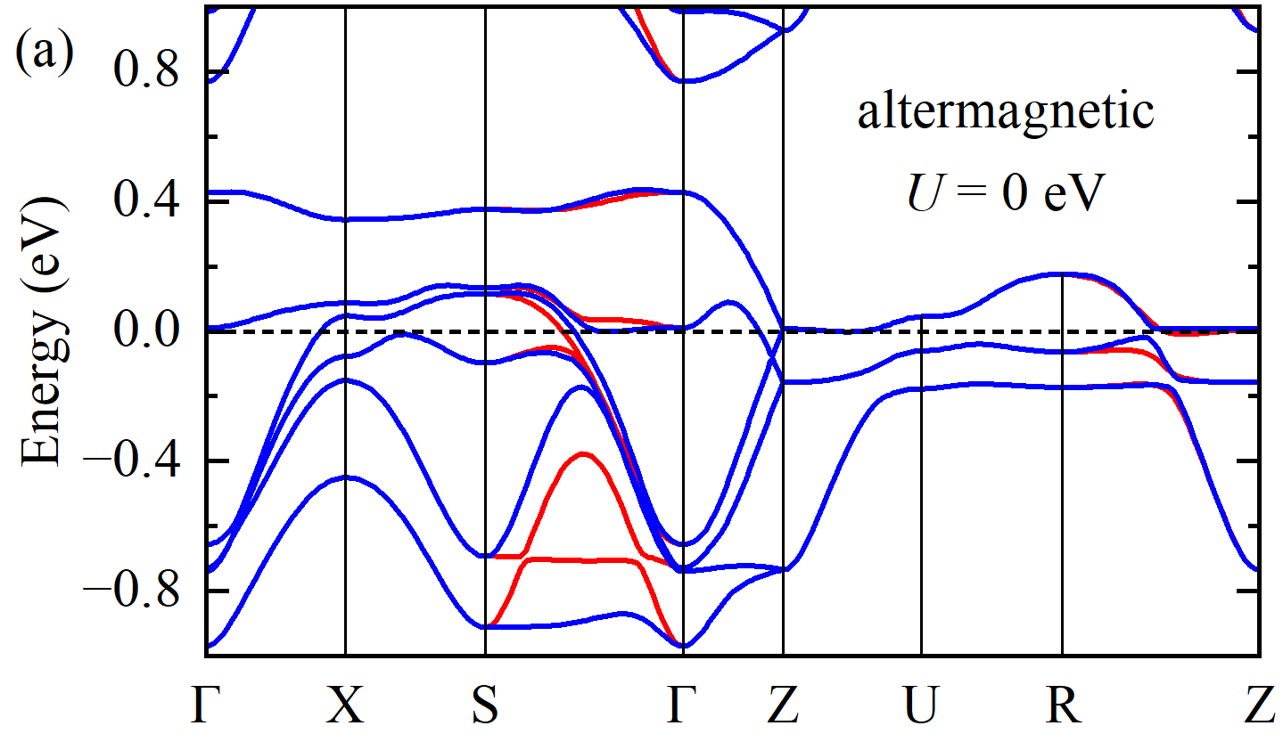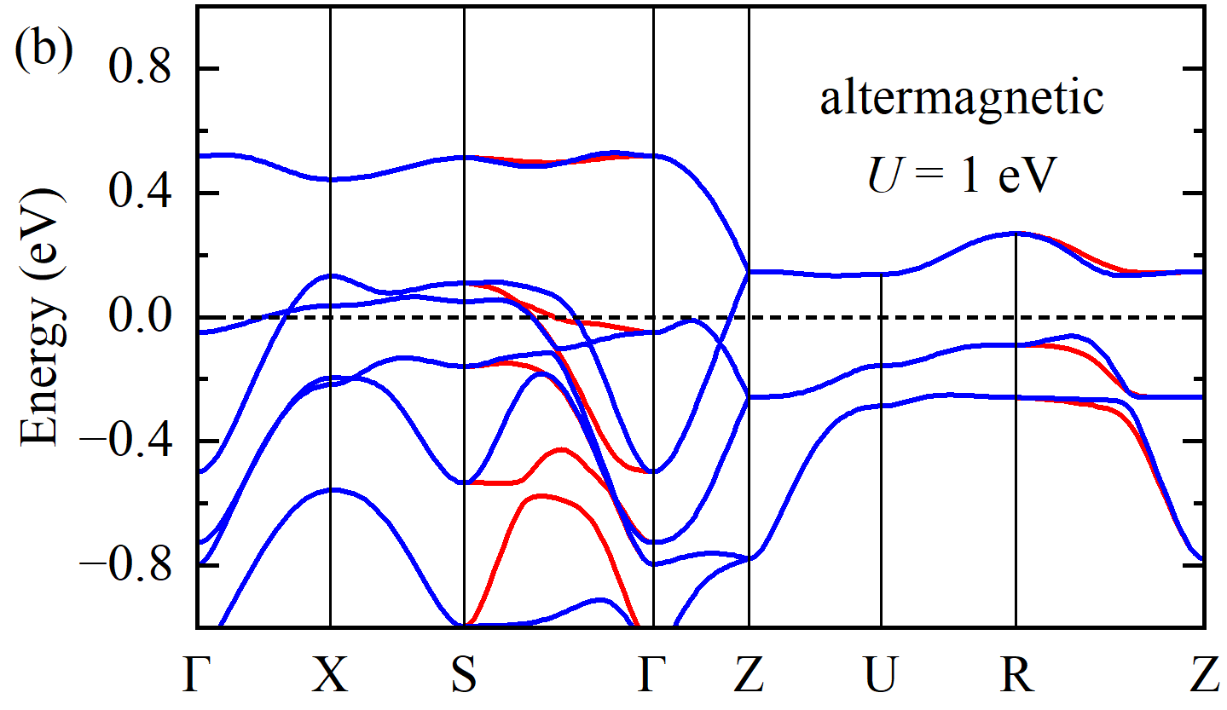
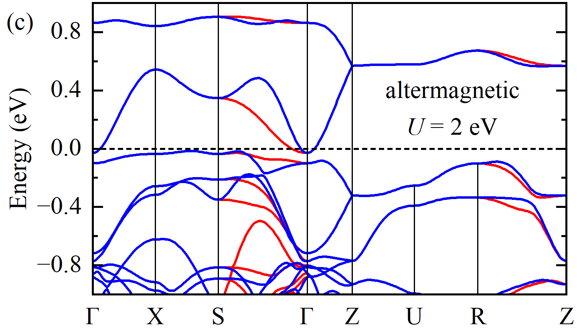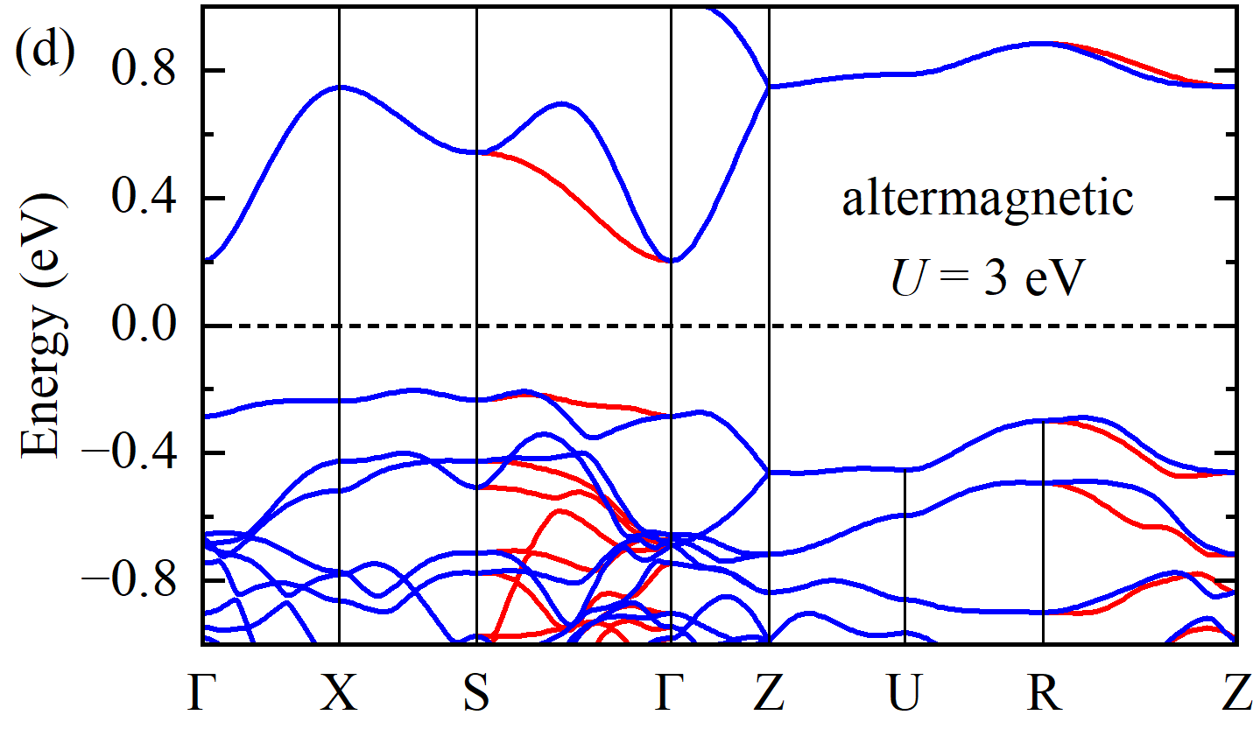
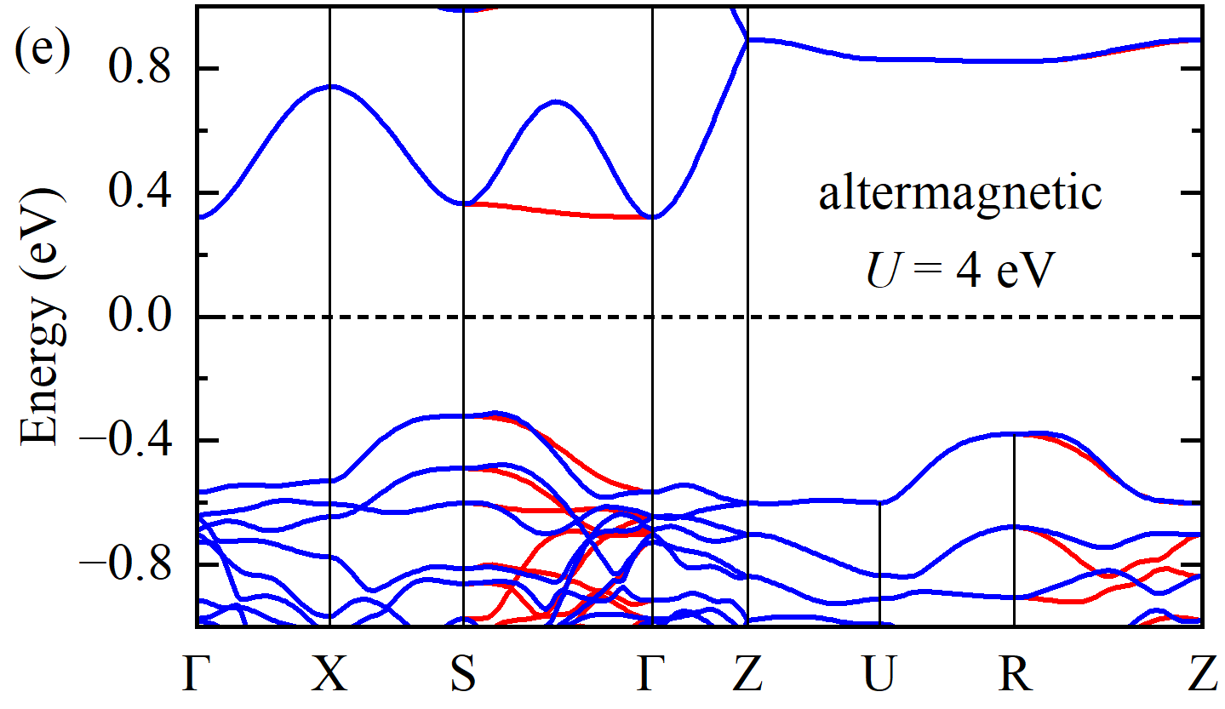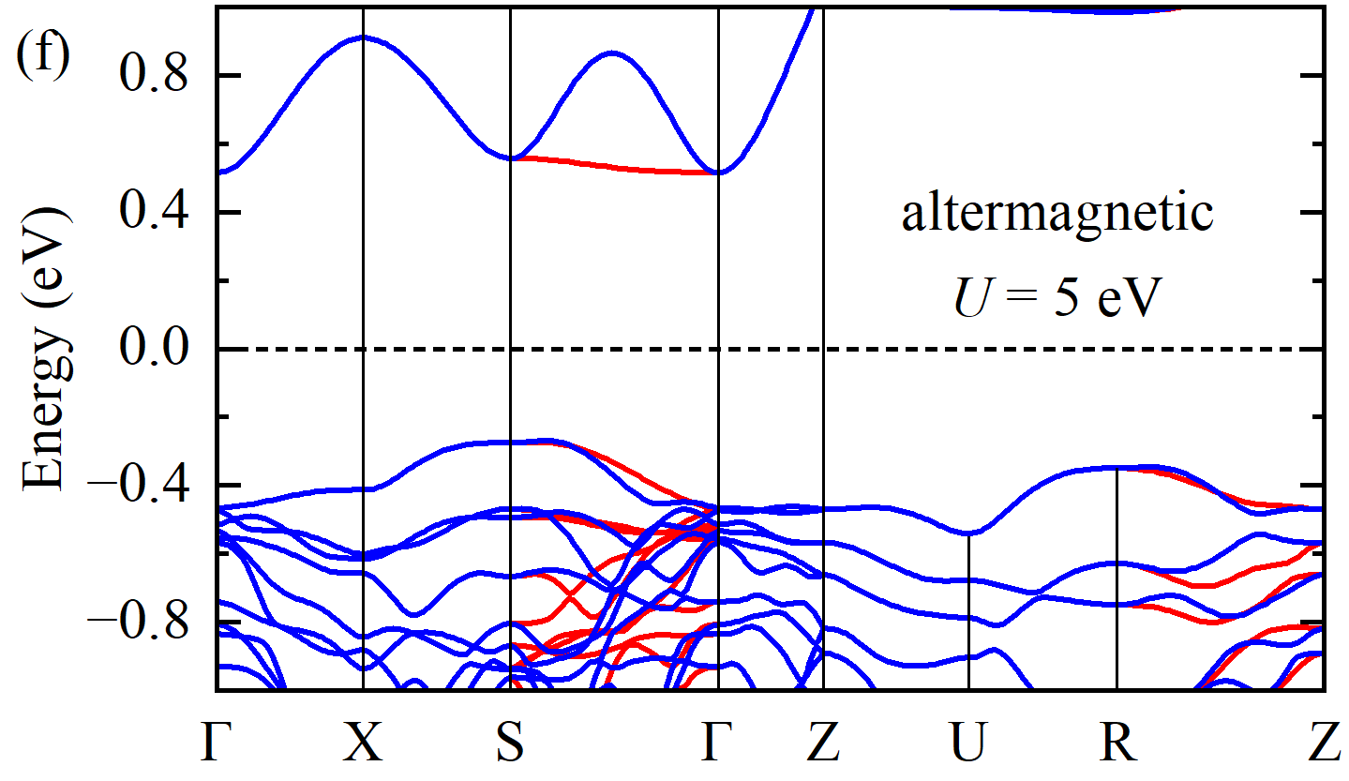
Supplementary Figure 1. DFT+U calculated band structures of altermagnetic CaCrO₃. (a)-(f) Results for U = 0, 1, 2, 3, 4, and 5 eV, respectively.
Static DFT+U calculated results
As shown in Supplementary Figure 1, the introduction of static electronic correlation causes a band shift, which corresponds to an overall upward shift of the band energies. The band shift is proportional to the increase in the effective Hubbard U. A band gap emerges when U is larger than 2 eV, which conflicts with the experimentally observed correlated metallic behavior. These findings strongly suggest that DFT+U fails to describe the strong electronic correlation of CaCrO₃.
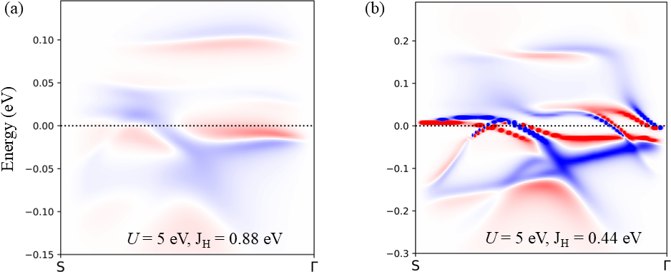
Supplementary Figure 2. DFT+DMFT calculated spectral functions A(k, ω) along the S-Γ path for altermagnetic CaCrO₃ with different J_{H}. (a) J_{H} = 0.88 eV and (b) J_{H} = 0.44 eV. The value of Hubbard U is fixed to 5 eV.

Altermagnetism under different Hund’s coupling J_{H}
In Supplementary Figure 2, we show the correlated band structure of altermagnetic CaCrO₃ by the differential spin-resolved spectral function A_{up}(k, ω)－A_{down}(k, ω). The spin splitting of correlated altermagnetic CaCrO₃ is obvious, although electronic correlation further renormalizes the bands. We also find that the reduction of J_{H} significantly affects the band renormalization and enhances the coherence of the spectral functions around the low-energy region, which is consistent with Hund’s physics. However, the altermagnetic spin splitting is not sensitive to J_{H}. For example, when J_{H} reduces from 0.88 eV to 0.44 eV, the flat bands at 0.1 eV above the Fermi level in Supplementary Figure 2(a) shift to about 0.2 eV above the Fermi level, while the spin splitting does not significantly change as J_{H} decreases.
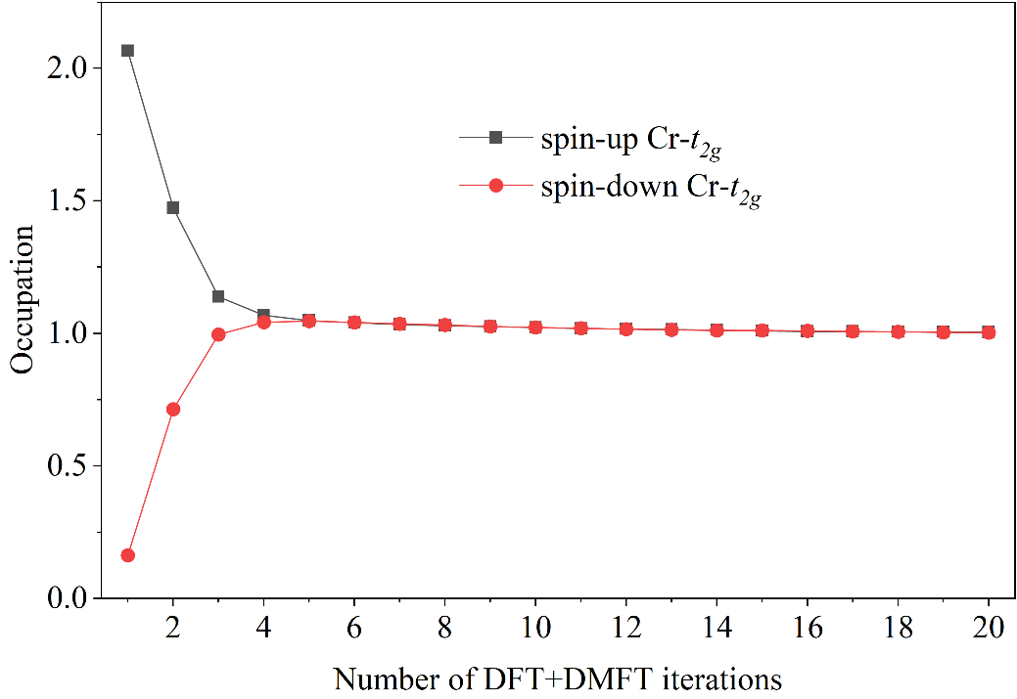
Supplementary Figure 3. Evolution of the occupations for the spin-up and spin-down t_{2g} orbitals of a Cr atom during the DFT+DMFT iterations. U and J_{H} are set to 5 and 0.22 eV, respectively.
Furthermore, we find that J_{H} is important for hosting altermagnetism. Specifically, when J_{H} is set to 0.22 eV, we artificially create a large energy gap of ~2 eV between the spin-up and spin-down t_{2g} orbitals at the start of the DFT+DMFT cycle, to break the spin degeneracy and induce an initial spin polarization. However, the occupations of the spin-up and spin-down t_{2g} orbitals of a Cr atom soon converge to the same value within 5 cycles of the DFT+DMFT iteration, and the system becomes a paramagnetic state, as shown in Supplementary Figure 3. This finding strongly indicates that Hund’s correlation is important for hosting altermagnetism.
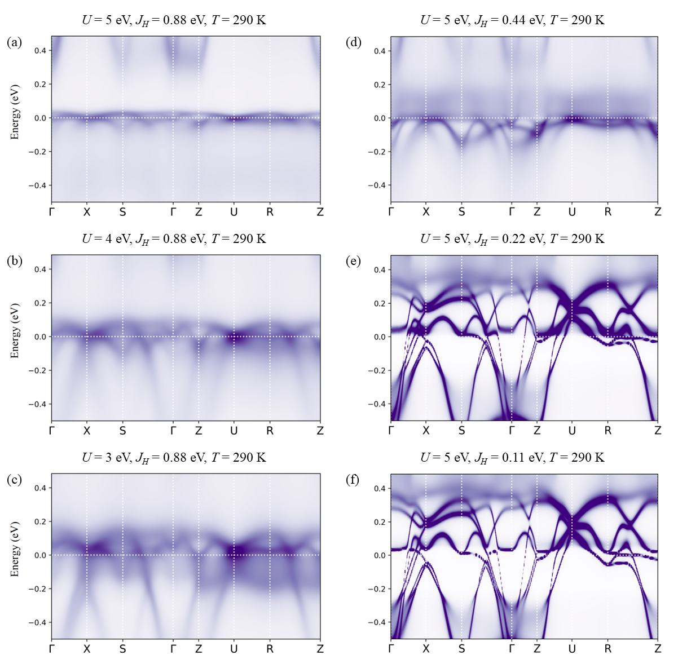
Supplementary Figure 4. DFT+DMFT calculated spectral functions A(k, ω) of paramagnetic CaCrO₃ with different sets of parameters.

Evidence for Hundness
As shown in Supplementary Figure 4, for the paramagnetic phase of CaCrO₃, the low-energy bandwidth decreases with increasing Hubbard U within the DFT+DMFT framework, showing the dynamical correlation and describing the experimentally observed metallic behavior of CaCrO₃ correctly. On the contrary, the results of DFT+U in Supplementary Figure 1 show that the bands are rigidly shifted, and a gap is found when Hubbard U exceeds 2 eV, while the bandwidth is almost unchanged.
By fixing U and decreasing J_{H}, the low-energy spectra become increasingly coherent, and good coherence appears when J_{H} = 0.22 and 0.11 eV [Supplementary Figures 4(e) and (f)]. As shown in Supplementary Figures 4(a)-(c), these spectral functions with a large J_{H} but different U remain incoherent. The spectral functions A(ω) exhibited in Supplementary Figure 5 also show that the electronic structure is more sensitive to Hund’s coupling J_{H}. These findings strongly indicate that Hund’s coupling J_{H} is vital for the incoherence and band renormalization.
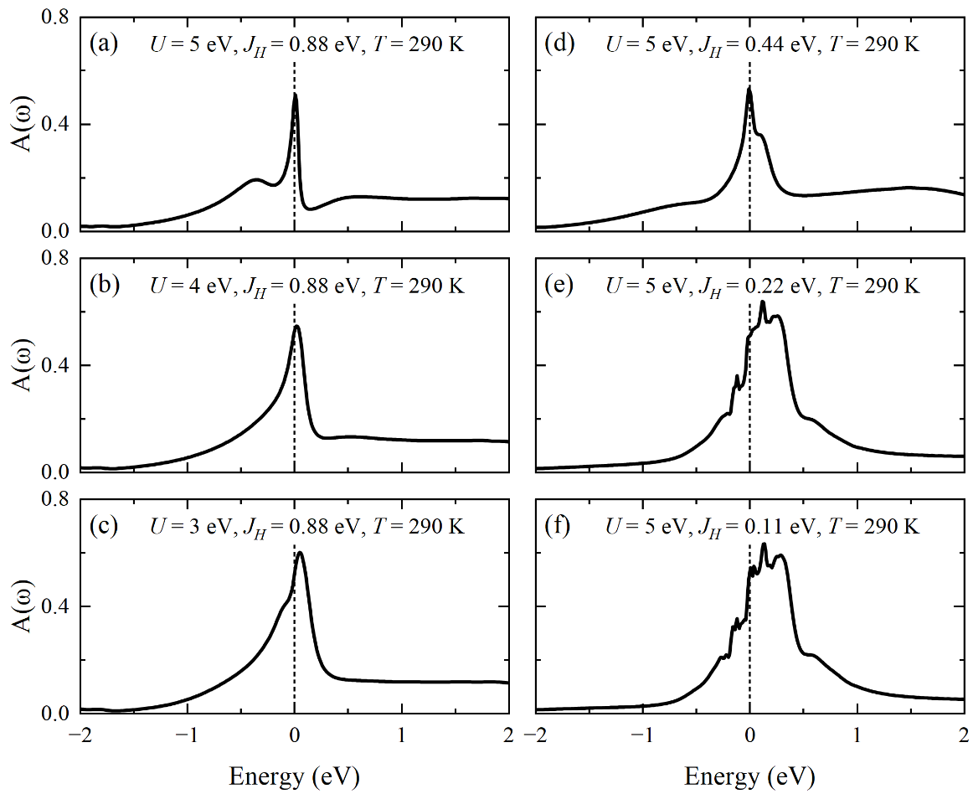
Supplementary Figure 5. DFT+DMFT calculated spectral functions A(ω) of the Cr-t_{2g} orbital of paramagnetic CaCrO₃ with different sets of parameters.
As shown in Supplementary Figure 6, except for the cases of the small J_{H} = 0.22 and 0.11 eV, all the Matsubara self-energy functions deviate from linearity in the low-frequency region, which indicates their non-Fermi liquid behavior. These findings strongly indicate that the non-Fermi liquid behavior of paramagnetic CaCrO₃ is driven by Hundness.
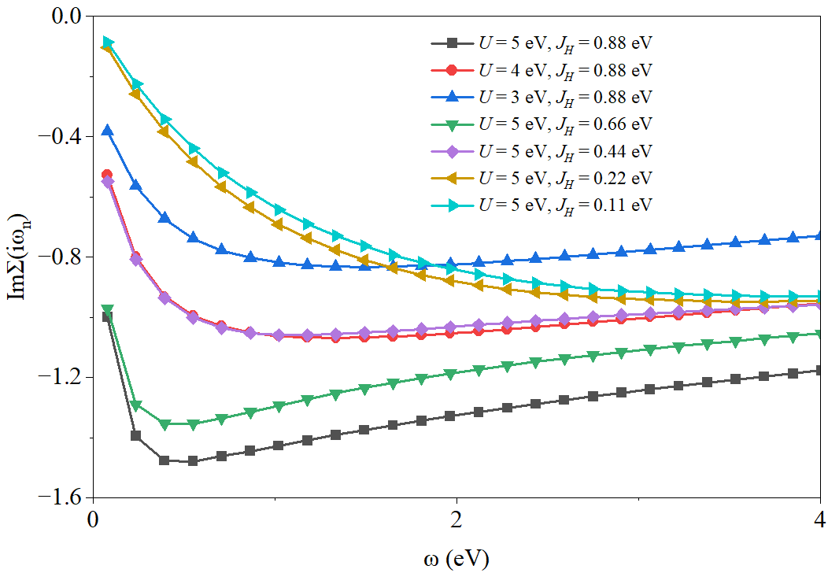
Supplementary Figure 6. DFT+DMFT calculated imaginary parts of the self-energy functions ImΣ(iω_{n}) for the t_{2g} orbital of paramagnetic CaCrO₃ at 290 K with different interaction parameters.

Supplementary Table I. DFT+DMFT calculated weights (%) of the local spin multiplets composed of the Cr-t_{2g} orbitals for low-temperature (80 K) altermagnetic (AM) and high-temperature (290 K) paramagnetic (PM) CaCrO₃ with different sets of parameters.
N | 2 | 2 | 2 | 3 | 3 | 3 | 3 | other
S_{z} | 0 | 1 | -1 | 1/2 | -1/2 | 3/2 | -3/2 | other
U = 5 eV, J_{H} = 0.88 eV (AM) | 5.29 | 47.29 | 7.43 | 14.09 | 2.97 | 13.20 | 2.12 | 7.61
U = 3 eV, J_{H} = 0.88 eV (PM) | 7.69 | 18.96 | 18.96 | 9.10 | 9.10 | 11.34 | 11.34 | 13.51
U = 4 eV, J_{H} = 0.88 eV (PM) | 6.32 | 23.21 | 23.21 | 8.94 | 8.94 | 9.71 | 9.71 | 9.96
U = 5 eV, J_{H} = 0.88 eV (PM) | 4.43 | 27.97 | 27.97 | 8.65 | 8.65 | 7.61 | 7.61 | 7.11
U = 5 eV, J_{H} = 0.66 eV (PM) | 5.59 | 27.55 | 27.55 | 9.53 | 9.53 | 6.47 | 6.47 | 7.31
U = 5 eV, J_{H} = 0.44 eV (PM) | 10.04 | 24.14 | 24.14 | 11.12 | 11.12 | 5.62 | 5.62 | 8.20
U = 5 eV, J_{H} = 0.22 eV (PM) | 29.71 | 15.60 | 15.60 | 7.72 | 7.72 | 1.35 | 1.35 | 20.95
U = 5 eV, J_{H} = 0.11 eV (PM) | 32.92 | 13.57 | 13.57 | 7.37 | 7.37 | 1.02 | 1.02 | 23.16

As listed in Supplementary Table I, for the cases of J_{H} = 0.22 and 0.11 eV, the high-spin state |𝑁 = 2, |S_{z}| = 1⟩ loses dominance, suggesting the absence of local spin moments. These results are consistent with those of Supplementary Figures 4(e) and (f), where the spectral functions show good coherence. This is direct evidence that Hundness in CaCrO₃ generates the local spin moments. Additionally, the weights of local spin multiplets labeled by the good quantum number N in both paramagnetic and altermagnetic phases (U = 5.0 eV and J_{H} = 0.88 eV) are close, which indicates that there is no valence change. The high-spin state |𝑁 = 2, |S_{z}| = 1⟩ for the Cr-t_{2g} orbital also dominates throughout, manifesting Hundness.

