A Water-Soluble Bimane Fluorophore for Reversible Fluorescent and Colorimetric Detection of Indium(III)
Jiawei Liu,† Nathaniel Chennattuparambil Roy,† Flavio Grynszpan, and Mindy Levine
†These authors contributed equally to this work.
TABLE OF CONTENTS
- Materials and Methods…………………………………………………………....…………..S3
- Experimental Procedures…………………………………………………………………......S4
- Summary Tables…………………………………………………………………………….S14
- Summary Figures…………………………………………………………………………....S28
- References…………………………………………………………………………………...S62
- MATERIALS AND METHODS
- Chemical sources and purification procedures:
  - All chemicals were purchased from commercial suppliers and used without further purification, except where otherwise noted.
  - All organic solvents used were HPLC grade and were dried over activated molecular sieves (3 Å or 4 Å) prior to use.
  - NMR solvents were purchased from Thermo Scientific Chemicals and dried over activated molecular sieves (3 Å or 4 Å) prior to use.
  - The filter papers used were Munktell filter papers (Grade: 100/N).
  - Ultrapure water was obtained using a Milli-Q® ultrapure water purification system, in which water is processed through the QPAK® purification cartridge to reach a resistivity of 18.2 MΩ•cm (25 °C) and a TOC value below 5 ppb.
- Instrument parameters:
  - All UV–visible absorbance spectra were recorded on a Varian Cary 50 Bio UV–visible spectrophotometer.
  - Fluorescence spectra were recorded on a Varian Cary Eclipse fluorescence spectrophotometer, with emission recorded at a 90º angle relative to the excitation source.
  - All FTIR spectra were recorded on a Perkin Elmer Spectrum One FTIR spectrometer. The measurements were carried out using a MIRacle TM single reflection ATR accessory from PIKE Technologies, without any sample processing.
  - All of the high-resolution mass spectra (HRMS) were measured in positive ionization mode using a Waters Micromass Quattro Micro instrument, which was equipped with an electrospray ionization source and Waters 2795 and 996 PDA detectors.
  - ¹H NMR spectra were obtained using a Bruker Avance III spectrometer operating at 400 MHz.
  - The pH values of aqueous solutions were recorded on a Mettler Toledo Education Line pH meter.
- Computer analysis/processing:
  - All fluorescence spectra were integrated vs. wavenumber on the X-axis using OriginPro 2020.
  - All curve fitting was done using OriginPro curve fitting options (either linear or non-linear curve fitting, as applicable).
  - All colorimetric analysis was done using freely available ImageJ software (https://imagej.net/ij/index.html).

- EXPERIMENTAL PROCEDURES
- Synthesis of compound 1:
Scheme S1. Synthesis of compound 1
Synthesis of compound 5: Compound 5 was prepared following a literature-reported procedure.¹ In brief, 4-aminobenzenesulfonic acid S1 (500 mg, 2.89 mmol, 1 equiv.) was dissolved in 2 N hydrochloric acid (10 mL). The resulting solution was cooled to 0 °C and an aqueous solution (6 mL) of sodium nitrite (249.2 mg, 3.61 mmol, 1.25 equiv.) was added dropwise, followed by stirring the reaction for one hour. A solution of sodium azide (375.7 mg, 5.78 mmol, 2 equiv.) in water (4 mL) was then added, and the reaction mixture was allowed to warm to room temperature and stir overnight at room temperature. The crude product was precipitated by the addition of sodium chloride (2.0 grams), filtered, and dried under reduced pressure to obtain compound 5 as a white solid (345 mg, 54% yield). ¹H NMR (400 MHz, DMSO-d₆) δ = 7.63 (d, J = 8.7 Hz, 2 H), 7.07 (d, J = 8.7 Hz, 2 H) ppm; ¹³C NMR (101 MHz, DMSO-d₆) δ = 145.21, 139.39, 127.39, 118.31 ppm; LC-MS: m/z calcd. for C₆H₄N₃NaO₃S: 220.9 found: 221.9 [M+H]⁺.
Synthesis of compound 4: Compound 4 was prepared using modified literature-reported procedures.^{2,3} In brief, in a 250 mL round-bottomed flask, syn-(CH₃,I)bimane 2 (200 mg, 0.48 mmol, 1.0 equiv.) was dissolved in 100 mL acetonitrile. To this solution, trimethylsilylacetylene 3 (343 µL, 2.4 mmol, 5 equiv.), bis(triphenylphosphine)palladium (II) chloride (33.6 mg, 0.048 mmol, 0.10 equiv.), cuprous iodide (4.6 mg, 0.024 mmol, 0.05 equiv.) and N,N-diisopropylethylamine (839 µL, 4.8 mmol, 10 equiv.) were added. The reaction mixture was stirred at 80 °C for 2 hours under an inert nitrogen atmosphere and the solvent was then evaporated under reduced pressure. The crude product was purified via column chromatography using 100% dichloromethane as an eluent to yield compound 4 as a yellow solid (116 mg, 68% yield). ¹H NMR (400 MHz, CDCl₃): δ = 2.48 (s, 3 H), 0.23 (s, 9 H) ppm; ¹³C NMR (101 MHz, CDCl₃) δ = 156.53, 150.11, 105.32, 104.14, 91.51, 12.88, −0.03 ppm; HRMS: m/z calcd. for C₁₈H₂₄N₂O₂Si₂: 357.1454; found: 357.1444 [M + H]⁺.
Synthesis of compound 1: Compound 4 (50 mg, 0.14 mmol, 1.0 equiv.) was dissolved in 50 mL of an acetonitrile: water solvent mixture (1:1 vol:vol) under a nitrogen atmosphere, followed by the addition of sodium p-azidobenzenesulfonate (5) (68.5 mg, 0.31 mmol, 2.2 equiv.), copper (I) bromide (4.0 mg, 0.028 mmol, 0.2 equiv.), copper powder (9 mg, 0.14 mmol, 1 equiv.), and N,N-diisopropylethylamine (49 µL, 0.28 mmol, 2.0 equiv.). The reaction mixture was refluxed for 8 hours, and the solvent was then evaporated under reduced pressure. The crude residue was redissolved in 50 mL water and washed with dichloromethane (3 × 50 mL). The aqueous phase was collected and acidified with trifluoroacetic acid (TFA). The solution was concentrated and purified by reverse-phase preparative HPLC (20–30% acetonitrile in water + 0.1% TFA) to afford compound 1 as a yellow solid (35 mg, 41% yield). ¹H NMR (400 MHz, D₂O): δ = 8.29 (s, 1 H), 7.73 (d, J = 8.4 Hz, 2 H), 7.46 (d, J = 8.0 Hz, 2 H), 2.79 (s, 3 H) ppm; ¹³C NMR (101 MHz, D₂O): δ = 156.42, 146.93, 142.94, 137.15, 136.71, 127.14, 119.25, 119.15, 105.12, 12.66 ppm. HRMS: m/z calcd. for C₂₄H₁₈N₈O₈S₂: 611.0767; found: 611.0767 [M + H] ⁺.
- Extinction coefficient determination:
The molar extinction coefficient of compound 1 was calculated using the Beer–Lambert equation (Equation S1 below):
A = ε × c × l (Eq. S1),
where A is the absorbance of the solution at a specific wavelength, ε is the molar extinction coefficient, c is the concentration (mol/L) and l is the path length (cm). By rearranging the equation, the molar extinction coefficient can be expressed as:
ε = A/(c × l)
For these experiments, the path length was 1.0 cm, allowing the molar extinction coefficient to be calculated as the absorbance divided by the concentration. Absorbance was measured at 409 nm for multiple concentrations of compound 1 in aqueous solution (Table S1), and the average molar extinction coefficient was determined to be 1.00 × 10⁴ L M⁻¹ cm⁻¹.
Table S1. Relationship between the concentration of compound 1 in aqueous solutions and its absorbance at 409 nm.
Concentration (c) (mol/L) | Absorbance (A) at 409 nm | Molar Extinction Coefficient (ε) (L M⁻¹ cm⁻¹)
4.0E−6 | 0.0401 | 1.01E4
3.5E−6 | 0.0354 | 1.01E4
3.0E−6 | 0.0297 | 0.99E4

- Quantum yield determination:
The fluorescence spectra for calculating the quantum yield of compound 1 in water were recorded using a Varian Cary Eclipse fluorescence spectrophotometer equipped with a 10 mm pathlength quartz cuvette. The excitation slit width was 5 nm, the emission slit width was 5 nm, and the scan rate was 120 nm/min. Quantum yields were calculated using the single point relative quantum yield method, according to Equation S2, below:⁴
𝜙_{𝐹(𝑥)} = (𝑛_{𝑥}/𝑛_{𝑠} )² (𝐴_{𝑠}/𝐴_{𝑥})( 𝐼_{f(x)}/𝐼_{𝑓(𝑠)} )𝜙_{𝐹(𝑠)} (Eq. S2),
where 𝜙_{𝐹} represents the fluorescence quantum yield, A represents the absorbance value, I_{f} represents the integration of the fluorescence band, and n represents the solvent refractive index. The subscripts s and x refer to the standard and unknown sample, respectively. In this work, the fluorescence quantum yield standard was a solution of Rhodamine B in ethanol, with a quantum yield of 0.50.⁵ The results of these experiments are summarized in Tables S2 and S3, below:
Table S2. Summary of the experimental parameters used to calculate the relative quantum yield of compound 1.
Descriptor | Value
Refractive index of water (n_{x}) | 1.333
Refractive index of ethanol (n_{s}) | 1.361
Absorbance value of standard sample (A_{s}) | 0.0360
Integration value of fluorescence band for standard sample (I_{F(s)}) | 5214.26
Fluorescence quantum yield for standard sample (𝜙_{𝐹(𝑠)}) | 0.50

Table S3. Summary of the experimental results used to calculate the relative quantum yield of compound 1.
[1] (µM) | Absorbance Value (A_{x}) | Integration value (I_{F(x)}) | Quantum yield (𝜙_{𝐹(𝑥)})
4 | 0.0401 | 11305.66 | 0.93
3.5 | 0.0354 | 9994.8 | 0.93
3 | 0.0297 | 8588.83 | 0.95
Average relative quantum yield = 0.936 = 93.6%
- Selectivity and interference (competition) experiments − spectroscopic investigations:
An aqueous stock solution of compound 1 was prepared ([1] = 10 µM). The UV–visible absorbance spectrum (between 200 and 800 nm) and steady-state fluorescence emission spectrum (λ_{ex} = 410 nm; scanned between 415 and 800 nm) of this solution were recorded. The excitation and emission slit widths were 2.5 nm and 5.0 nm, respectively.
6 μL of an aqueous solution of each analyte ([analyte] = 20 mM; analytes: In(NO₃)₃, Tl(NO₃)₃, LiCl, NaNO₃, KCl, AgNO₃, Ca(NO₃)₂, MgCl₂, NiCl₂, BaCl₂, CdCl₂, MnCl₂, Cu(NO₃)₂, HgCl₂, Co(NO₃)₂, Pb(NO₃)₂, ZnSO₄, FeCl₂, CeCl₃, Al(NO₃)₃, FeCl₃, and Ga(NO₃)₃) were added to 3 mL of the stock solution of compound 1 to achieve a final analyte concentration of 40 µM. Each solution was stirred by hand for 2 minutes, followed by measuring its UV–visible absorbance and steady-state fluorescence emission spectra, using the experimental parameters detailed above.
After that, 6 μL of an aqueous solution of In(NO₃)₃ (20 mM) was added to 3 mL of the stock solution of compound 1 in the presence of 40 μM of other analytes (analyte: Tl(NO₃)₃, LiCl, NaNO₃, KCl, AgNO₃, Ca(NO₃)₂, MgCl₂, NiCl₂, BaCl₂, CdCl₂, MnCl₂, Cu(NO₃)₂, HgCl₂, Co(NO₃)₂, Pb(NO₃)₂, ZnSO₄, FeCl₂, CeCl₃, Al(NO₃)₃, FeCl₃, and Ga(NO₃)₃) to achieve the following final concentrations:
- [1] = 10 μM
- [In(NO₃)₃] = 40 μM
- [other analyte] = 40 μM
Each solution was stirred by hand for 2 minutes, followed by measuring its UV–visible absorbance and steady-state fluorescence emission spectra, using the experimental parameters detailed above. The UV–visible absorbance spectra (355–700 nm) and fluorescence emission spectra (418–800 nm) were integrated using OriginPro software. The results reported herein represent an average of three independent trials.
- Selectivity experiments − solution-state colorimetric investigations:
A stock solution of compound 1 was prepared ([1] = 10 µM in H₂O). 1 mL of this solution was added to each of 24 vials, and 4 μL of an aqueous solution of each analyte was then added to the vials (one analyte in each vial; ([analyte] = 20 mM; analytes: In(NO₃)₃, Tl(NO₃)₃, LiCl, NaNO₃, KCl, AgNO₃, Ca(NO₃)₂, MgCl₂, NiCl₂, BaCl₂, CdCl₂, MnCl₂, Cu(NO₃)₂, HgCl₂, Co(NO₃)₂, Pb(NO₃)₂, ZnSO₄, FeCl₂, CeCl₃, Al(NO₃)₃, FeCl₃, and Ga(NO₃)₃). Each solution was stirred by hand and allowed to sit at room temperature for 2 minutes. The vials were then photographed under both ambient light and 365 nm excitation, and the resulting images were subjected to quantitative colorimetric analysis using ImageJ software.

- Selectivity experiments − filter paper-based colorimetric investigations:
Compound 1 was adsorbed onto Munktell filter papers (Grade: 100/N) by submerging the filter papers overnight at room temperature in an aqueous solution of compound 1 ([1] = 50 µM). Following overnight submersion, the papers were removed from the solution and were allowed to dry in an open-air environment.
1 mL of an aqueous solution of each analyte was then added to the 24 vials (one analyte in each vial; [analyte] = 100 μM; analytes: none, In(NO₃)₃, Tl(NO₃)₃, LiCl, NaNO₃, KCl, AgNO₃, Ca(NO₃)₂, MgCl₂, NiCl₂, BaCl₂, CdCl₂, MnCl₂, Cu(NO₃)₂, HgCl₂, Co(NO₃)₂, Pb(NO₃)₂, ZnSO₄, FeCl₂, CeCl₃, Al(NO₃)₃, FeCl₃, and Ga(NO₃)₃).
The prepared papers were immersed in each of these vials. Each vial was shaken manually and allowed to sit at room temperature for one minute before removing the paper with tweezers. The papers were dried under ambient conditions for 3 minutes, and were then photographed under ambient light and under 365 nm excitation (using a hand-held TLC lamp). Colorimetric analysis of the resulting photographs was conducted using ImageJ software. The results reported herein represent an average of three independent trials.
- Filter paper optimization and stability experiments:
Filter papers (Munktell, Grade 100/N) were prepared as described above, except where the probe soak concentration was varied as noted below. All photographs were acquired using the same fixed-geometry camera setup used for Figure 4, and were analyzed using ImageJ. Mean pixel intensities for each RGB channel were recorded on a 0–255 scale. All experiments were repeated in 3 independent trials.
- Loading concentration. Papers were loaded using 10, 50, or 100 μM solutions of compound 1 (baseline: 50 μM), then separately exposed to blank or 100 μM In(NO₃)₃ (1 min exposure, dried for 3 min), and imaged under ambient light and under 365 nm excitation.
- Extended photostability. Papers loaded at the baseline 50 μM condition and subsequently exposed to either 0 or 100 μM In(III) solutions were photographed under 365 nm excitation before irradiation and after 60 minutes of continuous irradiation.
- Storage stability. Papers loaded at the baseline 50 μM condition were imaged under ambient lighting and under 365 nm excitation immediately after preparation and again after 2 days of storage under ambient lighting conditions.
- Titration experiments − solution-state spectroscopic investigations:
A 10 μM solution of compound 1 was prepared in Milli-Q water. The solution was transferred to a quartz cuvette and its fluorescence emission spectrum was recorded using a Varian Cary Eclipse fluorescence spectrometer (λ_{ex} = 410 nm; excitation slit width = 2.5 nm; emission slit width = 5.0 nm; fluorescence emission scan: 415–800 nm).
30 μL of an aqueous solution of In(NO₃)₃ (1 mM) was added to 3 mL of the stock solution of compound 1 to achieve a final In(NO₃)₃ concentration of 10 μM. The solution was stirred by hand for 2 minutes, followed by measuring its UV–visible absorbance and steady-state fluorescence emission spectra, using the experimental parameters detailed above. This step was repeated 13 times to get final In(NO₃)₃ concentrations of 20 µM, 30 µM, 40 µM, 50 µM, 60 µM, 70 µM, 80 µM, 90 µM, 100 µM, 150 µM, 200 µM, and 400 µM. In all cases, after the desired solution concentration was achieved, the solution was stirred by hand for 2 minutes and the UV–visible absorbance and steady-state fluorescence emission spectra were measured using the experimental parameters detailed above. All experiments were repeated in three independent trials.
- Titration experiments − solution-state colorimetric investigations:
A stock solution of compound 1 was prepared (10 µM in H₂O). 1 mL of this solution was added to each of 10 vials. 1 μL, 2 μL, 3 μL, 4 μL, 5 μL, 6 μL, 7 μL, 8 μL, 9 μL, and 10 μL of an aqueous solution of In(NO₃)₃ (10 mM) was added to each vial to achieve final In(NO₃)₃ concentrations of 10 μM, 20 µM, 30 µM, 40 µM, 50 µM, 60 µM, 70 µM, 80 µM, 90 µM, and 100 µM. Each solution was stirred by hand and allowed to sit at room temperature for 2 minutes. The vials were then photographed under both ambient light and 365 nm excitation, and the resulting images were subjected to quantitative colorimetric analysis using ImageJ software.
- Titration experiments − filter paper-based colorimetric investigations:
The compound 1-loaded filter papers were prepared as described previously. 1 mL of an aqueous solution of In(NO₃)₃ of varying concentrations were added to 9 vials (one concentration in each vial; [In(NO₃)₃] = 0, 5, 10, 20, 40, 60, 80, 100, and 1000 μM). The as-prepared papers were immersed in each of these vials. Each vial was shaken manually and allowed to sit at room temperature for 1 minute before removing the paper with tweezers. The papers were dried under ambient conditions for 3 minutes, and then were photographed under ambient light and under 365 nm excitation (using a hand-held TLC lamp). Colorimetric analysis of the resulting photographs was conducted using ImageJ software. The results reported herein represent an average of three independent trials.
- Variable concentration experiments:
A 20 μM solution of compound 1 was prepared in Milli-Q water. The solution was transferred to a quartz cuvette, and its fluorescence emission spectrum was recorded using a Varian Cary Eclipse fluorescence spectrometer (λ_{ex} = 410 nm; excitation slit width = 2.5 nm; emission slit width = 5.0 nm; fluorescence scan: 415–800 nm).
2.7 mL of a 20 μM aqueous solution of compound 1 was diluted with Milli-Q water to achieve a final concentration of 18 µM. The solution was stirred manually, followed by measuring its UV–visible absorbance and steady-state fluorescence emission spectra, using the experimental parameters detailed above. This step was repeated ten times to get final compound 1 concentrations of 16 µM, 14 µM, 12 µM, 10 µM, 8 µM, 6 µM, 4 µM, and 2 µM. In all cases, after the desired solution was achieved, the solution was stirred by hand for 2 minutes and the UV–visible absorbance and steady-state fluorescence emission spectra were measured, using the experimental parameters detailed above. All experiments were repeated in three independent trials.
- Other solvent experiments:
A 10 μM solution of compound 1 was prepared in N-methylpyrrolidone (NMP). The UV–visible absorbance spectrum and steady-state fluorescence emission spectrum of this solution were recorded using the following experimental parameters: UV–visible absorbance spectrum recorded from 200–800 nm; fluorescence emission spectrum recorded from 415–800 nm; λ_{ex} = 410 nm; excitation slit width = 2.5 nm; emission slit width = 5.0 nm.
30 μL of an aqueous solution of In(NO₃)₃ (4 mM) was added to 3 mL of the NMP solution of compound 1 to achieve a final In(NO₃)₃ concentration of 40 μM. The solution was stirred by hand for 2 minutes, followed by measuring its UV–visible absorbance and steady-state fluorescence emission spectra, using the experimental parameters detailed above.
The same procedure was repeated using an aqueous Ga(NO₃)₃ solution (4 mM) instead of In(NO₃)_{3.} In all cases, after the desired solution concentration was achieved, the solution was stirred by hand for 2 minutes and the UV–visible absorbance and steady-state fluorescence emission spectra were measured using the experimental parameters detailed above. All experiments were repeated in three independent trials.
The above procedures were repeated using a 10 μM solution of compound 1 prepared in methanol and a 10 μM solution of compound 1 prepared in dimethylsulfoxide (DMSO).
- ¹H NMR titration experiments:
Compound 1 (0.5 mg) was dissolved in 500 μL of D₂O, and its ¹H NMR spectrum was recorded. For complexation studies, separate NMR tubes were prepared with 1:1 and 1:2 molar ratios of compound 1 and In(NO₃)₃ in D₂O. Each solution was vortexed for 1 minute before recording the ¹H NMR spectrum.
- High-resolution mass spectrometry experiments:
Compound 1 (20 µg) was dissolved in 1 mL of water, followed by the addition of eight equivalents of an aqueous In(NO₃)₃ solution. The mixture was stirred manually for 2 minutes, filtered, and subsequently analyzed by HRMS to detect the bimane: In(III) (1:2) complex.
- Solid-state FTIR experiments:
To measure the solid-state FTIR spectra of the samples, a background scan (i.e., without the sample) was collected as the blank. Following that, a few milligrams of compound 1 were placed on the ATR attachment for the FTIR spectrometer and the spectrum was recorded. The same procedure was repeated with a few milligrams of the solid-state complex formed between In(III) and compound 1. All data were saved as ASCII files and plotted using OriginPro software.
- Limit of detection experiments:
A 10 μM solution of compound 1 was prepared in Milli-Q water. The solution was transferred to a quartz cuvette, and excited at 410 nm using a Varian Cary Eclipse fluorescence spectrometer. The fluorescence emission spectrum of the solution was recorded from 415–800 nm (excitation slit width = 2.5 nm; emission slit width = 5.0 nm).
3 μL of an aqueous solution of 200 μM of In(NO₃)₃ was added to 3 mL of the compound 1 stock solution to achieve the following final concentrations:
- [In(NO₃)₃] = 0.2 µM
- [1] = 10 µM
Each solution was stirred by hand for 2 minutes, followed by measuring its UV–visible absorbance and steady-state fluorescence emission spectra, using the experimental parameters detailed above.
The above step was repeated, but instead of adding 3 μL of the In(NO₃)₃ solution, we added 6 μL, 9 μL, 12 μL, 15 μL, and 18 μL, to obtain final In(NO₃)₃ concentrations of 0.4 μM, 0.6 μM, 0.8 μM, 1.0 μM, and 1.2 μM. In all cases, the solutions were stirred by hand for 2 minutes followed by measuring their UV–visible absorbance and steady-state fluorescence emission spectra, using the experimental parameters detailed above. All experiments were repeated in six independent trials.
We plotted the concentration of In(NO₃)₃ on the X-axis, and the measured output data on the Y-axis (integrated UV–visible absorbance spectra and integrated fluorescence emission spectra). The equations for the best linear fit for each data set were determined.
The limit of detection of the blank (LOD_{blank}) and limit of quantification of the blank (LOQ_{blank}) were calculated using Equations S3 and S4, below:
- LOD_{blank} = Average_{blank} − 3 * SD_{blank} (Eq. S3),
- LOQ_{blank} = Average_{blank} − 10 * SD_{blank} (Eq. S4),
where Average_{blank} represents the average measured value of the repeated trials of the sample without any analyte (i.e., In(NO₃)₃), and SD_{blank} represents the standard deviation of those measurements. Because indium(III) addition decreases the fluorescence and absorbance signal of compound 1, these thresholds were subtracted from the blank average.
For each category of output data, the LOD_{blank}​ and LOQ_{blank} ​ values were treated as signal thresholds and substituted into the best-fit linear calibration equation (y = mx + b). The corresponding analyte concentrations were then obtained by solving for x. This approach uses the full calibration equation and therefore does not require forcing the intercept to zero or assuming that the intercept is negligible.
- Job’s plot experiments:
A 20 μM solution of compound 1 was prepared in Milli-Q water. 2.7 mL of this solution was diluted with Milli-Q water to achieve a final concentration of 18 µM. The same step was repeated by diluting 2.4 mL, 2.1 mL, 1.8 mL, 1.5 mL, 1.2 mL, 0.9 mL, 0.6 mL and 0.3 mL of the 20 μM aqueous solution of compound 1 to achieve final concentrations of 16 µM, 14 μM, 12 μM, 10 μM, 8 μM, 6 μM, 4 μM, and 2 μM.
3 μL of an aqueous solution of 2 mM of In(NO₃)₃ was added to 3 mL of the 18 µM compound 1 solution to achieve the following final concentrations:
- [In(NO₃)₃] = 2 µM
- [1] = 18 µM
The solution was stirred manually for 2 minutes, followed by measuring its UV–visible absorbance and steady-state fluorescence emission spectra, using the experimental parameters detailed above.
The above step was repeated by adding 6 μL, 9 μL, 12 μL, 15 μL, 18 μL, 21 μL, 24 μL, and 27 μL of the aqueous solution of 2 mM of In(NO₃)₃ to the aqueous solution of compound 1 to obtain the following final In(NO₃)₃/compound 1 concentrations:
- [In(NO₃)₃] = 4 µM / [1] = 16 µM
- [In(NO₃)₃] = 6 µM / [1] =14 µM
- [In(NO₃)₃] = 8 µM / [1] =12 µM
- [In(NO₃)₃] = 10 µM / [1] =10 µM
- [In(NO₃)₃] = 12 µM / [1] = 8 µM
- [In(NO₃)₃] = 14 µM / [1] =6 µM
- [In(NO₃)₃] = 16 µM / [1] =4 µM
- [In(NO₃)₃] = 18 µM / [1] =2 µM
In all cases, the solutions were stirred by hand for 2 minutes followed by measuring their UV–visible absorbance and steady-state fluorescence emission spectra, using the experimental parameters detailed above. All experiments were repeated in three independent trials.
- EDTA experiments:
Solution-state spectroscopic investigations:
An aqueous stock solution of compound 1 was prepared (10 µM). The UV–visible absorbance spectrum and steady-state fluorescence emission spectrum of this solution were recorded (UV–visible absorbance spectrum recorded from 200–800 nm; λ_{ex} = 410 nm; fluorescence emission spectrum recorded from 415–800 nm; excitation slit width = 2.5 nm; emission slit width = 5.0 nm).
7.5 μL of an aqueous solution of In(NO₃)₃ (4 mM) was added to 3 mL of the compound 1 stock solution to achieve the following final concentrations:
- [In(NO₃)₃] = 10 µM
- [1] = 10 µM
The solution was stirred by hand for 2 minutes, followed by measuring its UV–visible absorbance and steady-state fluorescence emission spectra, using the experimental parameters detailed above.
After that, 3 μL of an aqueous solution of ethylene diamine tetraacetic acid disodium salt (EDTA-2Na; 10 mM) was added to this solution to achieve final solution concentrations of 10 μM compound 1; 10 μM In(NO₃)₃, and 10 μM of EDTA-2Na. The solution was stirred by hand for 2 minutes, followed by measuring its UV–visible absorbance and steady-state fluorescence emission spectra, using the experimental parameters detailed above.
This step was repeated three times to obtain the following final concentrations:
- 10 μM compound 1 / 10 μM In(NO₃)₃ / 10 μM EDTA-2Na
- 10 μM compound 1 / 20 μM In(NO₃)₃ / 20 μM EDTA-2Na
- 10 μM compound 1 / 40 μM In(NO₃)₃ / 40 μM EDTA-2Na
The same procedure was repeated using an aqueous Ga(NO₃)₃ solution (4 mM) instead of In(NO₃)_{3.} In all cases, after the desired solution concentration was achieved, the solution was stirred by hand for 2 minutes and the UV–visible absorbance and steady-state fluorescence emission spectra were measured, using the experimental parameters detailed above. All experiments were repeated in three independent trials.
Solution-state colorimetric investigations:
An aqueous stock solution of compound 1 was prepared (10 µM). 1 mL of this solution was added to five vials (1 mL in each vial). Then, 4 μL of an aqueous solution of analyte was added to each vial: H₂O to the first vial, In(NO₃)₃ (10 mM) to the second and third vials, and Ga(NO₃)₃ (10 mM) to the fourth and fifth vials. Each solution was stirred by hand and allowed to sit at room temperature for 2 minutes.
After that, 4 μL of an aqueous solution of ethylene diamine tetraacetic acid disodium salt (EDTA-2Na; 10 mM) was added to the third and fifth vial, to achieve the following final compositions:
- Vial 1: 10 μM compound 1
- Vial 2: 10 μM compound 1, 80 μM In(NO₃)₃
- Vial 3: 10 μM compound 1, 80 μM In(NO₃)₃, 80 μM EDTA-2Na
- Vial 4: 10 μM compound 1, 80 μM Ga(NO₃)₃
- Vial 5: 10 μM compound 1, 80 μM Ga(NO₃)₃, 80 μM EDTA-2Na
Each solution was stirred by hand and allowed to sit at room temperature for 2 minutes. The vials were then photographed under both ambient light and with 365 nm excitation, and the resulting images were subjected to quantitative colorimetric analysis using ImageJ software. All experiments were repeated in three independent trials.
- Time-dependent and photostability experiments:
Complexation kinetics:
- Using the full fluorescence spectra: A 10 μM solution of compound 1 was prepared in Milli-Q water. The solution was transferred to a quartz cuvette and its fluorescence emission spectrum was recorded using a Varian Cary Eclipse fluorescence spectrometer (λ_{ex} = 410 nm; excitation slit width = 2.5 nm; emission slit width = 5.0 nm; fluorescence emission scan: 415–800 nm; number of scan cycles: 20; cycle scan interval: 40 seconds). 30 μL of an aqueous solution of In(NO₃)₃ (4 mM) was added to 3 mL of the stock solution of compound 1 to achieve a final In(NO₃)₃ concentration of 40 μM. The solution was stirred by hand for 3 seconds, followed by measuring the steady-state fluorescence emission spectra, using the parameters detailed above. All experiments were repeated in three independent trials.
- Using limited wavelength data: A 10 μM solution of compound 1 was prepared in Milli-Q water. The solution was transferred to a quartz cuvette and its fluorescence emission spectrum was recorded using a Varian Cary Eclipse fluorescence spectrometer (λ_{ex} = 410 nm; excitation slit width = 2.5 nm; emission slit width = 5.0 nm; fluorescence emission scan: 505–525 nm; number of scan cycles: 300; cycle scans interval: 2 seconds). 30 μL of an aqueous solution of In(NO₃)₃ (4 mM) was added to 3 mL of the stock solution of compound 1 to achieve a final In(NO₃)₃ concentration of 40 μM. The solution was stirred by hand for 3 seconds, followed by measuring the steady-state fluorescence emission spectra, using the parameters detailed above. All experiments were repeated in three independent trials.
Photostability studies:
- Photostability of compound 1: A 10 μM solution of compound 1 was prepared in Milli-Q water. The solution was transferred to a quartz cuvette, and its UV–visible absorbance spectrum was recorded between 200 and 800 nm. The same solution was then continuously excited at λ_{ex} = 410 nm for 60 min, and its fluorescence emission was monitored using a Varian Cary Eclipse fluorescence spectrometer (λ_{ex} = 410 nm; excitation slit width = 2.5 nm; emission slit width = 5.0 nm; fluorescence emission scan: 505–525 nm; number of scan cycles: 1800; cycle scan interval: 0 seconds). Following completion of the scan cycles, the UV–visible absorbance spectrum of the same solution was recorded again between 200 and 800 nm. All experiments were repeated in three independent trials.
- Time-dependent response of the compound 1–In(III) system under continuous excitation: A 10 μM solution of compound 1 was prepared in Milli-Q water and transferred to a quartz cuvette. 30 μL of an aqueous solution of In(NO₃)₃ (4 mM) was added to 3 mL of the stock solution of compound 1 to achieve a final In(NO₃)₃ concentration of 40 μM, and the solution was stirred by hand for 30 seconds. The solution was then continuously excited at λ_{ex} = 410 nm for 60 min, and its fluorescence emission was monitored using the instrumental parameters detailed above. All experiments were repeated in three independent trials.
- pH-dependent experiments:
Twelve aqueous solutions of compound 1 ([1] = 10 μM) were prepared at varying pH values, using a combination of Milli-Q water, HCl, and NaOH. The final pH value of each solution was measured using a Mettler Toledo Education Line pH meter. The solution was transferred to a quartz cuvette and its fluorescence emission spectrum was recorded using a Varian Cary Eclipse fluorescence spectrometer (λ_{ex} = 410 nm; excitation slit width = 2.5 nm; emission slit width = 5.0 nm; fluorescence emission scan: 415–800 nm).
30 μL of an aqueous solution of In(NO₃)₃ (4 mM) was added to 3 mL of the stock solution of compound 1 to achieve a final In(NO₃)₃ concentration of 40 μM. The solution was stirred by hand for 3 seconds, followed by measuring its UV–visible absorbance and steady-state fluorescence emission spectra, using the experimental parameters detailed above. The above step was repeated by using aqueous solutions of compound 1 at varying pH values. All experiments were repeated in three independent trials.
- Real-world water sample experiments:
A 10 μM solution of compound 1 was prepared in Milli-Q water. The solution was transferred to a quartz cuvette and its fluorescence emission spectrum was recorded using a Varian Cary Eclipse fluorescence spectrometer (λ_{ex} = 410 nm; excitation slit width = 2.5 nm; emission slit width = 5.0 nm; fluorescence emission scan: 415–800 nm).
Two separate aqueous solutions of In(NO₃)₃ ([In(NO₃)₃] = 2 mM) were prepared: one in Milli-Q water and another in commercial bottled mineral water.
7.5 μL of the aqueous solution of In(NO₃)₃ (2 mM, prepared in Milli-Q water) was added to 3 mL of the stock solution of compound 1 to achieve a final In(NO₃)₃ concentration of 5 μM. The solution was stirred by hand for 2 minutes, followed by measuring its UV–visible absorbance and steady-state fluorescence emission spectra, using the experimental parameters detailed above. This step was repeated four times to get final In(NO₃)₃ concentrations of 10 µM, 15 µM, and 20 µM. In all cases, after the desired solution concentration was achieved, the solution was stirred by hand for 2 minutes and the UV–visible absorbance and steady-state fluorescence emission spectra were measured, using the experimental parameters detailed above.
The same procedure was repeated by using the aqueous solution of In(NO₃)₃ (2 mM) prepared in commercial mineral water. All experiments were repeated in three independent trials.
We plotted the concentration of In(NO₃)₃ on the X-axis, and the integrated fluorescence emission spectra on the Y-axis. The equations for the best linear fit for each dataset were determined. The % recovery is defined according to Equation S5, below:
% Recovery = [In]_{found}/[In]_{spiked} × 100% (Eq. S5),
where [In]_{found} represents the concentration of In(NO₃)₃ determined from the calibration curve, and [In]_{spiked} represents the known spiked concentration of In(NO₃)₃.
- Computational methods and protocols:
Theoretical calculations were conducted using ORCA 6.0.1.^{6,7} The ground state (S₀) geometries of the bimane ligand and In(III) complex were optimized through DFT calculations. The optimizations of the ligand and the In(III) complex structure involved a four-step process. Initially, the structures were generated with Avogadro⁸ and minimized using the UFF force field.^{9,10} These preliminary structures were then geometry-optimized using ORCA 6.0.1 with the RHF method and def2-SVP basis set.⁶ Subsequent optimization was performed with the B3LYP hybrid functional and def2-TZVP basis set. Finally, the model underwent further optimization using the B97M-V functional,^{11,12} def2-TZVP basis set, and an SMD solvation model to simulate the effect of water as an intrinsic solvent.^{13,14} Single point energies were calculated using the MMFF94 force field as implemented by AVOGADRO.⁸
- SUMMARY TABLES
- Selectivity and interference (competition) experiments − spectroscopic investigations:
Table S4. UV–visible absorbance data for selectivity and interference (competition) experiments with compound 1.ª
- Selectivity: Absorbance changes after exposure to various analytes
- Interference (competition): Absorbance changes after adding In(NO₃)₃ to compound 1 solutions containing various analytes
Analyte | Selectivity Experimental Results: Normalized Absorbance Integration | Interference (Competition) Experimental Results: % Change in Absorbance^{b}
None | 0.54 ± 0.03 | N/A
In(NO₃)₃ | 0.69 ± 0.03 | N/A
Al(NO₃)₃ | 0.56 ± 0.01 | 8.7
Ga(NO₃)₃ | 0.54 ± 0.02 | 15.3
Tl(NO₃)₃ | 0.88 ± 0.02 | 18.3
LiCl | 0.53 ± 0.02 | 5.7
NaNO₃ | 0.58 ± 0.09 | 13.4
KCl | 0.57 ± 0.01 | 2.3
AgNO₃ | 0.52 ± 0.07 | 9.0
MgCl₂ | 0.57 ± 0.01 | 2.1
Ca(NO₃)₂ | 0.57 ± 0.01 | 2.0
MnCl₂ | 0.58 ± 0.02 | 8.4
FeCl₂ | 0.62 ± 0.00 | 7.1
Co(NO₃)₂ | 0.56 ± 0.03 | 4.3
NiCl₂ | 0.53 ± 0.01 | 9.9
Cu(NO₃)₂ | 0.51 ± 0.03 | 3.3
ZnSO₄ | 0.58 ± 0.01 | 3.5
CdCl₂ | 0.55 ± 0.01 | 6.9
BaCl₂ | 0.60 ± 0.10 | 1.3
HgCl₂ | 0.51 ± 0.03 | 10.0
Pb(NO₃)₂ | 0.61 ± 0.02 | 19.2
FeCl₃ | 0.94 ± 0.05 | 36.5
CeCl₃ | 0.52 ± 0.05 | 7.6
ª [1] = 10 µM; [analyte] = 40 µM; all results represent an average of three independent trials.
^{b} % Change was calculated according to Equation S6, below:
% Change = (Int_{analyte} – Int_{In(NO3)3})/Int_{In(NO3)3} * 100% (Eq. S6),
where Int_{analyte} represents the integrated absorbance of compound 1 in the presence of analyte and In(NO₃)₃, and Int_{In(NO3)3} represents the integrated absorbance of compound 1 in the presence of In(NO₃)₃ without additional analyte.

Table S5. Fluorescence emission data for selectivity and interference (competition) experiments with compound 1.ª
- Selectivity: Fluorescence changes after exposure to various analytes
- Interference (competition): Fluorescence changes after adding In(NO₃)₃ to compound 1 solutions containing various analytes
Analyte | Selectivity Experimental Results: Normalized Fluorescence Integration | Interference (Competition) Experimental Results: % Change in Fluorescence^{b}
None | 0.98 ± 0.01 | N/A
In(NO₃)₃ | 0.41 ± 0.00 | N/A
Al(NO₃)₃ | 0.83 ± 0.01 | 5.7
Ga(NO₃)₃ | 0.46 ± 0.01 | 10.0
Tl(NO₃)₃ | 0.96 ± 0.03 | 74.5
LiCl | 0.97 ± 0.03 | 3.1
NaNO₃ | 0.95 ± 0.01 | 7.5
KCl | 0.94 ± 0.01 | 2.8
AgNO₃ | 0.97 ± 0.01 | 4.1
MgCl₂ | 0.98 ± 0.01 | 8.8
Ca(NO₃)₂ | 0.96 ± 0.01 | 11.8
MnCl₂ | 0.96 ± 0.01 | 7.3
FeCl₂ | 0.97 ± 0.02 | 13.8
Co(NO₃)₂ | 0.98 ± 0.01 | 11.7
NiCl₂ | 0.99 ± 0.00 | 2.7
Cu(NO₃)₂ | 0.99 ± 0.00 | 9.6
ZnSO₄ | 0.96 ± 0.00 | 14.7
CdCl₂ | 0.99 ± 0.01 | 5.3
BaCl₂ | 0.99 ± 0.01 | 12.9
HgCl₂ | 0.99 ± 0.01 | 10.4
Pb(NO₃)₂ | 0.98 ± 0.01 | 5.6
FeCl₃ | 0.79 ± 0.03 | 67.6
CeCl₃ | 0.97 ± 0.03 | 13.1
ª [1] = 10 µM; [analyte] = 40 µM; λ_{ex} = 410 nm; all results represent an average of 3 independent trials.
^{b} % Change was calculated according to Equation S6, below:
% Change = (Int_{analyte} – Int_{In(NO3)3})/Int_{In(NO3)3} * 100% (Eq. S6),
where Int_{analyte} represents the integrated emission of compound 1 in the presence of analyte and In(NO₃)₃, and Int_{In(NO3)3} represents the integrated emission of compound 1 in the presence of In(NO₃)₃ without additional analyte.

- Selectivity experiments − solution-state colorimetric investigations:
Table S6. Summary of the quantitative colorimetric data of solutions of compound 1 following exposure to various analytes, viewed under ambient light.ª
Analyte | Red | Green | Blue
None | 170.9 ± 17.5 | 171.3 ± 17.8 | 157.4 ± 17.3
In(NO₃)₃ | 173.2 ± 25.7 | 173.5 ± 25.6 | 154.0 ± 24.6
Al(NO₃)₃ | 176.2 ± 29.0 | 177.1 ± 28.9 | 157.1 ± 25.3
Ga(NO₃)₃ | 171.8 ± 27.1 | 171.9 ± 27.9 | 150.6 ± 25.5
Tl(NO₃)₃ | 186.3 ± 19.6 | 184.8 ± 22.3 | 162.3 ± 25.4
LiCl | 178.0 ± 19.4 | 179.4 ± 19.1 | 162.7 ± 17.8
NaNO₃ | 167.1 ± 24.0 | 168.5 ± 24.2 | 151.4 ± 21.4
AgNO₃ | 172.3 ± 24.9 | 172.7 ± 25.4 | 156.8 ± 22.3
MgCl₂ | 180.0 ± 26.4 | 180.9 ± 24.9 | 163.8 ± 22.5
Ca(NO₃)₂ | 171.9 ± 22.1 | 173.7 ± 22.3 | 157.2 ± 21.1
MnCl₂ | 173.3 ± 19.3 | 175.3 ± 19.9 | 158.3 ± 18.3
FeCl₂ | 175.9 ± 30.3 | 176.8 ± 29.6 | 159.9 ± 26.6
Co(NO₃)₂ | 177.5 ± 14.4 | 178.8 ± 14.7 | 162.6 ± 13.5
NiCl₂ | 172.4 ± 14.6 | 173.7 ± 14.6 | 157.9 ± 11.1
Cu(NO₃)₂ | 172.5 ± 15.9 | 174.3 ± 16.3 | 157.9 ± 13.6
ZnSO₄ | 179.7 ± 20.2 | 180.2 ± 18.3 | 163.6 ± 15.5
CdCl₂ | 174.6 ± 27.1 | 176.3 ± 26.9 | 160.4 ± 24.9
BaCl₂ | 187.1 ± 24.8 | 187.6 ± 23.2 | 171.5 ± 20.3
HgCl₂ | 184.0 ± 15.5 | 183.9 ± 14.2 | 167.9 ± 11.1
Pb(NO₃)₂ | 168.7 ± 29.5 | 169.2 ± 28.1 | 152.7 ± 24.4
FeCl₃ | 174.2 ± 22.8 | 175.0 ± 22.6 | 158.0 ± 19.0
CeCl₃ | 179.9 ± 16.3 | 180.9 ± 16.6 | 163.3 ± 12.7
ª [1] = 10 µM; [analyte] = 80 µM; all results represent the average of three independent trials.
Table S7. Summary of the quantitative colorimetric data of solutions of compound 1 following exposure to various analytes, viewed under 365 nm excitation.ª
Analyte | Red | Green | Blue
None | 68.3 ± 9.5 | 155.3 ± 35.7 | 62.9 ± 20.0
In(NO₃)₃ | 85.3 ± 60.0 | 96.8 ± 63.5 | 20.5 ± 7.7
Al(NO₃)₃ | 97.0 ± 42.3 | 168.0 ± 58.2 | 78.8 ± 8.5
Ga(NO₃)₃ | 85.5 ± 49.1 | 131.8 ± 90.4 | 55.3 ± 34.3
Tl(NO₃)₃ | 85.7 ± 32.3 | 164.8 ± 69.4 | 73.0 ± 37.8
LiCl | 76.3 ± 17.8 | 170.4 ± 14.8 | 72.2 ± 7.0
NaNO₃ | 76.6 ± 16.8 | 171.8 ± 17.4 | 73.5 ± 6.5
AgNO₃ | 59.5 ± 5.0 | 163.7 ± 39.9 | 69.4 ± 12.8
MgCl₂ | 60.4 ± 0.4 | 177.5 ± 41.2 | 75.9 ± 9.3
Ca(NO₃)₂ | 66.5 ± 6.6 | 179.7 ± 37.6 | 79.7 ± 14.2
MnCl₂ | 67.8 ± 7.5 | 183.4 ± 39.6 | 81.9 ± 14.9
FeCl₂ | 59.3 ± 3.6 | 163.8 ± 23.2 | 74.3 ± 8.8
Co(NO₃)₂ | 70.0 ± 8.8 | 184.8 ± 43.6 | 83.8 ± 15.6
NiCl₂ | 77.7 ± 8.1 | 188.0 ± 40.0 | 77.5 ± 22.4
Cu(NO₃)₂ | 74.3 ± 8.5 | 183.2 ± 32.9 | 76.0 ± 18.3
ZnSO₄ | 71.0 ± 14.3 | 188.2 ± 35.0 | 73.2 ± 13.4
CdCl₂ | 63.6 ± 3.4 | 171.3 ± 30.6 | 75.8 ± 10.3
SnCl₂ | 76.6 ± 9.2 | 190.7 ± 34.1 | 81.3 ± 16.1
BaCl₂ | 73.0 ± 18.2 | 184.6 ± 29.5 | 70.9 ± 12.0
HgCl₂ | 73.9 ± 17.1 | 189.7 ± 35.5 | 74.9 ± 13.0
Pb(NO₃)₂ | 74.0 ± 16.0 | 180.0 ± 22.3 | 70.1 ± 5.8
FeCl₃ | 77.4 ± 17.2 | 175.6 ± 28.1 | 78.5 ± 22.1
CeCl₃ | 84.6 ± 18.7 | 183.2 ± 22.8 | 80.4 ± 16.3
ª [1] = 10 µM; [analyte] = 80 µM; all results represent the average of three independent trials.
- Selectivity experiments − filter paper-based colorimetric investigations:
Table S8. Summary of the quantitative colorimetric data of compound 1-loaded filter paper following exposure to various analytes, viewed under ambient light.ª
Analyte | Red | Green | Blue
None | 197.3 ± 21.4 | 187.7 ± 19.1 | 162.6 ± 15.9
In(NO₃)₃ | 193.4 ± 32.6 | 184.8 ± 31.1 | 144.8 ± 32.1
Al(NO₃)₃ | 196.0 ± 21.9 | 187.3 ± 18.8 | 155.8 ± 19.9
Ga(NO₃)₃ | 198.8 ± 23.7 | 189.8 ± 22.5 | 154.7 ± 22.5
Tl(NO₃)₃ | 200.2 ± 24.4 | 191.7 ± 23.6 | 156.0 ± 16.2
LiCl | 198.9 ± 20.7 | 189.4 ± 18.6 | 160.7 ± 29.7
NaNO₃ | 196.5 ± 17.6 | 187.5 ± 16.3 | 157.5 ± 25.3
KCl | 194.0 ± 18.0 | 186.4 ± 15.7 | 155.6 ± 20.0
AgNO₃ | 193.4 ± 21.5 | 183.9 ± 20.7 | 155.0 ± 25.9
MgCl₂ | 188.9 ± 17.5 | 182.0 ± 17.4 | 148.4 ± 14.3
Ca(NO₃)₂ | 188.9 ± 13.3 | 181.1 ± 12.3 | 148.6 ± 5.7
MnCl₂ | 195.3 ± 21.3 | 186.4 ± 18.7 | 157.6 ± 18.4
FeCl₂ | 194.9 ± 25.3 | 187.0 ± 23.8 | 149.8 ± 18.4
Co(NO₃)₂ | 195.8 ± 28.3 | 186.8 ± 25.5 | 157.0 ± 24.4
NiCl₂ | 193.3 ± 25.0 | 185.9 ± 24.0 | 152.8 ± 20.2
Cu(NO₃)₂ | 190.5 ± 24.1 | 182.0 ± 22.0 | 149.7 ± 17.4
ZnSO₄ | 188.2 ± 27.5 | 180.5 ± 26.5 | 148.1 ± 21.7
CdCl₂ | 192.0 ± 20.0 | 183.4 ± 19.2 | 150.8 ± 23.7
SnCl₂ | 190.4 ± 22.4 | 182.0 ± 19.1 | 154.7 ± 26.8
BaCl₂ | 191.2 ± 23.4 | 183.6 ± 21.5 | 149.3 ± 27.4
HgCl₂ | 187.8 ± 27.4 | 179.1 ± 25.3 | 146.9 ± 28.1
Pb(NO₃)₂ | 192.5 ± 23.3 | 184.8 ± 21.5 | 152.1 ± 21.2
FeCl₃ | 196.3 ± 29.6 | 188.1 ± 28.4 | 157.8 ± 30.4
CeCl₃ | 184.4 ± 26.0 | 176.0 ± 25.2 | 140.3 ± 29.3
ª All results represent the average of three independent trials.
Table S9. Summary of the quantitative colorimetric data of compound 1-loaded filter paper following exposure to various analytes, viewed under 365 nm excitation.ª
Analyte | Red | Green | Blue
None | 74.3 ± 46.9 | 219.1 ± 13.6 | 162.8 ± 4.9
In(NO₃)₃ | 185.9 ± 11.9 | 245.4 ± 7.7 | 109.1 ± 24.8
Al(NO₃)₃ | 102.1 ± 24.0 | 238.7 ± 16.6 | 163.4 ± 8.5
Ga(NO₃)₃ | 135.8 ± 9.7 | 243.3 ± 19.5 | 164.0 ± 9.4
Tl(NO₃)₃ | 62.3 ± 42.6 | 212.6 ± 27.6 | 166.0 ± 5.0
LiCl | 92.0 ± 60.6 | 233.2 ± 19.2 | 171.1 ± 6.3
NaNO₃ | 87.7 ± 42.0 | 241.2 ± 10.3 | 172.4 ± 8.0
KCl | 85.7 ± 53.7 | 234.8 ± 17.5 | 176.6 ± 4.3
AgNO₃ | 87.3 ± 40.7 | 234.9 ± 17.5 | 169.7 ± 3.3
MgCl₂ | 112.5 ± 24.4 | 236.9 ± 26.0 | 156.0 ± 4.9
Ca(NO₃)₂ | 88.1 ± 46.1 | 231.1 ± 21.5 | 167.0 ± 11.6
MnCl₂ | 80.7 ± 38.0 | 230.6 ± 16.8 | 158.0 ± 9.1
FeCl₂ | 118.7 ± 25.1 | 235.4 ± 24.1 | 128.9 ± 8.0
Co(NO₃)₂ | 88.7 ± 37.1 | 233.8 ± 22.0 | 159.2 ± 3.8
NiCl₂ | 83.9 ± 24.2 | 235.5 ± 21.6 | 159.0 ± 3.6
Cu(NO₃)₂ | 68.9 ± 47.0 | 211.8 ± 12.0 | 142.5 ± 24.4
ZnSO₄ | 106.9 ± 24.2 | 245.1 ± 12.8 | 166.0 ± 4.5
CdCl₂ | 108.6 ± 31.0 | 247.3 ± 11.7 | 172.7 ± 5.5
SnCl₂ | 82.1 ± 50.7 | 223.8 ± 22.1 | 162.2 ± 3.9
BaCl₂ | 114.3 ± 44.0 | 229.5 ± 9.9 | 142.5 ± 22.7
HgCl₂ | 93.3 ± 30.9 | 229.8 ± 14.9 | 148.3 ± 6.9
Pb(NO₃)₂ | 108.5 ± 39.0 | 235.8 ± 15.3 | 154.5 ± 13.8
FeCl₃ | 93.4 ± 52.2 | 227.0 ± 23.3 | 150.9 ± 12.6
CeCl₃ | 112.2 ± 39.3 | 239.4 ± 11.5 | 148.9 ± 14.2
ª All results represent the average of three independent trials.
- Filter paper optimization experiments:
Table S10. Summary of the quantitative colorimetric data of compound 1-loaded filter paper prepared using varying probe loading concentrations, in the absence and presence of In(NO₃)₃.ª
[1]_{loading} (μM) | Illumination | RGB_{avg} ([In(NO₃)₃] = 0 μM) | RGB_{avg} ([In(NO₃)₃] = 100 μM)
10 μM | Ambient | 204.3 ± 1.2 | 204.3 ± 2.0
50 μM | Ambient | 197.2 ± 1.6 | 196.2 ± 2.7
100 μM | Ambient | 187.3 ± 3.2 | 190.4 ± 3.0
10 μM | 365 nm | 130.3 ± 13.4 | 141.8 ± 10.1
50 μM | 365 nm | 153.3 ± 16.9 | 174.7 ± 8.3
100 μM | 365 nm | 211.7 ± 9.0 | 217.7 ± 8.9
ª RGB_{avg} = (R + G + B)/3, quantified using ImageJ; all results represent the average ± the standard deviation of three independent trials.

Table S11. Summary of the quantitative colorimetric data of compound 1-loaded filter paper before and after 60 minutes of continuous 365 nm irradiation.ª
[In(NO₃)₃] (μM) | Illumination | RGB_{avg}, 0 min | RGB avg, 60 min
0 | Ambient | 196.5 ± 1.0 | 204.2 ± 8.0
100 | Ambient | 188.1 ± 3.7 | 194.8 ± 1.7
0 | 365 nm | 159.3 ± 8.0 | 160.7 ± 7.6
100 | 365 nm | 168.9 ± 6.4 | 167.5 ± 13.9
ª RGB_{avg} = (R + G + B)/3, quantified using ImageJ; all results represent the average ± the standard deviation of three independent trials.
Table S12. Summary of the quantitative colorimetric data of compound 1-loaded filter paper before and after 2 days of storage.ª
Illumination | RGB_{avg} (0 days) | RGB_{avg} (2 days) | Retention (%)
Ambient | 215.0 ± 2.9 | 210.2 ± 0.7 | 97.8
365 nm | 161.4 ± 11.5 | 159.0 ± 6.2 | 98.5
ª RGB_{avg} = (R + G + B)/3, quantified using ImageJ; all results represent the average ± the standard deviation of three independent trials.
- Titration experiments − solution-state spectroscopic investigations:
Table S13. UV–visible absorbance and fluorescence emission data of aqueous solutions of compound 1 in the presence of increasing concentrations of In(NO₃)₃.ª
[In(NO₃)₃] (µM) | Maximum absorbance wavelength | Integrated fluorescence emission
0 | 412.2 ± 1.6 | 0.99 ± 0.011
10 | 415.0 ± 0.0 | 0.80 ± 0.010
20 | 419.0 ± 1.7 | 0.61 ± 0.011
30 | 421.3 ± 0.6 | 0.49 ± 0.007
40 | 424.5 ± 2.9 | 0.39 ± 0.010
50 | 423.7 ± 1.5 | 0.33 ± 0.004
60 | 425.3 ± 0.6 | 0.28 ± 0.011
70 | 427.3 ± 1.2 | 0.28 ± 0.005
80 | 431.0 ± 1.4 | 0.28 ± 0.015
90 | 429.0 ± 1.0 | 0.27 ± 0.005
100 | 429.0 ± 1.7 | 0.25 ± 0.011
150 | 426.7 ± 0.6 | 0.24 ± 0.007
200 | 425.0 ± 1.0 | 0.24 ± 0.005
400 | 427.3 ± 1.5 | - ± 0.002
ª [1] = 10 µM in water; UV–visible maximum absorbance wavelength measured between 322 and 600 nm; fluorescence emission spectra integrated from 415–800 nm; λ_{ex} = 410 nm; all results represent an average of three independent trials.

- Titration experiments − solution-state colorimetric investigations:
Table S14. Summary of the quantitative colorimetric data of aqueous solutions of compound 1 exposed to varying concentrations of In(NO₃)₃, photographed under 365 nm excitation.ª
[In(NO₃)₃] (µM) | Red | Green | Blue
0 | 80.1 ± 16.0 | 189.0 ± 18.8 | 91.3 ± 12.3
10 | 88.9 ± 17.5 | 201.6 ± 18.4 | 119.0 ± 3.1
20 | 87.4 ± 22.5 | 196.8 ± 16.1 | 117.0 ± 5.3
30 | 74.5 ± 14.7 | 167.0 ± 9.0 | 92.0 ± 13.5
40 | 71.4 ± 6.9 | 141.0 ± 11.8 | 72.7 ± 2.0
50 | 77.4 ± 1.7 | 117.2 ± 8.1 | 69.6 ± 0.6
60 | 82.3 ± 4.2 | 110.4 ± 12.3 | 68.4 ± 4.9
70 | 79.6 ± 5.1 | 91.5 ± 9.7 | 69.3 ± 7.2
80 | 80.6 ± 6.6 | 84.7 ± 7.5 | 63.1 ± 4.8
90 | 77.5 ± 9.7 | 83.7 ± 15.0 | 59.1 ± 5.9
100 | 64.4 ± 10.3 | 63.9 ± 7.8 | 45.5 ± 7.0
ª [1] = 10 µM in water; all results represent the average of three independent trials.
- Titration experiments − filter paper-based colorimetric investigations:
Table S15. Summary of the quantitative colorimetric data of compound 1-loaded filter papers exposed to varying concentrations of In(NO₃)₃, photographed under 365 nm excitation.ª
[In(NO₃)₃] (µM) | Red | Green | Blue
0 | 80.5 ± 32.5 | 213.5 ± 17.6 | 148.4 ± 17.9
5 | 108.3 ± 0.1 | 214.6 ± 12.4 | 139.2 ± 7.2
10 | 106.1 ± 23.4 | 221.4 ± 10.4 | 136.8 ± 10.3
20 | 135.7 ± 12.0 | 224.1 ± 11.4 | 110.9 ± 32.4
40 | 149.4 ± 12.0 | 230.7 ± 6.7 | 101.9 ± 24.2
60 | 158.3 ± 10.0 | 245.5 ± 6.9 | 114.7 ± 21.5
80 | 166.2 ± 15.1 | 243.2 ± 14.8 | 117.3 ± 15.8
100 | 167.8 ± 29.6 | 245.8 ± 14.3 | 117.0 ± 25.2
1000 | 178.8 ± 4.8 | 247.1 ± 6.5 | 132.2 ± 24.2
ª All results represent the average of three independent trials.

- Other solvent experiments:
Table S16. Analyte-induced absorbance changes in solutions of compound 1 in various solvents.ª
Solvent | Ga(NO₃)₃ | In(NO₃)₃
Methanol | 82.6 ± 1.3% | 84.6 ± 0.9%
Dimethylsulfoxide (DMSO) | 96.1 ± 1.7% | 96.4 ± 3.4%
N-Methylpyrrolidone (NMP) | 91.3 ± 0.5% | 89.0 ± 1.6%
Water | 99.8 ± 1.2% | 125.2 ± 0.7%
ª [1] = 10 µM; [Ga(NO₃)₃] = [In(NO₃)₃] = 40 µM; UV–visible absorbance changes are defined according to Equation S7, below:
Abs_{analyte}/Abs_{blank} * 100% (Eq. S7),
where Abs_{analyte} is the integrated UV–visible absorbance spectrum of the solution of compound 1 in the presence of the analyte and Abs_{blank} is the integrated UV–visible absorbance spectrum of the solution of compound 1 in the absence of analyte.
Table S17. Analyte-induced fluorescence decreases in solutions of compound 1 in various solvents.ª
Solvent | Ga(NO₃)₃ | In(NO₃)₃
Methanol | 14.8 ± 0.1% | 11.7 ± 0.9%
Dimethylsulfoxide (DMSO) | 98.6 ± 0.1% | 98.3 ± 0.3%
N-Methylpyrrolidone (NMP) | 56.2 ± 0.9% | 43.1 ± 1.9%
Water | 53.3 ± 0.7% | 39.0 ± 0.8%
ª λ_{ex} = 410 nm; 2.5 nm excitation and emission slit widths for methanol, DMSO, and NMP; 2.5 nm excitation and 5 nm emission slit widths for water; fluorescence spectra integrated from 415–800 nm; [1] = 10 µM; [Ga(NO₃)₃] = [In(NO₃)₃] = 40 µM; fluorescence decreases are defined according to Equation S8, below:
Fl_{analyte}/Fl_{blank} * 100% (Eq. S8),
where Fl_{analyte} is the integrated fluorescence emission of the solution of compound 1 in the presence of the analyte and Fl_{blank} is the integrated fluorescence emission of the solution of compound 1 in the absence of analyte.
- ¹H NMR titration experiments:
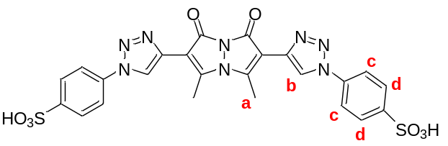
Table S18. Chemical shifts of compound 1's proton signals in the presence of In(III) at 1:1 and 1:2 stoichiometric ratios.ª
Proton | Compound 1 | Compound 1 in a 1:1 ratio with In(III) | Δδ (1:1 complex – uncomplexed 1) | Compound 1 in a 1:2 ratio with In(III) | Δδ (1:2 complex – uncomplexed 1)
H_{a} | 2.925 | 2.925 | 0 ppm | 2.929 | 0.004 ppm
H_{b} | 8.560 | 8.558 | −0.002 ppm | 8.612 | 0.052 ppm
H_{c} | 7.669 | 7.668 | −0.001 ppm | 7.722 | 0.053 ppm
H_{d} | 7.878 | 7.878 | 0 ppm | 7.907 | 0.029 ppm
ª All spectra were acquired on a 400 MHz NMR at 298 K in D₂O.
- Limit of detection experiments:
Table S19. Limits of detection and quantification of In(III) using analyte-induced changes in the photophysical properties of aqueous solutions of compound 1.ª
Input data | Best-fit equation | R² value | Limit of detection (LOD) (µM) | Limit of quantification (LOQ) (µM)
Fluorescence integration | y = 1E6 − 1.65E4x | R² = 0.99582 | 0.18 | 0.94
Fluorescence intensity | y = 321 − 5.7x | R² = 0.99532 | 0.36 | 1.15
ª [1] = 10 µM in water; fluorescence emission spectra integrated from 415–800 nm; λ_{ex} = 410 nm.
Table S20. Summary of selected literature-reported results for other fluorescence-based In(III) sensors.
Compound | Solvent system | Mode of action | LOD (nM) | Reference
pyrazolo[1,5-a]pyrimidine | CH₃CN | turn-off | 190 | 15
hydrazono-quinoline composite structure | DMF/H₂O (7:3) | turn-on | 889 | 16
6-phenylimidazo[2,1-b]thiazole - salicylaldehyde derivative | DMF/H₂O (9:1) | turn-on | 2.59 | 17
(E)-N’-(4-(diethylamino)-2-hydroxybenzylidene)imidazo[2,1-b]thiazole-6-carbohydrazide | DMF/H₂O (9:1) | turn-on | 1.02 | 18
thieno[2,3-b]quinoline-2-carbohydrazide and salicylaldehyde Schiff's base derivatives | DMF/H₂O (9:1) | turn-on | 0.116 | 19
N’-(3-ethoxy-2-hydroxybenzylidene)-4,5-dihydronaphtho[1,2-b]thiophene-2-carbohydrazide | DMF/H₂O (9:1) | turn-on | 8.05 | 20
(E)-N’-((3-hydroxypyridin-2-yl)methylene)-4,5-dihydronaphtho[1,2-b]thiophene-2-carbohydrazide | DMF/H₂O (9:1) | turn-on | 0.020 | 21
5-(thiophen-2-yl)oxazole-4-carbohydrazide and 4-diethylaminosalicylal-dehyde derivative | DMF/H₂O (9:1) | turn-on | 0.621 | 22
N’,N’-bis((E)-2-hydroxy-3-methyl benzylidene)pyridine-2,6-dicarbohydrazide | DMSO/H₂O (2:8) | turn-on | 62.7 | 23
7-(diethylamino)-2-oxo-2 H-chromene-3-carbohydrazide | DMF/H₂O (7:3) | turn-off | 5.93 | 24

- Binding mechanism experiments:
Table S21. Summary of experimental data obtained via Job plot analysis.ª
 | UV–visible absorbance data | Fluorescence emission data
Best-fit equation | y = −0.0153x² + 0.0215x + 3.71E−4 | y = −7.56E5x² + 9.19E5x −7.83E4
R² value | 0.977 | 0.976
Calculated mole fraction at maximum | 0.70 | 0.61
ª UV–visible absorbance data = absorbance intensity at 410 nm; fluorescence emission data = integrated fluorescence emission from 415–800 nm; calculated mole fraction was calculated from the best-fit equation; all experiments were repeated in three independent trials.
Table S22. Summary of supramolecular complexation data obtained via nonlinear fitting.ª
 | Fluorescence intensity data
First binding constant | 2.48E4 (± 5.4%)
Second binding constant | 2.33E5 (± 7.6%)
ª All data were obtained using supramolecular.org software; with the data fit to a 1:2 binding model. Input data for fluorescence spectroscopy were 31 emission intensities, measured at wavelengths between 460 and 600 nm (5 nm intervals between measured wavelengths).
- EDTA experiments:
Table S23. Percent change in the integrated UV–visible absorbance spectra of aqueous compound 1 solutions in the presence of varying amounts of In(NO₃)₃ or Ga(NO₃)₃ with and without EDTA.ª
 | 1 equiv. analyte | 2 equiv. analyte | 4 equiv. analyte
In(NO₃)₃ | 101.8 ± 0.4% | 111.4 ± 1.1% | 108.8 ± 1.6%
In(NO₃)₃ + EDTA | 99.2 ± 1.0% | 99.4 ± 0.8% | 95.8 ± 0.6%
Ga(NO₃)₃ | 100.8 ± 0.2% | 98.5 ± 0.5% | 99.3 ± 1.2%
Ga(NO₃)₃ + EDTA | 99.7 ± 1.8% | 98.3 ± 0.9% | 98.0 ± 0.5%
ª [1] = 10 µM in water; UV–visible absorbance spectra integrated from 350–800 nm; percent change is defined according to Equation S9, below:
Int_{change}/Int_{original} * 100% (Eq. S9),
where Int_{change} is the integrated UV–visible absorbance of the solution of compound 1 in the presence of the analyte and/or EDTA, and Int_{original} is the integrated UV–visible absorbance of the original solution of compound 1.

Table S24. Percent change in the integrated fluorescence emission spectra of aqueous compound 1 solutions in the presence of varying amounts of In(NO₃)₃ or Ga(NO₃)₃ with and without EDTA.ª
 | 1 equiv. analyte | 2 equiv. analyte | 4 equiv. analyte
In(NO₃)₃ | 84.1 ± 0.4% | 68.7 ± 1.4% | 45.0 ± 2.2%
In(NO₃)₃ + EDTA | 99.7 ± 0.2% | 98.2 ± 0.5% | 96.2 ± 0.8%
Ga(NO₃)₃ | 89.5 ± 0.1% | 77.8 ± 1.2% | 50.9 ± 1.5%
Ga(NO₃)₃ + EDTA | 90.4 ± 0.8% | 79.8 ± 1.7% | 56.3 ± 3.1%
ª [1] = 10 µM in water; fluorescence emission spectra integrated from 415–800 nm; λ_{ex} = 410 nm; percent change is defined according to Equation S10, below:
Fl_{change}/Fl_{original} * 100% (Eq. S10),
where Fl_{change} is the integrated fluorescence emission of the solution of compound 1 in the presence of the analyte and/or EDTA, and Fl_{original} is the integrated fluorescence emission of the original solution of compound 1.
Table S25. Summary of the quantitative colorimetric data of aqueous solutions of compound 1 in the presence of varying amounts of In(NO₃)₃ or Ga(NO₃)₃ with and without EDTA, photographed in ambient light.ª
Solution | Red | Green | Blue
compound 1 | 172.8 ± 6.3 | 164.4 ± 6.6 | 146.2 ± 6.1
compound 1 + 8 equiv. In(NO₃)₃ | 171.6 ± 7.7 | 163.5 ± 7.7 | 144.0 ± 6.8
compound 1 + 8 equiv. In(NO₃)₃ + 8 equiv. EDTA | 175.0 ± 8.8 | 166.2 ± 8.6 | 149.1 ± 8.8
compound 1 + 8 equiv. Ga(NO₃)₃ | 175.1 ± 11.8 | 166.1 ± 11.4 | 146.6 ± 10.5
compound 1 + 8 equiv. Ga(NO₃)₃ + 8 equiv. EDTA | 178.7 ± 5.0 | 170.6 ± 5.1 | 151.5 ± 4.8
ª [1] = 10 µM in water; all results represent the average of three independent trials.
Table S26. Summary of the quantitative colorimetric data of aqueous solutions of compound 1 in the presence of varying amounts of In(NO₃)₃ or Ga(NO₃)₃ with and without EDTA, photographed under 365 nm excitation.ª
Solution | Red | Green | Blue
compound 1 | 96.3 ± 10.9 | 200.0 ± 3.1 | 100.5 ± 23.1
compound 1 + 8 equiv. In(NO₃)₃ | 74.0 ± 7.7 | 106.4 ± 12.1 | 22.6 ± 14.2
compound 1 + 8 equiv. In(NO₃)₃ + 8 equiv. EDTA | 94.1 ± 8.7 | 202.7 ± 5.8 | 103.1 ± 27.0
compound 1 + 8 equiv. Ga(NO₃)₃ | 85.2 ± 13.0 | 134.0 ± 5.2 | 37.8 ± 11.9
compound 1 + 8 equiv. Ga(NO₃)₃ + 8 equiv. EDTA | 95.9 ± 14.0 | 170.5 ± 9.4 | 70.6 ± 27.0
ª [1] = 10 µM in water; all results represent the average of three independent trials.

- Photostability and time-dependent response experiments:
Table S27. Photostability of compound 1 under continuous excitation.ª
Signal monitored | Percent retention
Integrated UV–visible absorbance | 99.06 ± 0.29%
Integrated fluorescence emission | 99.95 ± 0.23%
ª [1] = 10 µM in water; values represent percent retention of the initial signal after 60 minutes of continuous excitation. All values represent the mean ± SD of 3 independent trials; λ_{ex} = 410 nm; fluorescence emission scanned and integrated from 505–525 nm; UV–visible absorbance spectra integrated from 350–500 nm.
Table S28. Time-dependent fluorescence response of the compound 1–In(III) system under continuous excitation.ª
Time (min) | Percent retention
0 | 100.0 ± 0.0%
2 | 78.9 ± 6.1%
10 | 70.6 ± 6.4%
30 | 63.7 ± 5.9%
60 | 60.8 ± 5.8%
^{ᵃ} [1] = 10 μM; [In(NO₃)₃] = 40 μM in water; λₑₓ = 410 nm; fluorescence emission scanned from 505 to 525 nm. Values represent percent retention relative to the signal recorded at the beginning of continuous excitation, following a 30-s mixing period after indium(III) addition. Values are reported as the mean ± SD of three independent trials.
- pH-dependent experiments:
Table S29. Summary of pH-dependent absorbance properties of aqueous solutions of compound 1, in the absence and presence of In(NO₃)₃.ª
Solution pH | Normalized integration (blank) | Normalized integration (with In(NO₃)₃) | Ratio Abs_{blank}/Abs_{In(NO3)3}
0.02 | 0.73 ± 0.008 | 0.72 ± 0.011 | 1.01
0.98 | 0.75 ± 0.001 | 0.74 ± 0.003 | 1.01
2.06 | 0.76 ± 0.003 | 0.76 ± 0.009 | 1.00
3.17 | 0.80 ± 0.080 | 0.81 ± 0.073 | 0.99
4.08 | 0.84 ± 0.020 | 0.91 ± 0.051 | 0.92
5.21 | 0.81 ± 0.013 | 0.99 ± 0.008 | 0.82
6.23 | 0.79 ± 0.004 | 0.95 ± 0.054 | 0.83
7.04 | 0.79 ± 0.014 | 0.97 ± 0.031 | 0.82
7.88 | 0.77 ± 0.002 | 0.89 ± 0.027 | 0.87
8.89 | 0.79 ± 0.004 | 0.90 ± 0.049 | 0.87
9.06 | 0.85 ± 0.010 | 0.93 ± 0.051 | 0.90
ª [1] = 10 µM in water; [In(NO₃)₃] = 40 µM; UV–visible absorbance spectra integrated from 335–800 nm; all results represent an average of three independent trials.
Table S30. Summary of pH-dependent fluorescence properties of aqueous solutions of compound 1, in the absence and presence of In(NO₃)₃.ª
Solution pH | Normalized integration (blank) | Normalized integration (with In(NO₃)₃) | Ratio Fl_{blank}/Fl_{In(NO3)3}
0.02 | 0.53 ± 0.007 | 0.52 ± 0.008 | 1.01
0.98 | 0.79 ± 0.003 | 0.78 ± 0.002 | 1.01
2.06 | 0.87 ± 0.001 | 0.84 ± 0.003 | 1.03
3.17 | 0.88 ± 0.014 | 0.86 ± 0.009 | 1.03
4.08 | 0.91 ± 0.005 | 0.58 ± 0.023 | 1.58
5.21 | 0.92 ± 0.001 | 0.46 ± 0.012 | 2.03
6.23 | 0.92 ± 0.002 | 0.41 ± 0.007 | 2.25
7.04 | 0.94 ± 0.001 | 0.37 ± 0.017 | 2.55
7.88 | 0.90 ± 0.004 | 0.21 ± 0.011 | 4.31
8.89 | 0.90 ± 0.002 | 0.20 ± 0.016 | 4.44
9.86 | 0.94 ± 0.005 | 0.34 ± 0.026 | 2.78
ª [1] = 10 µM in water; [In(NO₃)₃] = 40 µM; fluorescence emission spectra integrated from 415–800 nm; λ_{ex} = 410 nm; all results represent an average of three independent trials.
- Computational investigations:
Table S31. Summary of the computed structural properties of compound 1 (in two possible conformations) as well as the complex between compound 1 and In(III) adopting an octahedral geometry, with four additional water ligands per metal center.ª
Molecule | C=O (Å) | Bimane interplanar angle (⁰) | Torsional angle bimane – triazole (⁰)
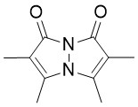 | 1.21 (average) | 179 (average) | N/A
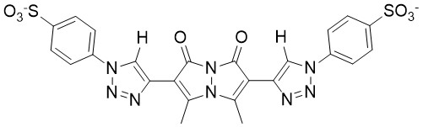 | 1.219 | 178 | 27.5/20.7
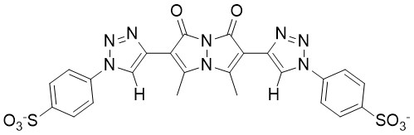 | 1.217 | 155 | 35.2/34.4
Octahedral complex of compound 1 and In(III) (H₂O ligands: 4) | 1.237/1.239 | 161.5 | 12.2/6.8
ª Theoretical calculations were conducted using ORCA 6.0.1.

- Real-world water experiments:
Table S32. Normalized integrated emission of solutions of compound 1 after exposure to varying concentrations of In(III), in Milli-Q water and in commercially available bottled mineral water.ª
[In(NO₃)₃] (µM) | Milli-Q water | Mineral water
0 | 0.97 ± 0.01 | 0.99 ± 0.01
5 | 0.90 ± 0.005 | 0.90 ± 0.002
10 | 0.78 ± 0.005 | 0.79 ± 0.003
15 | 0.68 ± 0.01 | 0.72 ± 0.01
20 | 0.61 ± 0.01 | 0.66 ± 0.01
ª [1] = 10 µM; All results represent an average of three independent trials.
Table S33. Percent recovery of In(III) added to Milli-Q water and to commercial mineral water based on the analyte-induced fluorescence changes to compound 1, relative to calibration curve and the known In(NO₃)₃ concentration.ª
[In(NO₃)₃] (μM) | % recovery in Milli-Q water | % recovery in mineral water
5 | 85.7 ± 4.7% | 85.8 ± 2.3%
10 | 105.7 ± 2.4% | 99.6 ± 1.5%
15 | 102.9 ± 2.7% | 89.5 ± 3.0%
20 | 95.8 ± 2.4% | 82.4 ± 1.7%
ª [1] = 10 µM; fluorescence emission spectra integrated from 415–800 nm; λ_{ex} = 410 nm; Recovery % is defined according to Equation S5:
Recovery % = [In(NO₃)₃]_{found}/[In(NO₃)₃]_{spiked} × 100% (Eq. S5),
where [In(NO₃)₃]_{found} represents the concentration of In(NO₃)₃ determined from the calibration curve, and [In(NO₃)₃]_{spiked} represents the known spiked concentration of In(NO₃)₃.

IV. SUMMARY FIGURES
- Synthesis figures:
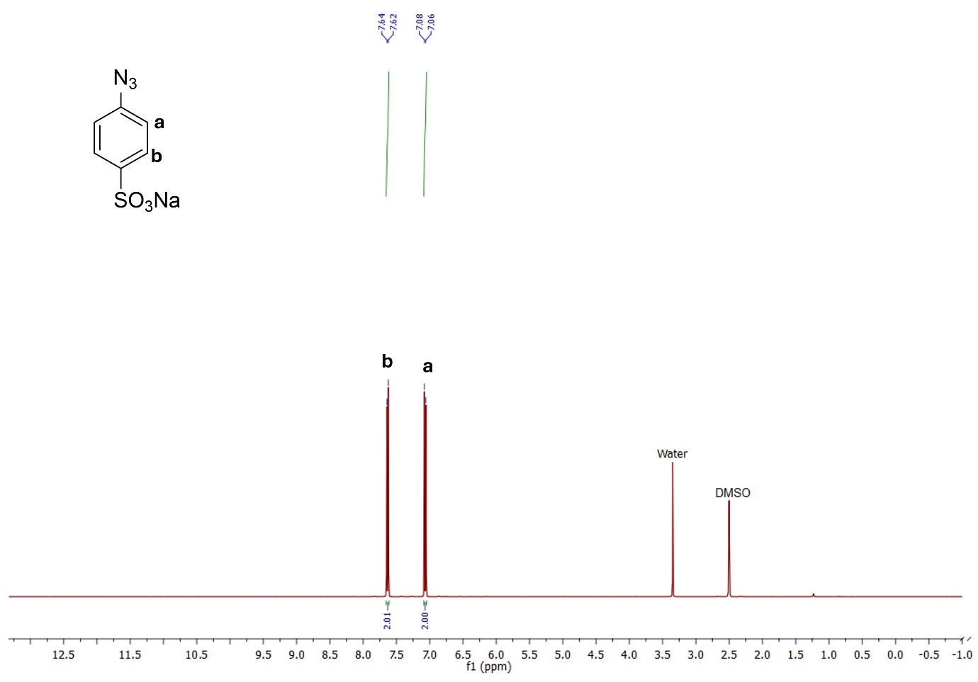
Figure S1. ¹H NMR spectrum of compound 5 (DMSO-d₆, 400 MHz).
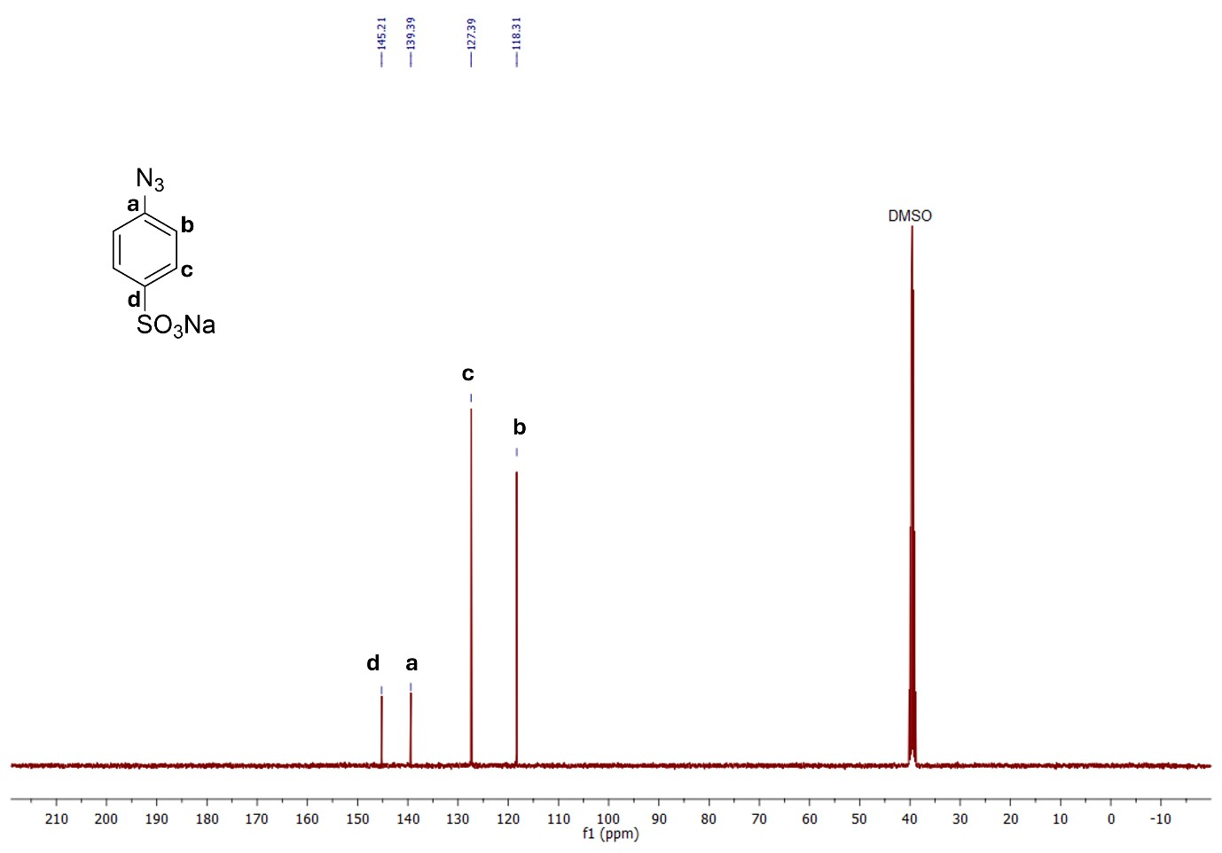
Figure S2. ¹³C NMR spectrum of compound 5 (DMSO-d₆, 101 MHz).
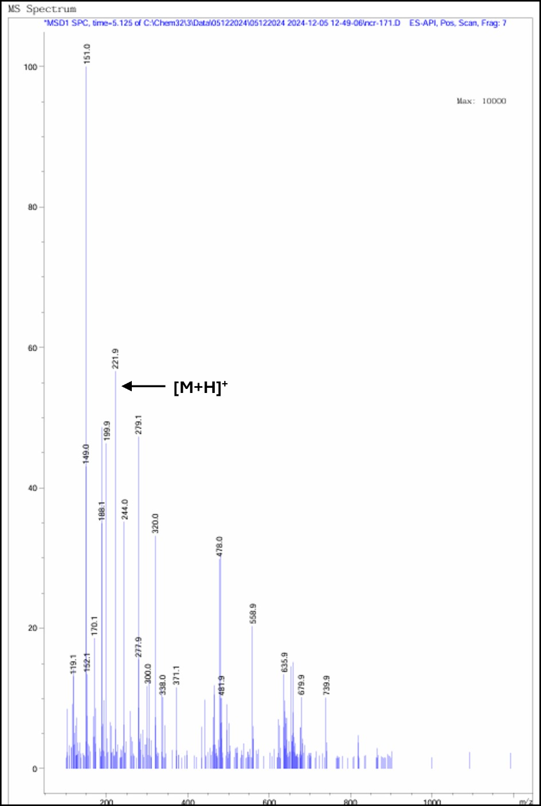
Figure S3. Mass spectrum of compound 5.
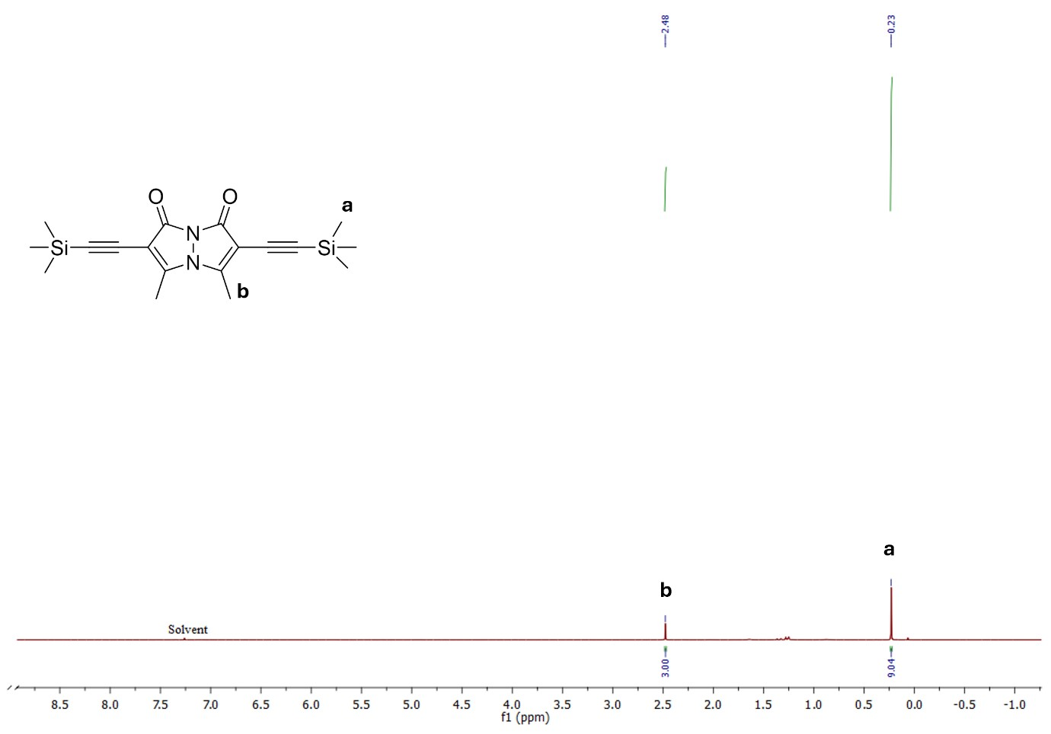
Figure S4. ¹H NMR spectrum of compound 4 (CDCl₃, 400 MHz).
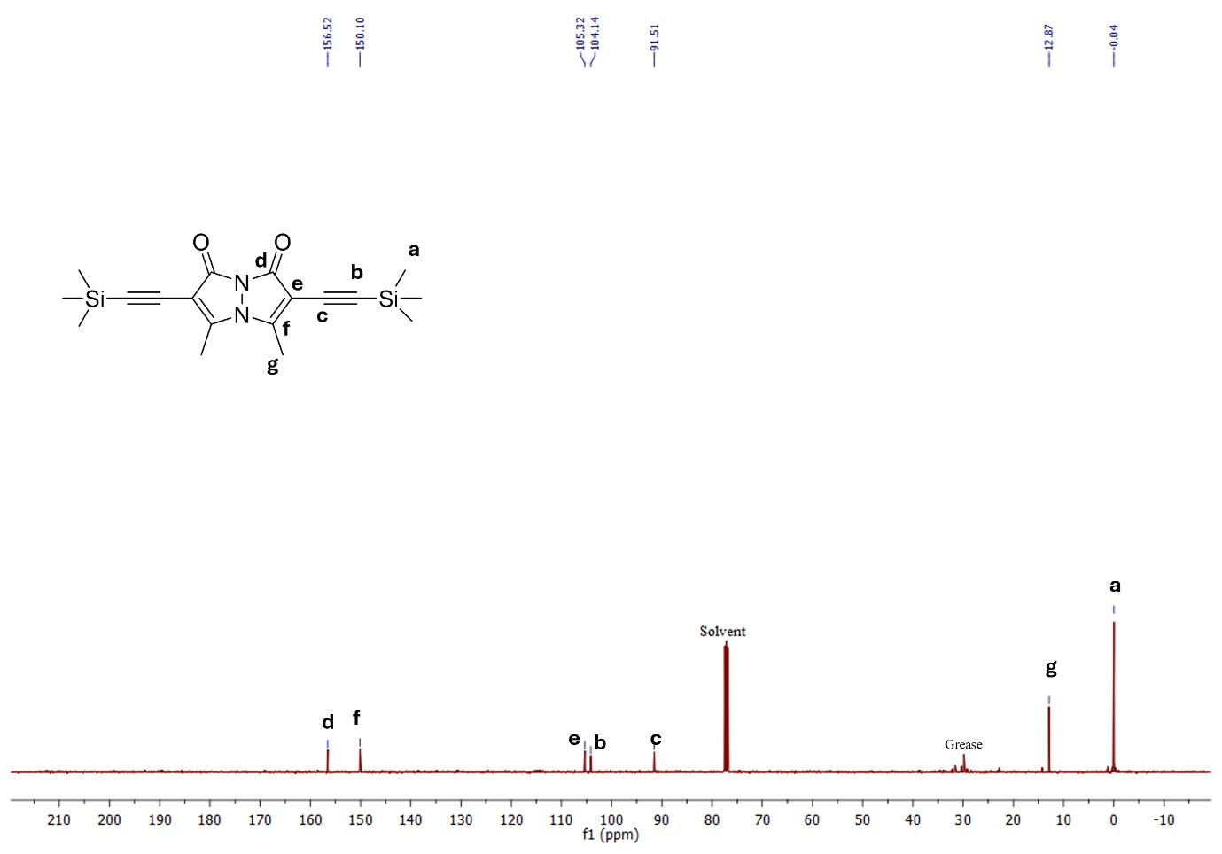
Figure S5. ¹³C NMR spectrum of compound 4 (CDCl₃, 101 MHz).
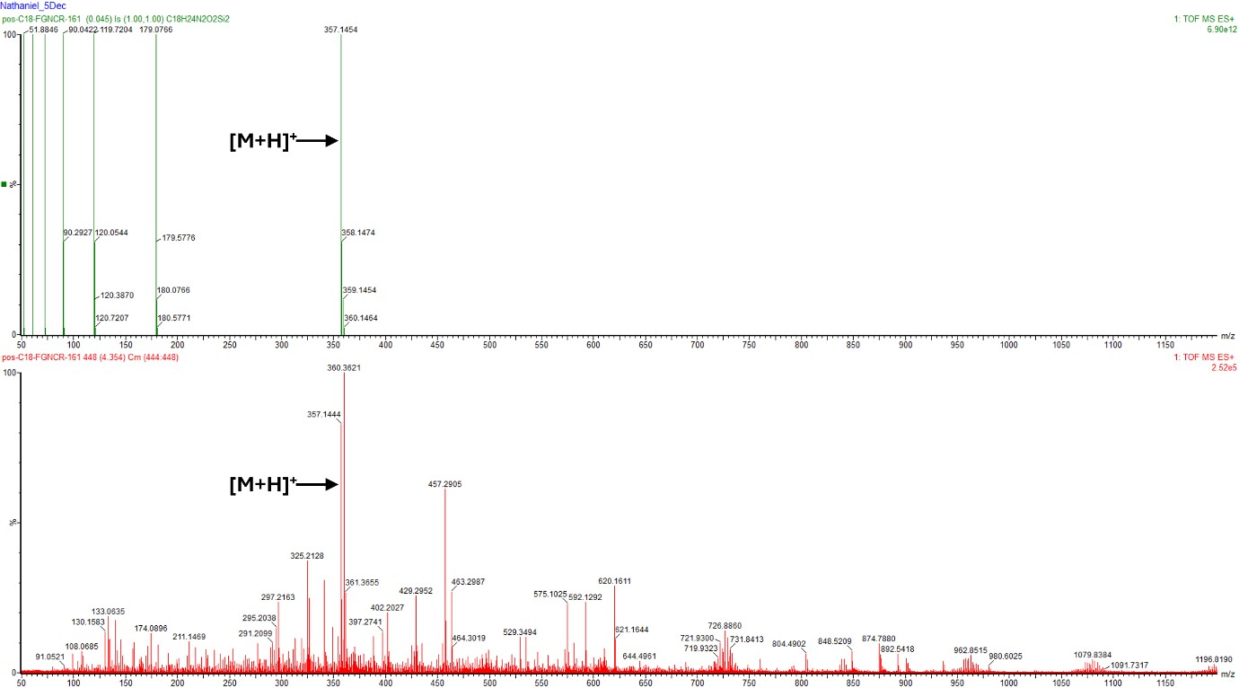
Figure S6. High-resolution mass spectrum of compound 4 (top: computationally predicted spectrum; bottom: experimentally-obtained spectrum).
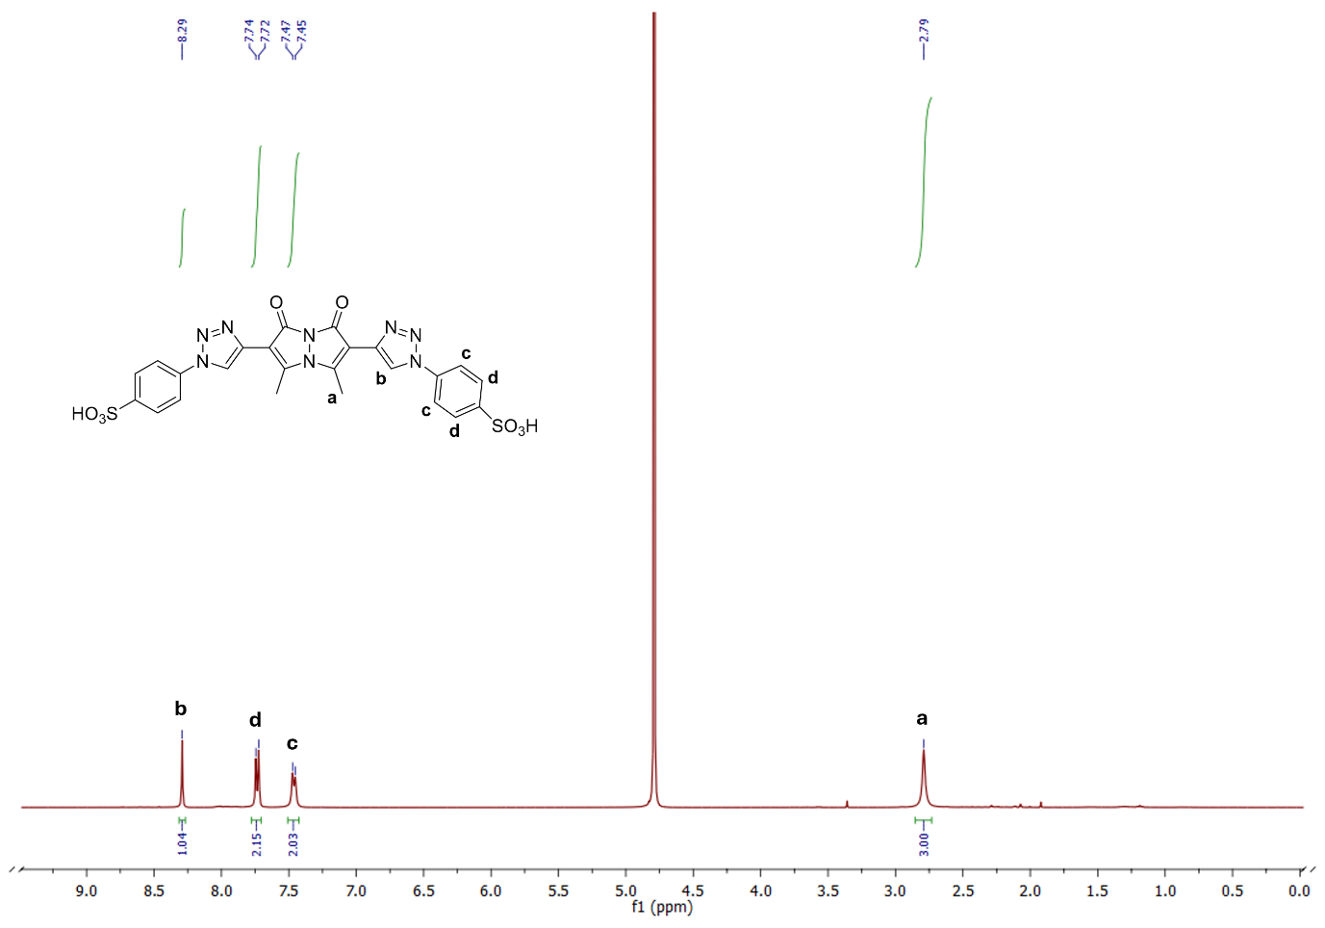
Figure S7. ¹H NMR spectrum of compound 1 (D₂O, 400 MHz).
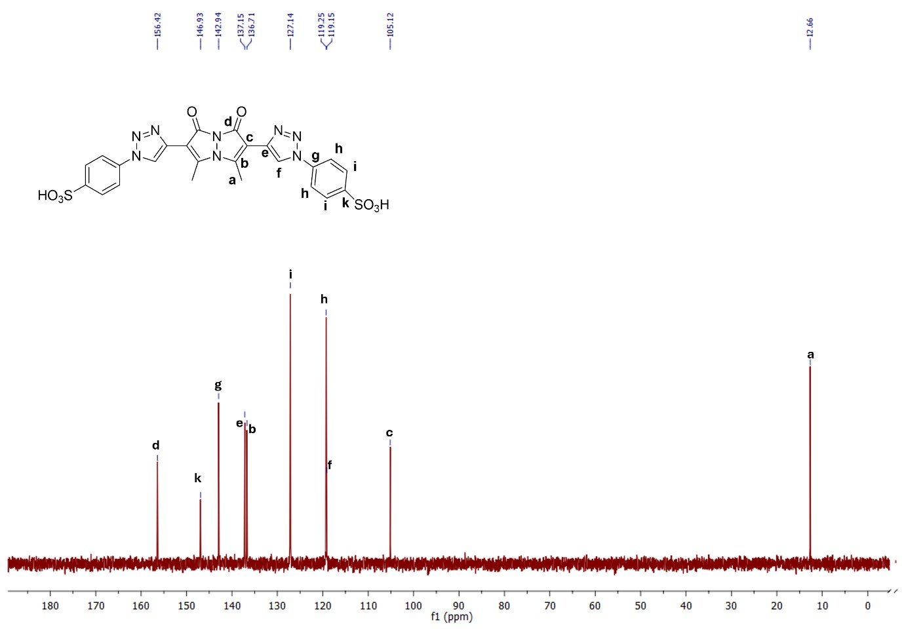
Figure S8. ¹³C NMR spectrum of compound 1 (D₂O, 101 MHz).
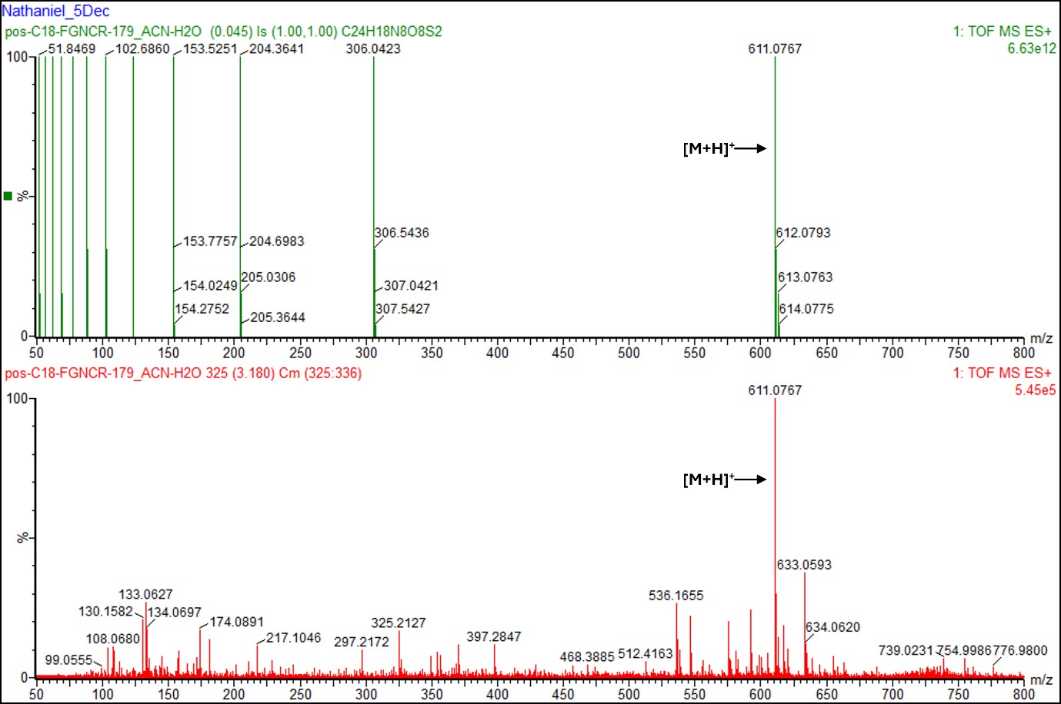
Figure S9. High-resolution mass spectrum of compound 1 (top: computationally predicted spectrum; bottom: experimentally-obtained spectrum).
- Solvatochromic experiments
Figure S10. Correlation between solvent E_{T}(30) values and the maximum emission wavelength of compound 1 in solution.
- Selectivity and interference (competition) experiments − spectroscopic investigations:
Selectivity experiments – spectroscopic investigations – in 100% aqueous solution
UV–visible absorbance spectra:
Figure S11. Normalized UV–visible absorbance spectra of solutions of compound 1 following exposure to various analytes ([1] = 10 µM; [analyte] = 40 µM).
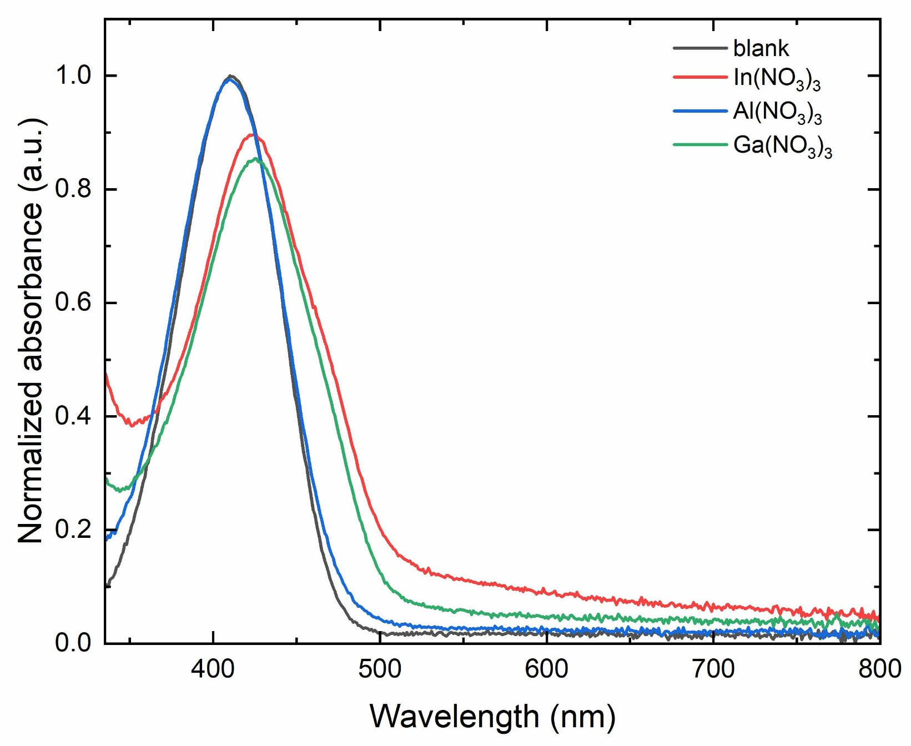
Figure S12. Normalized UV–visible absorbance spectra of solutions of compound 1 following exposure to group 13-containing nitrate compounds ([1] = 10 µM; [analyte] = 40 µM).
Fluorescence emission spectra:
Figure S13. Normalized fluorescence emission spectra of solutions of compound 1 following exposure to various analytes ([1] = 10 µM; [analyte] = 40 µM; λ_{ex} = 410 nm).
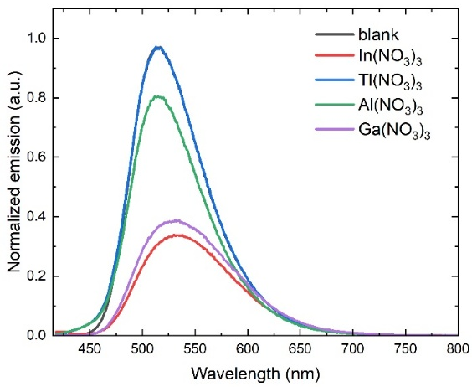
Figure S14. Normalized fluorescence emission spectra of solutions of compound 1 following exposure to group 13-containing nitrate compounds ([1] = 10 µM; [analyte] = 40 µM; λ_{ex} = 410 nm).
Interference (competition) experiments – spectroscopic investigations – in 100% aqueous solution
UV–visible absorbance spectra:
Figure S15. Summary of the integrated UV–visible absorbance spectra of aqueous solutions of compound 1 in the absence of analyte, in the presence of In(NO₃)₃, and in the presence of analyte + In(NO₃)₃.
Figure S16. UV–visible absorbance spectra of aqueous solutions of compound 1 in the absence of analyte, in the presence of In(NO₃)₃, and in the presence of analyte + In(NO₃)₃.
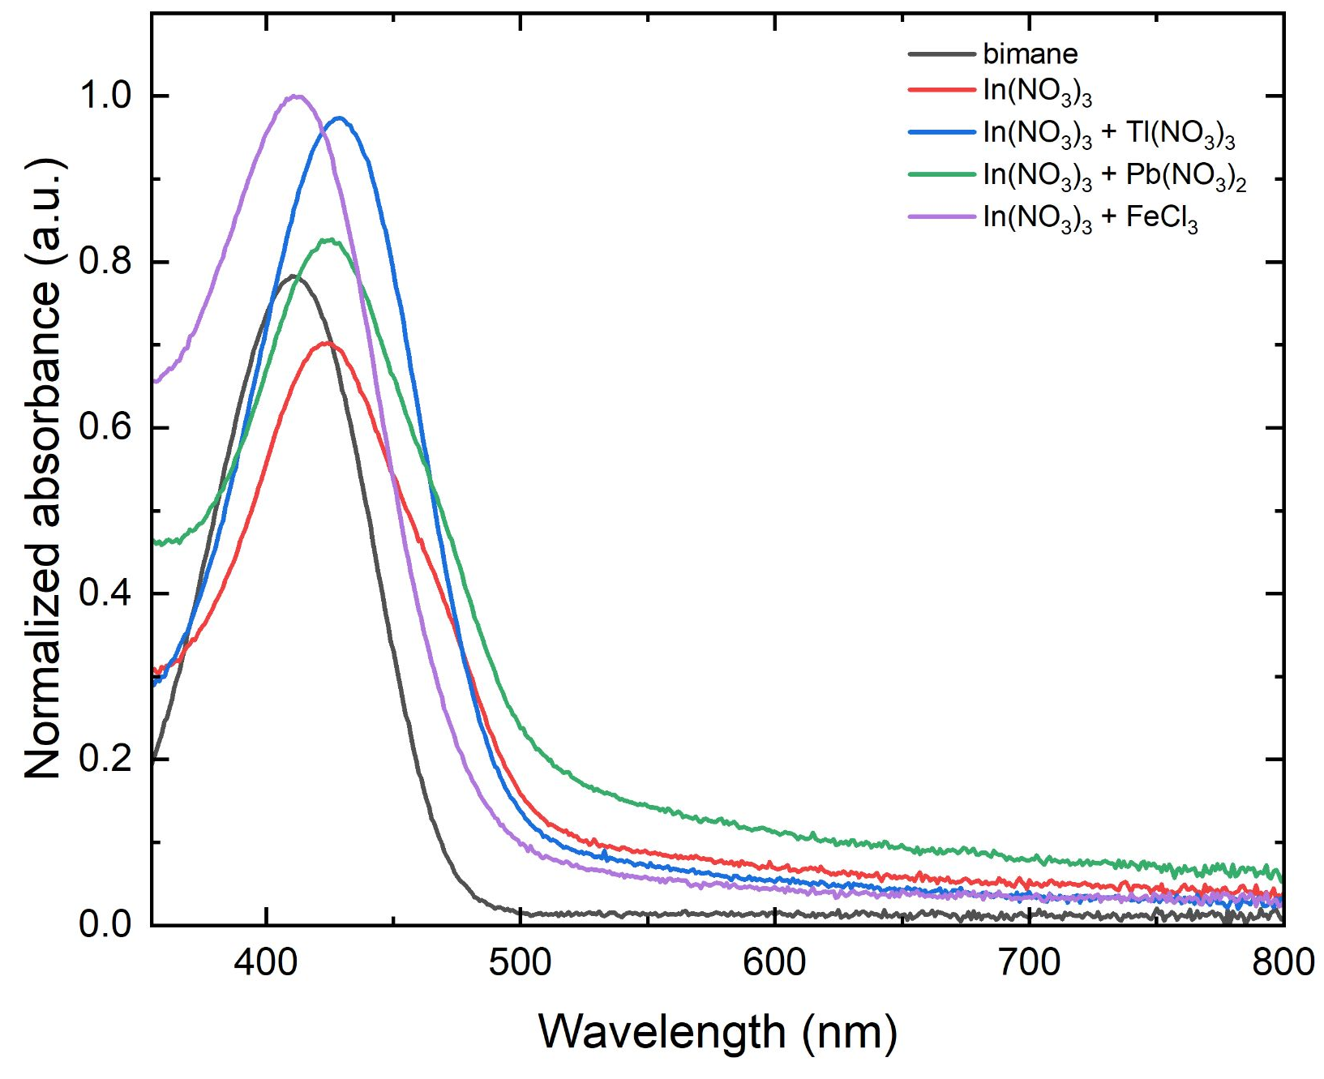
Figure S17. Selected UV–visible absorbance spectra of aqueous solutions of compound 1 in the absence of analyte, in the presence of In(NO₃)₃, and in the presence of analyte + In(NO₃)₃.
Fluorescence emission spectra:
Figure S18. Summary of the integrated fluorescence emission of aqueous solutions of compound 1 in the absence of analyte, in the presence of In(NO₃)₃, and in the presence of analyte + In(NO₃)₃.
Figure S19. Fluorescence emission spectra of aqueous solutions of compound 1 in the absence of analyte, in the presence of In(NO₃)₃, and in the presence of analyte + In(NO₃)₃.
Figure S20. Selected fluorescence emission spectra of aqueous solutions of compound 1 in the absence of analyte, in the presence of In(NO₃)₃, and in the presence of In(NO₃)₃ and other analytes that interfere with the In(NO₃)₃-induced photophysical changes.
- Selectivity experiments − solution-state colorimetric studies – in 100% aqueous solution:
Figure S21. Photograph of aqueous solutions of compound 1 after exposure to eight equivalents of various inorganic analytes, photographed under ambient light (L-to-R: blank, Ca(NO₃)₂, MnCl₂, Co(NO₃)₂, Cu(NO₃)₂, NiCl₂, CdCl₂, FeCl₃, CeCl₃, ZnSO₄, HgCl₂, Pb(NO₃)₂, MgCl₂, BaCl₂, In(NO₃)₃, Ga(NO₃)₃, Al(NO₃)₃, Tl(NO₃)₃, LiCl, NaNO₃, KCl, AgNO₃, FeCl₂).
Figure S22. Photograph of aqueous solutions of compound 1 after exposure to eight equivalents of various inorganic analytes, photographed under 365 nm excitation (L-to-R: blank, Ca(NO₃)₂, MnCl₂, Co(NO₃)₂, Cu(NO₃)₂, NiCl₂, CdCl₂, FeCl₃, CeCl₃, ZnSO₄, HgCl₂, Pb(NO₃)₂, MgCl₂, BaCl₂, In(NO₃)₃, Ga(NO₃)₃, Al(NO₃)₃, Tl(NO₃)₃, LiCl, NaNO₃, KCl, AgNO₃, FeCl₂).
- Selectivity experiments − filter paper-based colorimetric investigations:
Figure S23. Photographs of compound 1-loaded filter papers after exposure to various analytes, viewed under ambient light.
Figure S24. Quantitative red values of compound 1-loaded filter papers after exposure to various analytes, viewed under ambient light.
Figure S25. Photographs of compound 1-loaded filter papers after exposure to various analytes, viewed under 365 nm excitation.
Figure S26. Quantitative red values of compound 1-loaded filter papers after exposure to various analytes, viewed under 365 nm excitation.

- Filter paper optimization experiments:
Figure S27. Photographs of filter papers loaded using 10, 50, or 100 μM compound 1, in the absence and presence of 100 μM In(NO₃)₃, viewed under ambient light.
Figure S28. Photographs of filter papers loaded using 10, 50, or 100 μM compound 1, in the absence and presence of 100 μM In(NO₃)₃, viewed under 365 nm excitation.
Figure S29. Photographs of compound 1-loaded filter papers (blank and 100 μM In(NO₃)₃) at 0 and 60 minutes of continuous 365 nm irradiation, viewed under ambient light.
Figure S30. Photographs of compound 1-loaded filter papers (blank and 100 μM In(NO₃)₃) at 0 and 60 minutes of continuous 365 nm irradiation, viewed under 365 nm excitation.
Figure S31. Photographs of compound 1-loaded filter papers freshly prepared and after 2 days of storage under ambient conditions, viewed under 365 nm excitation and under ambient light.

- Titration experiments − solution-state spectroscopic studies − in 100% aqueous solution:
UV–visible absorbance data
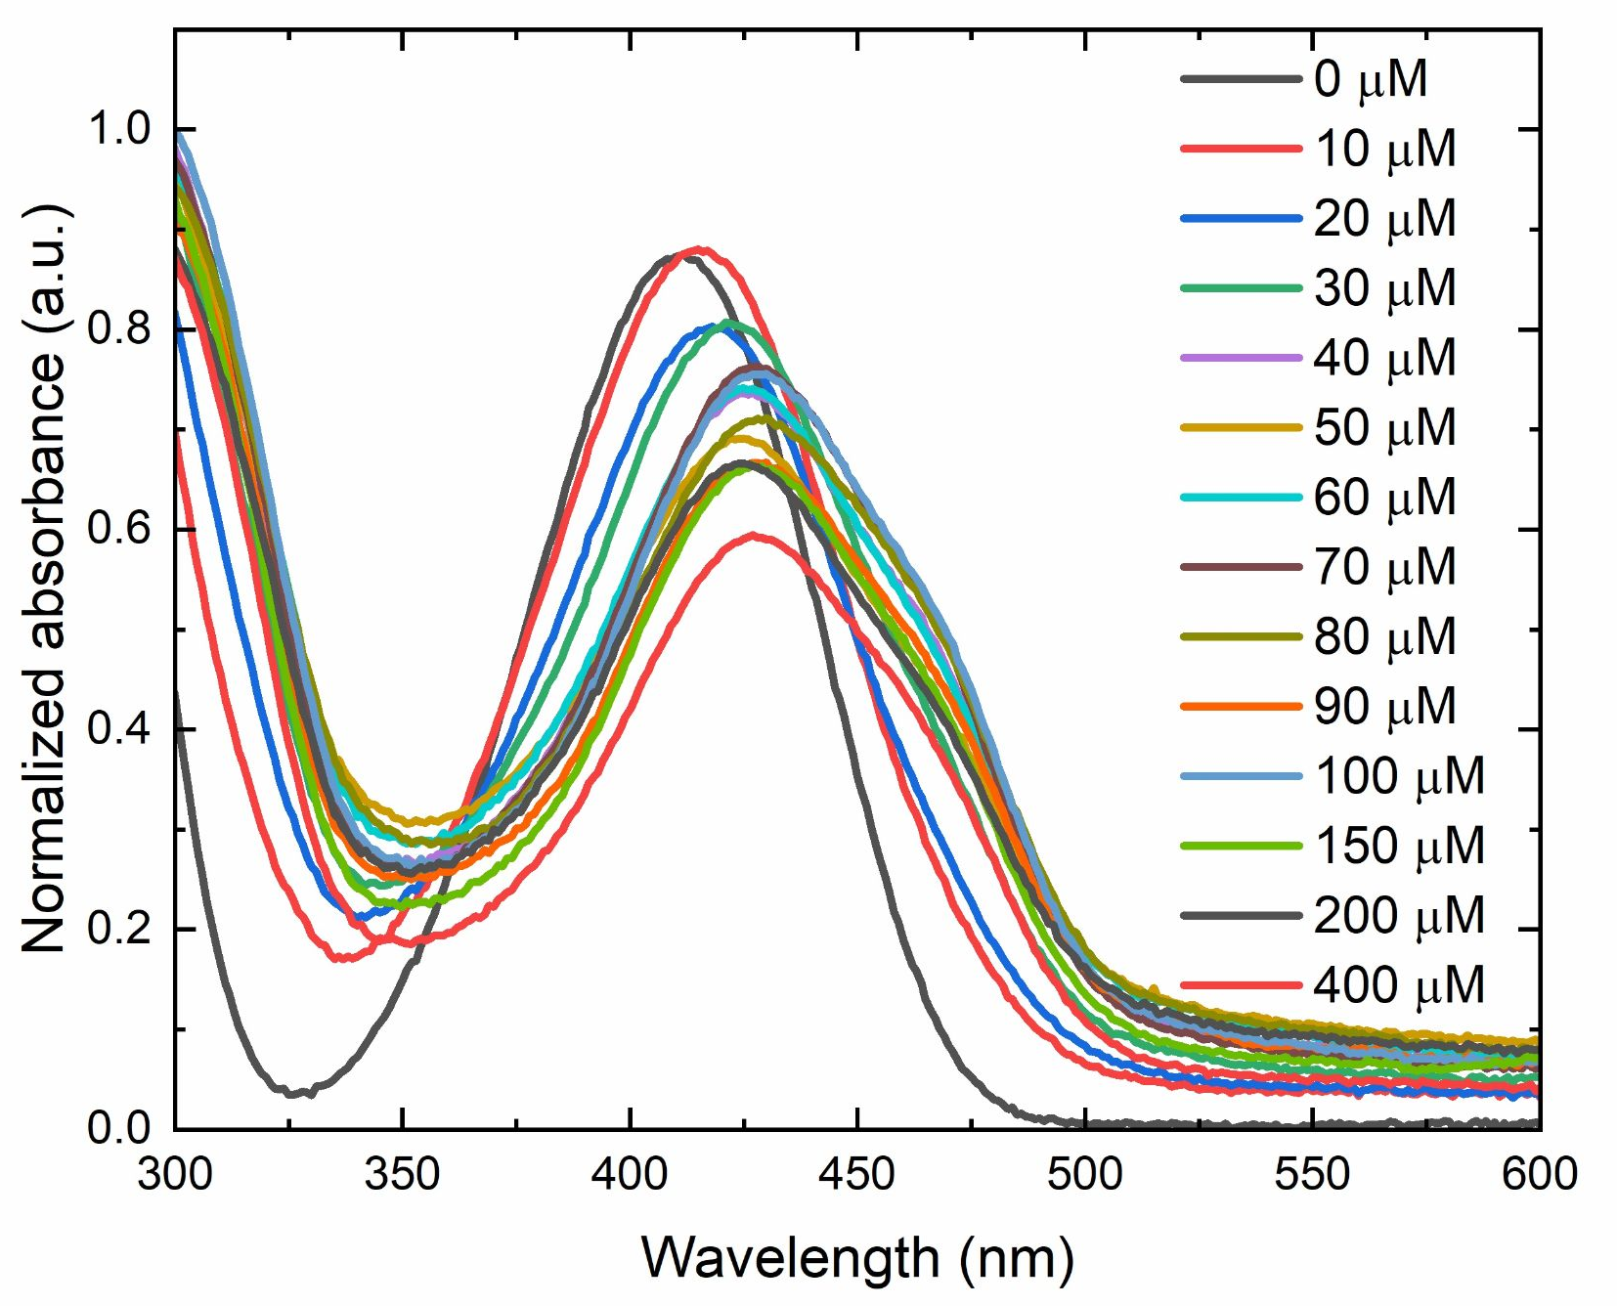
Figure S32. UV–visible absorbance spectra of aqueous solutions of compound 1 with the addition of increasing concentrations of In(NO₃)₃ ([1] = 10 µM; [In(NO₃)₃] = 0–400 µM).
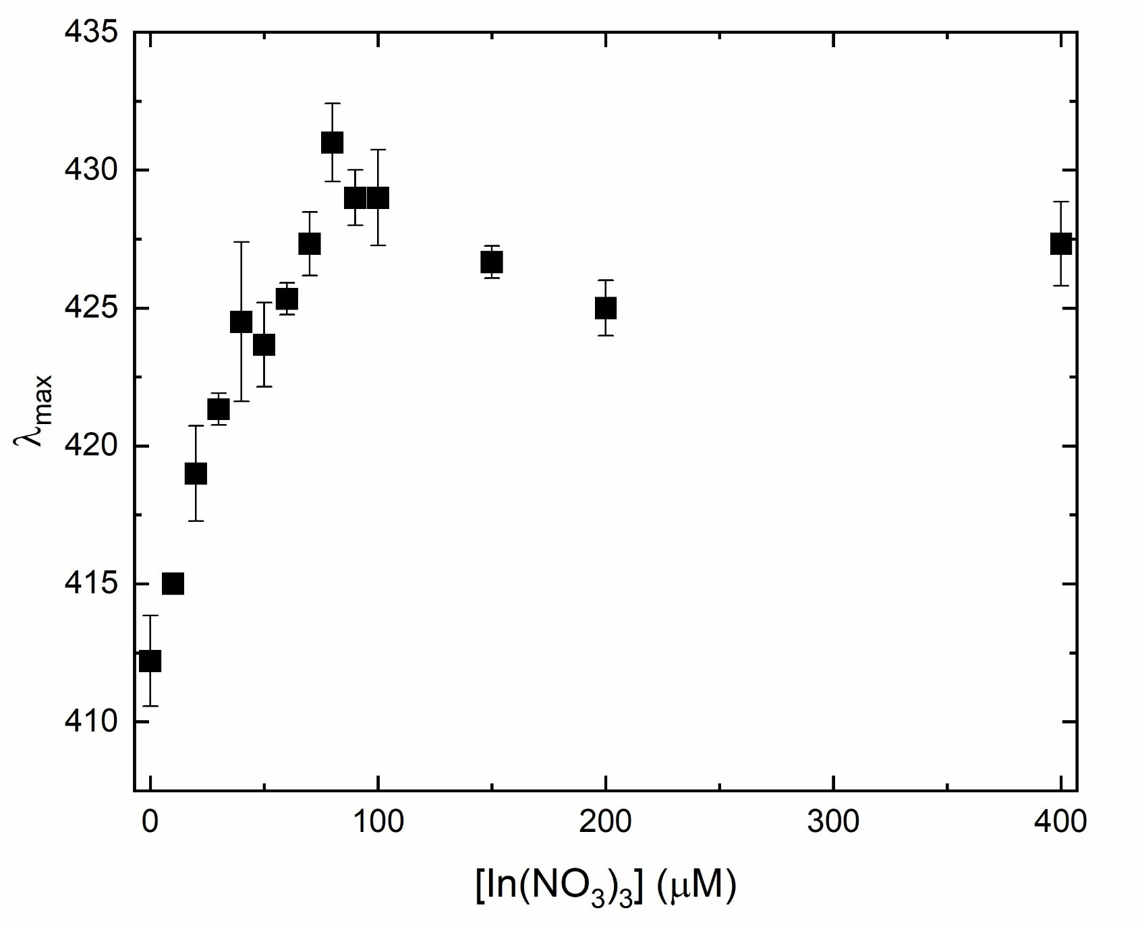
Figure S33. Maximum absorbance wavelength of aqueous solutions of compound 1 in the presence of varying concentrations of In(NO₃)₃ ([1] = 10 µM).
Fluorescence emission data
Figure S34. Fluorescence emission spectra of aqueous solutions of compound 1 with the addition of increasing concentrations of In(NO₃)₃ ([1] = 10 µM; [In(NO₃)₃] = 0–400 µM; λ_{ex} = 410 nm).
Figure S35. Integrated fluorescence emission of aqueous solutions of compound 1 in the presence of increasing concentrations of In(NO₃)₃. Red line represents the best nonlinear fit to the data ([1] = 10 µM; [In(NO₃)₃] = 0–400 µM; λ_{ex} = 410 nm; equation: y = 0.788*exp(–x/25.6) + 0.231; R² = 0.99412).
- Titration experiments − solution-state colorimetric studies − in 100% aqueous solution:
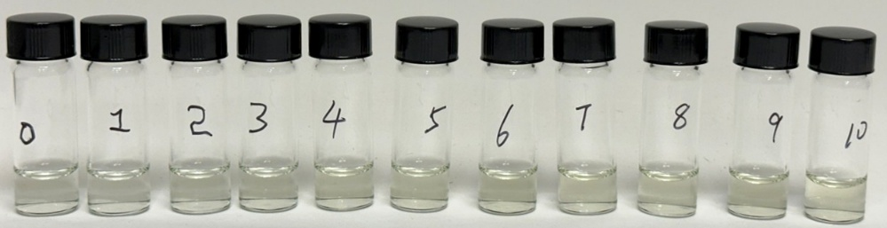
Figure S36. Photographs of aqueous solutions of compound 1 upon exposure to varying concentrations of In(NO₃)₃ (L-to-R: blank, 10 µM, 20 µM, 30 µM, 40 µM, 50 µM, 60 µM, 70 µM, 80 µM, 90 µM, 100 µM, viewed under ambient light; [1] = 10 µM).
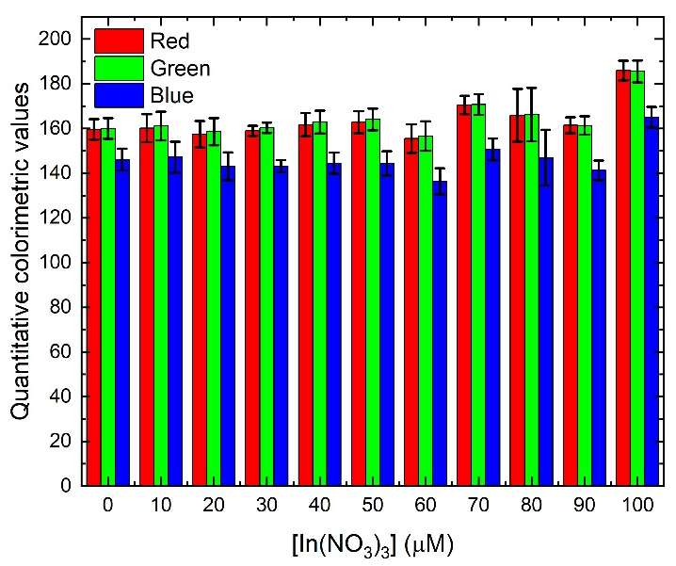
Figure S37. Quantitative colorimetric values of aqueous solutions of compound 1 exposed to varying concentrations of In(NO₃)₃ and photographed under ambient light ([1] = 10 µM).
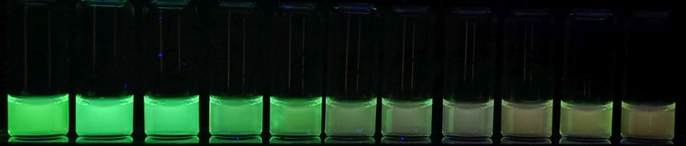
Figure S38. Photographs of aqueous solutions of compound 1 upon exposure to varying concentrations of In(NO₃)₃ (L-to-R: blank, 10 µM, 20 µM, 30 µM, 40 µM, 50 µM, 60 µM, 70 µM, 80 µM, 90 µM, 100 µM, viewed under 365 nm excitation; [1] = 10 µM).
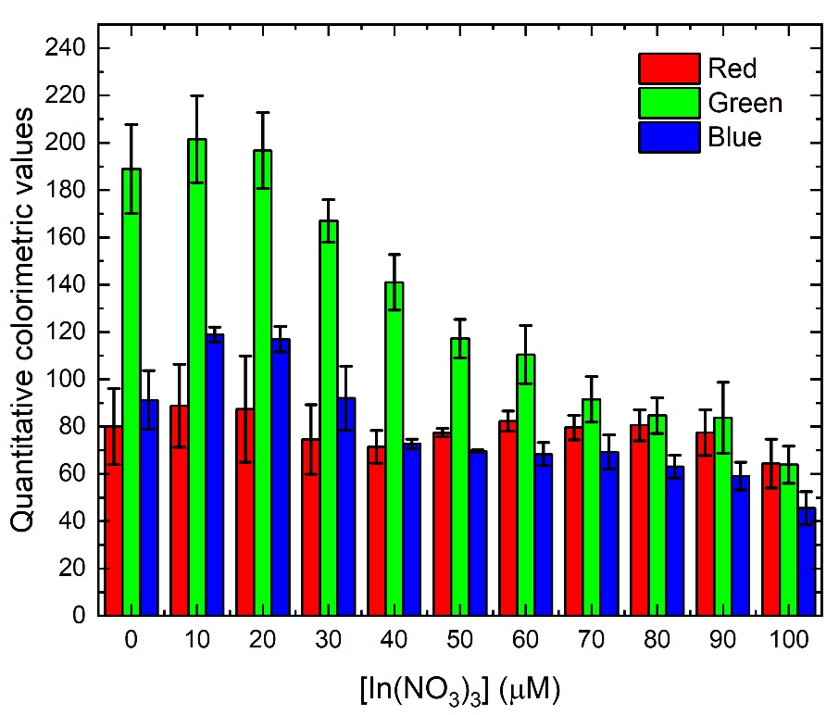
Figure S39. Quantitative colorimetric values of aqueous solutions of compound 1 exposed to varying concentrations of In(NO₃)₃ and photographed under 365 nm excitation ([1] = 10 µM).
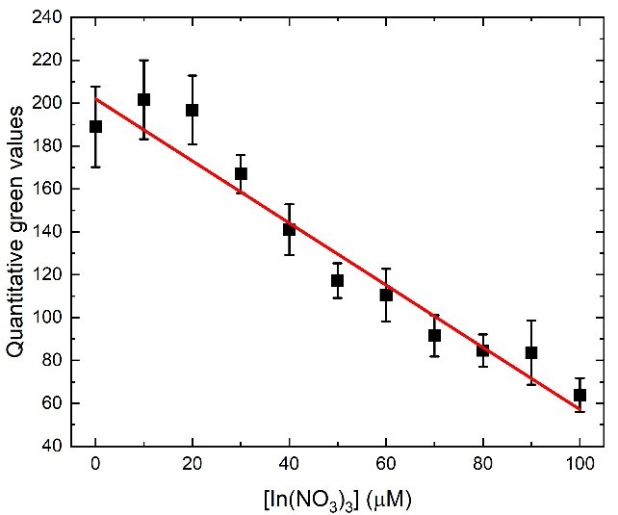
Figure S40. Linear relationship between the concentration of In(NO₃)₃ and the quantitative green values of aqueous solutions of compound 1 exposed to those In(NO₃)₃ concentrations ([1] = 10 µM; red line shows the line that best fits the data; equation of the line: y = –1.45x + 202.0; R² = 0.94755).

- Titration experiments − filter paper-based colorimetric investigations:
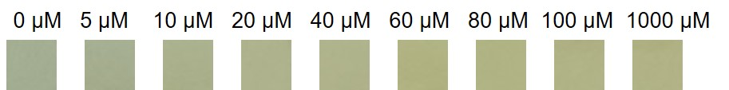
Figure S41. Photographs of compound 1-loaded filter papers upon exposure to varying concentrations of In(NO₃)₃, viewed under ambient light.
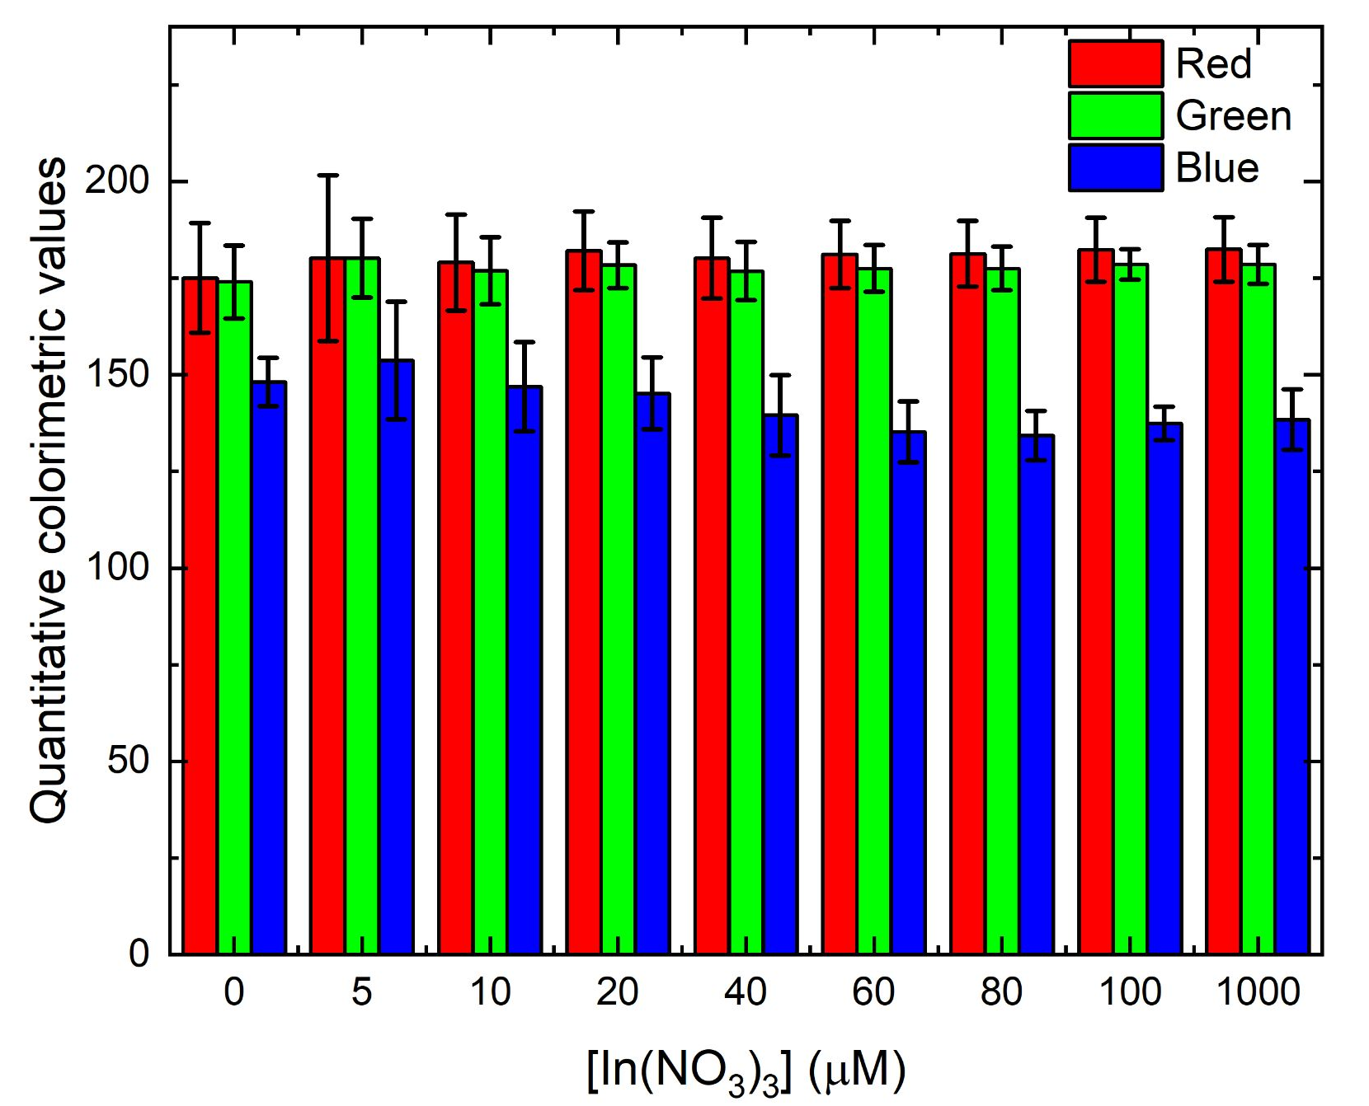
Figure S42. Quantitative colorimetric values of compound 1-loaded filter papers exposed to varying concentrations of In(NO₃)₃ and photographed under ambient light.
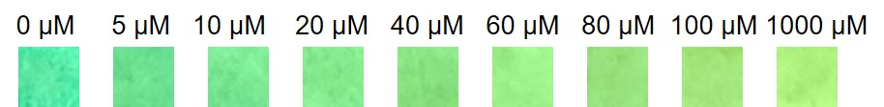
Figure S43. Photographs of compound 1-loaded filter papers upon exposure to varying concentrations of In(NO₃)₃, viewed under 365 nm excitation.
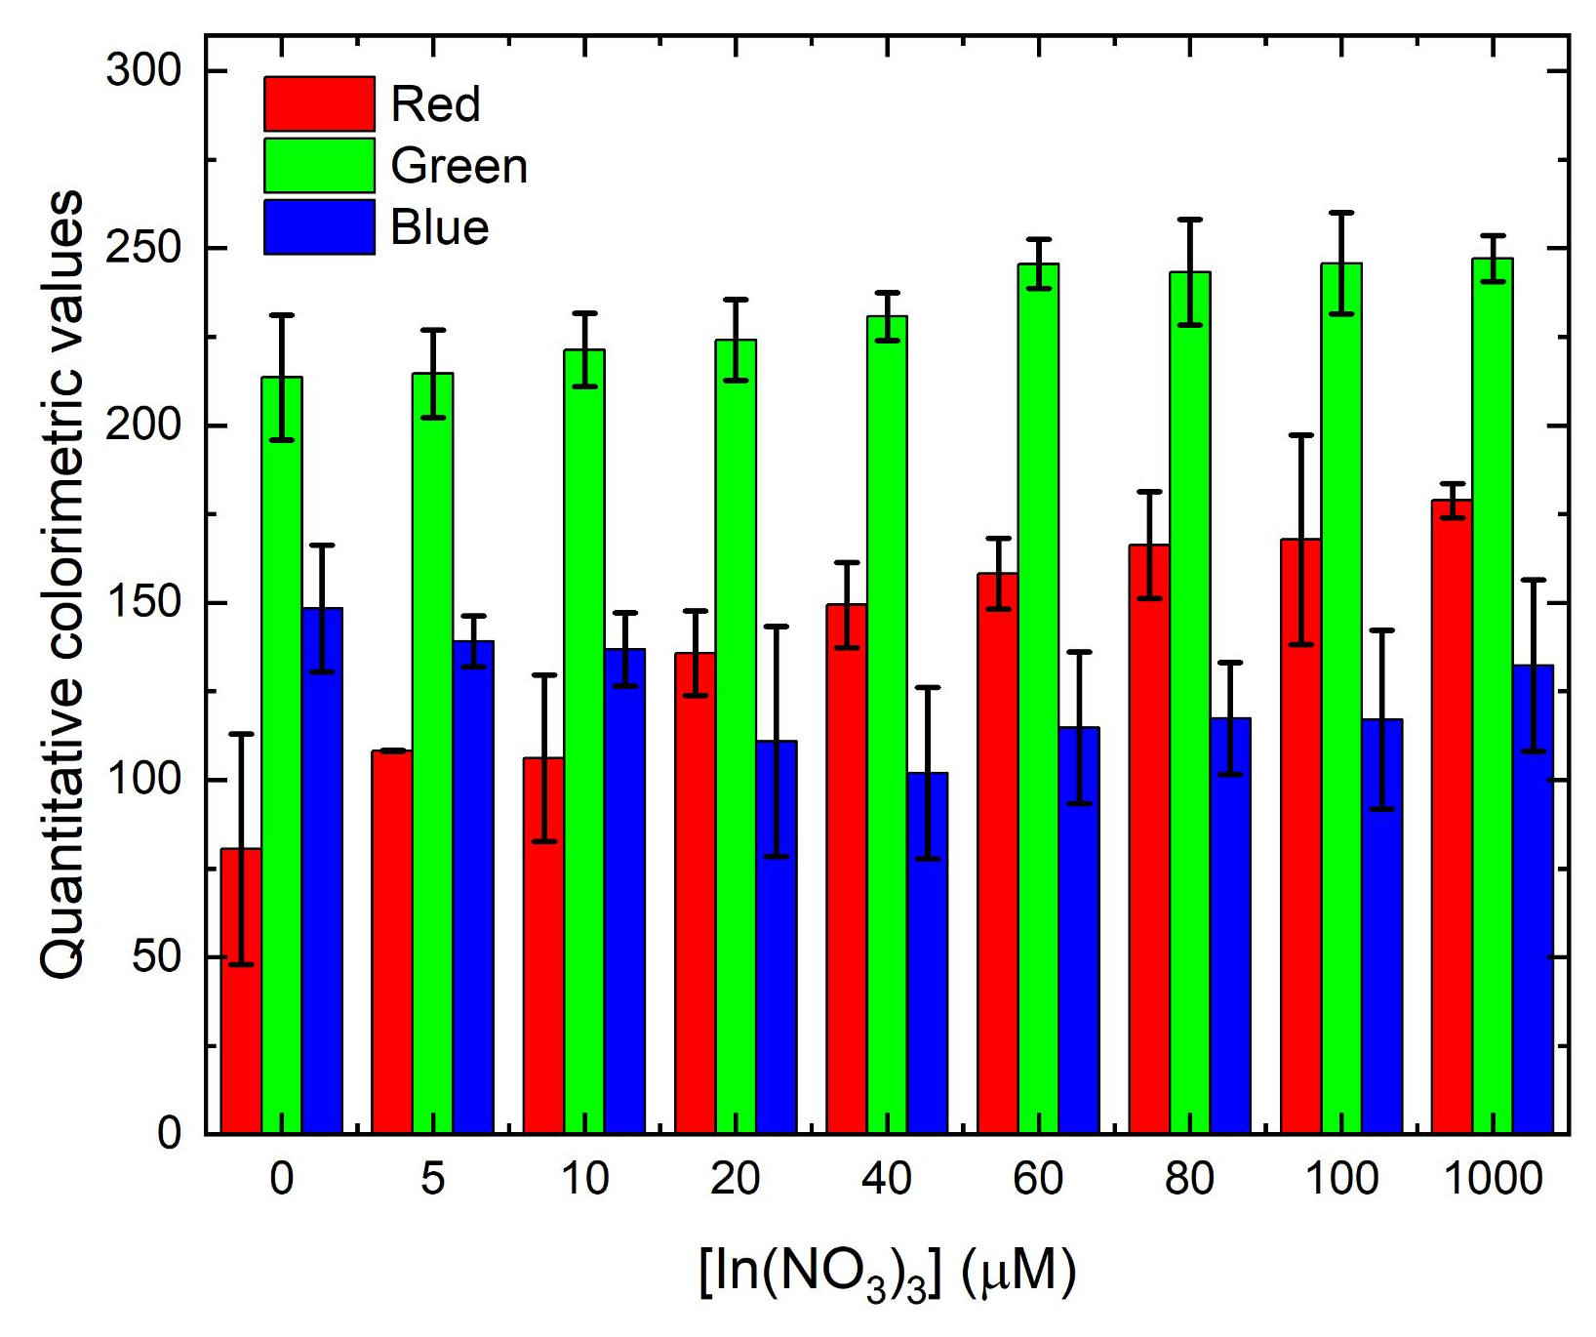
Figure S44. Quantitative colorimetric values of compound 1-loaded filter papers exposed to varying concentrations of In(NO₃)₃ and photographed under 365 nm excitation.
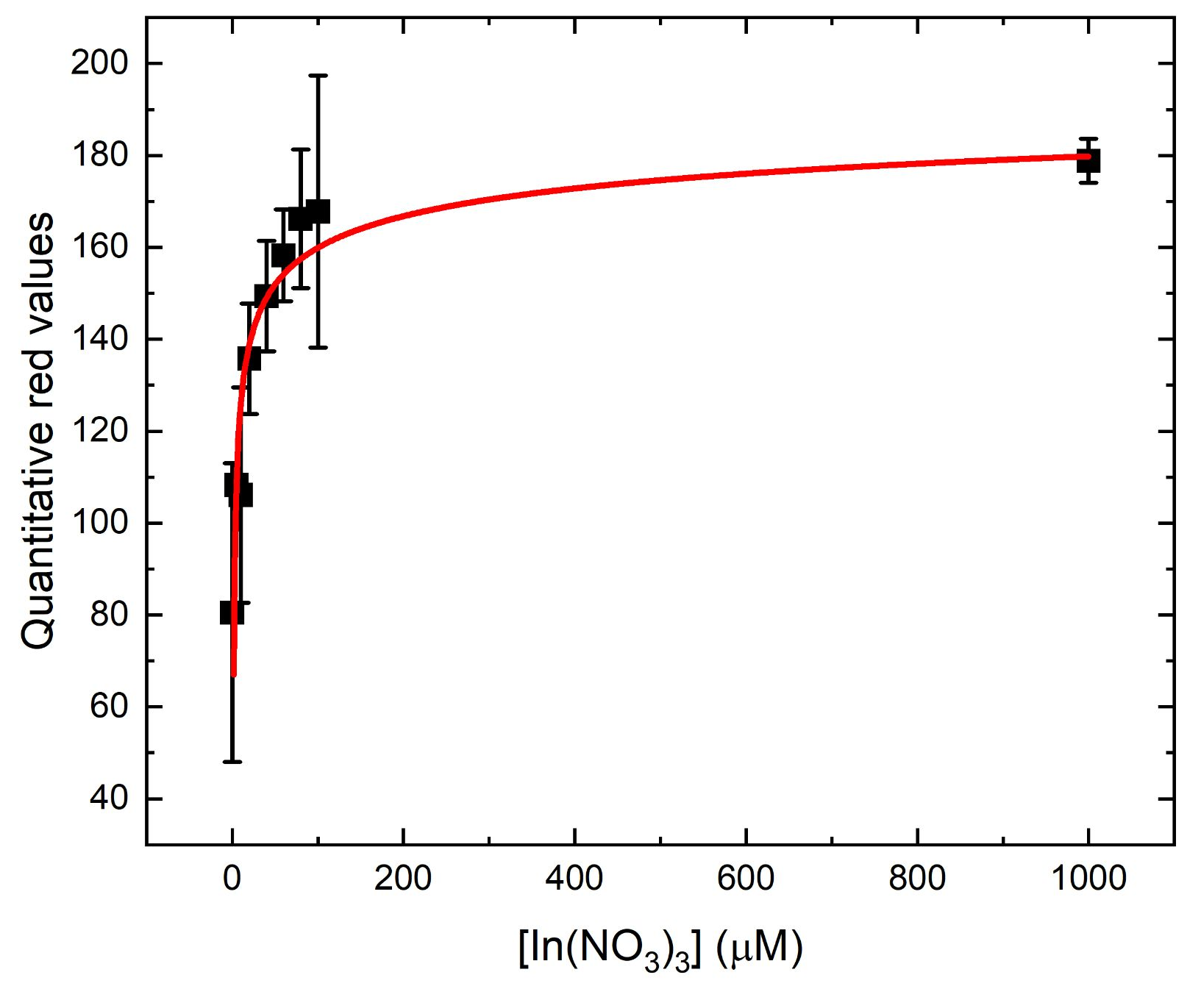
Figure S45. Graphical depiction of the nonlinear relationship between the concentration of In(NO₃)₃ and the quantitative red values of compound 1-loaded filter papers after exposure to those In(NO₃)₃ concentrations (red line shows the best nonlinear curve fit; equation of best fit: y = 49.1*ln(5.6*ln(x)); R² = 0.99497).
- Variable concentration experiments − in 100% aqueous solution:
UV–visible absorbance data
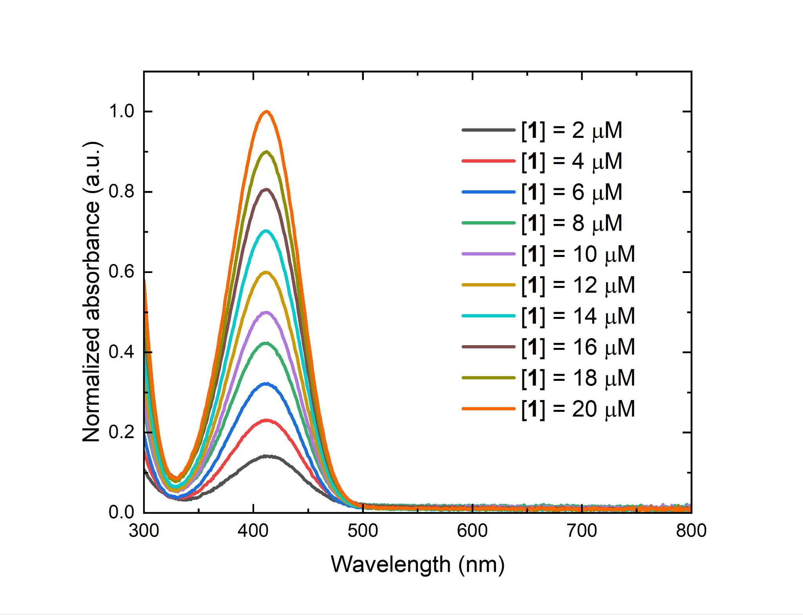
Figure S46. UV–visible absorbance spectra of aqueous solutions of compound 1 at varying concentrations ([1] = 2–20 µM).
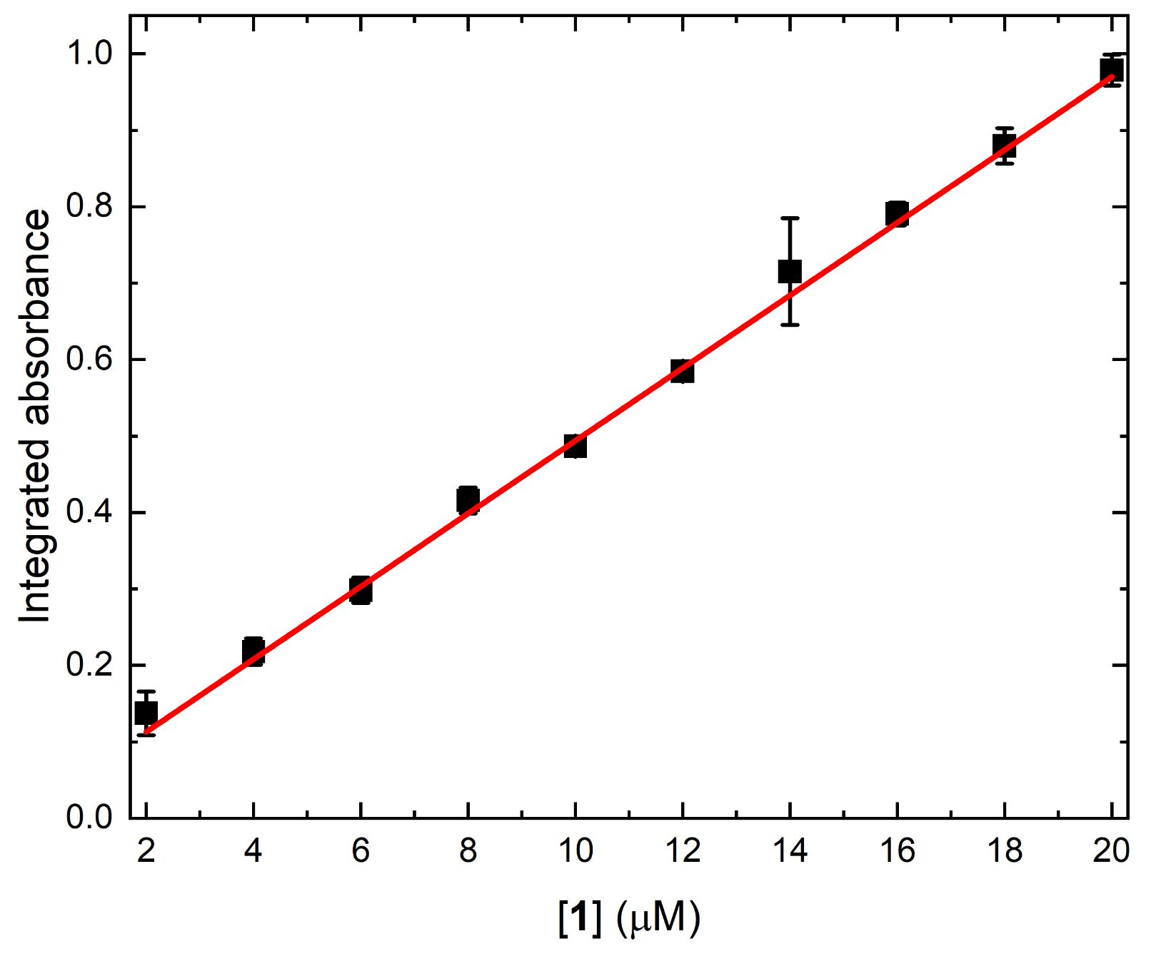
Figure S47. Integrated UV–visible absorbance spectra of aqueous solutions of compound 1 as a function of the concentration of compound 1. Red line shows the best linear equation fit to the data (equation: y = 0.0176 + 0.0476*x; R² = 0.99768).
Fluorescence emission data
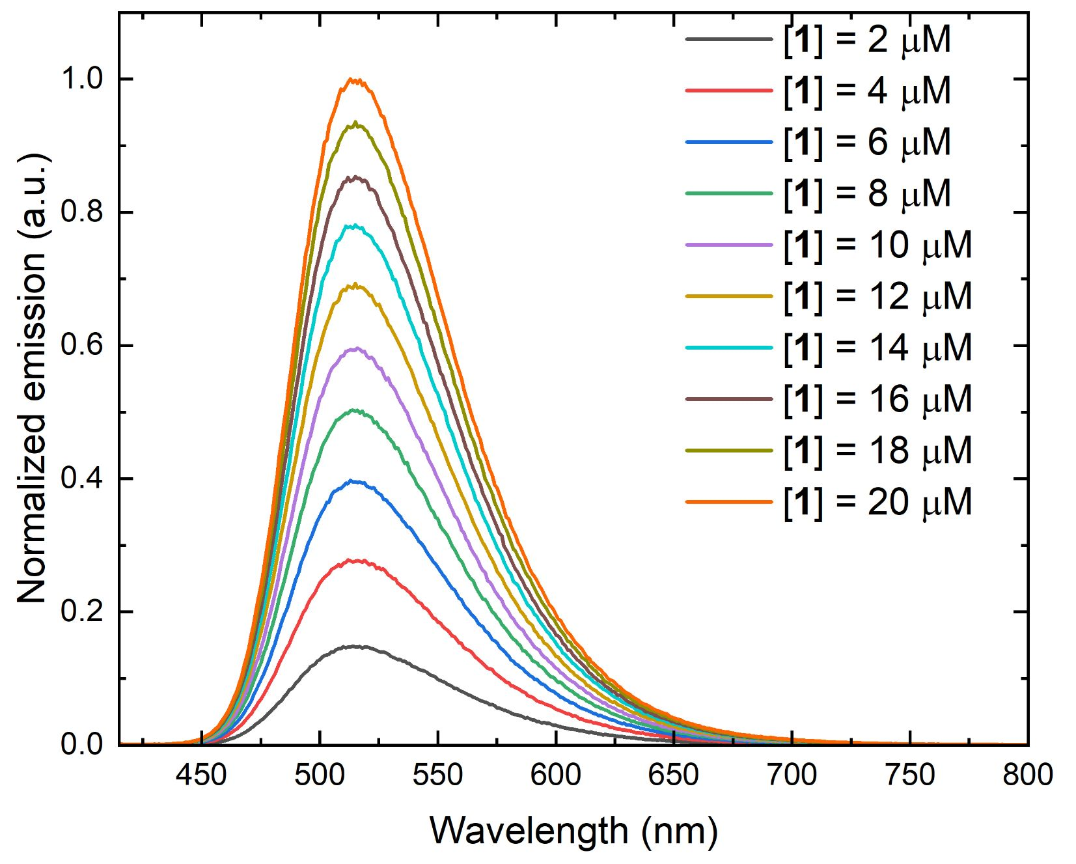
Figure S48. Fluorescence emission spectra of aqueous solutions of compound 1 at varying concentrations ([1] = 2–20 µM; λ_{ex} = 410 nm).
Figure S49. Integrated fluorescence emission of aqueous solutions of compound 1 as a function of the concentration of compound 1. Red line shows the best linear fit to the data (λ_{ex} = 410 nm; equation: y = 0.05074x + 0.0638; R² = 0.98779).
- Other solvent experiments:
UV–visible absorbance data:
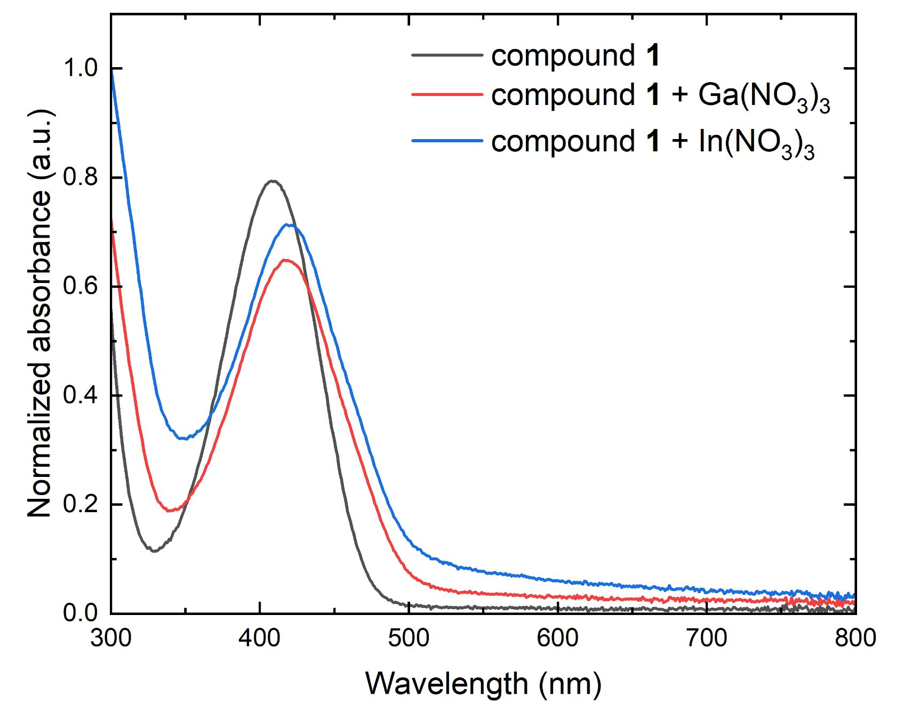
Figure S50. UV–visible absorbance spectra of an aqueous solution of compound 1 in the absence of analyte and in the presence of Ga(NO₃)₃ and In(NO₃)₃ ([1] = 10 µM; [analyte] = 40 µM).
Fluorescence emission data:
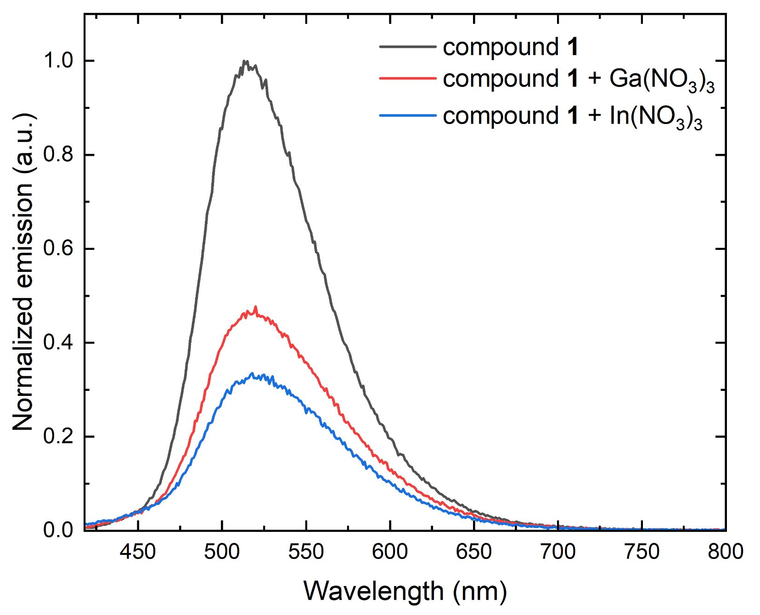
Figure S51. Fluorescence emission spectra of an aqueous solution of compound 1 in the absence of analyte and in the presence of Ga(NO₃)₃ and In(NO₃)₃ ([1] = 10 µM; [analyte] = 40 µM; λ_{ex} = 410 nm).
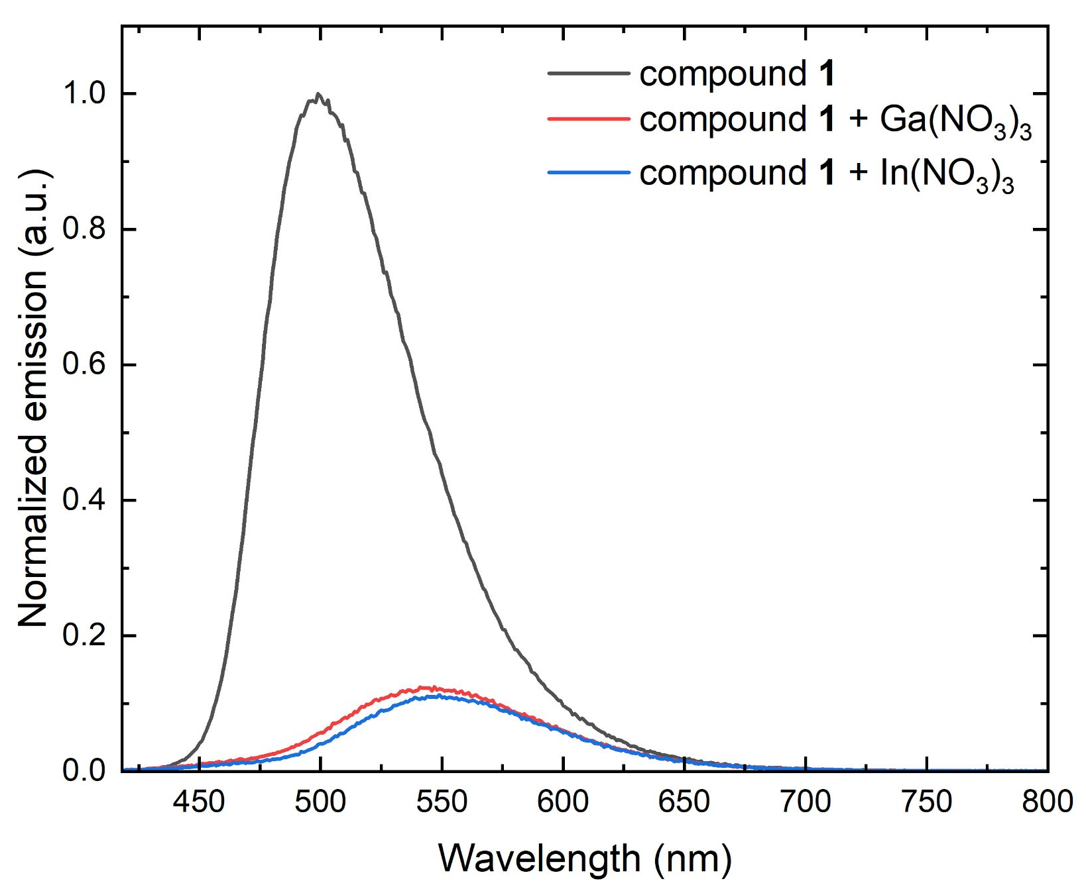
Figure S52. Fluorescence emission spectra of a methanol solution of compound 1 in the absence of analyte and in the presence of Ga(NO₃)₃ and In(NO₃)₃ ([1] = 10 µM; [analyte] = 40 µM; λ_{ex} = 410 nm).
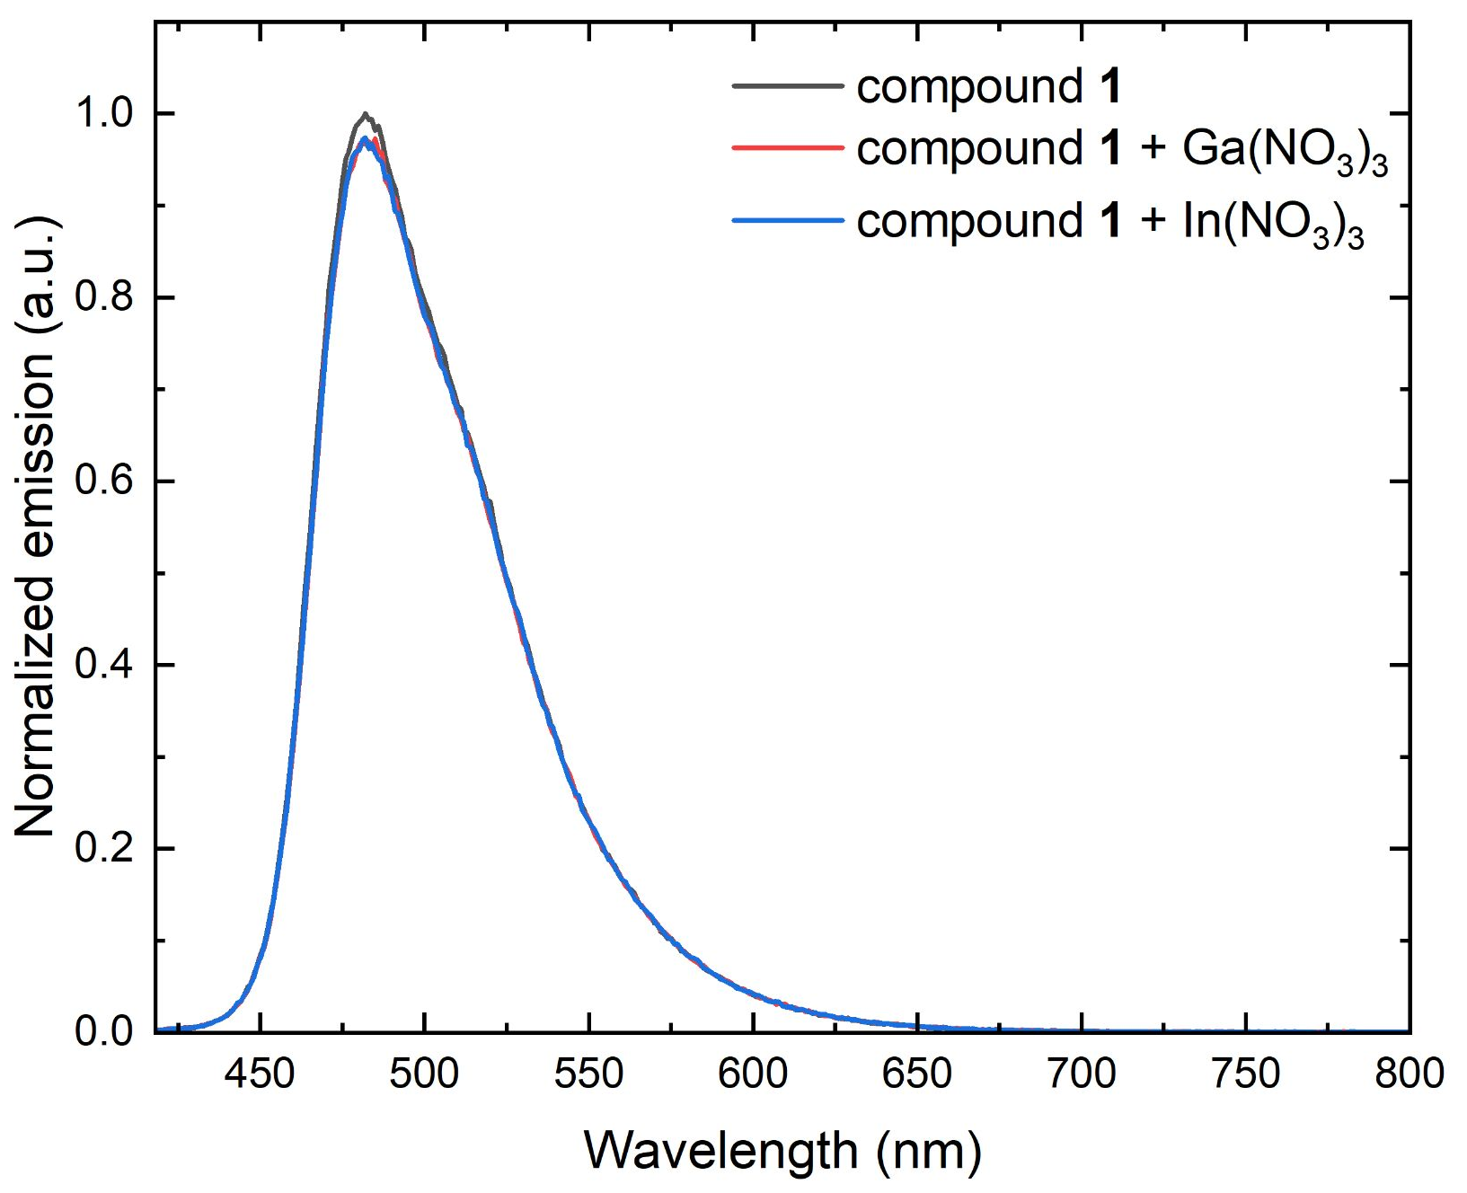
Figure S53. Fluorescence emission spectra of a DMSO solution of compound 1 in the absence of analyte and in the presence of Ga(NO₃)₃ and In(NO₃)₃ ([1] = 10 µM; [analyte] = 40 µM; λ_{ex} = 410 nm).
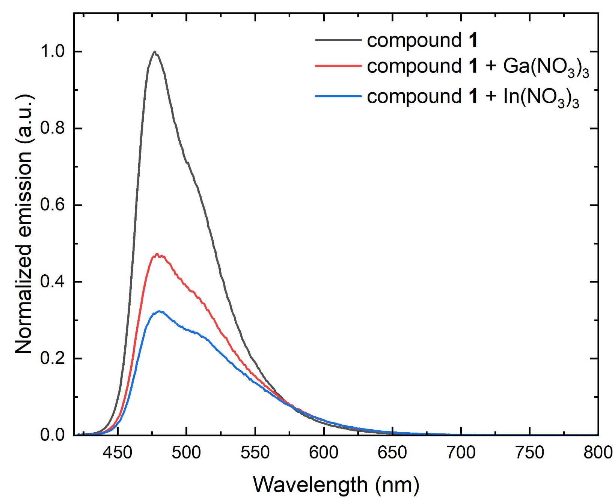
Figure S54. Fluorescence emission spectra of an NMP solution of compound 1 in the absence of analyte and in the presence of Ga(NO₃)₃ and In(NO₃)₃ ([1] = 10 µM; [analyte] = 40 µM; λ_{ex} = 410 nm).
- ¹H NMR titration experiments − in 100% D₂O:
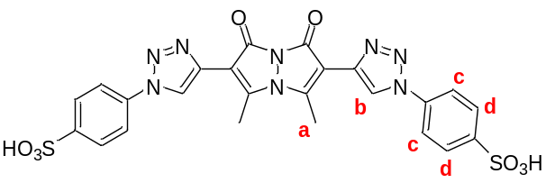
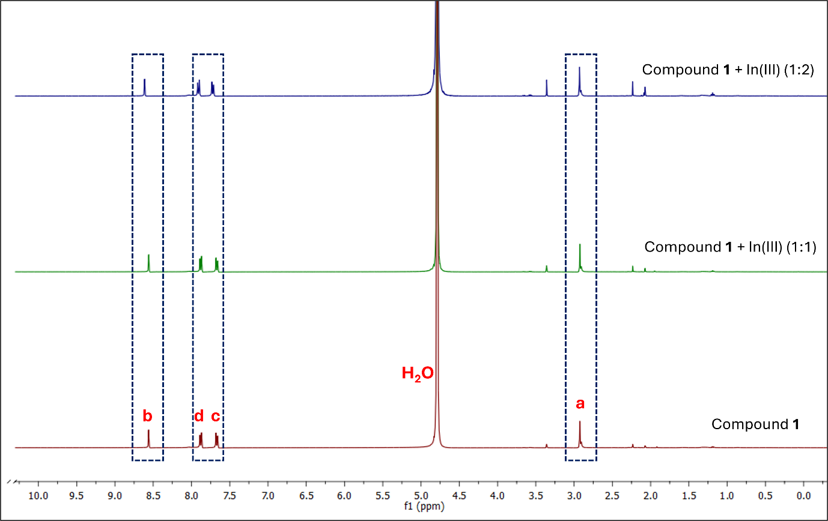
Figure S55. ¹H NMR spectra of compound 1 (bottom) in the presence of 1 equivalent (middle) and 2 equivalents (top) of In(NO₃)₃ (D₂O, 298 K).
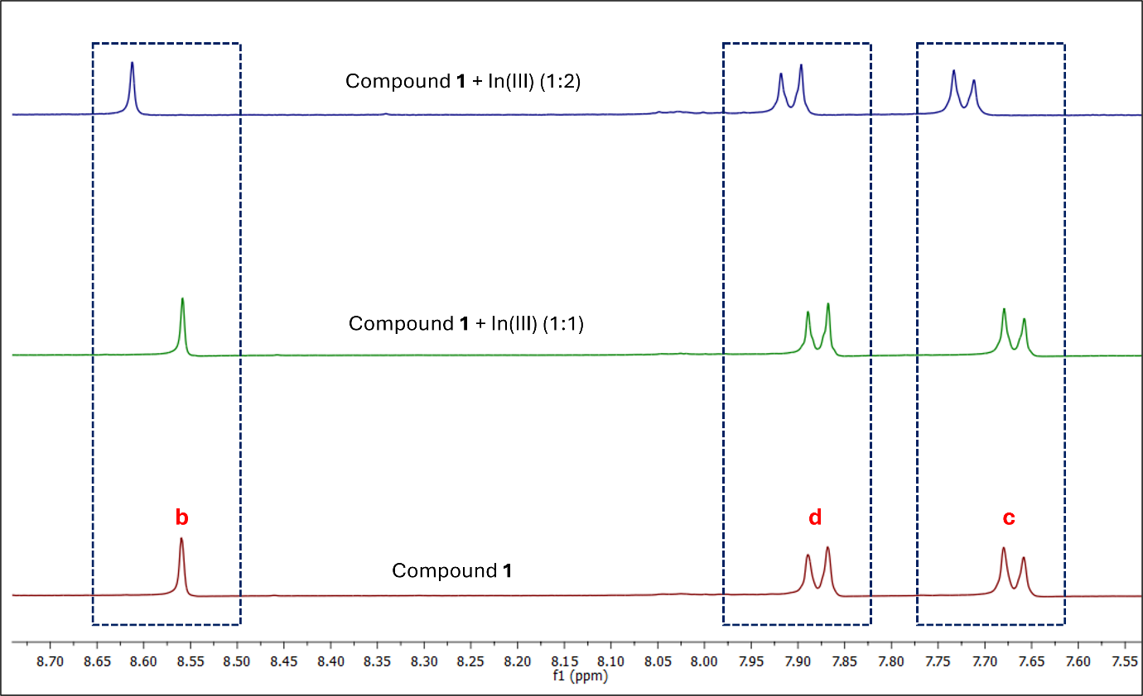
Figure S56. Expanded view of the aromatic region from the ¹H NMR spectra of compound 1 (bottom) in the presence of 1 equivalent (middle) and 2 equivalents (top) of In(NO₃)₃ (D₂O, 298 K).
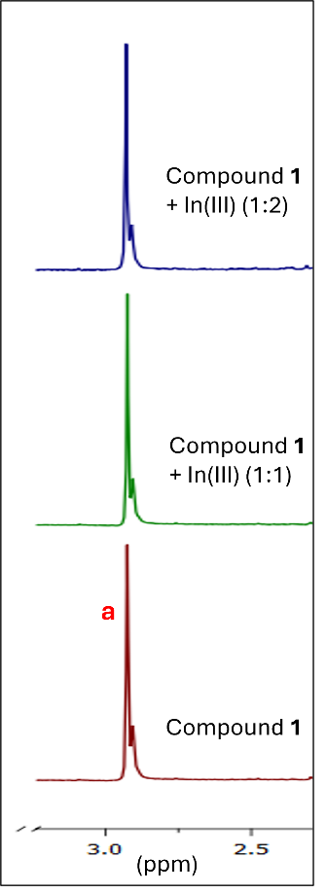
Figure S57. Expanded view of the methyl proton region from the ¹H NMR spectra of compound 1 (bottom) in the presence of 1 equiv. (middle) and 2 equiv. (top) of In(NO₃)₃ (D₂O, 298 K).

- High-resolution mass spectrometry experiments:
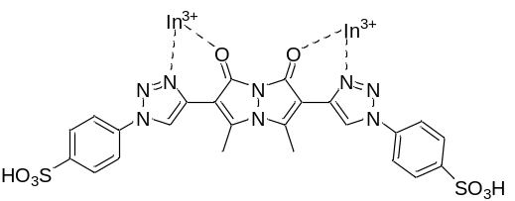
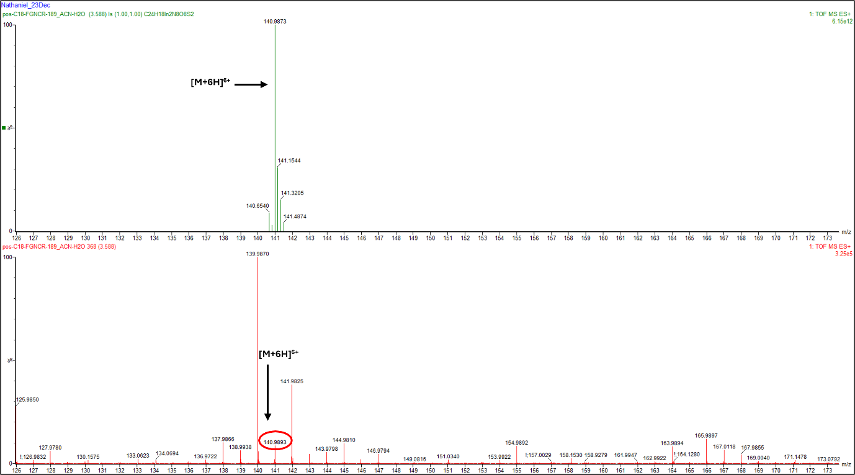
Figure S58. High-resolution mass spectrometry (HRMS) analysis performed in support of a proposed complex between compound 1 and In(III) (1:2 compound:metal ratio), recorded in positive ionization mode. The top spectrum represents the computationally predicted isotope pattern; the bottom spectrum is the experimentally obtained spectrum. The experimental spectrum contains a prominent ion cluster centered at m/z 140.9893 with an isotope pattern consistent with a highly charged species containing two indium atoms. Additional peaks were observed at m/z 154.9892 and 163.9894, which are tentatively assigned to hydrated 2:1 In(III):compound 1 species. The calculated m/z values for [C₂₄H₁₈In₂N₈O₈S₂ + 5 H₂O]⁶⁺ and for [C₂₄H₁₈In₂N₈O₈S₂ + 8 H₂O]⁶⁺ are approximately 154.9877 and 163.9930, respectively.

- Limit of detection experiments – in 100% aqueous solution:
Figure S59. Fluorescence integration of aqueous solutions of compound 1 as a function of increasing concentrations of In(NO₃)₃. Red line represents the best linear fit to the data ([1] = 10 µM; [In(NO₃)₃] = 0–1.2 µM; λ_{ex} = 410 nm; best-fit equation: y = 1E6 – 1.65E4x; R² = 0.99582).
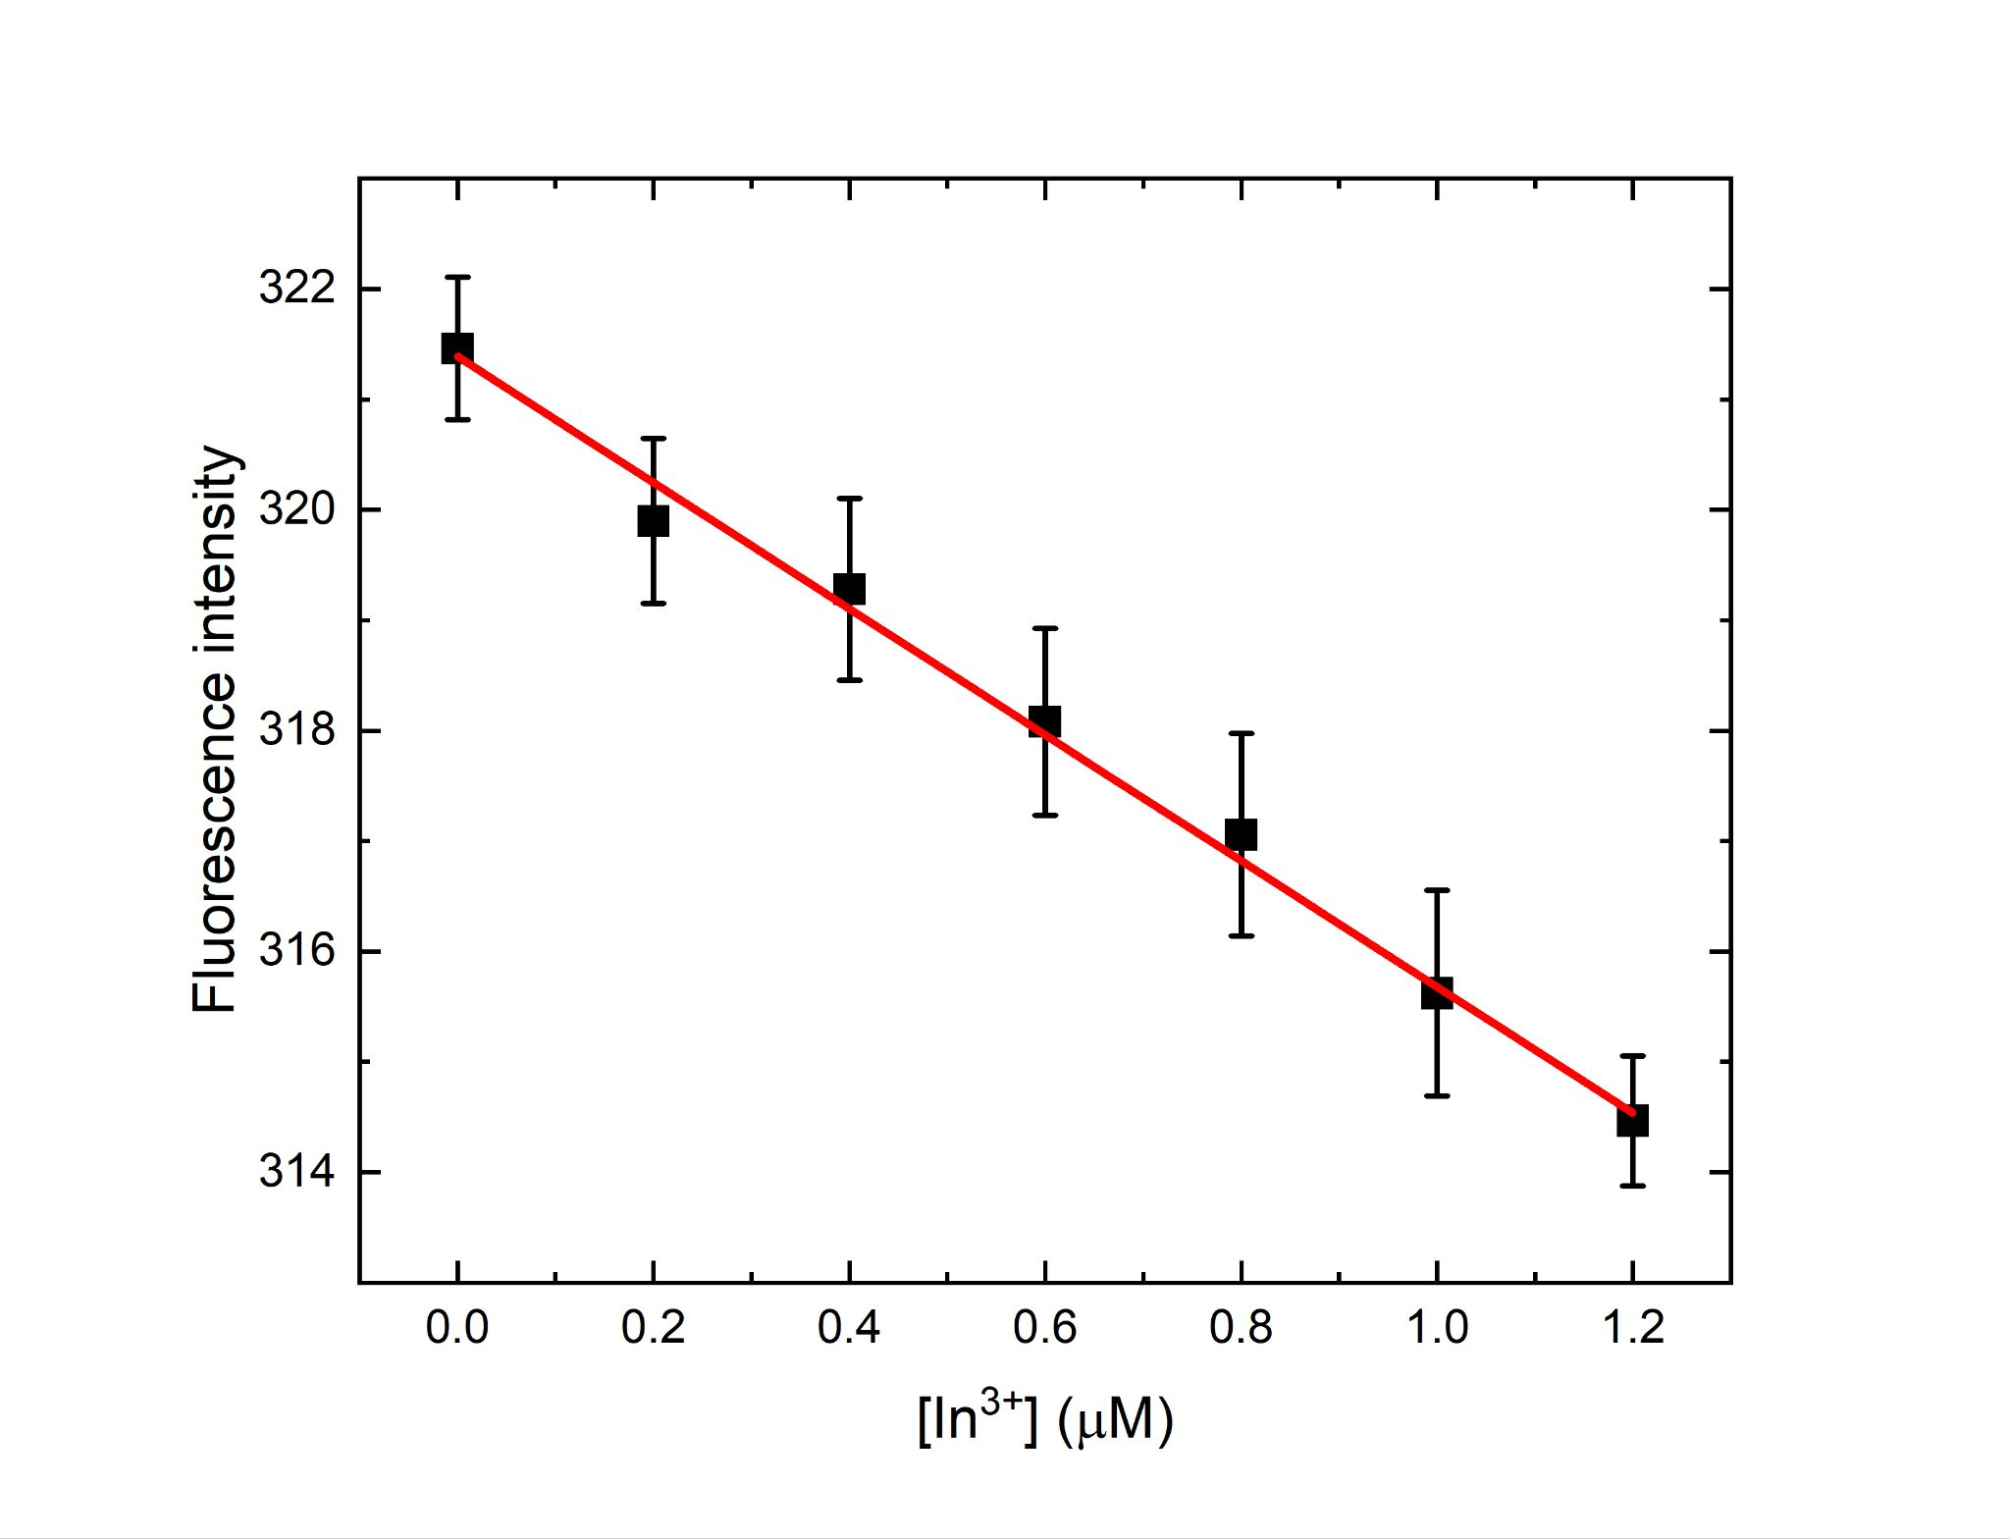
Figure S60. Fluorescence intensity of aqueous solutions of compound 1 as a function of increasing concentrations of In(NO₃)₃. Red line represents the best linear fit to the data ([1] = 10 µM; [In(NO₃)₃] = 0–1.2 µM; fluorescence intensity measured at 510 nm; best-fit equation: y = 321 – 5.7x; R² = 0.99532).

- Binding mechanism experiments − in 100% aqueous solution:
Figure S61. Job’s plot analysis of the absorbance intensity of compound 1, plotted as the difference in the UV–visible absorbance intensity at 410 nm with and without added In(NO₃)₃ on the Y-axis, and the mole fraction of In(NO₃)₃ on the X-axis. The best nonlinear fit to the data is shown in red, and the equation and R² value of the best fit equation are shown on the graph.
Figure S62. Job’s plot analysis of the integrated fluorescence emission of compound 1, plotted as the difference in the integrated emission with and without added In(NO₃)₃ on the Y-axis, and the mole fraction of In(NO₃)₃ on the X-axis. The best nonlinear fit to the data is shown in red, and the equation and R² value of the best fit equation are shown on the graph.

- EDTA experiments − in 100% aqueous solution:
UV–visible absorbance spectra:
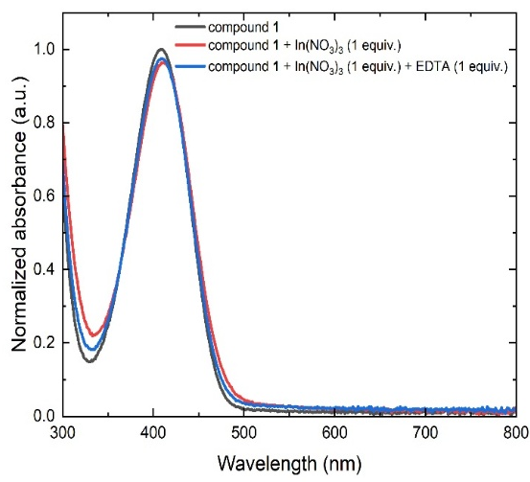
Figure S63. UV–visible absorbance spectra of aqueous solutions of compound 1 in the absence of analyte, after the addition of In(NO₃)₃ (1 equiv.), and after the addition of In(NO₃)₃ (1 equiv.) followed by EDTA.
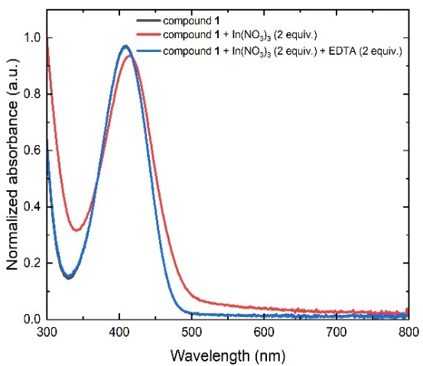
Figure S64. UV–visible absorbance spectra of aqueous solutions of compound 1 in the absence of analyte, after the addition of In(NO₃)₃ (2 equiv.), and after the addition of In(NO₃)₃ (2 equiv.) followed by EDTA.
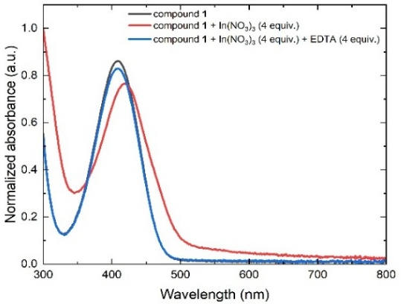
Figure S65. UV–visible absorbance spectra of aqueous solutions of compound 1 in the absence of analyte, after the addition of In(NO₃)₃ (4 equiv.), and after the addition of In(NO₃)₃ (4 equiv.) followed by EDTA.
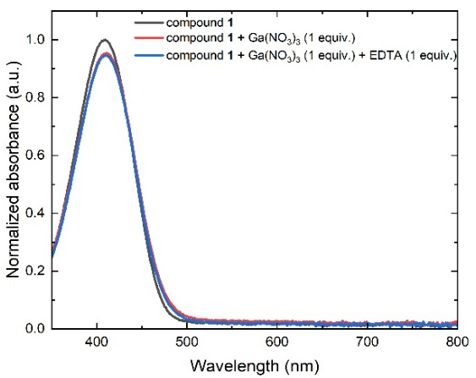
Figure S66. UV–visible absorbance spectra of aqueous solutions of compound 1 in the absence of analyte, after the addition of Ga(NO₃)₃ (1 equiv.), and after the addition of Ga(NO₃)₃ (1 equiv.) followed by EDTA.
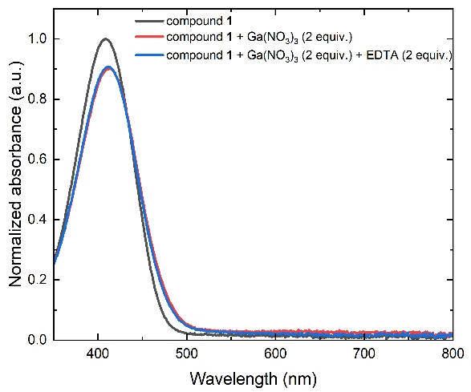
Figure S67. UV–visible absorbance spectra of aqueous solutions of compound 1 in the absence of analyte, after the addition of Ga(NO₃)₃ (2 equiv.), and after the addition of Ga(NO₃)₃ (2 equiv.) followed by EDTA.
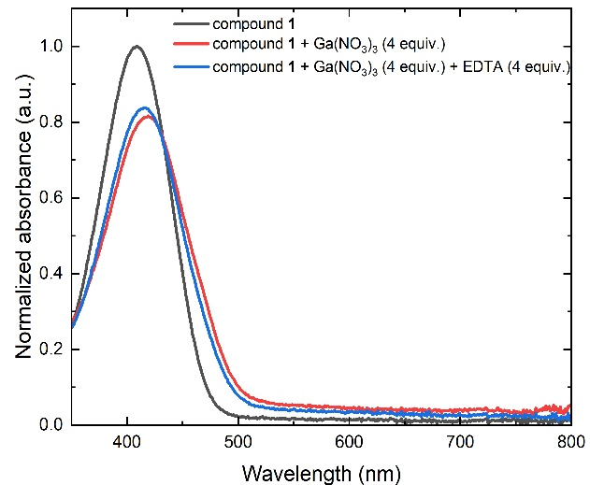
Figure S68. UV–visible absorbance spectra of aqueous solutions of compound 1 in the absence of analyte, after the addition of Ga(NO₃)₃ (4 equiv.), and after the addition of Ga(NO₃)₃ (4 equiv.) followed by EDTA.
Fluorescence emission spectra:
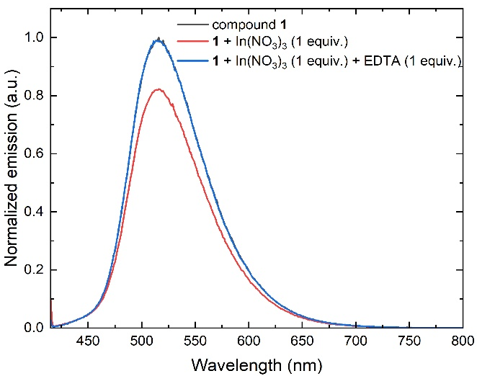
Figure S69. Fluorescence emission spectra of aqueous solutions of compound 1 in the absence of analyte, after the addition of In(NO₃)₃ (1 equiv.), and after the addition of In(NO₃)₃ (1 equiv.) followed by EDTA (1 equiv.).
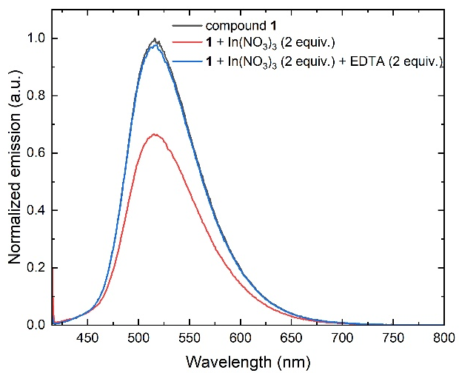
Figure S70. Fluorescence emission spectra of aqueous solutions of compound 1 in the absence of analyte, after the addition of In(NO₃)₃ (2 equiv.), and after the addition of In(NO₃)₃ (2 equiv.) followed by EDTA (2 equiv.).
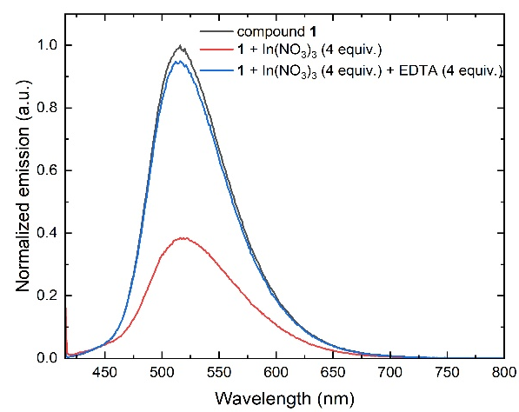
Figure S71. Fluorescence emission spectra of aqueous solutions of compound 1 in the absence of analyte, after the addition of In(NO₃)₃ (4 equiv.), and after the addition of In(NO₃)₃ (4 equiv.) followed by EDTA (4 equiv.).
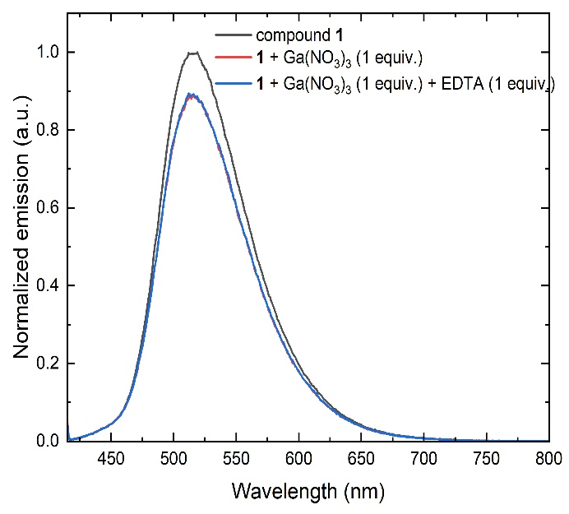
Figure S72. Fluorescence emission spectra of aqueous solutions of compound 1 in the absence of analyte, after the addition of Ga(NO₃)₃ (1 equiv.), and after the addition of Ga(NO₃)₃ (1 equiv.) followed by EDTA (1 equiv.).
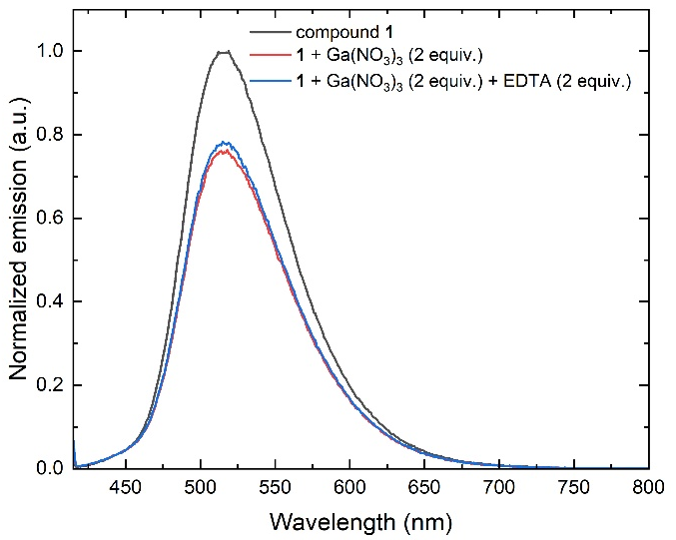
Figure S73. Fluorescence emission spectra of aqueous solutions of compound 1 in the absence of analyte, after the addition of Ga(NO₃)₃ (2 equiv.), and after the addition of Ga(NO₃)₃ (2 equiv.) followed by EDTA (2 equiv.).
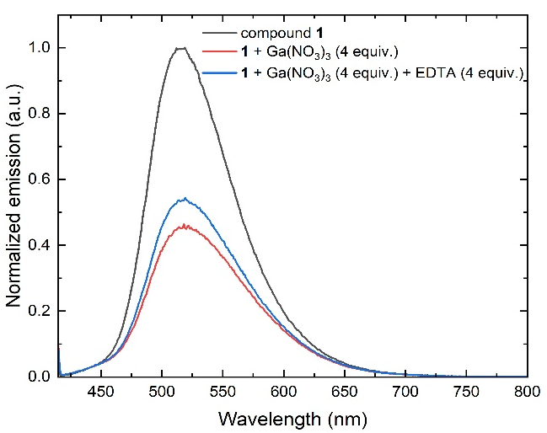
Figure S74. Fluorescence emission spectra of aqueous solutions of compound 1 in the absence of analyte, after the addition of Ga(NO₃)₃ (4 equiv.), and after the addition of Ga(NO₃)₃ (4 equiv.) followed by EDTA (4 equiv.).
Figure S75. Summary of the photophysical changes of aqueous solutions of compound 1 after the addition of Ga(NO₃)₃ or In(NO₃)₃ followed by EDTA.
Solution-state colorimetric data:
Figure S76. Photographs of an aqueous solution of compound 1 before the addition of analyte (left-most figure); after the addition of (A) In(NO₃)₃ or (B) Ga(NO₃)₃ (middle figure); and after the addition of (A) In(NO₃)₃ or (B) Ga(NO₃)₃ followed by EDTA (right-most figure), visualized under 365 nm excitation ([1] = 10 μM; [In(NO₃)₃] = [Ga(NO₃)₃] = [EDTA-2Na] = 80 μM).
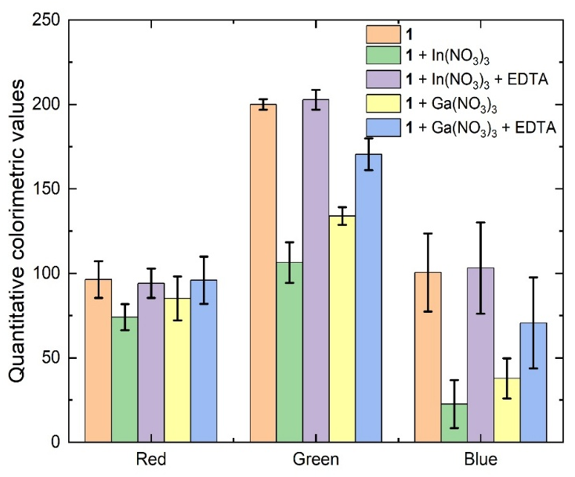
Figure S77. Quantitative colorimetric values of an aqueous solution of compound 1 before the addition of analyte, after the addition of In(NO₃)₃ or Ga(NO₃)₃, and after the addition of In(NO₃)₃ or Ga(NO₃)₃ followed by EDTA, visualized under 365 nm excitation.
- Time-dependent experiments − in 100% aqueous solution:
Complexation kinetics:
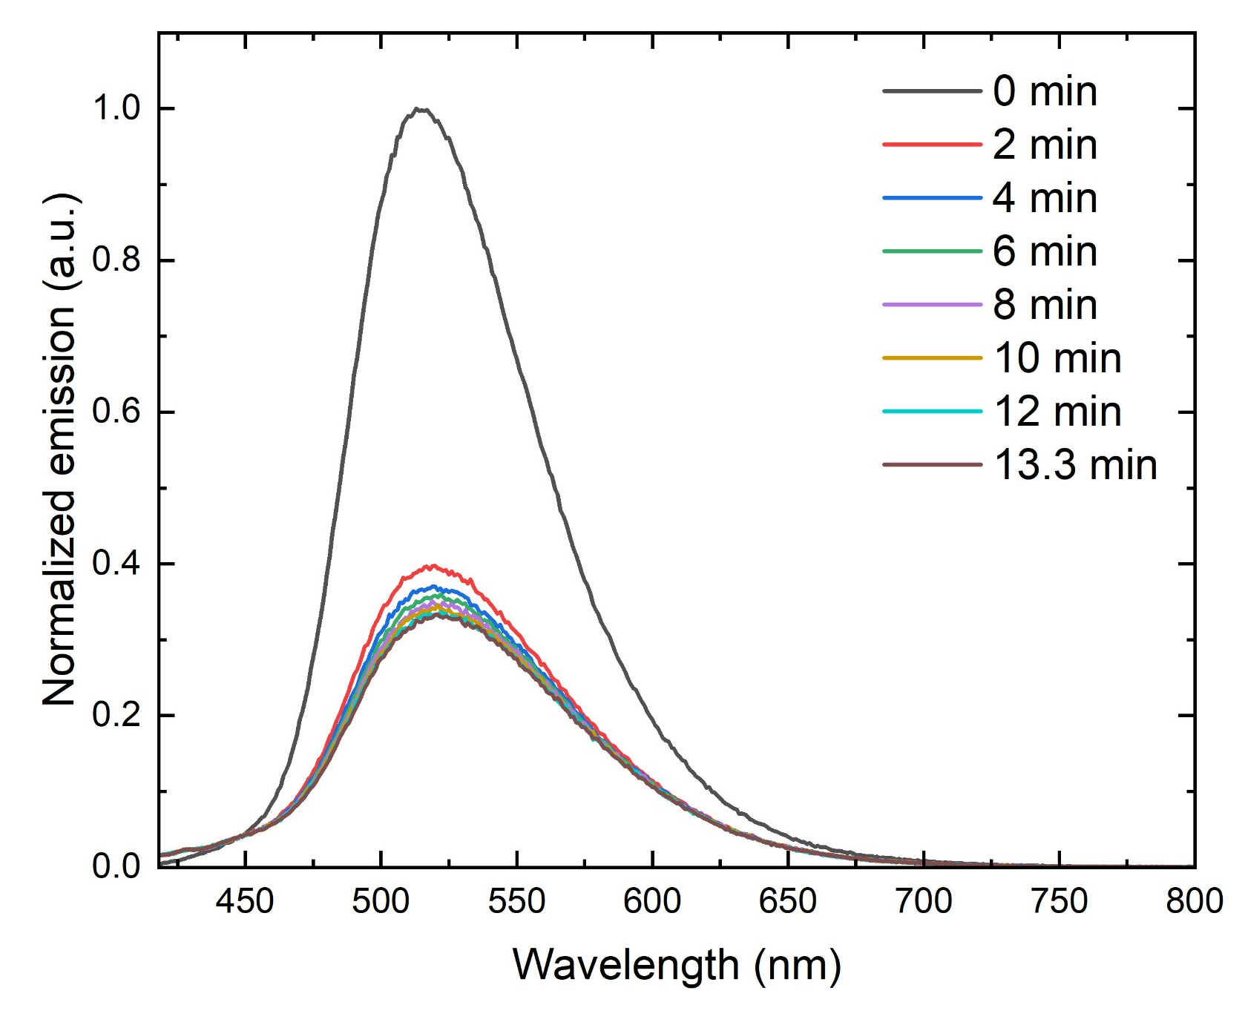
Figure S78. Fluorescence emission spectra of an aqueous solution of compound 1 as a function of time following the addition of In(NO₃)₃ ([1] = 10 µM; [In(NO₃)₃] = 40 µM; λ_{ex} = 410 nm).
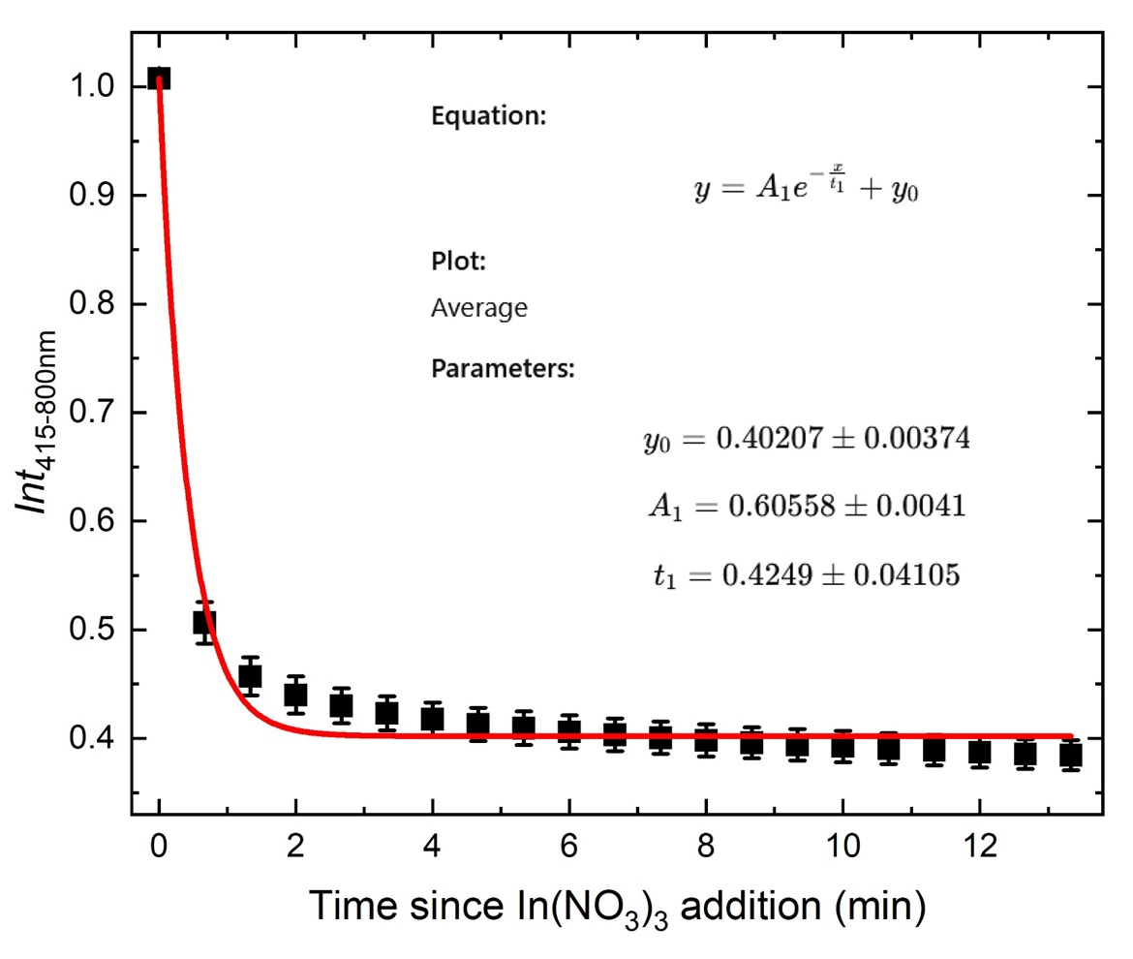
Figure S79. Fluorescence integration of aqueous solutions of compound 1 as a function of time since In(NO₃)₃ addition, with the red line representing the best-fit nonlinear equation to the data (Integration calculated between 415 and 800 nm; R² = 0.99921).
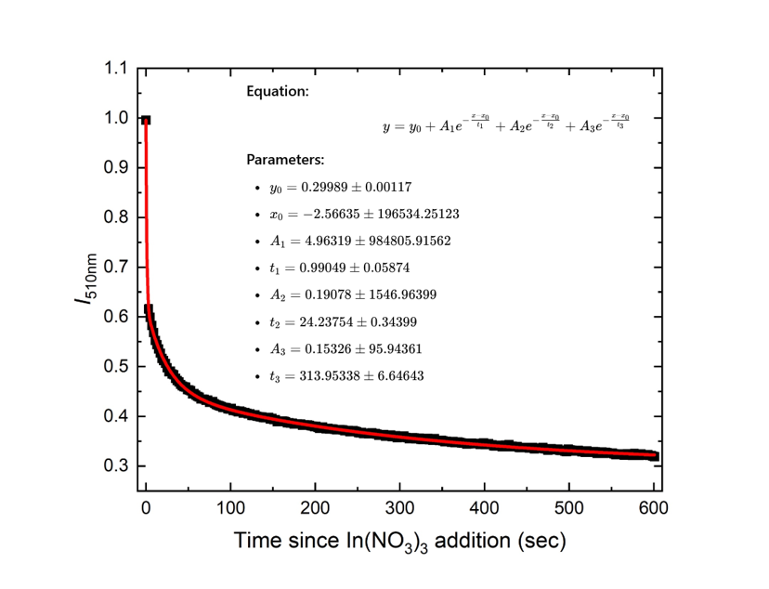
Figure S80. Fluorescence intensity of aqueous solutions of compound 1 as a function of time since In(NO₃)₃ addition, with the red line representing the best-fit nonlinear equation to the data (Intensity measured at 510 nm; R² = 0.99955).
Extended continuous-excitation measurements:
Figure S81. Normalized fluorescence intensity of aqueous solutions of compound 1 under continuous excitation at 410 nm over 60 min ([1] = 10 μM): (A) photostability of free compound 1 and (B) the time-dependent response of the compound 1–In(III) system following the addition of In(NO₃)₃.
- pH-dependent experiments − in 100% aqueous solution:
UV–visible absorbance data
Figure S82. Integrated UV–visible absorbance spectra of aqueous solutions of compound 1 at varying pH values, with (red circles) and without (black squares) the addition of In(NO₃)₃.
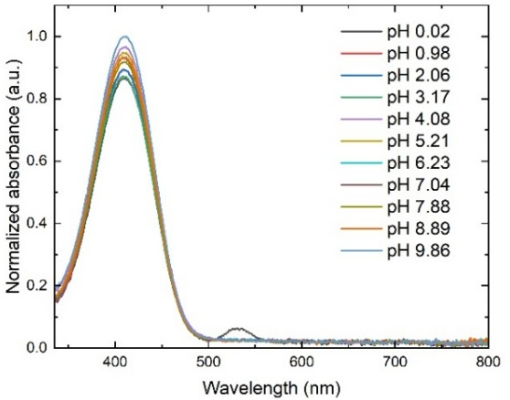
Figure S83. UV–visible absorbance spectra of solutions of compound 1 at varying solution pH values, before the addition of In(NO₃)₃.
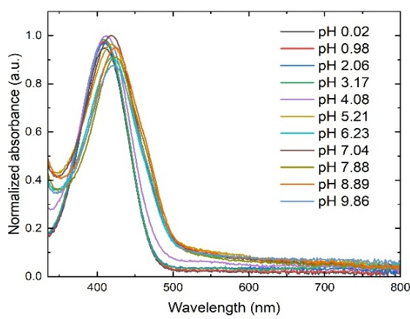
Figure S84. UV–visible absorbance spectra of solutions of compound 1 at varying solution pH values, after the addition of In(NO₃)₃.
Fluorescence emission data
Figure S85. Integrated fluorescence emission of aqueous solutions of compound 1 at varying pH values, with (red circles) and without (black squares) the addition of In(NO₃)₃ ([1] = 10 µM; [In(NO₃)₃] = 40 µM; λ_{ex} = 410 nm).
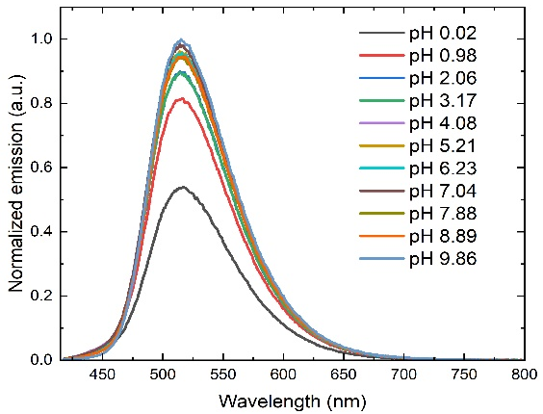
Figure S86. Fluorescence emission spectra of solutions of compound 1 at varying solution pH values, before the addition of In(NO₃)₃ ([1] = 10 µM; λ_{ex} = 410 nm).
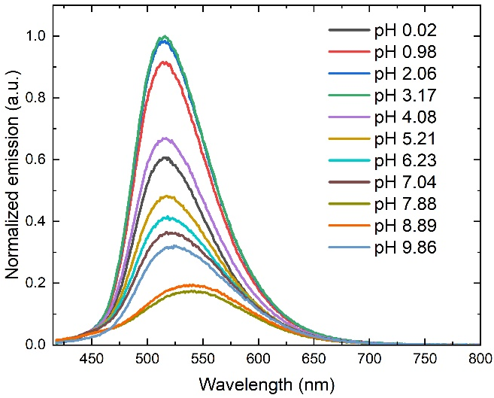
Figure S87. Fluorescence emission spectra of solutions of compound 1 at varying solution pH values, after the addition of In(NO₃)₃ ([1] = 10 µM; [In(NO₃)₃] = 40 µM; λ_{ex} = 410 nm).

- Real-world water sample experiments − in 100% aqueous solution:
UV–visible absorbance data:
Figure S88. Integrated UV–visible absorbance of aqueous solutions of compound 1 (integrated between 330 and 550 nm) in the presence of increasing concentrations of In(NO₃)₃, with lines representing the best linear fit to the data (Milli-Q water: y = 2.99x + 591; R² = 0.98722; Mineral water: y = 4.56x + 590; R² = 0.99293).
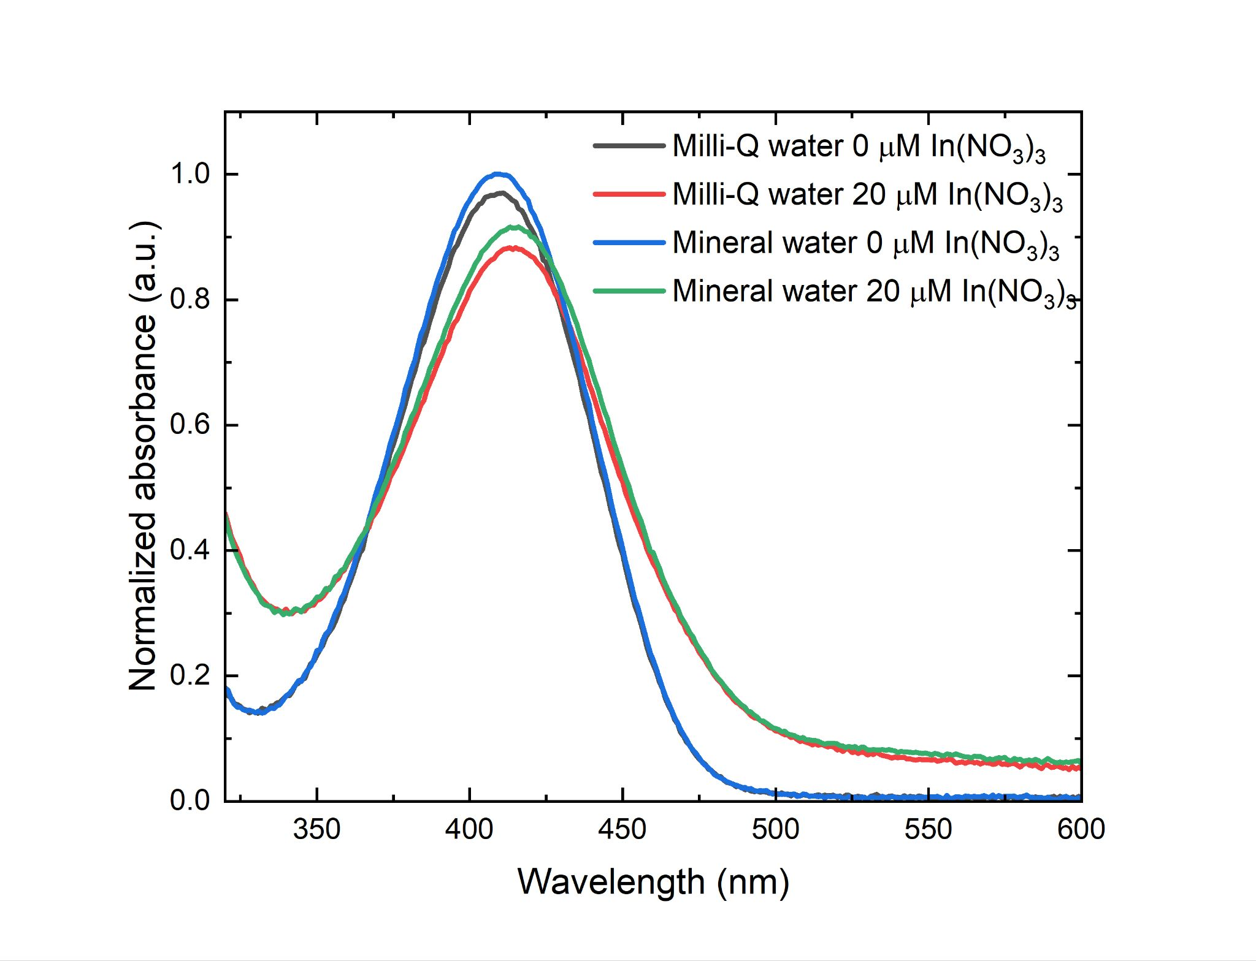
Figure S89. UV–visible absorbance spectra of aqueous solutions of compound 1 in Milli-Q water, in the absence of In(NO₃)₃ and in the presence of 20 µM of In(NO₃)₃.
Fluorescence emission data:
Figure S90. Integrated fluorescence emission of aqueous solutions of compound 1 in the presence of increasing concentrations of In(NO₃)₃, with lines representing the best linear fit to the data (Milli-Q water: y = –1.89E4x + 9.58E5; R² = 0.98706; Mineral water: y = –1.71E4x + 9.58E5; R² = 0.97317).
- Computational investigations:
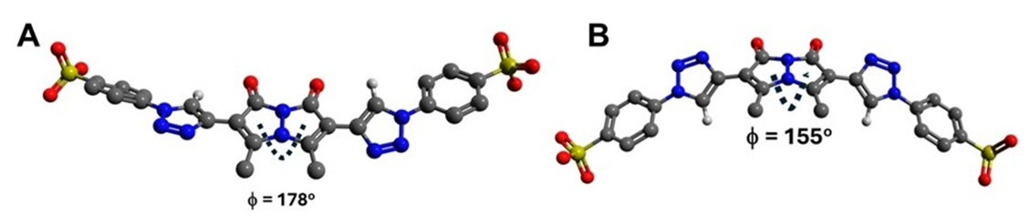
Figure S91. Energy-minimized structures of compound 1 with: (A) triazole H atoms syn to the bimane carbonyls, and (B) triazole H atoms anti to the bimane carbonyls, showing the interplanar bimane angle. The average dihedral angles between the bimane core and the triazole units are: 21⁰ in A and 34.8⁰ in B.

V. REFERENCES
- Steflova J, Storch G, Wiesner S, Stockinger S, Berg R, Trapp O (2018) Investigation of strain-promoted azide-alkyne cycloadditions in aqueous solutions by capillary electrophoresis. J Org Chem 83:604-613. https://doi.org/10.1021/acs.joc.7b02092.
- Szumski O, Karmakar J, Grynszpan F (2021) Re-enter the syn-(Me,I)bimane: a gateway to bimane derivatives with extended π-systems. Synlett 32:1141-1145. https://doi.org/10.1055/s-0040-1706045.
- Kosower EM, Ben-Shoshan M (1996) Bimane acetylenes and diacetylenes. Bimanes. 33. J Org Chem 61:5871-5884. https://doi.org/10.1021/jo951830b.
- Lakowicz JR (2006) Principles of fluorescence spectroscopy, 3rd edn. Springer, New York.
- Brouwer AM (2011) Standards for photoluminescence quantum yield measurements in solution (IUPAC technical report). Pure Appl Chem 83:2213-2228. https://doi.org/10.1351/PAC-REP-10-09-31.
- Neese F (2022) Software update: the ORCA program system-version 5.0. WIREs Comput Mol Sci 12:e1606. https://doi.org/10.1002/wcms.1606.
- Neese F (2023) The SHARK integral generation and digestion system. J Comput Chem 44:381-396. https://doi.org/10.1002/jcc.26942.
- Hanwell MD, Curtis DE, Lonie DC, Vandermeersch T, Zurek E, Hutchison GR (2012) Avogadro: an advanced semantic chemical editor, visualization, and analysis platform. J Cheminform 4:17. https://doi.org/10.1186/1758-2946-4-17.
- Rappe AK, Casewit CJ, Colwell KS, Goddard WA III, Skiff WM (1992) UFF, a full periodic table force field for molecular mechanics and molecular dynamics simulations. J Am Chem Soc 114:10024-10035. https://doi.org/10.1021/ja00051a040.
- Casewit CJ, Colwell KS, Rappe AK (1992) Application of a universal force field to organic molecules. J Am Chem Soc 114:10035-10046. https://doi.org/10.1021/ja00051a041.
- Hujo W, Grimme S (2011) Performance of the van der Waals density functional VV10 and (hybrid)GGA variants for thermochemistry and noncovalent interactions. J Chem Theory Comput 7:3866-3871. https://doi.org/10.1021/ct200644w.
- Vydrov OA, Van Voorhis T (2010) Nonlocal van der Waals density functional: the simpler the better. J Chem Phys 133:244103. https://doi.org/10.1063/1.3521275.
- Kromann JC, Steinmann C, Jensen JH (2018) Improving solvation energy predictions using the SMD solvation method and semiempirical electronic structure methods. J Chem Phys 149:104102. https://doi.org/10.1063/1.5047273.
- Marenich AV, Cramer CJ, Truhlar DG (2009) Universal solvation model based on solute electron density and on a continuum model of the solvent defined by the bulk dielectric constant and atomic surface tensions. J Phys Chem B 113:6378-6396. https://doi.org/10.1021/jp810292n.
- Wu YC, Li HJ, Yang HZ (2010) A sensitive and highly selective fluorescent sensor for In³⁺. Org Biomol Chem 8:3394-3397. https://doi.org/10.1039/C0OB00002G.
- Kim A, Kim C (2019) A hydrazono-quinoline-based chemosensor sensing In³⁺ and Zn²⁺ via fluorescence turn-on and ClO⁻ via color change in aqueous solution. New J Chem 43:7320-7328. https://doi.org/10.1039/C9NJ00899C.
- Li B, Shang X, Li L, Xu Y, Wang H, Yang X, et al (2020) A fluorescence probe based on 6-phenylimidazo[2,1-b]thiazole and salicylaldehyde for the relay discerning of In³⁺ and Cr³⁺. New J Chem 44:951-957. https://doi.org/10.1039/C9NJ05722F.
- Xu Y, Zhao S, Zhang Y, Wang H, Yang X, Pei M, et al (2020) A selective "turn-on" sensor for recognizing In³⁺ and Zn²⁺ in respective systems based on imidazo[2,1-b]thiazole. Photochem Photobiol Sci 19:289-298. https://doi.org/10.1039/C9PP00408D.
- Li L, Shang X, Li B, Xing Y, Liu Y, Yang X, et al (2021) A new sensor based on thieno[2,3-b]quinoline for the detection of In³⁺, Fe³⁺ and F⁻ by different fluorescence behaviour. Luminescence 36:1891-1900. https://doi.org/10.1002/bio.4119.
- Li B, Liu Z, Li L, Xing Y, Liu Y, Yang X, et al (2021) A Schiff base sensor for relay monitoring of In³⁺ and Fe³⁺ through "off-on-off" fluorescent signals. New J Chem 45:6753-6759. https://doi.org/10.1039/D1NJ00929J.
- Zhang Y, Li B (2022) A multifunctional selective fluorescent chemosensor for detection of Ga³⁺, In³⁺ and Fe³⁺ in different solvents. J Mol Struct 1250:131461. https://doi.org/10.1016/j.molstruc.2021.131461.
- Liu Y, Yang F, Wei K, Kang M, Liu P, Yang X, et al (2023) 5-(Thiophene-2-yl)oxazole derived "off-on-off" fluorescence chemosensor for sequential recognition of In³⁺ and Cr³⁺ ions. J Photochem Photobiol A Chem 437:114464. https://doi.org/10.1016/j.jphotochem.2022.114464.
- Mujthaba Aatif A, Selva Kumar R, Joseph S, Vetriarasu V, Abdul Majeed S, Ashok Kumar SK (2023) Pyridinecarbohydrazide-based fluorescent chemosensor for In³⁺ ions and its applications in water samples, live cells, and zebrafish imaging. J Photochem Photobiol A Chem 434:114257. https://doi.org/10.1016/j.jphotochem.2022.114257.
- Jayapriya S, Ebenazer AF, Sampathkumar N, Rajesh J, Rajagopal G (2025) Chromene carbohydrazide-Schiff base as a highly selective turn-off fluorescence chemosensor for In³⁺ ion and its application. J Fluoresc 35:1937-1948. https://doi.org/10.1007/s10895-024-03655-3.

