Lack of Cathepsin D in the central nervous system results in microglia and astrocyte activation and the accumulation of proteinopathy-related proteins.
Abbreviated Title: CNS-specific CtsD-knockout mice
Chigure Suzuki^{1, 2#}, Junji Yamaguchi^{1, 3#}, Takahito Sanada¹, Juan Alejandro Oliva Trejo¹, Souichirou Kakuta^{1, 3}, Masahiro Shibata^{4,} Isei Tanida^{1*}, Yasuo Uchiyama^{1*}.

Supplementary information includes:

Supplementary Figs. 1-4

Supplementary Fig. 1
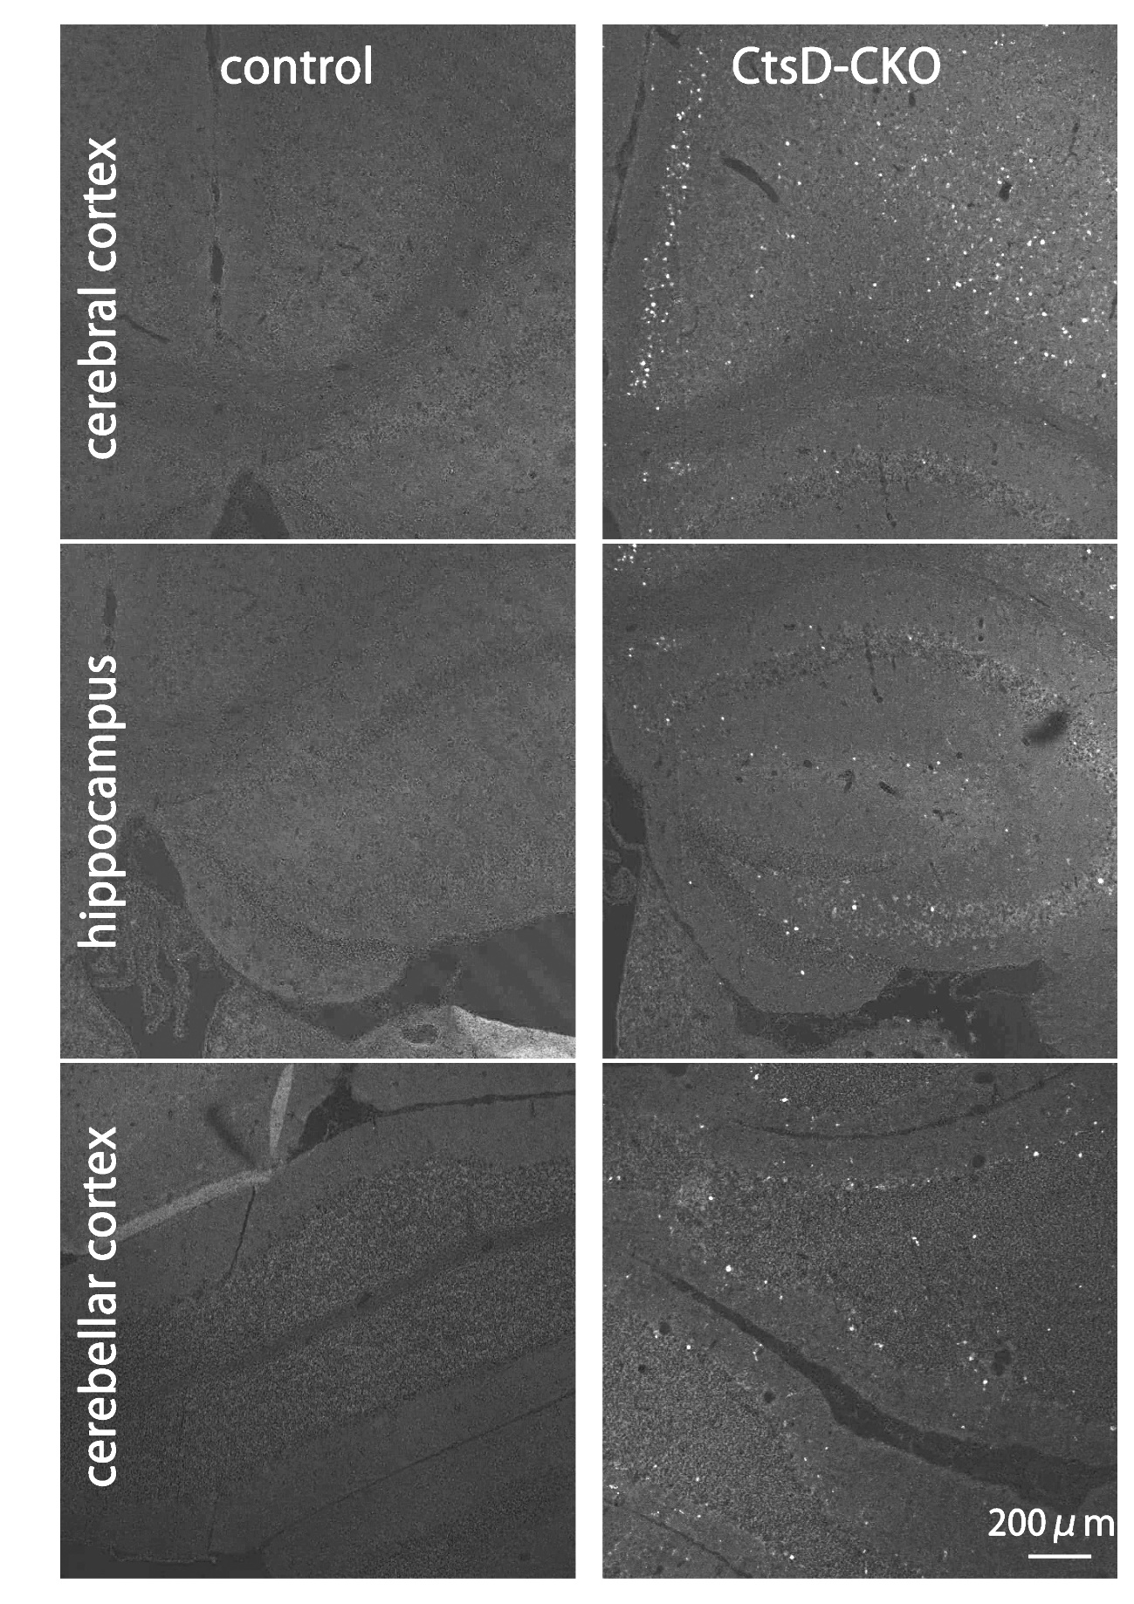

Supplementary Fig. 1(related to Fig. 2): Accumulation of autofluorescent lipofuscins in the brain of CtsD-CKO mouse. Representative images of autofluorescent signals (white particles) in the cerebral cortex, hippocampus, and cerebellum of CtsD-CKO and littermate control mouse brains at p25. Scale bar: 200 µm.

Supplementary Fig. 2
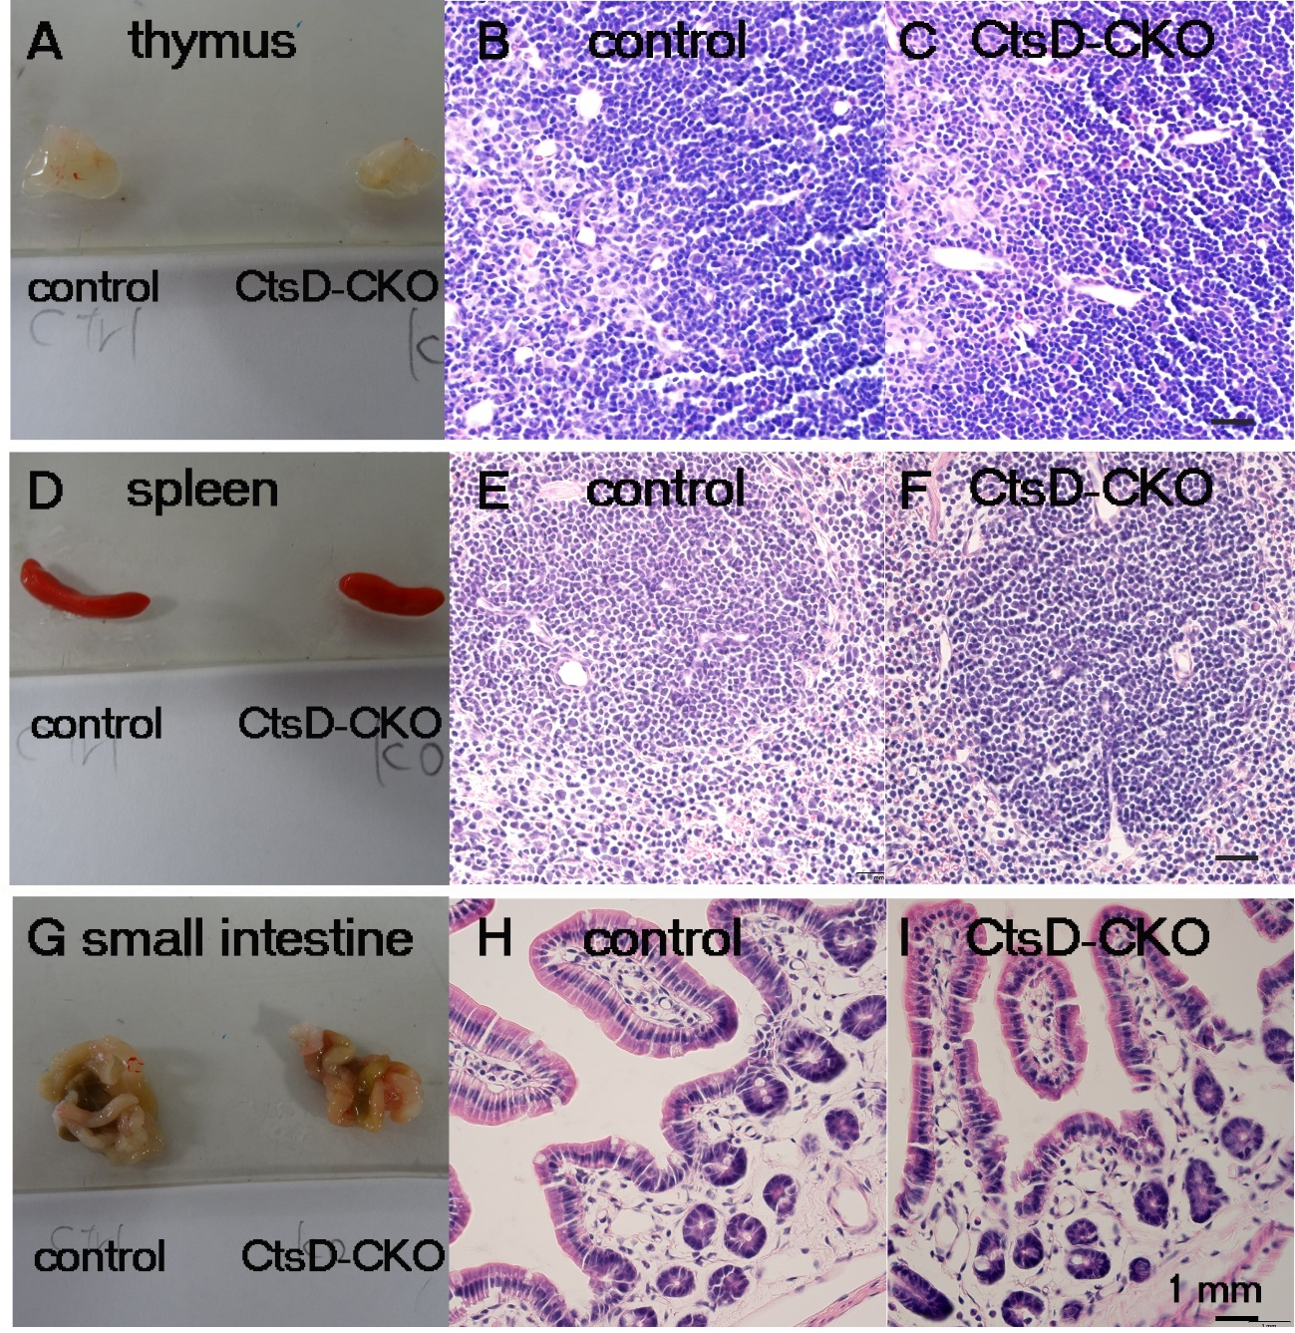
Supplementary Fig. 2 (related to Fig. 2): CtsD-CKO mice showed no necrotic injury in their thymus, spleen and small intestine at p25.
The size of thymus (A), spleen (D) and small intestine (G) of CtsD-CKO were smaller than those of control littermate at p25. H&E staining of thymus (B: control, C: CtsD-CKO), spleen (E: control, F: CtsD-CKO) and small intestine (H: control, I: CtsD-CKO) tissues showed no apparent histological abnormalities.
Scale bar: 1 mm

Supplementary Fig. 3
Supplementary Fig. 3 (related to Fig. 4): CtsD expression in the thalamus of CtsD-CKO mice and control littermates at p25. Immunohistochemical staining for CtsD was performed in thalami of CtsD-CKO and control mice at p25. Insets show enlarged images of the boxed areas in the thalami of control and CtsD-CKO mice. Positive staining for CtsD is mainly detected in neurons in the brain of control mice, while the nerve cell body shown in an inset contains a large nucleus (asterisk) and the perikaryal region where densely stained areas could be detected. On the other hand, CtsD-positive staining is densely detected in smaller cells with processes that seem to be microglia in the thalamus of CtsD-CKO mice. In an inset, a microglia positively stained for CtsD appears with branching processes (arrowheads). Scale bar: 20 µm.

Supplementary Fig. 4
Supplementary Fig. 4 (related to Fig. 4): iNOS- and Iba-1-double positive microglia are abundant in thalami of CtsD-CKO and control littermate mice at p25. Imunoreactivity for iNOS is hardly recognized in the control thalamus, although weak staining for Iba-1 is detected dispersedly in this area. In the thalamus of CtsD-CKO mice, Iba-1-positive microglia are abundantly detected and also stain positive for iNOS (inset). Scale bar: 20 µm.

