Supplementary Figure 1. Exploratory cross-outcome visualisation of adjusted associations between participant sociodemographic characteristics and PrEP-related outcomes.
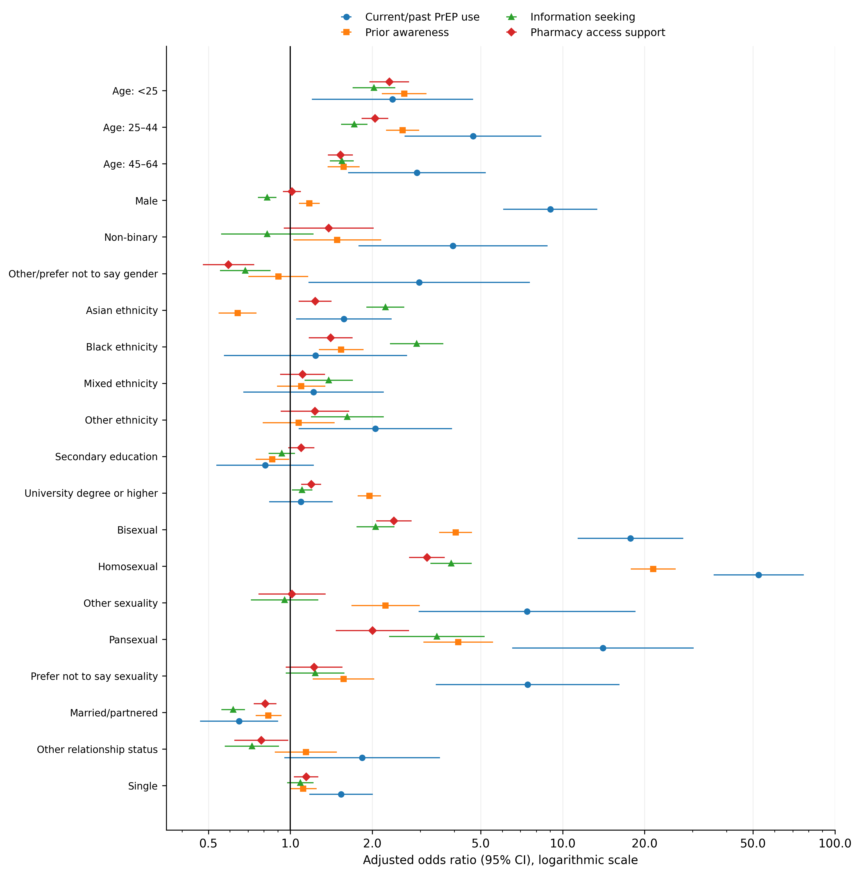
Adjusted odds ratios (aORs) and 95% confidence intervals are shown for current/past PrEP use, reported prior awareness that PrEP can prevent HIV, interest in seeking PrEP information, and support for obtaining PrEP from a local pharmacy. Estimates are from the multivariable logistic regression models reported in the main manuscript, adjusted for age, gender, ethnicity, educational attainment, sexual orientation and relationship status. Model-specific analytic denominators were n=14,007, n=14,218, n=14,199 and n=13,904, respectively. Pharmacy support was coded as agree/strongly agree versus neither agree nor disagree/disagree/strongly disagree; missing responses were excluded. The x-axis uses a common logarithmic scale and the vertical reference line denotes aOR=1. This display is descriptive and exploratory and does not represent an additional inferential model.

