Supplementary Figure 2. Exploratory joint correspondence analysis of participant sociodemographic characteristics.
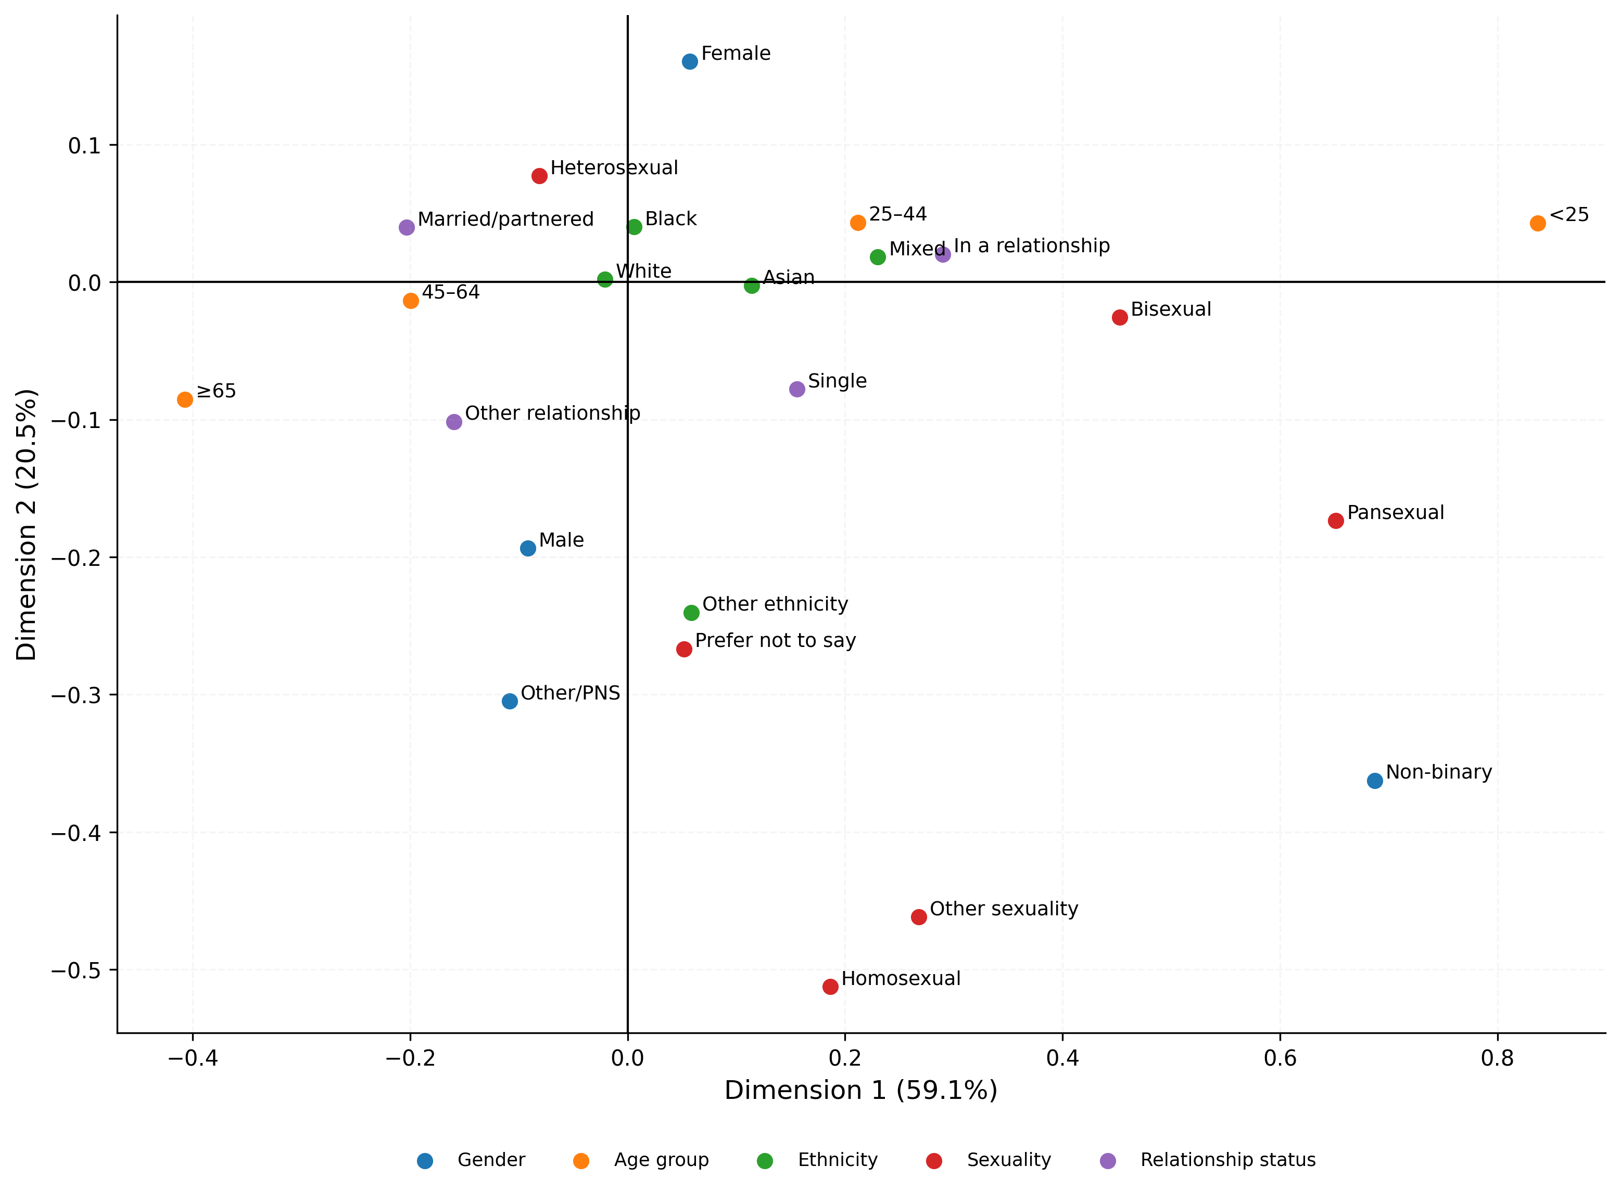
Joint correspondence plot showing category-level relationships across five categorical sociodemographic variables: gender, age group, ethnicity, sexual orientation and relationship status. The analysis used principal normalisation and complete cases for the five variables (n=14,282). Dimension 1 accounted for 59.1% of total inertia and Dimension 2 for 20.5%, together accounting for 79.6% of total inertia. Categories positioned more closely together have more similar multivariable category profiles within the JCA geometry; greater separation indicates more distinct profiles. PrEP outcomes were not included in the JCA. The analysis was exploratory and descriptive and was not used for hypothesis testing or participant classification.

