
Supplementary Material2 - Figures
Revisiting the taxonomic and genomic repertoire of the family Colwelliaceae with three new species
Min Seo Lee^{1,2}, Sung-Hyun Yang^{,1}, Mi-Jeong Park^{1*}, Kae Kyoung Kwon^{1,2*}

¹Marine Biotechnology Research Center, Korea Institute of Ocean Science & Technology, 385, Haeyang- ro, Yeongdo-gu, Busan, 49111, Republic of Korea
²KIOST School, University of Science and Technology, Daejeon 34113, Republic of Korea
* Correspondence:
Kae Kyoung Kwon: Phone: +82 51 664 3371. e-mail: kkkwon@kiost.ac.kr
Mi-Jeong Park: Phone: +82 51 664 3348. e-mail: mijeong16@kiost.ac.kr
Keywords: Amino-Acid Identity, Colwelliaceae, genome-based classification, in silico analysis, phylogenetic revision, cold adaption protein
Number of words:
Number of tables and figures:

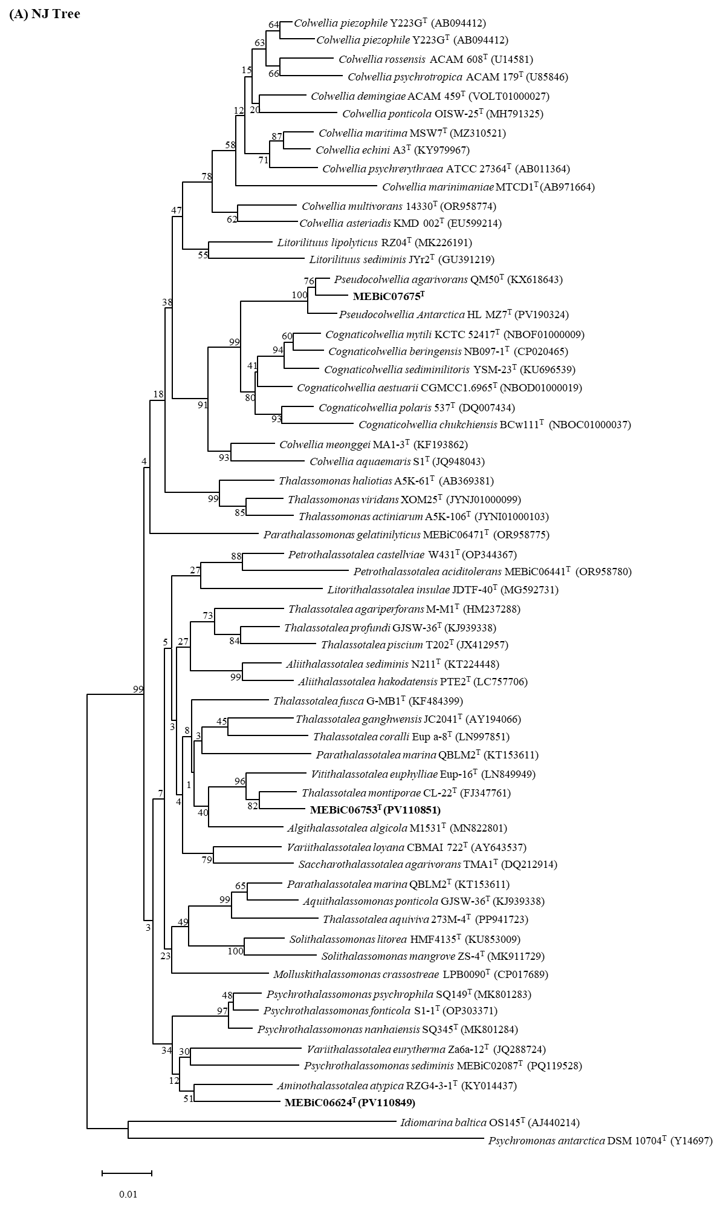
Figure S1. Phylogenetic tree of strains MEBiC07675^{T}, MEBiC06624^{T}, and MEBiC06753^{T} and closely related species based on nearly complete 16S rRNA gene sequence. Numbers at the nodes indicate percentages of replicate trees in which the associated taxa clustered together in toe bootstrap test. (1000 replicates) (A) Neighbor-joining phylogenetic tree. (B) Maximum-likelihood phylogenetic tree. (C) Minimum-evolution phylogenetic tree
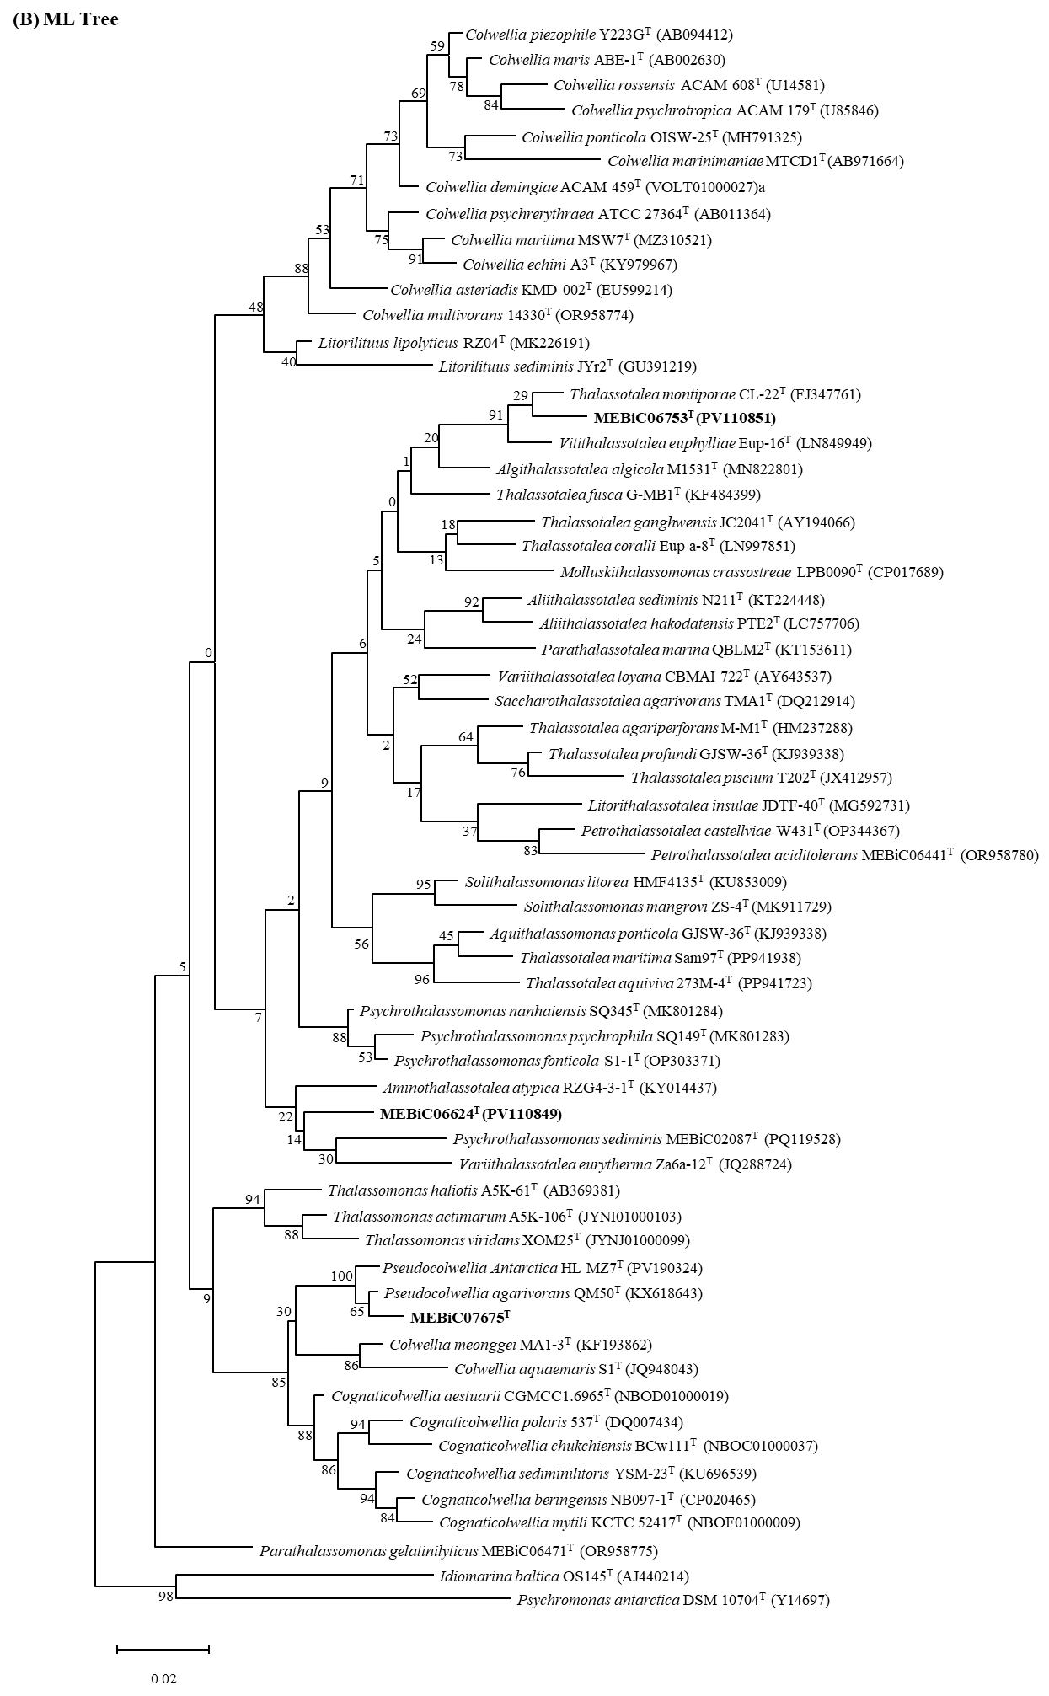
Figure S1. continued
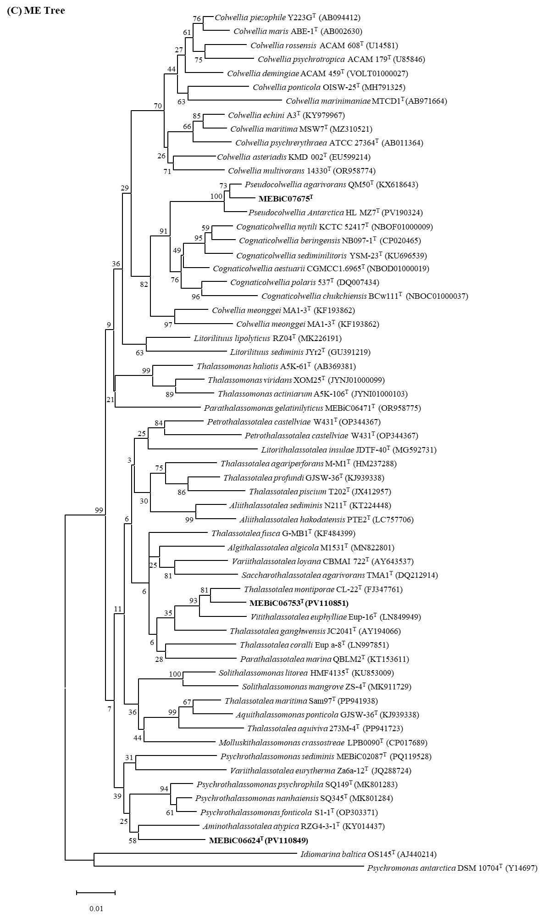
Figure S1. continued
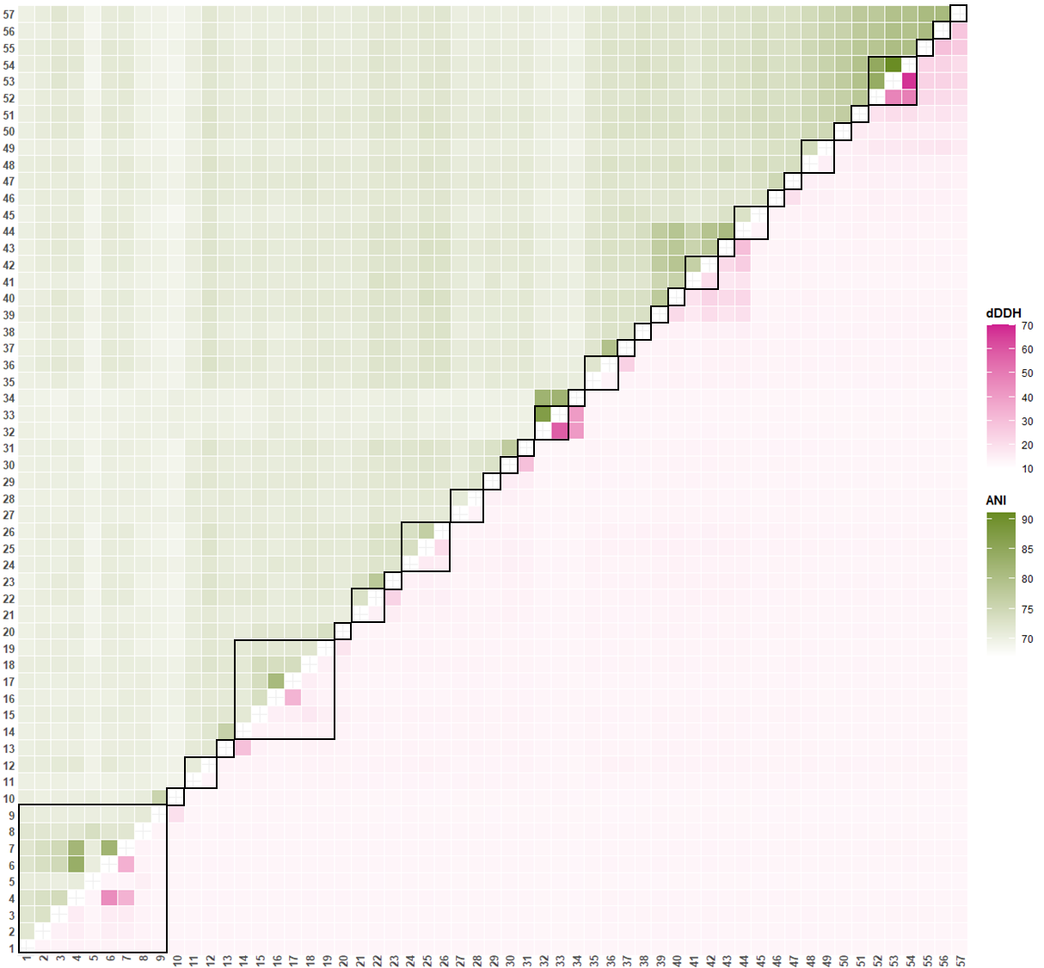
Figure S2. ANI and dDDH from pairwise whole-genome comparisons. The values of ANI and dDDH were expressed as heatmap. ANI is the lower left triangle indicated in olivedrab color, and dDDH is the upper right triangle indicated in pink. Groups identified as the same species based on ANI and dDDH values are surrounded by black squares.

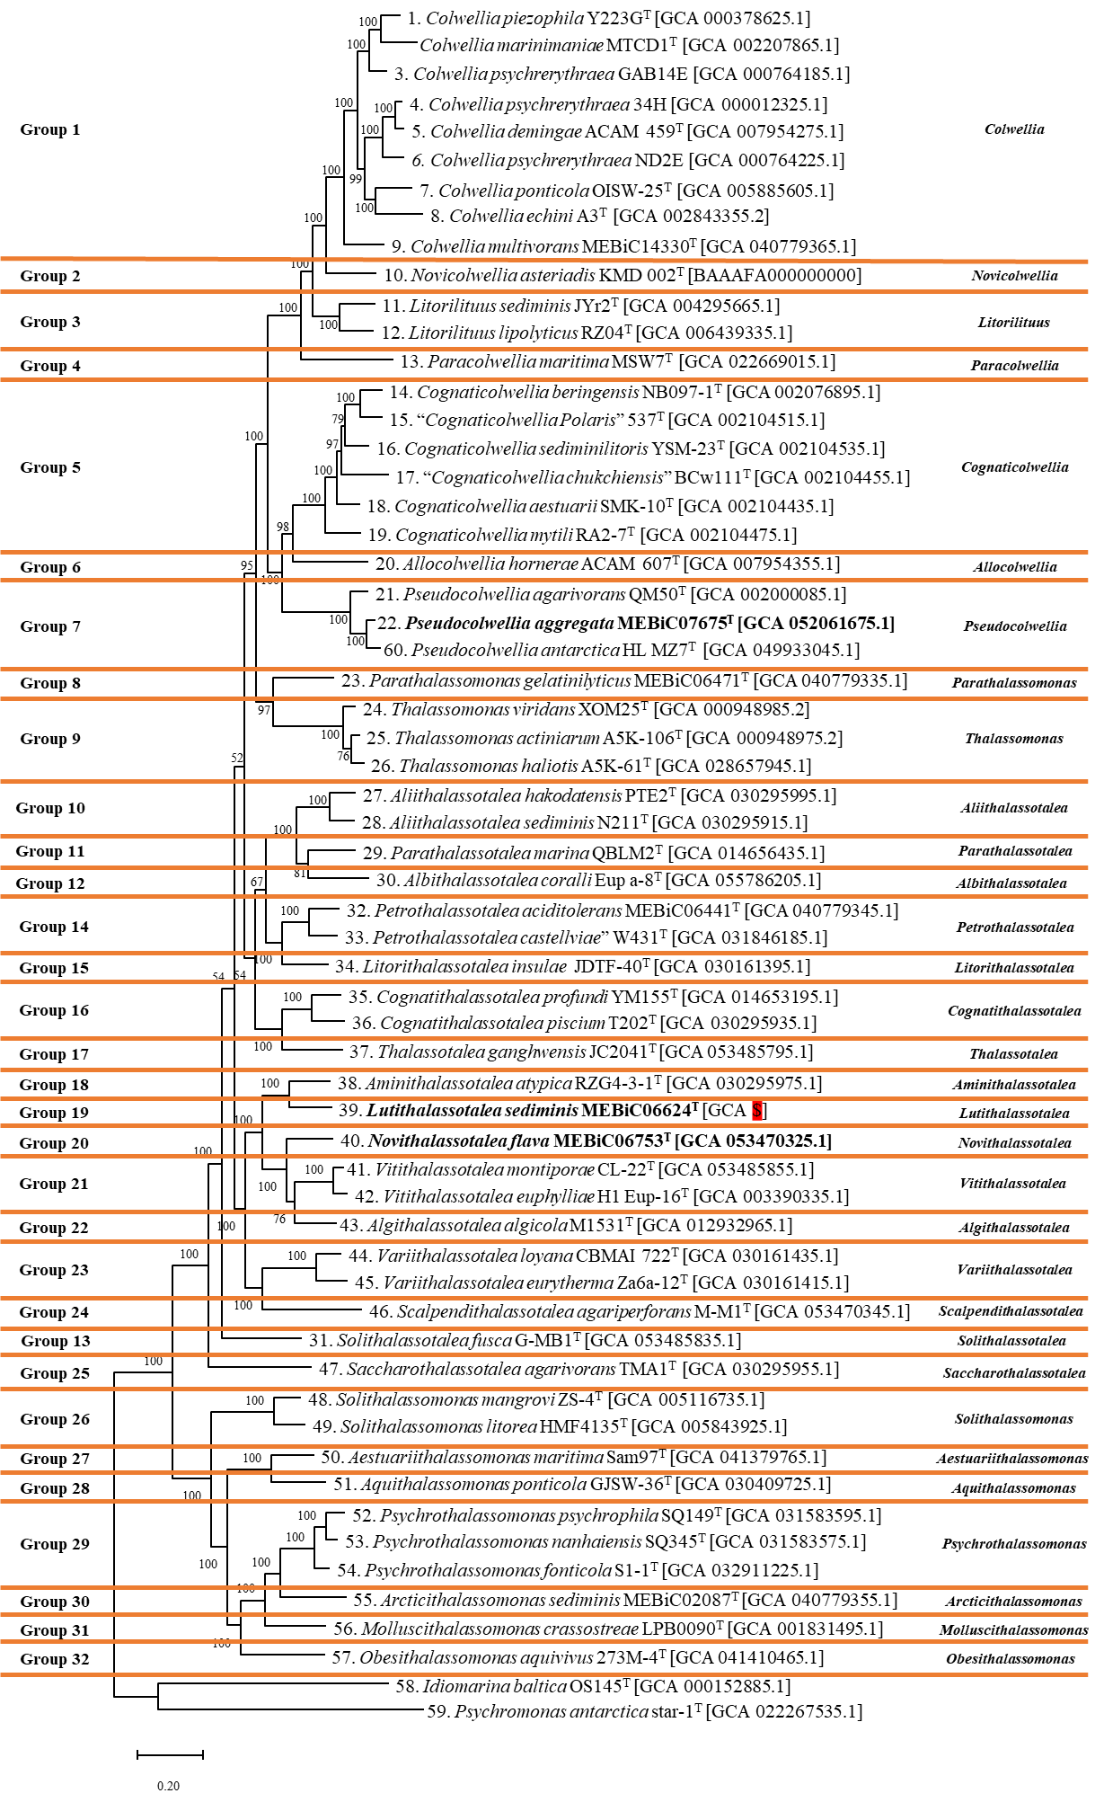
Figure S3. Phylogenomic tree of strains belonging to the family Colwelliaceae.
Phylogenomic tree constructed using IQ-TREE. The numbers at the nodes represent approximate likelihood ratio test (aLRT) values and bootstrap values from 1,000 replicates.
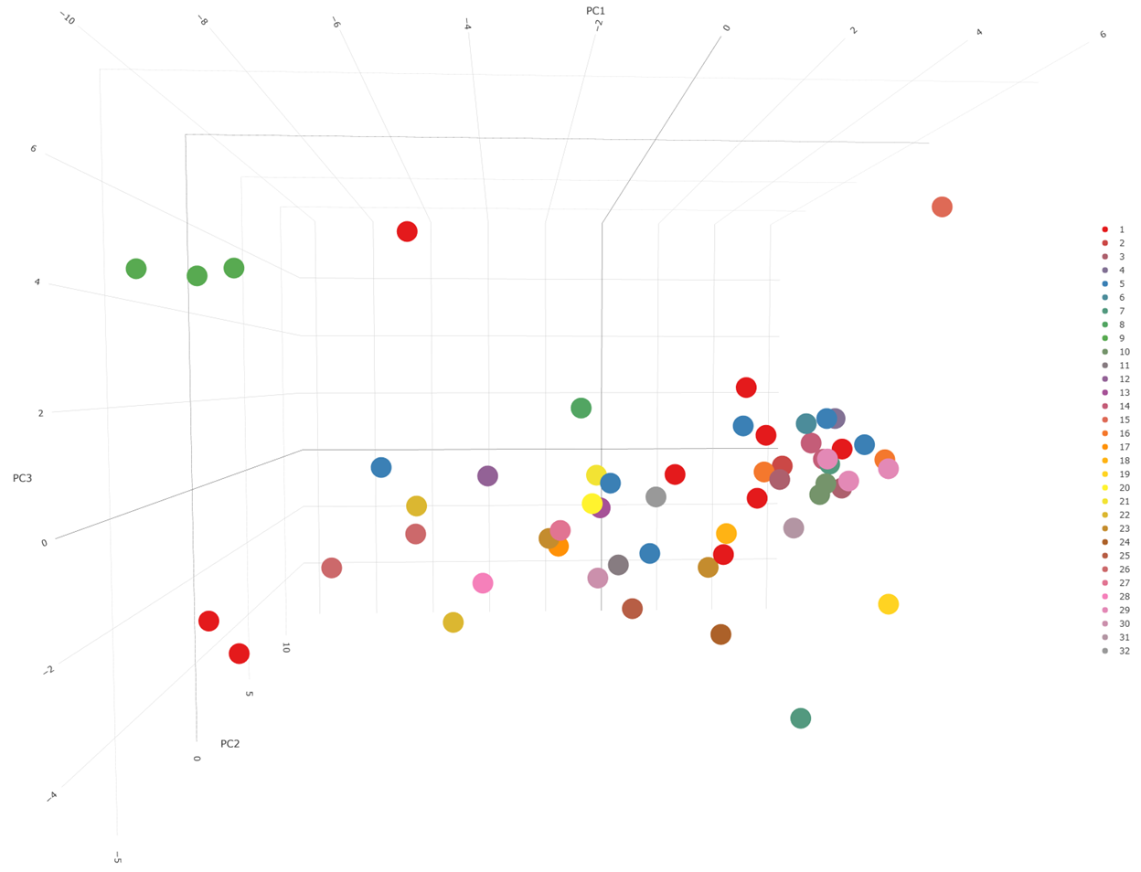
Figure S5. Comparison of the RSCU data of the 32 groups. This figure verifies that there is a distinguishable difference in codon usage between each group. A line plot showing the average value of RSCU for each group. An accompanying HTML file is provided as supplementary material for reference.

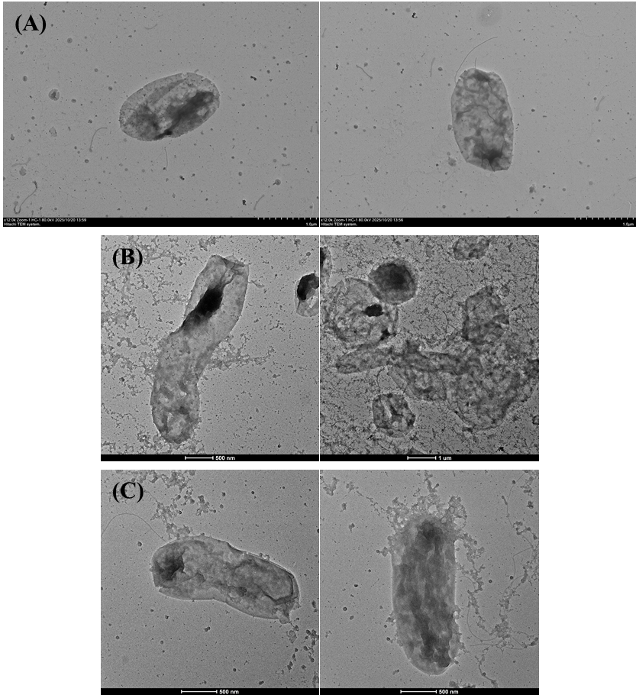
Fig S7. Transmission electron micrographs image of strains (A) MEBiC07675^{T}; (B) MEBiC06624^{T}; (C) MEBiC06753^{T}.

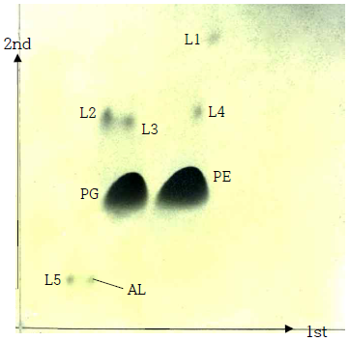
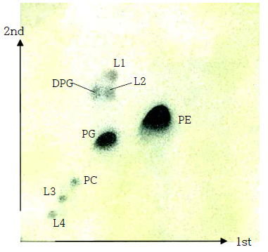
(B)
(A)

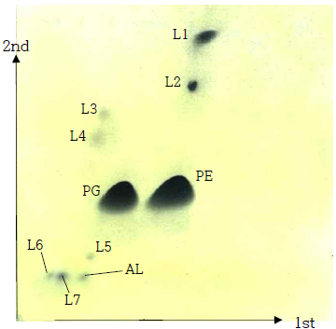
(C)

Fig S8. Two-dimensional TLC after staining with molybdophosphoric acid showing the total polar lipid profiles of strains (A) MEBiC07675^{T}; (B) MEBiC06624^{T}; (C) MEBiC06753^{T}.
PE; phosphatidylethanolamine, PG; phosphatidylglycerol, AL; unidentified aminolipid, L; unidentified

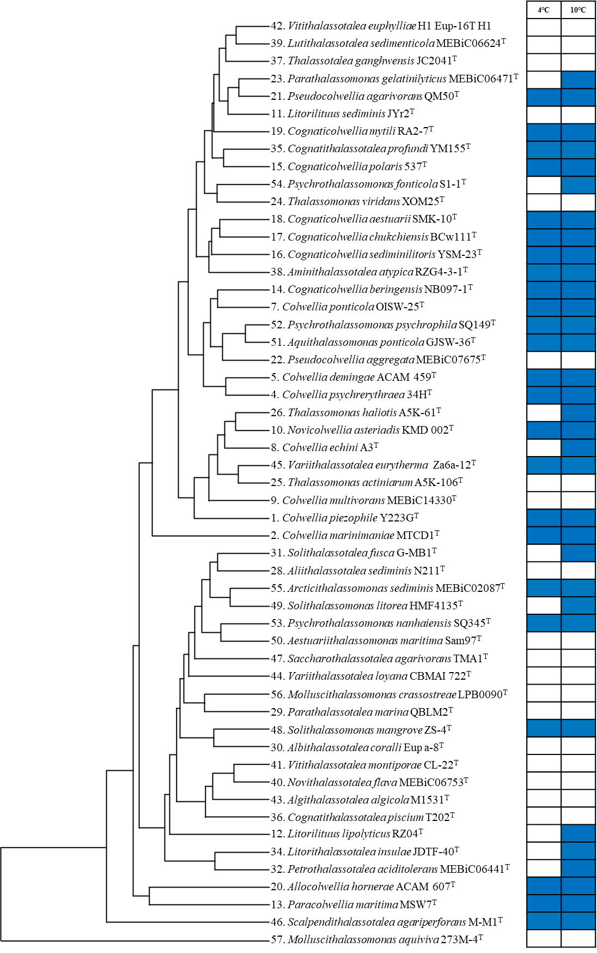
Fig S10. Clade structure based on fatty acid phenotypic profiles. The heatmap on the right indicates the ability of each strain to grow at the corresponding temperatures.

