Application Effects of Modified Coronectomy in Mandibular Third Molars with High-Risk Proximity to the Mandibular Canal and Characteristics of Residual Root Migration
Jianxian Hu^{1 †}, Jianguo Xu^{1 †}, Mengjie Shen¹, Xiaoyi Liu^{1,2}, Ruixue Cheng¹, Yuanyuan Ma¹, Gang Li^{1*}, Yu Xiong^{1*}
¹ Department of stomatology, Southwest Hospital, Third Military Medical University (Army Medical University), Chongqing 400038, P. R. China
²Department of Stomatology, The Second Affiliated Hospital of Guangdong Medical University, Zhanjiang 524002, P. R. China
*Corresponding authors. E-mails: ligang@tmmu.edu.cn; xytmmu@163.com
†These authors contributed equally to this work.

Table S1. Intraoperative blood loss, surgery duration, and VAS scores
 | Modified coronectomy | Exodontia | P
Surgery operation time (min) | 51.3±19.63 | 32.97±13.81 | ＜0.001
Intraoperative blood loss measurement (mL) | 15.07±7.03 | 10.42±5.88 | 0.0035
Visual Analogue Scale | 2.50±0.75 | 3.09±1.35 | 0.021

Table S2. Postoperative complications and assessment of inferior alveolar nerve injury
 | Total%(n=73) | Modified coronectomy | Exodontia | P
TMJ Clicking | 5.48% | 7.05% | 3.03% | 0.6216
Facial swelling | 16.44% | 12.5% | 21.21% | 0.3569
limitation of mouth opening | 9.57% | 5% | 15.15% | 0.2326
IANI | 5.48% | 0% | 12.12% | 0.0431

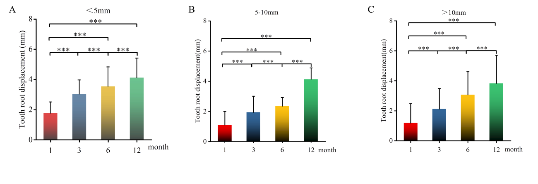
Figure S1. Displacement of residual root lengths at 12-month follow-up. (A-C) Displacement of residual roots shorter than 5 mm A), between 5 and 10 mm B), longer than 10 mm C). Data are presented as means ± SD. Statistical significance was assessed by the one-way ANOVA with post-hoc LSD. ***p < 0.001.

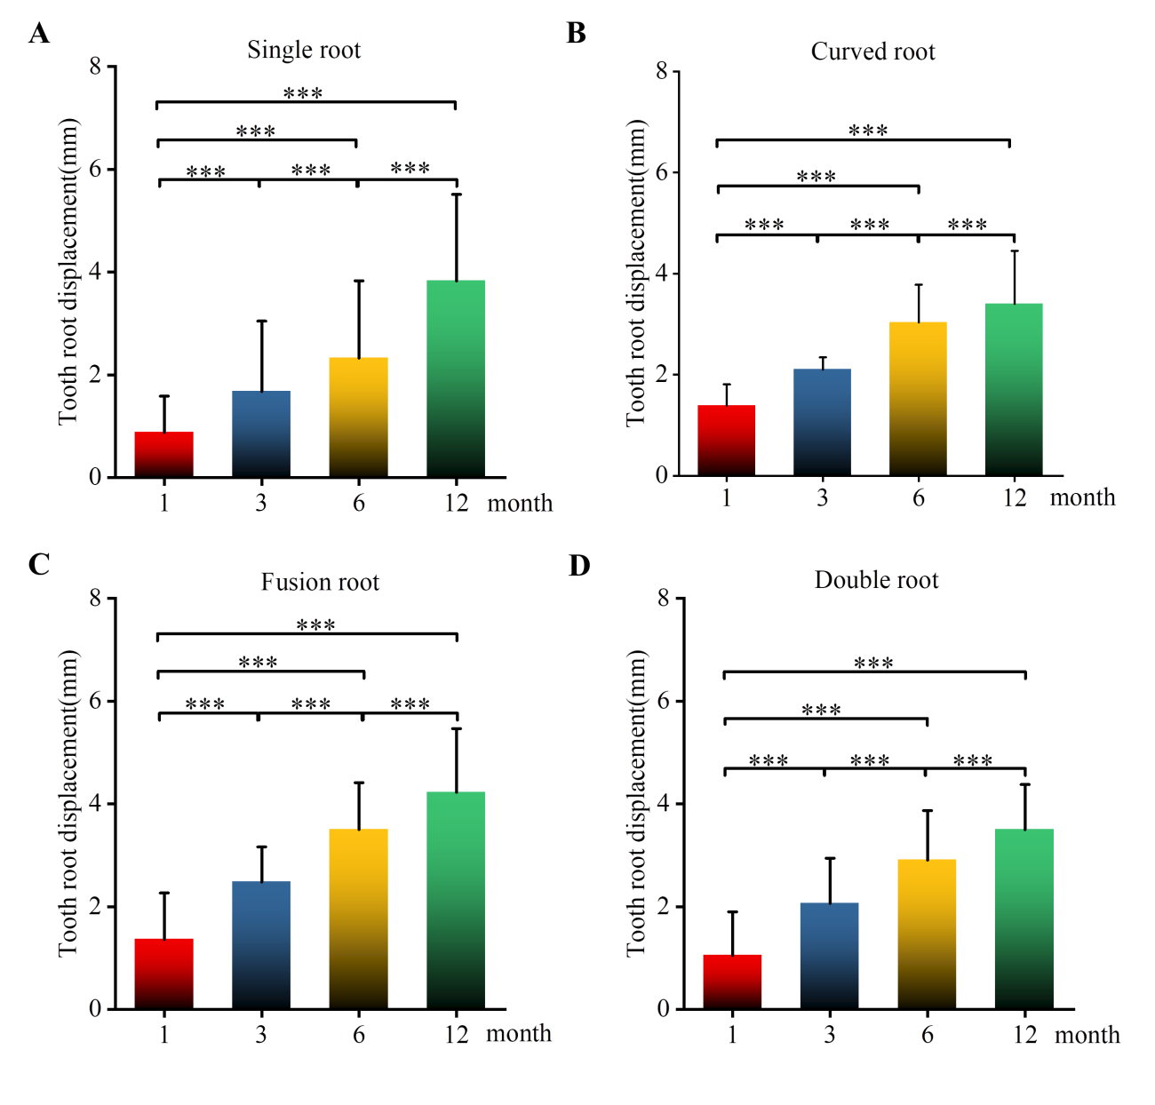
Figure S2. 12-Month follow-up on root displacement with different root morphologies. (A-D) Radiographic image showing root displacement in the single-rooted teeth A), the curved-rooted teeth B), the fused-rooted teeth C), and double-rooted teeth D). Data are presented as means ± SD. Statistical significance was assessed by the one-way ANOVA with post-hoc LSD. ***p < 0.001.

