Supplementary information

Freeform 3D Printing of Soft Hydrogel Electronics

Yue Hui^{1,2,*}, Qilin Qian^{1,2}, Yuan Yao^{1,2}, Hehao Chen^{1,2}, Zheng Qiao³, Yetian Yu^{1,2} and Nanjia Zhou^{1,2,*}

¹Key Laboratory of 3D Micro/Nano Fabrication and Characterization of Zhejiang Province, School of Engineering, Westlake University, Hangzhou, 310024, Zhejiang Province, China.
²Institute of Advanced Technology, Westlake Institute for Advanced Study, Hangzhou 310024, Zhejiang Province, China.
³Department of Biomedical Engineering, National University of Singapore, Singapore 117583, Singapore.
*To whom correspondence should be addressed; Email: huiyue@westlake.edu.cn (Y.H.), zhounanjia@westlake.edu.cn (N.Z.)

1. Preparation of supporting matrix and conductive ink for embedded 3D printing

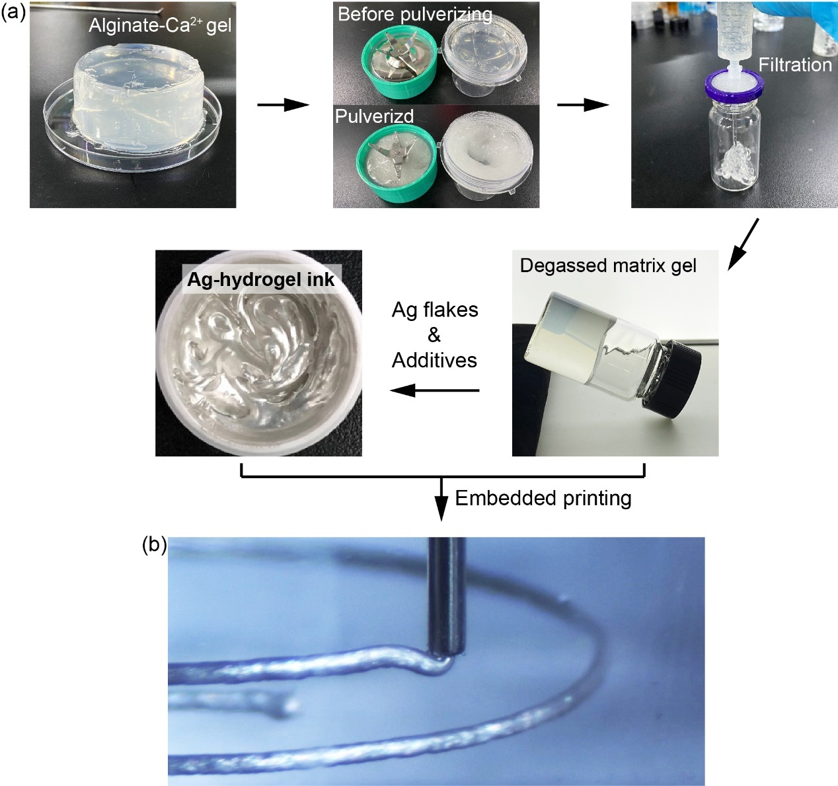
Supplementary Figure 1. (a) Preparation of supporting matrix gel and conductive ink for embedded 3D printing. (b) Optical image showing the programmable extruding of conductive Ag–hydrogel ink in the supporting matrix.

2. Sizes of the supporting matrix gel microparticles

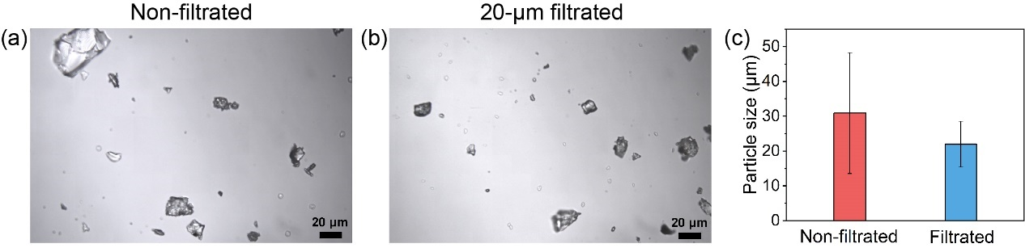
Supplementary Figure 2. Optical microscopic images of the (a) pulverized but non-filtrated and (b) pulverized and filtrated supporting matrix gel microparticles. (c) Average sizes of the non-filtrated and filtrated supporting matrix gel microparticles (n = 50).

3. The effect of hydrogel composition, conductive filler and ink additive on hydrogel electronics

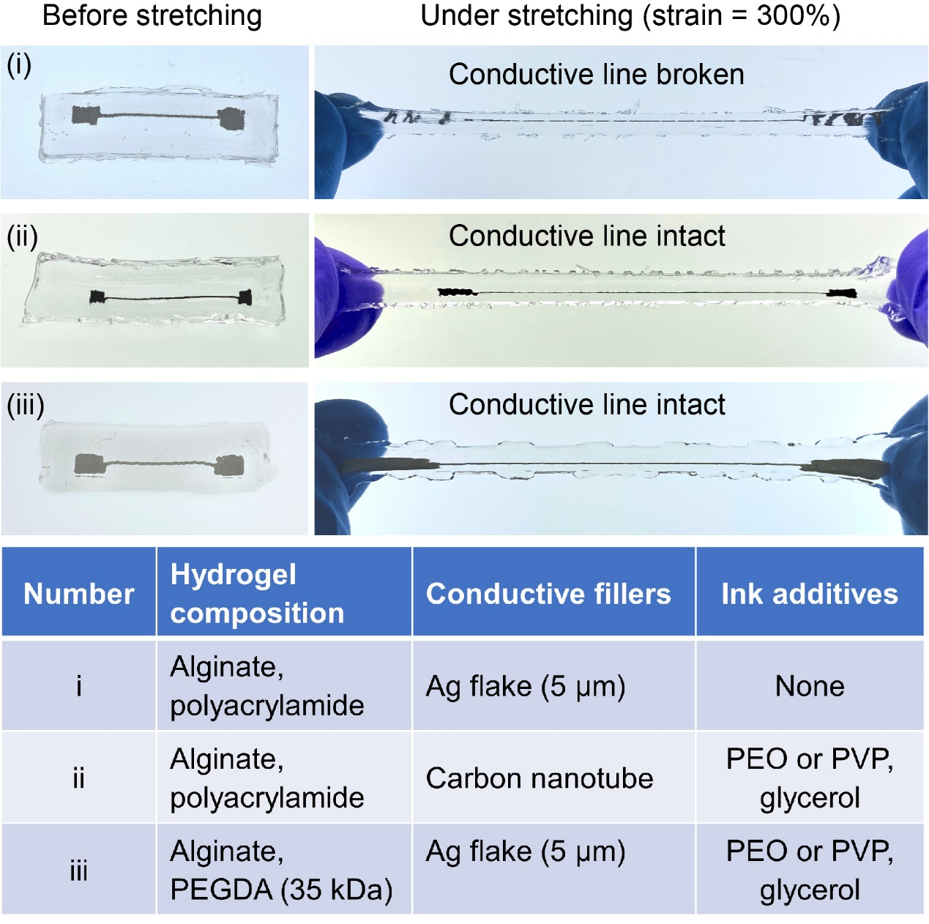
Supplementary Figure 3. The effect of hydrogel composition, conductive filler and ink additive on hydrogel electronics. (i) The lack of hydrophilic polymer (e.g., PEO or PVP) leads to the breakage of printed conductive ink under stretching. (ii) Replacing Ag flakes with carbon nanotube (CNT) in the conductive ink does not affect its printability and stretchability. (iii) The polyacrylamide (PAM) network in hydrogel composition was replaced by poly(ethylene glycol) diacrylate (PEGDA, 35 kDa) and the fabricated hydrogel electronic device remains curable and stretchable.

The synthesis of PEGDA (35 kDa)
PEGDA is synthesized according to a previous report.¹ The PEG powder (30 kDa, 4 g) is dissolved in 9 mL anhydrous dichloromethane, then appropriate amount of triethylamine (62.5 mL) and acryloyl chloride (0.1 mL) is added into the reaction flask dropwise, the mixture is allowed to react under nitrogen for 48 hours. Thereafter, the resulted mixture is washed by 2 M of K₂CO₃ solution, and then the water phase is removed by separating funnel. The DCM phase is further dried with MgSO₄ for 2 hours. The PEGDA is precipitated in diethyl ether, filtered, and dried in vacuum oven overnight, and further freeze-dried for 2 days.
4. Mechanical properties of ionically crosslinked alginate–Ca²⁺ hydrogels

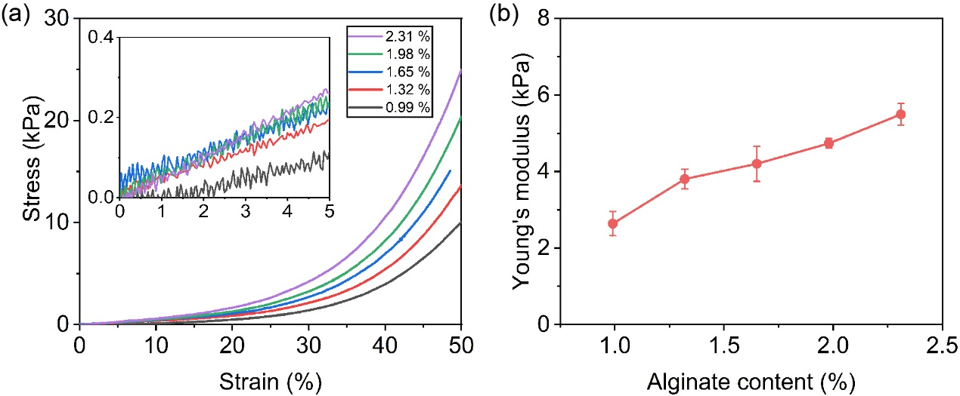
Supplementary Figure 4. (a) Stress–strain curves of ionically crosslinked alginate–Ca²⁺ hydrogels with different alginate content (0.99%, 1.32%, 1.65%, 1.98% and 2.31% by weight) under compressive stress. Inset shows the magnified stress–strain (0-5%) curves. (b) Compressive Young’s moduli of the hydrogels in (a), derived at a strain of 5%.

Rheological suitability between the inks and supporting matrices
When the alginate content is too low (0.99%), although the ink can be held at the position of extrusion (Figure 2b(i), middle), the stop-and-go printing is not possible as the yield stress of the supporting matrix is not sufficient to shear the ink (Figure 2c(i), right); matrix with a high alginate content (2.31%) is also not suitable for embedded printing, as when a nozzle moves through, it occasionally left behind transient (Figure 2b(iii), middle) and permanent crevasses (Figure 2b(iii), right), as reported for high yield stress supporting matrices;² For comparison, the supporting matrix with a medium (1.65%) alginate content displays the most suitable printing condition(Figure 2b(ii), middle) and readily sheared when pneumatic pressure is removed (Figure 2b(ii), right).

5. Mechanical properties of non-pulverized and pulverized hydrogels under tensile loading-unloading cycles

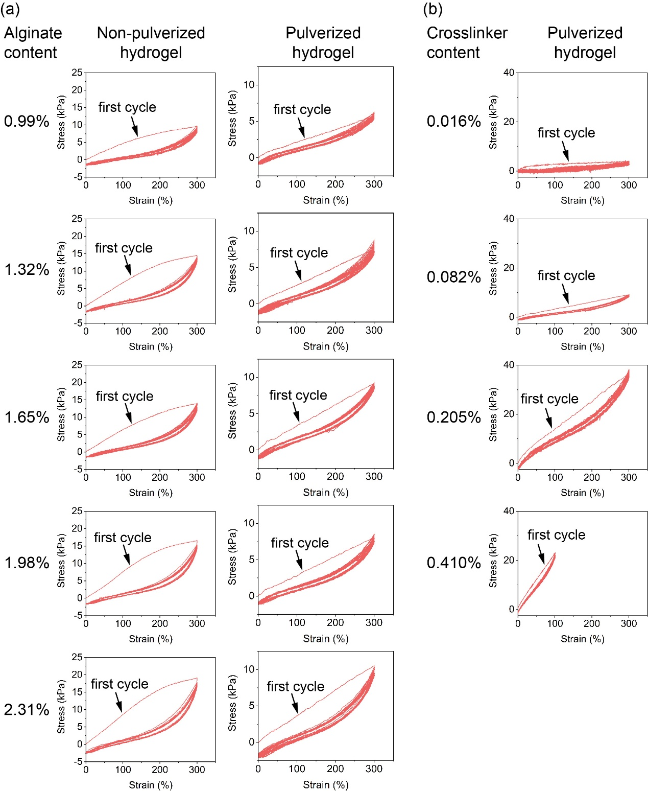
Supplementary Figure 5. (a) Cyclic stress–strain curves of non-pulverized and pulverized hydrogels with a varying alginate content (0.99%, 1.32%, 1.65%, 1.98% and 2.31% by weight) and a fixed crosslinker/monomer mass ratio of 0.082%. (b) Cyclic stress-strain curves of pulverized hydrogels with a varying crosslinker/monomer mass ratio (0.016%, 0.082%, 0.205% and 0.410%) and a fixed alginate content of 1.65%. 20 loading-unloading cycles are conducted for each sample.

6. The random distribution and segregated distribution of Ag flakes in hydrogel matrix

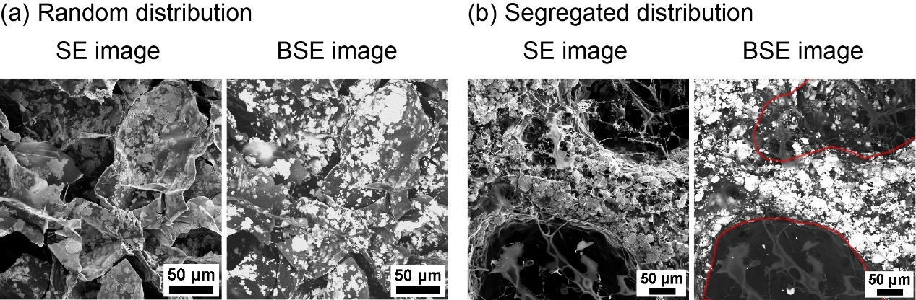
Supplementary Figure 6. SEM images showing the (a) random and (b) segregated distribution of Ag flakes in hydrogel matrix. Areas marked by solid red lines in (b) indicate the cured hydrogel microparticles.

7. Sample holder for measuring the conductivity of Ag–hydrogel conductive inks

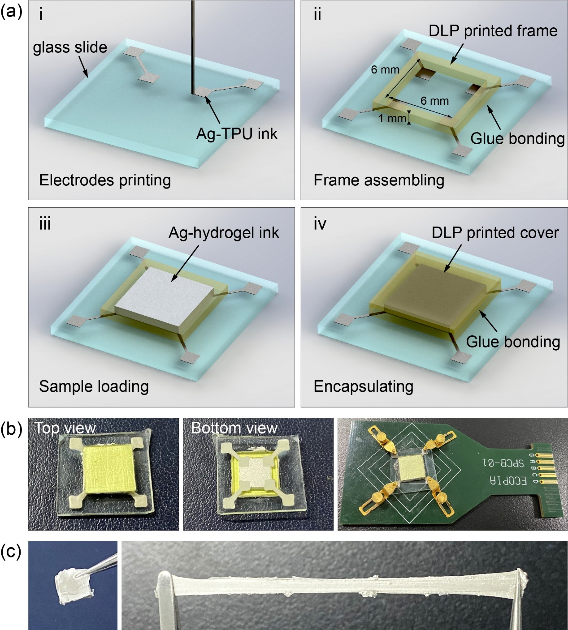
Supplementary Figure 7. (a) The fabrication of a sample holder designed for preventing the Ag–hydrogel inks from dehydration during conductivity measurements. (b) Top and bottom views of the loaded sample holder, which is mounted on the measuring board (right) for Van Der Pauw method testing. (c) The sample is taken out from the sample holder three days after measuring (left), which remained hydrated and highly stretchable (right).

In order to form an ohmic contact between the electrodes and the samples, the Ag-TPU electrodes are surface modified based on a previously reported method to allow the formation of a covalent connection with the Ag-hydrogel ink samples.³ Briefly, the electrodes are first plasma cleaned before they are treated with the acetone solution of a hydrophobic thermo-initiator azobisisobutyronitrile (AIBN) for 20 min. Next, the treated electrodes are washed by ethanol and isopropanol to remove the excessive AIBN crystals, and the sample holder is stored in fume hood at room temperature to allow the evaporation of organic solvents for 3 h. The Ag–hydrogel samples are prepared following the description in experimental section, except that during the first mixing step of supporting matrix and additives, 4 μL of tetramethylethylenediamine (TEMED) is added and blended with the hydrogel to facilitate the polymerization of PAM. After this, Ag flake is added and blended with the hydrogel matrix, and the obtained ink composite is quickly transferred into the sample holder, which is then covered with a 3D printed cap and heated at 60 ℃ to allow the curing of the conductive ink. The AIBN at the surface layer of the Ag-TPU electrodes can serve as a grafting agent to facilitate the covalent crosslinking of PAM (in Ag–hydrogel ink) and TPU polymer chains, forming a covalent connection between the electrodes and the ink composite.

8. Normalized resistance (R/R₀) of the printed 1.5×Ag linear resistor samples during repeated stretching test (300% strain) at different stretching speeds

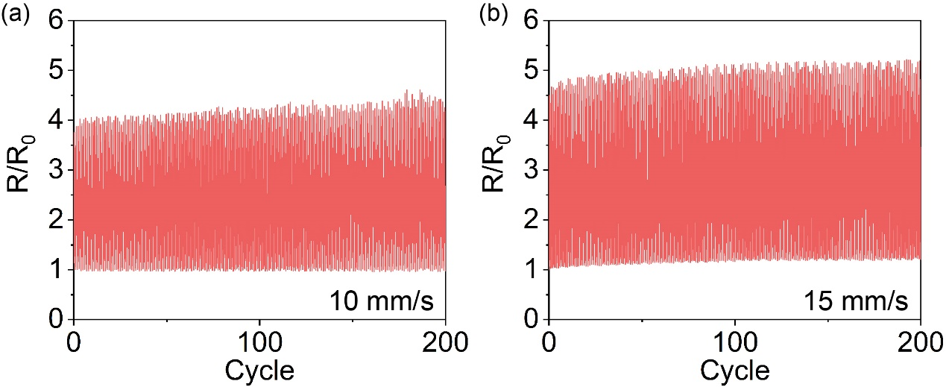
Supplementary Figure 8. Normalized resistance (R/R₀) of printed 1.5×Ag linear resistor samples under 300% strain cycles at a speed of (a) 10 mm/s and (b) 15 mm/s.

9. Design and simulation of 2D spiral and 3D helical inductors

Electrical simulation analysis is conducted using the COMSOL Multiphysics software (version 5.4a). To simulate the resistance (R) and inductance (L) of the spiral and helical inductors, we built simplified 2D and 3D coil models wrapped by cylinders in Comsol (Supplementary Figure 9, Supplementary Tables 1 and 2). The material of the coils is defined as Ag–hydrogel (1.5×Ag ink; relative permittivity = 1; relative permeability = 1; conductivity = 144000 S/m), while the material of the cylinder is defined as hydrogel (relative permittivity = 1; relative permeability = 1; conductivity = 0.77 S/m as experimentally measured). One terminal of each coil is assigned with a sinusoidal voltage (1 V, 200 kHz), while the other terminal was defined as ground. The original result obtained from the simulation is admittance (Y) from the terminal ports, and the R and L values of the inductors are derived from Y using the following equations:
$$L= \frac{imag(\frac{1}{Y})}{2πf}$$
$$R=real(\frac{1}{Y})$$
where f is the frequency (200 kHz) in the simulation.

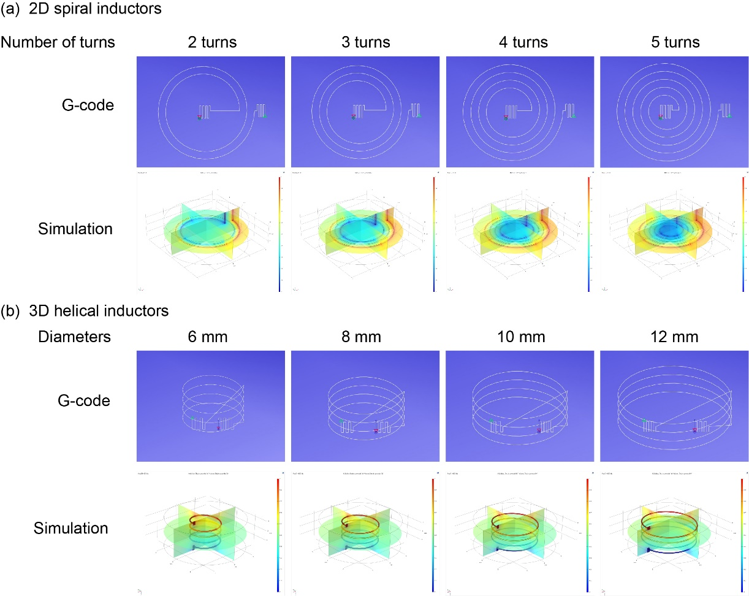
Supplementary Figure 9. Geometric illustrations of (a) 2D spiral and (b) 3D helical inductors by G-code and in Comsol software.

Supplementary Table 1. Designed geometric parameters of the 2D spiral inductors
Design No. | 1 | 2 | 3 | 4
Number of turns | 2 | 3 | 4 | 5
Pitch/mm | 1.2 | 1.2 | 1.2 | 1.2
Inner diameter/mm | 5.6 | 4.4 | 3.2 | 2
Outer diameter/mm | 8 | 8 | 8 | 8
Hydrogel cylinder size  Diameter × height / mm | 20 × 6

Supplementary Table 2. Designed geometric parameters of the 3D helical inductors
Design No. | 1 | 2 | 3 | 4
Number of turns | 4 | 4 | 4 | 4
Pitch/mm | 1.2 | 1.2 | 1.2 | 1.2
Diameter/mm | 6 | 8 | 10 | 12
Hydrogel cylinder size  Diameter × height / mm | 18 × 6

10. Working mechanism of the home-built transmitting coil

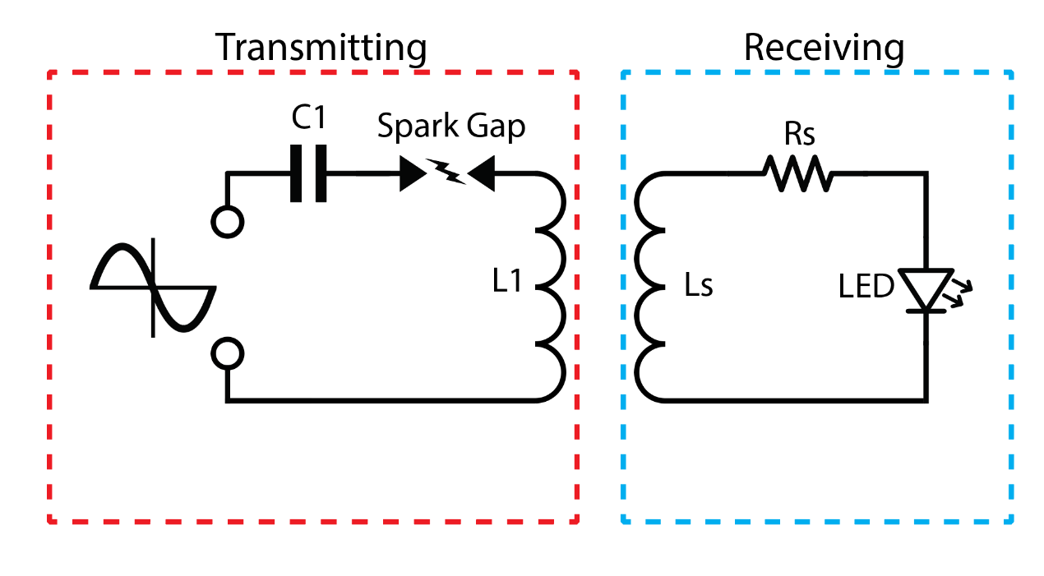
Supplementary Figure 10. A circuit diagram illustrating the working mechanism of the transmitting coil and the receiving inductor.

The transmitting circuit consists of an AC/DC generator (Model 615-3, Trek, USA), a capacitor (C1), a coil (L1) and an air gap. During wireless energy supplying experiments, the circuit is driven by a voltage of 1200 V and a current of 5 mA (6 W power input, 1 kHz) to charge the capacitor until its voltage becomes high enough to breakdown the air gap and cause air sparking. The spark gap can then instantaneously dump the large amount of energy in the capacitor into the coil, generating a strong electromagnetic pulse so that the inductor placed on the coil can generate an induced voltage to power the electrical components.

11. The creation of robust covalent connection between electrical components and hydrogel matrix/conductive ink

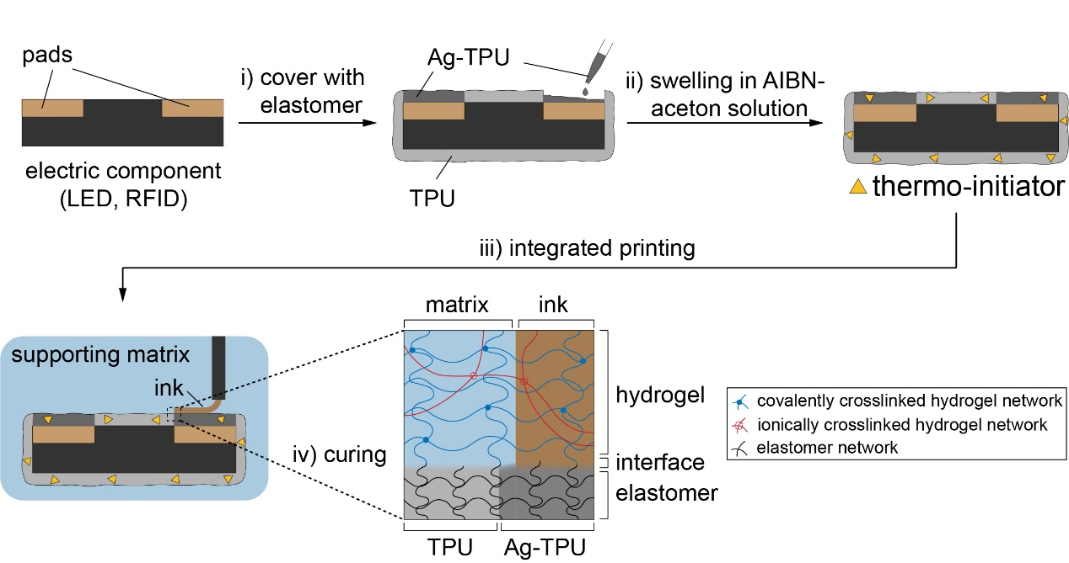
Supplementary Figure 11. A schematic illustration of the procedure for creating robust covalent connections between electrical components and hydrogel matrix/conductive ink.

The surface modification procedure of the electric components is similar to the process described in Supplementary Figure 7. Briefly, the body and pads of electric components (e.g., LED and RFID) are covered with thermoplastic polyurethane (TPU) and conductive Ag-TPU elastomer, respectively. Next, the elastomer-covered components are plasma cleaned and then soaked in the acetone solution of AIBN (10% wt.) for 2 h to allow the hydrophobic thermo-initiator AIBN to diffuse into the TPU layer. The components are then washed in ethanol and isopropanol, and stored in fume hood at room temperature for 3 h to allow the evaporation of organic solvents. During printing, the surface modified components are positioned in the hydrogel matrix (via pick-and-place process), and the conductive ink is extruded to contact with the Ag-TPU area covering the pads. After printing, the whole entity is heated at 60 ℃ so that AIBN can then serve as a grafting agent to induce the covalent crosslinking of PAM (in hydrogel matrix and ink) and the TPU polymer chains, forming a robust covalent connection between the components and the hydrogel as well as the ink.

12. Simulation of the induced voltage generated by 3D helical inductors under compressive deformation

Simplified model is built in Comsol software to simulate the induced voltage generated by 3D helical inductors under horizontal and vertical compression. The basic settings, including geometries and materials of the 3D helical inductors are the same as described in section 9 of the supplementary information. The inductors are placed in a spherical air domain with a diameter of 100 mm. The two terminals of each inductor coil are connected to a lumped port (for measuring) and a lumped element (as load) that are in parallel with each other. The impedance of the lumped port is set to be infinite, which can be considered as an ideal measuring port, and the impedance of the lumped element is set to be 1000 Ω (similar to a LED). A sinusoidal voltage of 1 V and 1 kHz is applied at the two terminals of the transmitting coil, and the inductors are placed 10 mm above the center of the transmitting coil during simulation. The original result obtained from the simulation is the induced voltage detected at the lumped port, which is then adopted to calculate the normalized voltage (V/V₀) variations during inductor deformation.
During the simulation, the shape changes of the 3D helical inductors under compression are regulated by a few simplified rules. First, under either horizontal or vertical compression, the volume of the hydrogel inductors always remains constant. Second, under horizontal compression, the perimeter of the coil cross section remains constant, while its aspect ratio increased from 1 (circle) to 4 (ellipse) (Supplementary Figure 12 and Supplementary Table 3), causing a corresponding elongation of the height. Third, under axial compression, the hydrogel inductors are compressed vertically and uniformly elongated horizontally (Supplementary Figure 12 and Supplementary Table 4).
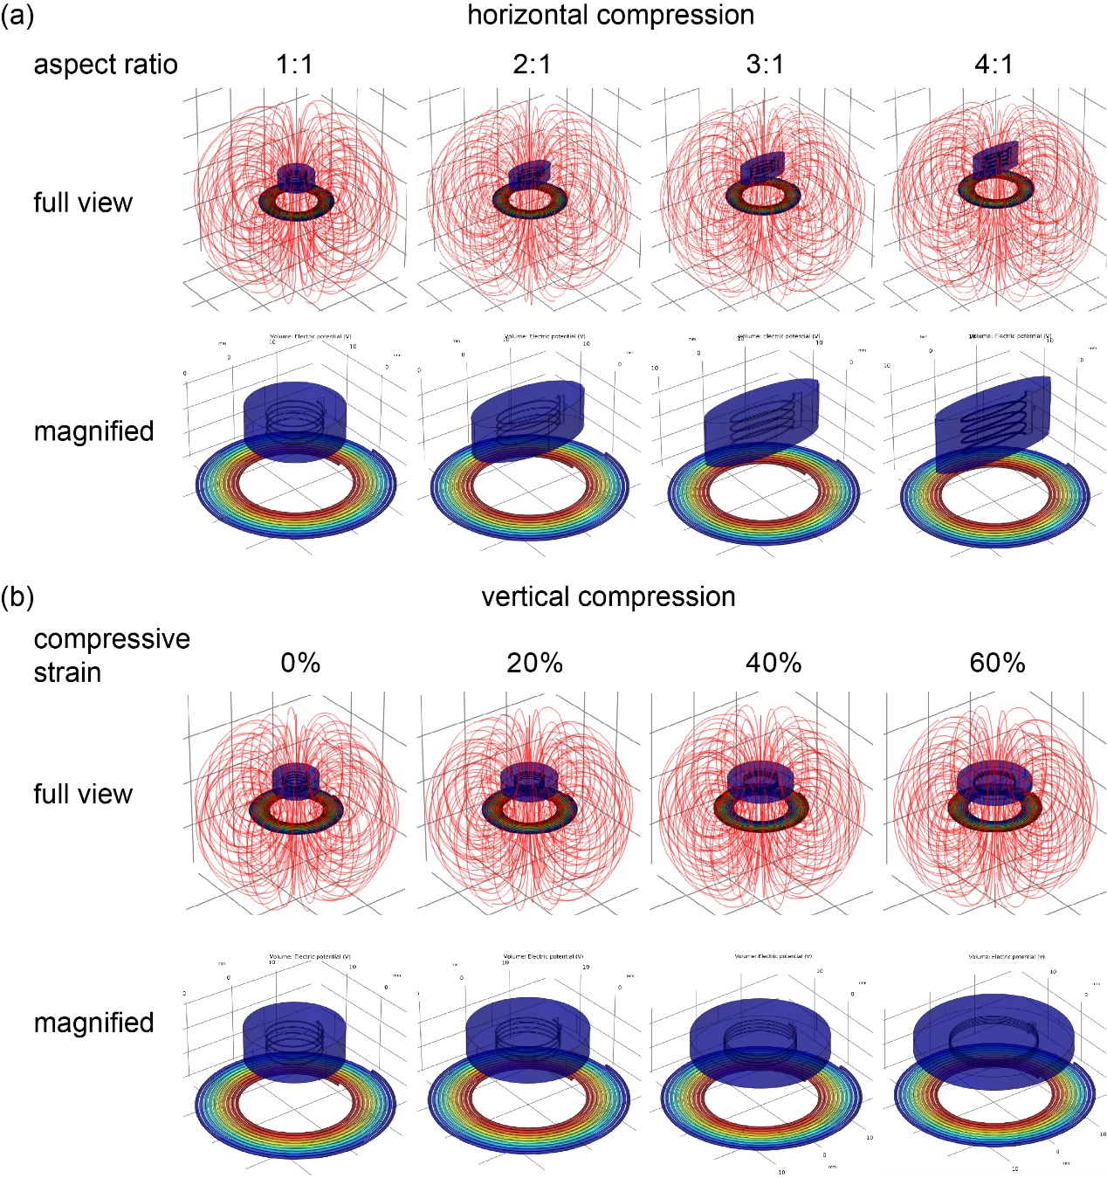
Supplementary Figure 12. Simulation of the induced voltage provided by 3D helical inductors under (a) horizontal and (b) vertical compression.

Supplementary Table 3. Geometric parameters of the 3D helical inductors under horizontal compression.
Coil
Aspect ratio | 1:1 | 2:1 | 3:1 | 4:1
2a/mm | 10 | 12.98 | 14.1 | 14.64
2b/mm | 10 | 6.49 | 4.7 | 3.66
Number of turns | 4 | 4 | 4 | 4
Pitch/mm | 1.2 | 1.42 | 1.81 | 2.24
Hydrogel cylinder
2a/mm | 18 | 23.36 | 25.38 | 26.352
2b/mm | 18 | 11.68 | 8.46 | 6.588
Height/mm | 6 | 7.1 | 9.05 | 11.2

Supplementary Table 4. Geometric parameters of the 3D helical inductors under vertical compression.
Compressive strain | 0% | 20% | 40% | 60%
Aspect ratio | 1 | 1 | 1 | 1
Number of turns | 4 | 4 | 4 | 4
Pitch/mm | 1.2 | 0.96 | 0.72 | 0.48
Diameter/mm | 10 | 11.18 | 12.91 | 15.81
Conductivity/S·cm⁻¹ | 1440.00 | 1409.36 | 1366.73 | 1300.77
Hydrogel cylinder size  Diameter × height / mm | 18 × 6 | 20.12 × 4.8 | 23.24 × 3.6 | 28.46 × 2.4

References
1 DeLong, S. A., Moon, J. J. & West, J. L. Covalently immobilized gradients of bfgf on hydrogel scaffolds for directed cell migration. Biomaterials 26, 3227-3234 (2005).
2 O’Bryan, C. S. et al. Three-dimensional printing with sacrificial materials for soft matter manufacturing. MRS Bull. 42, 571-577 (2017).
3 Yu, Y. et al. Multifunctional “hydrogel skins” on diverse polymers with arbitrary shapes. Adv. Mater. 31, 1807101 (2019).

