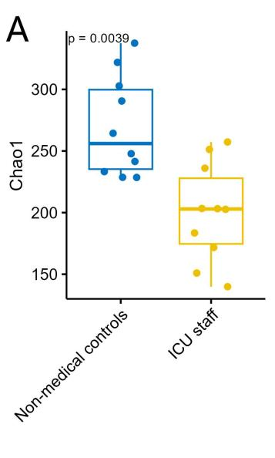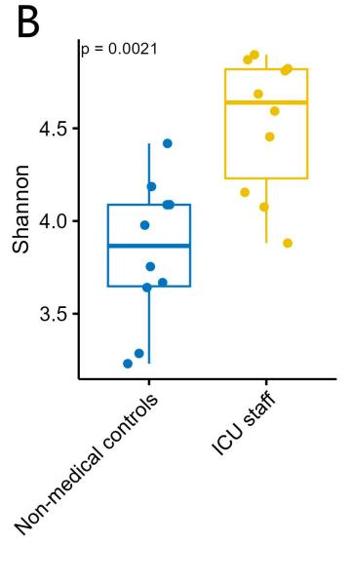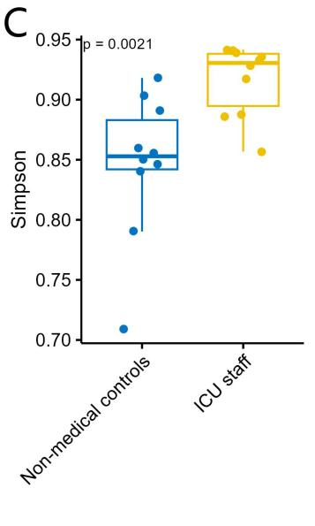

Figure 1. Alpha diversity of oropharyngeal microbiota. (A) Chao1 index reflecting microbial richness, significantly lower in ICU staff (P = 0.0039). (B) Shannon index integrating richness and community evenness, significantly higher in ICU staff (P = 0.0021). (C) Simpson index representing overall community diversity, significantly higher in ICU staff (P = 0.0021).

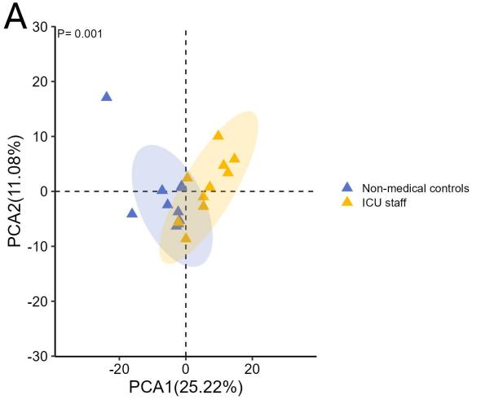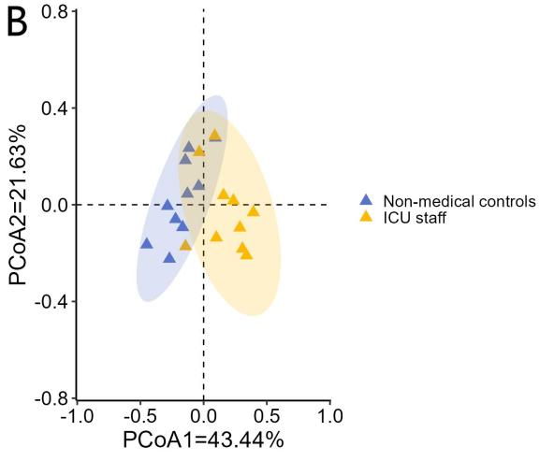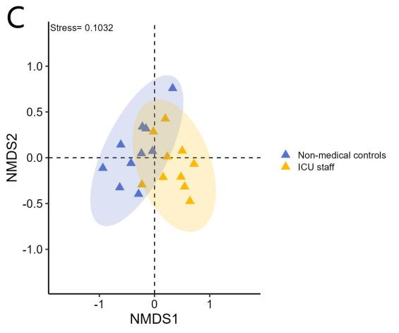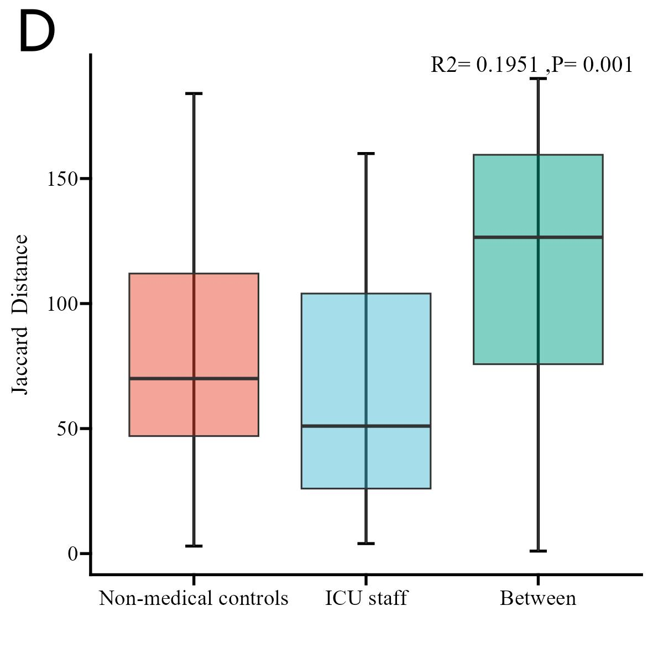

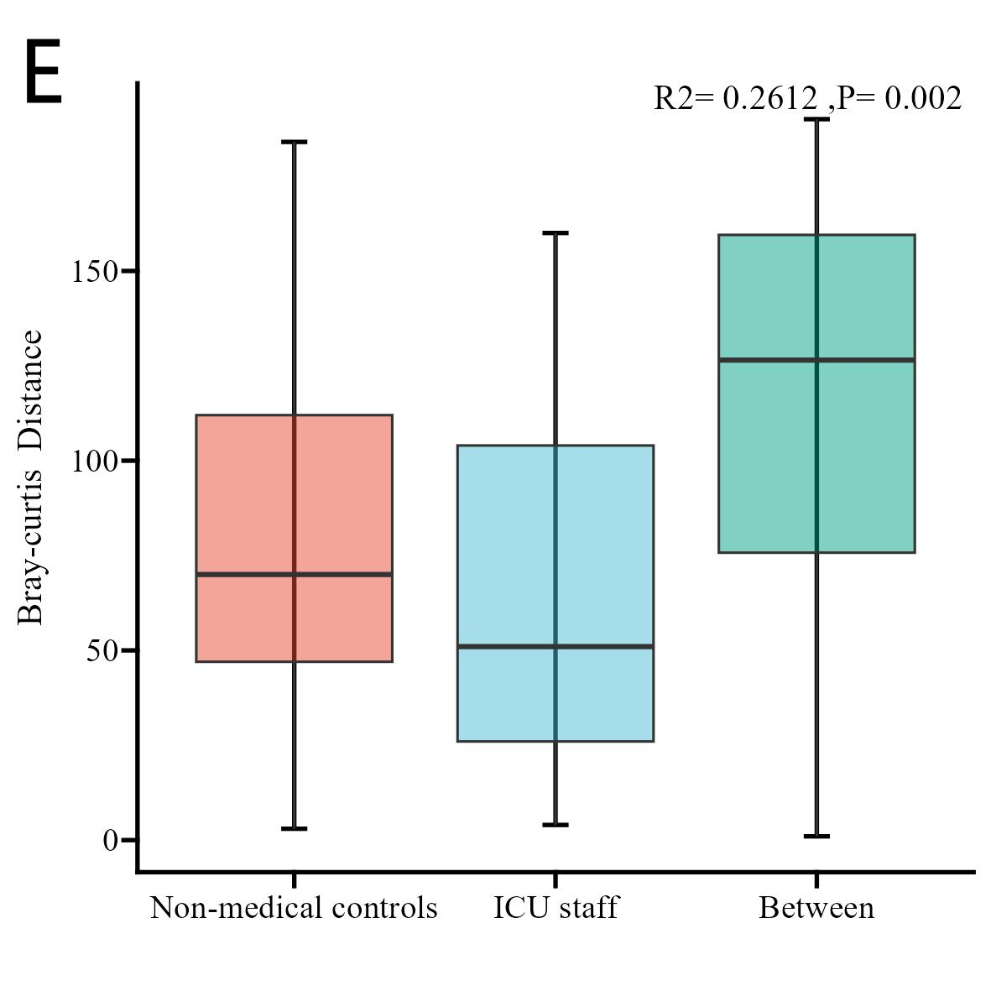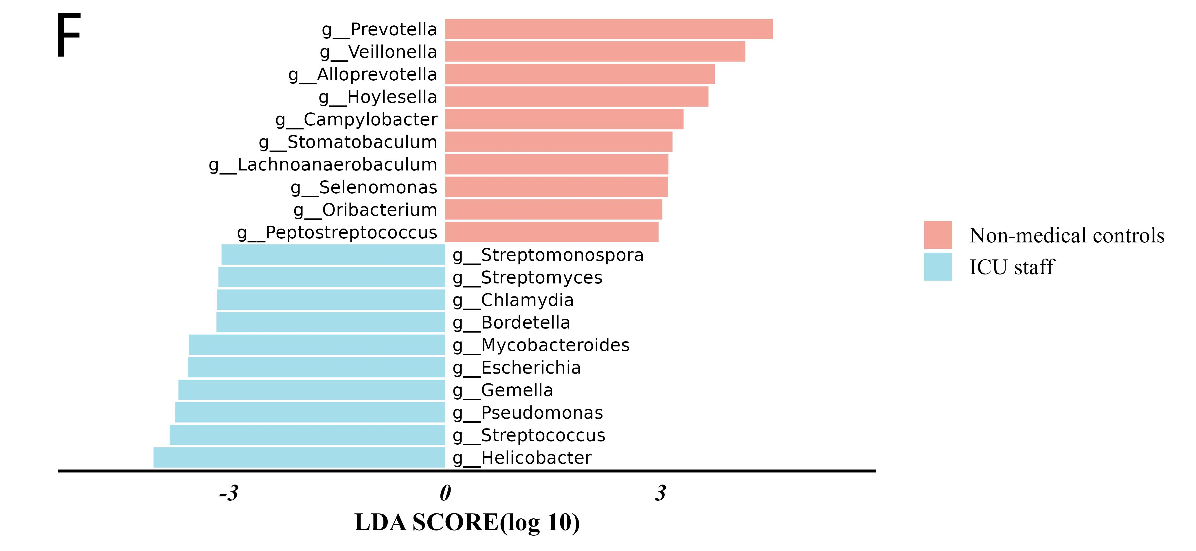
Figure 2. Beta diversity and differentially enriched genera. (A) Principal component analysis (PCA) showing distinct separation between groups. (B) Principal coordinate analysis (PCoA) showing distinct separation between groups. (C) Non-metric multidimensional scaling (NMDS) with stress = 0.1032, showing clear separation between groups. (D–E) PERMANOVA results for Jaccard distance (R² = 0.1951, P = 0.001) and Bray-Curtis distance (R² = 0.2612, P = 0.001) with 999 permutations. (F) Differentially enriched genera identified by LEfSe (LDA score > 3.0, P < 0.05), with oral commensal genera enriched in controls and potential pathogenic genera enriched in ICU staff.

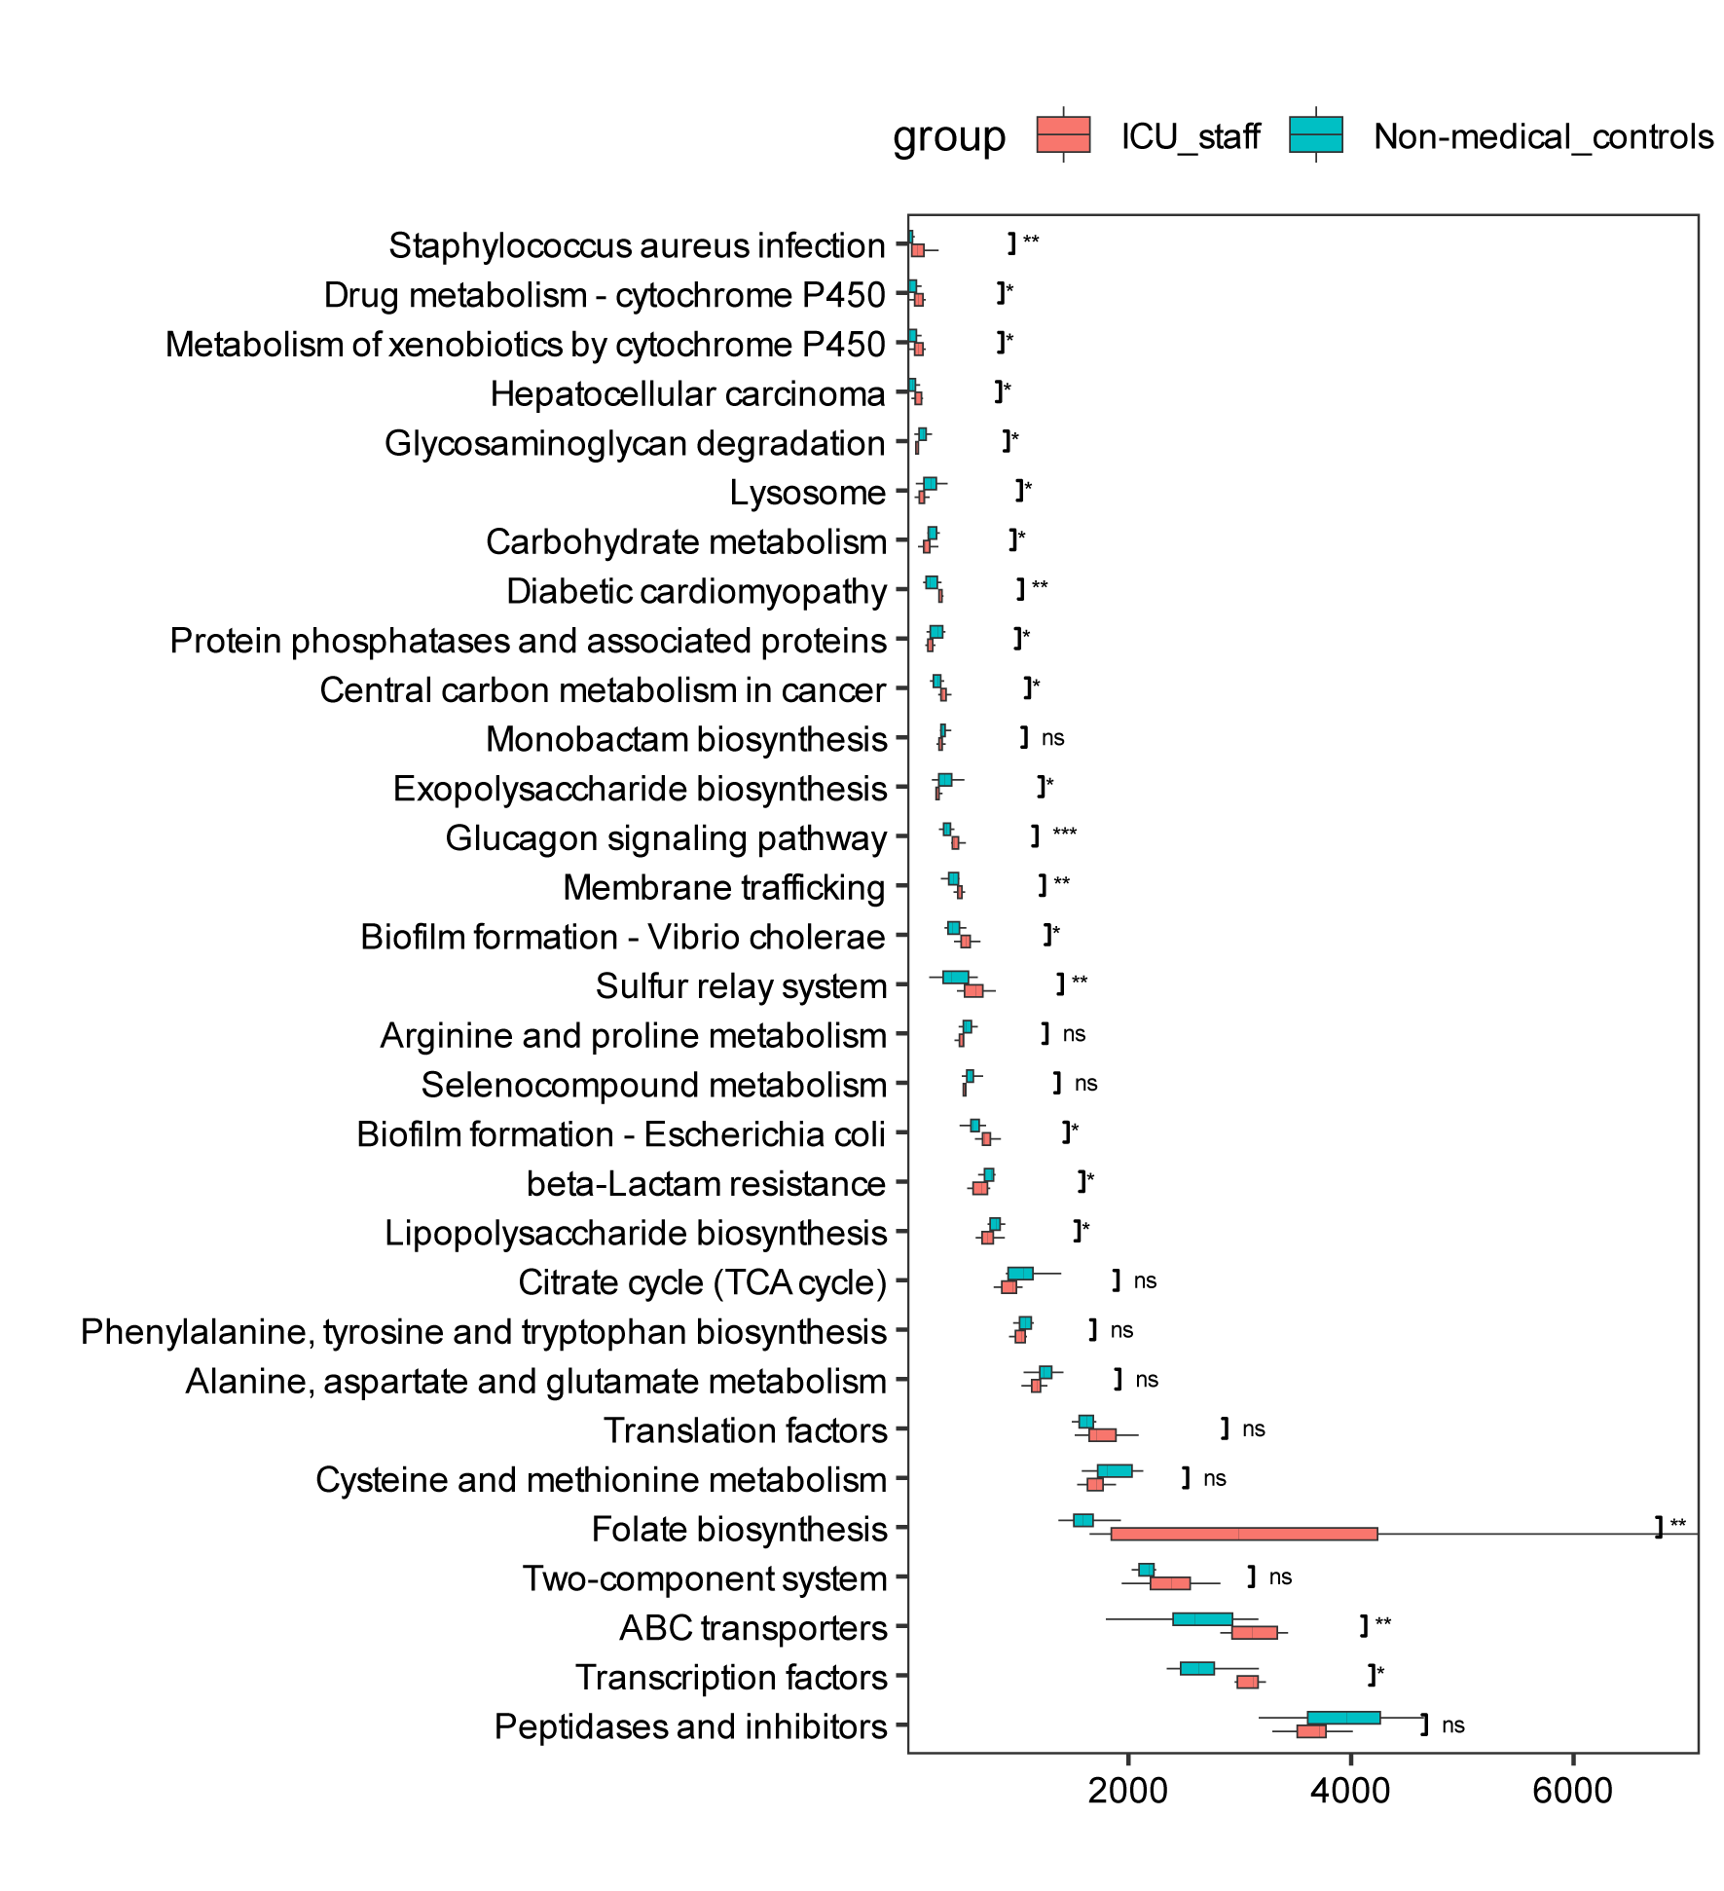Figure 3. Functional enrichment patterns of the oropharyngeal microbiome between ICU staff and non-medical controls. ns: not significant, * P< 0.05, **P < 0.01, ***P< 0.001.
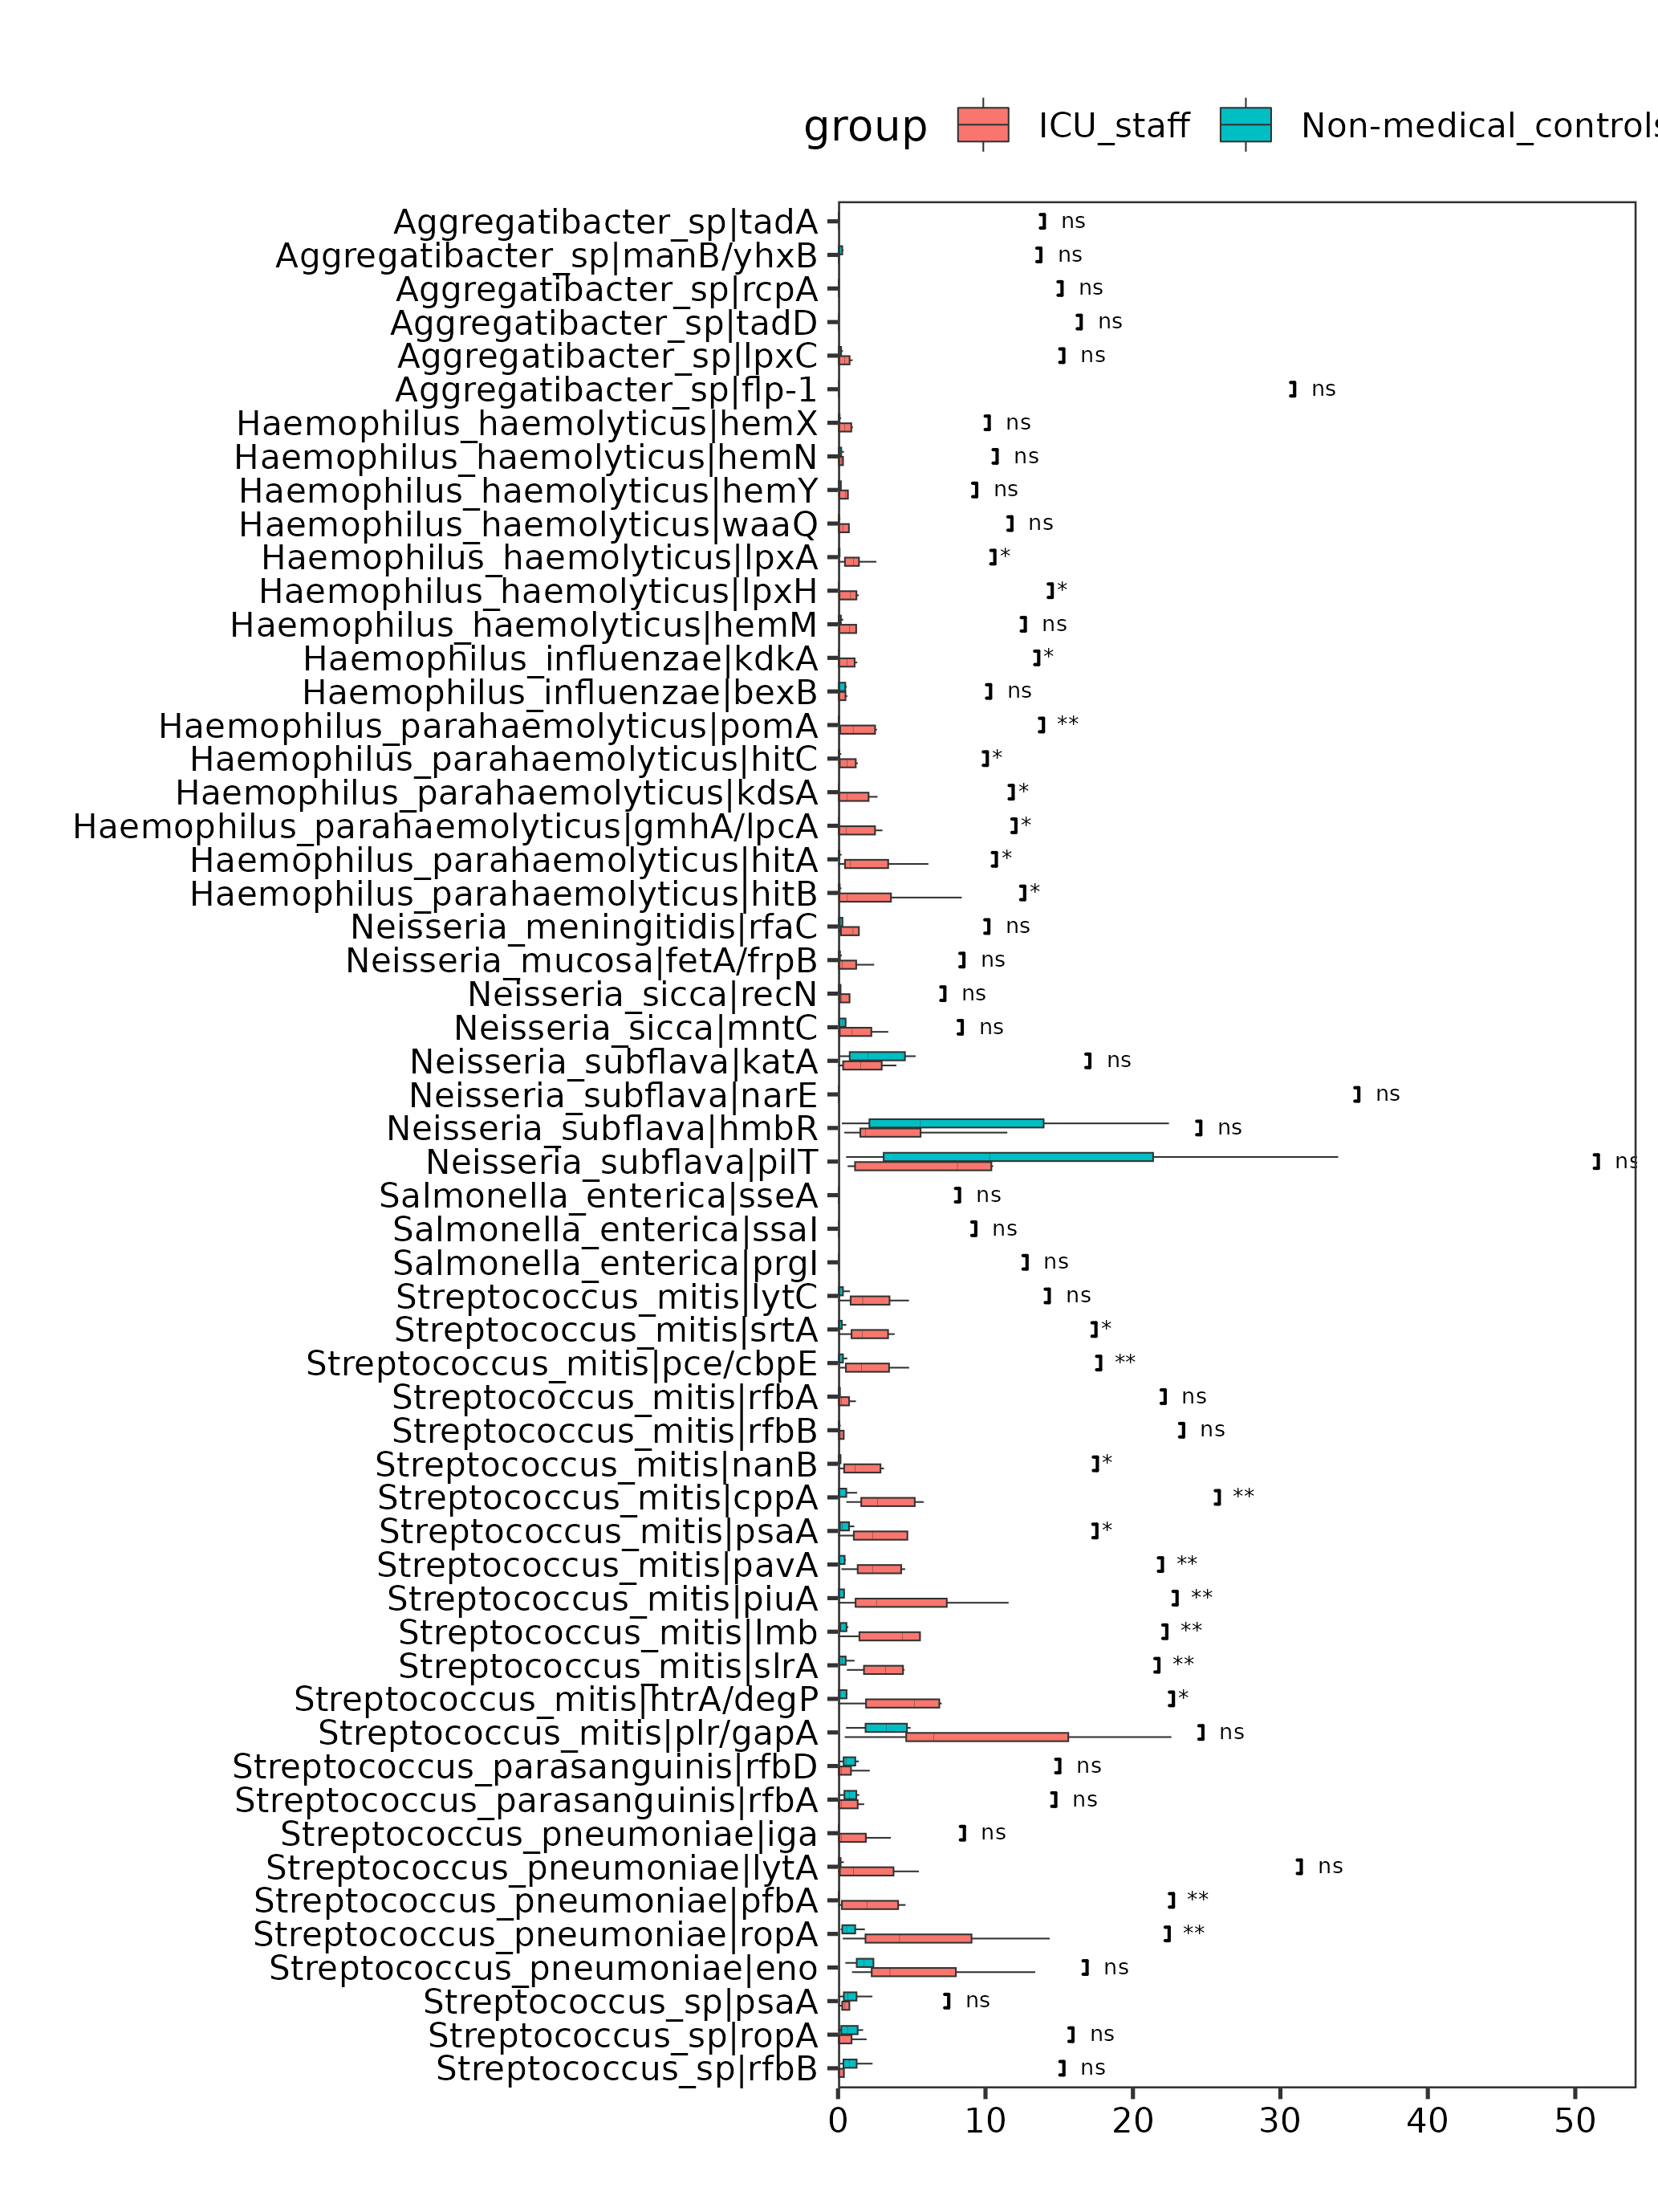Figure 4. Differentially enriched virulence factors between the two groups. ns: not significant, * P< 0.05, **P < 0.01.
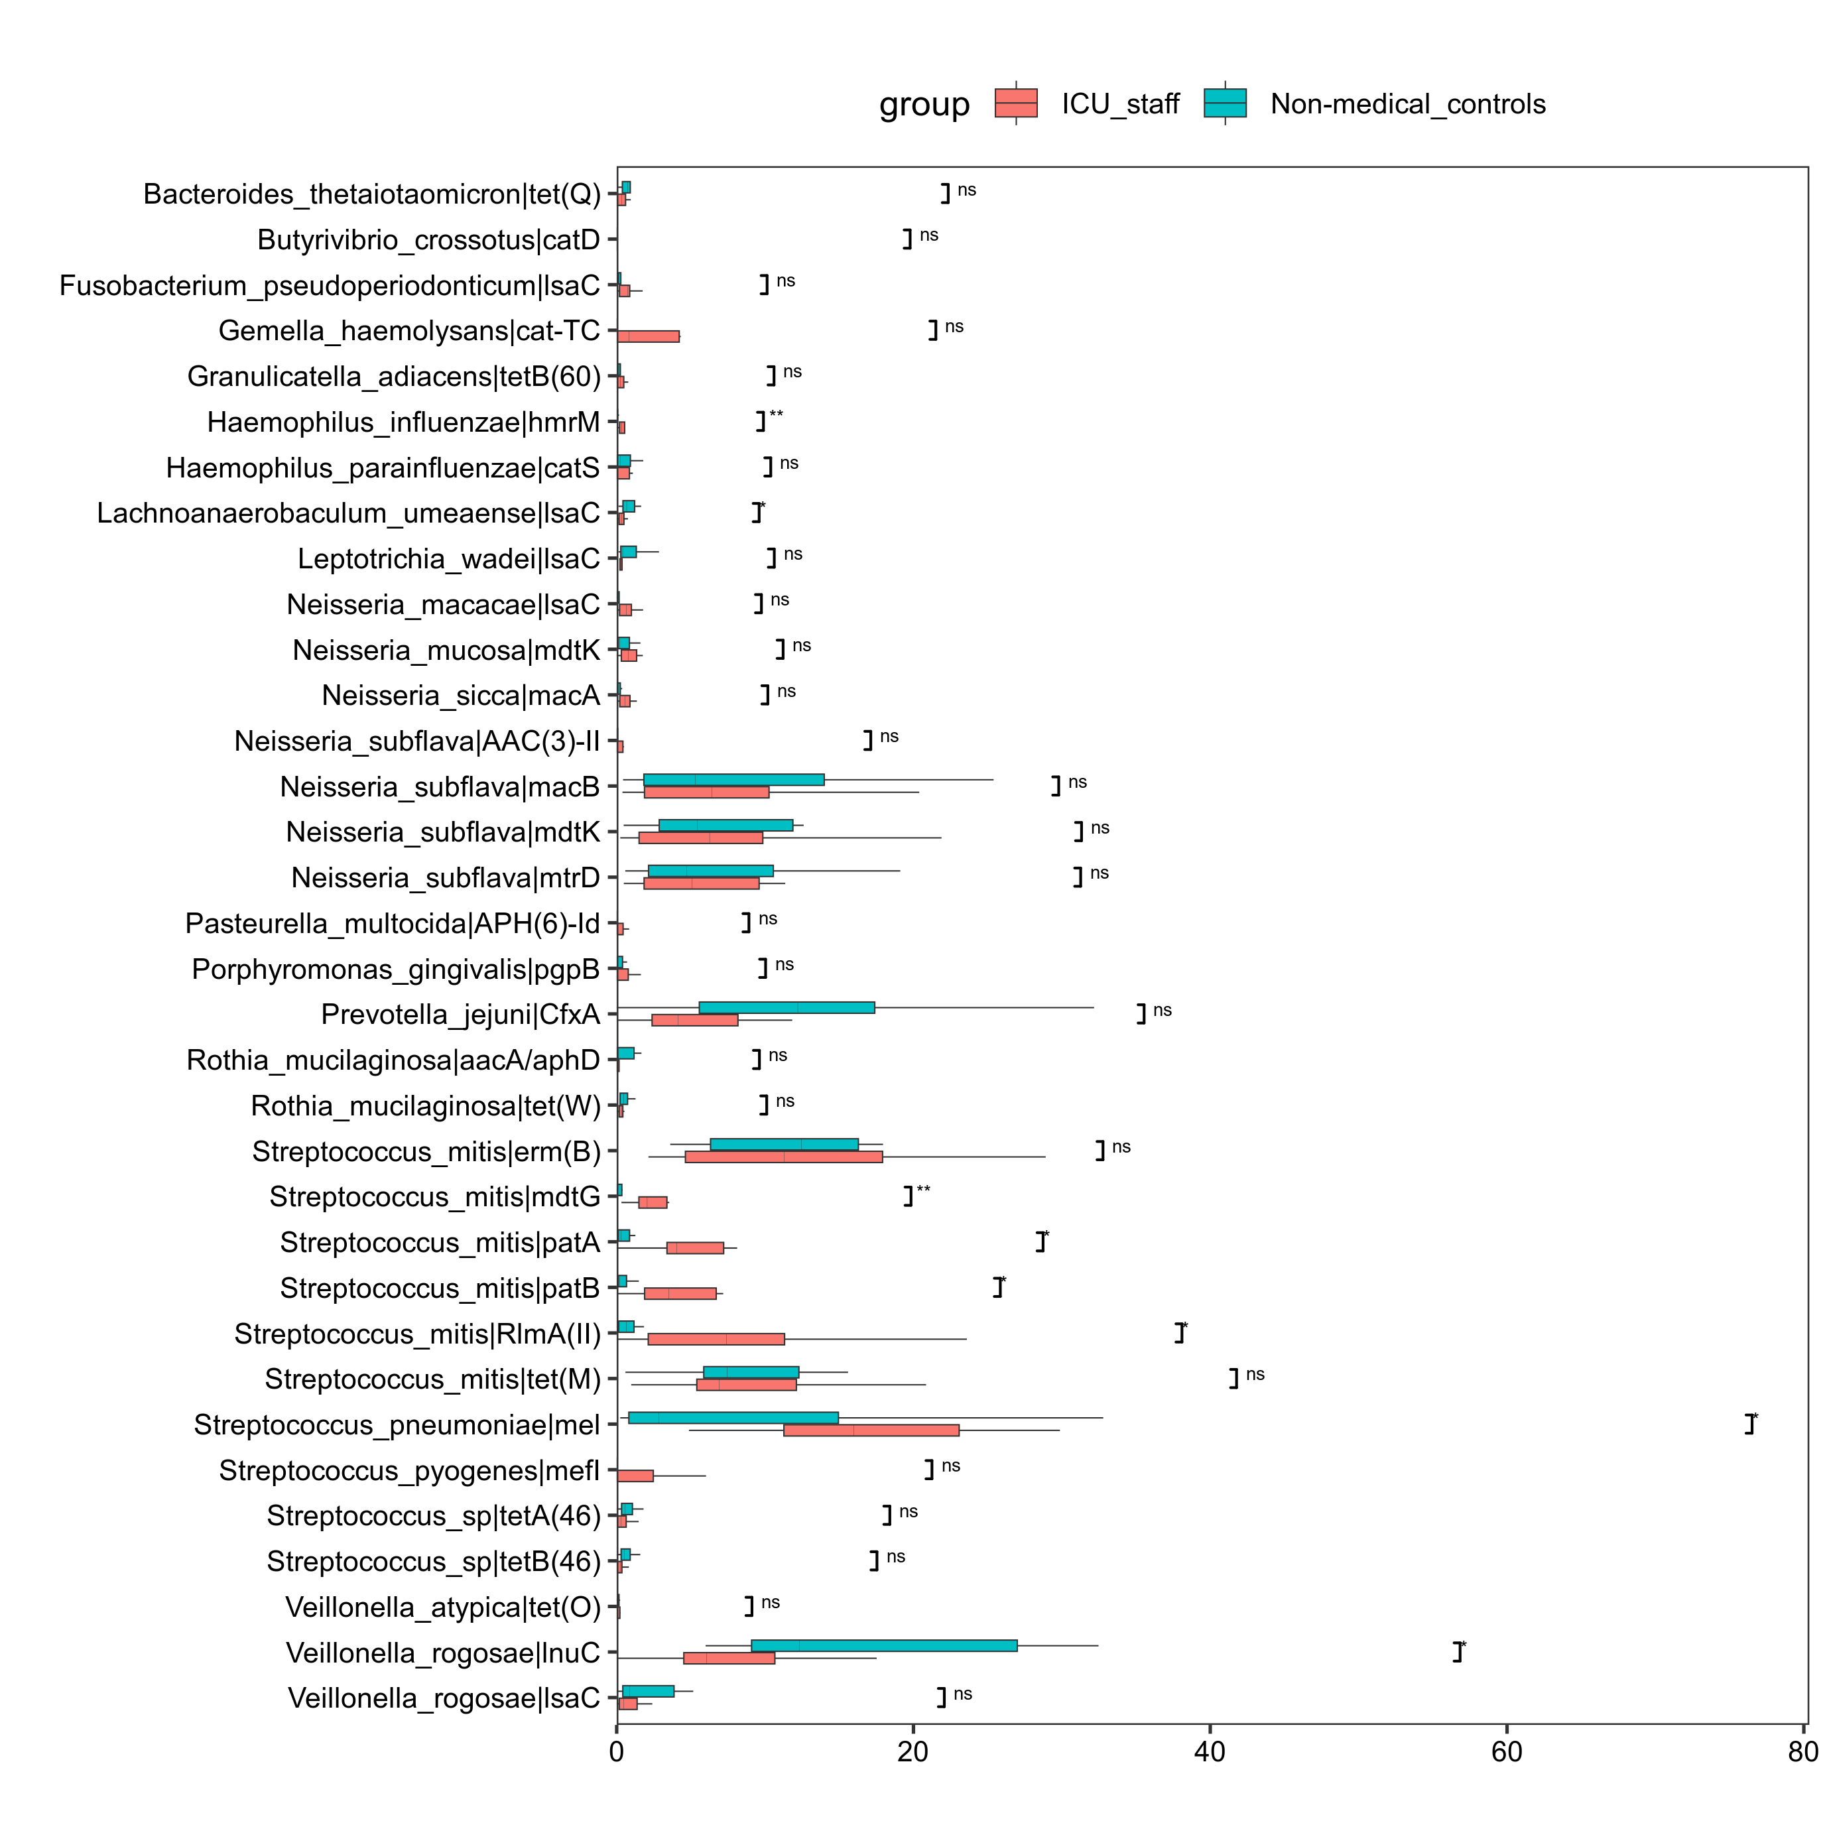
Figure 5. Abundance distribution of oropharyngeal antibiotic resistance genes between the two groups. ns: not significant, * P< 0.05, **P < 0.01.

