A
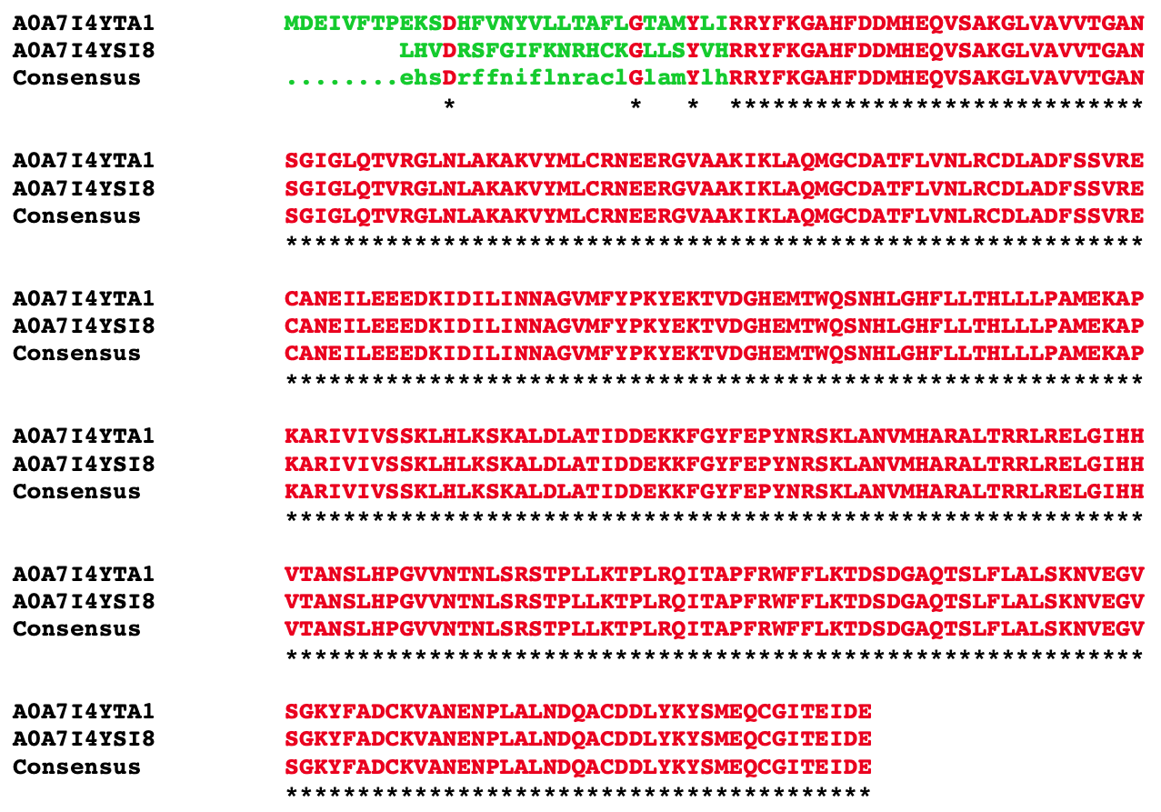

B
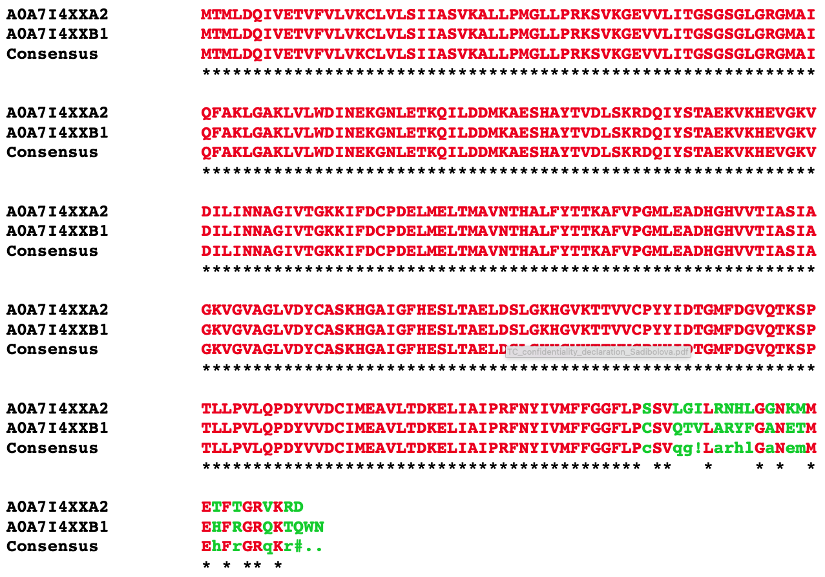
C
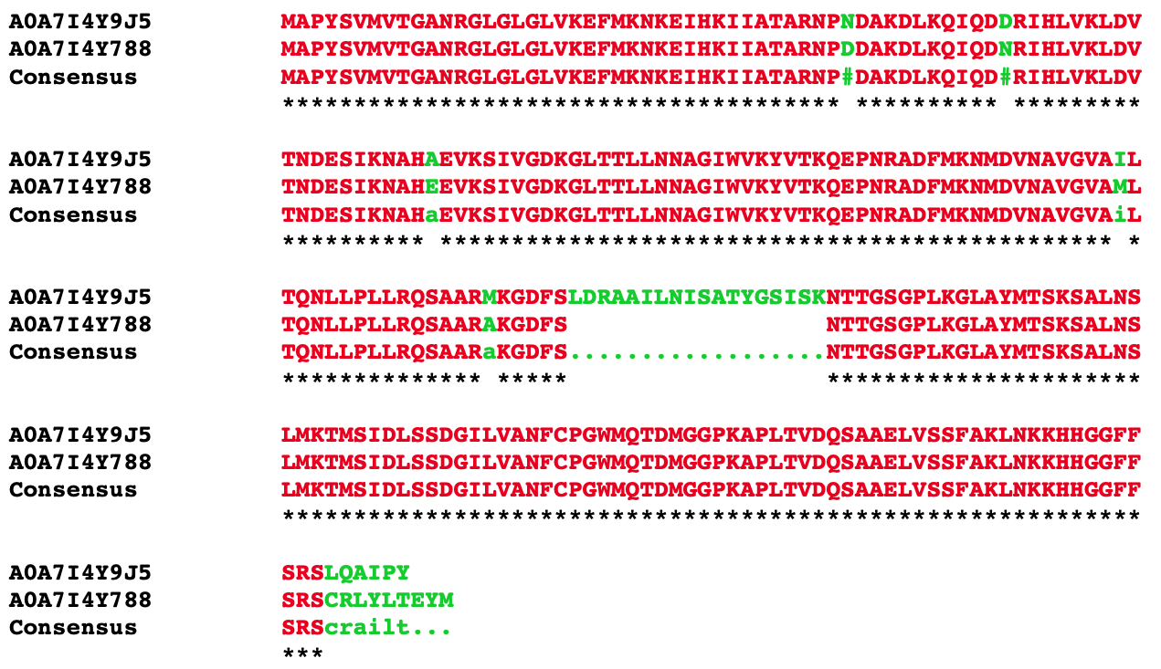

Additional file 5 Protein sequence overlap of (A) SDR6 (A0A7I4YTA1) with A0A7I4YSI8, (B) SDR14 (A0A7I4XXA2) with A0A7I4XXB1, and (C) SDR16 (A0A7I4Y9J5) with A0A7I4Y788. Sequence alignment was performed using Multalin [1] (v 5.4.1) with default settings.

References

1. Corpet F: Multiple sequence alignment with hierarchical clustering. Nucleic Acids Res 1988, 16(22):10881–10890.

