Supplementary Files

Eleni Adam¹, Desh Ranjan¹, Harold Riethman²
¹Old Dominion University, Department of Computer Science, Norfolk, VA,
²Old Dominion University, Medical Diagnostic and Translational Sciences, Norfolk, VA

Correspondence should be addressed to Eleni Adam (eadam002@odu.edu)

Table S1. Nanopore-based Corrections in 10x REXTAL contigs

Subtelomere | # Corrections in TR regions | # Corrections in non-TR regions
5p | 8 | 0
9p | 1 | 0
10p | 9 | 0
15q | 7 | 0
16p | 5 | 2*
18p | 8 | 0
19q | 5 | 1**
20p | 2 | 0
22q | 3 | 1***

* Associated with the alpha hemoglobin gene cluster within the 16p subtelomere region
** Associated with the zinc finger gene family within the 19q subtelomere region
*** Occurs in a potential alternative haplotype region of 22q as annotated in HG38

Table S2. Nanopore-based Corrections in TELL-Seq REXTAL contigs

Chromosome | # Corrections in TR regions | # Corrections in non-TR regions
5p | 4 | 0
9p | 0 | 1 (within a LINE/L1)
10p | 7 | 0
15q | 3 | 0
16p | 1 | 1 *
18p | 2 | 0
19q | 1 | 2 **
20p | 2 | 0
22q | 6 | 1***

* Associated with the alpha hemoglobin gene cluster within the 16p subtelomere region
** Associated with the zinc finger gene family within the 19q subtelomere region
*** Occurs in a potential alternative haplotype region of 22q as annotated in HG38

Figure S1. REXTAL modified for TELL-seq datasets (tREXTAL)

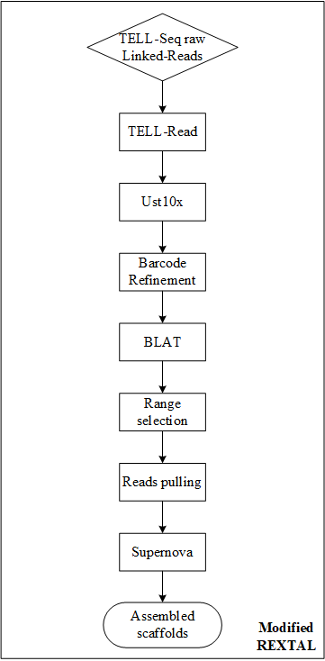

Legend figs S2 - S10.
The subtelomeric regions are evaluated with the QUAST tool and a minimum acceptable identity of 80% with the reference. In each image, at the bottom view, the assemblies are compared with the entire reference region and at the top, a zoom-in at a specific portion is shown in detail.

Each view consists of three parts: (1) the NPGREAT assembly (top part), (2) The REXTAL assembly (middle part), and (3) the hg38 reference genome region (bottom) to which each of these two assemblies are independently compared using QUAST. The TRs in the hg38 reference are masked to identify their locations, and appear as gaps in the reference sequence. The colors designate QUAST identified misassemblies relative to the reference sequence (misassemblies of length longer than 1 kb are designated with red color, while the gray color signifies gaps or overlaps of length less than 1 kb). (A) The NPGREAT and REXTAL assemblies with the use of the Nanopore and the 10x Linked-Reads datasets as input. (B) The NPGREAT and REXTAL assemblies with the use of the Nanopore and the TELL-Seq Linked-Reads datasets as input.

For all the subtelomeric regions, the reference sequence does not contain an accurate representation of the telomere repeat tract sequence and due to that, the comparison is resulting in (multiple) artifactual misassemblies presented by QUAST near the telomere area. These can be seen in the figures on the left side for the p-arm regions and on the right side for the q-arm regions, designated by the multiple small alignments occurring one on top of the other designated misassemblies. The remaining QUAST-identified misassemblies are artifactual as well, being actually differences in the variable Tandem Repeat regions of the genome. Therefore, there are no extensive misassemblies in the NPGREAT assemblies.

Compared to the REXTAL, which has a lot of misassemblies, these have been resolved in NPGREAT, where the Nanopore sequence enables the correction of the REXTAL contigs, either with the correct identification of the length of Tandem Repeat regions or simply with the split and positioning of the contigs. Distinct examples of the latter are the regions of 16p and 19q, where the contig alignments (colored red) in the REXTAL assemblies show that the contigs had to be split, so that other contigs could be positioned in between.

All NPGREAT assemblies extend to the telomere side beyond the reference and contain thousands of bases of the telomere repeat tract sequence, mainly because the single molecule Nanopore reads include it. The majority of the presented NPGREAT assemblies (9p, 15q, 16p, 18p, 19q, 20p and 22q) extend also beyond the QUAST analyzed regions shown in the non-telomeric side, presenting a continuous assembly even with a low coverage nanopore and TELL-Seq datasets.

A final notable observation in all figures is that the TELL-Seq Linked-Read dataset provides lower coverage compared to the 10x genomics Linked-Read dataset, resulting in shorter REXTAL assemblies with a larger number of gaps. Nevertheless, the ultra-long Nanopore reads span the entire region and enable the creation of a complete NPGREAT assembly.

Figure S2. Chromosome 5p Quast Comparison
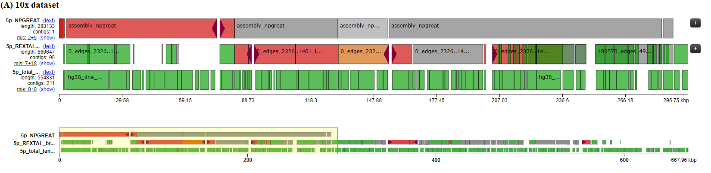
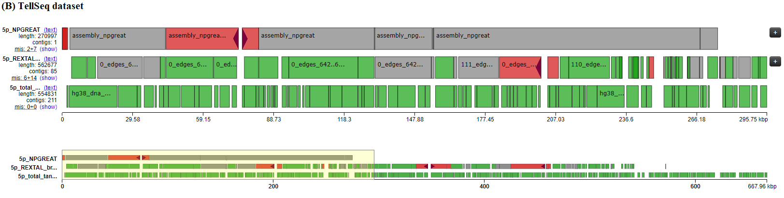

Figure S3. Chromosome 9p Quast Comparison
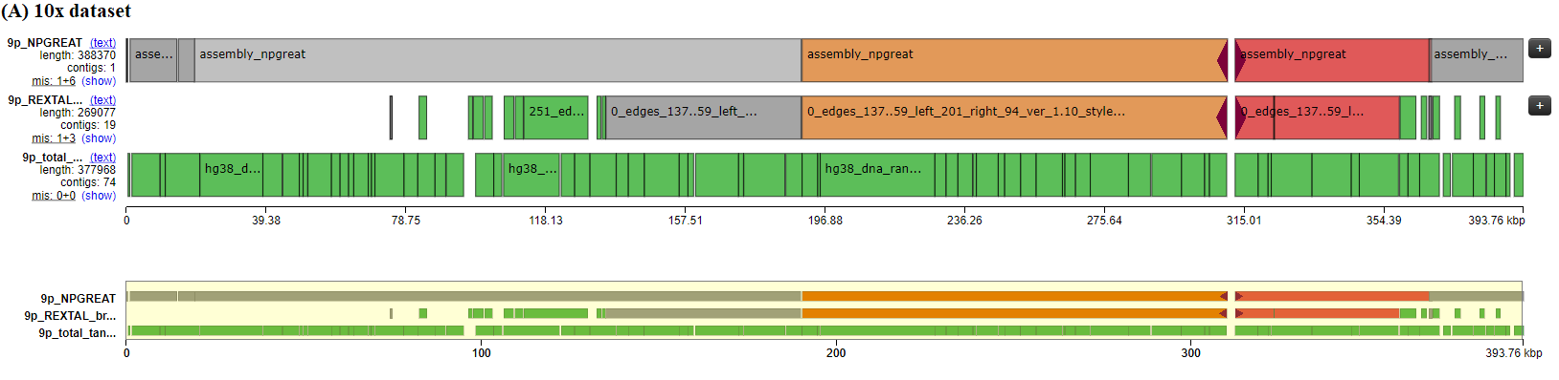
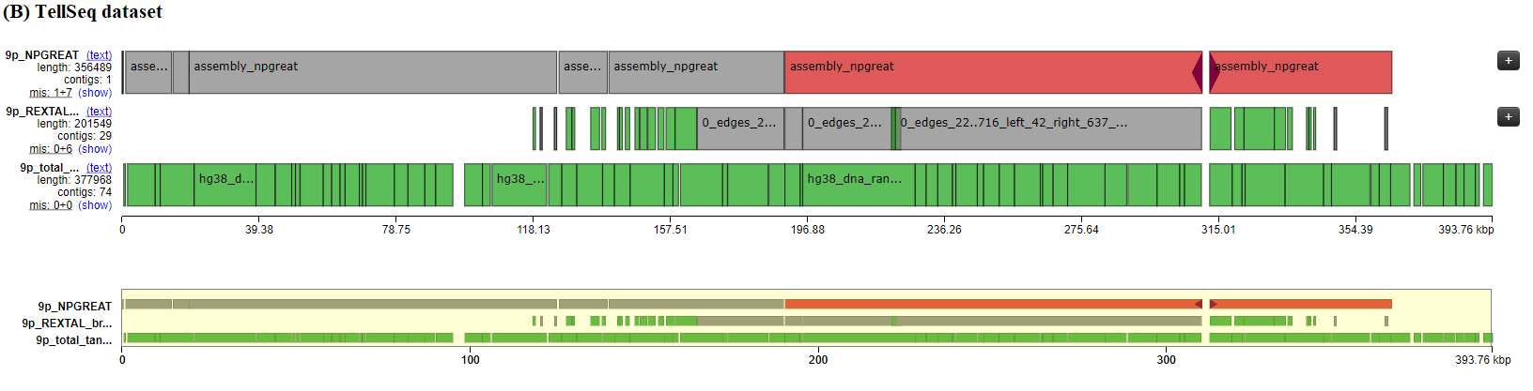

Figure S4. Chromosome 10p Quast Comparison
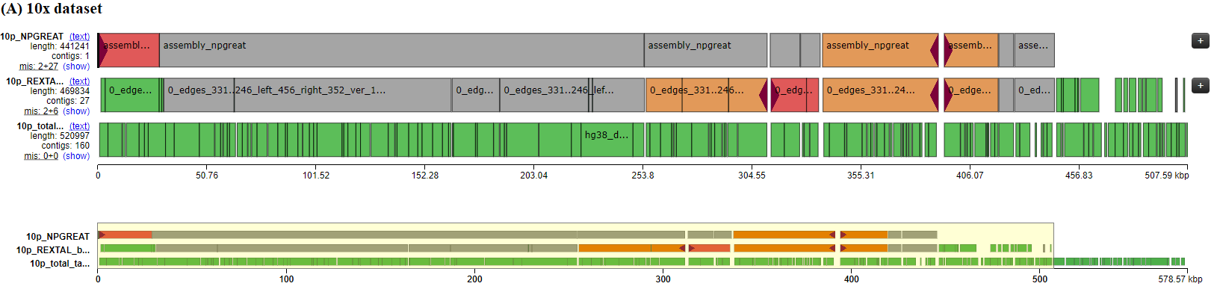
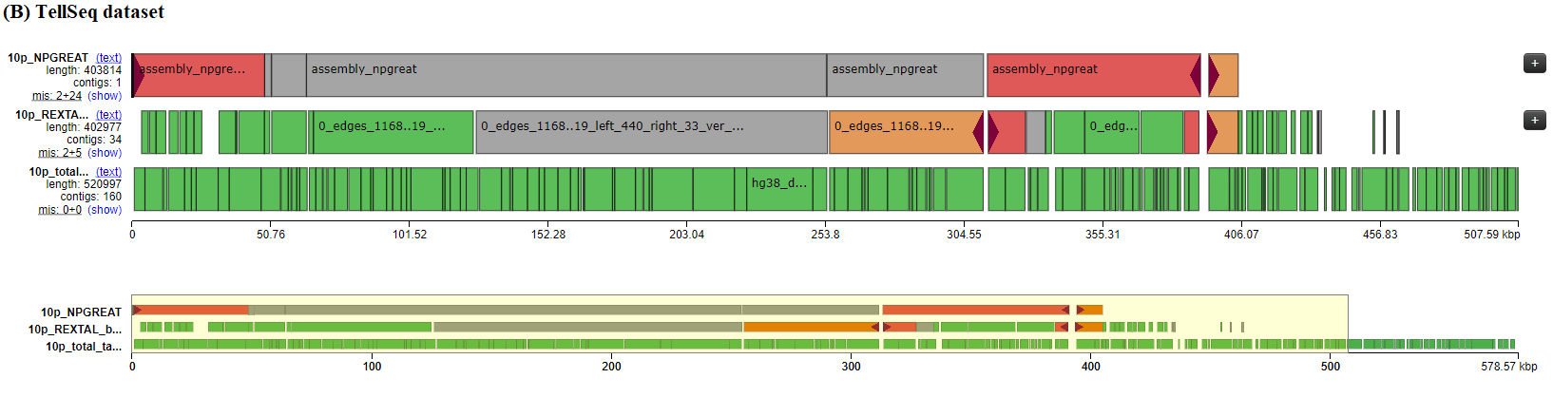

Figure S5. Chromosome 15q Quast Comparison
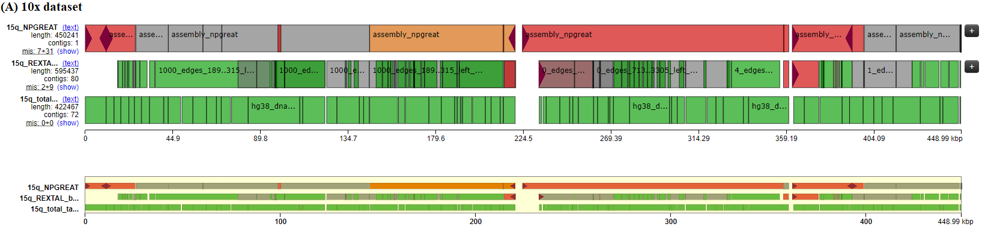
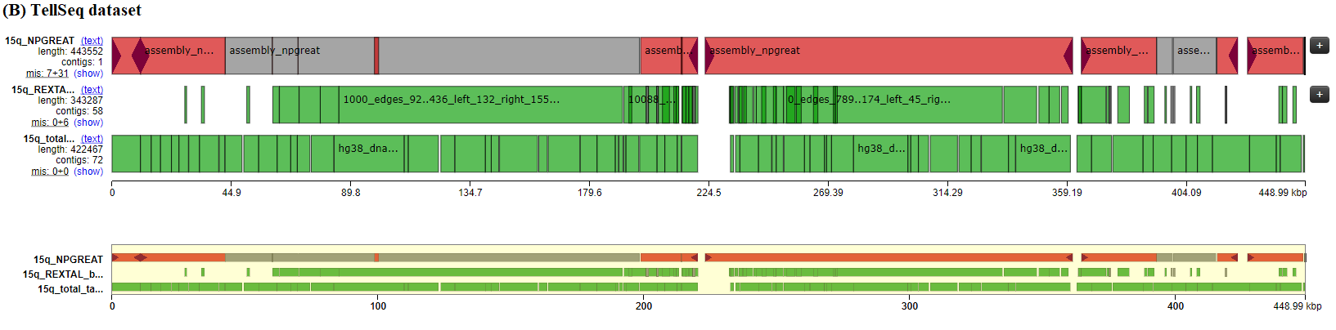

Figure S6. Chromosome 16p Quast Comparison
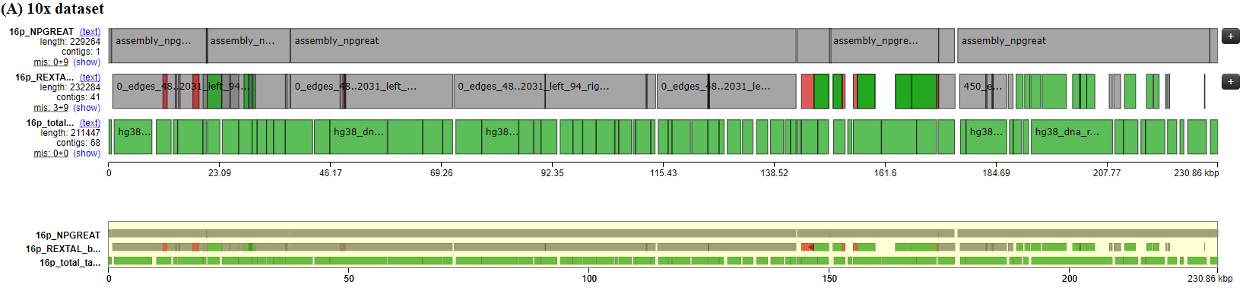
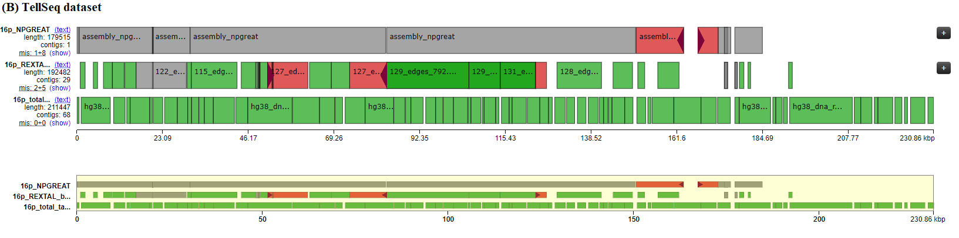

Figure S7. Chromosome 18p Quast Comparison
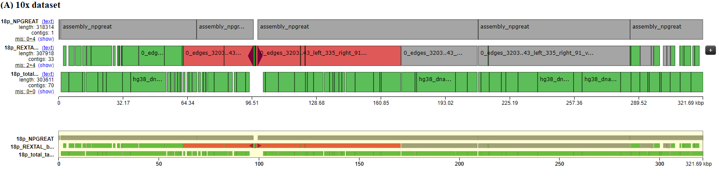
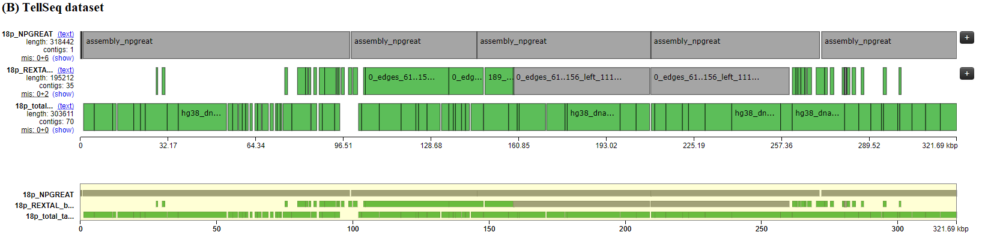

Figure S8. Chromosome 19q Quast Comparison
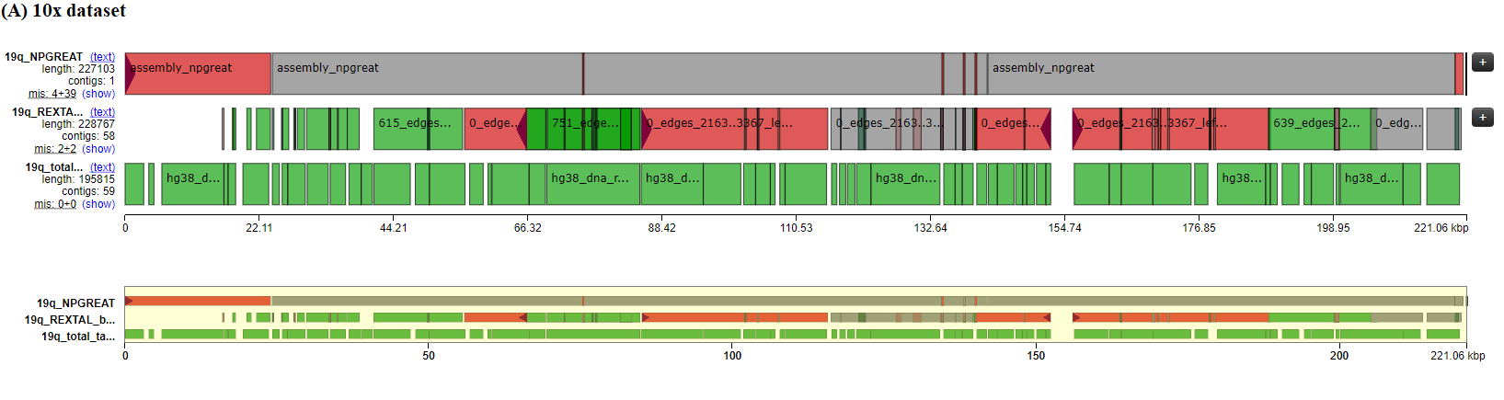
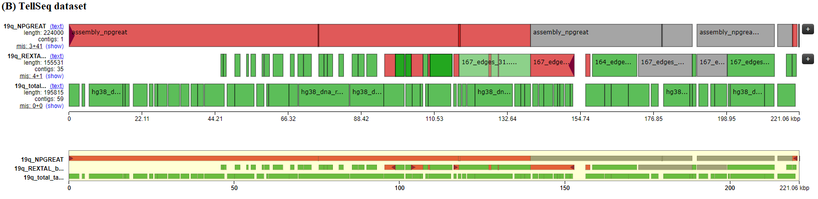

Figure S9. Chromosome 20p Quast Comparison
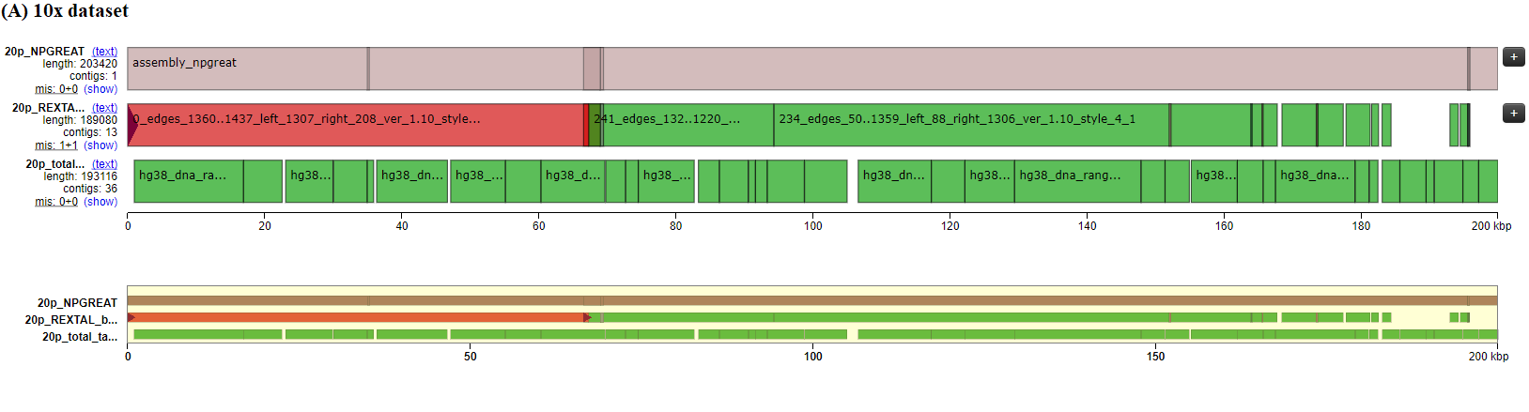
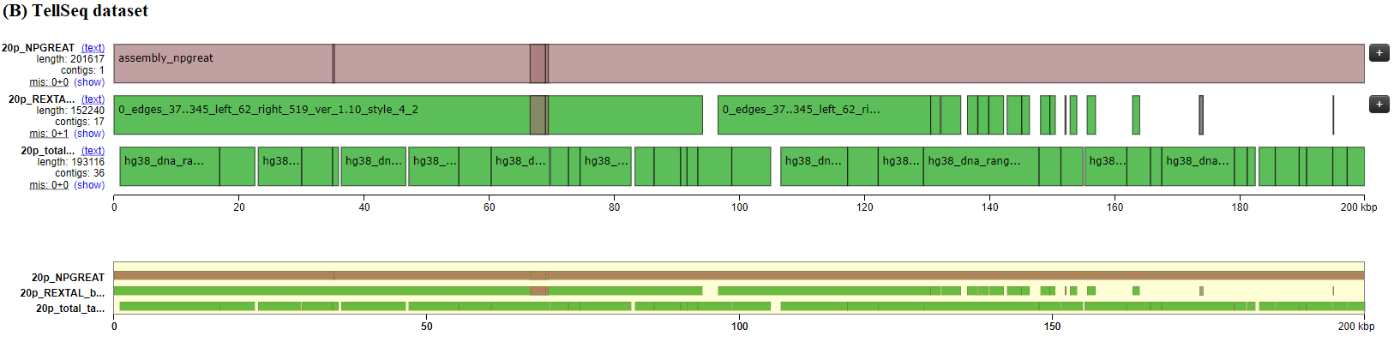

Figure S10. Chromosome 22q Quast Comparison
