Article title
Plant Nutrients Appears Decoupled from Soil: Increasing Influences from Changing Climate in the Grassland’s of Inner Mongolia, China
Running title: Global change and nutrient decoupling in grasslands
Xiang Li¹ • Qiang Deng³ • Lili Chen⁴ • Guiyao Liu⁵ • Xinrong Shi² • Thomas Ryan Lock⁶ • Robert L. Kallenbach⁶ • Zhiyou Yuan^{2*}

¹ Institute of Soil and Water Conservation Northwest A & F University, Yangling, Shaanxi, China

² State Key Laboratory of Soil Erosion and Dryland Farming on the Loess Plateau, Institute of Soil and Water Conservation, Chinese Academy of Sciences and Ministry of Water Resources, Yangling, Shaanxi, China
³ School of Surveying and Land Information Engineering, Henan Polytechnic University, Jiaozuo, China
⁴College of Geography and Land Engineering, Yuxi Normal University, Yuxi, Yunnan, China
⁵ Poyang Lake Eco‐economy Research Center, Jiujiang University, Jiujiang, Jiangxi Province, PR China
⁶ University of Missouri, Division of Plant Sciences, Columbia, MO, USA
Correspondence
Zhiyou Yuan, State Key Laboratory of Soil Erosion and Dryland Farming on the Loess Plateau, Institute of Soil and Water Conservation, Chinese Academy of Sciences and Ministry of Water Resources, Yangling, Shaanxi, China
E-mail: zyyuan@ms.iswc.ac.cn
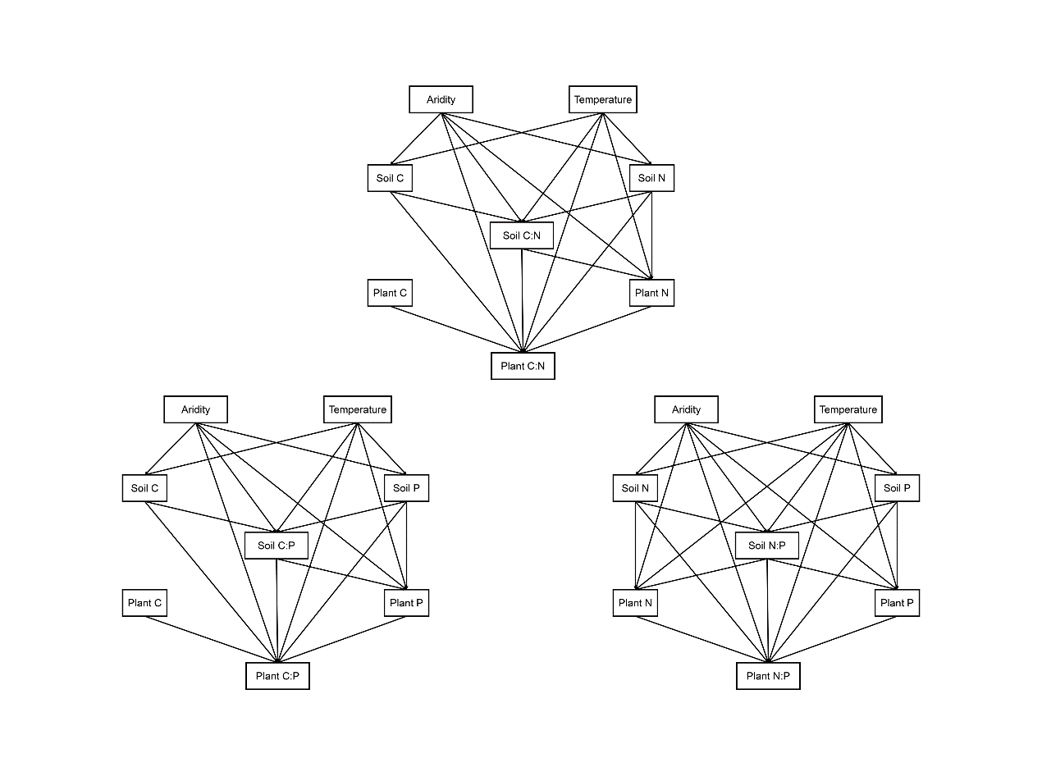
Fig. S1 Priori structural equation model used in this study. There are some differences between the priori model and the final model structures owing to removal of paths with coefficients close to zero (Figure 6).
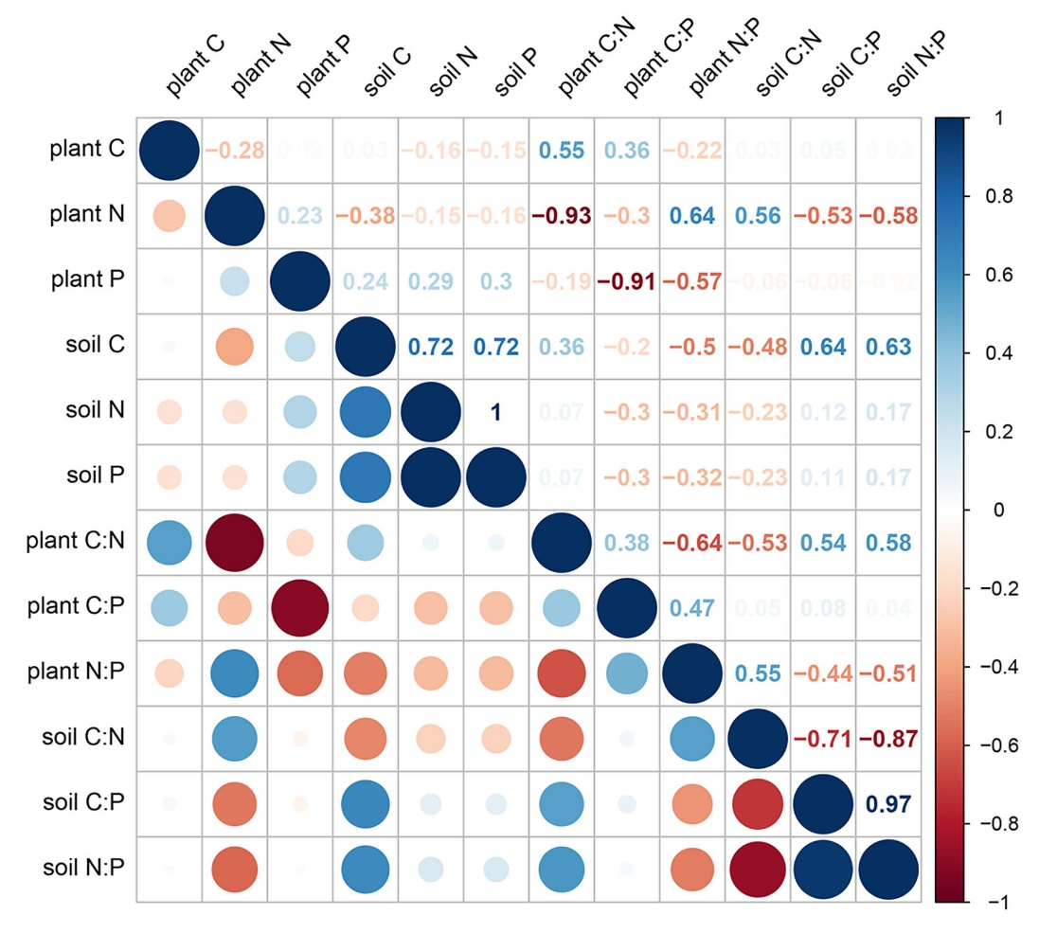
Fig. S2 Pearson correlation matrix of potential relationships between plant nutrients/stoichiometric ratios and soil nutrients/stoichiometric ratios. Significant correlation values considered at p < 0.01 level. Circles and values in blue and red represent positive and negative correlations, respectively.
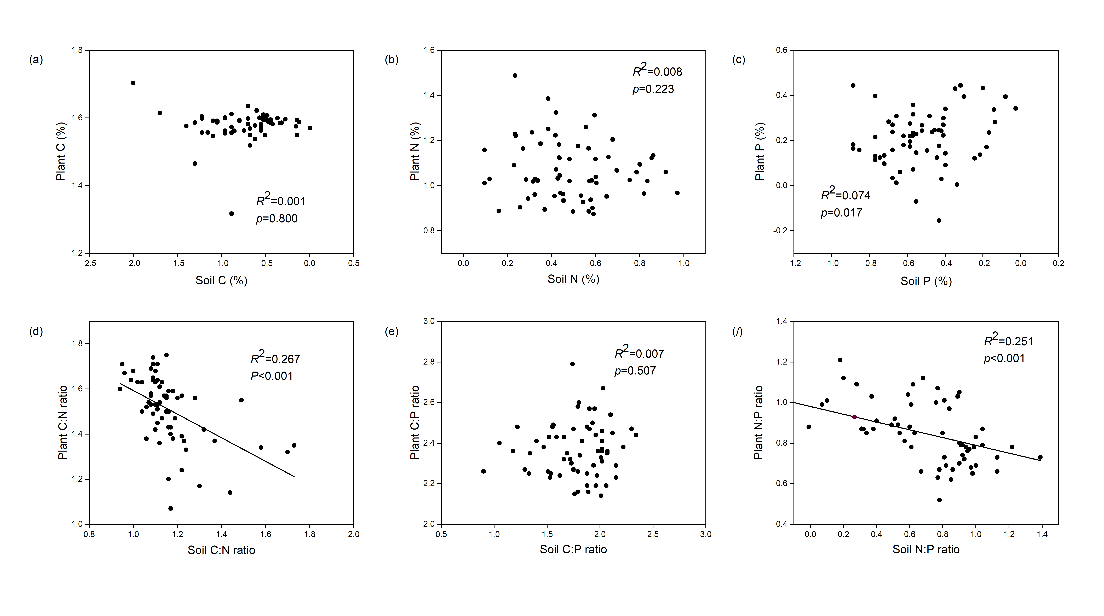
Fig. S3 Changes in plant nutrients and stoichiometry in relation to soil nutrients and stoichiometry. (a-c) plant and soil nutrients; (d-f) plant and soil stoichiometry. The solid red lines represent the fitted linear regressions. R² refers to proportion of variance explained by regression line. The values of nutrients and stochiometric C:N:P ratio are log₁₀-transformed.

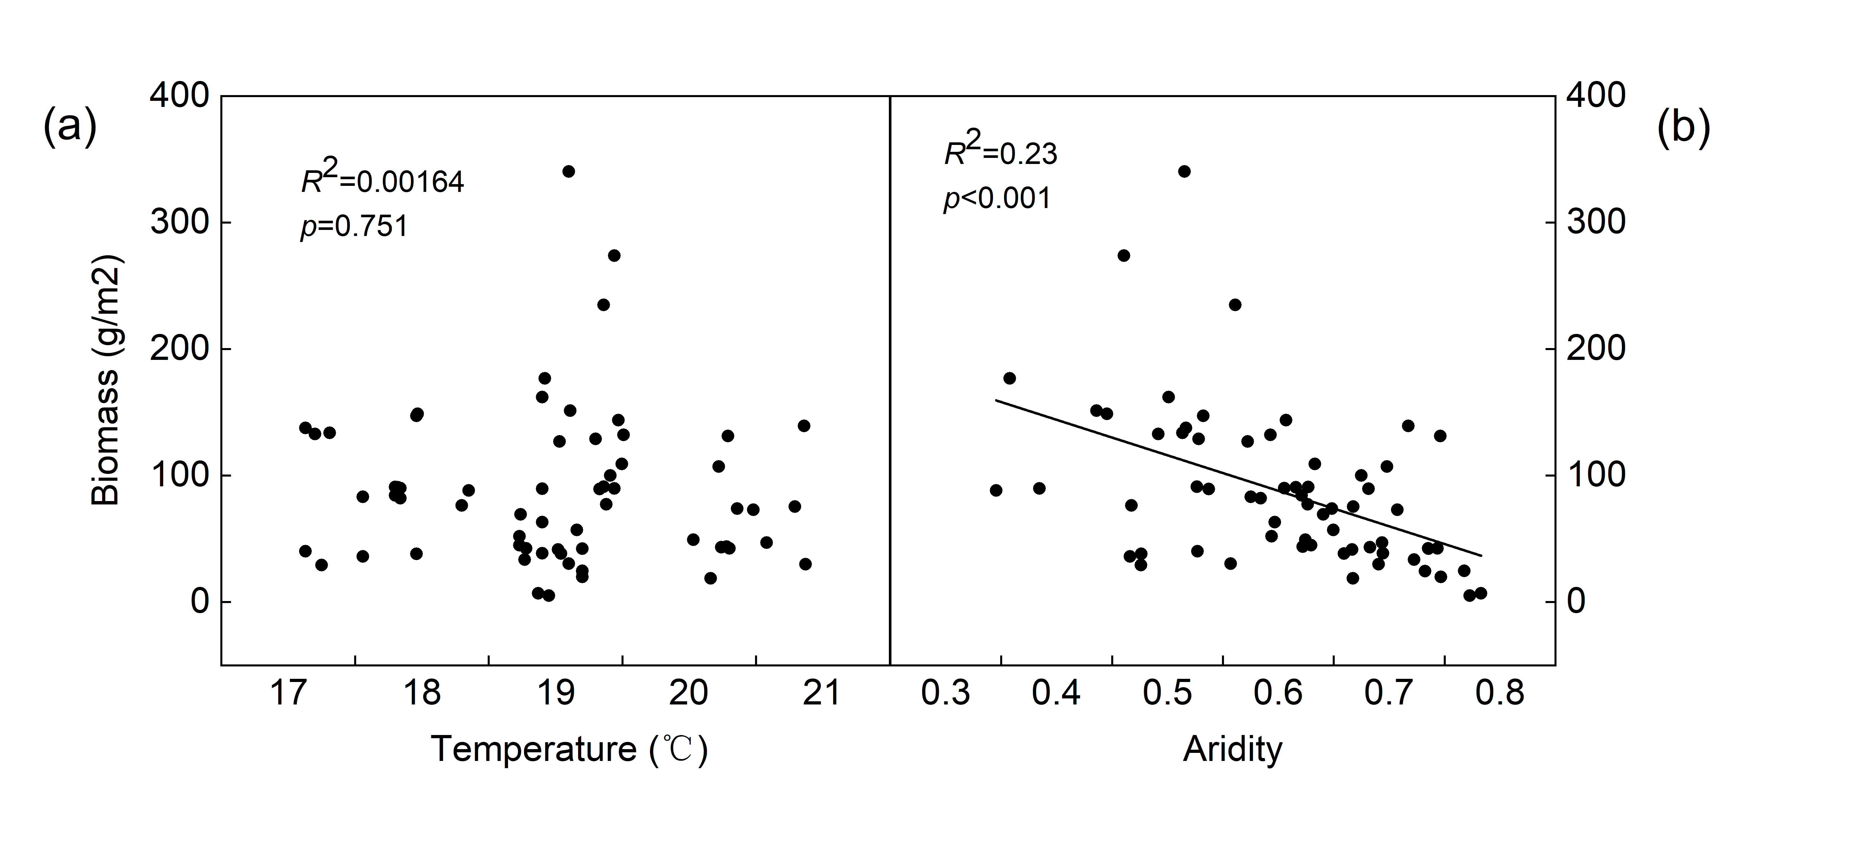
Fig. S4 Changes in biomass in relation to mean temperature and aridity. (a) mean temperature; (b) aridity. The solid lines represent the fitted linear regressions. R², proportion of variance explained by regression line.

