Supplementary material

Supplementary methods

MTL excision
The medial temporal lobe (MTL) block was extracted from the left hemisphere by TML. YS first verified that the specimen dimensions were compatible with the MRI coil requirements. On the lateral surface, the Sylvian fissure was dissected to expose the insula, planum polare, and temporal pole. On the medial surface, a small portion of the midbrain was removed to better identify the uncus, optic tract, and parahippocampal gyrus.
A linear incision was then planned using a transinsular approach toward the optic tract. Posteriorly, a vertical section was made through the occipital and posterior temporal lobes. The superior section was extended to the roof of the amygdala. The temporal horn of the lateral ventricle was then widely opened through a trans-T2 approach. The unco-hippocampal complex, including the hippocampus, amygdala, parahippocampal cortex and, in some cases, residual fusiform cortex, was isolated in one piece to fit the sample container.

Thickness measurements

Selecting thickness measurements
YS was trained by LEMW and manually placed dots to mark each anatomical location for every subregion.
The anterior section was defined as the first slice posterior to the disappearance of the characteristic X-shaped configuration formed by CA3 (Supplementary Figure 1).
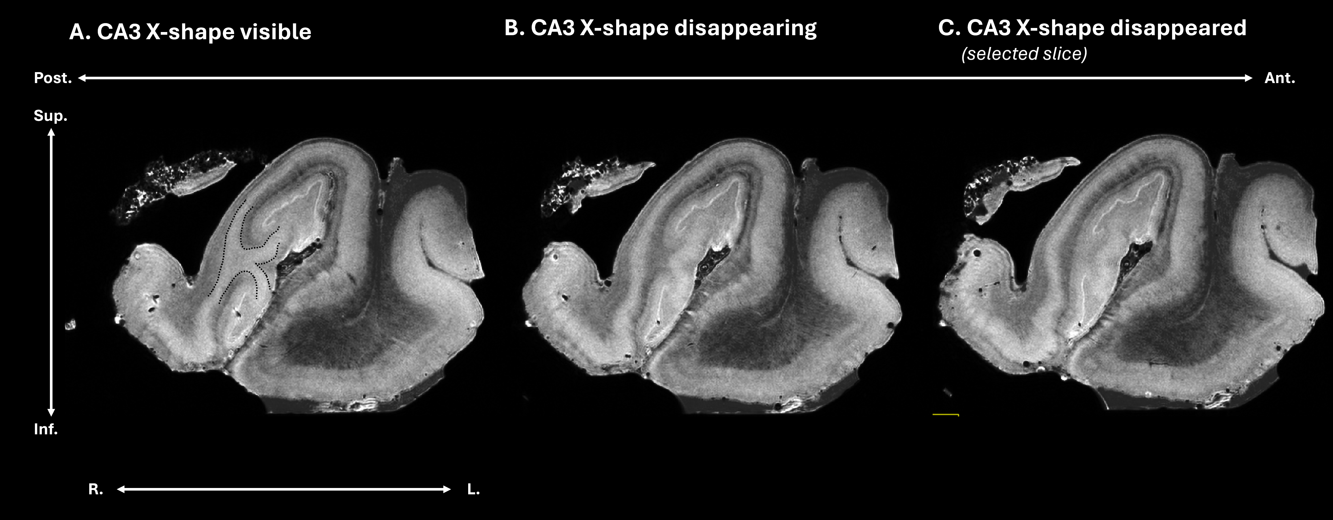
Supplementary Figure 1: Illustration of CA3 X-shape in anterior MTL slices. The X-shape is highlighted on panel A.

On this anterior section (see main figure 1A), the dot for the entorhinal cortex (ERC) was placed approximately at the midpoint of the width of the crown of the gyrus. For BA35, dot placement depended on the depth of the collateral sulcus, following previously described criteria [1]. When the collateral sulcus depth was less than 5 mm, the BA35 dot was positioned on the medial bank two-thirds of the way from the edge to the fundus. When the sulcus depth ranged between 5 and 10 mm, the dot was placed at the midpoint of the medial bank. When the sulcus depth exceeded 10 mm, the dot was positioned one-third of the way along the medial bank. For CA1, dots were placed along the lateral curve of CA1. The alveus dot was positioned in the middle of the hypointense external layer, the pyramidal layer dot in the center of the hyperintense band corresponding to the pyramidal cell layer, and the SRLM dot in the middle of the internal hypointense layer. CA3 dots were placed just superior to the level where the X-shaped configuration disappears. Similar to CA1, the alveus dot was positioned in the center of the hypointense external layer, the pyramidal layer dot in the middle of the hyperintense band, and the SRLM dot in the center of the internal hypointense layer. Subiculum (SUB) dots were placed approximately 1-2 mm medial to the visible boundary between CA1 and SUB, defined either by a change in pyramidal layer intensity and/or by a change in SLM lamination. As in CA regions, the pyramidal layer was positioned in the middle of the hyperintense band, and the SLM dot in the center of the internal hypointense layer. The dentate gyrus (DG) dot placement was aimed to position measurements as close as possible to CA1. The granule cell layer dot was placed in the middle of the thin hyperintense band corresponding to the granule cell layer, and the molecular layer dot was positioned in the center of the region separating the DG granule cell layer from the dark band of CA1. In practice, dot placement depended on where the granule cell layer was most clearly visible, making it less systematic than in other regions.
The posterior section (see main figure 1B), corresponding to the mid-hippocampus, was selected to match the anatomical level of the corresponding histological section, aligned with the level of the lateral geniculate nucleus. In this section, ERC and BA35 dots were not placed, as the cortex at this level could represent either residual ERC or transition into the parahippocampal cortex and the exact anatomical region cannot be determined on MRI. CA1, SUB, and DG dots were placed according to the same principles as in the anterior section; however, the DG granule cell layer was less frequently visible posteriorly than anteriorly. For CA3, only the pyramidal layer dot was placed, positioned in the middle of the hyperintense band that curves inwards into CA4.
Minor deviations from these placement rules were occasionally necessary to avoid air bubbles, tissue damage, or other artifacts that could compromise the reliability of thickness measurements at the initially intended location.
Finally, SOT systematically verified that all MRI-based annotations corresponded to the anatomically defined regions of interest on the matched histological sections.

Thickness measurement techniques
Thickness measurements were performed in a semi-automated manner in ITK-SNAP [2] for each anatomical location marked with a dot.
For ERC, BA35, the pyramidal layer of the subiculum, the pyramidal layer and alveus of CA1 (both anterior and posterior), the pyramidal layer and alveus of anterior CA3, and approximately half of the anterior DG measurements, segmentation was performed using the “Active Contour Segmentation Mode.” After locating the dot of interest (Supplementary figure 2A), the MRI volume was restricted to a bounding box encompassing the dot, the surrounding tissue, and a margin of background space (Supplementary figure 2B). Within this bounding box, a small portion of the region of interest was manually segmented (Supplementary figure 2C-left). A second label was then used to segment adjacent, non-target tissue to distinguish it clearly from the region of interest, and additional labels were applied when necessary to define background (Supplementary figure 2C-left). These labeled regions were used to train the classifier. Once the training samples were deemed satisfactory (Supplementary figure 2C-right), a bubble was initialized at the dot's location, and its radius was adjusted to approximate the tissue's size (Supplementary figure 2D). Automatic segmentation was then initiated and allowed to proceed until the resulting segmentation extended to approximately 1.5 times the width of the tissue of interest (Supplementary figure 2E). If the automated segmentation contained holes or extended into adjacent, non-target tissue, manual corrections were performed to ensure anatomical accuracy (Supplementary figure 2G).
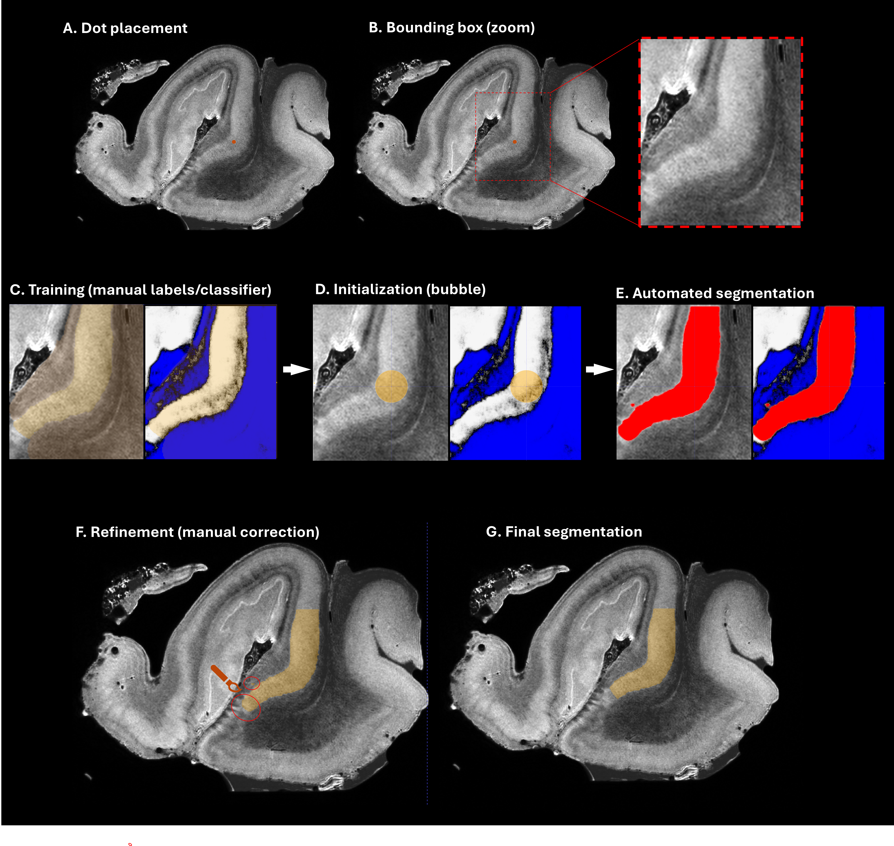
Supplementary Figure 2: Segmentation procedure using the Active Contour Segmentation Mode in ITK-SNAP. (A) A dot was placed at the center of the anatomical structure of interest. (B) The MRI volume was restricted to a bounding box encompassing the dot, the surrounding tissue, and a margin of background space, with a corresponding zoomed-in view. (C) Within this bounding box, training data were defined by manually segmenting a portion of the region of interest and labeling adjacent non-target tissue and background to train the classifier. (D) A bubble was initialized at the dot location, and its radius was adjusted to approximate the size of the structure. (E) Automated segmentation was then performed based on the trained classifier. (F) The segmentation was allowed to expand to approximately 1.5 times the width of the structure, enabling identification of regions requiring manual refinement. (G) Final segmentation was obtained after manual correction of holes or leakage into adjacent tissues to ensure anatomical accuracy.

For the posterior CA3 pyramidal layer, posterior DG granule cell layer, and molecular layer, as well as approximately half of the anterior DG measurements, contrast between adjacent regions was less distinct, thereby limiting the utility of the active contour algorithm. In the case of the SRLM layers, the limitation was primarily related to their intrinsic heterogeneity, as these layers consist of multiple strata with varying signal intensities, which reduced the reliability of the Active Contour Segmentation Mode for consistent delineation. In all these instances, manual segmentation was performed on every fifth slice, and the intermediate slices were subsequently interpolated using contour- and intensity-guided interpolation, followed by manual refinement where necessary to ensure anatomical accuracy.
Thickness measurements were not available for all regions in every specimen due to tissue damage (e.g., tears) or insufficient contrast. The exact number of each thickness measurement available per region is reported in Supplementary Table 1.
 | Anterior MTL | Posterior MTL
CA1 Alveus | 15 | 14
CA1 Pyramidal cell layer | 17 | 15
CA1 SRLM | 14 | 15
CA3 Alveus | 19 | /
CA3 Pyramidal cell layer | 18 | 13
CA3 SRLM | 19 | /
DG GCL | 16 | /
DG ML | 15 | /
SUB Pyramidal cell layer | 19 | 14
SUB SLM | 18 | 14
ERC | 17 | /
BA35 | 16 | /
Supplementary Table 1: Number of cases in which measurements could be performed per region.

Supplementary results

Demographics
Supplementary Table 2 provides complementary demographic information to Table 1 of the main manuscript, including each participant’s precise neuropathological diagnosis, cause of death, postmortem delay between death and tissue fixation, and cognitive status prior to death, offering a more detailed characterization of the cohort.
ID | Cause of death | Postmortem delay | Postmortem diagnosis | Cognitive status
UCL8 | Brain trauma | 86 hours | PART | CN
UCL9 | Pulmonary embolism | 13 hours | AGD, PART | CN
UCL10 | Grele occlusion | 24 hours | Control | CN
UCL11 | Septic shock | 27 hours | ADNC | CN
UCL12 | Grele occlusion | 40 hours | ADNC, LBD | CN
UCL13 | Pulmonary sepsis | 24 hours | LBD, AGD, LATE-NC | CI: fluctuating cognition, visual hallucinations, spatial and temporal disorientation, balance problems, and falls (no MMSE data)
UCL14 | Euthanasia | 72 hours | FTLD-TDP-C, ADNC | CI: logopenic FTLD syndrome (no MMSE data)
UCL15 | Unknown | 10 hours | LBD, ARTAG, ADNC | CI: dysexecutive disorder, visual hallucinations; last MMSE 28/30
UCL16 | Unknown | 20 hours | FTLD-TDP-B, ARTAG, PART | CI: primary progressive aphasia; last MMSE 24/30
UCL17 | Euthanasia | 4 hours | LBD, ADNC, LATE-NC | CI: fluctuating cognition, visual hallucinations; last MMSE 22/30
UCL18 | Euthanasia | 19 hours | LBD, PART, ARTAG, LATE-NC | CN
UCL19 | Brain trauma | 20 hours | PART, ARTAG, LATE-NC. | CN
UCL20 | Euthanasia | 24 hours | ADNC, LBD | CN
UCL21 | Euthanasia | 24 hours | Multiple brain metastases | CN
UCL22 | Unknown | 48 hours | Multiple brain metastases | CN
UCL23 | Euthanasia | 5 hours | ADNC | CN
UCL24 | Unknown | 48 hours | Control | CN
UCL25 | Pneumonia | 24 hours | PART, LATE-NC | CN
UCL26 | Unknown | 48 hours | ADNC, ARTAG | CN
UCL27 | Unknown | 48 hours | ADNC, AGD | CN
Supplementary Table 2: Complementary demographics data
Abbreviations: ADNC: Alzheimer’s disease neuropathologic changes; AGD: Argyrophilic Grain Disease; ARTAG: Aging-related tau astrogliopathy; CI: Cognitively impaired, CN : cognitively normal; LATE-NC: Limbic-predominant Age-related TDP-43 Encephalopathy neuropathological changes; LBD: Lewy body dementia; PART: Primary age-related tauopathy; FTLD-TDP: frontotemporal lobe degeneration caused by TDP-43 pathology.

Partial correlations analysis
Solely significant partial correlations between thickness and pathology are reported in Figure 6 in the main manuscript. In Supplementary Table 3, we provide comprehensive results of the partial Spearman correlations between thickness in all MTL subregions and NFT density.

 |  | NFTs density
 |  | ERC/BA35  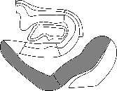 | Anterior CA1/SUB  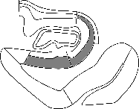
 |  | R  (p) | R  (p)
Thickness (mm) | BA35 | -0.57  (0.33) | -0.39  (0.23)
Thickness (mm) | ERC | -0.34  (0.28) | -0.10  (0.76)
Thickness (mm) | Anterior CA1 pyramidal cell layer | -0.70  (0.01) | -0.32  (0.31)
Thickness (mm) | Anterior CA1 Alveus | 0.38  (0.31) | 0.16  (0.69)
Thickness (mm) | Anterior CA1 SRLM | -0.34  (0.38) | -0.31  (0.41)
Thickness (mm) | Anterior SUB Pyramidal cell layer | 0.03  (0.92) | 0.10  (0.81)
Thickness (mm) | Anterior SUB SLM | -0.72  (0.005) | -0.59  (0.03)
Thickness (mm) | Anterior CA3 pyramidal cell layer | 0.18  (0.55) | 0.01  (0.97)
Thickness (mm) | Anterior CA3 Alveus | -0.09  (0.77) | 0.11  (0.72)
Thickness (mm) | Anterior CA3 SRLM | 0.03  (0.92) | 0.17  (0.56)
Thickness (mm) | Anterior DG GCL | -0.12  (0.75) | 0.05  (0.89)
Thickness (mm) | Anterior DG ML | -0.54  (0.11) | -0.57  (0.09)
Thickness (mm) | Posterior CA1 pyramidal cell layer | 0.12  (0.74) | -0.03  (0.93)
Thickness (mm) | Posterior CA1 Alveus | -0.48  (0.31) | 0.03  (0.93)
Thickness (mm) | Posterior CA1 SRLM | 0.45  (0.19) | 0.53  (0.12)
Thickness (mm) | Posterior SUB Pyramidal cell layer | -0.03  (0.94) | 0.10  (0.81)
Thickness (mm) | Posterior SUB SLM | -0.36  (0.34) | -0.31  (0.42)
Thickness (mm) | Posterior CA3 pyramidal cell layer | 0.25  (0.55) | 0.22  (0.60)

Supplementary Table 3: Partial Spearman correlations between MTL subregions thickness and NFTs density in ERC/BA35 and anterior CA1/SUB. The regions where NFT density was measured are displayed in grey as part of the column titles. Cells with p < 0.1 are highlighted in bold to indicate trends or marginal significance, while standard text indicates non-significant associations. Abbreviations: BA35; Brodmann area 35; CA, Cornu Amonis; DG, dentate gyrus; ERC, entorhinal cortex; GCL, granular cell layer; ML, molecular layer; SUB: subiculum S(R)LM, stratum (radiatum) lacunosum moleculare.

The main manuscript includes a partial correlation analysis between thickness and NFT density (Main Figure 5). However, as we are here focusing on very early tau pathology cases, we added a partial correlation analysis between thickness and pretangle density.
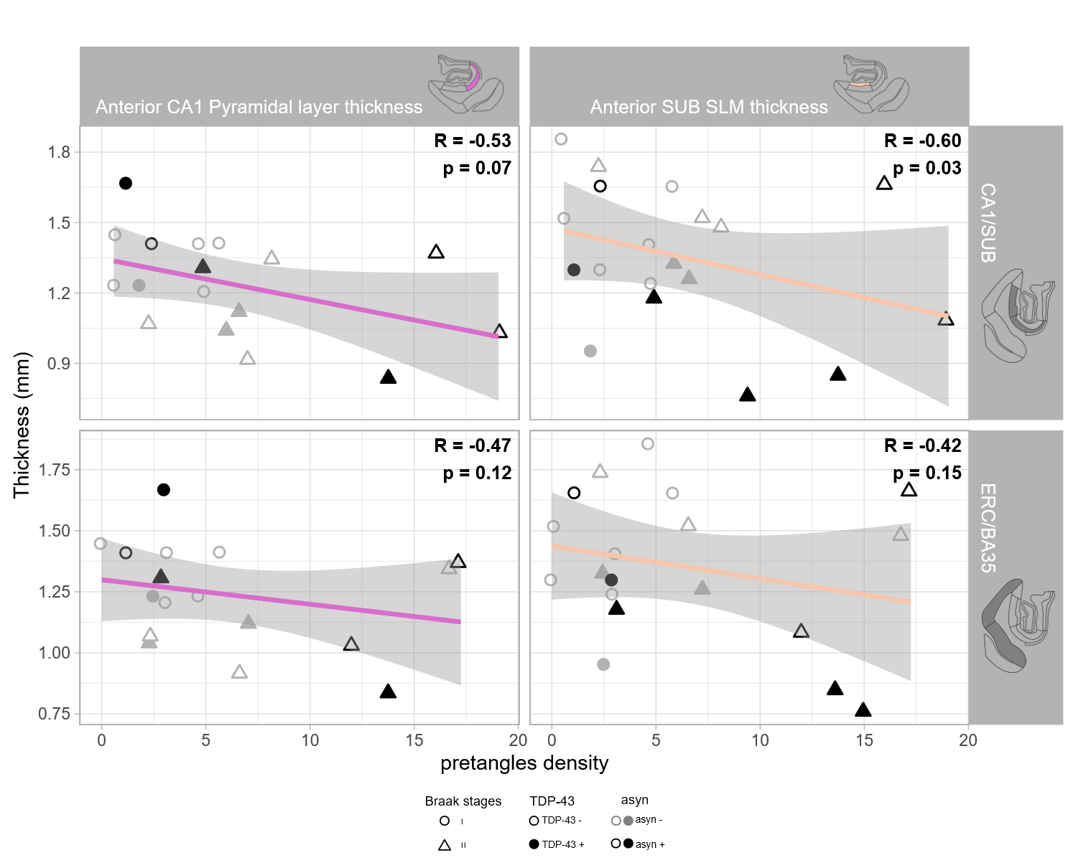
Supplementary Figure 3 : Correlations between MTL subregion thickness and pretangles density in ERC/BA35 (Braak I region) and CA1/SUB (Braak II region). Raw data are shown, while partial Spearman correlations were computed. Colors indicate the different regions where thickness was measured and are also represented graphically in the column titles. The regions where NFT density was measured are displayed in grey as part of the raw titles. Individual data points are coded by Braak stage (circles for stage I, triangles for stage II), TDP-43 status (empty for negative, filled for positive), and α-synuclein status (grey for negative, black for positive). Abbreviations: BA35; Brodmann area 35; CA, Cornu Amonis; ERC, entorhinal cortex; SLM, stratum lacunosum moleculare.

References
1. Berron D, Vieweg P, Hochkeppler A, Pluta JB, Ding S-L, Maass A, Luther A, Xie L, Das SR, Wolk DA, Wolbers T, Yushkevich PA, Düzel E, Wisse LEM (2017) A protocol for manual segmentation of medial temporal lobe subregions in 7 Tesla MRI. NeuroImage Clin 15:466–482. doi: 10.1016/j.nicl.2017.05.022
2. Yushkevich PA, Piven J, Hazlett HC, Smith RG, Ho S, Gee JC, Gerig G (2006) User-guided 3D active contour segmentation of anatomical structures: Significantly improved efficiency and reliability. NeuroImage 31:1116–1128. doi: 10.1016/j.neuroimage.2006.01.015

