Supplementary Information

Supplementary Note: Materials and Methods

Characterization of hydroxyapatite nanoparticles
The hydrodynamic diameter and zeta potential of the nHAp were assessed through dynamic light scattering (DLS) on a Zetasizer Nano ZS (Malvern Panalytical, Worchestershire, UK). Quantitative multi-elemental analysis using inductively coupled plasma mass spectrometry (ICP-MS) was done on a 7900 ICP-Q-MS (Agilent Technologies, Santa Clara, CA, USA) to determine the elemental composition of the nanoparticles. The mineral composition of the bottom-up synthesized particles was examined using X-ray diffraction (XRD). XRD patterns were collected using an Aeris diffractometer (Malvern Panalytical) operated at 40 kV and 15 mA with Cu Kα radiation (λ = 1.5418 Å, 2θ range 10° to 60° with a step of 2θ = 0.02°, scan speed 0.04° s⁻¹). Morphology and size of the bottom-up synthesized nHAp were assessed using a transmission electron microscope (TEM). 2 µl of the nHAp solution was spread on a Formvar/carbon-coated copper grid, air-dried for 24 hours at room temperature, and imaged with a 120-kV Talos L120C Electron Microscope (Thermo Fisher Scientific, Waltham, MA, USA), equipped with a Velox software and Ceta 16M camera (Thermo Fisher Scientific). Nanoparticle length and width distributions were determined from TEM images using ImageJ software.
The citrate content of the bottom-up synthesized particles was quantified using thermogravimetric analysis (TGA). This was done both for particles dialyzed in an ammonium citrate buffer and for particles that had been dialyzed in water to remove free citrate ions from the suspension. Prior to the analysis, nHAp suspensions were dried into a powder in a rotary evaporator. The TGA was carried out up to 750 °C at a heating rate of 5 K min⁻¹ in a dynamic atmosphere consisting of air at normal pressure in a model STA 449C (NETZSCH-Gerätebau GmbH, Selb, Germany). The air flow was set to 40 mL min⁻¹. The crucibles (6 mm diameter and 3 mm depth) were made of alumina. Buoyancy corrections were performed using data recorded on empty crucibles. The dried nHAp powder was not compacted. To estimate the percentage of organic material, a sample of powders without surface functionalization was measured and its TGA trace subtracted from those of the other samples. This was done to avoid including the intrinsic mass loss of hydroxyapatite (about 2.5% at 750 °C).

Dissolution assay
3 mL of nHAp (in 100 mM ammonium citrate, pH 9) of known P content was added into a SnakeSkin® dialysis tube with 3.5 kDa MWCO. The dialysis tube was closed and put into a BlueCap flask filled with 200 mL of 50 mM ammonium acetate buffer of either pH 4, 5, 6, 7, or 50 mM ammonium citrate pH 9 as a control. All treatments were done in quadruplicates. The flasks were neatly closed to avoid evaporation and incubated on a magnetic stirrer. 50 µL samples were taken from the dissolution buffers after 0 h, 30 min, 1, 2, 4, 6, 8, 24, 30, 48, and 72 h. The P concentration in the samples was determined using the molybdenum-blue method. Samples were diluted with Milli-Q water to obtain a final P concentration within the linear range of the assay (0-8 mg P L⁻¹). A standard P calibration curve was made by diluting a KH₂PO₄ solution of known P concentration.

Rhizobox experiment
We cultivated spring barley (Hordeum vulgare L., KWS cv. Irina) in rhizoboxes and applied radioisotope-labelled nHAp and Pi to study the uptake and distribution of the added P. We used the CRUCIAL soil mixed with sand in a 3:1 ratio based on weight. N-K fertilizer (Yara Danmark, Fredericia, Denmark) equivalent to 300 mg N kg⁻¹ soil was added and additional N (15 mg kg⁻¹), in the form of NH₄NO₃, was added to the Pi treatments to compensate for the N content of the nHAp suspension. The soil was pre-incubated with water for two weeks at 30% water holding capacity (WHC). An equivalent of 2.2 kg dry soil was packed into rhizoboxes (40 x 20 x 2 cm). A layer of cellophane was placed between the soil and the acrylic glass plate to prevent root damage whenever the glass plate was removed during imaging. Barley seeds were germinated in vermiculite for five days before being transplanted, one plant per box. Germination and growth took place in a greenhouse at 20/16 °C minimum day/night temperatures and 16/8-hour day/night light cycles. Relative humidity was kept at ~60% and minimum light intensity at 300 μmol photons m⁻² s⁻¹.
The bottom of each rhizobox had two openings, allowing a fleece wick to be placed in the bottom to soak up water from a plastic tray in which it was standing. The rhizoboxes were kept in racks, holding them at a 45° angle to promote root growth along the acrylic glass plate. An opaque plastic cover was placed on the acrylic glass during growth to protect the roots from light exposure. Watering was done by filling the trays with water, allowing the boxes to soak up water, and draining the trays the following day. Moisture levels were maintained at approximately 60% WHC during the experiment, with random sampling to check the weight.
The fertilizer solutions were both spiked with a β-emitting P radioisotope (³³P) to allow for radioactive imaging (autoradiography). As described in section 2.1, phosphoric acid containing ³³P was added during the bottom-up nHAp synthesis so it would be incorporated into the mineral structure. It was also added to the Pi solution (K₂HPO₄, pH 7) prior to soil application to ensure equilibrium between the stable P isotope (³¹P) and ³³P. Both liquids contained a ³³P activity of 370 kBq mL⁻¹. The quantity of P added as ³³P (= 0.11 ng P per rhizobox) was negligible from a nutritional perspective considering the total amount of P applied. 8 mL of fertilizer (= 22 mg P kg⁻¹ dry soil) were applied to the soil in a broad band approximately 5 cm from the bottom of the rhizobox. This P application rate is closer to standard agricultural practices (~24 kg P ha⁻¹, assuming 1.1 g cm⁻³ soil bulk density in the top 10 cm) compared to quantities used in many other nHAp studies (~165 kg P ha⁻¹). The dose was also chosen to avoid oversaturating the soil with moisture upon application.
In two control treatments, a root-impermeable polyester filter was placed 8 cm from the bottom of the rhizobox. The P fertilizers were applied below the filter, so roots were prevented from coming into direct contact with the fertilizers. These controls were made to assess upwards movement of fertilizer-P via water crossing the filter barrier. All treatments were performed in triplicate.

Radioactive imaging and elemental analysis
Autoradiography is a non-destructive method, and storage phosphor screens (Molecular Dynamics, Sunnyvale, CA, USA) were used throughout the experiment to detect the distribution of ³³P in the soil and roots. However, it was only possible to have sufficiently long screen-exposure time, obtaining a detailed image of the root system, after harvesting the shoots to avoid excessive stress on the roots. The shoot biomass was harvested after 5 weeks. This timeframe was chosen because it covers growth stages where spring barley has a high sensitivity to P deficiency and because ³³P has a half-life of 25.34 days, we needed to ensure that there would still be a significant radioactive signal at harvest. Roots and soil still contained in the rhizoboxes were scanned with a large phosphor screen, while harvested shoots from the same rhizoboxes were scanned with four smaller screens. The screen exposure time started at 48 hours for the first rhizoboxes and increased for the following measurements to compensate for the decay of the radioisotope. In addition to the cellophane already present to protect the roots, contamination of the screens was prevented by covering them in a thin layer of plastic film. The screens were scanned on a Typhoon IP Phosphorimager (Amersham BioSciences, Buckinghamshire, UK) with 25 µm resolution. The resulting digital images were analysed using the associated software ImageQuaNT™. After exposure to radioactivity, the screens were reset through constant white light exposure on an Image Eraser (Molecular Dynamics) for 1 hour, after which the screens could be used for new measurements.
While the images obtained with autoradiography provide qualitative and semi-quantitative information about ³³P distribution in soil, roots and shoots, a liquid scintillation counter (LSC) was used to quantitatively assess ³³P contents in the shoots. The harvested biomass was dried at 60 °C and homogenized by zirconium balls in a paint-shaker. 150-250 mg of each sample was weighed prior to microwave-digestion with 70% HNO₃ and 15% H₂O₂. The samples were diluted with Milli-Q water before further analysis. A small quantity (0.5-5 mL) of the digested plant material was mixed with 15 mL of scintillation cocktail (UltimaGold™, PerkinElmer) and measured in duplicate on a Packard 1900 TR LSC (PerkinElmer, Waltham, MA, USA). The remainder of the digested material was used for ICP-OES analysis for measurement of the total P content. By quantifying total P and radioisotope P (³³P) in the biomass, it was possible to distinguish P derived from the soil and the fertilizer, respectively. The specific activity in the shoot (kBq mg⁻¹ P), the amount of P in the shoot derived from the applied fertilizer (%) and the recovery of ³³P (%) was calculated according to the equations described in Koch et al. (2019).

Sequential chemical extraction of phosphorus
Chemical P extractions were done according to a modified version of Hedley, Stewart and Chauhan (Hedley et al. 1982). The extractants used were Milli-Q water, 0.5 M NaHCO₃ (pH 8.5), 0.1 M NaOH and 1 M HCl. The weaker extraction agents are meant to capture P in the soil solution, while stronger extractants are meant to assess the P fractions that buffer the soil solution P (Zehetner et al. 2018). In the case of the Hedley-protocol, the P fractions are considered as: 1) loosely bound/labile species (extracted with water and NaHCO₃), 2) moderately labile species bound to Al- and Fe-minerals (extracted with NaOH) and 3) low-lability species bound to Ca- and Mg-minerals (extracted with HCl).
After 1, 3 and 7 weeks a soil sample equivalent to 0.5 dry soil was weighed into a falcon tube and mixed with 30 mL of the first extractant (water) on an end-over-end shaker for 16 hours. This was followed by centrifugation on a Sigma 3-16L centrifuge (Sigma Laborzentrifugen GmbH, Osterode am Harz, Germany) for 30 min at 3606 rpm and 4 °C. The supernatant was filtered through a Whatman filter paper (no. 5) into a new falcon tube and stored in the fridge for maximum 24 hours. The remaining soil pellet was resuspended in 30 mL of the next extractant (sodium bicarbonate), before shaking for 16 hours. This procedure was repeated for all four extractants. The P concentrations in the extracts were measured using the molybdenum-blue method. NaHCO₃ and NaOH extracts were acidified using 1.5 M and 0.5 M H₂SO₄, respectively, before measuring the P concentrations.

Supplementary Figures and Tables

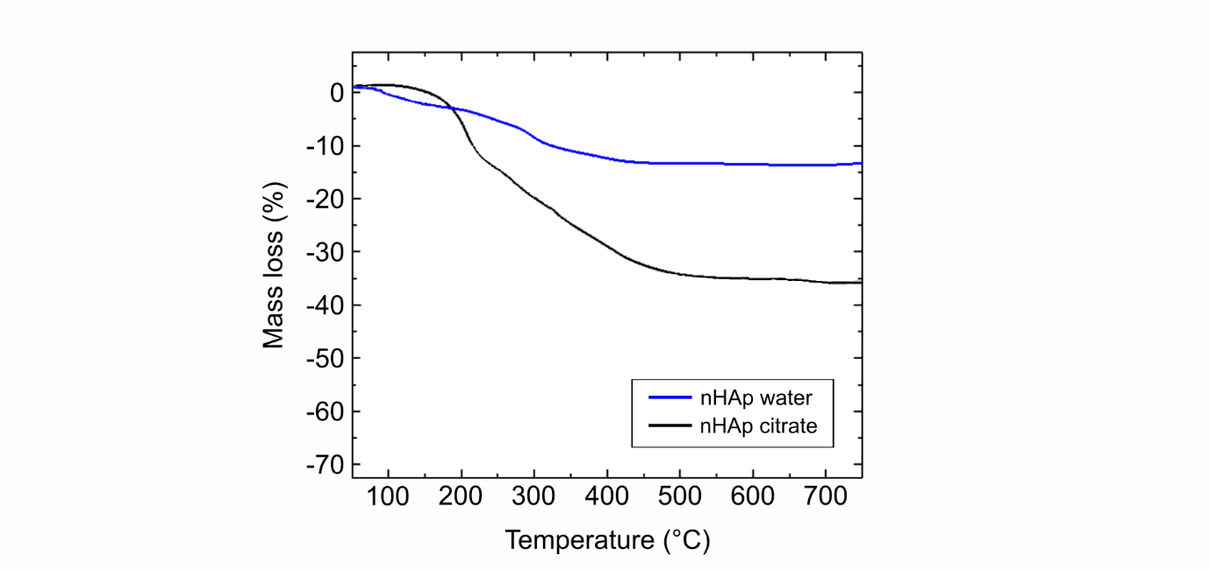
Fig. S1. Thermogravimetry measurements of the mass loss (%) of organic material from nano-hydroxyapatite (nHAp) dialyzed in water and 50 mM ammonium citrate.

Table S1. Soil properties of the three soils from Northern Jutland. Values are means (n = 4).
Soil characteristics | NJ1 | NJ2 | NJ3
pH | 5.2 | 4.7 | 5.7
Olsen-P (mg kg⁻¹) | 41 | 44 | 39
DGT-P (µg P L⁻¹) | 409 | 450 | 291
K (mg 100 g⁻¹) | 15.8 | 9.9 | 14.3
Mg (mg 100 g⁻¹) | 3.3 | 3.1 | 5.7
Alox (mmol kg⁻¹) | 80 | 8.5 | 110
Feox (mmol kg⁻¹) | 32 | 28 | 22
Pox (mmol kg⁻¹) | 18 | 8.4 | 16
Texture (%):  - Clay  - Silt  - Fine sand  - Coarse sand  - Organic matter | 5.7  1.4  73.1  16.0  3.9 | 6.5  3.5  73.0  15.0  2.1 | 6.5  5.5  68.9  9.2  10.0
Soil type | Sand | Sand | Loamy sand

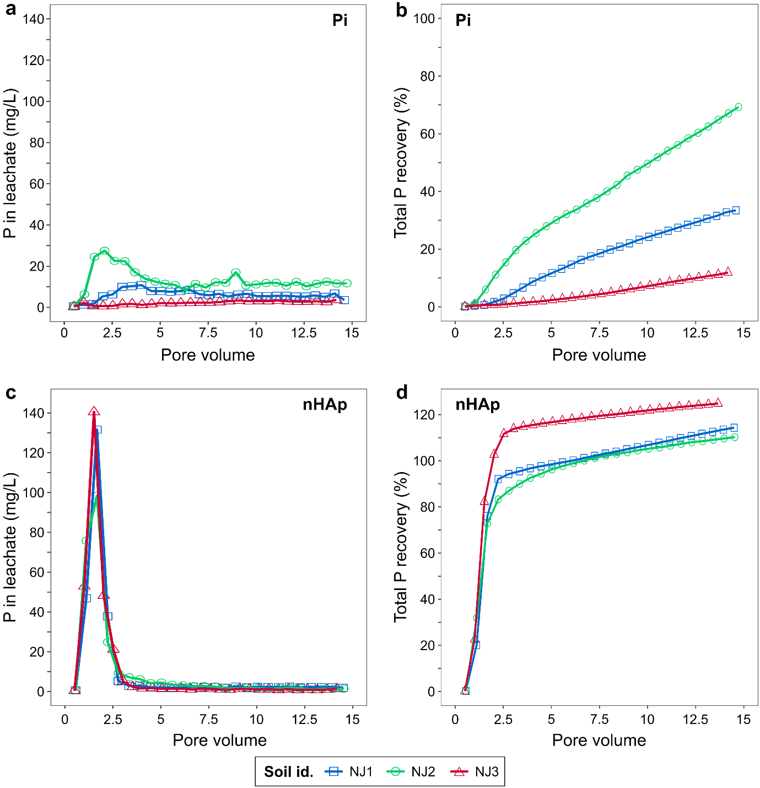
Fig. S2. Phosphorus (P) concentration (mg L⁻¹) in leachate (a, c) and cumulative recovery of applied P (%) (b, d) as a function of pore volumes in sandy soil columns (NJ1, NJ2, NJ3). Columns were treated with Pi (a, b) or nano-hydroxyapatite (nHAp) (c, d). Results are means (n = 3).

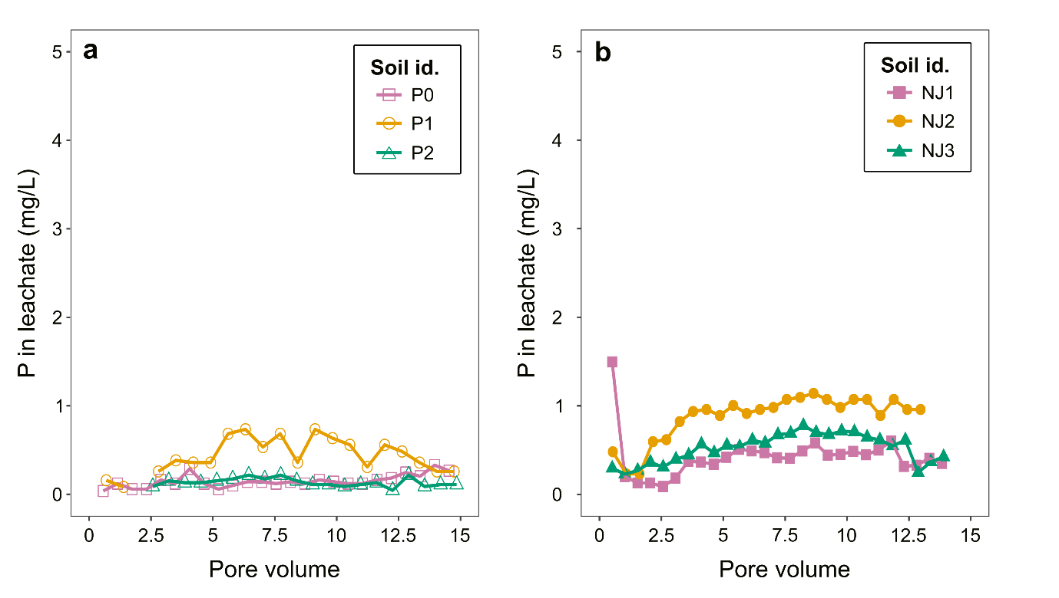
Fig. S3. Phosphorus (P) concentration in the leachate as a function of pore volumes leached through the control columns where no P fertilizer was added to P0, P1 and P2 (a) and NJ1, NJ2 and NJ3 (b). Values are means (n = 3).

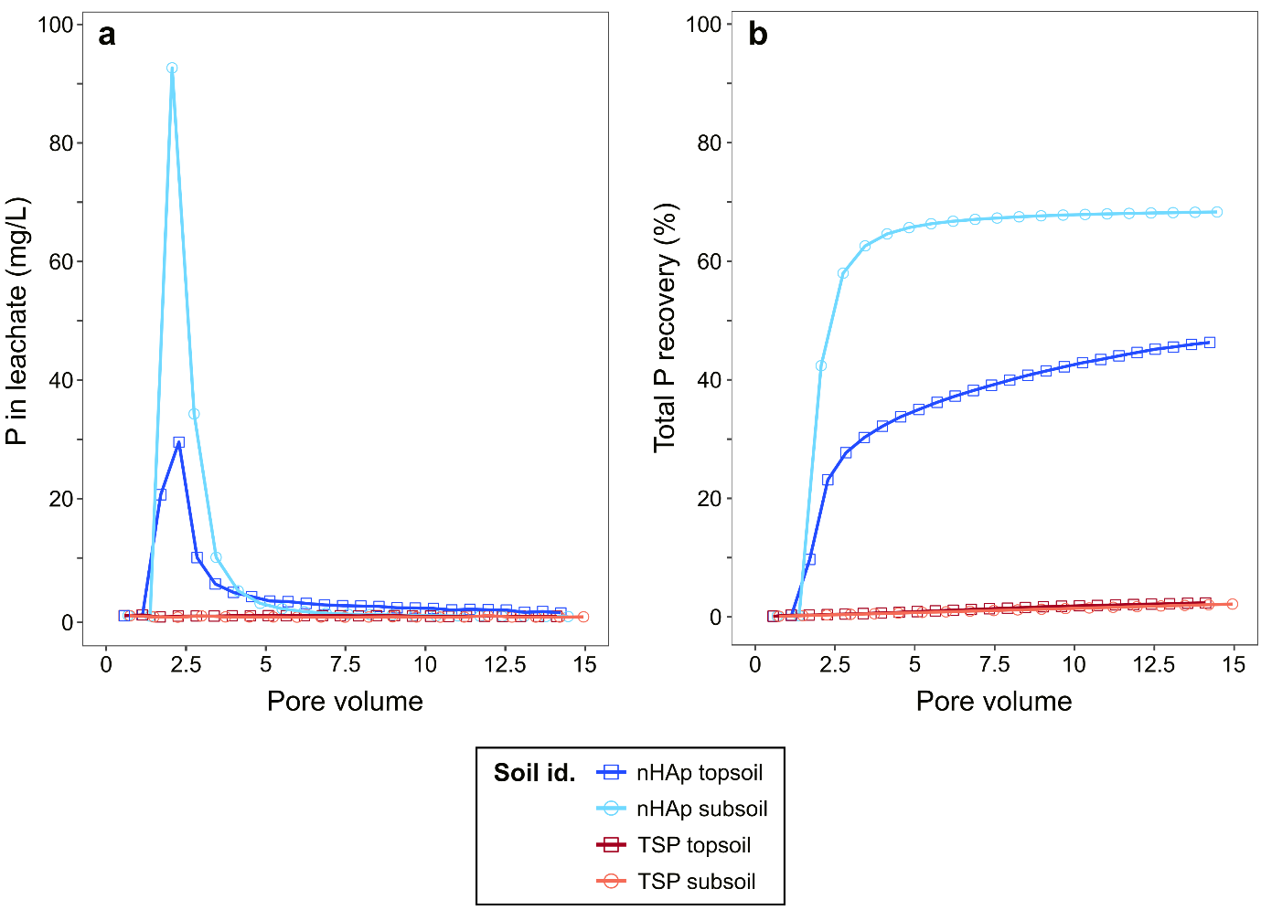
Fig. S4. Phosphorus (P) concentration (mg L⁻¹) in leachate (a) and cumulative recovery of applied P (%) (b) as a function of pore volumes in NJ3 topsoil and subsoil. Columns were treated with nano-hydroxyapatite (nHAp) and TSP. Results are means (n = 3).
Table S2. Dry weight of spring barley shoot biomass from the rhizobox experiment. Values are means (n = 3) ± standard error.
Treatment | Dry weight (g)
Pi | 4.78 ± 1.9
Pi w. filter | 5.30 ± 0.7
nHAp | 6.53 ± 1.7
nHAp w. filter | 5.58 ± 0.2

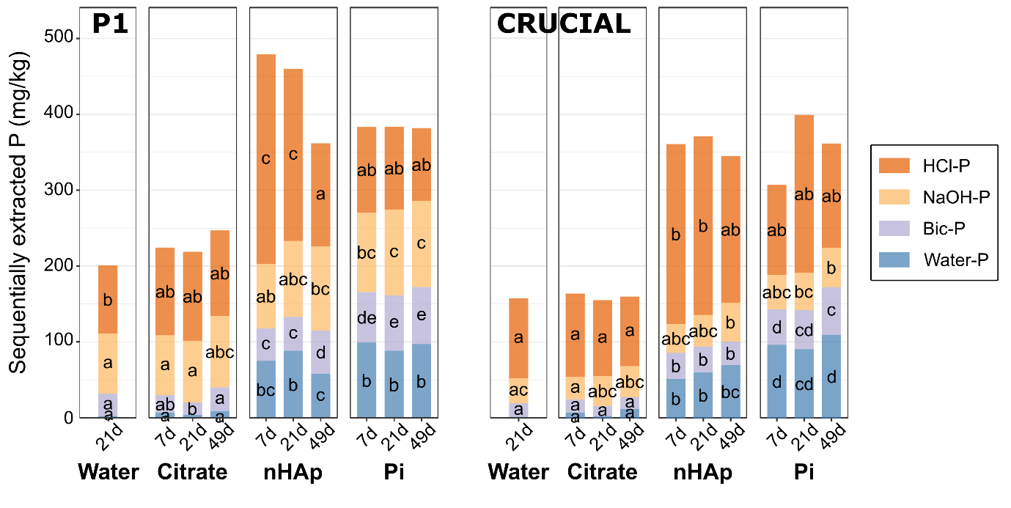
Fig. S5. Sequential chemical extractions of phosphorus (P) on P1 and CRUCIAL soils incubated with water, ammonium citrate, nano-hydroxyapatite (nHAp) or Pi, measured after 7, 21 and 49 days. Values are means (n = 4). Different letters indicate significant differences (p < 0.05) among fractions extracted from the same soil using the same extractant. Bic-P = bicarbonate-extractable P.
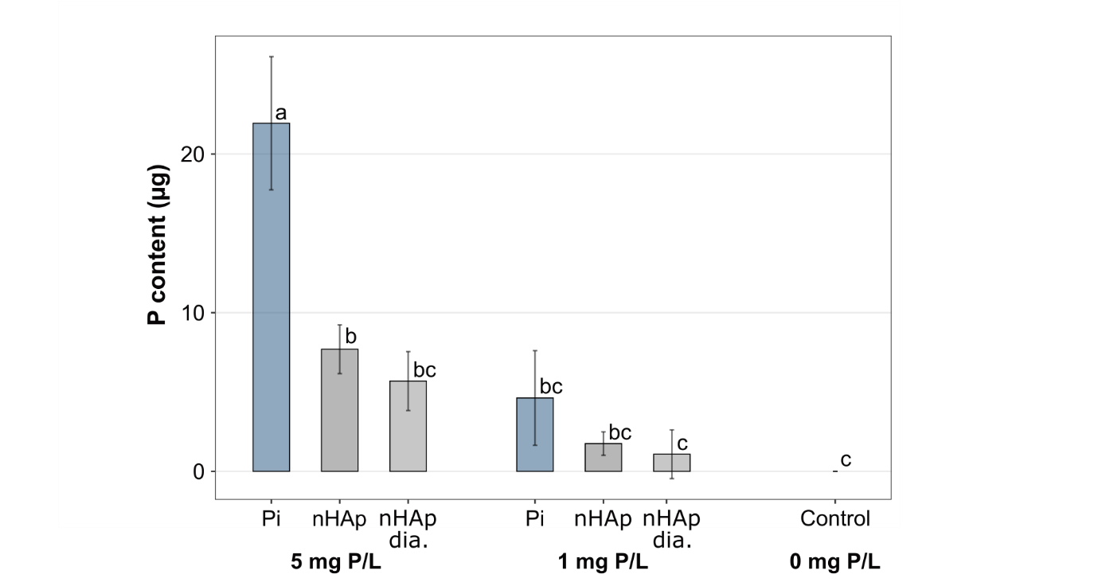
Fig. S6. Phosphorus (P) content (µg) of zirconium oxide binding gels treated with nano-hydroxyapatite (nHAp) and potassium phosphate (Pi) at different P concentrations: 5 mg/L and 1 mg/L. The negative control was water (0 mg P/L). Values are means (n = 3). Error bars show standard errors and different letters indicate significant differences (p < 0.05).

References
Hedley MJ, Stewart JWB, Chauhan BS. 1982. Changes in Inorganic and Organic Soil Phosphorus Fractions Induced by Cultivation Practices and by Laboratory Incubations. Soil Sci Soc Am J. 46(5):970–976. https://doi.org/10.2136/SSSAJ1982.03615995004600050017X
Koch M, Guppy C, Amelung W, Gypser S, Bol R, Seidel S, Siebers N. 2019. Insights into 33phosphorus utilisation from Fe-and Al-hydroxides in Luvisol and Ferralsol subsoils. Soil Res. 57(5):447–458. https://doi.org/10.1071/SR18223
Zehetner,F, Wuenscher R, Peticzka R, Unterfrauner H. 2018. Correlation of Extractable Soil Phosphorus (P) with Plant P Uptake: 14 Extraction Methods Applied to 50 Agricultural Soils from Central Europe. Plant, Soil and Env, 4(4):192–201. https://doi.org/10.17221/70/2018-PSE

