Supplement:

Economic analysis for sustainable utilization of ethanol production residues from grain and inedible plant wastes

May-Suan Leeª, Andrew Hoadley^{a*}, Jim Patel^{b}, Seng Lim^{b}, Karen Kozielski^{b}, Chao’en Li^{b*}

ªSchool of Chemical Engineering, Monash University, Clayton, Victoria 3168, Australia.
^{b}CSIRO Energy, 71 Normanby Road, Clayton North, Victoria 3169, Australia.

*Corresponding authors:

Andrew Hoadley: School of Chemical Engineering, Monash University, Clayton, Victoria 3168, Australia. Telephone: +61 3 99053421; e-mail: Andrew.Hoadley@monash.edu

Chao’en Li: CSIRO Energy, 71 Normanby Road, Clayton North, Victoria 3169, Australia. Telephone: +61 3 9545 8335; Fax: +61 3 9545 8380; e-mail: Chaoen.Li@csiro.au

The distribution of various amino acids was reported by Kim et al. [35]. The amino acids as well as other species were listed in Table S1.
Table S1: Species applied in anaerobic digestion of WDGS
Name | Formula | Structure | M (g/mol)
Gas components
Hydrogen | H₂ | - | 2.02
Methane | CH₄ | - | 16.04
Ammonia | NH₃ | - | 17.03
Hydrogen sulphide | H₂S | - | 34.08
Carbon dioxide | CO₂ | - | 44.01
Methanethiol | CH₄S | 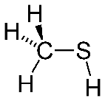 | 48.11
Liquid components
Water | H₂O | - | 18.01
Formamide | CH₃NO | 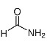 | 45.04
Acetic acid | C₂H₄O₂ | 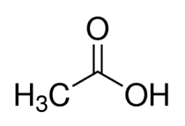 | 60.05
Propionic acid | C₃H₆O₂ | 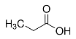 | 74.08
Glycine | C₂H₅NO₂ | 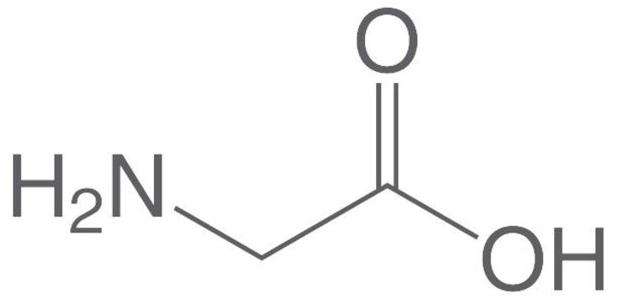 | 75.07
Benzene | C₆H₆ | 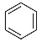 | 78.11
N-butyric acid | C₄H₈O₂ | 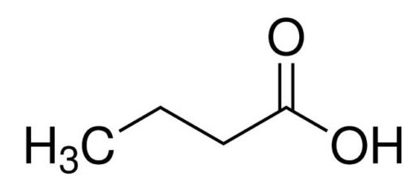 | 88.10
Iso-butyric acid | C₄H₈O₂ | 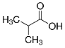 | 88.10
L-alanine | C₃H₇NO₂ | 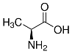 | 89.09
Glycerol | C₃H₈O₃ | 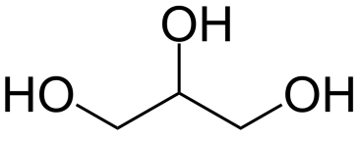 | 92.09
Phenol | C₆H₆O | 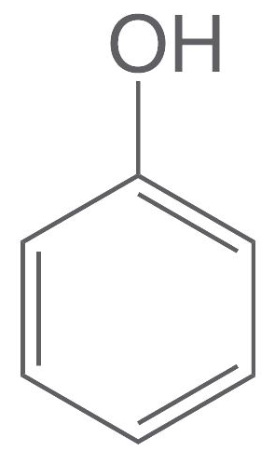 | 94.11
Isovaleric acid | C₅H₁₀O₂ | 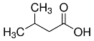 | 102.13
2-methylbutyric acid | C₅H₁₀O₂ | 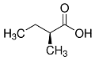 | 102.13
L-serine | C₃H₇NO₃ | 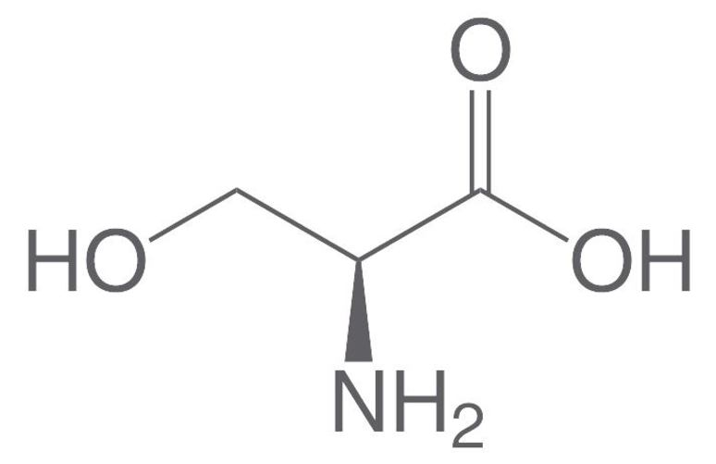 | 105.09
Ethyl cyanoacetate | C₅H₇NO₂ | 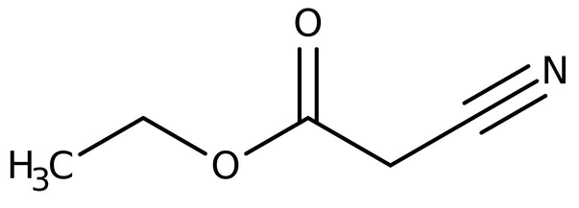 | 113.11
L-Proline | C₅H₉NO₂ | 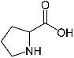 | 115.13
L-valine | C₅H₁₁NO₂ | 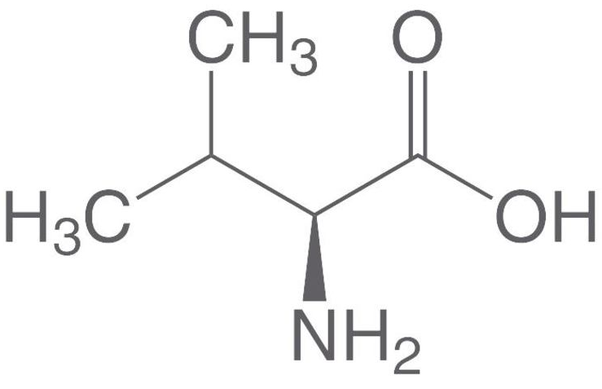 | 117.15
Indole | C₈H₇N | 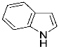 | 117.15
Threonine | C₄H₉NO₃ | 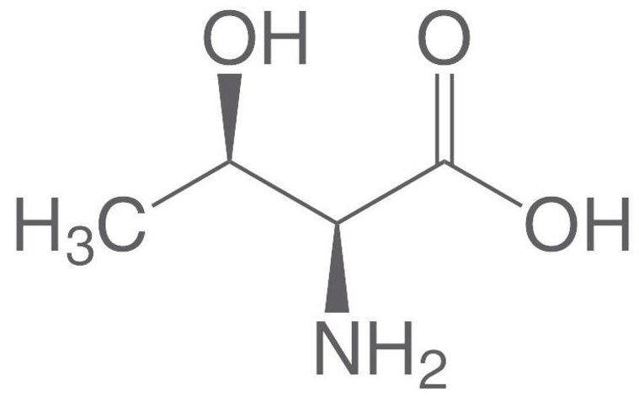 | 119.12
L-Hydroxyproline | C₅H₉NO₃ | 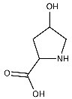 | 131.13

Table S1: Species applied in anaerobic digestion of WDGS (continue)

Name | Formula | Structure | M (g/mol)
Liquid components
Leucine | C₆H₁₃NO₂ | 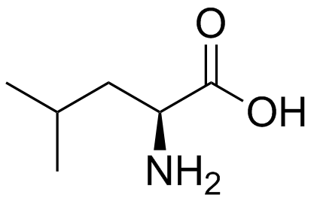 | 131.17
L-isoleucine | C₆H₁₃NO₂ | 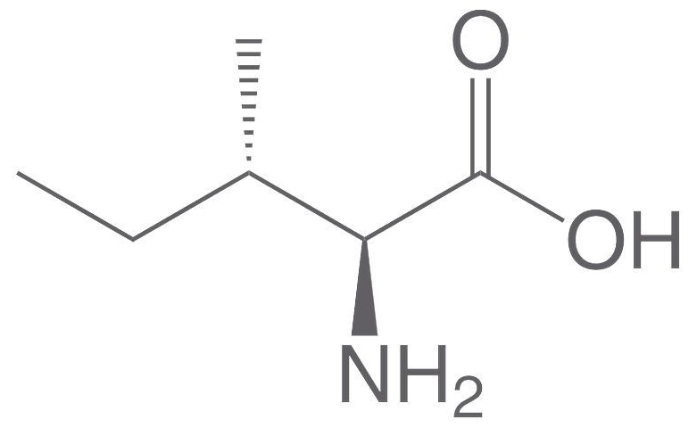 | 131.17
L-Ornithine | C₅H₁₂N₂O₂ | 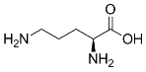 | 132.16
L-aspartic acid | C₄H₇NO₄ | 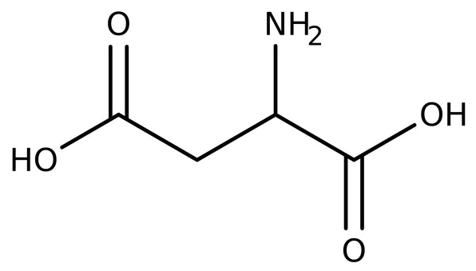 | 133.10
L-lysine | C₆H₁₄N₂O₂ | 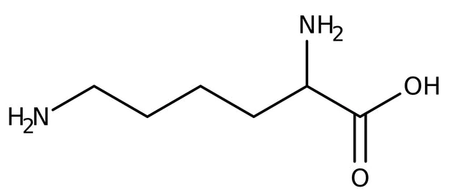 | 146.19
L-glutamic acid | C₅H₉NO₄ | 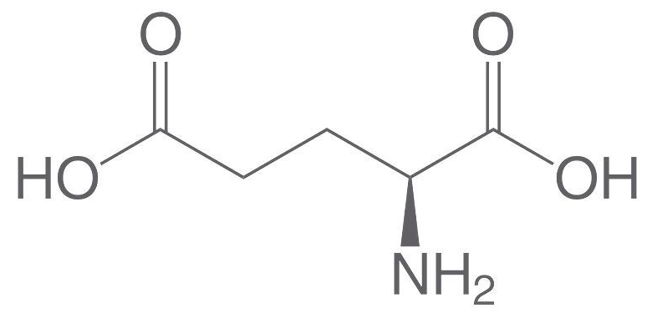 | 147.13
L-methionine | C₅H₁₁NO₂S | 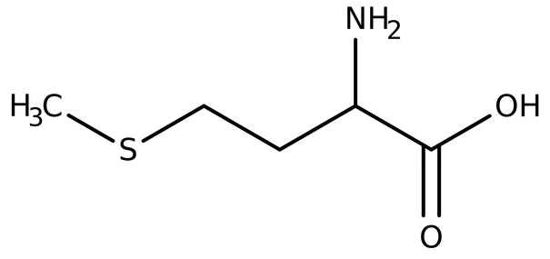 | 149.21
L-Histidine | C₆H₉N₃O₂ | 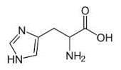 | 155.15
L-phenylalanine | C₉H₁₁NO₂ | 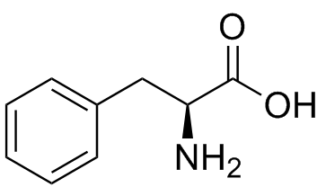 | 165.19
L-arginine | C₆H₁₄N₄O₂ | 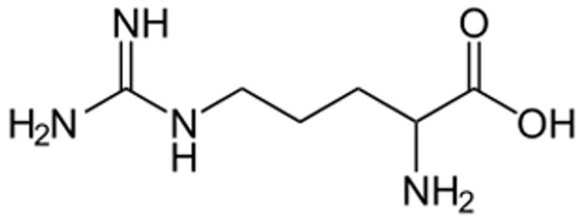 | 174.20
Dextrose | C₆H₁₂O₆ | 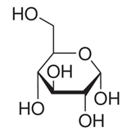 | 180.15
Glucose | C₆H₁₂O₆ | 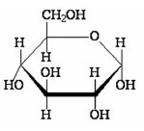 | 180.15
Fructose | C₆H₁₂O₆ | 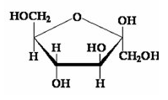 | 180.15
L-tyrosine | C₉H₁₁NO₃ | 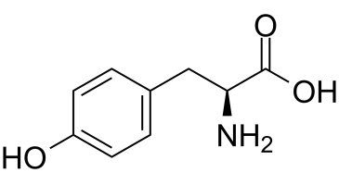 | 181.19
Tryptophan | C₁₁H₁₂N₂O₂ | 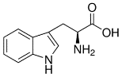 | 204.22
L-Lanthionine | C₆H₁₂N₂O₄S | 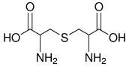 | 208.23
Cystine | C₆H₁₂N₂O₄S₂ | 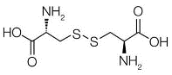 | 240.30
Oleic acid | C₁₈H₃₄O₂ | 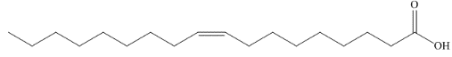 | 282.46

Note: L represents the -NH₂ group is linked on the α carbon that attaches to the acidic functional group (-COOH).

Table S2: Composition of the liquid stream after hydrolysis in this study
Name | Formula | M (g/mol) | C (mol%) | C (wt%)
Carbon dioxide | CO₂ | 44.01 | 0.04 | 0.07
Water | H₂O | 18.01 | 94.39 | 64.45
Glycine | C₂H₅NO₂ | 75.07 | 0.53 | 1.51
Alanine | C₃H₇NO₂ | 89.09 | 0.13 | 0.43
Serine | C₃H₇NO₃ | 105.09 | 0.08 | 0.32
L-proline | C₅H₉NO₂ | 115.13 | 0.13 | 0.58
Valine | C₅H₁₁NO₂ | 117.15 | 0.10 | 0.44
Threonine | C₄H₉NO₃ | 119.12 | 0.07 | 0.33
L-hydroxyproline | C₅H₉NO₃ | 131.13 | 0.01 | 0.03
Leucine | C₆H₁₃NO₂ | 131.17 | 0.22 | 1.09
Isoleucine | C₆H₁₃NO₂ | 131.17 | 0.07 | 0.36
L-ornithine | C₅H₁₂N₂O₂ | 132.16 | 0.01 | 0.03
Aspartic acid | C₄H₇NO₄ | 133.10 | 0.11 | 0.57
Lysine | C₆H₁₄N₂O₂ | 146.19 | 0.07 | 0.37
L-glutamic acid | C₅H₉NO₄ | 147.13 | 0.22 | 1.22
L-histidine | C₆H₉N₃O₂ | 155.15 | 0.05 | 0.31
L-phenylalanine | C₉H₁₁NO₂ | 165.19 | 0.09 | 0.58
Arginine | C₆H₁₄N₄O₂ | 174.20 | 0.09 | 0.61
Dextrose | C₆H₁₂O₆ | 180.15 | 2.92 | 19.95
Tyrosine | C₉H₁₁NO₃ | 181.19 | 0.08 | 0.55
Tryptophan | C₁₁H₁₂N₂O₂ | 204.22 | 0.01 | 0.10
Oleic acid | C₁₈H₃₄O₂ | 282.46 | 0.57 | 6.12

Note: L represents the -NH₂ group is linked on the α carbon that attaches to the acidic functional group (-COOH).

Table S3: Anaerobic digestion reactions applied in simulation

Acidogenesis
R8 | $$C_{11}H_{12}N_{2}O_{2}\left(Tryptoph\right)+2H_{2}O→C_{8}H_{7}N\left(Indole\right)+C_{2}H_{4}O_{2}(Acetic acid)+CO_{2}+NH_{3}+H_{2}$$
R9 | $$C_{9}H_{11}NO_{3}\left(Tyrosine\right)+2H_{2}O→C_{6}H_{5}OH\left(Phenol\right)+C_{2}H_{4}O_{2}+CO_{2}+NH_{3}+H_{2}$$
R10 | $$C_{9}H_{11}NO_{2}\left(L-Phenylalanine\right)+2H_{2}O→C_{6}H_{6}\left(Benzene\right)+C_{2}H_{4}O_{2}+CO_{2}+NH_{3}+H_{2}$$
R11 | $$2C_{6}H_{14}N_{4}O_{2}\left(Arginine\right)+6H_{2}O+2H_{2}→C_{5}H_{10}O_{2}\left(Isovaleric acid\right)+C_{3}H_{6}O_{2}\left(Propionic acid\right)+C_{2}H_{4}O_{2}+2CO_{2}+8NH_{3}$$
R12 | $$C_{6}H_{14}N_{2}O_{2}\left(Lysine\right)+2H_{2}O→C_{4}H_{8}O_{2}\left(N-Butyric acid\right)+C_{2}H_{4}O_{2}+2NH_{3}$$
R13 | $$C_{6}H_{13}{NO}_{2}(Leucine)+2H_{2}O→C_{5}H_{10}O_{2}(Isovaleric acid)+CO_{2}+NH_{3}+2H_{2}$$
R14 | $$C_{6}H_{13}{NO}_{2}(Isoleucine)+2H_{2}O→C_{5}H_{10}O_{2}(Isovaleric acid)+CO_{2}+NH_{3}+2H_{2}$$
R15 | $$C_{5}H_{12}N_{2}O_{2}\left(L-Ornithithine\right)+2H_{2}O→C_{4}H_{8}O_{2}\left(N-Butyric acid\right)+CO_{2}+2NH_{3}+H_{2}$$
R16 | $$C_{5}H_{11}NO_{2}S\left(Methionine\right)+2H_{2}O→C_{3}H_{6}O_{2}+CH_{3}SH\left(Methanethiol\right)+CO_{2}+NH_{3}+H_{2}$$
R17 | $$C_{5}H_{11}{NO}_{2}(Valine)+2H_{2}O→C_{4}H_{8}O_{2}(Isobutyric acid)+CO_{2}+NH_{3}+2H_{2}$$
R18 | $$C_{6}H_{9}N_{3}O_{2}\left(L-Histidine\right)+6H_{2}O→C_{3}H_{6}O_{2}+3CO_{2}+3NH_{3}+3H_{2}$$
R19 | $${2C}_{5}H_{9}NO_{4}\left(L-Glutamic acid\right)+2H_{2}O→C_{4}H_{8}O_{2}\left(N-Butyric acid\right)+2C_{2}H_{4}O_{2}+2CO_{2}+2NH_{3}$$
R20 | $$C_{5}H_{9}NO_{3}\left(L-Hydroxyproline\right)+H_{2}O→C_{4}H_{8}O_{2}\left(N-Butyric acid\right)+CO_{2}+NH_{3}$$
R21 | $$C_{5}H_{9}NO_{2}\left(L-Proline\right)+2H_{2}O→C_{4}H_{8}O_{2}\left(N-Butyric acid\right)+CO_{2}+NH_{3}+H_{2}$$
R22 | $$C_{4}H_{9}NO_{3}\left(Threonine\right)+H_{2}O→C_{3}H_{6}O_{2}+CO_{2}+NH_{3}+H_{2}$$
R23 | $$C_{4}H_{7}NO_{4}\left(Aspartic acid\right)+2H_{2}O→C_{2}H_{4}O_{2}+2CO_{2}+NH_{3}+{2H}_{2}$$
R24 | $$C_{3}H_{7}NO_{3}\left(Serine\right)+H_{2}O→C_{2}H_{4}O_{2}+CO_{2}+NH_{3}+H_{2}$$
R25 | $$C_{3}H_{7}NO_{2}\left(Alanine\right)+2H_{2}O→C_{2}H_{4}O_{2}+CO_{2}+NH_{3}+{2H}_{2}$$
R26 | $$4C_{2}H_{5}NO_{2}\left(Glycine\right)+2H_{2}O→3C_{2}H_{4}O_{2}+2CO_{2}+4NH_{3}$$

Table S3: Anaerobic digestion reactions applied in simulation (continue)

Acetogenesis and methanogenesis
R27 | $$C_{18}H_{34}O_{2}(Oleic acid)+10H_{2}O→12CH_{4}+6CO_{2}+3H_{2}$$
R28 | $$C_{8}H_{7}N\left(Indole\right)+8H_{2}O→4CH_{4}+4CO_{2}+NH_{3}+2H_{2}$$
R29 | $$C_{6}H_{12}O_{6}(Dextrose)→3CH_{4}+3CO_{2}$$
R30 | $$C_{6}H_{5}OH+5H_{2}O→3CH_{4}+3CO_{2}+2H_{2}$$
R31 | $$C_{6}H_{6}+6H_{2}O→3CH_{4}+3CO_{2}+3H_{2}$$
R32 | $$C_{5}H_{10}O_{2}(Isovaleric acid)+2H_{2}O→3CH_{4}+2CO_{2}+H_{2}$$
R33 | $$C_{5}H_{10}O_{2}(2-Methylbutyric acid)+2H_{2}O→3CH_{4}+2CO_{2}+H_{2}$$
R34 | $$C_{4}H_{8}O_{2}(N-Butyric acid)+2H_{2}O→2CH_{4}+2CO_{2}+2H_{2}$$
R35 | $$C_{4}H_{8}O_{2}(Isobutyric acid)+2H_{2}O→2CH_{4}+2CO_{2}+2H_{2}$$
R36 | $$C_{3}H_{8}O_{3}(Glycerol)+H_{2}O→CH_{4}+2CO_{2}+3H_{2}$$
R37 | $$C_{3}H_{6}O_{2}+2H_{2}O→CH_{4}+2CO_{2}+3H_{2}$$
R6 | $$C_{2}H_{4}O_{2}→CH_{4}+CO_{2}$$
R38 | $$CH_{3}SH+2H_{2}O→H_{2}S+2CO_{2}+3H_{2}$$
R7 | $CO_{2}+4H_{2}→CH_{4}+2H_{2}O$ ($CO_{2}$ conversion ratio = 0.93)

Table S4: Products of anaerobic digestion
 | Biogas | Liquid waste
Temperature (ºC) | 45.0 | 55.0
Pressure (bar) | 1.0 | 1.0
Mass Flows (tonnes/hour) | 42.5 | 51.6
Composition (mol%)
H₂ | 8.5 | 0.0
CH₄ | 42.0 | 0.1
NH₃ | 3.7 | 1.0
CO₂ | 36.5 | 0.3
H₂O | 9.2 | 98.6

S1. Aspen Plus flowsheet of different scenarios:
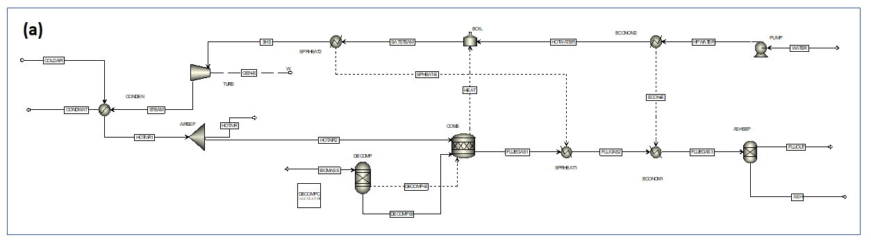
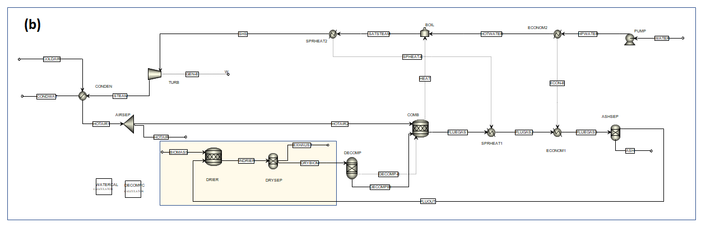
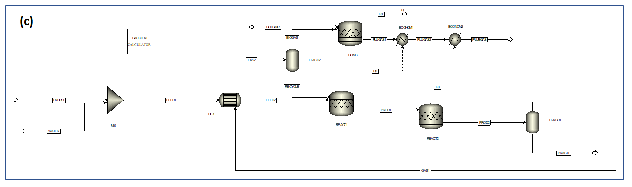
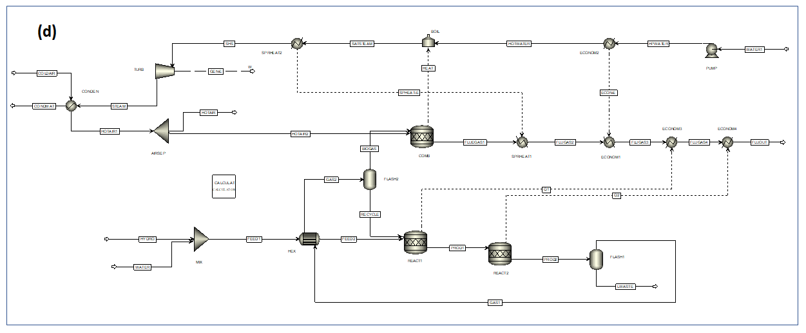

Figure S1 Aspen Plus flowsheets of different scenarios: (a) combustion of DDGS, (b) combustion of WDGS, (c) anaerobic digestion to produce heat, and (d) anaerobic digestion to produce electricity

