Supplementary Information

Supplementary analyses of participants who noticed the presence of idioms in Experiment 2
In Experiment 2, the post-experiment interview revealed that 18 of the 24 participants noticed the presence of idioms in the displays, but none correctly identified that the idioms appeared only within a single stream. We therefore repeated the analyses using data from these 18 participants to examine whether awareness of the presence of idioms affected the results. The results were consistent with those obtained from the full sample.
Overall attentional effect. When the idiom streams were presented, probe detection accuracy did not differ significantly between the structured and random streams, t(17) = 0.92, p = 0.37, Cohen’s d = 0.22, 95% CI for the mean difference [−0.01, 0.02], BF₁₀ = 0.35. Moreover, there was no significant difference in RTs, t(17) = 0.35, p = 0.73, Cohen's d = 0.08, 95% CI for the mean difference [−6.24, 8.72], BF₁₀ = 0.26 (Figure S1a), indicating that attention was not biased toward semantic regularities.
Intra-trial temporal dynamics. Analysis of the time course of the attentional effect within trials likewise revealed no significant cluster (Figure S1b).

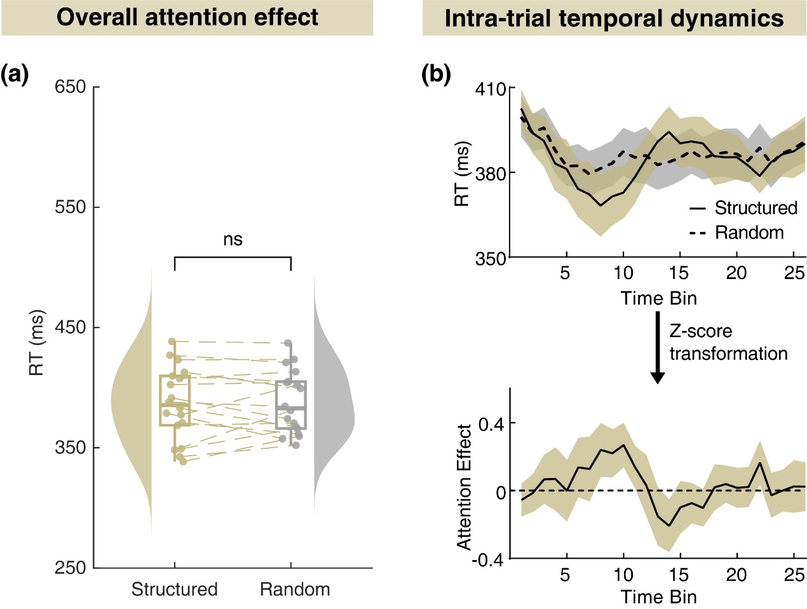
Figure S1. Results of the overall attentional effect and intra-trial temporal dynamics based on the 18 participants who noticed the presence of idioms in Experiment 2.
(a) Overall response times (RTs) in the structured and random conditions. Data are displayed as half-violin distributions, boxplots, individual dots, and paired connecting lines. ns, nonsignificant. (b) Intra-trial temporal dynamics of the attentional effect. Shaded areas indicate ±1 standard error of the mean (SEM).

