Supplementary Material
Community-based primary care and inpatient costs and length of stay in Henan, China: retrospective cohort study of 5.9 million older adults

Contents
eTables 1-11
eFigures 1-7
eTable 11. RECORD checklist

eTables
eTable 1. Full baseline characteristics with standardized mean differences.
Characteristic | Not enrolled | NEPHS enrolled | SMD
No. of admissions | 9,048,355 | 10,377,454 | —
Age, mean (SD) | 74.89 (7.30) | 73.15 (6.13) | 0.258
Sex: Male | 4,976,308 (55.0) | 4,980,655 (48.0) | 0.140
Female | 4,072,047 (45.0) | 5,396,799 (52.0) | —
Marital status: Married | 7,281,729 (80.5) | 8,648,624 (83.3) | 0.082
Widowed | 1,218,639 (13.5) | 1,124,627 (10.8) | —
Other | 547,987 (6.1) | 604,203 (5.8) | —
Insurance type: UEBMI | 2,594,491 (28.7) | 1,863,879 (18.0) | 0.341
URBMI | 2,086,937 (23.1) | 3,793,426 (36.6) | —
NRCMS | 2,697,101 (29.8) | 2,842,616 (27.4) | —
Self-pay | 700,457 (7.7) | 722,112 (7.0) | —
Other | 969,369 (10.7) | 1,155,421 (11.1) | —
Principal diagnosis category: Health-service factors | 1,180,407 (13.0) | 961,097 (9.3) | 0.250
Other | 39,242 (0.4) | 38,112 (0.4) | —
Endocrine | 253,264 (2.8) | 320,941 (3.1) | —
Respiratory | 1,092,062 (12.1) | 1,026,445 (9.9) | —
Circulatory | 2,924,628 (32.3) | 3,526,308 (34.0) | —
Infectious | 111,904 (1.2) | 130,848 (1.3) | —
Injury and musculoskeletal | 405,778 (4.5) | 616,777 (5.9) | —
Genitourinary | 283,591 (3.1) | 335,384 (3.2) | —
Digestive | 683,284 (7.6) | 842,084 (8.1) | —
Symptoms and signs | 207,630 (2.3) | 183,259 (1.8) | —
Skin | 36,788 (0.4) | 36,876 (0.4) | —
Eye and ear | 371,610 (4.1) | 688,502 (6.6) | —
Nervous system | 400,046 (4.4) | 572,091 (5.5) | —
Mental and behavioural | 58,794 (0.6) | 75,895 (0.7) | —
Musculoskeletal | 298,122 (3.3) | 520,013 (5.0) | —
Neoplasm | 532,648 (5.9) | 336,143 (3.2) | —
Blood and immune | 168,557 (1.9) | 166,679 (1.6) | —
Charlson comorbidity index, mean (SD) | 1.91 (1.82) | 1.56 (1.57) | 0.204
CCI category: CCI=0 | 2,016,360 (22.3) | 2,824,176 (27.2) | 0.173
CCI=1–2 | 4,660,268 (51.5) | 5,524,377 (53.2) | —
CCI≥3 | 2,371,727 (26.2) | 2,028,901 (19.6) | —
Surgical admission: No surgery | 6,685,372 (73.9) | 7,367,876 (71.0) | 0.065
Surgery | 2,362,983 (26.1) | 3,009,578 (29.0) | —
Admission year: 2019 | 1,459,745 (16.1) | 672,174 (6.5) | 0.667
2020 | 1,539,861 (17.0) | 867,707 (8.4) | —
2021 | 1,704,135 (18.8) | 1,153,712 (11.1) | —
2022 | 1,603,251 (17.7) | 1,532,085 (14.8) | —
2023 | 1,603,348 (17.7) | 2,762,247 (26.6) | —
2024 | 1,138,015 (12.6) | 3,389,529 (32.7) | —
Admission quarter: 1 | 2,208,968 (24.4) | 2,569,791 (24.8) | 0.014
2 | 2,317,835 (25.6) | 2,602,722 (25.1) | —
3 | 2,163,525 (23.9) | 2,471,078 (23.8) | —
4 | 2,358,027 (26.1) | 2,733,863 (26.3) | —
Region: Central | 1,597,851 (17.7) | 1,973,754 (19.0) | 0.199
East | 1,892,925 (20.9) | 2,406,292 (23.2) | —
West | 1,297,582 (14.3) | 849,830 (8.2) | —
North | 1,731,940 (19.1) | 2,204,147 (21.2) | —
South | 2,528,057 (27.9) | 2,943,431 (28.4) | —
Total inpatient cost (CNY), mean (SD) | 12,103.72 (21,926.19) | 10,123.27 (90,551.80) | 0.030
Length of stay (days), mean (SD) | 10.22 (10.31) | 8.92 (8.18) | 0.139
No. of admissions per patient, mean (SD) | 8.05 (8.63) | 6.32 (6.99) | 0.221
No. of diagnoses per admission, mean (SD) | 5.43 (3.48) | 5.16 (3.19) | 0.082
Note: Values are n (%) unless otherwise indicated. SMD=standardized mean difference. Baseline p values are omitted because SMDs are more informative in very large samples.

eTable 2. Primary and stepwise regression models.
Outcome | Specification | Coeff. | 95% CI | P value | N | Cost change
ln(total inpatient cost) | Crude (unadjusted) | −0.133 | −0.134, −0.131 | <0.001 | 19,425,809 | −12.4%
ln(total inpatient cost) | Model 1 (core confounders) | −0.105 | −0.106, −0.103 | <0.001 | 19,425,809 | −9.9%
ln(total inpatient cost) | Model 2 (+ CCI) | −0.071 | −0.073, −0.07 | <0.001 | 19,425,809 | −6.9%
ln(total inpatient cost) | Model 3 (full clinical) | −0.059 | −0.061, −0.058 | <0.001 | 19,425,809 | −5.7%
Length of stay, days | Crude (unadjusted) | −1.294 | −1.312, −1.276 | <0.001 | 19,425,809 | —
Length of stay, days | Model 1 (core confounders) | −0.679 | −0.697, −0.661 | <0.001 | 19,425,809 | —
Length of stay, days | Model 2 (+ CCI) | −0.511 | −0.529, −0.493 | <0.001 | 19,425,809 | —
Length of stay, days | Model 3 (full clinical) | −0.492 | −0.508, −0.475 | <0.001 | 19,425,809 | —
Note: Model 1 adjusts for core confounders. Model 2 additionally includes CCI. Model 3 further adjusts for diagnosis category and surgery.

eTable 3. Full estimator comparison table.
Contrast | Method | Outcome | Coeff. | 95% CI | Cost change | Cost 95% CI | N | Restriction
A. Population-level adjusted | Multivariable regression (Model 1) | ln(total inpatient cost) | −0.105 | −0.106, −0.103 | −9.9% | −10.1% to −9.8% | 19,425,809 | Full complete-covariate cohort (N = 19,425,809 admissions)
A. Population-level adjusted | Multivariable regression (Model 1) | Length of stay, days | −0.679 | −0.697, −0.661 | — | — | 19,425,809 | Full complete-covariate cohort (N = 19,425,809 admissions)
B. Design-balanced | Inverse-probability-of-treatment weighting (IPTW) | ln(total inpatient cost) | −0.104 | −0.105, −0.102 | −9.9% | −10.0% to −9.7% | 19,425,809 | Full cohort, stabilised IPTW weights
B. Design-balanced | Inverse-probability-of-treatment weighting (IPTW) | Length of stay, days | −0.665 | −0.683, −0.647 | — | — | 19,425,809 | Full cohort, stabilised IPTW weights
B. Design-balanced | Overlap weighting | ln(total inpatient cost) | −0.107 | −0.108, −0.105 | −10.1% | −10.3% to −10.0% | 19,425,809 | Full cohort, overlap weights
B. Design-balanced | Overlap weighting | Length of stay, days | −0.675 | −0.693, −0.657 | — | — | 19,425,809 | Full cohort, overlap weights
B. Design-balanced | Propensity-score matching — confounders² | ln(total inpatient cost) | −0.134 | −0.136, −0.132 | −12.5% | −12.7% to −12.4% | 3,782,666 | 1:1 matched on core confounders (patient-level PSM)
B. Design-balanced | Propensity-score matching — confounders² | Length of stay, days | −0.662 | −0.680, −0.644 | — | — | 3,782,666 | 1:1 matched on core confounders (patient-level PSM)
B. Design-balanced | Propensity-score matching — confounders + CCI² | ln(total inpatient cost) | −0.093 | −0.094, −0.091 | −8.8% | −9.0% to −8.7% | 3,686,346 | 1:1 matched including CCI mediator (supplementary, not in Figure 3)
B. Design-balanced | Propensity-score matching — confounders + CCI² | Length of stay, days | −0.405 | −0.423, −0.387 | — | — | 3,686,346 | 1:1 matched including CCI mediator (supplementary, not in Figure 3)
Note: PSM + CCI is retained as a supplementary CCI-pathway analysis and is not included in the main-text Figure 2.

eTable 4. Covariate balance across weighting and propensity-score matching specifications.
Panel A. Balance after weighting specifications
Covariate | Before weighting | After IPTW | After overlap weighting
Admission year | 0.495 | 0.006 | 0.002
Insurance type | 0.298 | 0.003 | 0.002
Age, mean | 0.258 | 0.005 | 0.003
Region | 0.196 | 0.015 | 0.003
Sex, female | 0.140 | <0.001 | 0.001
Marital status | 0.081 | 0.004 | 0.001
Admission quarter | 0.012 | 0.003 | <0.001
Panel B. Balance after propensity-score matching specifications
Covariate | Before matching | After PSM-1: confounders only | After PSM-2: confounders + CCI
Admission year | 0.660 | 0.000 (exact matched) | 0.000 (exact matched)
Insurance type | 0.322 | 0.149 | 0.160
Age, mean | 0.299 | 0.071 | 0.065
CCI, mean | 0.248 | 0.313 | 0.034
CCI category | 0.207 | 0.266 | 0.045
Region | 0.134 | 0.098 | 0.060
Sex, female | 0.125 | 0.089 | 0.062
Marital status | 0.117 | 0.112 | 0.080
Admission quarter | 0.022 | 0.053 | 0.110
Surgical admission | 0.018 | — | 0.027
Note: Values are absolute standardized mean differences. IPTW=inverse probability of treatment weighting; PSM=propensity-score matching; CCI=Charlson Comorbidity Index. Panel A shows balance for the weighting specifications used as design-balanced contrasts. Panel B shows balance for the matching specifications. Admission year was exactly matched in both PSM specifications. PSM-1 matched on core confounders only and deliberately did not include CCI because CCI was modeled as a candidate clinical pathway. PSM-2 additionally included CCI and was used as a secondary design-based check of the comorbidity pathway, not as the main total-association estimate. Differences in “before” SMDs between panels reflect specification-specific analytic samples and covariate-coding summaries.

eTable 5. Secondary-diagnosis-only CCI: attenuation and mediation analyses.
Panel | Outcome | Model | Coeff. | 95% CI | P value | N | Cost change | ACME (95% CI) | ADE (95% CI) | Total (95% CI) | Proportion accounted for by CCI | rho for ACME=0
A | ln(total inpatient cost) | M1 (no CCI) | −0.105 | −0.106 to −0.103 | <0.001 | 19,425,809 | −9.9% | — | — | — | — | —
A | ln(total inpatient cost) | M2 (+ secondary-diagnosis-only CCI) | −0.079 | −0.081 to −0.077 | <0.001 | 19,425,809 | −7.6% | — | — | — | — | —
A | Length of stay, days | M1 (no CCI) | −0.679 | −0.697 to −0.661 | <0.001 | 19,425,809 | — | — | — | — | — | —
A | Length of stay, days | M2 (+ secondary-diagnosis-only CCI) | −0.594 | −0.612 to −0.576 | <0.001 | 19,425,809 | — | — | — | — | — | —
B | ln(total inpatient cost) | Mediation decomposition | — | — | <0.001 | 1,936,130 | — | −0.025 (−0.026 to −0.025) | −0.075 (−0.079 to −0.073) | −0.101 (−0.104 to −0.098) | 25.2% (24.4% to 26.0%) | 0.110
B | Length of stay, days | Mediation decomposition | — | — | <0.001 | 1,936,130 | — | −0.085 (−0.089 to −0.081) | −0.540 (−0.566 to −0.512) | −0.625 (−0.651 to −0.598) | 13.6% (12.8% to 14.5%) | 0.037
Note: Panel A shows attenuation using secondary-diagnosis-only CCI. Panel B shows mediation decomposition in the analytic subset with the variables required for mediation decomposition.

eTable 6. Prior-admission CCI mediation decomposition.
Outcome | ACME (95% CI) | ADE (95% CI) | Total (95% CI) | Proportion accounted for by prior CCI | rho for ACME=0 | N
ln(total inpatient cost) | −0.020 (−0.021 to −0.020) | −0.087 (−0.090 to −0.084) | −0.107 (−0.111 to −0.104) | 19.1% (18.4% to 19.8%) | 0.087 | 1,342,303
Length of stay, days | −0.064 (−0.069 to −0.060) | −0.584 (−0.619 to −0.550) | −0.648 (−0.684 to −0.614) | 9.9% (9.1% to 10.8%) | 0.027 | 1,342,303
Note: Prior-admission CCI mediation decomposition was restricted to the analytic subset with a prior inpatient admission record within the study window, from which prior-admission CCI could be calculated.

eTable 7. Sensitivity analyses for inpatient cost and length of stay.
Analysis family | Specification | Outcome | Coeff. | 95% CI | P value | N | Cost change
Primary | Model 1 (core confounders) — main estimate | Length of stay, days | −0.679 | −0.697, −0.661 | <0.001 | 19,425,809 | —
Primary | Model 1 (core confounders) — main estimate | ln(total inpatient cost) | −0.105 | −0.106, −0.103 | <0.001 | 19,425,809 | −9.9%
Model specification | Model 3 (full clinical: + ICD chapter + surgery) | Length of stay, days | −0.492 | −0.508, −0.475 | <0.001 | 19,425,809 | —
Model specification | Model 3 (full clinical: + ICD chapter + surgery) | ln(total inpatient cost) | −0.059 | −0.061, −0.058 | <0.001 | 19,425,809 | −5.7%
Design | Individual fixed effects, restricted to patients whose enrollment status changed | Length of stay, days | −0.274 | −0.341, −0.206 | <0.001 | 1,777,499 | —
Design | Individual fixed effects, restricted to patients whose enrollment status changed | ln(total inpatient cost) | −0.027 | −0.034, −0.019 | <0.001 | 1,777,499 | −2.6%
Exposure definition | Concurrent enrollment definition (treat = currently enrolled) | Length of stay, days | −0.708 | −0.726, −0.689 | <0.001 | 19,425,809 | —
Exposure definition | Concurrent enrollment definition (treat = currently enrolled) | ln(total inpatient cost) | −0.108 | −0.11, −0.107 | <0.001 | 19,425,809 | −10.3%
Outcome specification | Winsorised length of stay (1st–99th percentile) | Length of stay, days | −0.587 | −0.602, −0.573 | <0.001 | 19,425,809 | —
Sample restriction | 2024 cross-section only | Length of stay, days | −0.462 | −0.493, −0.43 | <0.001 | 4,527,544 | —
Sample restriction | 2024 cross-section only | ln(total inpatient cost) | −0.070 | −0.074, −0.067 | <0.001 | 4,527,544 | −6.8%
Sample restriction | Exclude quality-flagged records | Length of stay, days | −0.664 | −0.682, −0.647 | <0.001 | 19,422,546 | —
Sample restriction | Exclude quality-flagged records | ln(total inpatient cost) | −0.104 | −0.106, −0.103 | <0.001 | 19,422,546 | −9.9%
Sample restriction | Excluding 2020 (first COVID year) | Length of stay, days | −0.647 | −0.666, −0.629 | <0.001 | 17,018,241 | —
Sample restriction | Excluding 2020 (first COVID year) | ln(total inpatient cost) | −0.104 | −0.105, −0.102 | <0.001 | 17,018,241 | −9.8%
Sample restriction | Patient-level means (all admissions aggregated) | Length of stay, days | −0.554 | −0.567, −0.541 | <0.001 | 5,938,289 | —
Sample restriction | Patient-level means (all admissions aggregated) | ln(total inpatient cost) | −0.107 | −0.109, −0.106 | <0.001 | 5,938,289 | −10.2%
Sample restriction | Single-admission patients only | Length of stay, days | −0.348 | −0.374, −0.322 | <0.001 | 1,936,586 | —
Sample restriction | Single-admission patients only | ln(total inpatient cost) | −0.103 | −0.106, −0.1 | <0.001 | 1,936,586 | −9.8%
Sample restriction | Trimmed costs (1st–99th percentile) | Length of stay, days | −0.595 | −0.613, −0.578 | <0.001 | 19,037,291 | —
Sample restriction | Trimmed costs (1st–99th percentile) | ln(total inpatient cost) | −0.101 | −0.102, −0.1 | <0.001 | 19,037,291 | −9.6%
Coding completeness | Exclude Z-code-primary admissions (health-service contacts) | Length of stay, days | −0.786 | −0.804, −0.767 | <0.001 | 17,284,305 | —
Coding completeness | Exclude Z-code-primary admissions (health-service contacts) | ln(total inpatient cost) | −0.105 | −0.106, −0.103 | <0.001 | 17,284,305 | −10.0%
Note: Individual fixed effects are shown as a complementary within-person contrast rather than as a conventional sensitivity specification.

eTable 8. Period-stratified analyses.
Panel | Period/term | Outcome | Coeff. | 95% CI | P value | N | Cost change
A. Period-stratified estimates | Pre-COVID (2019) | ln(total inpatient cost) | −0.134 | −0.138, −0.13 | <0.001 | 2,131,919 | −12.5%
A. Period-stratified estimates | Pre-COVID (2019) | Length of stay, days | −1.105 | −1.15, −1.06 | <0.001 | 2,131,919 | —
A. Period-stratified estimates | COVID (2020–2022) | ln(total inpatient cost) | −0.117 | −0.119, −0.115 | <0.001 | 8,400,751 | −11.1%
A. Period-stratified estimates | COVID (2020–2022) | Length of stay, days | −0.775 | −0.8, −0.75 | <0.001 | 8,400,751 | —
A. Period-stratified estimates | Post-COVID (2023–2024) | ln(total inpatient cost) | −0.101 | −0.104, −0.099 | <0.001 | 8,893,139 | −9.6%
A. Period-stratified estimates | Post-COVID (2023–2024) | Length of stay, days | −0.605 | −0.63, −0.581 | <0.001 | 8,893,139 | —
B. Period × treatment interaction (relative to 2019 reference) | COVID (2020–2022) | ln(total inpatient cost) | 0.017 | 0.012, 0.022 | <0.001 | 19,425,809 | 1.7%
B. Period × treatment interaction (relative to 2019 reference) | Post-COVID (2023–2024) | ln(total inpatient cost) | 0.041 | 0.037, 0.046 | <0.001 | 19,425,809 | 4.2%
B. Period × treatment interaction (relative to 2019 reference) | COVID (2020–2022) | Length of stay, days | 0.289 | 0.242, 0.336 | <0.001 | 19,425,809 | —
B. Period × treatment interaction (relative to 2019 reference) | Post-COVID (2023–2024) | Length of stay, days | 0.575 | 0.526, 0.625 | <0.001 | 19,425,809 | —
Note: Period-stratified analyses are reported for contextual robustness and are not estimates of DRG/DIP policy effects.

eTable 9. Full subgroup analyses including diagnosis categories and neoplasm reversal.
Subgroup type | Subgroup | Outcome | Coeff. | 95% CI | P value | N | Cost change
Sex | Male | ln(total inpatient cost) | −0.104 | −0.106, −0.102 | <0.001 | 9,956,963 | −9.9%
Sex | Female | ln(total inpatient cost) | −0.105 | −0.107, −0.103 | <0.001 | 9,468,846 | −10.0%
Sex | P for interaction | ln(total inpatient cost) | — | — | 0.011 | 19,425,809 | —
Sex | Male | Length of stay, days | −0.667 | −0.693, −0.641 | <0.001 | 9,956,963 | —
Sex | Female | Length of stay, days | −0.687 | −0.711, −0.663 | <0.001 | 9,468,846 | —
Sex | P for interaction | Length of stay, days | — | — | <0.001 | 19,425,809 | —
Age | 65–74 | ln(total inpatient cost) | −0.096 | −0.098, −0.094 | <0.001 | 11,604,320 | −9.1%
Age | 75–84 | ln(total inpatient cost) | −0.109 | −0.112, −0.107 | <0.001 | 6,128,719 | −10.4%
Age | 85+ | ln(total inpatient cost) | −0.144 | −0.15, −0.138 | <0.001 | 1,692,770 | −13.4%
Age | P for interaction | ln(total inpatient cost) | — | — | <0.001 | 19,425,809 | —
Age | 65–74 | Length of stay, days | −0.539 | −0.561, −0.516 | <0.001 | 11,604,320 | —
Age | 75–84 | Length of stay, days | −0.768 | −0.796, −0.739 | <0.001 | 6,128,719 | —
Age | 85+ | Length of stay, days | −1.321 | −1.394, −1.247 | <0.001 | 1,692,770 | —
Age | P for interaction | Length of stay, days | — | — | <0.001 | 19,425,809 | —
Insurance | UEBMI | ln(total inpatient cost) | −0.093 | −0.096, −0.089 | <0.001 | 4,458,370 | −8.8%
Insurance | URBMI | ln(total inpatient cost) | −0.100 | −0.102, −0.097 | <0.001 | 5,880,363 | −9.5%
Insurance | NRCMS | ln(total inpatient cost) | −0.133 | −0.136, −0.13 | <0.001 | 5,539,717 | −12.5%
Insurance | Self-pay | ln(total inpatient cost) | −0.065 | −0.074, −0.056 | <0.001 | 1,422,569 | −6.3%
Insurance | Other | ln(total inpatient cost) | −0.112 | −0.116, −0.108 | <0.001 | 2,124,790 | −10.6%
Insurance | P for interaction | ln(total inpatient cost) | — | — | <0.001 | 19,425,809 | —
Insurance | UEBMI | Length of stay, days | −0.839 | −0.877, −0.801 | <0.001 | 4,458,370 | —
Insurance | URBMI | Length of stay, days | −0.666 | −0.692, −0.639 | <0.001 | 5,880,363 | —
Insurance | NRCMS | Length of stay, days | −0.626 | −0.649, −0.602 | <0.001 | 5,539,717 | —
Insurance | Self-pay | Length of stay, days | −0.252 | −0.334, −0.17 | <0.001 | 1,422,569 | —
Insurance | Other | Length of stay, days | −0.790 | −0.853, −0.727 | <0.001 | 2,124,790 | —
Insurance | P for interaction | Length of stay, days | — | — | <0.001 | 19,425,809 | —
CCI | CCI=0 | ln(total inpatient cost) | −0.039 | −0.043, −0.036 | <0.001 | 4,840,536 | −3.9%
CCI | CCI=1–2 | ln(total inpatient cost) | −0.088 | −0.09, −0.086 | <0.001 | 10,184,645 | −8.4%
CCI | CCI≥3 | ln(total inpatient cost) | −0.094 | −0.098, −0.091 | <0.001 | 4,400,628 | −9.0%
CCI | P for interaction | ln(total inpatient cost) | — | — | <0.001 | 19,425,809 | —
CCI | CCI=0 | Length of stay, days | −0.421 | −0.458, −0.384 | <0.001 | 4,840,536 | —
CCI | CCI=1–2 | Length of stay, days | −0.541 | −0.561, −0.52 | <0.001 | 10,184,645 | —
CCI | CCI≥3 | Length of stay, days | −0.598 | −0.636, −0.559 | <0.001 | 4,400,628 | —
CCI | P for interaction | Length of stay, days | — | — | <0.001 | 19,425,809 | —
Surgery | No surgery | ln(total inpatient cost) | −0.093 | −0.095, −0.092 | <0.001 | 14,053,248 | −8.9%
Surgery | Surgery | ln(total inpatient cost) | −0.173 | −0.176, −0.17 | <0.001 | 5,372,561 | −15.9%
Surgery | P for interaction | ln(total inpatient cost) | — | — | <0.001 | 19,425,809 | —
Surgery | No surgery | Length of stay, days | −0.501 | −0.522, −0.48 | <0.001 | 14,053,248 | —
Surgery | Surgery | Length of stay, days | −1.253 | −1.283, −1.224 | <0.001 | 5,372,561 | —
Surgery | P for interaction | Length of stay, days | — | — | <0.001 | 19,425,809 | —
ICD_major | Circulatory | ln(total inpatient cost) | −0.079 | −0.081, −0.077 | <0.001 | 6,450,936 | −7.6%
ICD_major | Respiratory | ln(total inpatient cost) | −0.207 | −0.211, −0.203 | <0.001 | 2,118,507 | −18.7%
ICD_major | Digestive | ln(total inpatient cost) | −0.067 | −0.072, −0.063 | <0.001 | 1,525,368 | −6.5%
ICD_major | Nervous | ln(total inpatient cost) | −0.081 | −0.086, −0.076 | <0.001 | 972,137 | −7.8%
ICD_major | Injury and musculoskeletal | ln(total inpatient cost) | −0.034 | −0.039, −0.029 | <0.001 | 1,840,690 | −3.4%
ICD_major | Neoplasm | ln(total inpatient cost) | 0.141 | 0.132, 0.15 | <0.001 | 868,791 | 15.2%
ICD_major | Endocrine | ln(total inpatient cost) | −0.074 | −0.08, −0.068 | <0.001 | 574,205 | −7.2%
ICD_major | Other | ln(total inpatient cost) | −0.128 | −0.132, −0.125 | <0.001 | 5,075,175 | −12.0%
ICD_major | P for interaction | ln(total inpatient cost) | — | — | <0.001 | 19,425,809 | —
ICD_major | Circulatory | Length of stay, days | −0.589 | −0.611, −0.567 | <0.001 | 6,450,936 | —
ICD_major | Respiratory | Length of stay, days | −0.952 | −1.002, −0.901 | <0.001 | 2,118,507 | —
ICD_major | Digestive | Length of stay, days | −0.540 | −0.573, −0.506 | <0.001 | 1,525,368 | —
ICD_major | Nervous | Length of stay, days | −0.993 | −1.063, −0.924 | <0.001 | 972,137 | —
ICD_major | Injury and musculoskeletal | Length of stay, days | −0.050 | −0.102, 0.002 | 0.059 | 1,840,690 | —
ICD_major | Neoplasm | Length of stay, days | 0.117 | 0.04, 0.194 | 0.003 | 868,791 | —
ICD_major | Endocrine | Length of stay, days | −0.574 | −0.642, −0.506 | <0.001 | 574,205 | —
ICD_major | Other | Length of stay, days | −0.980 | −1.022, −0.938 | <0.001 | 5,075,175 | —
ICD_major | P for interaction | Length of stay, days | — | — | <0.001 | 19,425,809 | —
Region | Central | ln(total inpatient cost) | −0.092 | −0.096, −0.088 | <0.001 | 3,571,605 | −8.8%
Region | East | ln(total inpatient cost) | −0.119 | −0.122, −0.115 | <0.001 | 4,299,217 | −11.2%
Region | West | ln(total inpatient cost) | −0.097 | −0.103, −0.092 | <0.001 | 2,147,412 | −9.3%
Region | North | ln(total inpatient cost) | −0.103 | −0.106, −0.099 | <0.001 | 3,936,087 | −9.8%
Region | South | ln(total inpatient cost) | −0.120 | −0.123, −0.117 | <0.001 | 5,471,488 | −11.3%
Region | P for interaction | ln(total inpatient cost) | — | — | <0.001 | 19,425,809 | —
Region | Central | Length of stay, days | −0.968 | −1.017, −0.918 | <0.001 | 3,571,605 | —
Region | East | Length of stay, days | −0.532 | −0.567, −0.496 | <0.001 | 4,299,217 | —
Region | West | Length of stay, days | −0.412 | −0.478, −0.346 | <0.001 | 2,147,412 | —
Region | North | Length of stay, days | −0.724 | −0.764, −0.685 | <0.001 | 3,936,087 | —
Region | South | Length of stay, days | −0.661 | −0.69, −0.631 | <0.001 | 5,471,488 | —
Region | P for interaction | Length of stay, days | — | — | <0.001 | 19,425,809 | —
Note: P for interaction rows refer to interaction tests. Among admissions with neoplasm as the principal diagnosis, the association with cost was reversed. This exploratory finding should be interpreted with caution given the heterogeneity of neoplasm diagnoses and potential case-mix confounding.

eTable 10. Characteristics of patients whose enrollment status changed versus those whose status did not.
Characteristic | Status unchanged | Status changed | SMD
No. of patients | 5,641,110 | 297,179 | —
Age, mean (SD) | 73.23 (6.73) | 72.20 (5.96) | 0.161
Sex, n (%): Male | 2,741,814 (48.6) | 142,334 ( 47.9) | 0.014
Female | 2,899,296 (51.4) | 154,845 ( 52.1) | —
Marital status, n (%): Married | 4,611,956 (81.8) | 248,792 ( 83.7) | 0.081
Widowed | 675,992 (12.0) | 28,253 ( 9.5) | —
Other | 353,162 ( 6.3) | 20,134 ( 6.8) | —
Insurance type, n (%): UEBMI | 1,077,629 (19.1) | 82,561 ( 27.8) | 0.405
URBMI | 1,707,379 (30.3) | 43,194 ( 14.5) | —
NRCMS | 1,804,756 (32.0) | 116,895 ( 39.3) | —
Self-pay | 464,829 ( 8.2) | 24,755 ( 8.3) | —
Other | 586,517 (10.4) | 29,774 ( 10.0) | —
Total inpatient cost (CNY) | 11,169.48 (21,379.47) | 10,191.33 (16,944.43) | 0.051
Length of stay (days) | 9.33 (8.48) | 9.86 (7.99) | 0.064
Charlson comorbidity index | 1.32 (1.37) | 1.23 (1.22) | 0.071
Surgical admission, n (%): No surgery | 3,788,194 (67.2) | 219,314 ( 73.8) | 0.146
Surgery | 1,852,916 (32.8) | 77,865 ( 26.2) | —
No. of admissions per patient | 3.13 (3.41) | 5.98 (4.79) | 0.685
Note: Patients whose status did not change were patients who were never enrolled or always enrolled across admissions; patients whose status changed transitioned between enrolled and non-enrolled status. The individual fixed-effects estimate applies only to patients whose enrollment status changed and should not be extrapolated to the full cohort.

eTable 11. RECORD checklist
The RECORD statement: checklist of items, extended from the STROBE statement, that should be reported in observational studies using routinely collected health data (Benchimol EI, et al. PLoS Med. 2015;12:e1001885; reference 20 of the main text).
Item No. | STROBE item | RECORD extension | Location in manuscript
1 | Title and abstract: (a) Indicate the study design with a commonly used term in the title or the abstract; (b) provide in the abstract an informative and balanced summary of what was done and what was found. | RECORD 1.1: The type of data used should be specified in the title or abstract. RECORD 1.2: If applicable, the names of the databases used should be included. RECORD 1.3: The geographic region and time frame of the study should be reported in the title or abstract. | Abstract (Design: retrospective cohort study using linked hospital discharge records, the NEPHS elderly health management registry, and patient identifier files; Setting: public hospitals in Henan Province, China; period 2019-2024). Title states the setting (Henan, China).
2 | Background/rationale: Explain the scientific background and rationale for the investigation. |  | Introduction, paragraphs 1-2.
3 | Objectives: State specific objectives, including any prespecified hypotheses. |  | Introduction, final paragraph.
4 | Study design: Present key elements of study design early in the paper. |  | Methods, Study Design and Data Sources.
5 | Setting: Describe the setting, locations, and relevant dates, including periods of recruitment, exposure, follow-up, and data collection. |  | Methods, Study Design and Data Sources (Henan Province, public hospitals, admissions 2019-2024).
6 | Participants: Give the eligibility criteria and the sources and methods of selection of participants. | RECORD 6.1: Describe the methods of study population selection (such as codes or algorithms used to identify subjects) in detail. RECORD 6.2: Any validation studies of the codes or algorithms used to select the population should be referenced. RECORD 6.3: If the study involved linkage of databases, consider use of a flow diagram or other graphical display to demonstrate the data linkage process. | 6 and 6.1: Methods, Study Population (age 65 years or older, admission in 2019-2024, exclusion criteria) and Exposures and Outcomes (enrollment record before admission date). 6.2: Validation studies of the selection codes were not performed; this is acknowledged in Discussion, Limitations. 6.3: Figure 1 (data linkage and cohort construction).
7 | Variables: Clearly define all outcomes, exposures, predictors, potential confounders, and effect modifiers; give diagnostic criteria, if applicable. | RECORD 7.1: A complete list of codes and algorithms used to classify exposures, outcomes, confounders, and effect modifiers should be provided. | Methods, Exposures and Outcomes and Covariates (NEPHS enrollment definition; total cost; length of stay; core confounders; CCI from ICD-10 codes using the Quan algorithm, reference 21; surgical admission from procedure or charge information; principal diagnosis from ICD-10 chapters).
8 | Data sources/measurement: For each variable of interest, give sources of data and details of methods of assessment. |  | Methods, Study Design and Data Sources (discharge front-page summaries, NEPHS registry, patient identifier files).
9 | Bias: Describe any efforts to address potential sources of bias. |  | Methods, Exposures and Outcomes (lagged exposure definition to reduce reverse causality); Statistical Analysis (weighting, matching, fixed effects, E-values); Discussion (residual selection).
10 | Study size: Explain how the study size was arrived at. |  | Methods, Study Population; Figure 1 (cohort flow with exclusions).
11 | Quantitative variables: Explain how quantitative variables were handled in the analyses. |  | Methods, Exposures and Outcomes (log-transformed cost; length of stay in days; duration categories) and Covariates (age groups; CCI categories).
12 | Statistical methods: (a) Describe all statistical methods, including those used to control for confounding; (b) describe methods for subgroups and interactions; (c) explain how missing data were addressed; (d) address loss to follow-up; (e) describe sensitivity analyses. | RECORD 12.1: Authors should describe the extent to which the investigators had access to the database population used to create the study population. RECORD 12.2: Authors should provide information on the data cleaning methods used in the study. RECORD 12.3: State whether the study included person-level, institutional-level, or other data linkage across two or more databases; linkage techniques and methods of evaluating linkage quality should be provided. | 12a-b, e: Methods, Statistical Analysis; eMethods in this Supplement. 12c: Methods, Study Population (complete-case restriction; implications addressed in Discussion, Limitations). 12d: Not applicable (admission-level analysis of discharge records). RECORD 12.1: Methods, Study Design and Data Sources; Article Information, Data Sharing Statement (data owned by the Health Commission of Henan Province). RECORD 12.2: Methods, Study Population (exclusion of invalid or missing records). RECORD 12.3: Methods, Study Design and Data Sources (person-level linkage via pseudonymized identity codes); formal evaluation of linkage quality was not reported.
13 | Participants: Report numbers of individuals at each stage of the study. | RECORD 13.1: Describe in detail the selection of the persons included in the study (selection of the study population), including filtering based on data quality, data availability, and linkage. | Results, Study Cohort and Baseline Characteristics; Figure 1.
14 | Descriptive data: Give characteristics of study participants and information on exposures and potential confounders. |  | Results, Study Cohort and Baseline Characteristics; Table 1; eTable 1.
15 | Outcome data: Report numbers of outcome events or summary measures over time. |  | Results, Study Cohort and Baseline Characteristics (median cost, mean length of stay); Table 1; eTable 1.
16 | Main results: (a) Give unadjusted estimates and, if applicable, confounder-adjusted estimates and their precision; (b) report category boundaries when continuous variables were categorized; (c) if relevant, consider translating estimates of relative risk into absolute risk. |  | Results, Primary and Complementary Analytic Contrasts (unadjusted and adjusted coefficients with 95% CIs; percentage transformation of log-cost coefficients); Figure 2; eTables 2-4.
17 | Other analyses: Report other analyses done, such as analyses of subgroups and interactions and sensitivity analyses. |  | Results, Comorbidity Burden as a Candidate Pathway, Management Duration, Subgroup and Regional Heterogeneity, and Sensitivity Analyses; Figures 3-4; eTables 5-10; eFigures 2-7.
18 | Key results: Summarize key results with reference to study objectives. |  | Discussion, paragraph 1.
19 | Limitations: Discuss limitations of the study, taking into account sources of potential bias or imprecision. | RECORD 19.1: Discuss the implications of using data that were not created or collected to answer the specific research question(s), including misclassification bias, unmeasured confounding, missing data, and changing eligibility over time, as they pertain to the study being reported. | Discussion, Limitations (residual confounding; administrative coding limits; secular price and payment changes; complete-case restriction; single-province public-hospital records).
20 | Interpretation: Give a cautious overall interpretation of results considering objectives, limitations, multiplicity of analyses, results from similar studies, and other relevant evidence. |  | Discussion, paragraphs 1-5 and Conclusions.
21 | Generalizability: Discuss the generalizability (external validity) of the study results. |  | Discussion, Limitations (public hospitals in a single province; fixed-effects estimates apply only to patients whose enrollment status changed).
22 | Funding: Give the source of funding and the role of the funders for the present study. | RECORD 22.1: Authors should provide information on how to access any supplemental information such as the study protocol, raw data, or programming code. | Article Information, Funding/Support and Role of the Funder/Sponsor; Data Sharing Statement (aggregate statistics and analysis code available on reasonable request).

eFigures
eFigure 1. Conceptual framework for community-based preventive care, comorbidity burden, and inpatient resource use
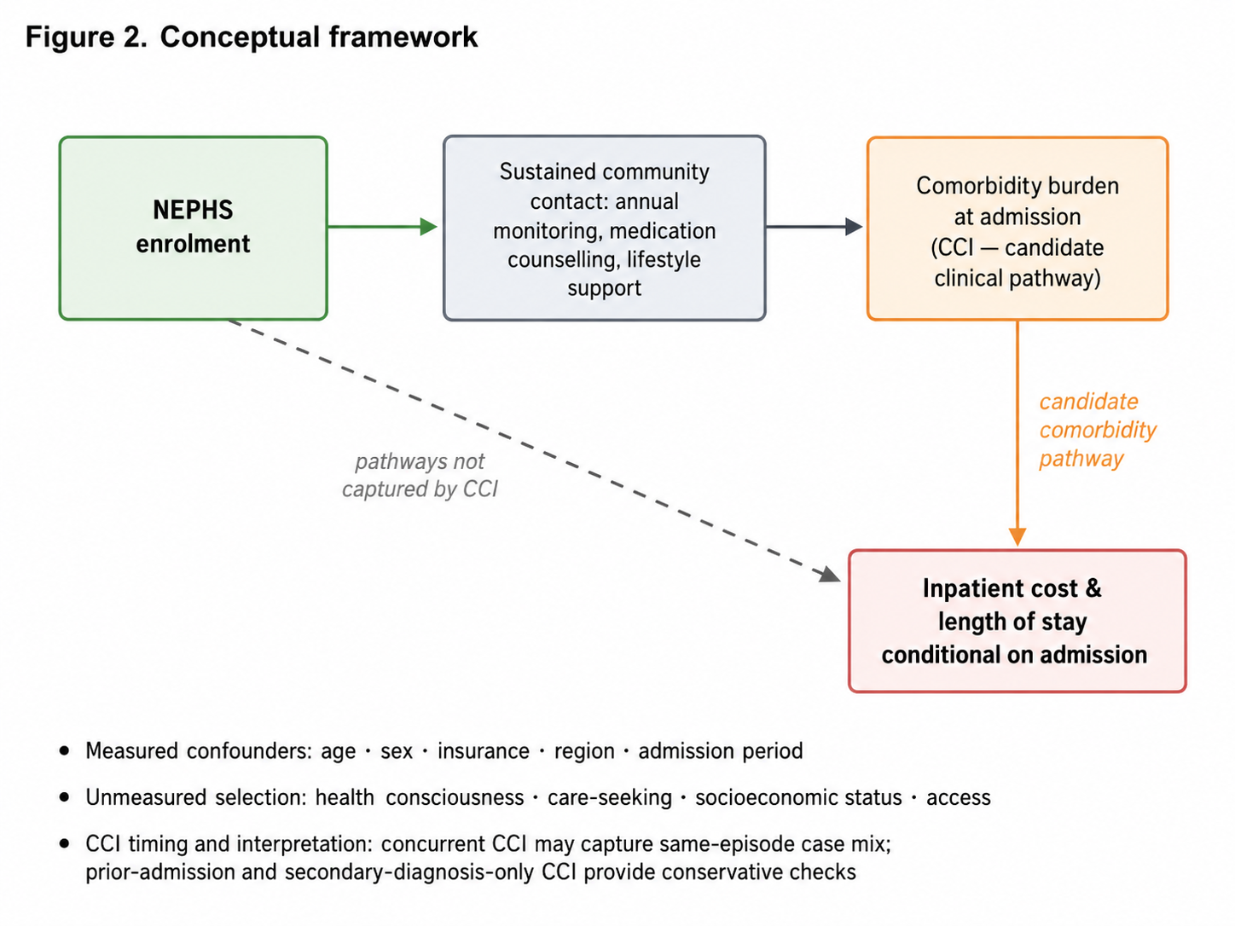
CCI is treated as a candidate clinical pathway rather than as a baseline confounder in the primary model. Concurrent CCI may capture same-episode case mix; prior-admission CCI and secondary-diagnosis-only CCI are used as conservative specifications. CCI indicates Charlson Comorbidity Index; SES, socioeconomic status.

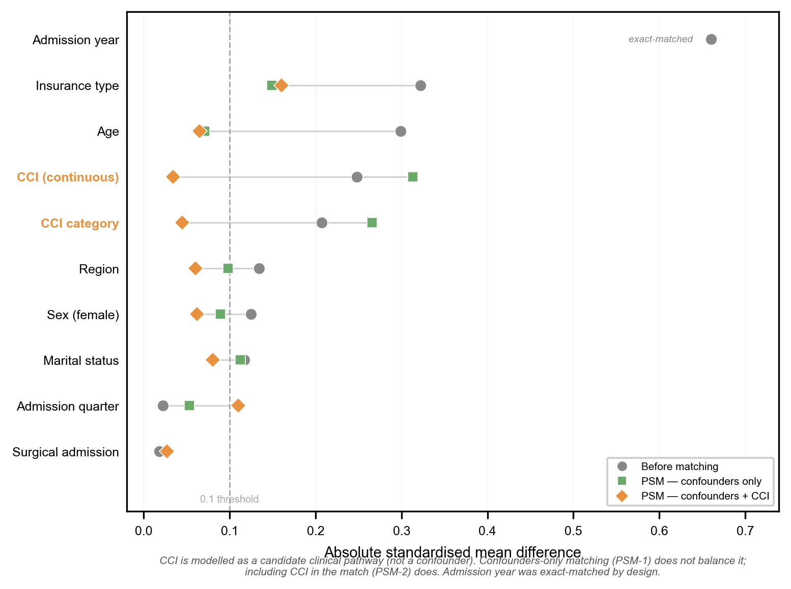
eFigure 2. Covariate balance across propensity-score matching specifications.
Absolute standardized mean differences are shown before matching, after PSM-1 (confounders only), and after PSM-2 (confounders + CCI).

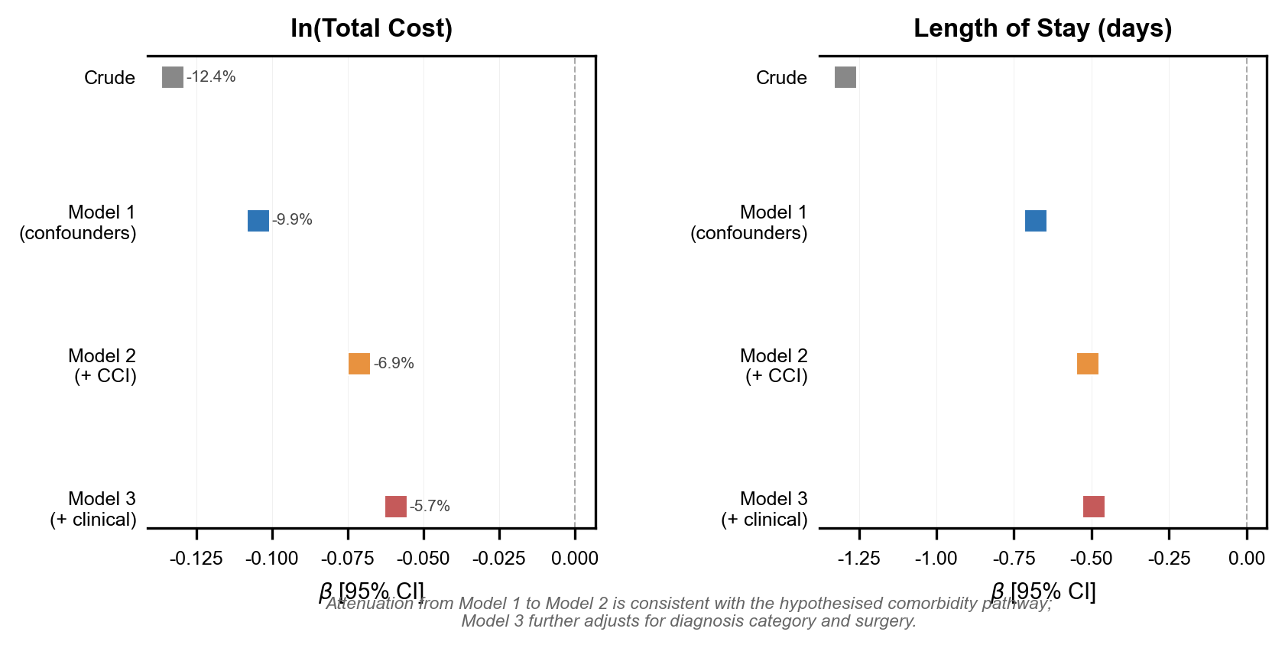
eFigure 3. Stepwise attenuation across model specifications.
Attenuation from Model 1 to Model 2 is consistent with the hypothesised comorbidity pathway; Model 3 further adjusts for diagnosis category and surgery.

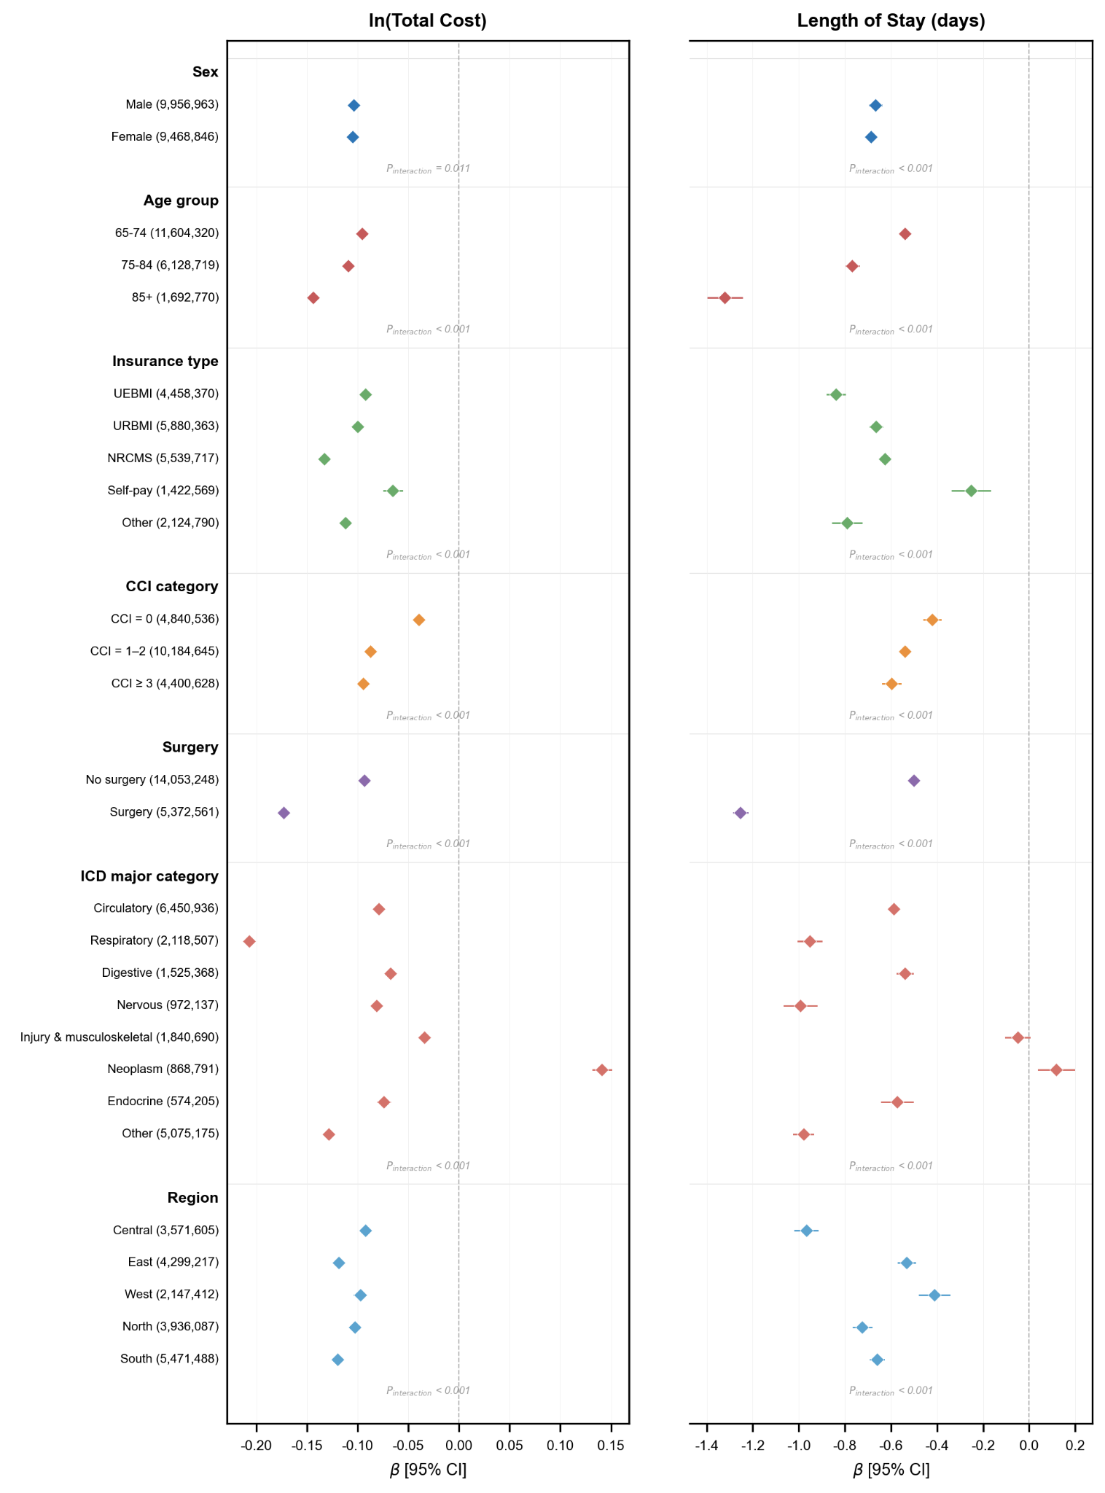
eFigure 4. Full subgroup forest plot for cost and length of stay.
Full subgroup estimates are shown for demographic, clinical, diagnostic, and regional strata. Pinteraction values refer to interaction tests.
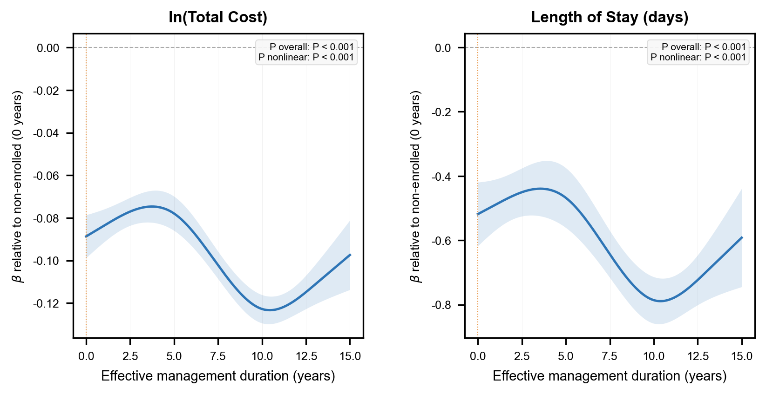
eFigure 5. Restricted cubic spline for management duration.
Associations are shown relative to non-enrolled admissions (0 years). The nonlinear pattern should be interpreted descriptively.

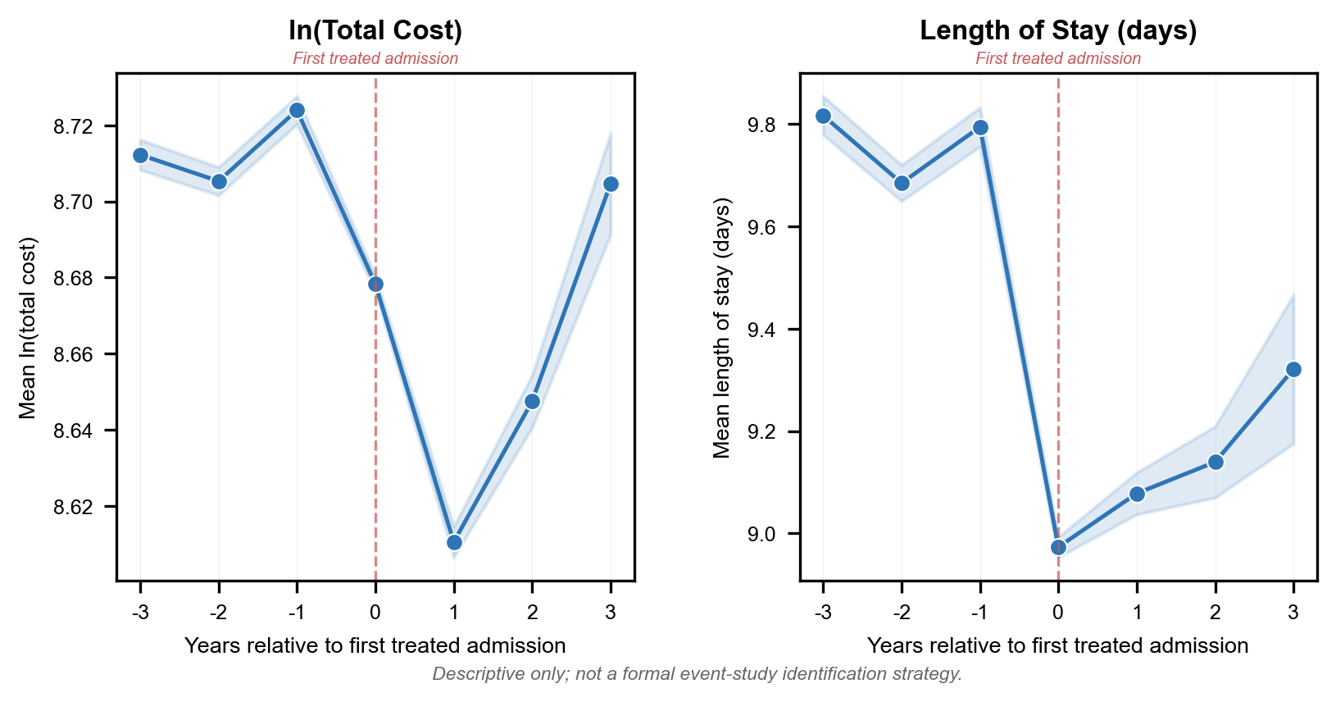
eFigure 6. Descriptive event-time trajectories among patients whose enrollment status changed.
Values are unadjusted means among patients whose enrollment status changed. This is descriptive only and is not a formal event-study identification strategy.

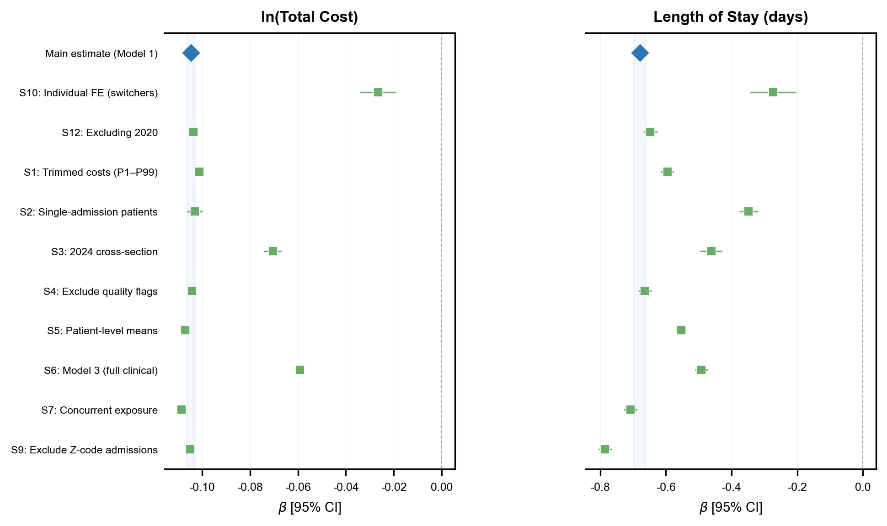
eFigure 7. Sensitivity analysis summary.
The shaded band indicates the main estimate and its 95% CI. Individual fixed effects are shown as a complementary within-person contrast rather than as a conventional specification check.

