Supplementary material
Supplementary tables and figures cited in the main text are consolidated below.
Supplementary Table S1. Definitions, coding, and analytical use of variables recorded for verified leopard attacks.
Variable | Description | Categories/coding | Included in GLM
Attack outcome | Outcome for the victim | Fatal = 1; non-fatal = 0 | Response
Age class | Victim age | Child 0-15; adult 16-59; older adult 60 or more | Yes
Gender | Victim gender | Male; female | Yes
Party presence | Companions present | Alone; group | Yes
Season | Season of attack | Summer Mar-Jun; monsoon Jul-Sep; winter Oct-Feb | Yes
Time period | Time of attack | Morning twilight; daytime; evening twilight; nighttime | Yes
Activity | Activity at contact | Agricultural/livelihood; movement/resource use; recreational/resting | Yes
Posture | Body position | Low; upright | Yes
Attack-site context | Dominant local setting | Agricultural; settlement | Yes
Victim response | Reaction during attack | Physical defence; escape; vocal; none; unknown | No
Companion response | Action by companions | Intervention; escape; passive; unknown | No
Tool use | Defensive object used | Present; absent; unknown | No
Barrier context | Physical obstruction | Partial barrier; none; unknown | No
Leopard disengagement | How contact ended | Immediate retreat; resistance; intervention; crowd; predation; other | No
Information source | Primary evidentiary source | Victim; relative; community; Forest Department; media | No
Likely predatory | Prey-oriented indicators | Likely predatory; not classified | No

Supplementary Table S2. Candidate logistic regression models ranked by Akaike's Information Criterion corrected for small sample size (AICc).
Model | Predictors | df | LogLik | AICc | ΔAICc | Weight
M6 | Age class + party presence + season | 6 | -62.66 | 137.9 | 0.00 | 0.788
M5 | Age class + party presence | 4 | -66.79 | 141.9 | 3.93 | 0.111
M7 | Age class + gender + party + season + time + activity + context + posture | 14 | -55.37 | 142.0 | 4.10 | 0.102
M2 | Party presence | 2 | -76.53 | 157.2 | 19.20 | <0.001
M3 | Season + time period | 6 | -77.46 | 167.5 | 29.60 | <0.001
M1 | Age class + gender | 4 | -81.36 | 171.0 | 33.07 | <0.001
M4 | Activity + context + posture | 5 | -84.21 | 178.9 | 40.92 | <0.001
M0 | Intercept only | 1 | -88.68 | 179.4 | 41.44 | <0.001

Notes: df is the number of estimated parameters. Weights may sum to 1.001 because of rounding.

Supplementary Table S3. Tukey-adjusted pairwise comparisons of estimated marginal means for predictors in the top-ranked model. Estimates are on the log-odds scale.
Variable | Contrast | Estimate | SE | z | Adjusted P
Age class | Adult vs child | -2.217 | 0.566 | -3.915 | <0.001
 | Adult vs older adult | -0.265 | 0.774 | -0.343 | 0.937
 | Child vs older adult | 1.952 | 0.857 | 2.277 | 0.059
Party presence | Group vs alone | -2.505 | 0.544 | -4.606 | <0.001
Season | Summer vs monsoon | -1.550 | 0.581 | -2.668 | 0.021
 | Summer vs winter | -0.212 | 0.529 | -0.401 | 0.915
 | Monsoon vs winter | 1.338 | 0.588 | 2.274 | 0.060

Notes:The group-versus-alone contrast is -2.505, consistent with the fitted coefficient and OR = 0.08.

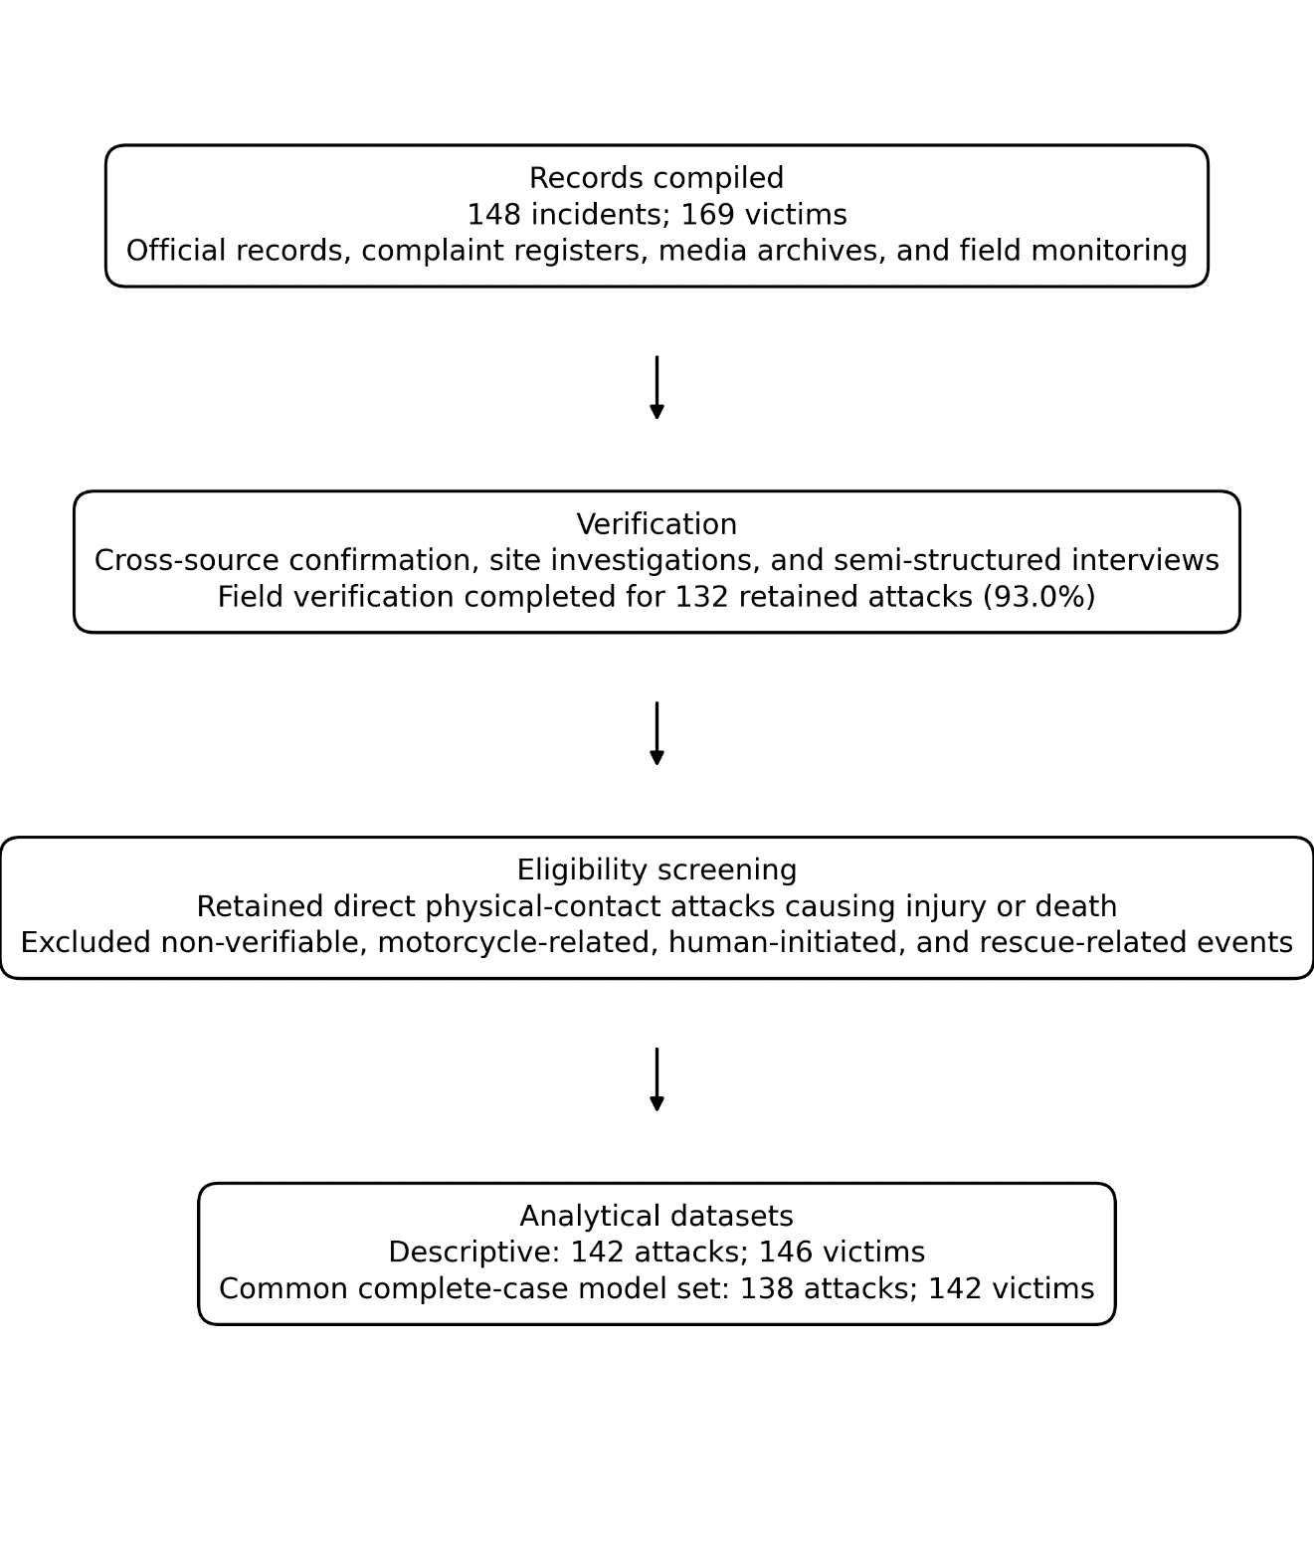
Supplementary Figure S1. Workflow for compilation, verification, eligibility screening, and construction of the descriptive and common complete-case model datasets.

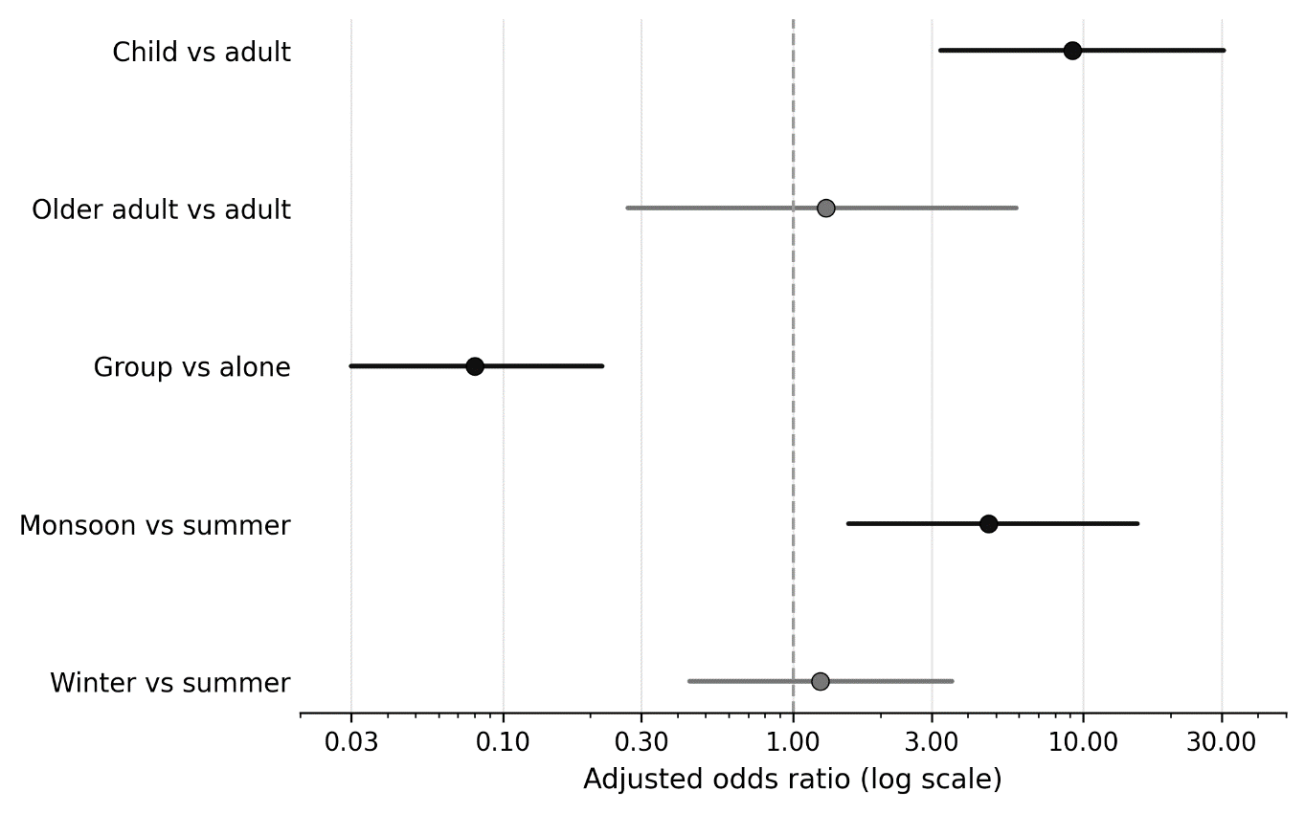

Supplementary Figure S2. Adjusted odds ratios and 95% confidence intervals from the top-ranked model. The vertical dashed line indicates no difference (OR = 1). Estimates are plotted on a logarithmic scale.

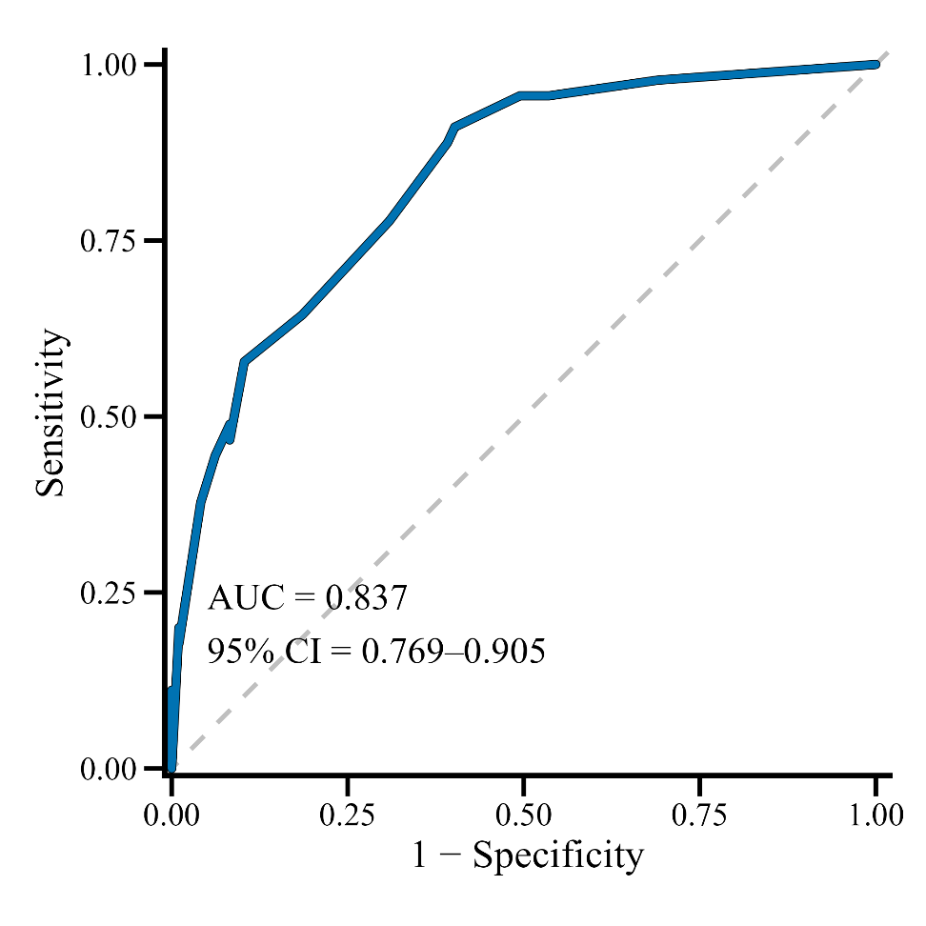
Supplementary Figure S3. Receiver operating characteristic curve for the top-ranked model. AUC = 0.837 (95% CI = 0.769-0.905). This is internal, not external, discrimination.
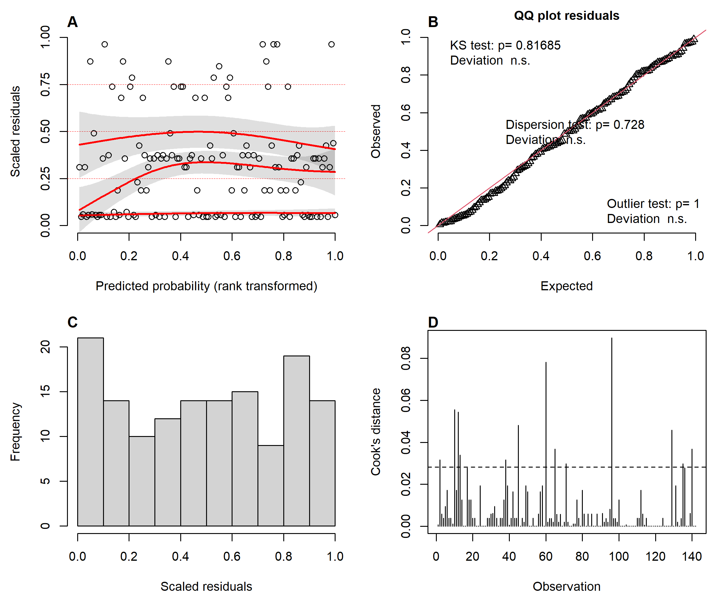
Supplementary Figure S4. Diagnostics for the top-ranked logistic regression model: conditional quantile residuals (A), Q-Q plot and global tests (B), simulated residual distribution (C), and Cook's distance (D). The combined conditional-quantile test indicates localized departures even though the displayed global uniformity, dispersion, and outlier tests are non-significant; several Cook's-distance values exceed the plotted heuristic threshold.

