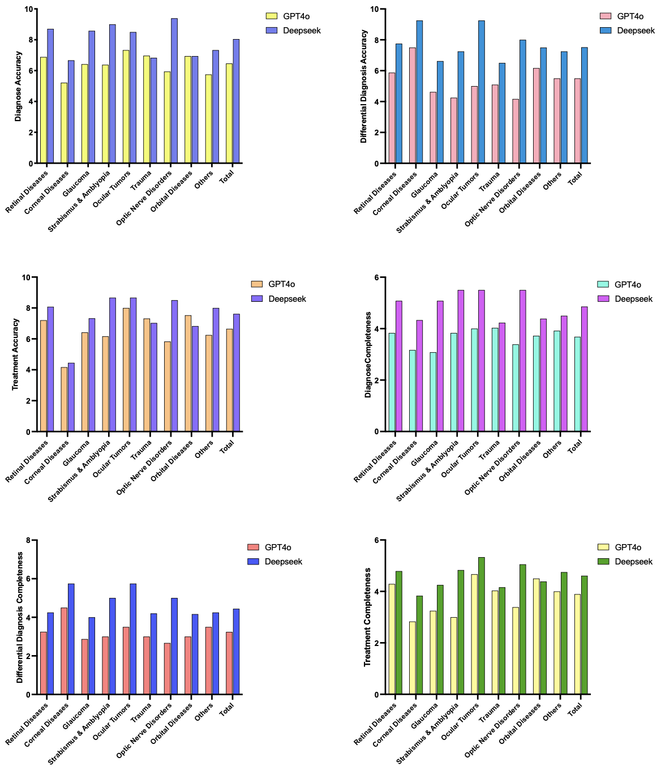
Figure S1. Comparison of GPT-4o and DeepSeek across multiple ophthalmology-related evaluation dimensions.
The figure includes six bar charts representing Diagnose Accuracy, Treatment Accuracy, Differential Diagnosis Completeness, Differential Diagnosis Accuracy, Diagnose Completeness, and Treatment Completeness. Each chart compares the performance of the two models across nine ophthalmic disease categories—Retinal Diseases, Corneal Diseases, Glaucoma, Strabismus & Amblyopia, Ocular Tumors, Trauma, Optic Nerve Disorders, Orbital Diseases, Others—as well as the overall total. Distinct bar colors indicate the respective scores of GPT-4o and DeepSeek.

This is the instruction I gave to DeepSeek and GPT-4o.
“Please act as a senior ophthalmologist and provide the following responses based on the information above. Preliminary Diagnosis, Primary Diagnosis, Secondary Diagnosis, Basis for Diagnosis, Differential Diagnosis, Treatment Plan.”

Below is a representative example of one of the 33 cases:

Case 1
Patient: Female, 62 years old
Chief Complaint: Progressive decline in vision in both eyes for 2 years; right eye vision loss for 1 month; left eye pain and headache for 2 weeks.

History of Present Illness
The patient developed progressively worsening vision in both eyes over the past 2 years, decreasing from 0.8 to 0.1, without symptoms of eye redness, pain, or tearing. One year ago she was diagnosed elsewhere with “fundus hemorrhage” and treated with oral hemostatic medication, resulting in temporary improvement. Over the past 6 months, vision has fluctuated and has been accompanied by dark shadows. One month ago, vision in the right eye further deteriorated. Two weeks ago, the left eye became red and painful with tearing and headache, prompting medical consultation.

Past Medical History
Diabetes mellitus for 10 years, controlled with medication.

General Physical Examination
Blood pressure: 140/90 mmHg.
General condition good. Heart and lung auscultation: (—).
Abdominal exam: liver and spleen not palpable. No masses, no tenderness, no shifting dullness.

Ophthalmic Examination
- Visual acuity: Right eye 0.1; Left eye 0.05; near vision: both eyes cannot read Jr7
- Intraocular pressure: R 17.30 mmHg; L 43.39 mmHg
- External exam: No eyelid edema.

Right eye
Conjunctiva: no congestion
Cornea: clear
Anterior chamber: clear
KPs: (—)
Aqueous flare: (—)
Iris neovascularization: (—)
Lens: mild cortical opacity

Left eye
Ciliary injection (++), corneal epithelial edema (+), anterior chamber clear
KPs: (—)
Aqueous flare: (—)
Fine neovascularization visible at 3 o’clock and 9 o’clock on the pupillary margin
Lens: mild opacity

Fundus
Right eye: vitreous hemorrhage, inferior half obscured; superior part faintly shows retina. Along the temporal superior vascular arcade from the optic disc, proliferative membrane with neovascularization is present. Retina shows patchy hemorrhages, cotton-wool spots, and hard exudates.
Left eye: hazy but optic disc margins visible, color slightly pale; retina has multiple hemorrhages; circinate exudates at the posterior pole; microaneurysms; localized neovascular membrane in the temporal mid-periphery. (See fundus image)

Laboratory Tests
- CBC: (—)
- Urinalysis: Pro 150 mg/dl; Glu 150 mg/dl; Ery 25/ml
- Liver function: (—)
- Renal function: BUN 9.40 mmol/L; Creatinine 122 mmol/L
- Blood glucose: 10.7 mmol/L

Initial Diagnosis
Primary Diagnosis:
- Stage V diabetic retinopathy in both eyes (proliferative vitreoretinal disease, diabetes most likely)
Secondary Diagnoses:
- Left eye secondary neovascular glaucoma
- Early age-related cataract in both eyes

Basis for Diagnosis
Primary diagnosis:
- History of diabetes
- Retinal hemorrhages, exudates, neovascular membranes, proliferative changes
- Vitreous hemorrhage
Secondary diagnosis:
- Elevated IOP in left eye
- Corneal edema, iris neovascularization
- Mild lens opacity in both eyes

Differential Diagnosis
- Hypertensive retinopathy: usually involves more optic disc edema and arterial sclerosis.
- Renal retinopathy: retinal edema and exudative retinal detachment are predominant.
- Central retinal vein occlusion: usually unilateral; flame-shaped and patchy hemorrhages; may have optic disc edema.
- Retinal vasculitis: common in young males; peripheral retinal venous hemorrhages and perivascular sheathing; recurrent bleeding may lead to vascular occlusion; may be bilateral.

Management Plan

Further Examinations
- B-scan ultrasound – rule out retinal detachment.
- FFA (Fundus Fluorescein Angiography) – observe non-perfusion areas and staging.
- Systemic evaluation: renal function to rule out diabetic nephropathy; ECG; blood glucose.

Treatment Recommendations
- Systemic blood glucose control.
- Lower intraocular pressure:
  - Topical (timolol, dipivefrin)
  - Systemic (acetazolamide, hyperosmotic agents)
  - If IOP remains uncontrolled, consider cyclocryotherapy.
- After IOP decreases, perform retinal photocoagulation.
- If systemic condition permits, perform vitrectomy and endolaser photocoagulation in the right eye.

Questions & Answers

1. Pathogenesis of diabetic retinopathy
Diabetes primarily damages retinal capillary endothelial cells, impairing the blood-retina barrier and causing leakage, leading to retinal edema and dot hemorrhages. Capillary occlusion follows, with microaneurysms and ischemic edema in non-perfusion areas, leading to cotton-wool spots and hard exudates due to chronic edema. This constitutes non-proliferative diabetic retinopathy (NPDR).
Retinal edema induces angiogenic factors, promoting neovascularization with fibrous proliferation. New vessels easily bleed, causing vitreous hemorrhage and fibrosis, eventually forming proliferative vitreoretinal disease (PDR).

2. Ocular complications of diabetes
- Diabetic cataract: early onset, rapid progression, similar morphology to senile cataract.
- Refractive errors: fluctuate with blood glucose; hyperglycemia increases lens volume → increased myopia; hypoglycemia reverses it.
- Iridocyclitis
- Ocular motor nerve palsy: diplopia, motility restriction; typically pupil-sparing; self-limiting.
- Retinopathy
- Rubeosis iridis: extensive iris neovascularization
- Neovascular glaucoma: new vessels close the angle → impaired aqueous outflow → elevated IOP (angle-closure mechanism)

3. Complications of diabetic retinopathy
- Rubeosis iridis
- Cystoid macular edema
- Neovascular glaucoma
- Tractional retinal detachment

4. Optimal treatment strategy for diabetic retinopathy
Perform regular fundus examinations to detect early changes.
In NPDR and early PDR (Stage IV), cryotherapy or photocoagulation can be performed.
In established PDR, vitreoretinal surgery combined with photocoagulation or cryotherapy is indicated.
Prognosis is poor when retinal detachment is present.

5. Surgical indications
Stages IV–VI of diabetic retinopathy, with neovascularization, fibrous proliferation, vitreous hemorrhage, and tractional retinal detachment.

6. Staging of diabetic retinopathy
Type | Stage | Findings
Non-proliferative | I | Microaneurysms and/or small hemorrhages
 | II | Hard exudates and/or hemorrhages
 | III | Cotton-wool spots and/or hemorrhages
Proliferative | IV | Neovascularization and/or vitreous hemorrhage
 | V | Neovascularization with fibrous proliferation
 | VI | Neovascularization and fibrous proliferation with tractional retinal detachment

7. Principles of photocoagulation treatment
- Destroy hypoxic retina to reduce release of angiogenic factors and decrease neovascularization.
- Destroy outer retinal layers and RPE to reduce oxygen consumption and improve inner retinal oxygenation.
- Improved oxygenation enhances macular blood flow and nutrition, reducing macular disease.
- Creates strong chorioretinal adhesions, resisting traction and preventing vitreoretinal tractional damage.

