Supplementary Material
An Integrated Sensitivity and Surrogate Modelling Framework for Stakeholder-Aware Groundwater Management under Salinity Stress
Ali Ranjbar; Claudia Cherubini; Tom Baldock
2. 7. 1. Nash technique
Stakeholder competition over groundwater allocation is evaluated using a Nash bargaining index (Nash, 1950). The preferred Nash scenarios are selected from the Pareto-optimal set by maximizing the joint stakeholder benefit while satisfying the prescribed feasibility criteria:
Maximize$F={\left(P_{1}-P_{S1}\right)}^{v_{1}}×{\left(P_{2}-P_{S2}\right)}^{v_{2}}×…..×{\left(P_{j}-P_{Sj}\right)}^{v_{j}}$ (13)
Subject to: $P_{Sj}<P_{ST} j=1,…., 5$

where $F$ is the Nash index, $P_{Sj }$is the profit value of stakeholder $j$, $p_{j}$ is the Pareto solution which meets the criteria, $v_{k}$ is the strength of the stakeholder v. The most superior scenario is selected from high Nash alternatives which provide 50% of the maximum NASH value.

2. 7. 2. Social choice approach
In the social choice framework, stakeholders have equal voting power when selecting management scenarios based on their relative benefits. Each stakeholder ranks the Pareto alternatives according to its profit function, and the collective decision is obtained through preference aggregation. Voting and Borda scoring (Fishburn, 2015) are used to identify scenarios with broad stakeholder support rather than scenarios favored by only one stakeholder group.

2. 7. 3. Borda scoring (BS)
In this approach, all possible management scenarios are identified by decision-makers, and the scenario with the maximum number of votes is introduced as the best choice (Young, 1995). Therefore, the worst and the best-case scenario earn $0$ and $m-1$ votes associated with $m$ stakeholders, respectively. The scores obtained for the components of the decision matrix are calculated below:
$E\left(k_{i,j}\right)=m-k_{i,j}$ (14)
Thus, the selection criteria of the scenario $j$ is the summation of votes for that scenario as described below:
$C_{1×m}=\sum_{i=1}^{n}{E\left(k_{i,j}\right)=(c_{1}, c_{2},…,c_{m})}$ (15)
in which, $C_{1×m}$ is the score vector for scenario $m$, considering the total number of $n$ decision makers.

2. 7. 4. Updated voting technique (VT)
The updated voting technique evaluates management scenarios through pairwise comparisons. In each duel, the scenario receiving more than 50% of the stakeholder votes is considered superior.
A superiority matrix is constructed to compare the total votes obtained by each pair of scenarios in both directions (Ghodsi et al., 2016):
$S_{k×k}=\left[\begin{matrix}K_{1,1}, K_{1,2}, & K_{1,3}⋯ & K_{1,k} \\ ⋮ & ⋱ & ⋮ \\ { K}_{k,1}, { K}_{k,2}, & K_{k,3}⋯ & K_{k,k}\end{matrix}\right]$ (16)
subject to $K_{i,j}=0 if i=j, otherwise, K_{i,j}+K_{j,i}=m$ (17)
which $K_{1,2}$ and $K_{2,1}$ are the votes obtained by scenario$i_{1}$ and scenario$i_{2}$ from the total existing votes ($z$), respectively. The most preferred scenario is identified as the alternative with the highest total number of wins across all pairwise comparisons.
Supplementary Text S2. NSGA-II parameter-sensitivity analysis
Estimating additional non-dominated solutions through interpolation, without increasing the optimization population size, can help avoid management scenarios that may trigger rapid advancement of the saltwater intrusion (SI) front toward zone 5. By generating intermediate solutions between existing Pareto members, the distribution of the Pareto front becomes smoother and provides a more complete representation of the trade-off space among the optimization objectives. The total groundwater pumping volume corresponding to several non-dominated solutions on the three-dimensional Pareto surface is approximately 15% lower than the pumping volumes obtained from the two-dimensional Pareto front.
This reduction occurs because the 92 non-dominated solutions shown in Fig. 10 satisfy the threshold condition imposed to maintain a relatively uniform SI-front geometry, whereas this additional constraint is not included in the two-objective optimization. Consequently, incorporating the uniformity constraint for the SI shape leads to more conservative pumping strategies that reduce the risk of irregular or localized saltwater intrusion advancement while still maintaining acceptable groundwater extraction levels. The sensitivity of the generated three-dimensional Pareto fronts to different NSGA-II parameter configurations indicates that lower population sizes (1000) and mutation rates (0.015) produce sparse and clustered Pareto solutions, resulting in limited coverage of the objective space. Increasing the population size to 2,000 individuals improves solution diversity and expands the explored-off region. Similarly, increasing the mutation probability enhances the exploration capability of the algorithm, leading to a broader distribution of non-dominated solutions and reducing clustering around local optima.
The results further indicate that stronger crowding-distance preservation and larger numbers of generations enhances the spread of solutions across the trade-off surface. These settings enhance the representation of both central and extreme management scenarios and provide a more continuous approximation of the trade-off relationships. Higher crossover coefficients also contribute to smoother transitions between neighboring Pareto solutions by improving the recombination of candidate solutions.
Among the evaluated configurations, the high-diversity setting, which combines a larger population size, increased number of generations, stronger crowding-distance preservation, and seeded extreme solutions, produces the most continuous and uniformly distributed Pareto front. This configuration provides the most comprehensive representation of trade-offs among saltwater intrusion length, total groundwater pumping rate, and pumping-uniformity objectives, thereby offering decision-makers a broader range of feasible management alternatives.
Supplementary Text S3. Detailed stakeholder ranking and conflict-resolution results
Table S5. Ranking matrix of the optimal scenarios for the five stakeholders.
Scenario index (part 1)
 | 1 | 2 | 3 | 4 | 5 | 6 | 7 | 8 | 9 | … | 51
ST1 | 91 | 64 | 43 | 36 | 61 | 74 | 72 | 57 | 48 | … | 59
ST2 | 67 | 65 | 71 | 72 | 77 | 86 | 87 | 59 | 56 | … | 51
ST3 | 74 | 41 | 62 | 61 | 40 | 47 | 46 | 38 | 33 | … | 1
ST4 | 89 | 47 | 61 | 58 | 45 | 91 | 88 | 41 | 37 | … | 5
ST5 | 51 | 48 | 72 | 73 | 46 | 43 | 31 | 42 | 34 | … | 45
Table S5. Ranking matrix of the optimal scenarios for the five stakeholders (continued).
Scenario index (part 2)
 | … | 73 | … | 80 | … | 87 | 88 | 89 | 90 | 91 | 92
ST1 | … | 7 | … | 1 | … | 75 | 29 | 23 | 66 | 68 | 12
ST2 | … | 9 | … | 1 | … | 8 | 26 | 21 | 62 | 91 | 76
ST3 | … | 6 | … | 92 | … | 65 | 83 | 84 | 79 | 77 | 57
ST4 | … | 1 | … | 55 | … | 68 | 71 | 69 | 77 | 81 | 52
ST5 | … | 1 | … | 87 | … | 67 | 63 | 66 | 53 | 9 | 80
3.5. 1. Voting approach (VA)
The selection of a management scenario among the five stakeholders is determined by the relative preference of each stakeholder for a given scenario compared with the 92 Pareto-optimal alternatives. Each stakeholder compares a given scenario with all other alternatives, assigning an ordinal preference score ranging from 0 to 5. A scenario receiving more than three votes is considered preferable in the pairwise comparison. Accordingly, the preference matrix is constructed to evaluate the pairwise comparison of the 92 Pareto-optimal scenarios (Table S6).

Table S6. Preference matrix used for pairwise comparison of the management scenarios.
Row | 1 | 2 | 3 | 4 | 5 | … | 39 | 40 | 41 | … | 89 | 90 | 91 | 92
Column
1 | 0 | 0 | 0 | 0 | 0 | … | 2 | 3 | 2 | … | 0 | 0 | 0 | 0
2 | 5 | 0 | 0 | 0 | 0 | … | 4 | 4 | 4 | … | 0 | 0 | 0 | 0
3 | 3 | 1 | 1 | 1 | 0 | … | 2 | 3 | 3 | … | 1 | 1 | 1 | 1
4 | 3 | 1 | 1 | 1 | 0 | … | 2 | 3 | 3 | … | 1 | 1 | 1 | 1
5 | 5 | 5 | 0 | 0 | 0 | … | 4 | 4 | 4 | … | 1 | 0 | 1 | 0
… | … | … | … | … | … |  | … | … | … |  | … | … | … | …
39 | 3 | 1 | 1 | 1 | 1 | … | 2 | 3 | 3 | … | 1 | 1 | 1 | 1
40 | 3 | 1 | 1 | 1 | 1 | … | 0 | 3 | 3 | … | 1 | 1 | 1 | 1
41 | 5 | 5 | 5 | 5 | 5 | … | 4 | 5 | 5 | … | 4 | 4 | 5 | 4
… | … | … | … | … | … |  | … | … | … |  | … | … | … | …
89 | 3 | 2 | 2 | 2 | 2 | … | 2 | 3 | 3 | … | 2 | 2 | 2 | 2
90 | 3 | 1 | 1 | 0 | 0 | … | 2 | 3 | 3 | … | 1 | 0 | 0 | 0
91 | 3 | 1 | 1 | 1 | 1 | … | 1 | 2 | 2 | … | 1 | 1 | 1 | 1
92 | 3 | 1 | 1 | 1 | 1 | … | 2 | 3 | 3 | … | 1 | 1 | 1 | 1

The resulting vector $S$represents the aggregated score assigned to each scenario based on the negotiation among the five stakeholders. The values in the preference matrix provide insights into the sensitivity of stakeholder preferences to changes in management decisions. Based on the values in the $P$ matrix, abrupt variations in rows or columns indicate significant changes in the decision variables, which consequently alter each stakeholder’s groundwater profit and the associated value assessment (VA) results. Among the evaluated alternatives, management scenario 73 achieves the highest total score of 436, indicating the greatest overall stakeholder acceptance. This scenario is capable of satisfying more than 75% of the maximum groundwater demand across the five agricultural zones. According to the values of vector $S$, scenarios 73, 79, and 17 emerge as the most favorable alternatives. However, these scenarios differ significantly in terms of total groundwater extraction and the resulting extent of saltwater intrusion, particularly affecting Zone 5, which is located within the saltwater intrusion (SI) region. For instance, the simulated SI lengths for scenarios 73 and 17, corresponding to extracted groundwater volumes of $9.83×{10}^{7}m^{3}$ and $8.12×{10}^{7}m^{3}$, are 2.8 $km$ and 6.5 $km$ respectively. Since selecting scenario 17 would lead to an SI extent exceeding 40% of Zone 5, scenario 73 is considered the most balanced and sustainable management alternative. To prevent excessive seawater encroachment while maintaining groundwater supply, the optimization framework imposes a constraint limiting the maximum allowable saltwater intrusion length to 50% of the vulnerable coastal zone. This threshold ensures that groundwater extraction remains compatible with long-term aquifer sustainability.

3. 5. 2. Borda scoring (BS)
To construct the score matrix, the groundwater extraction volume associated with each of the 92 management scenarios is evaluated for the five stakeholders. Based on these rankings, each scenario is assigned a score ranging from 0 to 92 for each stakeholder, reflecting the relative preference of stakeholders according to the groundwater volume allocated under each scenario.
$P_{1×92}=(1, 0, 0, 0, … , 250, 65, 434, 184, 0, 0, 0, 64, 175, 0, 86 , 70 , 74, 0, 84, 81)$Based on the Borda score vector $P_{\left(1 × 92\right)}$, the management scenarios with the highest scores are identified as the most favorable alternatives. To further reduce the number of candidate scenarios, a maximum threshold score of 27 for each stakeholder is adopted in the modified Borda count, and only the top 30% of high-ranked scenarios are retained for further evaluation. Accordingly, each scenario receives either a score of zero or a value greater than 27 depending on the ranking assigned by the stakeholders. The modified Borda score (BS) analysis identifies scenarios 79, 73, and 17 as the most competitive management alternatives, as they achieve the highest aggregated scores from the five agricultural zones and consistently rank among the top 30% of preferred scenarios for each stakeholder. According to Fig. 11, the total volumes of groundwater abstraction associated with scenario 79 at the end of the six-year operation period are 16,290, 18,990, 3,645, 6,417, and 13,617 for $Q_{1}$, $Q_{2}$, $Q_{3}$, $Q_{4}$, and $Q_{5}$, respectively. These pumping rates result in a saltwater intrusion (SI) advance of approximately 2.5 $km$ toward agricultural Zone 5. The corresponding extraction ratios relative to the maximum feasible pumping volumes are 0.66, 0.61, 0.64, 0.97, and 0.94 for Zones $Z_{1}$, $Z_{2}$, $Z_{3}$, $Z_{4}$, and $Z_{5}$, respectively. These results indicate that Scenario 79 provides a relatively balanced compromise between groundwater production and SI control while maintaining high pumping efficiencies in the most productive agricultural zones.

3. 5. 3. Nash index
Based on game-theoretic concepts, the robustness of the 92 non-dominated Pareto solutions under uncertain aquifer parameters is evaluated using an uncertainty-based framework, and the most robust scenario is subsequently selected for the conflict resolution stage. Fig. 12 presents the Nash index, the robustness factor, and the percentage of groundwater extracted from Zones 5 and 2 (illustrated with error bars) for all Pareto-optimal scenarios. As shown in Fig. 12, the robustness factor of the optimal scenarios and the total pumping rate from Zones 5 and 2 $\left(Q_{5} + Q_{2}\right)$exhibit a negative correlation. Stakeholder satisfaction, represented by the Nash index, is not strongly correlated with the robustness factor. This behavior may be attributed to the relatively low uncertainty associated with the Pareto solutions. Furthermore, the advancement of the saltwater intrusion (SI) wedge is strongly influenced by the spatial variability of horizontal hydraulic conductivity within these zones.
The results indicate that scenarios achieving high levels of stakeholder acceptance do not necessarily provide the highest resilience to parameter uncertainty. In contrast, scenarios associated with larger groundwater abstraction from the coastal zones generally tend to exhibit lower robustness values, reflecting the greater sensitivity of saltwater intrusion dynamics to pumping stresses in these vulnerable areas. This behavior is consistent with the strong influence of horizontal hydraulic conductivity uncertainty on the advancement of the saltwater intrusion front.
Overall, three scenarios (highlighted in Fig. 12) with relatively high Nash index values are identified as superior alternatives, although no single scenario clearly dominates in terms of robustness.
Although Scenarios 73 and 79 achieve high stakeholder satisfaction, their robustness values are lower than that of Scenario 17. Consequently, Scenario 17 is identified as the preferred compromise solution within the Conflict Resolution Nash (CRN) framework because it combines a high Nash index with a comparatively higher level of robustness under uncertainty.

Overall, the CRN analysis confirms that Scenarios 73 and 79 remain attractive management alternatives; however, Scenario 17 provides the best balance between stakeholder satisfaction and robustness, making it the most resilient option for long-term groundwater management under uncertain aquifer conditions.

Supplementary Tables and Figures
Table S1. Details of information regarding pumping wells in the management zone
X-Coordinate ($m$) | Y-Coordinate ($m$) | Pumping Rate ($m^{3}/day$) | Screen elevation ($m$) | Distance from MP1 ($km$) | Distance from MP2 ($km$) | Distance from MP3 ($km$)
514219 | 3830768 | 0 | 839.0 | 4.0 | 3.6 | 3.5
514219 | 3829768 | 1324 | 839.0 | 4.3 | 3.2 | 2.5
513719 | 3833268 | 0 | 840.0 | 3.8 | 5.1 | 5.9
513719 | 3832768 | 551 | 840.0 | 3.6 | 4.7 | 5.4
513719 | 3829268 | 1036 | 840.0 | 4.1 | 2.6 | 1.9
513719 | 3828768 | 0 | 840.0 | 4.4 | 2.6 | 1.4
513719 | 3827268 | 1483 | 840.0 | 5.5 | 3.0 | 0.2
513219 | 3832268 | 0 | 841.5 | 3.0 | 4.0 | 4.9
513219 | 3831768 | 2445 | 841.5 | 2.9 | 3.6 | 4.4
513219 | 3830768 | 1784 | 841.5 | 3.0 | 2.8 | 3.4
513219 | 3828268 | 719 | 841.5 | 4.5 | 2.2 | 0.9
513219 | 3827268 | 0 | 841.5 | 5.3 | 2.6 | 0.3
513219 | 3826768 | 1274 | 841.5 | 5.7 | 3.0 | 0.7
512719 | 3831268 | 1262 | 844.0 | 2.5 | 2.9 | 4.0
512719 | 3829768 | 0 | 844.0 | 3.1 | 1.8 | 2.5
512719 | 3828268 | 0 | 844.0 | 4.1 | 1.7 | 1.2
512719 | 3827768 | 1245 | 844.0 | 4.6 | 1.9 | 0.9
512719 | 3826268 | 2056 | 844.0 | 5.9 | 3.0 | 1.4
512219 | 3832768 | 836 | 845.5 | 2.2 | 4.0 | 5.5
512219 | 3832268 | 1463 | 845.5 | 2.0 | 3.6 | 5.0
512219 | 3829268 | 2609 | 845.5 | 3.0 | 1.1 | 2.3
512219 | 3828768 | 1830 | 845.5 | 3.4 | 1.1 | 1.9
512219 | 3828268 | 1007 | 845.5 | 3.9 | 1.2 | 1.6
512219 | 3827768 | 1007 | 845.5 | 4.3 | 1.5 | 1.4
512219 | 3826768 | 1274 | 845.5 | 5.2 | 2.4 | 1.4
512219 | 3826268 | 0 | 845.5 | 5.7 | 2.8 | 1.7
511719 | 3832768 | 484 | 848.0 | 1.8 | 3.9 | 5.7
511719 | 3831768 | 2637 | 848.0 | 1.4 | 3.0 | 4.7
511719 | 3830768 | 3021 | 848.0 | 1.7 | 2.0 | 3.8
511219 | 3831268 | 890 | 848.0 | 1.0 | 2.4 | 4.5
511219 | 3828768 | 1659 | 848.0 | 3.0 | 0.1 | 2.7
510719 | 3831768 | 1120 | 850.5 | 0.5 | 2.9 | 5.2
510719 | 3830268 | 1495 | 850.5 | 1.4 | 1.5 | 4.0
510719 | 3828768 | 1036 | 850.5 | 2.9 | 0.4 | 3.1
510219 | 3831768 | 1107 | 850.5 | 0.2 | 3.0 | 5.5
510219 | 3830268 | 1234 | 850.5 | 1.4 | 1.7 | 4.4
510219 | 3829268 | 836 | 850.5 | 2.4 | 1.0 | 3.8
510219 | 3828768 | 656 | 850.5 | 2.9 | 0.9 | 3.6
510219 | 3828268 | 1421 | 850.5 | 3.4 | 1.1 | 3.4
510219 | 3827768 | 1462 | 850.5 | 3.9 | 1.4 | 3.3
509719 | 3832768 | 647 | 850.5 | 1.3 | 4.2 | 6.6
509719 | 3831768 | 593 | 853.5 | 0.6 | 3.2 | 5.8
509719 | 3830768 | 2424 | 853.5 | 1.0 | 2.4 | 5.1
509719 | 3829268 | 986 | 853.5 | 2.4 | 1.5 | 4.2
509219 | 3832268 | 250 | 853.5 | 1.2 | 3.9 | 6.5
509219 | 3831268 | 927 | 853.5 | 1.1 | 3.1 | 5.8
509219 | 3830268 | 493 | 853.5 | 1.7 | 2.4 | 5.2
509219 | 3828768 | 585 | 853.5 | 3.0 | 1.9 | 4.5
508719 | 3833268 | 0 | 856.0 | 2.3 | 5.0 | 7.6
508719 | 3832768 | 0 | 856.0 | 1.9 | 4.6 | 7.2
508719 | 3832768 | 0 | 856.0 | 1.9 | 4.6 | 7.2
508719 | 3831268 | 100 | 856.0 | 1.6 | 3.4 | 6.2
508719 | 3828768 | 275 | 856.0 | 3.3 | 2.4 | 5.0

Table S2. Cluster-based Evolutionary Polynomial Regression (EPR) equations developed for estimating pumping-induced drawdown ($DH$) as a function of radial distance ($R$) from observation wells for MP1, MP2, and MP3.
MP1 | Relationships
Cluster 1 | $$DH=0.0828(-(-1.844)-ln⁡(1.873R^{2})+1.873R^{2}-0.580R^{4}+0.0544R^{6})$$
Cluster 2 | $$DH=9.518(-0.700-ln⁡(0.445R^{2})+0.445R^{2}-0.0344R^{4}+0.00121R^{6})$$
Cluster 3 | $$DH=12.617(-0.732-ln⁡(0.257R^{2})+0.257R^{2}-0.0108R^{4}+0.000201R^{6})$$
Cluster 4 | $$DH=-338.056(-0.740-ln⁡(0.139R^{2})+0.139R^{2}-0.00318R^{4}+0.000032R^{6})$$
Cluster 5 | $$DH=-26.219(-0.743-ln⁡(0.0737R^{2})+0.0737R^{2}-0.000899R^{4}+0.000005R^{6})$$
MP 2
Cluster 1 | $$DH=2.055(-0.701-ln⁡(2.281R^{2})+2.281R^{2}-0.782R^{4}+0.108R^{6})$$
Cluster 2 | $$DH=-228.067(-0.741-ln⁡(0.800R^{2})+0.800R^{2}-0.105R^{4}+0.00611R^{6})$$
Cluster 3 | $$DH=1081.520(-0.738-ln⁡(0.543R^{2})+0.543R^{2}-0.0488R^{4}+0.00194R^{6})$$
Cluster 4 | $$DH=27.125(-0.750-ln⁡(0.406R^{2})+0.406R^{2}-0.0264R^{4}+0.000730R^{6})$$
Cluster 5 | $$DH=-361.220(-0.743-ln⁡(0.202R^{2})+0.202R^{2}-0.00670R^{4}+0.000097R^{6})$$
MP3
Cluster 1 | $$DH=0.0721(-(-2.684)-ln⁡(0.648R^{2})+0.648R^{2}-(-0.148)R^{4}-0.00817R^{6})$$
Cluster 2 | $$DH=-4.656(-0.764-ln⁡(0.171R^{2})+0.171R^{2}-0.00463R^{4}+0.000053R^{6})$$
Cluster 3 | $$DH=-73.364(-0.751-ln⁡(0.106R^{2})+0.106R^{2}-0.00180R^{4}+0.000013R^{6})$$
Cluster 4 | $$DH=8239.316(-0.735-ln⁡(0.0941R^{2})+0.0941R^{2}-0.00147R^{4}+0.000010R^{6})$$
Cluster 5 | $$DH=159.698(-0.736-ln⁡(0.0710R^{2})+0.0710R^{2}-0.000838R^{4}+0.000004R^{6})$$

Table S3. Spatial distribution of pumping wells assigned to five distance-based clusters for each observation well used in the development of the cluster-based EPR drawdown relationships.
MP1 | Well coordinates (X, Y)
Cluster 1 | (510219,3827768), (510219,3828268), (510219,3828768), (510219,3829268), (511219,3828768), (512219,3827768), (512219,3828268), (512719,3827768), (512719,3828268), (509219,3828768)
Cluster 2 | (510219,3830268), (510719,3828768), (512219,3828768), (512219,3829268), (512719,3829768), (509719,3829268), (510719,3830268), (512719,3826268), (512219,3826768), (512219,3826268)
Cluster 3 | (513219,3828268), (513219,3827268), (513219,3826768), (513719,3827268), (510219,3831768), (509219,3830268), (509219,3831268), (509219,3832268), (508719,3828768), (510719,3831768)
Cluster 4 | (513219,3830768), (513219,3831768), (513219,3832268), (512719,3831268), (511719,3830768), (511219,3831268), (509719,3830768), (509719,3831768), (508719,3831268), (508719,3832768)
Cluster 5 | (514219,3830768), (514219,3829768), (513719,3833268), (513719,3832768), (513719,3829268), (513719,3828768), (512219,3832768), (512219,3832268), (511719,3832768), (511719,3831768), (509719,3832768), (508719,3833268)
MP2 | Well coordinates (X, Y)
Cluster 1 | (511719,3830768), (511219,3831268), (510719,3830268), (510719,3831768), (510219,3830268), (510219,3831768), (510219,3829268), (509719,3829268), (510719,3828768), (510219,3828768)
Cluster 2 | (512219,3829268), (512219,3828768), (512219,3828268), (512719,3828268), (512719,3827768), (511219,3828768), (509719,3830768), (509719,3831768), (509219,3828768), (509219,3830268)
Cluster 3 | (513219,3830768), (513219,3828268), (513219,3827268), (512719,3829768), (512719,3826268), (512219,3826768), (512219,3826268), (509219,3831268), (509219,3832268), (508719,3828768)
Cluster 4 | (514219,3830768), (514219,3829768), (513219,3831768), (513219,3832268), (513719,3829268), (513719,3828768), (513719,3827268), (512719,3831268), (508719,3831268), (508719,3832768)
Cluster 5 | (513719,3833268), (513719,3832768), (512219,3832768), (512219,3832268), (511719,3832768), (511719,3831768), (509719,3832768), (508719,3833268)
MP3 | Well coordinates (X, Y)
Cluster 1 | (513719,3833268), (513719,3832768), (513219,3832268), (513219,3831768), (512219,3832768), (512219,3832268), (511719,3832768)
Cluster 2 | (514219,3830768), (513219,3830768), (512719,3831268), (511719,3831768), (511719,3830768), (510719,3831768), (509719,3832768), (508719,3833268)
Cluster 3 | (514219,3829768), (513719,3829268), (513719,3828768), (512719,3829768), (510719,3830268), (509719,3831768), (509719,3830768), (508719,3832768)
Cluster 4 | (513719,3827268), (513219,3828268), (513219,3827268), (512719,3828268), (512719,3827768), (512219,3829268), (512219,3828768), (510219,3829268), (509219,3832268)
Cluster 5 | (513219,3826768), (512719,3826268), (512219,3828268), (512219,3827768), (512219,3826768), (512219,3826268), (511219,3828768), (510719,3828768), (510219,3828768), (510219,3828268), (510219,3827768), (509719,3829268), (509219,3828768), (508719,3828768)

Table. S4. EPR equations for estimating SI shift in three monitoring points for MP1, MP2, and MP3.
Zone | Observation Well | Relationship
z1 | MP1 | $$ΔL_{SI,Obs1}^{z1}≈0.300Q_{3}+0.300Q_{4}+0.438Q_{8}+0.431Q_{9}+0.446Q_{10}+0.554Q_{14}+0.608Q_{15}+0.608Q_{19}+0.615Q_{20}+0.662Q_{27}+0.692Q_{28}+0.800Q_{30}$$
 | MP2 | $$ΔL_{SI,Obs2}^{z1}≈0.648Q_{3}+0.648Q_{4}+1.569Q_{8}+1.569Q_{9}+1.459Q_{10}+2.593Q_{14}+2.049Q_{15}+2.423Q_{19}+2.593Q_{20}+2.769Q_{27}+3.530Q_{28}+4.496Q_{30}$$
 | MP3 | $$ΔL_{SI,Obs3}^{z1}≈5.507Q_{3}+7.692Q_{4}+1.923Q_{8}+0.923Q_{9}+0.285Q_{10}+0.554Q_{14}+0.100Q_{15}+1.138Q_{19}+0.923Q_{20}+0.923Q_{27}+0.731Q_{28}+0.354Q_{30}$$
z2 | MP1 | $$ΔL_{SI,Obs1}^{z2}≈0.200Q_{1}+0.208Q_{2}+0.331Q_{5}+0.315Q_{6}+0.231Q_{7}+0.462Q_{11}+0.392Q_{12}+0.385Q_{13}+0.638Q_{16}+0.600Q_{17}+0.438Q_{18}+0.785Q_{21}+0.815Q_{22}+0.838Q_{23}+0.792Q_{24}+0.692Q_{25}+0.615Q_{26}$$
 | MP2 | $$ΔL_{SI,Obs2}^{z2}≈0.288Q_{1}+0.162Q_{2}+0.288Q_{5}+0.200Q_{6}+0.072Q_{7}+0.251Q_{11}+0.110Q_{12}+0.067Q_{13}+0.512Q_{16}+0.279Q_{17}+0.098Q_{18}+1.801Q_{21}+1.153Q_{22}+0.663Q_{23}+0.450Q_{24}+0.233Q_{25}+0.200Q_{26}$$
 | MP3 | $$ΔL_{SI,Obs3}^{z2}≈0.102Q_{1}+0.011Q_{2}+0.011Q_{5}+0.011Q_{6}+0.011Q_{11}+0.004Q_{16}+0.001Q_{17}+0.033Q_{21}+0.016Q_{22}+0.007Q_{23}+0.004Q_{24}$$
z3 | MP1 | $$ΔL_{SI,Obs1}^{z3}≈0.438Q_{18}+0.692Q_{25}+0.615Q_{26}$$
 | MP2 | $$ΔL_{SI,Obs2}^{z3}≈0.098Q_{18}+0.233Q_{25}+0.200Q_{26}$$
 | MP3 | $$ΔL_{SI,Obs3}^{z3}≈0.000Q_{18}+0.000Q_{25}+0.000Q_{26}$$
z4 | MP1 | $$ΔL_{SI,Obs1}^{z4}≈1.231Q_{31}+0.808Q_{32}+1.008Q_{33}+1.385Q_{34}+0.846Q_{35}+1.054Q_{36}+1.385Q_{37}+1.462Q_{38}+1.615Q_{39}+1.846Q_{40}+0.992Q_{43}+1.385Q_{44}$$
 | MP2 | $$ΔL_{SI,Obs2}^{z4}≈1.459Q_{31}+3.598Q_{32}+4.420Q_{33}+1.502Q_{34}+3.496Q_{35}+3.496Q_{36}+2.049Q_{37}+1.502Q_{38}+1.251Q_{39}+1.059Q_{40}+3.364Q_{43}+2.049Q_{44}$$
 | MP3 | $$ΔL_{SI,Obs3}^{z4}≈0.029Q_{31}+0.558Q_{32}+0.147Q_{33}+0.033Q_{34}+0.383Q_{35}+0.156Q_{36}+0.050Q_{37}+0.033Q_{38}+0.026Q_{39}+0.019Q_{40}+0.210Q_{43}+0.102Q_{44}$$
z5 | MP1 | $$ΔL_{SI,Obs1}^{z5}≈0.823Q_{41}+0.877Q_{42}+0.869Q_{45}+0.946Q_{46}+1.062Q_{47}+1.423Q_{48}+0.862Q_{49}+0.869Q_{50}+0.946Q_{51}+1.308Q_{52}$$
 | MP2 | $$ΔL_{SI,Obs2}^{z5}≈3.138Q_{41}+3.299Q_{42}+3.106Q_{45}+3.106Q_{46}+2.890Q_{47}+1.683Q_{48}+3.013Q_{49}+3.013Q_{50}+2.951Q_{51}+4.983Q_{52}$$
 | MP3 | $$ΔL_{SI,Obs3}^{z5}≈0.558Q_{41}+0.344Q_{42}+0.357Q_{45}+0.164Q_{47}+0.055Q_{48}+0.370Q_{49}+0.370Q_{50}+0.251Q_{51}+0.083Q_{52}$$

Fig. S1. comparison fitting graph of observed and simulated head

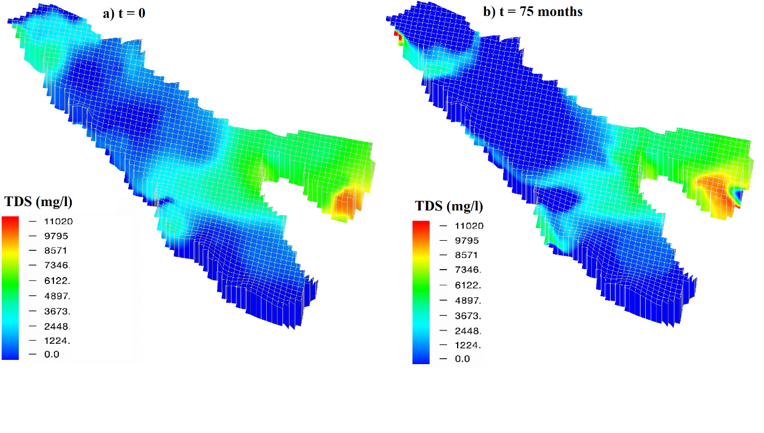
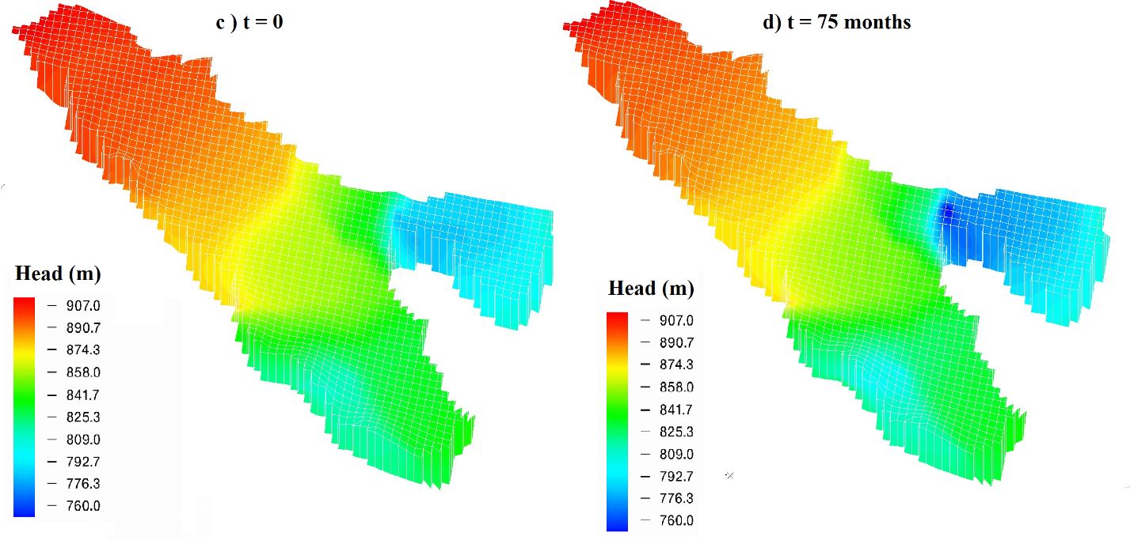
Fig. S2. Three-dimensional spatial distributions of TDS concentration and hydraulic head at the initial condition and after 75 months of simulation. Panels (a) and (b) show the temporal change in TDS concentration, while panels (c) and (d) show the corresponding hydraulic head distribution.

Fig. S3. Sensitivity of groundwater drawdown at monitoring points to pumping wells: (a) MP1, (b) MP2, and (c) MP3.

Fig. S4. Matrix plot of the Latin Hypercube Sampling (LHS) design used for generating combinations of pumping rate (q), radial distance from the pumping well (r), and hydraulic conductivity (k)

The color classification in Fig. S3 reflects the logarithmic sampling strategy for radial distance, with denser sampling at short distances to capture the strong nonlinear drawdown gradients near pumping wells.

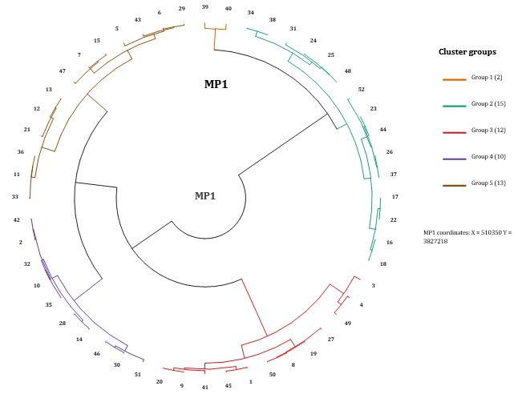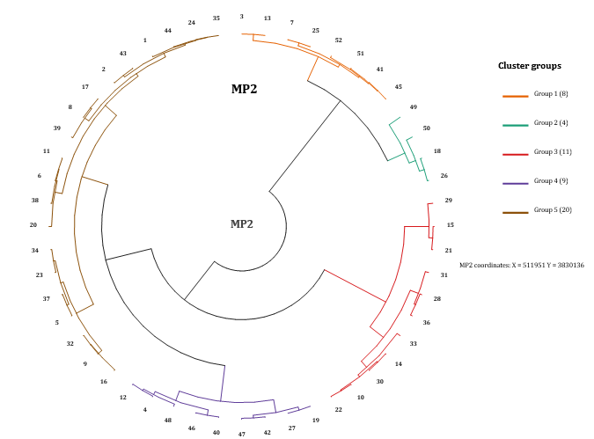

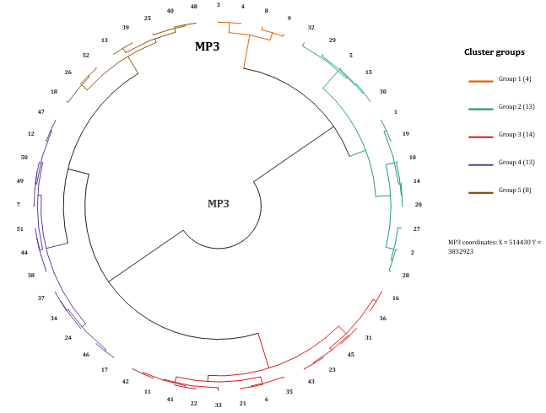

Fig. S5. Hierarchical dendrograms of pumping-well coordinates for MP1, MP2, and MP3, showing the spatial grouping of wells into five clusters.

