Appendix A. Supplementary Information

Distinct Structuring Mechanisms of Extrinsic and Intrinsic Factors on the Wild Marine Fish Gut Microbiome

Gyeong Hak Han^{1,2}, Jihyun Yu¹, Min Joo Kang³, Choong Hwan Noh¹, Kae Kyoung Kwon^{1,2*}, Mi-Jeong Park^{1*}
¹Marine Biotechnology & Bioresource Research Department, Korea Institute of Ocean Science and Technology, Busan 49111, Republic of Korea
²Marine Technology and Convergence Engineering, KIOST School, University of Science and Technology, Daejeon 34113, Republic of Korea
³Resources Management Division, Fisheries Resources Department, Korea Fisheries Resources Agency, Busan 46041, Republic of Korea

E-mail: Gyeong Hak Han (asdf7341@kiost.ac.kr); Jihyun Yu (jihyunyu@kiost.ac.kr); Min Joo Kang (mjkang@fira.or.kr); Choong Hwan Noh (chnoh@kiost.ac.kr); Kae Kyoung Kwon (kkkwon@kiost.ac.kr); Mi-Jeong Park (mijeong16@kiost.ac.kr)

ORCID: Gyeong Hak Han (0009-0003-3925-3371); Jihyun Yu (0009-0000-9065-8364); Min Joo Kang (0000-0001-8272-3592); Choong Hwan Noh (0000-0002-8651-8825); Kae Kyoung Kwon (0000-0002-0606-4545); Mi-Jeong Park (0000-0002-4965-5476)

*Corresponding authors: Kae Kyoung Kwon (kkkwon@kiost.ac.kr); Mi-Jeong Park (E-mail: mijeong16@kiost.ac.kr);

Supplementary Table S1. The effects of season, trophic level, and fish species on the fish GM using PERMANOVA and ANOSIM, according to three dissimilarity measurement methods. Verification of significant differences among the groups in the factors by comparing the dispersions of the groups. The p-value (disp) represents the significant differences in dispersion of groups.
Factor | Dissimilarity Method | PERMANOVA |  |  | ANOSIM |  | p-value (disp)
Factor | Dissimilarity Method | F-value | R² | p-value | R | p-value | p-value (disp)
a Season | Bray-Curtis | 26.609 | 0.1906 | 0.0001 | 0.8707 | 0.0001 | 0.2792
a Season | Unweighted UniFrac | 4.023 | 0.0344 | 0.0001 | 0.1007 | 0.0001 | 0.2308
a Season | Weighted UniFrac | 8.700 | 0.0715 | 0.0001 | 0.1198 | 0.0001 | 0.0014
b Trophic level | Bray-Curtis | 2.8733 | 0.3349 | 0.0001 | 0.2543 | 0.0001 | 5.90E-07
b Trophic level | Unweighted UniFrac | 2.2153 | 0.2740 | 0.0001 | 0.2223 | 0.0001 | 0.0069
b Trophic level | Weighted UniFrac | 6.4954 | 0.5324 | 0.0001 | 0.1633 | 0.0001 | 0.0064
c Fish species | Bray-Curtis | 2.920 | 0.3832 | 0.0001 | 0.3000 | 0.0001 | 2E-09
c Fish species | Unweighted UniFrac | 2.2426 | 0.3230 | 0.0001 | 0.3000 | 0.0001 | 0.0569
c Fish species | Weighted UniFrac | 5.8789 | 0.5557 | 0.0001 | 0.1691 | 0.0001 | 0.0028

Supplementary Table S2. Fish trophic level effects on the fish GM using the Mantel test, according to three dissimilarity measurement methods.
Comparison | Dissimilarity methods | Mantel’s R | p-value
Trophic level vs. GM | Bray-Curtis | 0.1305 | 0.0001
Trophic level vs. GM | Unweighted UniFrac | 0.000515 | 0.4919
Trophic level vs. GM | Weighted UniFrac | -0.02754 | 0.6944

Supplementary Table S3. Correlation analysis between fish trophic level and microbial diversity based on Shannon, Simpson, and Faith’s phylogenetic diversity (PD). The microbial diversity values for each trophic level used in this analysis are the average within that trophic level. Because the microbial diversity values were denormalized, we used the Spearman and Kendall methods.
Method | Comparison group | p-value
Spearman | Trophic level vs. Microbial diversity (Shannon) | 0.7419
Spearman | Trophic level vs. Microbial diversity (Simpson) | 0.5861
Spearman | Trophic level vs. Microbial diversity (Faith’s PD) | 0.9541
Kendall | Trophic level vs. Microbial diversity (Shannon) | 0.654
Kendall | Trophic level vs. Microbial diversity (Simpson) | 0.6009
Kendall | Trophic level vs. Microbial diversity (Faith’s PD) | 0.9405

Supplementary Table S4. The fish-species-core ASVs of 16 fish species (prevalence: 0.99; detection abundance: 1E-05)
Fish species | Taxon | Core ASVs
Acanthopagrus schlegelii (As) | Photobacterium | ASV2165, ASV2171
Acanthopagrus schlegelii (As) | Vibrio | ASV2666, ASV2667
Acanthopagrus schlegelii (As) | Catenococcus | ASV2699, ASV2722
Acanthopagrus schlegelii (As) | Vibrionaceae | ASV2779, ASV2789, ASV2791
Chromis notata (Cn) | Photobacterium | ASV2165
Chromis notata (Cn) | Vibrio | ASV2446, ASV2480, ASV2504, ASV2535, ASV2536, ASV2627, ASV2662, ASV2666, ASV2762, ASV2766
Chromis notata (Cn) | Catenococcus | ASV2699, ASV2722
Chromis notata (Cn) | Vibrionaceae | ASV2705, ASV2708, ASV2779, ASV2789, ASV2791
Hexagrammos agrammus (Ha) | Cetobacterium | ASV1521
Hexagrammos agrammus (Ha) | Photobacterium | ASV2165, ASV2171, ASV2180
Hexagrammos agrammus (Ha) | Vibrio | ASV2504
Hexagrammos agrammus (Ha) | Catenococcus | ASV2699, ASV2722
Hexagrammos agrammus (Ha) | Vibrionaceae | ASV2779
Pseudopleuronects herzensteini (Ph) | Brevinema | ASV0276
Pseudopleuronects herzensteini (Ph) | env.OPS_17 | ASV0429
Pseudopleuronects herzensteini (Ph) | Enterovibrio | ASV2258, ASV2260, ASV2261, ASV2262
Pseudopleuronects herzensteini (Ph) | Photobacterium | ASV2165
Pseudopleuronects herzensteini (Ph) | Catenococcus | ASV2699, ASV2722
Pseudopleuronects herzensteini (Ph) | Vibrionaceae | ASV2779, ASV2789, ASV2791
Platycephalus indicus (Pi) | Nautella | ASV1333
Platycephalus indicus (Pi) | Cetobacterium | ASV1521, ASV1526, ASV1535, ASV1541, ASV1543, ASV1552
Platycephalus indicus (Pi) | SAR11_Clade_ Ia | ASV1575
Platycephalus indicus (Pi) | Shewanella | ASV2050
Platycephalus indicus (Pi) | Photobacterium | ASV2148, ASV2155, ASV2156, ASV2165, ASV2167, ASV2170, ASV2171, ASV2180, ASV2197, ASV2344, ASV2370
Platycephalus indicus (Pi) | Vibrio | ASV2430, ASV2517, ASV2535, ASV2662
Platycephalus indicus (Pi) | Catenococcus | ASV2699, ASV2722
Platycephalus indicus (Pi) | Vibrionaceae | ASV2789, ASV2791
Pagrus major (Pm) | Flavobacterium | ASV0576
Pagrus major (Pm) | Cetobacterium | ASV1535, ASV1552
Pagrus major (Pm) | SAR11_Clade_ Ia | ASV1575
Pagrus major (Pm) | Photobacterium | ASV2165
Pagrus major (Pm) | Vibrio | ASV2517, ASV2535, ASV2666, ASV2762
Pagrus major (Pm) | Catenococcus | ASV2699
Pagrus major (Pm) | Vibrionaceae | ASV2777, ASV2779, ASV2789
Parajulis poecilepterus (Pp) | Propionigenium | ASV1514
Parajulis poecilepterus (Pp) | SAR11_Clade_ Ia | ASV1575
Parajulis poecilepterus (Pp) | SAR11_Clade_ II | ASV1584
Parajulis poecilepterus (Pp) | Endozoicomonas | ASV1877
Parajulis poecilepterus (Pp) | Marinomonas | ASV1898
Parajulis poecilepterus (Pp) | Shewanella | ASV2074
Parajulis poecilepterus (Pp) | Photobacterium | ASV2165
Parajulis poecilepterus (Pp) | Vibrio | ASV2424, ASV2441, ASV2446, ASV2447, ASV2480, ASV2495, ASV2508, ASV2517, ASV2518, ASV2522, ASV2535, ASV2536, ASV2627, ASV2666, ASV2762, ASV2766
Parajulis poecilepterus (Pp) | Catenococcus | ASV2699, ASV2722, ASV2774
Parajulis poecilepterus (Pp) | Vibrionaceae | ASV2705, ASV2708, ASV2779, ASV2789, ASV2791
Pseudolabrus sieboldi (Ps) | Vibrionaceae | ASV2789
Parapercis sexfasciata (Pse) | Mycoplasma | ASV0175
Seriola lalandi (Sl) | Asinibacterium | ASV0392
Seriola lalandi (Sl) | Weeksellaceae_uncultured | ASV0471
Seriola lalandi (Sl) | Nautella | ASV1333
Seriola lalandi (Sl) | SAR11_Clade_ Ia | ASV1575
Seriola lalandi (Sl) | Pseudoalteromonas | ASV1999, ASV2006, ASV2012
Seriola lalandi (Sl) | Photobacterium | ASV2153, ASV2155, ASV2156, ASV2165, ASV2171, ASV2196
Seriola lalandi (Sl) | Enterovibrio | ASV2252, ASV2253, ASV2254, ASV2258, ASV2259, ASV2260, ASV2261, ASV2262
Seriola lalandi (Sl) | Vibrio | ASV2446, ASV2535
Seriola lalandi (Sl) | Catenococcus | ASV2722
Seriola lalandi (Sl) | Vibrionaceae | ASV2791
Hexagrammos otakii (Ho) | Tenacibaculum | ASV0691
Hexagrammos otakii (Ho) | Aurantimicrobium | ASV1025
Hexagrammos otakii (Ho) | Xanthobacteraceae | ASV1215
Hexagrammos otakii (Ho) | Pelomonas | ASV1628
Hexagrammos otakii (Ho) | Shewanella | ASV2089
Hexagrammos otakii (Ho) | Enterovibrio | ASV2281, ASV2286
Hexagrammos otakii (Ho) | Photobacterium | ASV2368
Hexagrammos otakii (Ho) | Aliivibrio | ASV2594
Lycodes tanakae (Lt) | Candidatus Obscuribacter | ASV0228
Lycodes tanakae (Lt) | Chitinophaga | ASV0385
Lycodes tanakae (Lt) | env.OPS_17 | ASV0429
Lycodes tanakae (Lt) | Tenacibaculum | ASV0691
Lycodes tanakae (Lt) | Methylobacterium-Methylorubrum | ASV1219
Lycodes tanakae (Lt) | Pelomonas | ASV1628
Lycodes tanakae (Lt) | Acidibacter | ASV1711
Lycodes tanakae (Lt) | Photobacterium | ASV2370
Lycodes tanakae (Lt) | Aliivibrio | ASV2594
Lycodes tanakae (Lt) | Catenococcus | ASV2722
Microstomus achne (Ma) | Ureaplasma | ASV0174
Microstomus achne (Ma) | Fimbiimonadaceae | ASV0351
Microstomus achne (Ma) | Chitinophaga | ASV0385
Microstomus achne (Ma) | Sediminbacterium | ASV0389
Microstomus achne (Ma) | env.OPS_17 | ASV0429
Microstomus achne (Ma) | Tenacibaculum | ASV0691
Microstomus achne (Ma) | Methylobacterium-Methylorubrum | ASV1219
Microstomus achne (Ma) | Pelomonas | ASV1628
Microstomus achne (Ma) | Acidibacter | ASV1711
Microstomus achne (Ma) | Catenococcus | ASV2722
Microstomus achne (Ma) | Vibrionaceae | ASV2791
Pseudopleuronectes yokohamae (Py) | Flavobacterium | ASV0576
Pseudopleuronectes yokohamae (Py) | SAR11_Clade_ Ia | ASV1575
Pseudopleuronectes yokohamae (Py) | SAR11_Clade_ II | ASV1584
Pseudopleuronectes yokohamae (Py) | Pelomonas | ASV1628
Pseudopleuronectes yokohamae (Py) | Acidibacter | ASV1711
Sebastes thompsoni (St) | Sphingomonadaceae | ASV1442
Sebastes thompsoni (St) | Moritella | ASV2031
Sebastes thompsoni (St) | Shewanella | ASV2080, ASV2089, ASV2090, ASV2097, ASV2101
Sebastes thompsoni (St) | Photobacterium | ASV2329, ASV2337, ASV2345, ASV2350, ASV2368, ASV2370, ASV2375, ASV2379, ASV2381, ASV2384, ASV2413
Sebastes thompsoni (St) | Aliivibrio | ASV2560, ASV2565, ASV2575, ASV2580, ASV2594, ASV2595, ASV2605, ASV2620, ASV2635, ASV2637, ASV2640, ASV2655
Thamnaconus modestus (Tm) | Izemoplasmatales | ASV0185, ASV0186
Thamnaconus modestus (Tm) | Arcobacteraceae_uncultured | ASV0322
Thamnaconus modestus (Tm) | Rikenellaceae_RC9_gut_group | ASV0481
Thamnaconus modestus (Tm) | Rikenella | ASV0489, ASV0497
Thamnaconus modestus (Tm) | Parabacteroides | ASV0525, ASV0528
Thamnaconus modestus (Tm) | Paludibacteraceae_uncultured | ASV0541, ASV0552, ASV0556
Thamnaconus modestus (Tm) | Bacteroidales | ASV0548
Thamnaconus modestus (Tm) | Odoribacter | ASV0560
Thamnaconus modestus (Tm) | Peptostreptococcaceae_uncultured | ASV0777, ASV0779
Thamnaconus modestus (Tm) | [Anaerorhabdus]_furcosa_group | ASV0828
Thamnaconus modestus (Tm) | Angelakisella | ASV0844
Thamnaconus modestus (Tm) | Ruminococcaceae_uncultured | ASV0855
Thamnaconus modestus (Tm) | UCG-009 | ASV0863
Thamnaconus modestus (Tm) | Oscillibacter | ASV0878
Thamnaconus modestus (Tm) | Oscillospiraceae | ASV0883
Thamnaconus modestus (Tm) | Lachnospiraceae | ASV0895
Thamnaconus modestus (Tm) | Akkermansia | ASV0941
Thamnaconus modestus (Tm) | Propionigenium | ASV1509
Thamnaconus modestus (Tm) | Fusobacterium | ASV1560, ASV1565
Thamnaconus modestus (Tm) | Endozoicomonas | ASV1869, ASV1870, ASV1872
Thamnaconus modestus (Tm) | Shewanella | ASV2080, ASV2089
Thamnaconus modestus (Tm) | Aliivibrio | ASV2560, ASV2580, ASV2594, ASV2620, ASV2635, ASV2637, ASV2640
Thamnaconus modestus (Tm) | Vibrio | ASV2744

Supplementary Table S5. The fish species-core ASVs of seven fish species collected in summer and winter (prevalence: 0.99; detection abundance: 1E-05). The fish species-core ASVs for these fish species were detected by season, as they were not identified as being present in summer and winter, except for Ps and Pse.
Fish species | Taxon | Core ASVs
Acanthopagrus schlegelii (As) | Photobacterium | ASV2165, ASV2171
Acanthopagrus schlegelii (As) | Vibrio | ASV2666, ASV2667
Acanthopagrus schlegelii (As) | Catenococcus | ASV2699, ASV2722
Acanthopagrus schlegelii (As) | Vibrionaceae | ASV2779, ASV2789, ASV2791
Chromis notata (Cn) | Photobacterium | ASV2165
Chromis notata (Cn) | Vibrio | ASV2446, ASV2480, ASV2504, ASV2535, ASV2536, ASV2627, ASV2662, ASV2666, ASV2762, ASV2766
Chromis notata (Cn) | Catenococcus | ASV2699, ASV2722
Chromis notata (Cn) | Vibrionaceae | ASV2705, ASV2708, ASV2779, ASV2789, ASV2791
Hexagrammos agrammus (Ha) | Cetobacterium | ASV1521
Hexagrammos agrammus (Ha) | Photobacterium | ASV2165, ASV2171, ASV2180
Hexagrammos agrammus (Ha) | Vibrio | ASV2504
Hexagrammos agrammus (Ha) | Catenococcus | ASV2699, ASV2722
Hexagrammos agrammus (Ha) | Vibrionaceae | ASV2779
Pseudopleuronects herzensteini (Ph) | Brevinema | ASV0276
Pseudopleuronects herzensteini (Ph) | env.OPS_17 | ASV0429
Pseudopleuronects herzensteini (Ph) | Enterovibrio | ASV2258, ASV2260, ASV2261, ASV2262
Pseudopleuronects herzensteini (Ph) | Photobacterium | ASV2165
Pseudopleuronects herzensteini (Ph) | Catenococcus | ASV2699, ASV2722
Pseudopleuronects herzensteini (Ph) | Vibrionaceae | ASV2779, ASV2789, ASV2791
Platycephalus indicus (Pi) | Nautella | ASV1333
Platycephalus indicus (Pi) | Cetobacterium | ASV1521, ASV1526, ASV1535, ASV1541, ASV1543, ASV1552
Platycephalus indicus (Pi) | SAR11_Clade_ Ia | ASV1575
Platycephalus indicus (Pi) | Shewanella | ASV2050
Platycephalus indicus (Pi) | Photobacterium | ASV2148, ASV2155, ASV2156, ASV2165, ASV2167, ASV2170, ASV2171, ASV2180, ASV2197, ASV2344, ASV2370
Platycephalus indicus (Pi) | Vibrio | ASV2430, ASV2517, ASV2535, ASV2662
Platycephalus indicus (Pi) | Catenococcus | ASV2699, ASV2722
Platycephalus indicus (Pi) | Vibrionaceae | ASV2789, ASV2791
Pagrus major (Pm) | Flavobacterium | ASV0576
Pagrus major (Pm) | Cetobacterium | ASV1535, ASV1552
Pagrus major (Pm) | SAR11_Clade_ Ia | ASV1575
Pagrus major (Pm) | Photobacterium | ASV2165
Pagrus major (Pm) | Vibrio | ASV2517, ASV2535, ASV2666, ASV2762
Pagrus major (Pm) | Catenococcus | ASV2699
Pagrus major (Pm) | Vibrionaceae | ASV2777, ASV2779, ASV2789
Parajulis poecilepterus (Pp) | Propionigenium | ASV1514
Parajulis poecilepterus (Pp) | SAR11_Clade_ Ia | ASV1575
Parajulis poecilepterus (Pp) | SAR11_Clade_ II | ASV1584
Parajulis poecilepterus (Pp) | Endozoicomonas | ASV1877
Parajulis poecilepterus (Pp) | Marinomonas | ASV1898
Parajulis poecilepterus (Pp) | Shewanella | ASV2074
Parajulis poecilepterus (Pp) | Photobacterium | ASV2165
Parajulis poecilepterus (Pp) | Vibrio | ASV2424, ASV2441, ASV2446, ASV2447, ASV2480, ASV2495, ASV2508, ASV2517, ASV2518, ASV2522, ASV2535, ASV2536, ASV2627, ASV2666, ASV2762, ASV2766
Parajulis poecilepterus (Pp) | Catenococcus | ASV2699, ASV2722, ASV2774
Parajulis poecilepterus (Pp) | Vibrionaceae | ASV2705, ASV2708, ASV2779, ASV2789, ASV2791
Pseudolabrus sieboldi (Ps) | Vibrionaceae | ASV2789
Parapercis sexfasciata (Pse) | Mycoplasma | ASV0175
Seriola lalandi (Sl) | Asinibacterium | ASV0392
Seriola lalandi (Sl) | Weeksellaceae_uncultured | ASV0471
Seriola lalandi (Sl) | Nautella | ASV1333
Seriola lalandi (Sl) | SAR11_Clade_ Ia | ASV1575
Seriola lalandi (Sl) | Pseudoalteromonas | ASV1999, ASV2006, ASV2012
Seriola lalandi (Sl) | Photobacterium | ASV2153, ASV2155, ASV2156, ASV2165, ASV2171, ASV2196
Seriola lalandi (Sl) | Enterovibrio | ASV2252, ASV2253, ASV2254, ASV2258, ASV2259, ASV2260, ASV2261, ASV2262
Seriola lalandi (Sl) | Vibrio | ASV2446, ASV2535
Seriola lalandi (Sl) | Catenococcus | ASV2722
Seriola lalandi (Sl) | Vibrionaceae | ASV2791
Hexagrammos otakii (Ho) | Tenacibaculum | ASV0691
Hexagrammos otakii (Ho) | Aurantimicrobium | ASV1025
Hexagrammos otakii (Ho) | Xanthobacteraceae | ASV1215
Hexagrammos otakii (Ho) | Pelomonas | ASV1628
Hexagrammos otakii (Ho) | Shewanella | ASV2089
Hexagrammos otakii (Ho) | Enterovibrio | ASV2281, ASV2286
Hexagrammos otakii (Ho) | Photobacterium | ASV2368
Hexagrammos otakii (Ho) | Aliivibrio | ASV2594
Lycodes tanakae (Lt) | Candidatus Obscuribacter | ASV0228
Lycodes tanakae (Lt) | Chitinophaga | ASV0385
Lycodes tanakae (Lt) | env.OPS_17 | ASV0429
Lycodes tanakae (Lt) | Tenacibaculum | ASV0691
Lycodes tanakae (Lt) | Methylobacterium-Methylorubrum | ASV1219
Lycodes tanakae (Lt) | Pelomonas | ASV1628
Lycodes tanakae (Lt) | Acidibacter | ASV1711
Lycodes tanakae (Lt) | Photobacterium | ASV2370
Lycodes tanakae (Lt) | Aliivibrio | ASV2594
Lycodes tanakae (Lt) | Catenococcus | ASV2722
Microstomus achne (Ma) | Ureaplasma | ASV0174
Microstomus achne (Ma) | Fimbiimonadaceae | ASV0351
Microstomus achne (Ma) | Chitinophaga | ASV0385
Microstomus achne (Ma) | Sediminbacterium | ASV0389
Microstomus achne (Ma) | env.OPS_17 | ASV0429
Microstomus achne (Ma) | Tenacibaculum | ASV0691
Microstomus achne (Ma) | Methylobacterium-Methylorubrum | ASV1219
Microstomus achne (Ma) | Pelomonas | ASV1628
Microstomus achne (Ma) | Acidibacter | ASV1711
Microstomus achne (Ma) | Catenococcus | ASV2722
Microstomus achne (Ma) | Vibrionaceae | ASV2791
Pseudopleuronectes yokohamae (Py) | Flavobacterium | ASV0576
Pseudopleuronectes yokohamae (Py) | SAR11_Clade_ Ia | ASV1575
Pseudopleuronectes yokohamae (Py) | SAR11_Clade_ II | ASV1584
Pseudopleuronectes yokohamae (Py) | Pelomonas | ASV1628
Pseudopleuronectes yokohamae (Py) | Acidibacter | ASV1711
Sebastes thompsoni (St) | Sphingomonadaceae | ASV1442
Sebastes thompsoni (St) | Moritella | ASV2031
Sebastes thompsoni (St) | Shewanella | ASV2080, ASV2089, ASV2090, ASV2097, ASV2101
Sebastes thompsoni (St) | Photobacterium | ASV2329, ASV2337, ASV2345, ASV2350, ASV2368, ASV2370, ASV2375, ASV2379, ASV2381, ASV2384, ASV2413
Sebastes thompsoni (St) | Aliivibrio | ASV2560, ASV2565, ASV2575, ASV2580, ASV2594, ASV2595, ASV2605, ASV2620, ASV2635, ASV2637, ASV2640, ASV2655
Thamnaconus modestus (Tm) | Izemoplasmatales | ASV0185, ASV0186
Thamnaconus modestus (Tm) | Arcobacteraceae_uncultured | ASV0322
Thamnaconus modestus (Tm) | Rikenellaceae_RC9_gut_group | ASV0481
Thamnaconus modestus (Tm) | Rikenella | ASV0489, ASV0497
Thamnaconus modestus (Tm) | Parabacteroides | ASV0525, ASV0528
Thamnaconus modestus (Tm) | Paludibacteraceae_uncultured | ASV0541, ASV0552, ASV0556
Thamnaconus modestus (Tm) | Bacteroidales | ASV0548
Thamnaconus modestus (Tm) | Odoribacter | ASV0560
Thamnaconus modestus (Tm) | Peptostreptococcaceae_uncultured | ASV0777, ASV0779
Thamnaconus modestus (Tm) | [Anaerorhabdus]_furcosa_group | ASV0828
Thamnaconus modestus (Tm) | Angelakisella | ASV0844
Thamnaconus modestus (Tm) | Ruminococcaceae_uncultured | ASV0855
Thamnaconus modestus (Tm) | UCG-009 | ASV0863
Thamnaconus modestus (Tm) | Oscillibacter | ASV0878
Thamnaconus modestus (Tm) | Oscillospiraceae | ASV0883
Thamnaconus modestus (Tm) | Lachnospiraceae | ASV0895
Thamnaconus modestus (Tm) | Akkermansia | ASV0941
Thamnaconus modestus (Tm) | Propionigenium | ASV1509
Thamnaconus modestus (Tm) | Fusobacterium | ASV1560, ASV1565
Thamnaconus modestus (Tm) | Endozoicomonas | ASV1869, ASV1870, ASV1872
Thamnaconus modestus (Tm) | Shewanella | ASV2080, ASV2089
Thamnaconus modestus (Tm) | Aliivibrio | ASV2560, ASV2580, ASV2594, ASV2620, ASV2635, ASV2637, ASV2640
Thamnaconus modestus (Tm) | Vibrio | ASV2744

Supplementary Table S6. Effects of three factors on gene pathway composition, as measured by Aitchison dissimilarity, using PERMANOVA and ANOSIM. Verification of significant differences among the groups in the factors by comparing the dispersions of the groups. The p-value (disp) represents the significant differences in dispersion of groups.
Factor | Method | F-value | R² | p-value | R | p-value | p-value (disp)
Season | PERMANOVA | 14.555 | 0.1114 | 0.0001 | - | - | 5.96E-03
Season | ANOSIM | - | - | - | 0.3442 | 0.0001 | 5.96E-03
Fish species | PERMANOVA | 2.3012 | 0.3218 | 0.0001 | - | - | 0.0021
Fish species | ANOSIM | - | - | - | 0.2313 | 0.0001 | 0.0021
Trophic level | PERMANOVA | 2.2851 | 0.2800 | 0.0001 | - | - | 0.0011
Trophic level | ANOSIM | - | - | - | 0.2071 | 0.0001 | 0.0011

Supplementary Table S7. Trophic levels of 21 wild fish species are referred to FishBase website
Estimation method | Fish species | Trophic level
Food items | Stephanolepis cirrhifer, Sc | 2.84
Food items | Pseudolabrus sieboldi, Ps | 3.14
Food items | Acanthopagrus schlegelii, As | 3.24
Food items | Pleuronectes yokohamae, Py | 3.24
Food items | Pleuronectes herzensteini, Ph | 3.25
Food items | Microstomus achne, Ma | 3.39
Food items | Chromis notata, Cn | 3.40
Food items | Pagrus major, Pm | 3.45
Food items | Thamnaconus modestus, Tm | 3.61
Food items | Hexagrammos otakii, Ho | 3.68
Food items | Seriola lalandi, Sl | 3.85
Food items | Chelidonichthys spinosus, Cs | 3.98
Food items | Okamejei kenojei, Ok | 3.99
Food items | Sebastes inermis, Si | 4.02
Food items | Platycephalus indicus, Pi | 4.23
Diet composition | Hexagrammos agrammus, Ha | 3.34
Diet composition | Parajulis poecilepterus, Pp | 3.38
Sizes and trophic levels of closest relatives | Parapercis sexfasciata, Pse | 3.40
Sizes and trophic levels of closest relatives | Lycodes tankae, Lt | 3.60
Sizes and trophic levels of closest relatives | Sebastiscus marmoratus, Sm | 3.70
Sizes and trophic levels of closest relatives | Sebastes thompsoni, St | 3.70

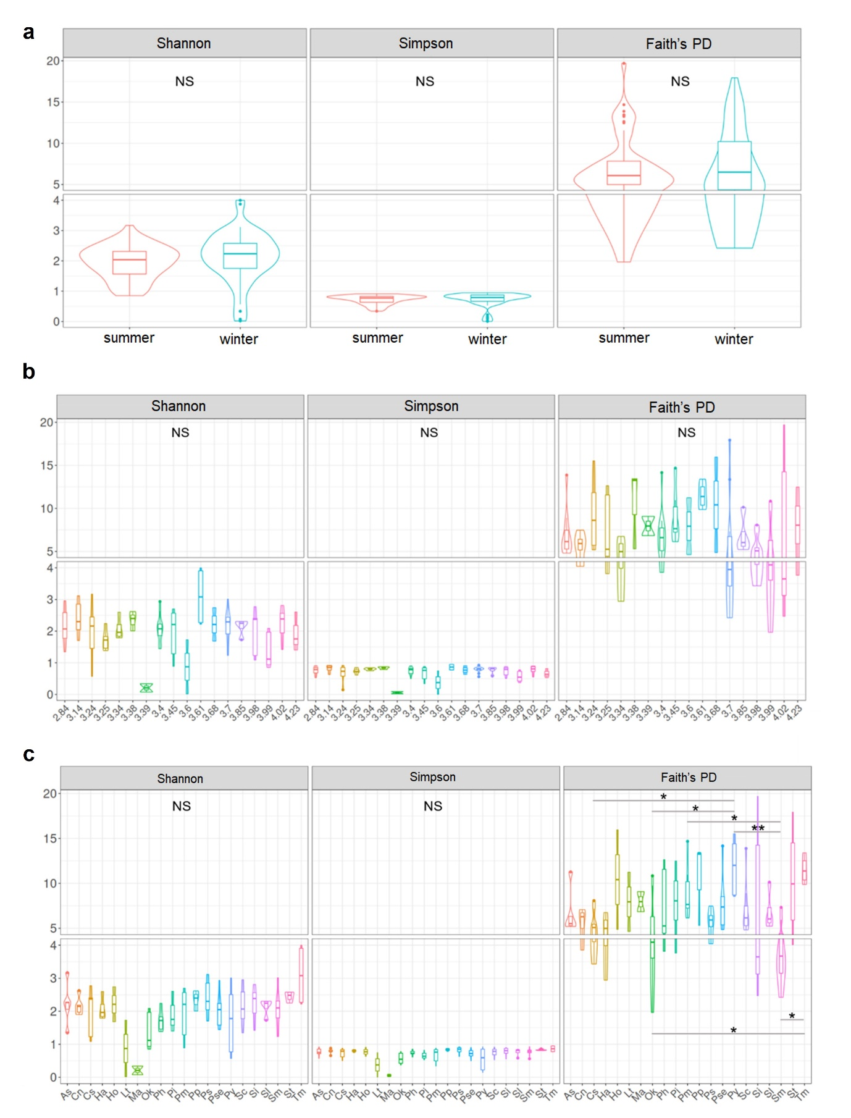Supplementary Fig. S1 Comparison of gut microbial diversity by season (a), fish trophic level (b), and fish species (c). In the 21 fish species, Faith’s phylogenetic diversity between some fish species was significantly different (Kruskal–Wallis test, p = 0.009508; Conover post hoc test with BH; Cs vs. Py, p = 0.0337; Ok vs. Py, p = 0.0288; Ok vs. Tm, p = 0.0457; Pm vs. Sm, p = 0.0337; Py vs. Sm, p = 0.0084; Sm vs. Tm, p = 0.0171) (NS, Not Significant; *, p < 0.05; **, p < 0.01).

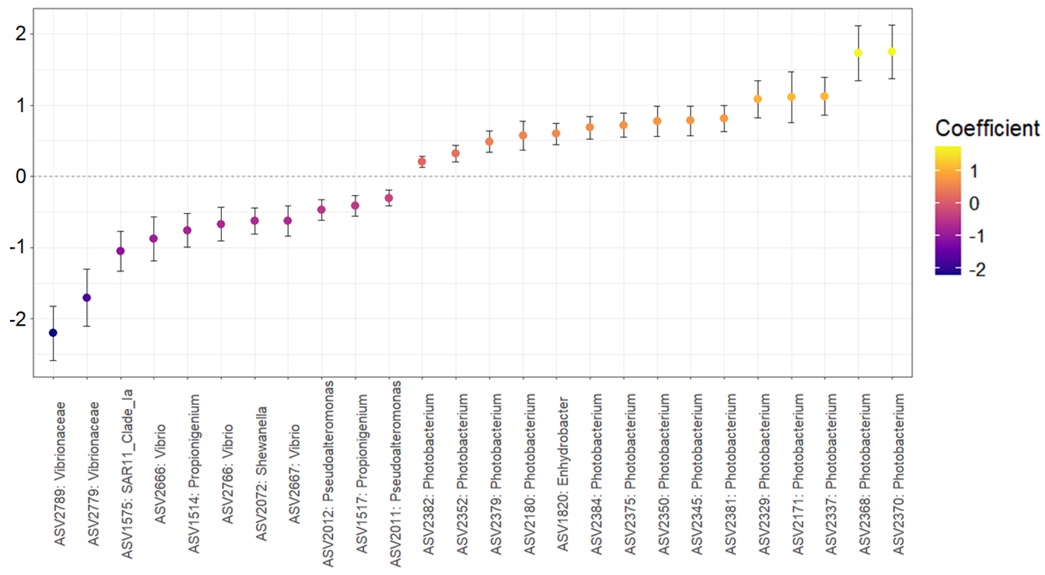
Supplementary Fig. S2 Significant 26 ASVs correlated with fish trophic levels using MaAsLin2. The abundance of ASVs with a positive coefficient value was positively correlated with the trophic level, while that of ASVs with a negative value was negatively correlated with it.

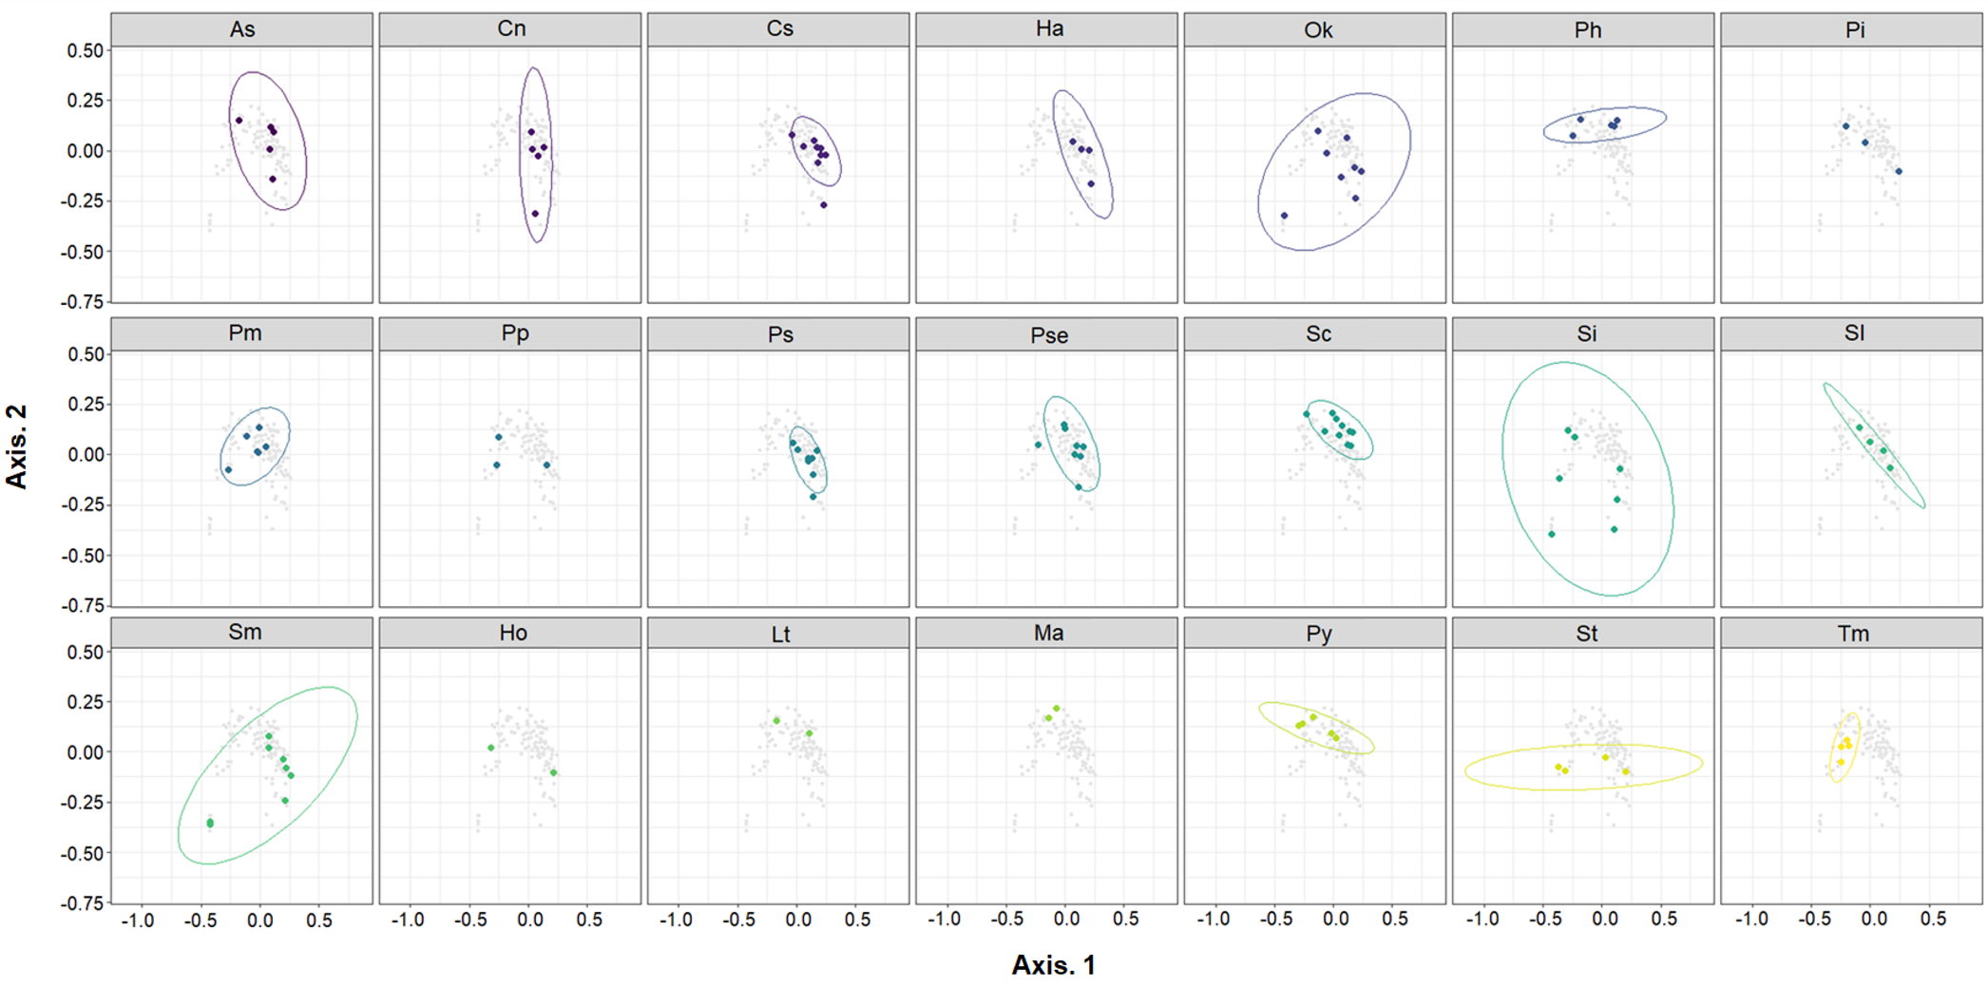
Supplementary Fig. S3 PCoA on the fish GM based on Unweighted UniFrac dissimilarity measurement. To improve the visualization of GM by 21 fish species, the panel was divided by fish species. Ellipses represent the standard deviation (0.95) from each centroid.

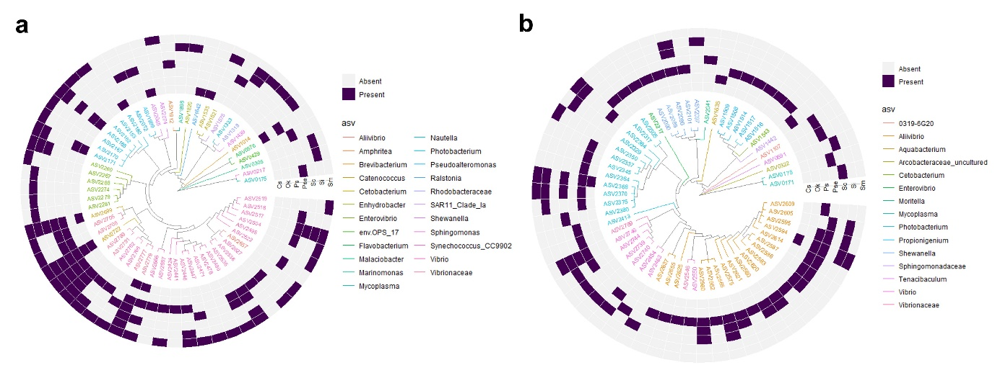
Supplementary Fig. S4 Circular cladogram reporting core ASVs by seven fish species, collected in summer and winter. a In summer, the total number of fish species-core ASVs is 62, with a prevalence threshold of 0.9 and a detection abundance of 1E-05. b In winter, the total number of fish species-core ASVs is 60, with a prevalence threshold of 0.9 and a detection abundance of 1E-05. Each fish species-core ASV of seven fish species was written in Supplementary Table S3 and S4.

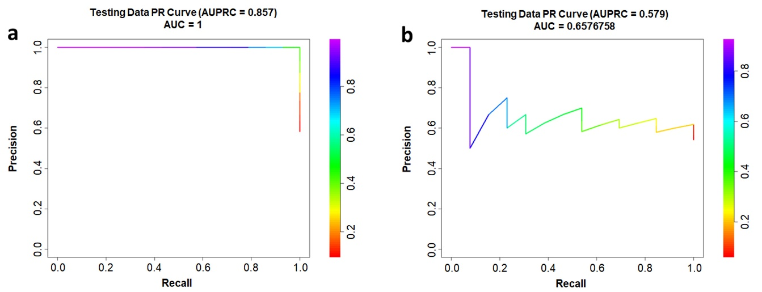
Supplementary Fig. S5 Performance evaluation of random forest classifiers using testing data. a AUPRC curve for seasonal classification (AUPRC = 0.857) showing high predictive power. b AUPRC curve for trophic category classification (AUPRC = 0.579).

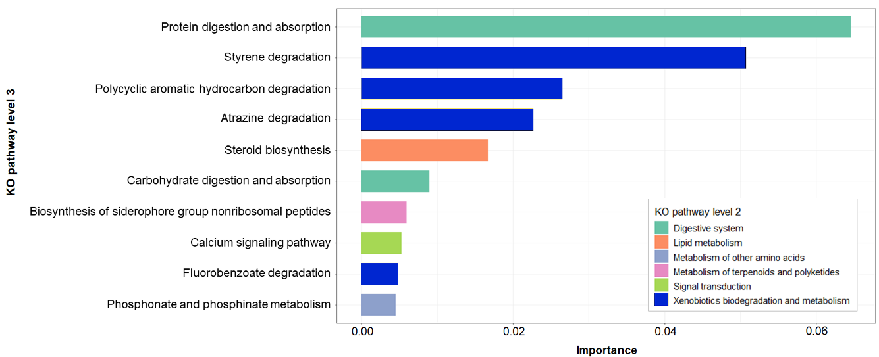
Supplementary Fig. S6 Top 10 feature importance of the random forest classifier for the season of functional pathway composition (KO abundance) in the fish gut. The KO abundance was transformed by the center-log ratio (CLR).

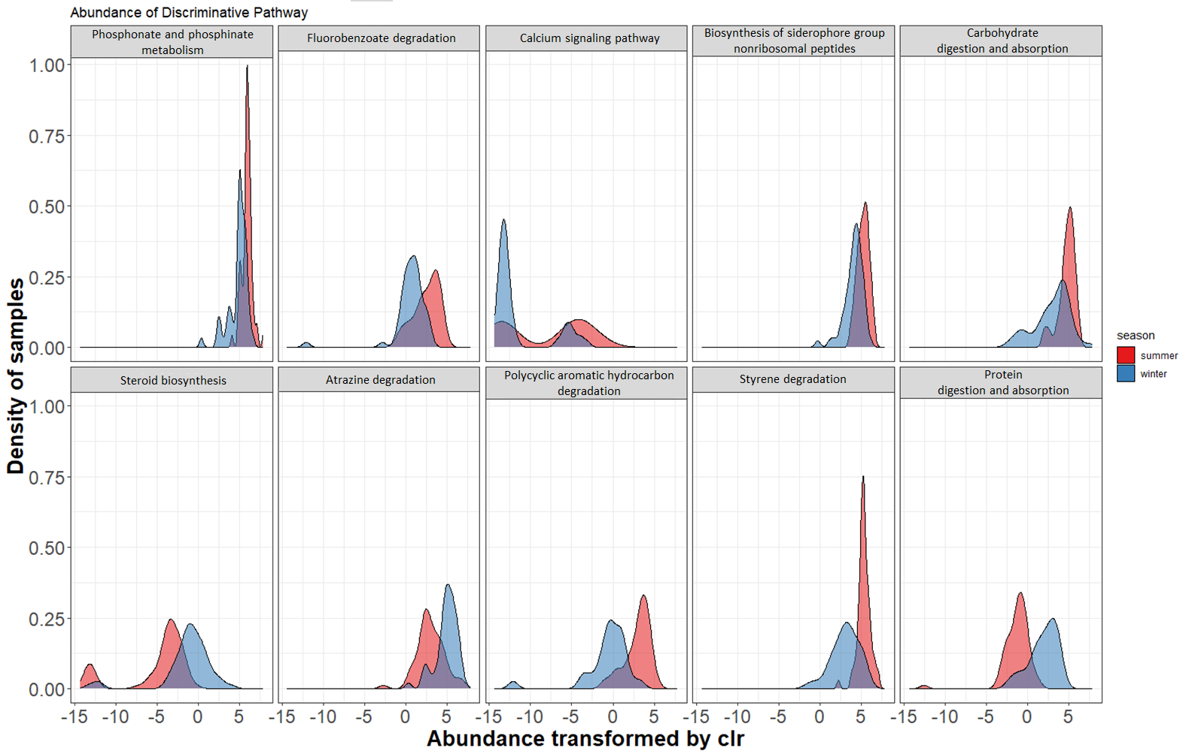
Supplementary Fig. S7 Center-log ratio (CLR)-transformed abundance of discriminative KOs of the fish GM from summer and winter. We selected the top 10 KOs based on feature importance in the random forest classification model
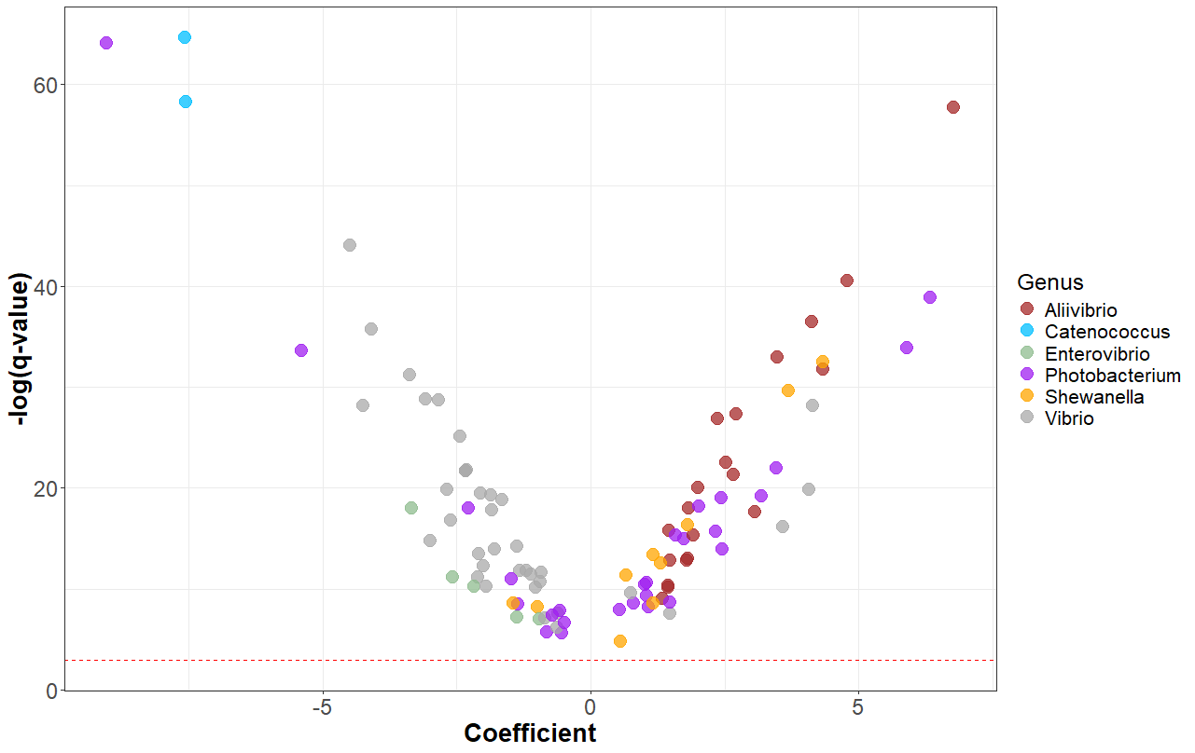
Supplementary Fig. S8 Volcano plot based on seasonal ASVs (belonging to Aliivibrio, Catenococcus, Enterovibrio, Photobacterium, Shewanella, and Vibrio), which were identified using MaAsLin2 The red line represents the -log(0.05). Positive coefficients indicate enrichment of the ASVs in winter, while negative coefficients show their enrichment in summer.

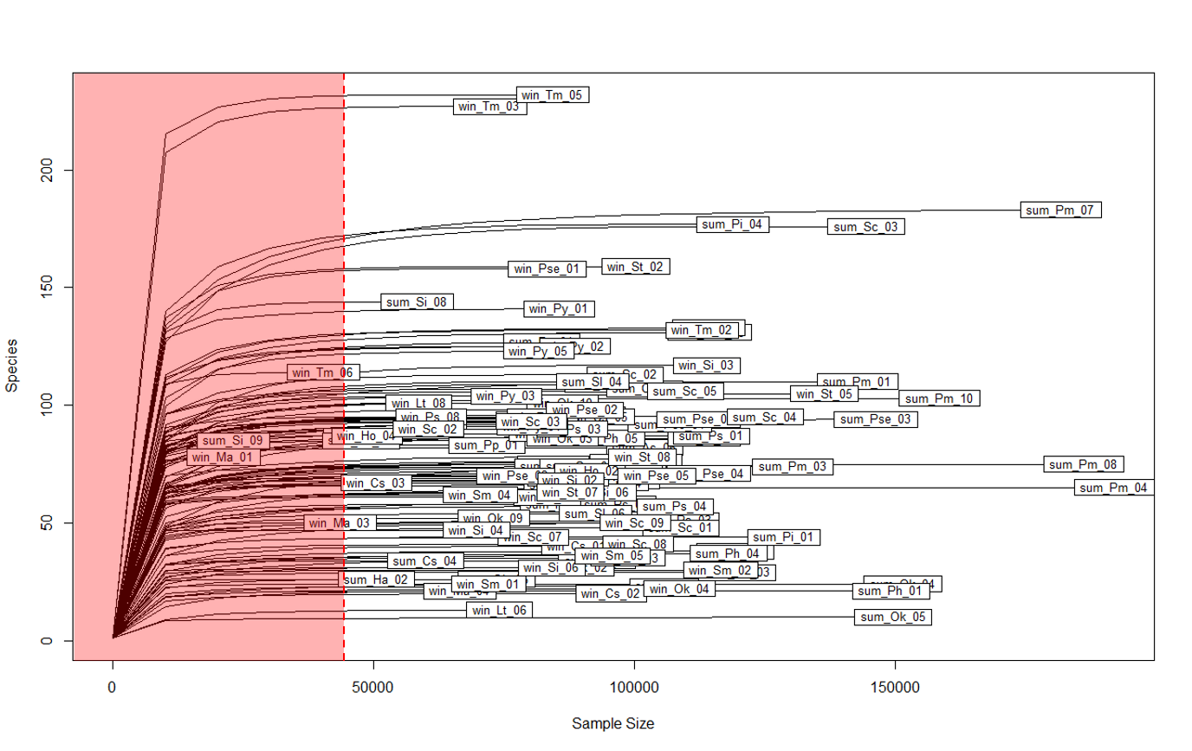
Supplementary Fig. S9 Rarefaction curve for standardization of samples that have different numbers of reads. We selected the depth value (red dot line) with the lowest number of reads (43,634), excluding win_Ma_01, sum_Si_09, and win_Tm_06.

