Supplementary Information

Figure 1: Consolidated criteria for reporting qualitative research (COREQ): a 32-item checklist for interviews and focus groups 2
Figure 2: Image of the Pixi Home-Hub device and Daily Wellbeing Survey Development 4
Figure 3: The Geneva Emotion Wheel (GEW), developed by Scherer, K. R. (2005) 5
Figure 4: Semi-Structured Interview Guide 6
Table 1. Parent and Household Characteristics (N = 22) 7
Table 2: Baseline adaptive functioning scores on the Vineland Adaptive Beahviours Scale (3rd Edition) 8
Table 3. Spearman’s correlation of associations between the Pixi Daily Wellbeing Survey and VABS-3 ABC Domain and Standard Scores 9
Table 4: Description of the Subjective Positions of the Study Researchers 10

Figure 1: Consolidated criteria for reporting qualitative research (COREQ): a 32-item checklist for interviews and focus groups
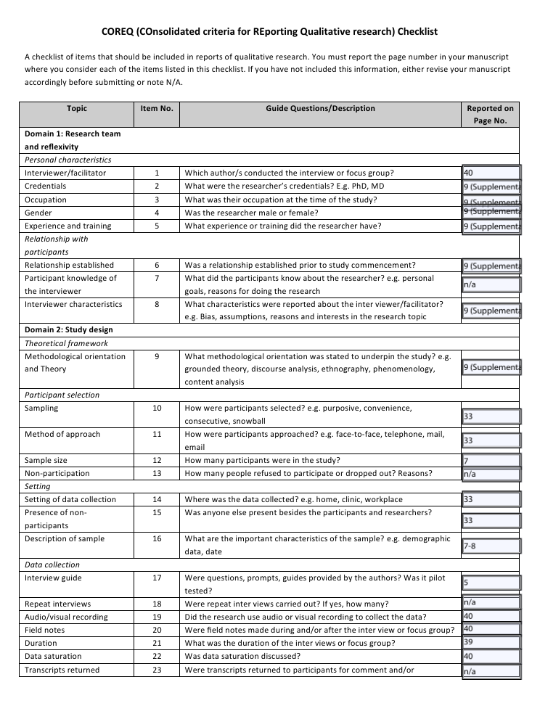

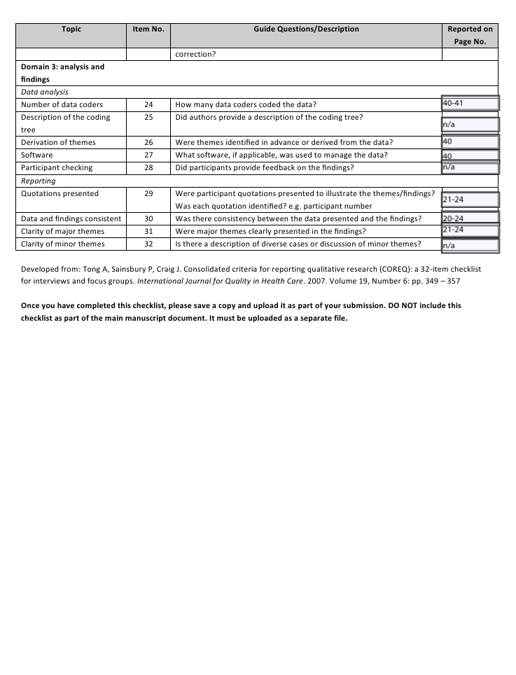

Figure 2: Image of the Pixi Home-Hub device and Daily Wellbeing Survey Development
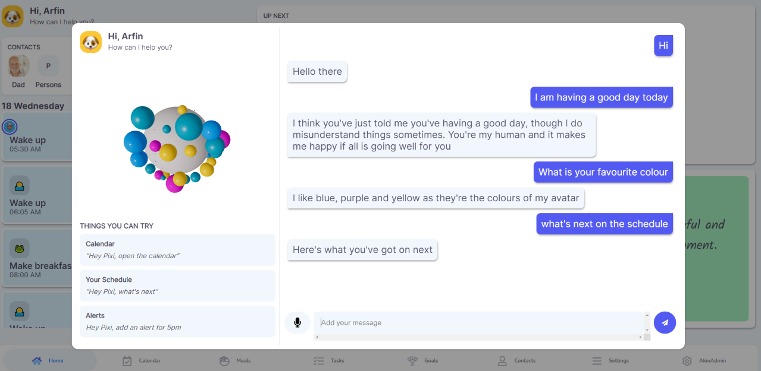
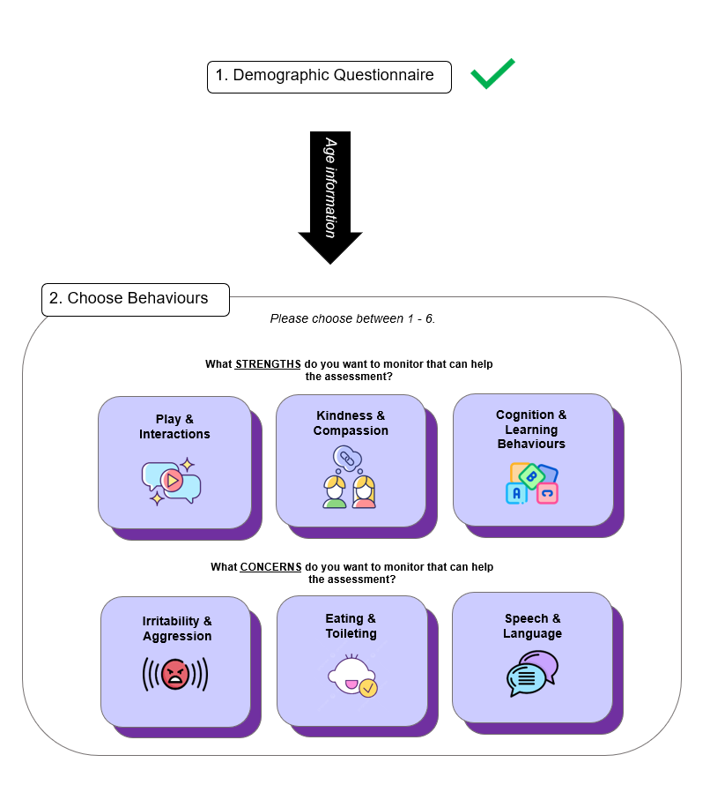

Figure 3: The Geneva Emotion Wheel (GEW), developed by Scherer, K. R. (2005)
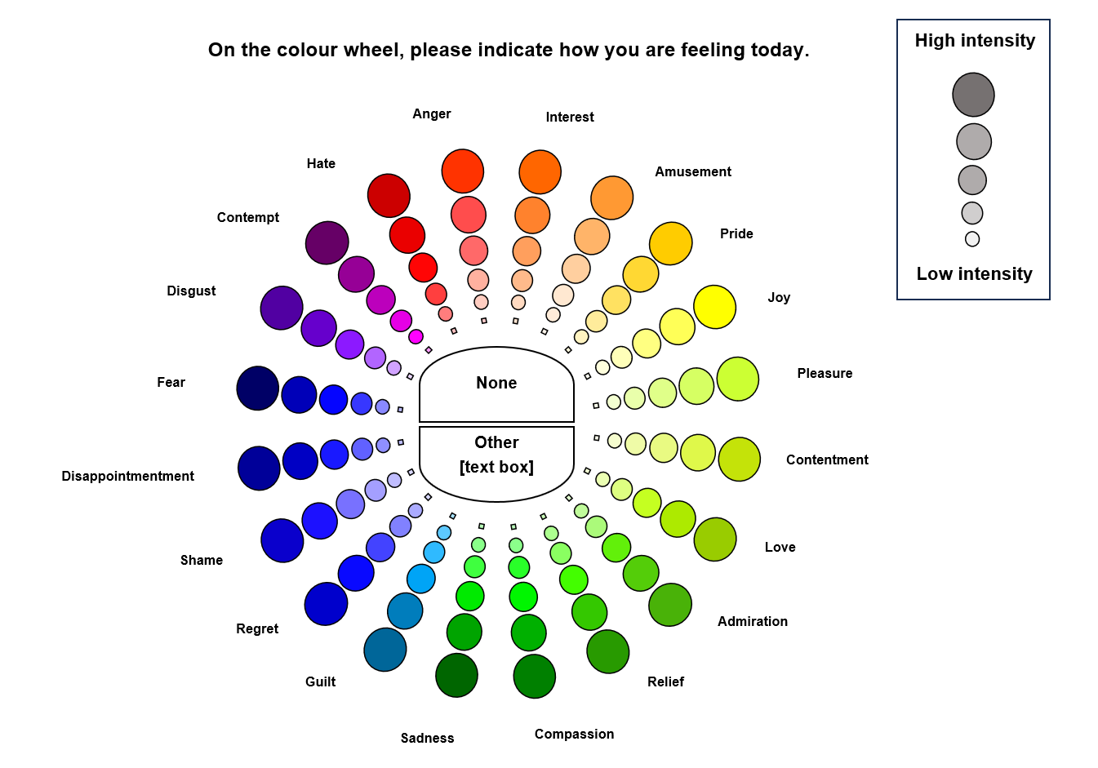

Figure 4: Semi-Structured Interview Guide
Semi-structured interview with parent/caregiver (post 2-week trial)

Thank you very much for being involved in this research. We hope that the past two weeks have gone well! This interview will give us a chance to hear about how you went using the Pixi home-hub device.

Just before we start, I was wondering whether it would be okay to tape record the interview. I find it hard to listen and write at the same time and so I find it helpful to tape record the interviews I do. The tape will only be listened to by myself and other members of our research team for the purpose of this research.

If you want to stop the interview at any point, you can do that without giving me a reason.

Do you have any questions about the interview before we start?

Okay, let’s start. I’m going to ask you some questions about the Pixi home-hub device overall, and then we will talk in a bit more detail about the different ways you used Pixi.

YOUR EXPERIENCE OF PIXI

Primary question 1: Tell me a bit about how prepared you felt to use Pixi.

Probe questions:
- How was the training session? What was good about it? What was not-so-good about it? Anything that could have been done differently?
- Did you have any questions that weren’t answered in the training? What were those questions? Was there someone available for you to ask questions when you needed it?
- Is there anything else you would have liked to have received, or to have known before using Pixi?

Primary question 2: Can you tell me about your overall experience of using the Pixi home-hub device?

Probe questions:
- Did you find Pixi easy to use? Was there anything that wasn’t so easy?
- How did you find the different screens? How easy were they to read/understand/navigate between? Anything that was a bit trickier?
- Which aspects of Pixi did you like the most? What did you like the least?
- How often did you use the device? Was that more or less than you expected?
- Was there anything stopping you from using the device?
- Did you need help in using Pixi while it was at home with you? Did you receive the right help?

Primary question 3: Let’s focus more on the specific tasks you were using Pixi for. How beneficial were they?

Probe questions:
- Which aspects of Pixi did you use the most (i.e., calendar, goal tracking, check lists, etc.)?
- Which did you use the least? Why?
- Did you find the dashboard helpful? What did you like about it, or not like about it?
- What was your experience of the calendar? What was good about it? What was not-so-good about it?
- Did you use the meal planners or shopping lists? What did you like about them? What did you not like about them?
- Did Pixi help you reach the goal you’d set at the beginning of the trial? Did you find the goal-setting tool helpful? Was there anything you didn’t like about it?
- What feature did you enjoy the most? And the least?
- What aspects were most beneficial for you? What about for your child?
- Anything else that could have been included in the device, or designed differently?

Primary question 4: How did you find the pop-up questions?
- How easy were the questions to think about and answer?
- Did you find they were relevant to what you had been doing that day? Did they capture what was happening at the time?
- Did you receive them at convenient times? Why were these convenient, or not so convenient?
- What about the way the questions were worded? Did you prefer a particular style?
- Was there anything else these pop-ups could have asked, that would have better captured what was happening for you and your child?

QUESTION TIME AND THANK YOU

This is the end of the interview! Thank you very much all your thoughts. Before you go, do you have any questions for me?

Thanks again.

Table 1. Parent and Household Characteristics (N = 22)
Parent Demographic Characteristic | Mean (SD) / n (%)
Relationship to Child
Mother | 17 (77.27%)
Father | 5 (22.72%)
Educational Attainment
Primary School | 1 (4.55%)
High School | 2 (9.09%)
TAFE/College Diploma | 5 (22.73%)
Trade/Apprenticeship | 1 (4.55%)
University Degree | 9 (40.91%)
Postgraduate Study | 4 (18.18%)
Employment Status
Permanent | 12 (54.55%)
Casual | 5 (22.73%)
Unemployed | 5 (22.73%)
Household Income
<$60K | 1 (4.55%)
$60-100K | 6 (27.27%)
$100-150K | 7 (31.82%)
$150-200K | 1 (4.55%)
>$200K | 1 (4.55%)
Not disclosed | 6 (27.27%)
Household Composition
Two-parent | 17 (77.27%)
Single parent | 5 (22.73%)
Perceived Health Status
Excellent | 3 (13.64%)
Very Good | 6 (27.27%)
Good | 6 (27.27%)
Fair | 7 (31.82%)
Note. Educational attainment is taken from primary contact caregiver.

Table 2: Baseline adaptive functioning scores on the Vineland Adaptive Behaviours Scale (3rd Edition)
Measure | Mean (SD) | Median  [IQR, Q1-Q3] | Range  (min-max) | Functioning Classification,  n (%)
Interview (Comprehensive) N = 4
Adaptive Behaviour Composite (ABC) standard score | 52.75 (22.87) | 42 [40.8–54] | 40–87 | Adequate: 1 (25%);  Low: 3 (75%)
Communication domain standard score | 50 (19.11) | 43 [39–54] | 36–78 | Adequate: 1 (25%);  Low: 3 (75%)
Receptive v-scale | 3.5 (3.79) | 2 [1–4.5] | 1–9 | Adequate: 1 (25%);  Low: 3 (75%)
Expressive v-scale | 3.50 (2.38) | 3.5 [1.8–5.3] | 1–6 | Adequate: 1 (25%);  Low: 3 (75%)
Written v-scale (if applicable) | 10.25 (7.8) | 11 [8.3–13] | 0–19 | Adequate: 1 (25%);  Low: 3 (75%)
Daily Living Skills domain standard score | 40.25 (17.5) | 34 [31.5–42.8] | 27–66 | Adequate: 1 (25%);  Low: 3 (75%)
Personal v-scale | 4.75 (1.26) | 5 [4.5–5.3] | 3–6 | Adequate: 1 (25%);  Low: 3 (75%)
Domestic v-scale | 2 (3.37) | 0.5 [0–2.5] | 0–7 | Adequate: 1 (25%);  Low: 3 (75%)
Community v-scale | 3 (6) | 0 [0–3] | 0–12 | Adequate: 1 (25%);  Low: 3 (75%)
Socialisation domain standard score | 49 (4.76) | 51 [48–52] | 42–52 | Adequate: 1 (25%);  Low: 3 (75%)
Interpersonal Relationships v-scale | 3.25 (0.50) | 3 [3–3.25] | 3–4 | Adequate: 1 (25%);  Low: 3 (75%)
Play and Leisure v-scale | 6.75 (1.26) | 7 [6.5–7.3] | 5–8 | Adequate: 1 (25%);  Low: 3 (75%)
Coping Skills v-scale | 7.25 (1.50) | 8 [7.25–8] | 5–8 | Adequate: 1 (25%);  Low: 3 (75%)
Motor Skills domain standard | 60 (15.25) | 62.5 [52.8–69.8] | 40–75 | Adequate: 1 (25%);  Low: 3 (75%)
Gross Motor v-scale | 7.75 (2.75) | 7.5 [5.75–9.50] | 5–11 | Adequate: 1 (25%);  Low: 3 (75%)
Fine Motor v-scale | 7.75 (1.50) | 7 [7–7.75] | 7–10 | Adequate: 1 (25%);  Low: 3 (75%)
Parent/Caregiver (Comprehensive) N = 11
Adaptive Behaviour Composite (ABC) standard score | 94.27 (29.40) | 100 [72–109] | 42–139 | Adequate: 7 (63.6%); Moderately Low: 1 (9.1%);  Low 3 (27.3%)
Communication domain standard score | 71.18 (30.37) | 65 [57–75] | 32–140
Receptive v-scale | 6.91 (3.91) | 8 [4.5–8.5] | 1–13
Expressive v-scale | 8.64 (3.80) | 8 [7–11.5] | 1–14
Written v-scale (if applicable) | 9.55 (4.82) | 11 [7.0–13] | 0–16
Daily Living Skills domain standard score | 117.73 (37.62) | 140 [107.5–140] | 36–140
Personal v-scale | 9.73 (3.95) | 9 [7.5–11] | 4–17
Domestic v-scale | 8.91 (4.95) | 10 [8.0–12] | 0–16
Community v-scale | 8.00 (4.49) | 9 [7–10.5] | 0–14
Socialisation domain standard score | 96.36 (28.42) | 100 [80.5–113.5] | 44–140
Interpersonal Relationships v-scale | 9.18 (3.22) | 9 [7–11.5] | 3–14
Play and Leisure v-scale | 9.55 (3.33) | 10 [8.5–11] | 2–14
Coping Skills v-scale | 9.45 (2.58) | 9 [7.5–12] | 6–13
Motor Skills domain standard | 48.36 (23.56) | 48 [42–52.2] | 0–102
Gross Motor v-scale | 11.27 (4.56) | 11 [9.5–14.5] | 0–16
Fine Motor v-scale | 9.82 (4.35) | 10 [8–12] | 0–17
Parent/Caregiver (Domain) N = 4
Adaptive Behaviour Composite (ABC) standard score | 71.0 (2.2) | 71.5 [70.3–72.3] | 68–73 | Moderately Low: 3 (75%); Low: 1 (25%)
Communication domain standard score | 67.8 (7.0) | 65.5 [64.3–69.0] | 62–78 | Moderately Low: 3 (75%); Low: 1 (25%)
Daily Living Skills domain standard score | 79.8 (6.7) | 82.0 [79.0–82.8] | 70–85 | Moderately Low: 3 (75%); Low: 1 (25%)
Socialisation domain standard score | 70.5 (9.9) | 74.0 [68.0–76.5] | 56–78 | Moderately Low: 3 (75%); Low: 1 (25%)
Motor Skills domain standard | 84.8 (6.1) | 84.5 [81.0–88.3] | 78–92 | Moderately Low: 3 (75%); Low: 1 (25%)
Domain and ABC values are VABS-3 standard scores (mean: 100; SD: 15). Subdomain values are v-scale scores (mean: 15; SD: 3). Higher scores indicate better adaptive functioning. Classifications shown for standard scores reflect ranges in the VABS-3 manual (e.g. adequate (86-114), moderately low (71-85), low (≤70). N may vary by domain due to missingness or age-based administration rules (e.g. Motor skills not administered to all participants. SD; Standard Deviation; IQR; Interquartile Range (Q1 = 25th percentile; Q3 = 75th percentile.

Table 3. Spearman’s correlation of associations between the Pixi Daily Wellbeing Survey and VABS-3 ABC Domain and Standard Scores
Domain |  | Communication |  | Socialisation |  | Daily Living Skills |  | Motor Skills |  | Vineland ABC Scores Combined |  | Magnitude with ABC
 | N | r | p-value | r | p-value | r | p-value | r | p-value | r | p-value
Play & Interactions | 9 | 0.23 | 0.55 | 0.05 | 0.90 | 0.09 | 0.82 | 0.07 | 0.86 | 0.07 | 0.87 | Negligible
Kindness & Compassion | 11 | -0.12 | 0.72 | -0.23 | 0.50 | -0.14 | 0.68 | 0.34 | 0.30 | -0.19 | 0.58 | Negligible
Cognition & Learning Behaviours | 17 | -0.11 | 0.66 | -0.04 | 0.88 | 0.13 | 0.62 | -0.22 | 0.40 | -0.02 | 0.94 | Negligible
Irritability & Aggression | 16 | 0.23 | 0.38 | 0.16 | 0.55 | 0.01 | 0.97 | 0.19 | 0.48 | 0.21 | 0.45 | Small
Eating & Toileting | 12 | 0.35 | 0.26 | 0.31 | 0.32 | 0.28 | 0.38 | 0.22 | 0.51 | 0.26 | 0.42 | Small
Speech & Language | 19 | 0.45 | 0.05* | 0.19 | 0.44 | 0.21 | 0.42 | 0.31 | 0.21 | 0.37 | 0.12 | Moderate
Note. Vineland Adaptive Behaviour Composite (ABC) Scores on the Parent/Caregiver and Interview Forms are directly comparable and were combined for analysis. Note. *Indicates statistical significance set as p = 0.05. Correlation magnitude was interpreted using established thresholds (negligible < 0.1, small 0.0–0.29, moderate 0.3–0.49, large 0.50–0.69, very large ≥ 0.70).

Table 4: Description of the Subjective Positions of the Study Researchers
Theoretical framework | The theoretical framework used in this project was content analysis. This was primarily used to identify meaning and patterns regarding the experiences among caregivers with children with neurodevelopmental conditions and their experiences navigating the Geneva Emotion Wheel (GEW) and Daily Wellbeing Survey (DWS) on an artificial intelligence (AI)-assistive technology. An inductive approach to content analysis was employed, (no pre-existing categories and themes emerging directly from the data), which is useful when there is limited prior knowledge in an area of research.
Beliefs | Families with children with neurodevelopmental conditions often exhibit challenges in adaptive functioning that can inhibit overall quality of life. Experience Sampling Methods (ESM) on technology equipped with AI can provide ways to capture adaptive functioning as it occurs naturally that can be helpful to inform clinical assessments.
Motivation | To explore the adaptive functioning experiences of families with children with neurodevelopmental conditions in their everyday lives using digital ESM on an AI-assistive device. To understand caregivers’ point of view in matters most relevant to them in their daily lives, including adaptive function and wellbeing. There is a lack of research on the experiences of families with children with a diverse range of neurodevelopmental conditions and how they navigate functioning needs, further, there has been limited information on how digital ESM on an AI-assistive device can assist these needs. This qualitative perspective can aid in understanding these perspectives, which may be of interest to health professionals, researchers and policymakers.
Researcher characteristics | Author N.P. is a female PhD student with postgraduate training in qualitative research methods and previous experience in neurodevelopment research with a focus on digital health, adaptive functioning and quality of life. She has no prior connections with the study participants.  Author M.M. is a female researcher with postgraduate training in qualitative research methods and previous neurodevelopment research with a focus on clinical neuropsychology. She has no prior connections with the study participants.  Author K.B. is a female senior research fellow with previous experience in neurodevelopment research with a focus on digital health and research translation. She has no prior connections with the study participants.  Author A.J.G. is a male professor in clinical psychology with previous experience in neurodevelopmental conditions with a focus on mental health and research translation. He has no prior connections with the study participants.

