Changes in the root system architecture of Agriophyllum squarrosum and soil-driven mechanisms along the sand fixation gradient on the southeastern edge of the Tengger Desert
Keer Lou¹ • Wenjie Qu² • Lin Chen³ • Yinglong Chen^{4 •} Xinguo Yang⁵
¹ College of Ecological Environment, Ningxia University, Yinchuan, China
² College of Agriculture, Forestry and Ecology, Ningxia University, Yinchuan, China
³ College of Ecological Environment, Ningxia University, Yinchuan, China
⁴ School of Agriculture and Environment, University of Western Australia, Perth, WA, Australia
⁵ College of Ecological Environment, Ningxia University, Yinchuan, China
- Xinguo Yang
Xinguoyang1976@163.com

Table. S1 Population characteristics of Agriophyllum squarrosum under different sand-fixation degrees
Area | Plant height/cm | Crown spread/cm² | Stem diameter/mm | Aboveground biomass/g
MD | 25.88±1.15a | 538.44±27.7a | 6.24±0.34a | 7.37±0.39a
SFD | 20.97±1.06b | 277.82±16.34b | 3.88±0.18b | 4.3±0.2b
FD | 14.45±0.72c | 95.03±5.15c | 2.47±0.13c | 1.94±0.09c
Different lowercase letters in the same column indicate significant differences among plots (P < 0.05). n=90. MD, SFD, and FD represent mobile dunes, semi-fixed dunes, and fixed dunes, respectively.

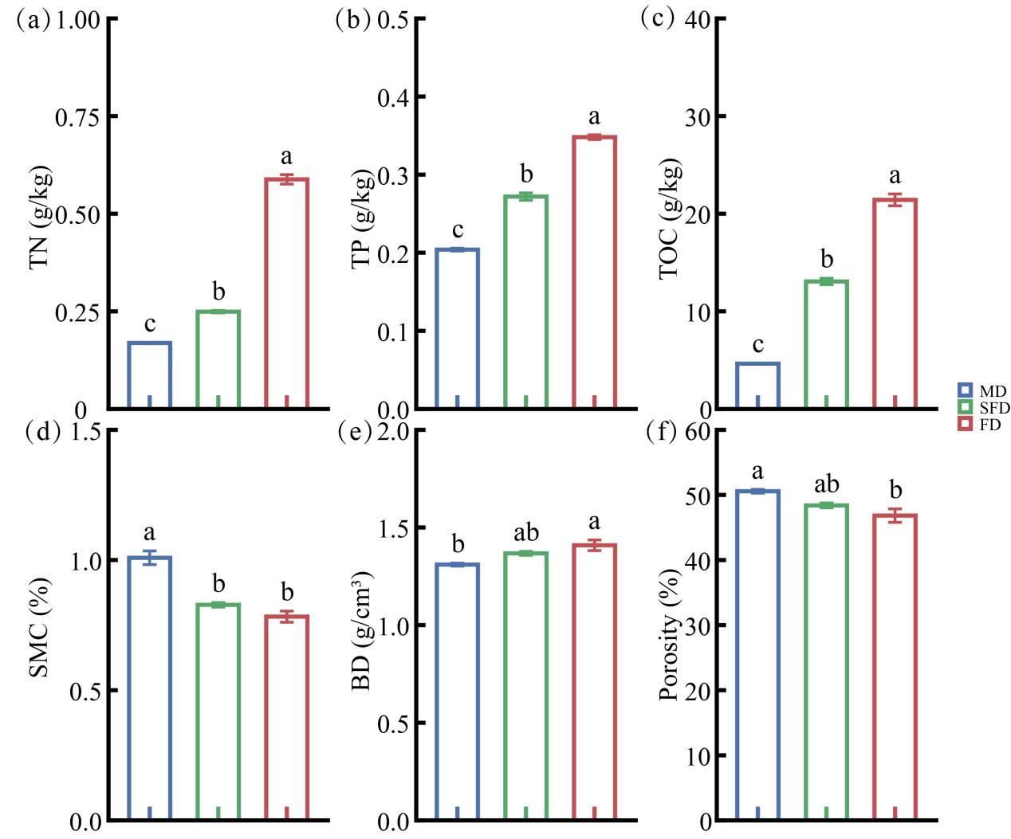
Fig. S1 Changes in overall soil physicochemical properties under sand fixation gradients (a) Total soil nitrogen; (b) Total soil phosphorus; (c) Soil organic carbon; (d) Soil moisture content; (e) Soil bulk density; (f) Soil porosity. Different lowercase letters indicate significant differences among the various levels of sand fixation (P < 0.05, one-way ANOVA + Tukey’s test). MD, SFD, and FD represent mobile dunes, semi-fixed dunes, and fixed dunes, respectively.

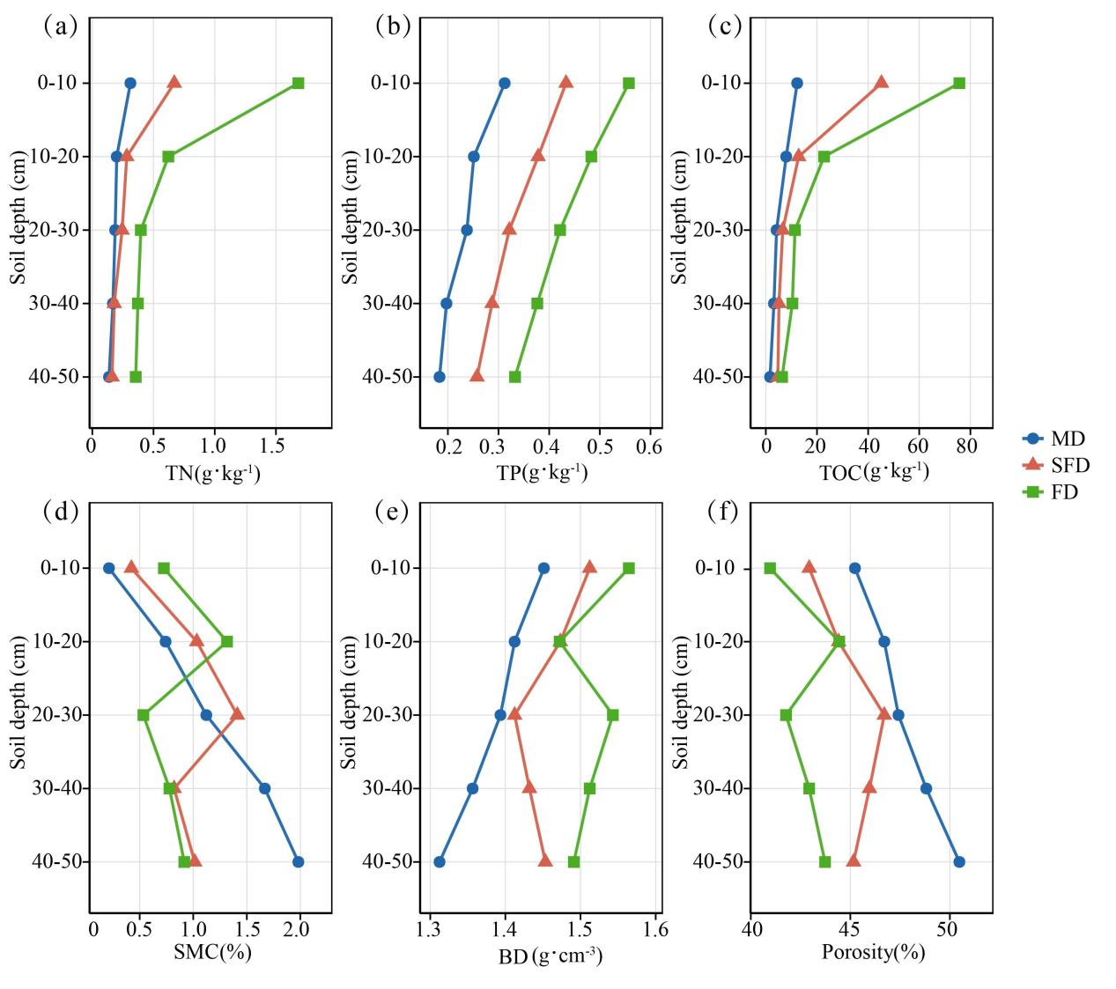
Fig. S2 Changes in the physicochemical properties of soil layers at 0 - 50 cm under sand fixation gradients (a) Total soil nitrogen; (b) Total soil phosphorus; (c) Soil organic carbon; (d) Soil moisture content; (e) Soil bulk density; (f) Soil porosity. MD, SFD, and FD represent mobile dunes, semi-fixed dunes, and fixed dunes, respectively.

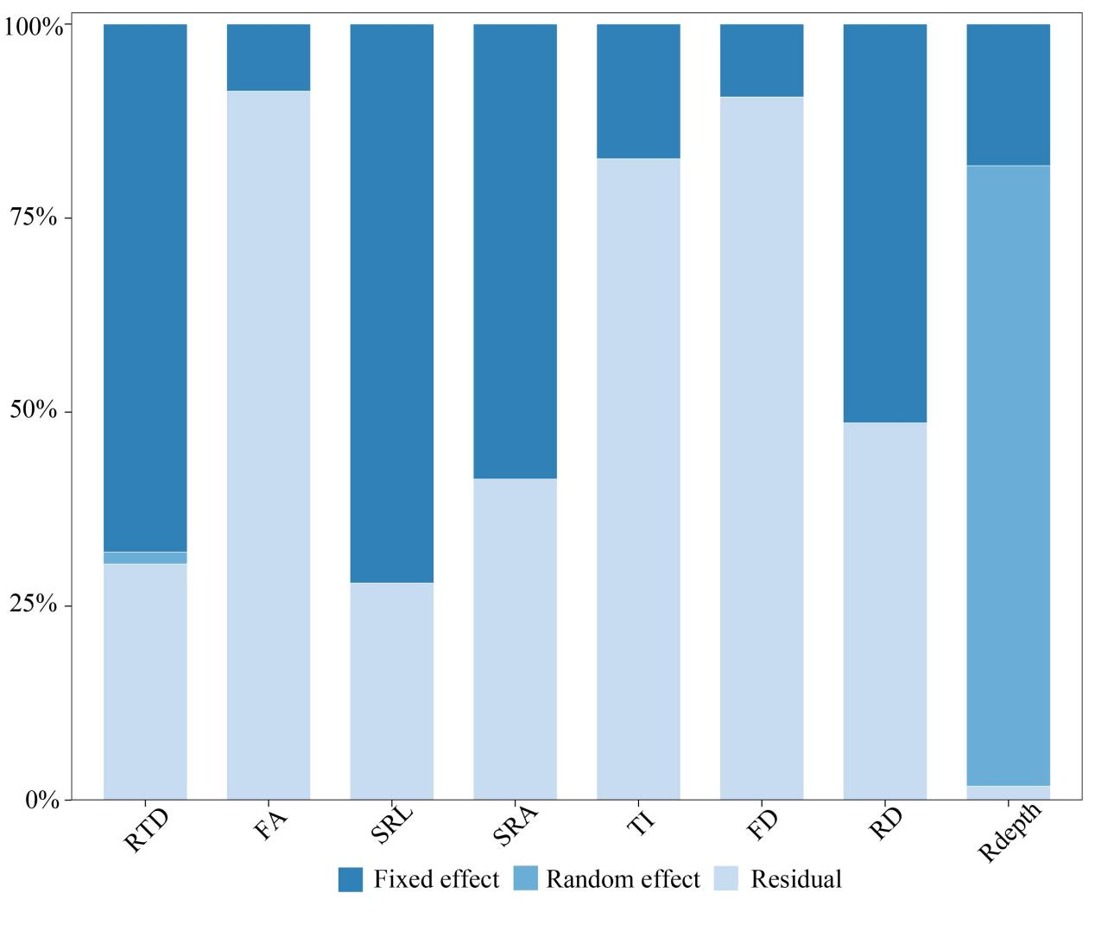
Fig. S3 Variance decomposition diagram of root system architecture variation based on linear mixed model. root depth (Depth). specific root length (SRL). specific root surface area (SRA). root diameter (RD). root tissue density (RTD). topological index (TI). fractal dimension (FD). fractal abundance (FA).

