SUPPORTING INFORMATION
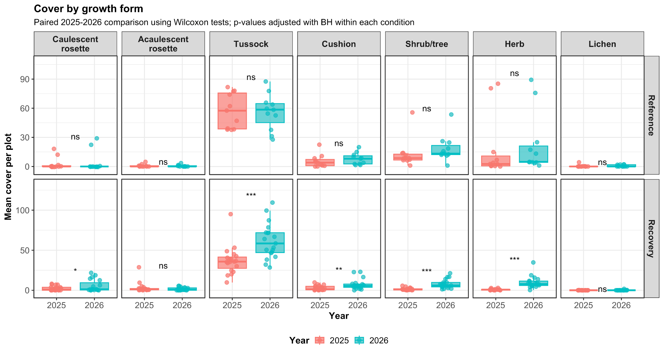
SI Figure 1. Temporal changes in mean plant cover of the ten most dominant species between 2025 and 2026.
SI Table 1. Species-level plant cover in recovery and reference plots in 2025 and 2026. Values represent mean cover per plot (%) ± standard deviation. Species recorded exclusively in recovery or reference plots across both years are shown in bold.

Scientific name | Family | Growth form | Recovery 2025 | Recovery 2026 | Reference 2025 | Reference 2026
Ageratina cf. elegans (Kunth) R.M. King & H. Rob. | Asteraceae | Shrub/tree | 0.321 ± 0.61 | 1.118 ± 1.858 | 0.545 ± 0.788 | 0.636 ± 1.343
Agrostis perennans (Walter) Tuck. | Poaceae | Tussock | 2.553 ± 9.712 | 4.632 ± 20.128 | 0.295 ± 0.678 | 4.341 ± 9.663
Alnus acuminata Kunth | Betulaceae | Shrub/tree |  |  | 4.659 ± 15.452 | 4.205 ± 13.945
Anthoxanthum odoratum L. | Poaceae | Tussock | 0.092 ± 0.401 |  | 2.318 ± 7.524 | 4.932 ± 10.065
Aragoa abietina Kunth | Plantaginaceae | Shrub/tree | 0.222 ± 0.531 | 1.224 ± 2.732 | 0.114 ± 0.377
Arcytophyllum muticum (Wedd.) Standl. | Rubiaceae | Shrub/tree |  | 0.171 ± 0.417 | 0.568 ± 1.725 | 1.364 ± 3.083
Arcytophyllum nitidum (Kunth) Schltdl. | Rubiaceae | Shrub/tree | 0.119 ± 0.236 | 0.434 ± 0.57 | 0.831 ± 1.383 | 1.659 ± 3.423
Baccharis tricuneata (L. f.) Pers. | Asteraceae | Shrub/tree | 0.002 ± 0.007 | 0.158 ± 0.458 | 0.367 ± 0.756 | 1.091 ± 1.828
Bartramia sp. | Bartramiaceae | Cushion |  |  | 0.003 ± 0.009
Bartsia sp. | Orobanchaceae | Herb | 0.057 ± 0.113
Breutelia sp. | Bartramiaceae | Cushion | 0.533 ± 1.189 |  | 3.333 ± 6.683
Calamagrostis sp. | Poaceae | Tussock |  |  | 2.25 ± 6.731
Campylopus pauper (Hampe) Mitt. | Leucobryaceae | Cushion | 0.656 ± 1.14 | 0.803 ± 0.836
Carex bonplandii Kunth | Cyperaceae | Tussock |  | 1.592 ± 2.757 |  | 2.659 ± 7.519
Carex pichinchensis Kunth | Cyperaceae | Tussock |  | 0.737 ± 1.072 |  | 1.568 ± 2.308
Castratella piloselloides Naudin | Melastomataceae | Herb | 0.039 ± 0.172 | 0.013 ± 0.057
Chusquea tessellata Munro | Poaceae | Tussock | 16.25 ± 12.024 | 17.632 ± 13.253 | 14.205 ± 12.628 | 9.364 ± 11.329
Cinnagrostis recta (Kunth) P.M. Peterson, Soreng, Romasch. & Barberá | Poaceae | Tussock |  | 4.171 ± 4.326 |  | 1.386 ± 2.038
Cladonia confusa R. Sant. | Cladoniaceae | Lichen | 0.013 ± 0.057 | 0.079 ± 0.289 | 0.412 ± 1.285 | 0.545 ± 0.813
Cladonia rappii A. Evans | Cladoniaceae | Lichen |  | 0.026 ± 0.115 | 0.007 ± 0.017 | 0.25 ± 0.622
Cortaderia columbiana (Pilg.) Pilg. | Poaceae | Tussock |  | 0.737 ± 2.52
Cortaderia nitida (Kunth) Pilg. | Poaceae | Tussock | 0.974 ± 2.274 | 1.75 ± 2.437 | 3.318 ± 3.292 | 7.068 ± 12.683
Danthonia secundiflora J. Presl | Poaceae | Tussock | 6.5 ± 5.595 | 11.974 ± 11.143 | 19.295 ± 22.203 | 11.136 ± 14.921
Diphasiastrum thyoides (Humb. & Bonpl. ex Willd.) Holub | Lycopodiaceae | Herb | 0.002 ± 0.007 | 0.013 ± 0.057 | 0.068 ± 0.226 | 0.114 ± 0.377
Elaphoglossum sp. | Dryopteridaceae | Herb |  | 0.013 ± 0.057 | 0.023 ± 0.075 | 0.023 ± 0.075
Epilobium cf. denticulatum Ruiz & Pav. | Onagraceae | Herb |  |  |  | 0.023 ± 0.075
Espeletia standleyana A.C. Sm. | Asteraceae | Caulescent rosette | 2.441 ± 2.933 | 5.395 ± 7.349 | 2.841 ± 6.128 | 4.591 ± 10.333
Galium hypocarpium (L.) Endl. ex Griseb. | Rubiaceae | Herb | 0.043 ± 0.145 | 0.408 ± 1.197 |  | 0.023 ± 0.075
Gaultheria anastomosans (L. f.) Kunth | Ericaceae | Shrub/tree | 0.099 ± 0.345 | 0.25 ± 0.782 | 0.003 ± 0.009
Gaultheria myrsinoides Kunth | Ericaceae | Shrub/tree | 0.06 ± 0.137 | 0.342 ± 0.473 | 0.301 ± 0.566 | 0.886 ± 2.226
Gaultheria santanderensis A.C. Sm. | Ericaceae | Shrub/tree | 0.116 ± 0.302 | 0.303 ± 0.724 | 0.322 ± 0.797 | 0.568 ± 0.888
Gaylussacia buxifolia Kunth | Ericaceae | Shrub/tree | 0.054 ± 0.114 | 0.487 ± 0.814 | 0.012 ± 0.039 | 0.023 ± 0.075
Gentianella sp. | Gentianaceae | Herb |  | 0.013 ± 0.057
Geranium holosericeum Willd. ex Spreng. | Geraniaceae | Herb |  | 0.092 ± 0.401
Geranium santanderiense R. Knuth | Geraniaceae | Herb | 0.368 ± 0.389 | 0.855 ± 0.709 | 0.401 ± 0.412 | 0.545 ± 0.557
Geranium sibbaldioides Benth. | Geraniaceae | Herb |  | 0.276 ± 0.463 | 0.037 ± 0.089 | 0.205 ± 0.416
Geranium sp. | Geraniaceae | Herb |  |  | 0.295 ± 0.98
Gnaphalium sp. | Asteraceae | Herb | 0.003 ± 0.011
Halenia adpressa C.K. Allen | Gentianaceae | Herb | 0.023 ± 0.051 | 1.526 ± 1.341 | 0.01 ± 0.025 | 0.273 ± 0.48
Harperocallis sessiliflora (Hook.) L.M. Campb. & Dorr | Tofieldiaceae | Herb | 0.041 ± 0.128 | 0.224 ± 0.862
Hesperomeles goudotiana (Decne.) Killip | Rosaceae | Shrub/tree |  | 0.066 ± 0.287 |  | 0.023 ± 0.075
Hesperomeles obtusifolia (Pers.) Lindl. | Rosaceae | Shrub/tree |  |  | 0.292 ± 0.652 | 0.477 ± 1.175
Hieracium frigidum Wedd. | Asteraceae | Herb | 0.038 ± 0.096 | 0.289 ± 0.522 |  | 0.114 ± 0.259
Holcus lanatus L. | Poaceae | Tussock | 2.368 ± 10.324 | 0.355 ± 1.549 | 5.159 ± 15.753 | 2.705 ± 5.095
Phlegmariurus sp. | Lycopodiaceae | Herb |  |  |  | 0.023 ± 0.075
Hydrocotyle sp. | Araliaceae | Herb |  |  |  | 0.023 ± 0.075
Hypericum gleasonii N. Robson | Hypericaceae | Shrub/tree |  |  | 0.364 ± 1.206
Hypericum juniperinum Kunth | Hypericaceae | Shrub/tree | 0.003 ± 0.011 | 0.171 ± 0.425 | 2.665 ± 4.022 | 3.205 ± 4.069
Hypericum mexicanum L. | Hypericaceae | Shrub/tree | 0.022 ± 0.064 | 0.579 ± 0.75 | 0.264 ± 0.483 | 1.318 ± 1.851
Hypericum tetrastichum Cuatrec. | Hypericaceae | Shrub/tree |  | 0.013 ± 0.057 | 0.042 ± 0.103 | 0.182 ± 0.462
Hypochaeris cf. radicata L. | Asteraceae | Herb |  |  |  | 0.136 ± 0.452
Hypochaeris sessiliflora Kunth | Asteraceae | Herb | 0.125 ± 0.546 | 0.118 ± 0.403 |  | 0.045 ± 0.151
Jamesonia sp. | Pteridaceae | Herb |  | 0.013 ± 0.057 | 0.039 ± 0.095 | 0.227 ± 0.454
Lachemilla hispidula (L.M. Perry) Rothm. | Rosaceae | Herb |  | 0.079 ± 0.251 | 0.045 ± 0.151
Lachemilla orbiculata (Ruiz & Pav.) Rydb. | Rosaceae | Herb |  | 0.039 ± 0.094 | 15.694 ± 32.016 | 15 ± 29.849
Lachemilla polylepis (Wedd.) Rothm. | Rosaceae | Herb |  | 0.145 ± 0.466 |  | 0.409 ± 0.896
Linochilus glutinosus (S.F. Blake) Saldivia & O.M. Vargas | Asteraceae | Shrub/tree | 0.001 ± 0.002 | 0.079 ± 0.187 | 0.045 ± 0.151 | 0.227 ± 0.754
Linochilus sp1 | Asteraceae | Shrub/tree |  | 0.026 ± 0.079 | 0.023 ± 0.075 | 0.25 ± 0.68
Lycopodium clavatum L. | Lycopodiaceae | Herb | 0.114 ± 0.239 | 0.434 ± 0.666 | 1.015 ± 1.502 | 1.705 ± 2.307
Lysipomia muscoides Hook. f. | Campanulaceae | Cushion |  | 0.039 ± 0.125
Melpomene moniliformis (Lag. ex Sw.) A.R. Sm. & R.C. Moran | Polypodiaceae | Herb |  | 0.026 ± 0.079 |  | 0.227 ± 0.325
Monochaetum strigosum Cogn. | Melastomataceae | Shrub/tree | 0.042 ± 0.107 | 0.408 ± 0.98 | 0.409 ± 1.2 | 1.25 ± 3.75
Monticalia abietina (Willd. ex Wedd.) C. Jeffrey | Asteraceae | Shrub/tree | 0.094 ± 0.147 | 1.145 ± 1.815 | 0.937 ± 3.089 | 0.795 ± 2.638
Monticalia ledifolia (Kunth) C. Jeffrey | Asteraceae | Shrub/tree | 0.003 ± 0.011 |  | 0.068 ± 0.226
Morfo sp10 | Poaceae | Tussock | 0.145 ± 0.631
Morfo sp4 | Poaceae | Tussock | 1.921 ± 2.43 |  | 1.114 ± 1.776
Neobartsia cf. laniflora (Benth.) Uribe-Convers & Tank | Orobanchaceae | Herb |  | 0.461 ± 0.718 |  | 0.114 ± 0.303
Noticastrum marginatum (Kunth) Cuatrec. | Asteraceae | Herb |  |  | 0.205 ± 0.485 | 1.318 ± 2.292
Oreobolus goeppingeri Suess. | Cyperaceae | Tussock |  | 5.803 ± 7.67 |  | 0.705 ± 1.724
Orthrosanthus chimboracensis (Kunth) Baker | Iridaceae | Tussock | 0.282 ± 0.504 | 1.237 ± 1.153 | 3.107 ± 3.797 | 4.136 ± 4.321
Paepalanthus karstenii Ruhland | Eriocaulaceae | Cushion; Herb | 0.008 ± 0.034 | 1 ± 0.782 | 0.012 ± 0.039
Parablechnum loxense (Kunth) Gasper & Salino | Blechnaceae | Acaulescent rosette; Herb | 2.471 ± 6.736 | 4 ± 7.927 | 0.636 ± 1.522 | 0.864 ± 1.973
Paramochloa effusa (Kunth) P.M. Peterson, Soreng, Romasch. & Barberá | Poaceae | Tussock |  | 4.75 ± 5.508 |  | 2.386 ± 3.302
Phytolacca sp. | Phytolaccaceae | Herb | 0.003 ± 0.011
Pterichis sp. | Orchidaceae | Herb |  | 0.013 ± 0.057
Puya bicolor Mez | Bromeliaceae | Acaulescent rosette | 0.757 ± 1.169 | 1.684 ± 1.929 | 0.198 ± 0.318 | 0.614 ± 1.08
Rhacocarpus purpurascens (Brid.) Paris | Rhacocarpaceae | Cushion | 1.492 ± 2.06 | 0.553 ± 2.179 | 2 ± 3.793
Rhynchospora macrochaeta Steud. ex Boeckeler | Cyperaceae | Tussock | 6.013 ± 6.204 | 6.092 ± 4.76 | 6.295 ± 4.281 | 3.659 ± 5.388
Rubus acanthophyllos Focke | Rosaceae | Shrub/tree | 0.011 ± 0.046 | 0.039 ± 0.172 | 0.023 ± 0.075 | 0.068 ± 0.226
Rumex acetosella L. | Polygonaceae | Herb |  | 0.039 ± 0.094 |  | 0.023 ± 0.075
Scorpidium scorpioides (Hedw.) Limpr. | Amblystegiaceae | Cushion |  |  | 0.091 ± 0.302
Sphagnum compactum DC. | Sphagnaceae | Cushion |  | 3.645 ± 3.388 |  | 5.977 ± 4.989
Sphagnum magellanicum Brid. | Sphagnaceae | Cushion |  | 1.803 ± 3.839 |  | 1.818 ± 6.03
Sphagnum sp. | Sphagnaceae | Cushion | 0.241 ± 0.506 |  | 0.012 ± 0.039
Stereocaulon ramulosum Raeusch | Stereocaulaceae | Lichen |  |  | 0.023 ± 0.075
Symplocos theiformis (L. f.) Oken | Symplocaceae | Shrub/tree |  | 0.026 ± 0.115
Taraxacum officinale F.H. Wigg. | Asteraceae | Herb |  | 0.066 ± 0.14 | 0.162 ± 0.394 | 0.659 ± 1.493
Ugni myricoides (Kunth) O. Berg | Myrtaceae | Shrub/tree |  | 0.026 ± 0.079
Vaccinium floribundum Kunth | Ericaceae | Shrub/tree | 0.299 ± 0.72 | 0.842 ± 1.048 | 0.007 ± 0.017 | 0.114 ± 0.234

