Supplementary Material 5: Analysis of assumptions on variables.
Analysis of assumptions on variable satisfied with information
Table 1. Linearity on variable satisfied with information
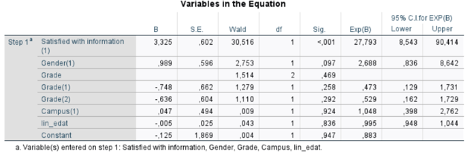
Figure 1. Influential observations using Cook’s distance on variable satisfied with information
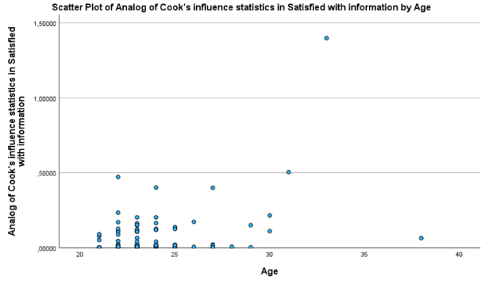
One influential observation was identified with a Cook’s distance >1 (record_id=3). Upon re-running the model excluding this observation, the odds ratio showed substantial change (+33%; OR = 32,76; 95% CI 9.17-116,99; p <0.001). While statistical significance was maintained, readers should be aware that the magnitude of this association may be sensitive to influential observations. This suggests that the magnitude of the effect is sensitive to extreme values, although the association remains robust.
Table 2. Correlation analysis using Spearman coefficient on variable satisfied with information
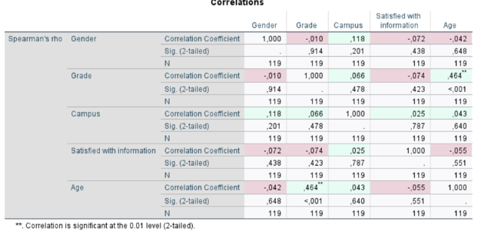

Analysis of assumptions on variable need
Table 3. Linearity on variable need
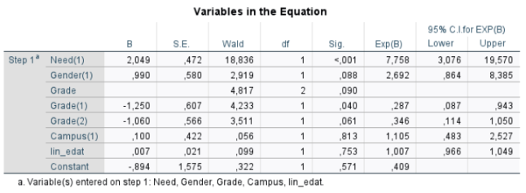
Figure 2. Influential observations using Cook’s distance on variable need
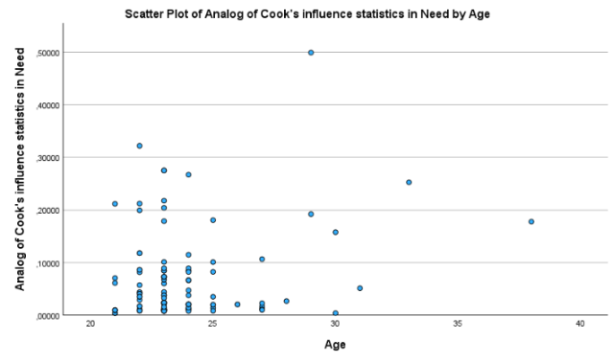
Table 4. Correlation analysis using Spearman coefficient on variable need
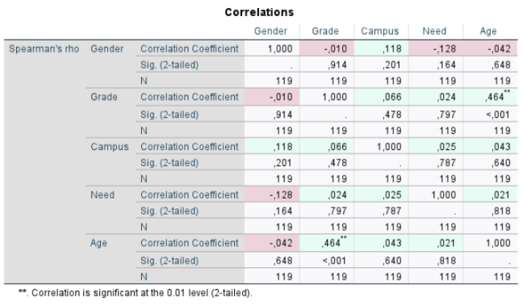

Analysis of assumptions on variable academic impact
Table 5. Linearity on variable academic impact
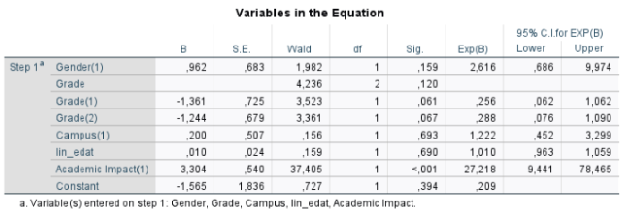
Figure 3. Influential observations using Cook’s distance on variable academic impact
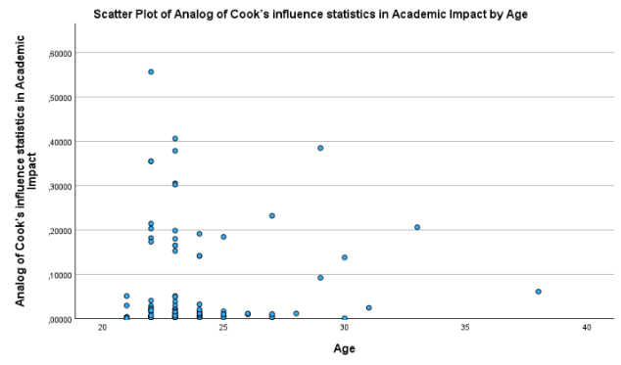
Table 6. Correlation analysis using Spearman coefficient on variable academic impact
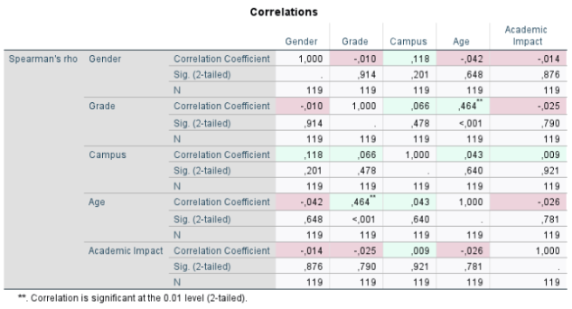

Analysis of assumptions on variable psychosocial impact
Table 7. Linearity on variable psychosocial impact
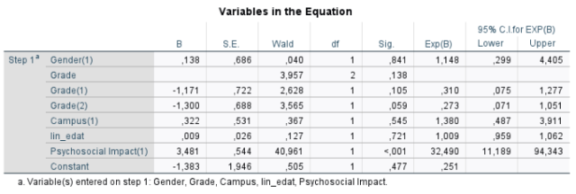
Figure 4. Influential observations using Cook’s distance on psychosocial impact
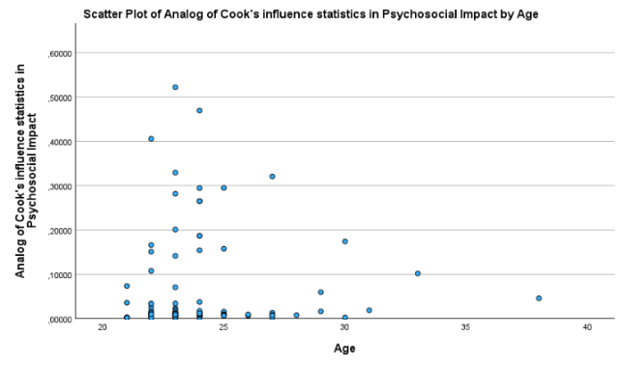
Table 8. Correlation analysis using Spearman coefficient on psychosocial impact
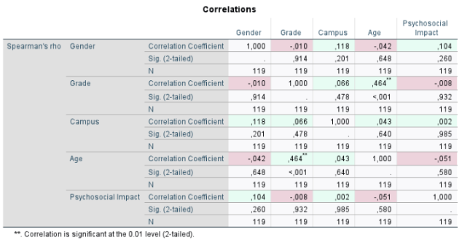

Analysis of assumptions on variable professional impact
Table 9. Linearity on variable professional impact
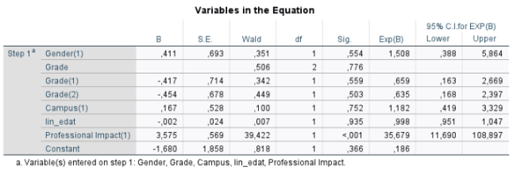
Figure 5. Influential observations using Cook’s distance on variable professional impact
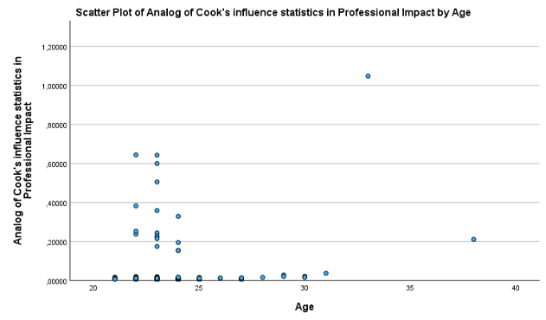
One influential observation was identified with a Cook’s distance > 1 (record_id=3). Upon re-running the model excluding this observation, the odds ratio did no show substantial change (<15%), and therefore all observations were retained in the final analysis.
Table 10. Correlation analysis using Spearman coefficient on variable professional impact
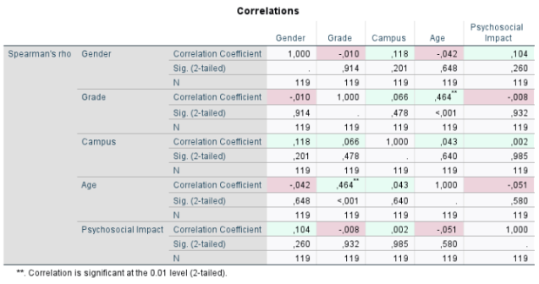

Analysis of assumptions on variable out-of-practicum meetings (regular contact)
Table 11. Linearity on variable out-of-practicum meetings (regular contact)
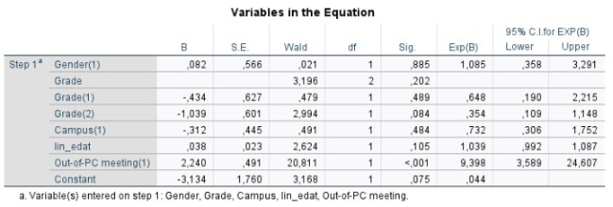
Figure 6. Influential observations using Cook’s distance on variable out-of-practicum meetings (regular contact)
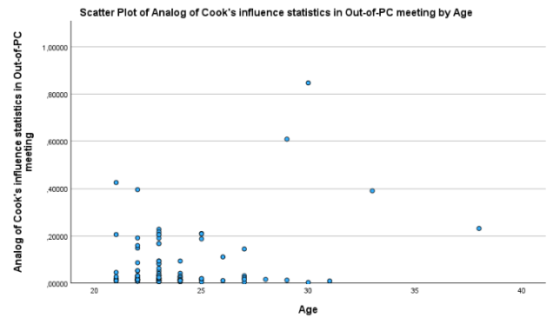
Table 12. Correlation analysis using Spearman coefficient on variable out-of-practicum meetings (regular contact)
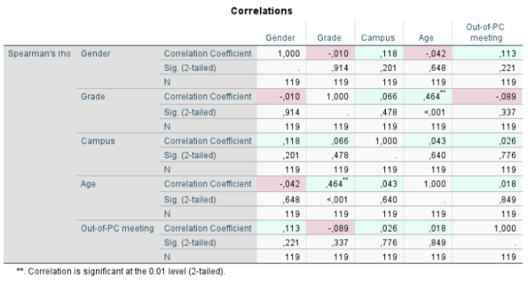

Analysis of assumptions on variable meetings format
Table 13. Linearity on variable meetings format
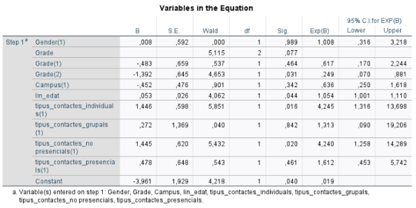
Figure 7. Influential observations using Cook’s distance on variable meetings format
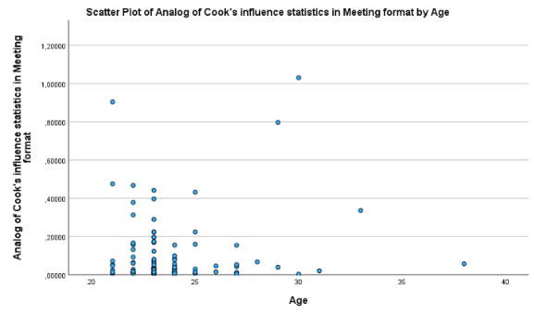
One influential observation was identified with a Cook’s distance > 1 (record_id=15) in the meeting format model. Upon re-running the model excluding this observation, the individual contact variable remained statistically significant with moderate changes in the odds ratio (+18,9%). Given that statistical significance was maintained, all observations were retained in the final analysis.
Table 14. Correlation analysis using Spearman coefficient on variable meetings format
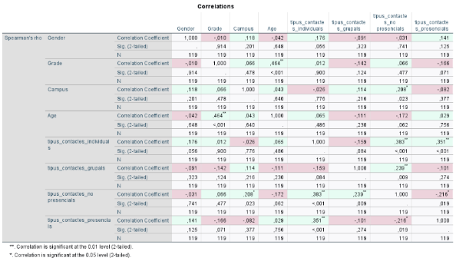
Analysis of assumptions on variable practicum assessment
Table 15. Linearity on variable practicum assessment
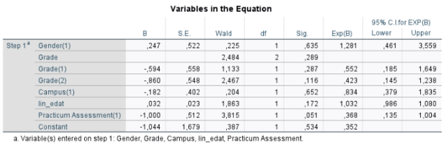
Figure 8. Influential observations using Cook’s distance on variable practicum assessment
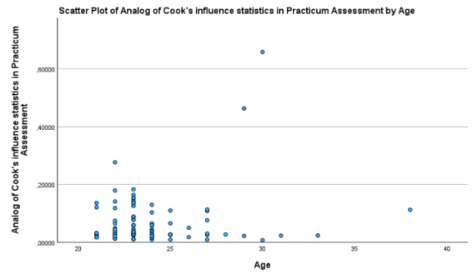
Table 16. Correlation analysis using Spearman coefficient on variable practicum assessment
