COM-B component | BCW  intervention function | BDG | BFDG | CG
 |  |  | - The same interventions from BDG will be implemented to the patients in this group
Motivation | Education | - Online lectures and videos: provide the basic knowledge of CRC and screening via, including definition, symptoms, pathological classifications, prognosis, rehabilitation, etc. | - Online lectures and video: Provide the knowledge and information to family members to assist the bowel preparation, including daily dietary, caring, etc. | - Distribute the "Early Screening, Early Diagnosis, Early Treatment Health Handbook" to promote knowledge on colorectal cancer prevention and treatment.  - Organize expert lectures and on-site consultations to leverage professional authority for guidance.  - Persuade individuals who have not made appointments to participate in screenings through phone or face-to-face communication.  - Provide one-time information on green channels, expert outpatient services, and colonoscopy subsidy policies.  - Offer consultations, but residents must take the initiative to request them.  - Promote actions through reminders and notifications without implementing mandatory measures.  - Make all resources openly available without restrictions.
Motivation | Persuasion | - The experiences will be shared by recovered individuals in WeChat groups.  - Small quizzes will be offered after each online lecture via WeChat. | - Recognize and encourage the key role of family members as "companions" to help establish positive beliefs.  - Encourage family members to provide emotional support through companionship, helping patients express and release negative emotions and alleviate anxiety.
Motivation | Incentivisation | - Establish electronic health records and document screening results, allowing individuals to view their own health data.  - Provide convenient resources such as green channels and specialist clinics to stimulate willingness to take action. | - Facilitate the signing of a "Family Health Contract" that links check-up behaviors with family responsibilities, enhancing motivation through shared commitment.  - Establish a family-based support system where members jointly commit to practicing a healthy lifestyle, forming long-term incentives through mutual accountability.
Capability | Training | - Online lectures and videos: provide the basic knowledge of CRC and screening via, including definition, symptoms, pathological classifications, prognosis, rehabilitation, etc.  - Digital tool guidance: conduct one-on-one demonstrations in WeChat groups to improve skills in viewing messages and sending text/voice messages.  - Online video meeting: organize a session on Wednesday to explain how to use the Yicheng mini program for self-screening. | - Expert guidance on family involvement: endoscopy specialists will explain how family members can supervise, remind, and assist patients in completing bowel preparation.
Capability | Education | - Online feedback session: provide personalized feedback and explain the information again on Thursday to help research subjects relate the information to their own situations.  - Small quiz and explanation: conduct a small test on Sunday and provide detailed explanations of incorrect answers to deepen understanding. | - Family members guide and correct the patient's misconceptions.
Opportunity | Environmental restructuring | - Digital route planning service: set up a specialist clinic with outpatient hours on Tuesdays and provide digital navigation support to help plan routes.  - Digital communication platform: create a WeChat group as a continuous channel for information sharing and interaction.  - Online service platform: establish a green referral platform and provide digital access to information on the colonoscopy subsidy policy. | - Social/Family Environment: Integrate family members into the intervention system to create a supportive family microenvironment.  - Service Process Environment: Ensure family members fully understand the green channel process to assist patients in overcoming practical obstacles.
Opportunity | Modelling | - Online role education: arrange a community lecture on Friday delivered by experts from a tertiary hospital and share recorded sessions digitally to provide professional role models.  • Digital behavioral examples: share science popularization videos in the WeChat group to provide observable behavioral examples. | - Invite recovered individuals (peers) who have completed colonoscopy screening to share their early screening experiences, providing psychological reference and coping models for family members and patients.
Opportunity | Enablement | - Digital opportunity empowerment: provide regular weekly specialist outpatient services with digital integration, online Q&A sessions, and phone consultations to offer research subjects continuous access to professional guidance.  • Digital tool empowerment: assist individuals without WeChat in registering for the platform to establish a digital communication channel and eliminate information barriers. | - Capability empowerment: Through training, equip family members with the abilities of "coach" and "coordinator" to effectively assist patients.  - Social support empowerment: Establish a family member WeChat group to form a peer support system for sharing and exchanging support experiences.
Opportunity | Coercion | - Digital voluntary engagement service: use digital reminders, appointment systems, and Q&A platforms to promote voluntary participation rather than mandatory measures. | - No mandatory measures: promote behavior through reminders and family plans rather than enforcement.
Opportunity | Restriction | - Digital open resource platform: provide unrestricted access to all digital resources and facilitative tools to support voluntary participation. | - No mandatory measures: promote behavior through reminders and family plans rather than enforcement.
BDG: the BCW-based digital-assisted group; BFDG: the BCW-based family-participated digital-assisted group; CG: the Control group; CRC: Colorectal Cancer

Early Screening, Early Diagnosis, Early Treatment Health Handbook
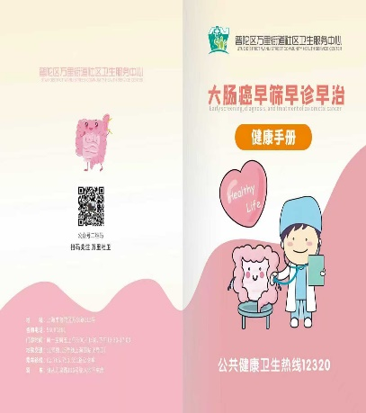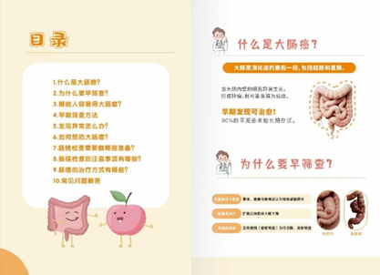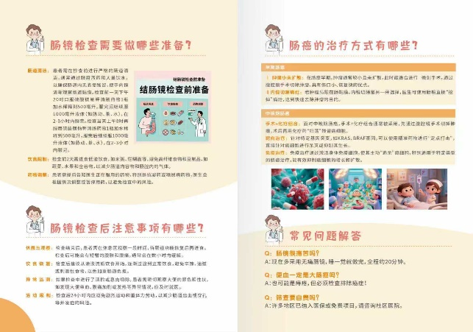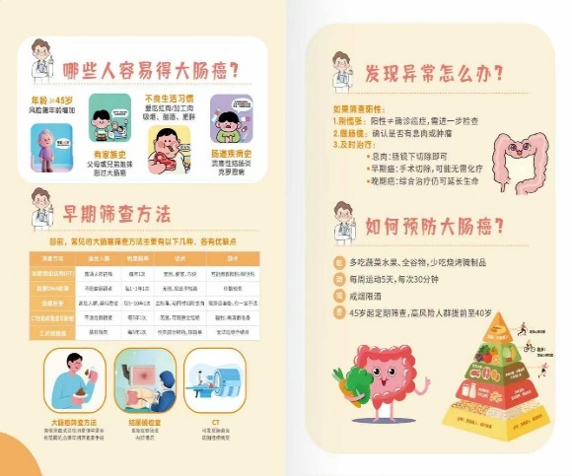
科普视频
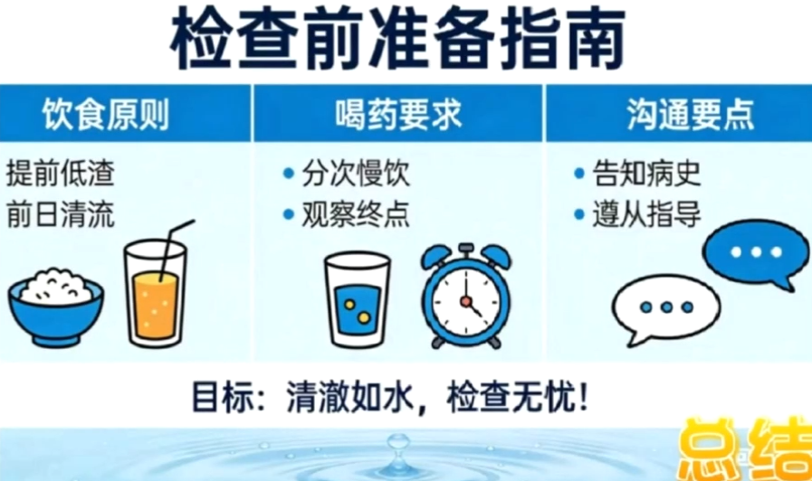 |  |  | 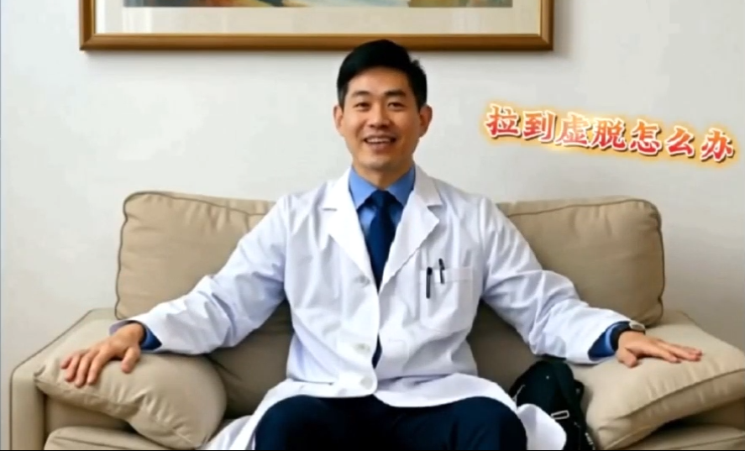 | 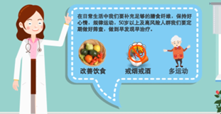
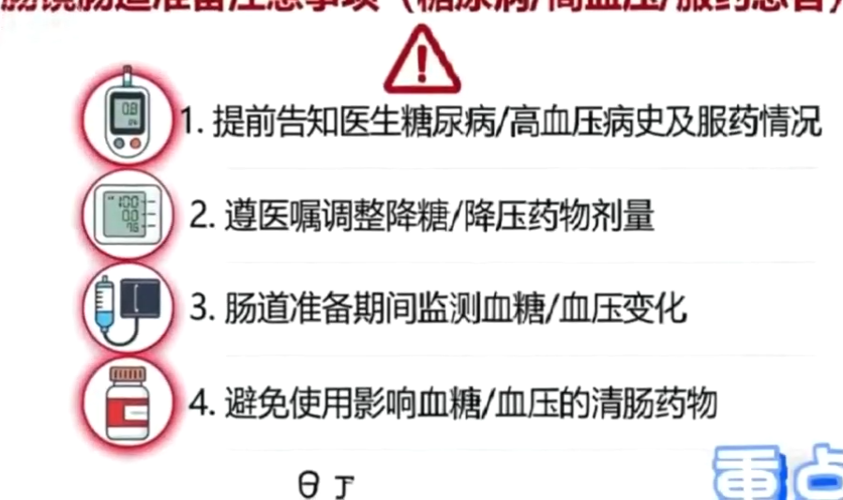 | 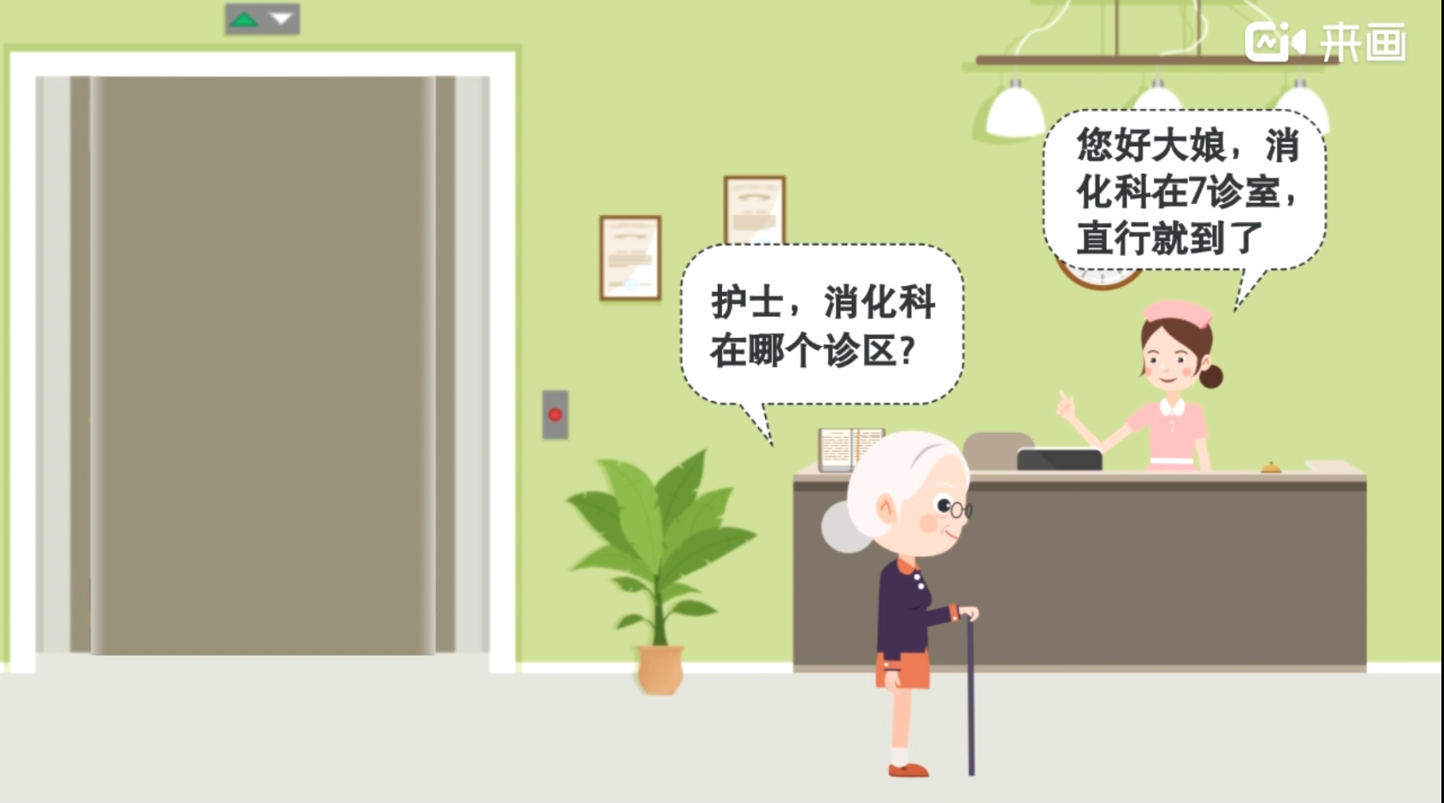 | 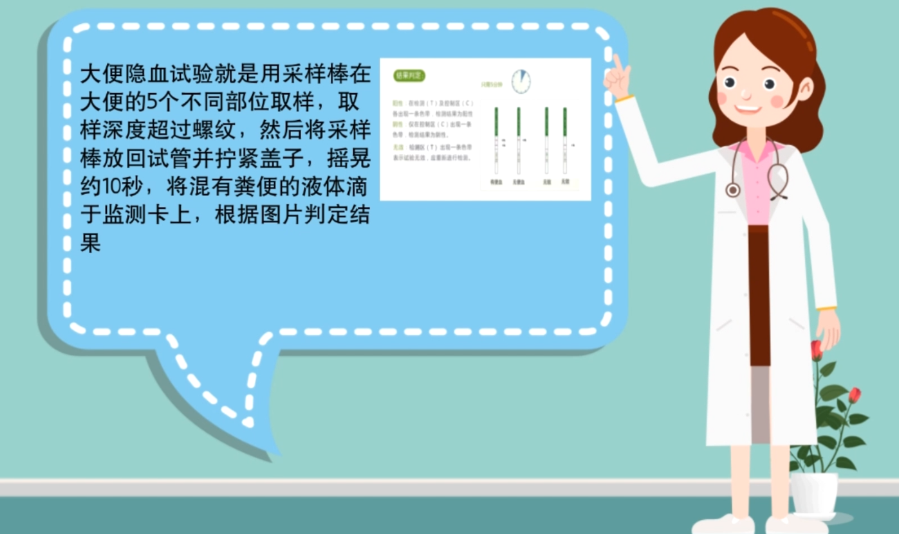 | 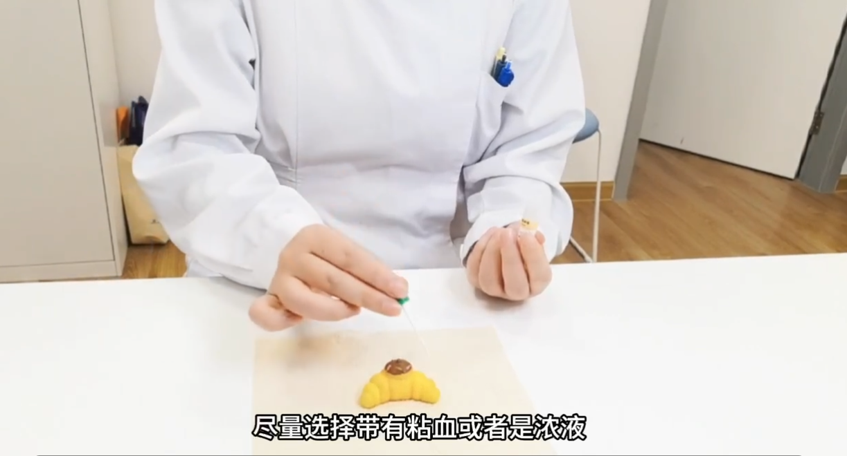 | 