Supplementary Materials

Supplementary Table S1. Demographic, Clinical, and Recording Characteristics of the Study Cohort
Subject ID | Age | Sex | Handed-  ness | SOZ | HFO/spike channels excluded | iEEG contacts | Scalp EEG channels | Completed trials
S1 | 24 | F |  | AHR, LR | AHR 1-2 | 48 | 19 | 200
S2 | 39 | M | R | AHR, PHR | AHR 1-2-3, PHR 5-6-7 | 64 | 8 | 250
S3 | 18 | F | R | AHL, PHL | AHL 1-2 | 40 | 8 | 100
S4 | 28 | M | R | AHL, AHR, PHL, PHR | AHL 1, PHL 2-3 | 64 | 19 | 100
S5 | 20 | F | R | DRR | DRR 2 | 32 | 20 | 200
S6 | 31 | M | R | AHL, PHL, ECL, AL | AHL 1 | 64 | 10 | 300
S7 | 47 | M | R | AHR, PHR | AHR 1, PHR 1 | 64 | 8 | 200
S8 | 56 | F | R | ECR | ECR 2 | 62 | 19 | 200
S9 | 19 | F | R | ECR, AR | AR 3 | 64 | 8 | 100

Supplementary Table S2. Intracranial HF response comparison by workload (maintain and retrieval).
 | Subject | iEEG Channel | Comparison | Duration (ms) | Mean Diff | Min P
Maintain | S1 | AHL | Set 6 vs Set 8 | 20.080 | 2.647 | 0.0004
Maintain | S1 | ECL | Set 6 vs Set 8 | 18.032 | -0.998 | 0.0002
Maintain | S1 | LR | Set 6 vs Set 8 | 14.989 | 0.839 | 0.0002
Maintain | S1 | PHL | Set 6 vs Set 8 | 16.064 | 0.723 | 0.0002
Maintain | S1 | PHL | Set 6 vs Set 8 | 12.048 | 0.509 | 0.0004
Maintain | S1 | PHR | Set 4 vs Set 6 | 40.080 | -0.633 | 0.0016
Maintain | S1 | PHR | Set 4 vs Set 6 | 28.112 | -1.116 | 0.0002
Maintain | S1 | PHR | Set 4 vs Set 6 | 24.096 | -0.520 | 0.0002
Maintain | S1 | PHR | Set 4 vs Set 6 | 20.080 | -0.722 | 0.0002
Maintain | S2 | AHR | Set 6 vs Set 8 | 12.048 | -0.732 | 0.0006
Maintain | S2 | ECR | Set 6 vs Set 8 | 18.032 | -0.908 | 0.0008
Maintain | S2 | ECR | Set 6 vs Set 8 | 12.048 | -0.758 | 0.0002
Maintain | S3 | PHL | Set 4 vs Set 8 | 12.048 | -0.907 | 0.0002
Maintain | S7 | AHL | Set 4 vs Set 8 | 13.058 | -0.722 | 0.0002
Maintain | S8 | AHL | Set 4 vs Set 6 | 12.048 | -0.541 | 0.0016
Maintain | S8 | AHL | Set 4 vs Set 6 | 16.064 | -0.940 | 0.0002
Maintain | S8 | AHL | Set 4 vs Set 6 | 12.048 | -0.752 | 0.0008
Maintain | S8 | AHL | Set 4 vs Set 6 | 12.048 | -0.616 | 0.0012
Maintain | S8 | AL | Set 6 vs Set 8 | 12.048 | -0.932 | 0.0002
Maintain | S8 | AR | Set 6 vs Set 8 | 16.064 | -0.980 | 0.0002
Maintain | S8 | ECL | Set 4 vs Set 6 | 20.032 | -0.875 | 0.0002
Maintain | S8 | PHL | Set 4 vs Set 6 | 16.064 | -0.854 | 0.0004
Maintain | S8 | PHL | Set 4 vs Set 6 | 12.048 | -0.893 | 0.0002
Maintain | S9 | AHR | Set 6 vs Set 8 | 16.064 | -0.834 | 0.0002
Maintain | S9 | AR | Set 6 vs Set 8 | 14.048 | -0.870 | 0.0004
Retrieval | S1 | AHL | Set 4 vs Set 8 | 36.145 | -0.658 | 0.0002
 | S1 | ECL | Set 4 vs Set 8 | 16.064 | -0.609 | 0.0002
 | S1 | PHL | Set 4 vs Set 8 | 32.129 | -0.400 | 0.0002
 | S4 | PHL | Set 4 vs Set 6 | 16.064 | -0.470 | 0.0002
 | S4 | PHR | Set 4 vs Set 8 | 8.032 | -0.303 | 0.0004
 | S6 | AHR | Set 4 vs Set 8 | 24.096 | -0.157 | 0.0002
 | S6 | AHR | Set 4 vs Set 8 | 16.064 | -0.178 | 0.0002
 | S6 | AHR | Set 4 vs Set 8 | 12.048 | -0.127 | 0.0014
 | S6 | AL | Set 6 vs Set 8 | 36.145 | -0.209 | 0.0002
 | S6 | AL | Set 6 vs Set 8 | 12.048 | -0.233 | 0.0022
 | S6 | AL | Set 6 vs Set 8 | 16.064 | -0.218 | 0.0002
 | S6 | PHR | Set 6 vs Set 8 | 16.064 | -0.085 | 0.0034
 | S6 | PHR | Set 6 vs Set 8 | 20.080 | -0.134 | 0.0012
 | S6 | PHR | Set 6 vs Set 8 | 32.129 | -0.195 | 0.0008
 | S6 | PHR | Set 6 vs Set 8 | 16.064 | -0.163 | 0.0002
 | S8 | AHL | Set 4 vs Set 8 | 12.048 | -0.806 | 0.0002
 | S8 | AL | Set 4 vs Set 8 | 20.080 | -0.688 | 0.0014
 | S8 | AL | Set 4 vs Set 8 | 12.048 | -0.648 | 0.0004
 | S8 | AL | Set 4 vs Set 8 | 20.080 | -0.730 | 0.0008
 | S8 | AL | Set 4 vs Set 8 | 16.064 | -0.796 | 0.0010
 | S8 | AL | Set 6 vs Set 8 | 12.048 | -0.869 | 0.0018
 | S8 | AL | Set 6 vs Set 8 | 24.096 | -0.927 | 0.0012

Supplementary Table S3. Scalp HF response comparison by workload (maintain and retrieval).
 | Subject | EEG Channel | Comparison | Duration (ms) | Mean Diff | Min P
Maintain | S5 | F8 | Set 6 vs Set 8 | 14.0161 | -0.6423 | 0.0002
Maintain | S5 | Pz | Set 4 vs Set 8 | 24.2353 | -0.7043 | 0.0002
Maintain | S5 | Pz | Set 4 vs Set 8 | 12.0482 | -1.8061 | 0.0002
Maintain | S6 | F3 | Set 4 vs Set 8 | 18.3448 | -1.4954 | 0.0002
Maintain | S6 | F4 | Set 4 vs Set 8 | 12.0482 | -1.0965 | 0.0004
Maintain | S8 | F3 | Set 4 vs Set 6 | 20.0803 | -1.4817 | 0.0002
Retrieval | S2 | O2 | Set 4 vs Set 6 | 28.112 | -1.039 | 0.0002
 | S3 | F3 | Set 4 vs Set 8 | 20.080 | -3.688 | 0.0002
 | S3 | F3 | Set 6 vs Set 8 | 20.080 | -3.494 | 0.0002
 | S3 | O2 | Set 4 vs Set 8 | 12.048 | -1.605 | 0.0002
 | S3 | O2 | Set 6 vs Set 8 | 24.096 | -2.329 | 0.0002
 | S3 | O2 | Set 6 vs Set 8 | 8.032 | -1.328 | 0.0024
 | S3 | O2 | Set 6 vs Set 8 | 16.064 | -2.034 | 0.0008
 | S5 | P3 | Set 4 vs Set 6 | 20.080 | -2.900 | 0.0002
 | S5 | O1 | Set 6 vs Set 8 | 20.080 | 5.529 | 0.0004
 | S5 | T5 | Set 4 vs Set 6 | 12.048 | -7.242 | 0.0004
 | S5 | T5 | Set 6 vs Set 8 | 16.064 | -4.855 | 0.0004
 | S5 | T6 | Set 4 vs Set 6 | 8.032 | -0.624 | 0.0002
 | S5 | T6 | Set 6 vs Set 8 | 12.048 | -2.142 | 0.0006
 | S9 | F4 | Set 4 vs Set 6 | 8.032 | -1.061 | 0.0002

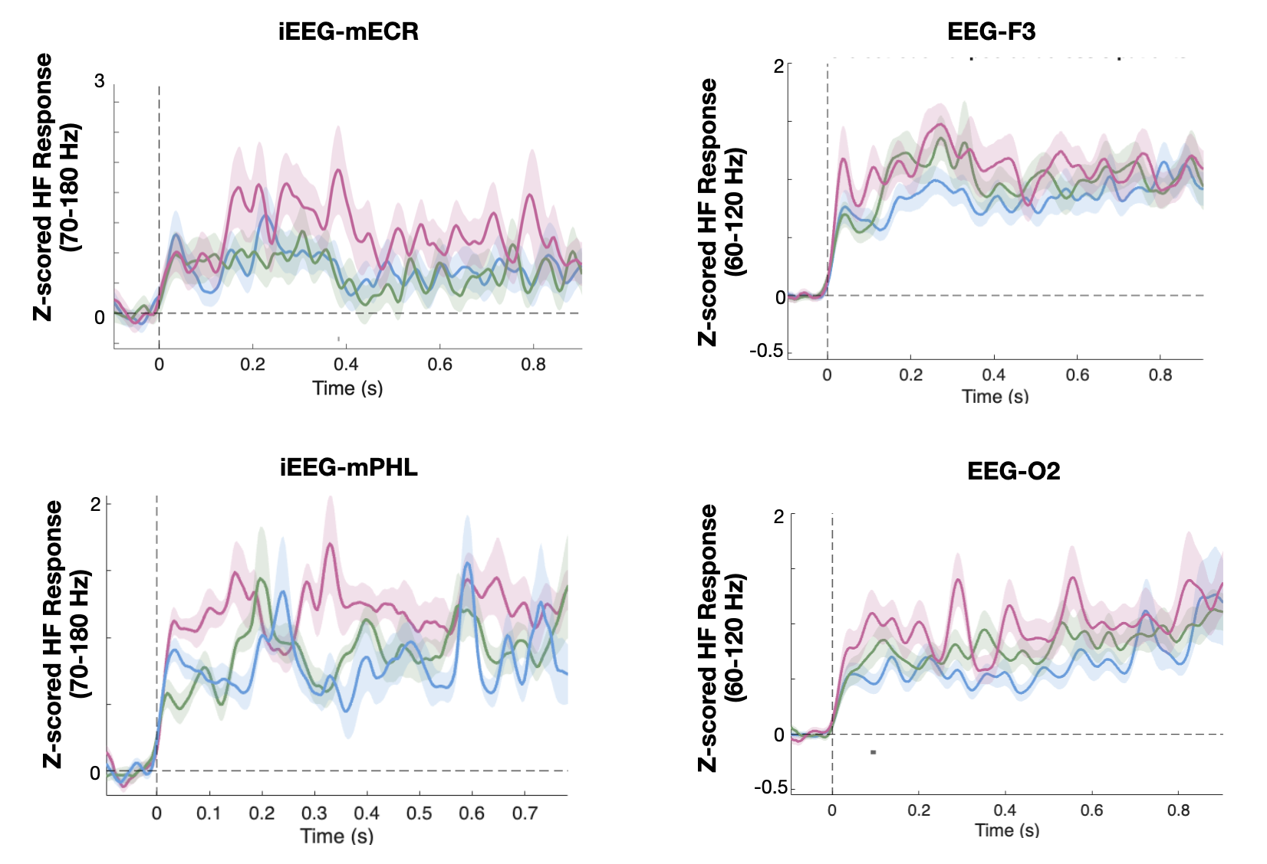
Supplementary Fig. S1. Intracranial and scalp HF response using set 4/6/8. Intracranial high-frequency (HF; 70–180 Hz) power time course during working memory (WM) retrieval in the ECR and PHL electrodes. Results were averaged across electrodes with the same anatomical label from nine participants. (B) Scalp HF (60–120 Hz) power time course during WM retrieval at the F2 and O2 electrodes.

A
B

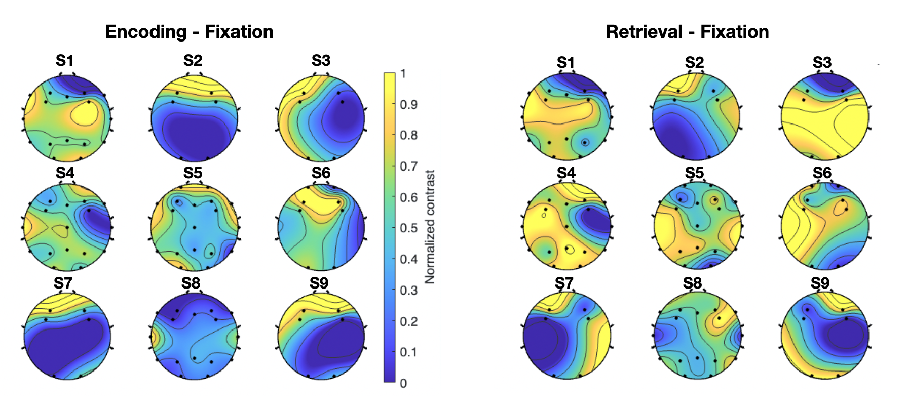
Suppementary Fig. S2. Scalp HF response in each individual subject. Results are shown for encoding and retrieval phases relative to fixation baseline.

