Supplementary Material
Butterfly diversity is lower in historically redlined neighborhoods: evidence from 151 US cities
Clark, Gownaris, and Wilson

Fig. S1. Monthly butterfly observations by HOLC grade across the study period (2016–2025). Lines show total observations across all zones of each grade. The dashed vertical line marks the start of the COVID-19 pandemic lockdowns (March 2020). The pronounced grade D peak in September 2019 corresponds to the concentrated recording event described in the Results.
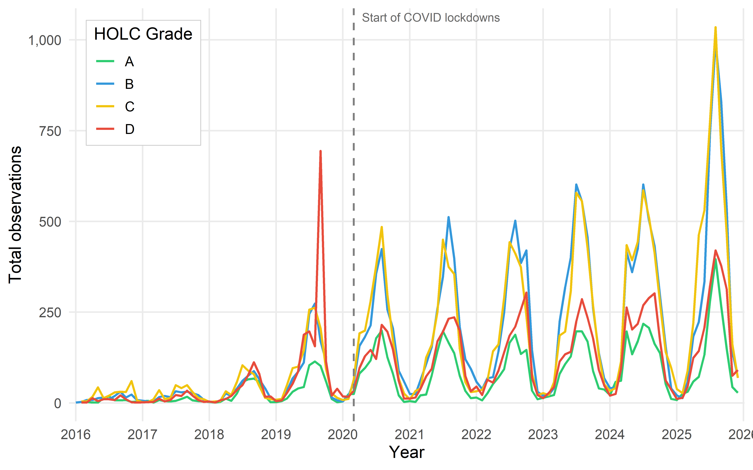

Fig. S2. Sensitivity analysis: effect of excluding the pandemic year 2020. Points and horizontal lines show HOLC grade coefficients and 95% Wald confidence intervals from the best-fitting mixed-effects model, fitted with (dark) and without (red) observations from 2020. Coefficients represent differences in Shannon (left) and Simpson (right) diversity relative to grade D (redlined zones). Results are consistent between models, indicating that the anomalous observer effort in 2020 did not materially influence conclusions.
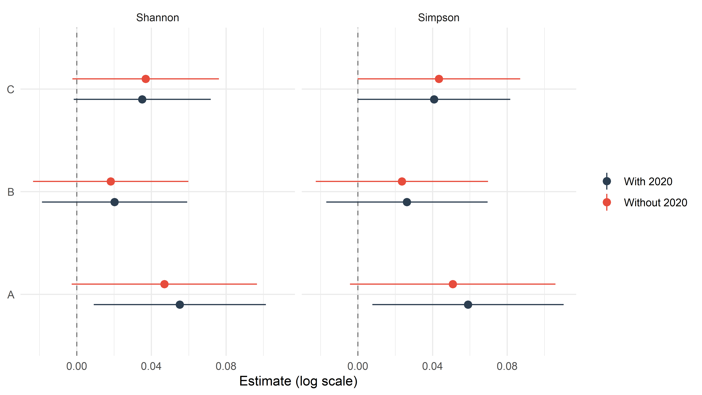

Fig. S3. Sensitivity analysis: effect of excluding Monarch butterfly (Danaus plexippus) records. Points and horizontal lines show HOLC grade coefficients and 95% Wald confidence intervals from models fitted with (dark) and without (orange) Monarch records. Monarch records comprised 18.8% of all observations. Excluding Monarch records slightly strengthened grade A and B effects, consistent with Monarch distribution being driven by migratory routes rather than local habitat quality.
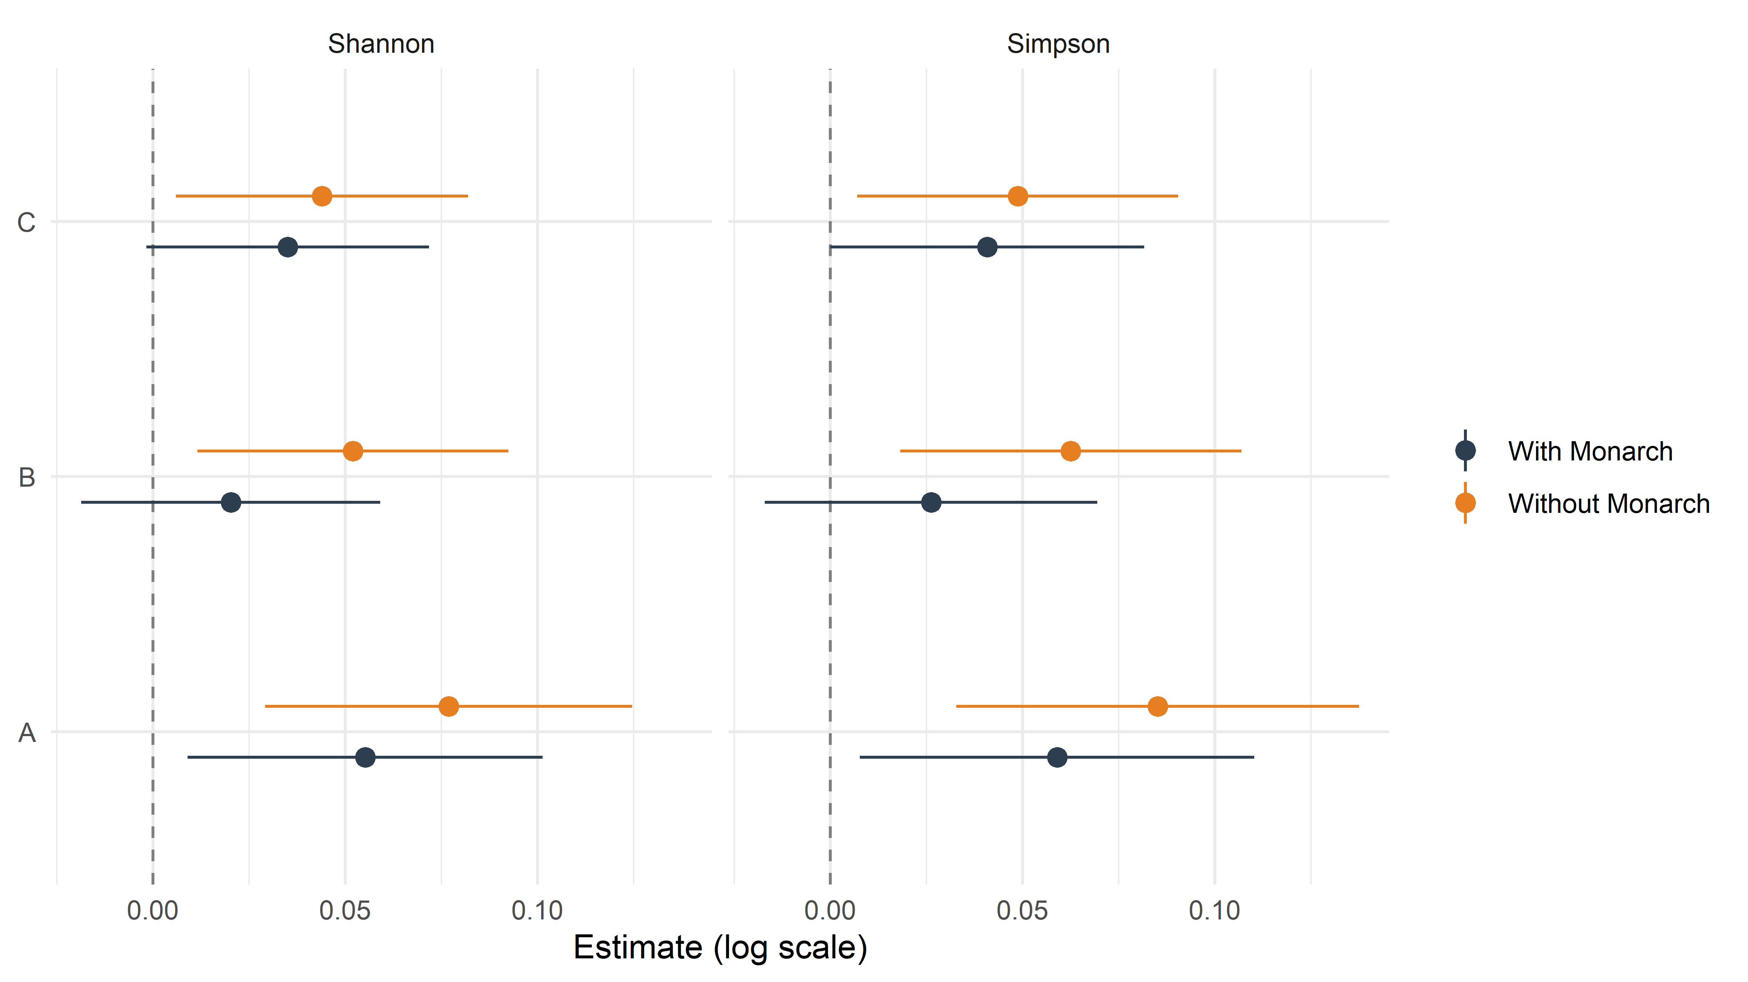

Fig. S4. Sensitivity analysis: effect of restricting the analysis to cities with all four HOLC grades. Points and horizontal lines show HOLC grade coefficients and 95% Wald confidence intervals from models using all 151 cities with ≥5 butterfly observations per zone (purple) and constrained to have all four HOLC grades (A, B, C, D) represented (dark). Results are directionally consistent, and confidence intervals overlap, confirming that inclusion of cities with incomplete grade representation did not bias conclusions.
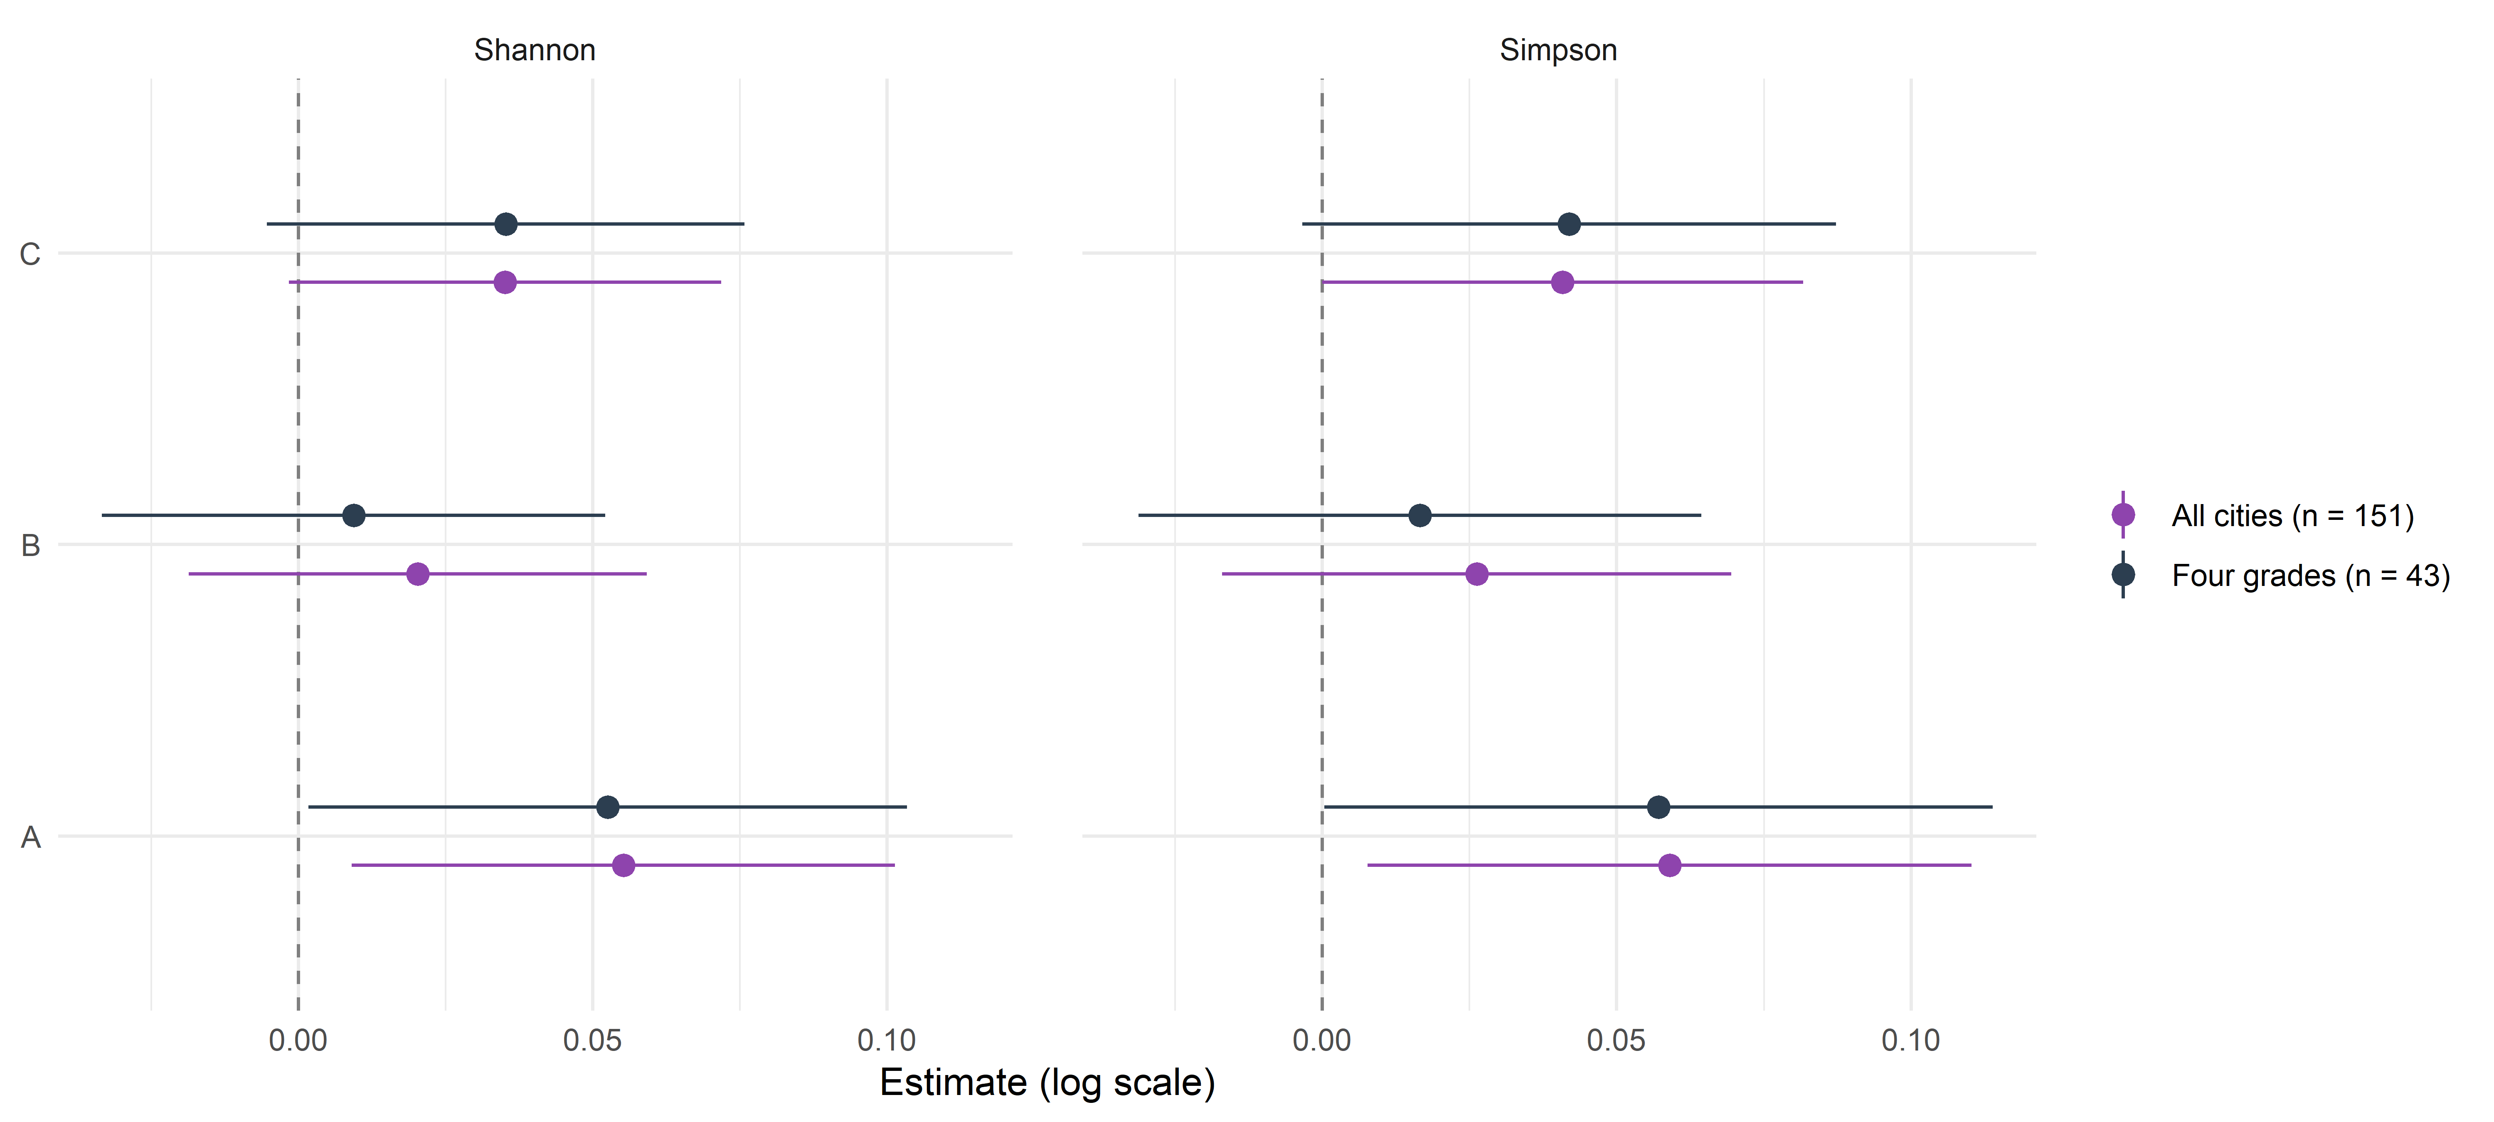

Fig. S5. Relationship between annual observation effort (log scale) and Shannon butterfly diversity (Hill q = 1) by HOLC grade at the zone × year level. Lines show fitted ordinary least-squares regressions per grade. The strong positive relationship between effort and diversity demonstrates the importance of controlling for sampling effort in models of observed diversity. The ordering of regression lines (B > C > A > D) is consistent across the full range of sampling effort, supporting the conclusion that grade differences are not a simple artefact of differential sampling.
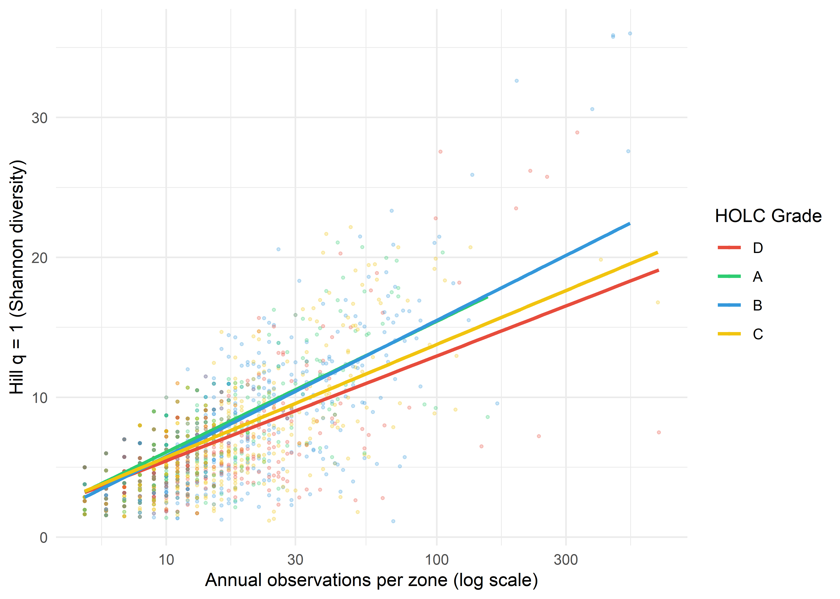
Fig. S6. Sensitivity analysis: effect of the minimum observation threshold. Points and horizontal lines show HOLC grade coefficients and 95% Wald confidence intervals from models fitted at minimum thresholds of 3, 5, 10, and 15 butterfly observations per zone, for Hill numbers of order q = 0, 1, and 2. Coefficients are positive at every threshold; confidence intervals widen at higher thresholds as fewer cities contribute to the analysis.
