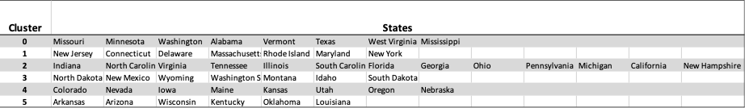
Table 1 – Final Cluster definitions as produced through iterative regression process

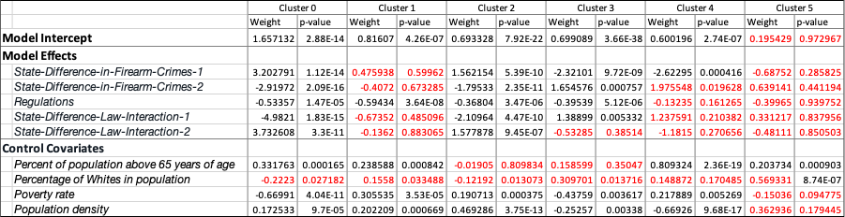
Table 2 – Results of linear regression fit in each of the 6 clusters alongside significance of each of the effects and covariates. Each effect and covariates were normalized through Z-transformation within clusters before training the model

