IONM TRANSIENT ALERT
CASE - 1 (L5 – S1 Lipomyelomeningocele with tethered cord)

Intraoperative IONM findings :
- Modalities used: TcMEPs, SSEPs, EMG.
- Intra-operative findings:
- Baseline signals were intact at the start of surgery.
- Intraoperatively, a transient decrease in MEP amplitude of more than 50% in the right vastus lateralis was seen during decompression of lipommc.
- At the time of dural closure, Recovery in MEP amplitude was seen completely.
- Interpretation: Safe detethering with preserved cord function.
- 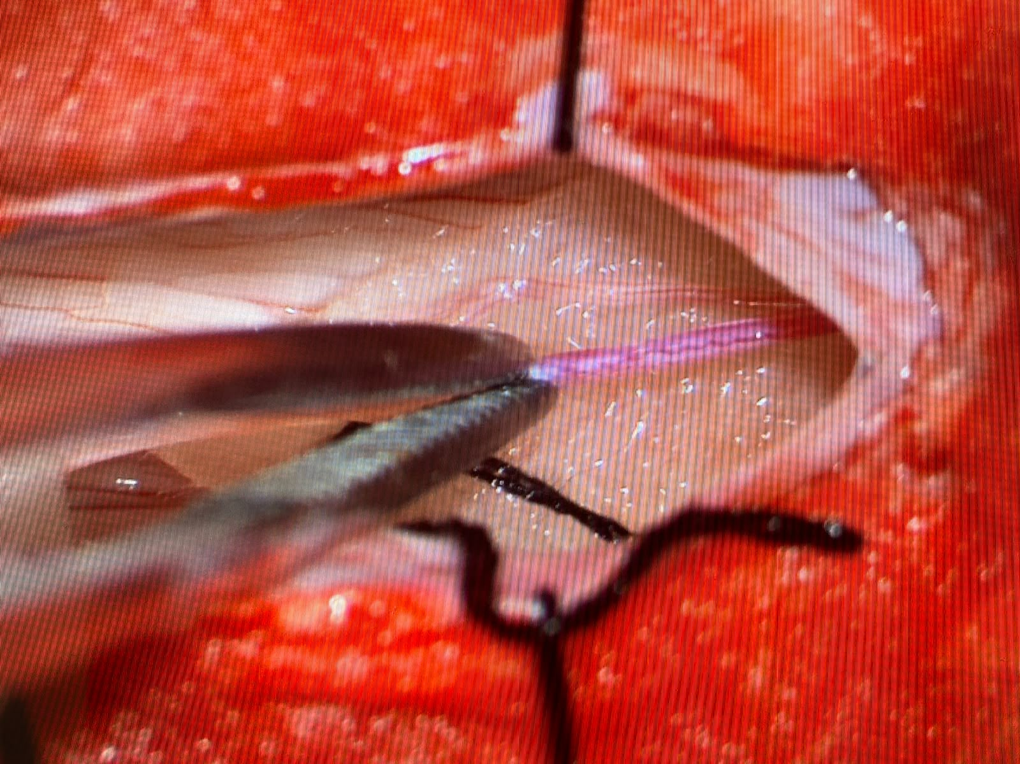
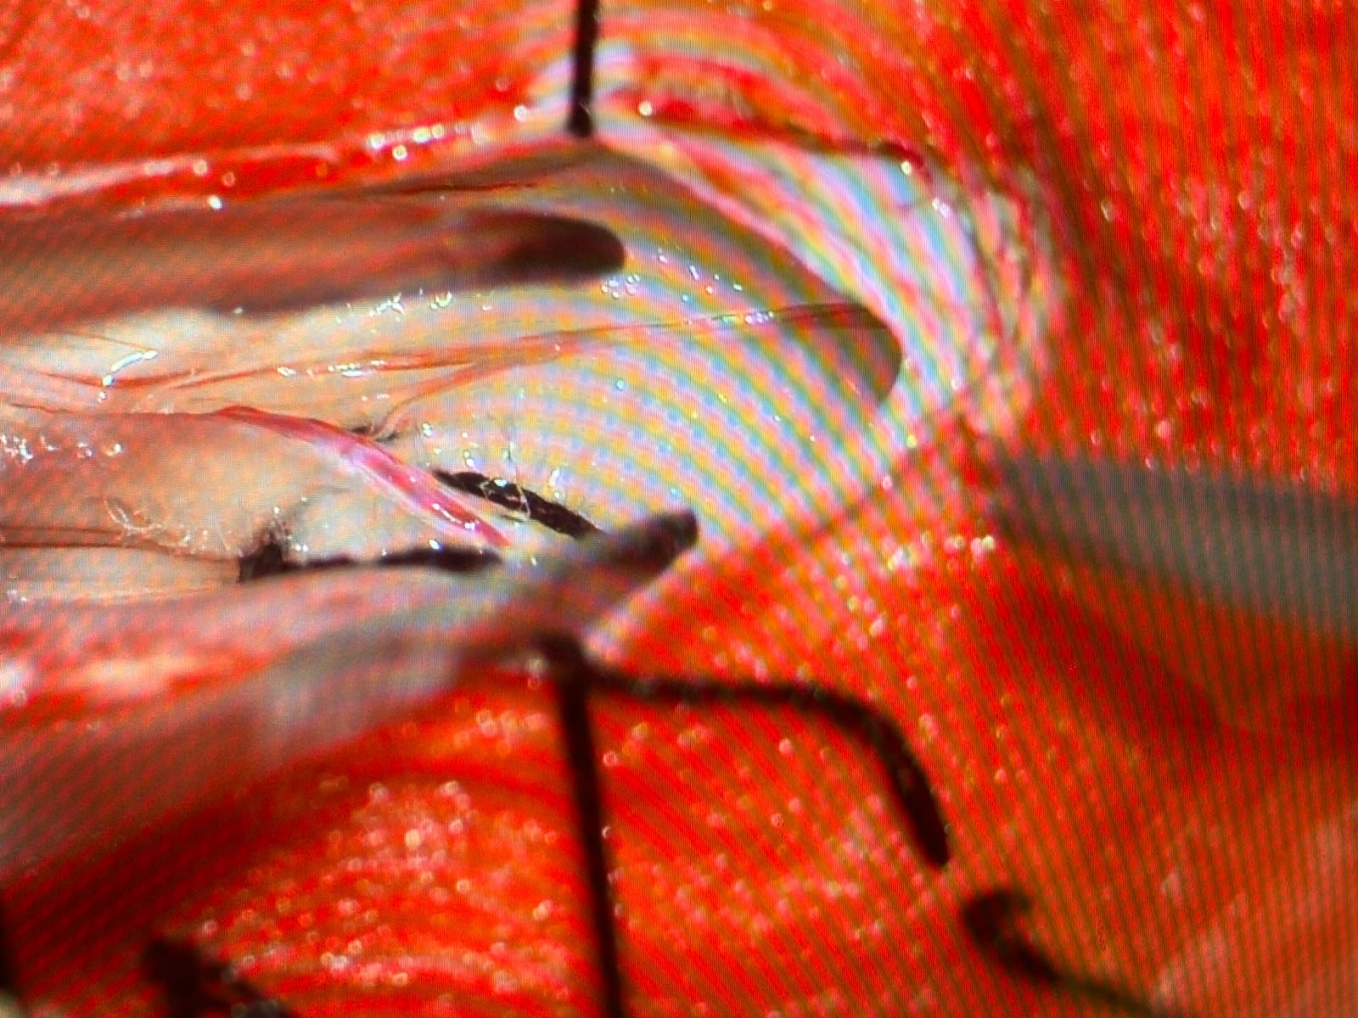

MEP WAVE - FORM AT BASELINE:
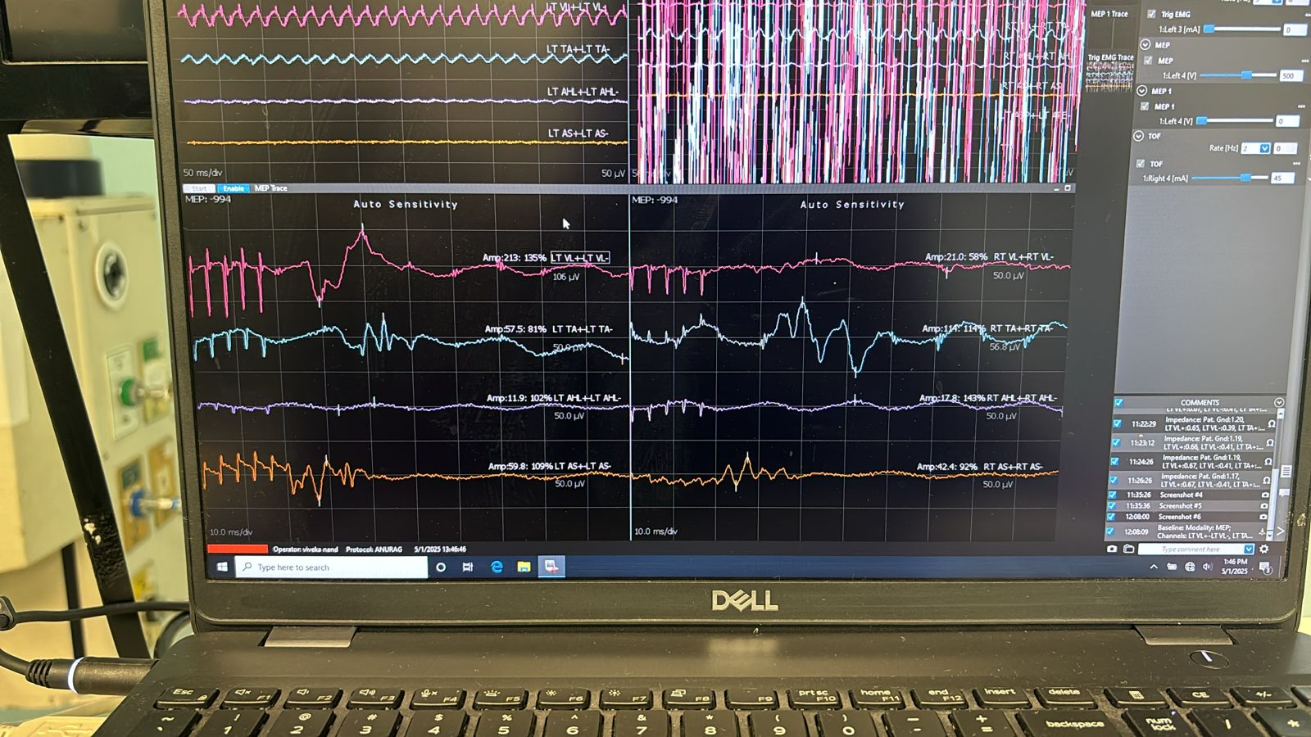
Figure: Baseline transcranial motor evoked potentials (TcMEPs) demonstrating stable and reproducible responses from bilateral vastus lateralis, tibialis anterior, abductor hallucis, and anal sphincter muscles prior to surgical intervention.
MEP Waveforms in right vastus lateralis at detethering:
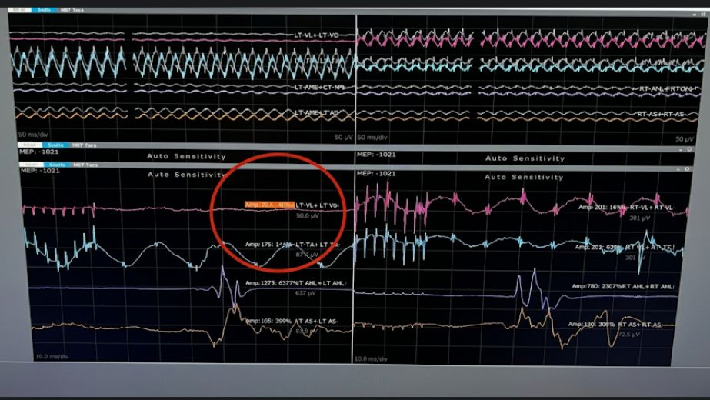

Fig: Intraoperative neuromonitoring showing a critical event during detethering, a significant acute reduction in transcranial motor evoked potential (TcMEPs) amplitudes is observed, most notably in the bilateral abductor hallucis (AH) and right tibialis anterior (TA) muscle groups (red circled area). The morphology shows a >80% drop in peak-to-peak amplitude compared with baseline polyphasic waveforms, suggesting potential mechanical or ischemic compromise of the corticospinal tract. This profound loss of voltage in the distal myotomes necessitates an immediate surgical pause, irrigation with warm saline, and mean arterial pressure (MAP) optimization to prevent permanent postoperative motor deficit.
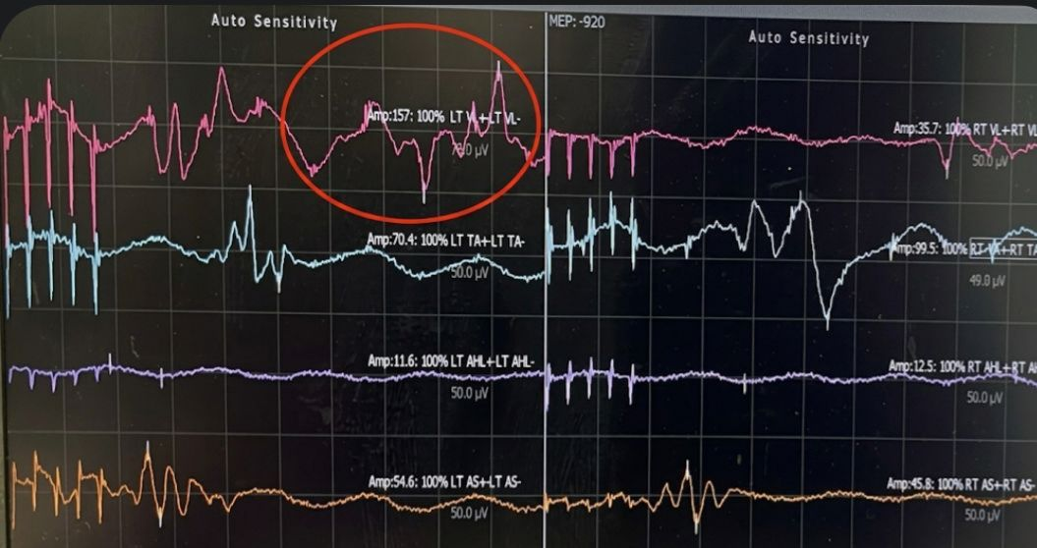
MEP WAVEFORM AT TIME OF SKIN CLOSURE:
Fig: Intraoperative neuromonitoring demonstrating reversal of the TcMEPs amplitude drop following corrective surgical manoeuvres. The polyphasic waveforms show a significant recovery in voltage, specifically in the bilateral abductor hallucis (AH) and tibialis anterior (TA) muscle groups (red circled area). The return to >80% of the baseline peak-to-peak amplitude indicates successful restoration of corticospinal tract perfusion and neural conduction, confirming that the preceding event was transient and potentially mitigating a permanent postoperative motor deficit.

