SUPPLEMENTARY MATERIAL

Mapping climate-change research on Brazilian biodiversity: Biases, gaps, and trends

Abreu, T.L.S.^{1, 2, *}; Cavalcante, V. H. G. L.^{1, 2, 3}; Ferreira, A. L. A.¹; Nacif, J. W. R.¹; De Paula, A.^{1, 2}; Oliveira, H. F. M.^{2, 4}; Colli, G. R.^{1, 2}

Table S1. List of the 111 scientific publications included in the evidence-mapping and bibliometric analyses of climate change impacts on Brazilian biodiversity.

- Almeida, A. C., Tourinho, L., Ramalho, Q., Jenkins, C. N., & Almeida-Gomes, M. (2022). Regional variation in responses of a vulnerable bird species to land-use and climate change. BIOTROPICA, 54(5), 1190–1204. https://doi.org/10.1111/btp.13142
- Araújo-Silva, C. L., Sarmento, V. C., & Santos, P. J. P. (2022). Climate change scenarios of increased CO₂ and temperature affect a coral reef peracarid (Crustacea) community. MARINE ENVIRONMENTAL RESEARCH, 173. https://doi.org/10.1016/j.marenvres.2021.105518
- Arruda, D. M., Schaefer, C., Fonseca, R. S., Fernandes, E. I., Veloso, G. V, Gomes, L. C., Oliveira, F. S., Corrêa, G. R., Espírito-Santo, M. M., Oliveira, G. C., & Solar, R. R. C. (2024). Amazonian vegetation types and indigenous lands threatened by upcoming climate change: Forecast impact for Brazilian biomes. AUSTRAL ECOLOGY, 49(1). https://doi.org/10.1111/aec.13369
- Barbosa, C., Pugnaire, F. I., Peroni, N., & Castellani, T. T. (2018). Warming effects on the colonization of a coastal ecosystem by Furcraea foetida (Asparagaceae), a clonal invasive species. PLANT ECOLOGY, 219(7), 813–821. https://doi.org/10.1007/s11258-018-0836-0
- Barrios-Leal, D. Y., Neves-da-Rocha, J., & Manfrin, M. H. (2019). Genetics and Distribution Modeling: The Demographic History of the Cactophilic Drosophila buzzatii Species Cluster in Open Areas of South America. JOURNAL OF HEREDITY, 110(1), 22–33. https://doi.org/10.1093/jhered/esy042
- Bedoya-Roqueme, E., & Tizo-Pedroso, E. (2023). How Can Climate Change Limit the Distribution of Cooperative Pseudoscorpions in Brazil? NEOTROPICAL ENTOMOLOGY, 52(1), 24–35. https://doi.org/10.1007/s13744-022-01006-0
- Beltramino, A. A., Vogler, R. E., Gregoric, D. E. G., & Rumi, A. (2015). Impact of climate change on the distribution of a giant land snail from South America: predicting future trends for setting conservation priorities on native malacofauna. CLIMATIC CHANGE, 131(4), 621–633. https://doi.org/10.1007/s10584-015-1405-3
- Biber, M. F., Voskamp, A., & Hof, C. (2023). Potential effects of future climate change on global reptile distributions and diversity. GLOBAL ECOLOGY AND BIOGEOGRAPHY, 32(4), 519–534. https://doi.org/10.1111/geb.13646
- Bitencourt, C., Rapini, A., Damascena, L. S., & De Marco, P. (2016). The worrying future of the endemic flora of a tropical mountain range under climate change. FLORA, 218, 1–10. https://doi.org/10.1016/j.flora.2015.11.001
- Borges, F. J. A., Ribeiro, B. R., Lopes, L. E., & Loyola, R. (2019). Bird vulnerability to climate and land use changes in the Brazilian Cerrado. BIOLOGICAL CONSERVATION, 236, 347–355. https://doi.org/10.1016/j.biocon.2019.05.055
- Carvalho, C. E., Sfair, J. C., Eller, C. B., Menezes, B. S., Menezes, M. O. T., & Araújo, F. S. (2023). Tree height, leaf thickness and seed size drive Caatinga plants’ sensitivity to climate change. JOURNAL OF BIOGEOGRAPHY, 50(12), 2057–2068. https://doi.org/10.1111/jbi.14717
- Castro, M. B., Barbosa, A., Pompeu, P. V, Eisenlohr, P. V, Pereira, G. D., Apgaua, D. M. G., Pires-Oliveira, J. C., Barbosa, J., Fontes, M. A. L., dos Santos, R. M., & Tng, D. Y. P. (2020). Will the emblematic southern conifer Araucaria angustifolia survive to climate change in Brazil? BIODIVERSITY AND CONSERVATION, 29(2), 591–607. https://doi.org/10.1007/s10531-019-01900-x
- Cavalcante, A. D. B., & Sampaio, A. C. P. (2022). Modeling the potential distribution of cacti under climate change scenarios in the largest tropical dry forest region in South America. JOURNAL OF ARID ENVIRONMENTS, 200. https://doi.org/10.1016/j.jaridenv.2022.104725
- Colombo, A. F., & Joly, C. A. (2010). Brazilian Atlantic Forest lato sensu: the most ancient Brazilian forest, and a biodiversity hotspot, is highly threatened by climate change. BRAZILIAN JOURNAL OF BIOLOGY, 70(3), 697–708. https://doi.org/10.1590/S1519-69842010000400002
- Costa, J., Dornak, L. L., Almeida, C. E., & Peterson, A. T. (2014). Distributional potential of the Triatoma brasiliensis species complex at present and under scenarios of future climate conditions. PARASITES & VECTORS, 7. https://doi.org/10.1186/1756-3305-7-238
- Costa, T. R., da Silva, L. A., de Moura, C. C., Azevedo, C. H. D., Bueno, M. L., Mucida, D. P., Santos, T., & Gonzaga, A. P. D. (2023). Vulnerability of the Cerrado-Atlantic Forest ecotone in the Espinhaco Range Biosphere Reserve to climate change. THEORETICAL AND APPLIED CLIMATOLOGY, 151(3–4), 1151–1170. https://doi.org/10.1007/s00704-022-04321-z
- Costa, T. R., de MOURA, C. C., Machado, E. L. M., & Bueno, M. L. (2018). Modelagem preditiva da espécie Lychnophora pohlii SCH. BIP., no estado de Minas Gerais. Nativa, 6(1), 100–106.
- Costa, W. F., Ribeiro, M., Saraiva, A. M., Imperatriz-Fonseca, V. L., & Giannini, T. C. (2018). Bat diversity in Carajas National Forest (Eastern Amazon) and potential impacts on ecosystem services under climate change. BIOLOGICAL CONSERVATION, 218, 200–210. https://doi.org/10.1016/j.biocon.2017.12.034
- Da Costa-Coutinho, J. M., Jardim, M. A. G., Miranda, L. S., & Castro, A. (2022). Climate change effects on marginal savannas from central-north Brazil. ANAIS DA ACADEMIA BRASILEIRA DE CIENCIAS, 94(3). https://doi.org/10.1590/0001-3765202220210191
- da Silva, C. H. F., Arnan, X., Andersen, A. N., & Leal, I. R. (2019). Extrafloral nectar as a driver of ant community spatial structure along disturbance and rainfall gradients in Brazilian dry forest. JOURNAL OF TROPICAL ECOLOGY, 35(6), 280–287. https://doi.org/10.1017/S0266467419000245
- da Silva, J. M. C., Rapini, A., Barbosa, L. C. F., & Torres, R. R. (2019). Extinction risk of narrowly distributed species of seed plants in Brazil due to habitat loss and climate change. PEERJ, 7. https://doi.org/10.7717/peerj.7333
- de Oliveira, G., Araújo, M. B., Rangel, T. F., Alagador, D., & Diniz, J. A. F. (2012). Conserving the Brazilian semiarid (Caatinga) biome under climate change. BIODIVERSITY AND CONSERVATION, 21(11), 2913–2926. https://doi.org/10.1007/s10531-012-0346-7
- de Santana, R. O., Delgado, R. C., & Schiavetti, A. (2020). The past, present and future of vegetation in the Central Atlantic Forest Corridor, Brazil. REMOTE SENSING APPLICATIONS-SOCIETY AND ENVIRONMENT, 20. https://doi.org/10.1016/j.rsase.2020.100357
- de Souza, A. C., & Prevedello, J. A. (2021). Climate change and biological invasion as additional threats to an imperiled palm. PERSPECTIVES IN ECOLOGY AND CONSERVATION, 19(2), 216–224. https://doi.org/10.1016/j.pecon.2021.02.003
- de Vasconcelos, M. A., Veiga, J. A. P., Silva, J. L. G., Guimaraes, D. F., Brito, A. L., dos Santos, Y. L. F., Lopes, M., Lima, A. L., & de Oliveira, E. T. (2022). Climate Change and Its Impact on the Agricultural Calendar of Riverine Farmers in Medio Jurua, Amazonas State, Brazil. ATMOSPHERE, 13(12). https://doi.org/10.3390/atmos13122018
- Dick, M., da Silva, M. A., da Silva, R. R. F., Ferreira, O. G. L., Maia, M. D., de Lima, S. F., Neto, V. B. D., & Dewes, H. (2022). Climate change and land use from Brazilian cow-calf production amidst diverse levels of biodiversity conservation. JOURNAL OF CLEANER PRODUCTION, 342. https://doi.org/10.1016/j.jclepro.2022.130941
- Diniz, J. A. F., Collevatti, R. G., Chaves, L. J., Soares, T. N., Nabout, J. C., Rangel, T. F., Melo, D. B., Lima, J. S., & Telles, M. P. C. (2012). Geographic shifts in climatically suitable areas and loss of genetic variability in Dipteryx alata (“Baru” Tree; Fabaceae). GENETICS AND MOLECULAR RESEARCH, 11(2), 1618–1626. https://doi.org/10.4238/2012.June.15.11
- dos Santos, G. N., da Silva, A. C., & Higuchi, P. (2020). IMPACT OF CLIMATE CHANGE ON THE GEOGRAPHICAL DISTRIBUTION OF A CLOUD FOREST INDICATOR TREE SPECIES. REVISTA ARVORE, 44. https://doi.org/10.1590/1806-908820200000032
- Duque, T. S., da Silva, R. S., Maciel, J. C., Silva, D. V, Fernandes, B. C. C., Júnior, A. P. B., & dos Santos, J. B. (2022). Potential Distribution of and Sensitivity Analysis for Urochloa panicoides Weed Using Modeling: An Implication of Invasion Risk Analysis for China and Europe. PLANTS-BASEL, 11(13). https://doi.org/10.3390/plants11131761
- Esser, L. F., Saraiva, D. D., & Jarenkow, J. A. (2019). Future uncertainties for the distribution and conservation of Paubrasilia echinata under climate change. ACTA BOTANICA BRASILICA, 33(4), 770–776. https://doi.org/10.1590/0102-33062019abb0173
- Estrada, A., Garber, P. A., & Chaudhary, A. (2019). Expanding global commodities trade and consumption place the world’s primates at risk of extinction. PEERJ, 7. https://doi.org/10.7717/peerj.7068
- Faleiro, F. V, Machado, R. B., & Loyola, R. D. (2013). Defining spatial conservation priorities in the face of land-use and climate change. BIOLOGICAL CONSERVATION, 158, 248–257. https://doi.org/10.1016/j.biocon.2012.09.020
- Fernandes, G. W., Barbosa, N. P. U., Alberton, B., Barbieri, A., Dirzo, R., Goulart, F., Guerra, T. J., Morellato, L. P. C., & Solar, R. R. C. (2018). The deadly route to collapse and the uncertain fate of Brazilian rupestrian grasslands. BIODIVERSITY AND CONSERVATION, 27(10), 2587–2603. https://doi.org/10.1007/s10531-018-1556-4
- Ferrante, L., Getirana, A., Baccaro, F. B., Schöngart, J., Leonel, A. C. M., Gaiga, R., Garey, M. V, & Fearnside, P. M. (2023). Effects of Amazonian flying rivers on frog biodiversity and populations in the Atlantic rainforest. CONSERVATION BIOLOGY, 37(3). https://doi.org/10.1111/cobi.14033
- Françoso, E., Zuntini, A. R., & Arias, M. C. (2019). Combining phylogeography and future climate change for conservation of Bombus morio and B. pauloensis (Hymenoptera: Apidae). JOURNAL OF INSECT CONSERVATION, 23(1), 63–73. https://doi.org/10.1007/s10841-018-0114-4
- Frederico, R. G., Olden, J. D., & Zuanon, J. (2016). Climate change sensitivity of threatened, and largely unprotected, Amazonian fishes. AQUATIC CONSERVATION-MARINE AND FRESHWATER ECOSYSTEMS, 26, 91–102. https://doi.org/10.1002/aqc.2658
- Fulgêncio-Lima, L. G., Andrade, A. F. A., Vilela, B., Lima, D. P., de Souza, R. A. N., Sgarbi, L. F., Simiao-Ferreira, J., De Marco, P., & Silva, D. P. (2021). Invasive plants in Brazil: climate change effects and detection of suitable areas within conservation units. BIOLOGICAL INVASIONS, 23(5), 1577–1594. https://doi.org/10.1007/s10530-021-02460-4
- Furtado, M. D. C., Queiroz, J. C. B., Bentes, B., Gouveia, N. D., de Lima, M. J. A., Ruffino, M. L., & Isaac, V. (2024). How does climate change affect small scale fisheries? A case study of the Lower Amazon in Brazil. FISHERIES MANAGEMENT AND ECOLOGY, 31(1). https://doi.org/10.1111/fme.12654
- Gateau-Rey, L., Tanner, E. V. J., Rapidel, B., Marelli, J. P., & Royaert, S. (2018). Climate change could threaten cocoa production: Effects of 2015-16 El Nino-related drought on cocoa agroforests in Bahia, Brazil. PLOS ONE, 13(7). https://doi.org/10.1371/journal.pone.0200454
- Giannini, T. C., Acosta, A. L., Garófalo, C. A., Saraiva, A. M., Alves-dos-Santos, I., & Imperatriz-Fonseca, V. L. (2012). Pollination services at risk: Bee habitats will decrease owing to climate change in Brazil. ECOLOGICAL MODELLING, 244, 127–131. https://doi.org/10.1016/j.ecolmodel.2012.06.035
- Giannini, T. C., Costa, W. F., Borges, R. C., Miranda, L., da Costa, C. P. W., Saraiva, A. M., & Fonseca, V. L. I. (2020). Climate change in the Eastern Amazon: crop-pollinator and occurrence-restricted bees are potentially more affected. REGIONAL ENVIRONMENTAL CHANGE, 20(1). https://doi.org/10.1007/s10113-020-01611-y
- Giannini, T. C., Costa, W. F., Cordeiro, G. D., Imperatriz-Fonseca, V. L., Saraiva, A. M., Biesmeijer, J., & Garibaldi, L. A. (2017). Projected climate change threatens pollinators and crop production in Brazil. PLOS ONE, 12(8). https://doi.org/10.1371/journal.pone.0182274
- Giannini, T. C., Maia-Silva, C., Acosta, A. L., Jaffé, R., Carvalho, A. T., Martins, C. F., Zanella, F. C. V, Carvalho, C. A. L., Hrncir, M., Saraiva, A. M., Siqueira, J. O., & Imperatriz-Fonseca, V. L. (2017). Protecting a managed bee pollinator against climate change: strategies for an area with extreme climatic conditions and socioeconomic vulnerability. APIDOLOGIE, 48(6), 784–794. https://doi.org/10.1007/s13592-017-0523-5
- Giannini, T. C., Tambosi, L. R., Acosta, A. L., Jaffé, R., Saraiva, A. M., Imperatriz-Fonseca, V. L., & Metzger, J. P. (2015). Safeguarding Ecosystem Services: A Methodological Framework to Buffer the Joint Effect of Habitat Configuration and Climate Change. PLOS ONE, 10(6). https://doi.org/10.1371/journal.pone.0129225
- Gomes, L. E. D., & Bernardino, A. F. (2020). Drought effects on tropical estuarine benthic assemblages in Eastern Brazil. SCIENCE OF THE TOTAL ENVIRONMENT, 703. https://doi.org/10.1016/j.scitotenv.2019.135490
- Gouveia, S. F., Souza-Alves, J. P., Rattis, L., Dobrovolski, R., Jerusalinsky, L., Beltrao-Mendes, R., & Ferrari, S. F. (2016). Climate and land use changes will degrade the configuration of the landscape for titi monkeys in eastern Brazil. GLOBAL CHANGE BIOLOGY, 22(6), 2003–2012. https://doi.org/10.1111/gcb.13162
- Helmer, E. H., Gerson, E. A., Baggett, L. S., Bird, B. J., Ruzycki, T. S., & Voggesser, S. M. (2019). Neotropical cloud forests and paramo to contract and dry from declines in cloud immersion and frost. PLOS ONE, 14(4). https://doi.org/10.1371/journal.pone.0213155
- Hernandez, L. M., Espitia, P., Florian, D., Castiblanco, V., Cardoso, J. A., & Gomez-Jimenez, M. I. (2021). Geographic Distribution of Colombian Spittlebugs (Hemiptera: Cercopidae) via Ecological Niche Modeling: A Prediction for the Main Tropical Forages’ Pest in the Neotropics. FRONTIERS IN SUSTAINABLE FOOD SYSTEMS, 5. https://doi.org/10.3389/fsufs.2021.725774
- Hidasi-Neto, J., Gomes, N. M. A., & Pinto, N. S. (2022). Cerrado native vegetation is a refuge for birds under the current climate change trajectory. AUSTRAL ECOLOGY, 47(8), 1622–1635. https://doi.org/10.1111/aec.13242
- Higgins, P. A. T. (2007). Biodiversity loss under existing land use and climate change: an illustration using northern South America. GLOBAL ECOLOGY AND BIOGEOGRAPHY, 16(2), 197–204. https://doi.org/10.1111/j.1466-8238.2006.00278.x
- Hoffmann, D., de Vasconcelos, M. F., & Fernandes, G. W. (2020). The fate of endemic birds of eastern Brazilian mountaintops in the face of climate change. PERSPECTIVES IN ECOLOGY AND CONSERVATION, 18(4), 257–266. https://doi.org/10.1016/j.pecon.2020.10.005
- Hughes, F. M., Côrtes-Figueira, J. E., & Drumond, M. A. (2019). Anticipating the response of the Brazilian giant earthworm (Rhinodrilus alatus) to climate change: implications for its traditional use. ANAIS DA ACADEMIA BRASILEIRA DE CIENCIAS, 91(1). https://doi.org/10.1590/0001-3765201820180308
- Inague, G. M., Zwiener, V. P., & Marques, M. C. M. (2021). Climate change threatens the woody plant taxonomic and functional diversities of the Restinga vegetation in Brazil. PERSPECTIVES IN ECOLOGY AND CONSERVATION, 19(1), 53–60. https://doi.org/10.1016/j.pecon.2020.12.006
- Jiménez, L. M., Simoes, N., & Yáñez-Arenas, C. (2022). Biodiversity and conservation of “solar-powered” sea slugs from the Western Atlantic under climate change scenarios. MARINE ECOLOGY-AN EVOLUTIONARY PERSPECTIVE, 43(3). https://doi.org/10.1111/maec.12706
- Kelmo, F., Attrill, M. J., Gomes, R. C. T., & Jones, M. B. (2004). El Nino induced local extinction of coral reef bryozoan species from Northern Bahia, Brazil. BIOLOGICAL CONSERVATION, 118(5), 609–617. https://doi.org/10.1016/j.biocon.2003.10.010
- Kelmo, F., Bell, J. J., Moraes, S. S., Gomes, R. D. T., Mariano-Neto, E., & Attrill, M. J. (2014). Differential Responses of Emergent Intertidal Coral Reef Fauna to a Large-Scale El-Nino Southern Oscillation Event: Sponge and Coral Resilience. PLOS ONE, 9(3). https://doi.org/10.1371/journal.pone.0093209
- Köhler, M., Esser, L. F., Font, F., Souza-Chies, T. T., & Majure, L. C. (2020). Beyond endemism, expanding conservation efforts: What can new distribution records reveal? PERSPECTIVES IN PLANT ECOLOGY EVOLUTION AND SYSTEMATICS, 45. https://doi.org/10.1016/j.ppees.2020.125543
- Lapola, D. M., da Silva, J. M. C., Braga, D. R., Carpigiani, L., Ogawa, F., Torres, R. R., Barbosa, L. C. F., Ometto, J., & Joly, C. A. (2020). A climate-change vulnerability and adaptation assessment for Brazil’s protected areas. CONSERVATION BIOLOGY, 34(2), 427–437. https://doi.org/10.1111/cobi.13405
- Lawler, J. J., Ruesch, A. S., Olden, J. D., & McRae, B. H. (2013). Projected climate-driven faunal movement routes. ECOLOGY LETTERS, 16(8), 1014–1022. https://doi.org/10.1111/ele.12132
- Leal, A., Benchimol, M., Costa, H. C. M., Faria, D., & Cazetta, E. (2022). Impacts of landscape-scale forest loss and a dry event on the demographic structure of the endangered palm Euterpe edulis Mart. in the Atlantic Forest. FRONTIERS IN FORESTS AND GLOBAL CHANGE, 5. https://doi.org/10.3389/ffgc.2022.909901
- Leao, T. C. C., Reinhardt, J. R., Lughadha, E. N., & Reich, P. B. (2021). Projected impacts of climate and land use changes on the habitat of Atlantic Forest plants in Brazil. GLOBAL ECOLOGY AND BIOGEOGRAPHY, 30(10), 2016–2028. https://doi.org/10.1111/geb.13365
- Lemes, L., de Andrade, A. F. A., & Loyola, R. (2020). Spatial priorities for agricultural development in the Brazilian Cerrado: may economy and conservation coexist? BIODIVERSITY AND CONSERVATION, 29(5), 1683–1700. https://doi.org/10.1007/s10531-019-01719-6
- Lima, V. P., de Lima, R. A. F., Joner, F., Siddique, I., Raes, N., & Ter Steege, H. (2022). Climate change threatens native potential agroforestry plant species in Brazil. SCIENTIFIC REPORTS, 12(1). https://doi.org/10.1038/s41598-022-06234-3
- Lima, V. P., de Lima, R. F., Joner, F., D’Orangeville, L., Raes, N., Siddique, I., & ter Steege, H. (2023). Integrating climate change into agroforestry conservation: A case study on native plant species in the Brazilian Atlantic Forest. JOURNAL OF APPLIED ECOLOGY, 60(9), 1977–1994. https://doi.org/10.1111/1365-2664.14464
- Lima, V. P., & Marchioro, C. A. (2021). Brazilian stingless bees are threatened by habitat conversion and climate change. REGIONAL ENVIRONMENTAL CHANGE, 21(1). https://doi.org/10.1007/s10113-021-01751-9
- Lira, A. F. D., Badillo-Montaño, R., Lira-Noriega, A., & de Albuquerque, C. M. R. (2020). Potential distribution patterns of scorpions in north-eastern Brazil under scenarios of future climate change. AUSTRAL ECOLOGY, 45(2), 215–228. https://doi.org/10.1111/aec.12849
- Loiselle, B. A., Graham, C. H., Goerck, J. M., & Ribeiro, M. C. (2010). Assessing the impact of deforestation and climate change on the range size and environmental niche of bird species in the Atlantic forests, Brazil. JOURNAL OF BIOGEOGRAPHY, 37(7), 1288–1301. https://doi.org/10.1111/j.1365-2699.2010.02285.x
- Loyola, R. D., Lemes, P., Brum, F. T., Provete, D. B., & Duarte, L. D. S. (2014). Clade-specific consequences of climate change to amphibians in Atlantic Forest protected areas. ECOGRAPHY, 37(1), 65–72. https://doi.org/10.1111/j.1600-0587.2013.00396.x
- Loyola, R. D., Lemes, P., Faleiro, F. V, Trindade, J., & Machado, R. B. (2012). Severe Loss of Suitable Climatic Conditions for Marsupial Species in Brazil: Challenges and Opportunities for Conservation. PLOS ONE, 7(9). https://doi.org/10.1371/journal.pone.0046257
- Machado, L. P. C., Caetano, G. H. D., Cavalcante, V. H. L., Miles, D. B., & Colli, G. R. (2023). Climate change shrinks environmental suitability for a viviparous Neotropical skink. CONSERVATION SCIENCE AND PRACTICE, 5(4). https://doi.org/10.1111/csp2.12895
- Machado, N., & Loyola, R. D. (2013). A Comprehensive Quantitative Assessment of Bird Extinction Risk in Brazil. PLOS ONE, 8(8). https://doi.org/10.1371/journal.pone.0072283
- Maciel, E. A., Martins, V. F., Torres, R. R., & Martins, F. R. (2023). How do intrinsic and extrinsic causes interact in the extinction vulnerability of South American savanna shrub and tree species? JOURNAL OF ENVIRONMENTAL MANAGEMENT, 343. https://doi.org/10.1016/j.jenvman.2023.118256
- Maciel, E. A., Oliveira, A. T., Sobral-Souza, T. S., Marimon, B. S., Cupertino-Eisenlohr, M. A., José-Silva, L., & Eisenlohr, P. V. (2021). Climate change forecasts suggest that the conservation area network in the Cerrado-Amazon transition zone needs to be expanded. ACTA OECOLOGICA-INTERNATIONAL JOURNAL OF ECOLOGY, 112. https://doi.org/10.1016/j.actao.2021.103764
- Magris, R. A., Costa, M. D. P., Ferreira, C. E. L., Vilar, C. C., Joyeux, J. C., Creed, J. C., Copertino, M. S., Horta, P. A., Sumida, P. Y. G., Francini, R. B., & Floeter, S. R. (2021). A blueprint for securing Brazil’s marine biodiversity and supporting the achievement of global conservation goals. DIVERSITY AND DISTRIBUTIONS, 27(2), 198–215. https://doi.org/10.1111/ddi.13183
- Magris, R. A., Pressey, R. L., Mills, M., Vila-Nova, D. A., & Floeter, S. (2017). Integrated conservation planning for coral reefs: Designing conservation zones for multiple conservation objectives in spatial prioritisation. GLOBAL ECOLOGY AND CONSERVATION, 11, 53–68. https://doi.org/10.1016/j.gecco.2017.05.002
- Marchioro, C. A., Santos, K. L., & Siminski, A. (2020). Present and future of the critically endangered Araucaria angustifolia due to climate change and habitat loss. FORESTRY, 93(3), 401–410. https://doi.org/10.1093/forestry/cpz066
- Marini, M. A., Barbet-Massin, M., Lopes, L. E., & Jiguet, F. (2009). Predicted Climate-Driven Bird Distribution Changes and Forecasted Conservation Conflicts in a Neotropical Savanna. CONSERVATION BIOLOGY, 23(6), 1558–1567. https://doi.org/10.1111/j.1523-1739.2009.01258.x
- Mazzuco, A. C. D., Stelzer, P. S., & Bernardino, A. F. (2020). Substrate rugosity and temperature matters: patterns of benthic diversity at tropical intertidal reefs in the SW Atlantic. PEERJ, 8. https://doi.org/10.7717/peerj.8289
- Moraes, B., Razgour, O., Souza-Alves, J. P., Boubli, J. P., & Bezerra, B. (2020). Habitat suitability for primate conservation in north-east Brazil. ORYX, 54(6), 803–813. https://doi.org/10.1017/S0030605319001388
- Mota, F. M. M., Heming, N. M., Morante, J. C., & Talora, D. C. (2022). Climate change is expected to restructure forest frugivorous bird communities in a biodiversity hot-point within the Atlantic Forest. DIVERSITY AND DISTRIBUTIONS, 28(12), 2886–2897. https://doi.org/10.1111/ddi.13602
- Nascimento, M. N., Martins, G. S., Cordeiro, R. C., Turcq, B., Moreira, L. S., & Bush, M. B. (2019). Vegetation response to climatic changes in western Amazonia over the last 7,600 years. JOURNAL OF BIOGEOGRAPHY, 46(11), 2389–2406. https://doi.org/10.1111/jbi.13704
- Nava, A., Shimabukuro, J. S., Chmura, A. A., & Luz, S. L. B. (2017). The Impact of Global Environmental Changes on Infectious Disease Emergence with a Focus on Risks for Brazil. ILAR JOURNAL, 58(3), 393–400. https://doi.org/10.1093/ilar/ilx034
- Oliveira, F. M. P., Andersen, A. N., Arnan, X., Ribeiro-Neto, J. D., Arcoverde, G. B., & Leal, I. R. (2019). Effects of increasing aridity and chronic anthropogenic disturbance on seed dispersal by ants in Brazilian Caatinga. JOURNAL OF ANIMAL ECOLOGY, 88(6), 870–880. https://doi.org/10.1111/1365-2656.12979
- Oliveira, G. D., Arruda, D. M., Fernandes, E. I., Veloso, G. V, Francelino, M. R., & Schaefer, C. (2021). Soil predictors are crucial for modelling vegetation distribution and its responses to climate change. SCIENCE OF THE TOTAL ENVIRONMENT, 780. https://doi.org/10.1016/j.scitotenv.2021.146680
- Oliveira, W., Cruz-Neto, O., Silva, J. L. S., Rito, K. F., Leal, I. R., Tabarelli, M., Albuquerque, U. P., & Lopes, A. V. (2022). Chronic anthropogenic disturbances and aridity negatively affect specialized reproductive traits and strategies of edible fruit plant assemblages in a Caatinga dry forest. FOREST ECOLOGY AND MANAGEMENT, 514. https://doi.org/10.1016/j.foreco.2022.120214
- Patrizzi, N. S., & Dobrovolski, R. (2018). Integrating climate change and human impacts into marine spatial planning: A case study of threatened starfish species in Brazil. OCEAN & COASTAL MANAGEMENT, 161, 177–188. https://doi.org/10.1016/j.ocecoaman.2018.05.003
- Pereira, I. M. S., Azevedo SMA, S. M. J., Oliveira, F. M. P., Santos, L. D. N., & Las-Casas, F. M. G. (2023). The influence of chronic anthropogenic disturbance and precipitation on endemic birds in a Seasonally Dry Tropical Forest. JOURNAL OF ARID ENVIRONMENTS, 210. https://doi.org/10.1016/j.jaridenv.2022.104917
- Ribeiro-Neto, J. D., Oliveira, F. M. P., Arcoverde, G. B., Tabarelli, M., Leal, I. R., & Arnan, X. (2023). Aridity and chronic anthropogenic disturbances cause a taxonomic, functional, and phylogenetic homogenization of ant communities in a Caatinga dry forest. BIOLOGICAL CONSERVATION, 284. https://doi.org/10.1016/j.biocon.2023.110151
- Rocha, D. G., Ferraz, K., Gonçalves, L., Tan, C. K. W., Lemos, F. G., Ortiz, C., Peres, C. A., Negroes, N., Antunes, A. P., Rohe, F., Abrahams, M., Zapata-Rios, G., Teles, D., Oliveira, T., von Mühlen, E. M., Venticinque, E., Gräbin, D. M., Mosquera, D., Blake, J., … Sollmann, R. (2020). Wild dogs at stake: deforestation threatens the only Amazon endemic canid, the short-eared dog (Atelocynus microtis). ROYAL SOCIETY OPEN SCIENCE, 7(4). https://doi.org/10.1098/rsos.190717
- Rodrigues, P. M. S., Silva, J. O., Eisenlohr, P., & Schaefer, C. (2015). Climate change effects on the geographic distribution of specialist tree species of the Brazilian tropical dry forests. BRAZILIAN JOURNAL OF BIOLOGY, 75(3), 679–684. https://doi.org/10.1590/1519-6984.20913
- Rodriguez-Cordero, A. L., Balaguera-Reina, S. A., Morales-Franco, J. C., Munn, M., & Densmore, L. D. (2022). Predicting habitat suitability of Caiman yacare and assessing the role of protected areas under current and future climate and deforestation models. CLIMATE RISK MANAGEMENT, 35. https://doi.org/10.1016/j.crm.2022.100407
- Sales, L. P., Rodrigues, L., & Masiero, R. (2021). Climate change drives spatial mismatch and threatens the biotic interactions of the Brazil nut. GLOBAL ECOLOGY AND BIOGEOGRAPHY, 30(1), 117–127. https://doi.org/10.1111/geb.13200
- Salvatierra, L. H. A., Ladle, R. J., Barbosa, H., Correia, R. A., & Malhado, A. C. M. (2017). Protected areas buffer the Brazilian semi-arid biome from climate change. BIOTROPICA, 49(5), 753–760. https://doi.org/10.1111/btp.12459
- Santos-Neto, P. E., Arnan, X., Ribeiro-Neto, J. D., Wirth, R., & Leal, I. R. (2022). Aridity, but not disturbance, reduces the specialization and modularity of plant-insect herbivore interaction networks in Caatinga dry forest. JOURNAL OF INSECT CONSERVATION, 26(2), 175–189. https://doi.org/10.1007/s10841-022-00376-5
- Saraiva, D. D., Esser, L. F., Grasel, D., & Jarenkow, J. A. (2021). Distribution shifts, potential refugia, and the performance of protected areas under climate change in the Araucaria moist forests ecoregion. APPLIED VEGETATION SCIENCE, 24(4). https://doi.org/10.1111/avsc.12628
- Schlickmann, M. B., da Silva, A. C., de Oliveira, L. M., Matteucci, D. O., Machado, F. D., Cuchi, T., Duarte, E., & Higuchi, P. (2020). Specific leaf area is a potential indicator of tree species sensitive to future climate change in the mixed Subtropical Forests of southern Brazil. ECOLOGICAL INDICATORS, 116. https://doi.org/10.1016/j.ecolind.2020.106477
- Shabani, F., Ahmadi, M., Kumar, L., Solhjouy-fard, S., Tehrany, M. S., Shabani, F., Kalantar, B., & Esmaeili, A. (2020). Invasive weed species’ threats to global biodiversity: Future scenarios of changes in the number of invasive species in a changing climate. ECOLOGICAL INDICATORS, 116. https://doi.org/10.1016/j.ecolind.2020.106436
- Silva, J. L. S., Cruz-Neto, O., Rito, K. F., Arnan, X., Leal, I. R., Peres, C. A., Tabarelli, M., & Lopes, A. V. (2020). Divergent responses of plant reproductive strategies to chronic anthropogenic disturbance and aridity in the Caatinga dry forest. SCIENCE OF THE TOTAL ENVIRONMENT, 704. https://doi.org/10.1016/j.scitotenv.2019.135240
- Simoes, S. D., Zappi, D., da Costa, G. M., de Oliveira, G., & Aona, L. Y. S. (2020). Spatial niche modelling of five endemic cacti from the Brazilian Caatinga: Past, present and future. AUSTRAL ECOLOGY, 45(1), 35–47. https://doi.org/10.1111/aec.12825
- Souza, A. F., & Longhi, S. J. (2019). Disturbance history mediates climate change effects on subtropical forest biomass and dynamics. ECOLOGY AND EVOLUTION, 9(12), 7184–7199. https://doi.org/10.1002/ece3.5289
- Tagliari, M. M., Bogoni, J. A., Blanco, G. D., Cruz, A. P., & Peroni, N. (2023). Disrupting a socio-ecological system: could traditional ecological knowledge be the key to preserving the Araucaria Forest in Brazil under climate change? CLIMATIC CHANGE, 176(2). https://doi.org/10.1007/s10584-022-03477-x
- Trindade, W. C. F., Santos, M. H., & Artoni, R. F. (2020). Climate change shifts the distribution of vegetation types in South Brazilian hotspots. REGIONAL ENVIRONMENTAL CHANGE, 20(3). https://doi.org/10.1007/s10113-020-01686-7
- Vale, M. M., Souza, T. V, Alves, M. A. S., & Crouzeilles, R. (2018). Planning protected areas network that are relevant today and under future climate change is possible: the case of Atlantic Forest endemic birds. PEERJ, 6. https://doi.org/10.7717/peerj.4689
- Vasconcelos, T. D. (2014). Tracking climatically suitable areas for an endemic Cerrado snake under climate change. NATUREZA & CONSERVACAO, 12(1), 47–52. https://doi.org/10.4322/natcon.2014.009
- Velazco, S. J. E., Villalobos, F., Galvao, F., & De Marco, P. (2019). A dark scenario for Cerrado plant species: Effects of future climate, land use and protected areas ineffectiveness. DIVERSITY AND DISTRIBUTIONS, 25(4), 660–673. https://doi.org/10.1111/ddi.12886
- Venegas-González, A., Roig, F. A., Lisi, C. S., Albiero, A., Alvares, C. A., & Tomazello, M. (2018). Drought and climate change incidence on hotspot Cedrela forests from the Mata Atlantica biome in southeastern Brazil. GLOBAL ECOLOGY AND CONSERVATION, 15. https://doi.org/10.1016/j.gecco.2018.e00408
- Wilson, O. J., Mayle, F. E., Walters, R. J., Lingner, D. V, & Vibrans, A. C. (2021). Floristic change in Brazil’s southern Atlantic Forest biodiversity hotspot: From the Last Glacial Maximum to the late 21st Century. QUATERNARY SCIENCE REVIEWS, 264. https://doi.org/10.1016/j.quascirev.2021.107005
- Wilson, O. J., Walters, R. J., Mayle, F. E., Lingner, D., & Vibrans, A. C. (2019). Cold spot microrefugia hold the key to survival for Brazil’s Critically Endangered Araucaria tree. GLOBAL CHANGE BIOLOGY, 25(12), 4339–4351. https://doi.org/10.1111/gcb.14755
- Zanin, M., Tessarolo, G., Machado, N., & Albernaz, A. L. M. (2017). Climatically-mediated landcover change: impacts on Brazilian territory. ANAIS DA ACADEMIA BRASILEIRA DE CIENCIAS, 89(2), 939–952. https://doi.org/10.1590/0001-3765201720160226
- Zwiener, V. P., Lira-Noriega, A., Grady, C. J., Padial, A. A., & Vitule, J. R. S. (2018). Climate change as a driver of biotic homogenization of woody plants in the Atlantic Forest. GLOBAL ECOLOGY AND BIOGEOGRAPHY, 27(3), 298–309. https://doi.org/10.1111/geb.12695
- Zwiener, V. P., Padial, A. A., Marques, M. C. M., Faleiro, F. V, Loyola, R., & Peterson, A. T. (2017). Planning for conservation and restoration under climate and land use change in the Brazilian Atlantic Forest. DIVERSITY AND DISTRIBUTIONS, 23(8), 955–966. https://doi.org/10.1111/ddi.12588

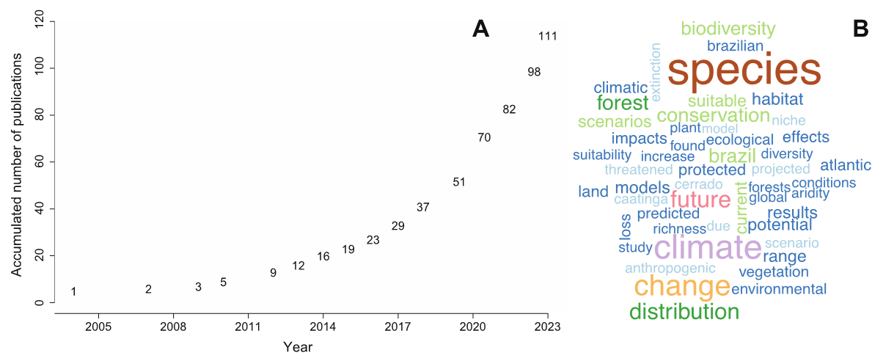
Fig. S1. (A) Annual scientific production on climate change and Brazilian biodiversity. (B) Word cloud showing the 40 most frequent terms in the abstracts of the 111 included articles.

Table S2. Exploratory data analysis using the Boruta algorithm with Random Forest to select a priori predictors for subsequent evidence-mapping and bibliometric analyses. Mean, median, minimum, and maximum importance, normalized hit rate, and Boruta decision are shown for each attribute (Kursa & Rudnicki, 2010).

Effects | meanImp | medianImp | minImp | maxImp | Norm Hits | Decision
Climatic aspect | 60.5 | 60.5 | 56.1 | 63.6 | 1 | Confirmed
Ecological level | 84.1 | 83.6 | 78.0 | 90.1 | 1 | Confirmed
Ecosystem | 86.8 | 86.2 | 83.4 | 92.1 | 1 | Confirmed
Coverage | 86.2 | 86.1 | 83.4 | 89.9 | 1 | Confirmed
Biological aspect | 69.3 | 68.7 | 65.3 | 72.8 | 1 | Confirmed
Publication Year | 90.9 | 90.6 | 87.3 | 98.3 | 1 | Confirmed
Effects | 60.4 | 60.0 | 57.5 | 64.07 | 1 | Confirmed
Impacts | 76.6 | 76.4 | 73.2 | 80.3 | 1 | Confirmed
Regions | 7.7 | 8.0 | 6.3 | 9.0 | 1 | Confirmed
TaxonomicGroups | 90.9 | 91.4 | 83.1 | 94.5 | 1 | Confirmed
Biomes | 20.3 | 20.2 | 18.2 | 22.6 | 1 | Confirmed

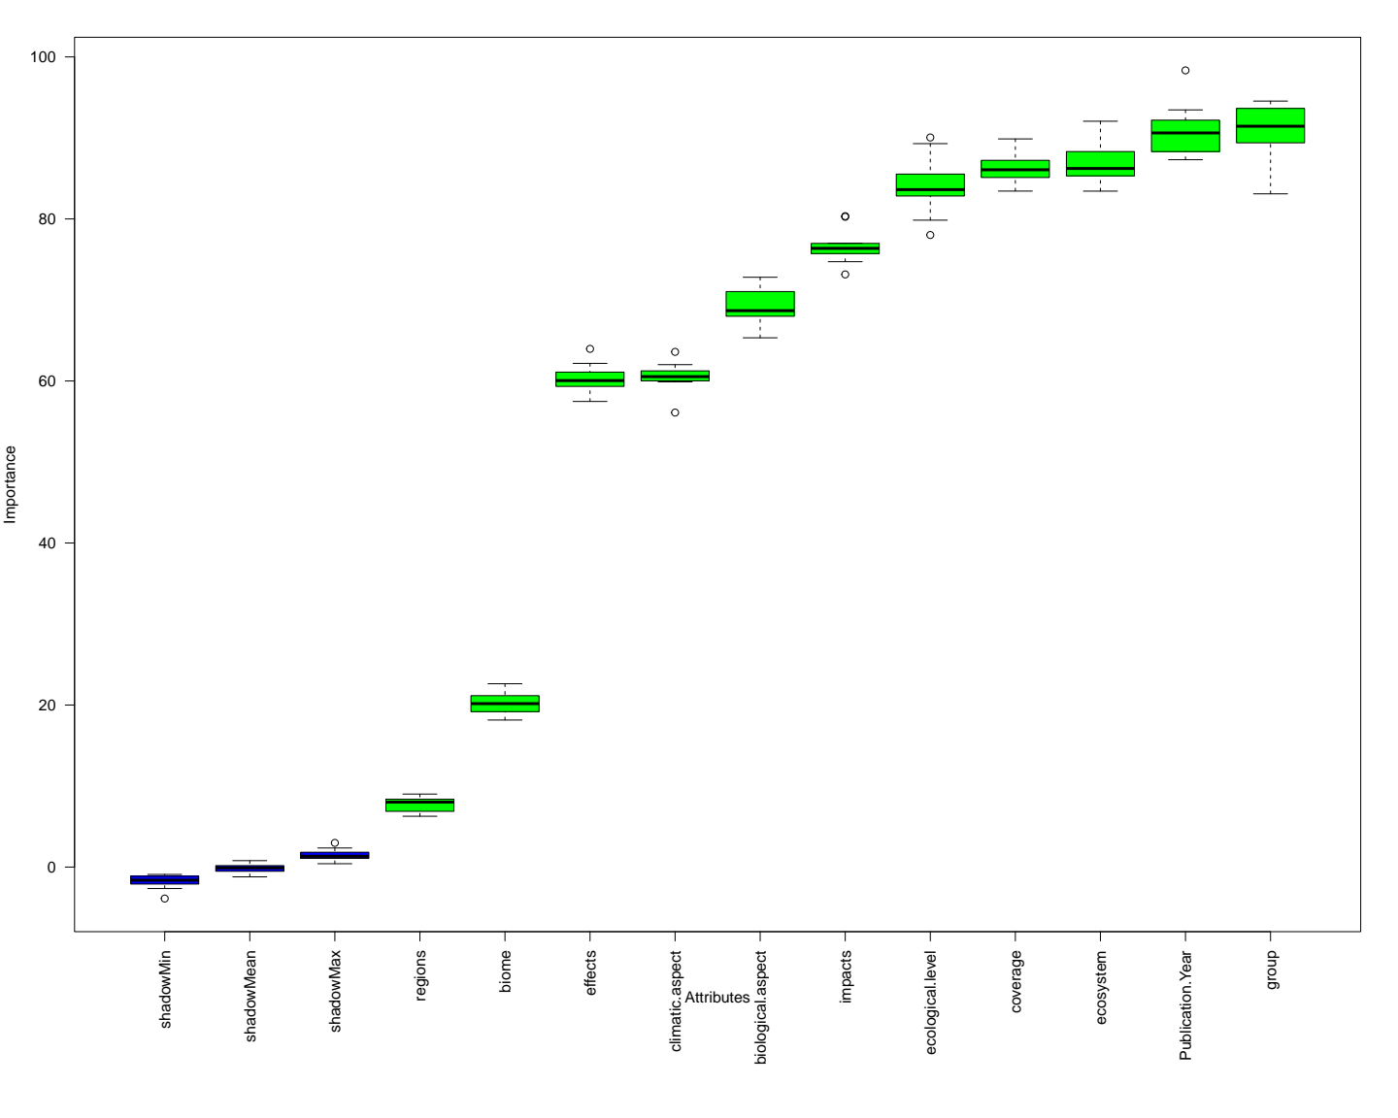
Fig. S2. Boxplot of variable importance obtained from exploratory data analysis using the Boruta algorithm with Random Forest. This method was used to select a priori predictors for subsequent statistical analyses by comparing the importance of observed attributes with that of shadow attributes created by random permutation.

Table S3. Comparison of Bayesian brms models used to select the most appropriate error distribution (Poisson, zero-inflated Poisson, negative binomial, or zero-inflated negative binomial) and, subsequently, the best-supported model structure (global interaction, additive, single fixed-effect, or null model). Model fit was compared using the leave-one-out information criterion (LOOIC). The best-supported models (lowest LOOIC) are highlighted in bold.

Global Models | Biomes x  Taxonomic groups |  | Regions x  Taxonomic groups |  | Effects x Impacts |  | Effects x  Taxonomic groups
Distribution selection | LOOIC | (SE) | LOOIC | (SE) | LOOIC | (SE) | LOOIC | (SE)
Poisson | 1090.8 | 60.4 | 1098.7 | 51.4 | 471.2 | 40.1 | 503.3 | 39.7
Negative Binomial | 1090.0 | 60.2 | 1099.9 | 51.4 | 471.3 | 39.7 | 505.9 | 39.9
Zero-inflated Poisson | 1090.5 | 60.1 | 1099.7 | 51.2 | 472.1 | 39.9 | 506.3 | 39.6
Zero-inflated Negative Binomial | 1094.8 | 60.6 | 1102.7 | 51.3 | 472.9 | 39.6 | 508.0 | 39.7
Model fit Selection | LOOIC | (SE) | LOOIC | (SE) | LOOIC | (SE) | LOOIC | (SE)
Global model | 1090.8 | 60.4 | 1098.7 | 51.4 | 471.2 | 40.1 | 503.3 | 39.7
Additive model | 1020.2 | 54.0 | 1033.0 | 47.6 | 444.8 | 35.7 | 483.9 | 36.7
Only the 1st fixed effect model | 1177.9 | 60.9 | 1279.1 | 62.8 | 720.8 | 70.1 | 636.5 | 55.9
Only the 2nd fixed effect model | 1054.4 | 54.8 | 1045.8 | 47.3 | 648.3 | 53.1 | 607.8 | 44.2
Null model | 1206.1 | 64.9 | 1287.5 | 63.6 | 905.9 | 99.2 | 751.7 | 70.2
Distribution selection | ΔLOOIC | (SE) | ΔLOOIC | (SE) | ΔLOOIC | (SE) | ΔLOOIC | (SE)
Poisson | -0.7 | 1.7 | 0 | - | 0 | - | 0 | -
Negative Binomial | 0 | - | -1.2 | 1.2 | -0.1 | 0.9 | -2.6 | 1.0
Zero-inflated Poisson | -0.5 | 3.1 | -1.0 | 1.9 | -0.5 | 1.2 | -2.9 | 1.6
Zero-inflated Negative Binomial | -4.8 | 3.5 | -4.0 | 2.5 | -0.9 | 1.4 | -4.7 | 1.9
Model fit Selection | ΔLOOIC | (SE) | ΔLOOIC | (SE) | ΔLOOIC | (SE) | ΔLOOIC | (SE)
Global model | -70.6 | 23.8 | - 65.7 | 10.8 | -26.3 | 11.1 | -21.2 | 8.2
Additive model | 0 | - | 0 | - | 0 | - | 0 | -
Only the 1st fixed effect model | -155.4 | 30.4 | -246.1 | 40.2 | -203.4 | 35.8 | -152.3 | 38.9
Only the 2nd fixed effect model | -34.1 | 14.2 | -12.8 | 8.2 | -276.0 | 53.3 | -123.3 | 22.4
Null model | -185.8 | 38.6 | -254.6 | 42.5 | -461.0 | 85.1 | -267.9 | 56.4

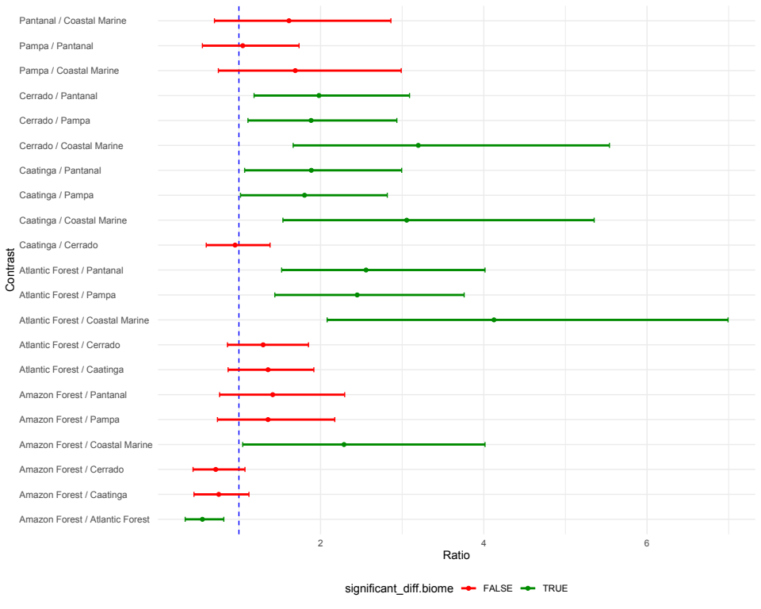
Fig. S3. Pairwise posterior contrasts in estimated publication counts among Brazilian biomes from the additive Bayesian brms model for biomes and taxonomic groups. Green bars indicate contrasts clearly differentiated by the model, whereas red bars indicate contrasts not clearly differentiated.
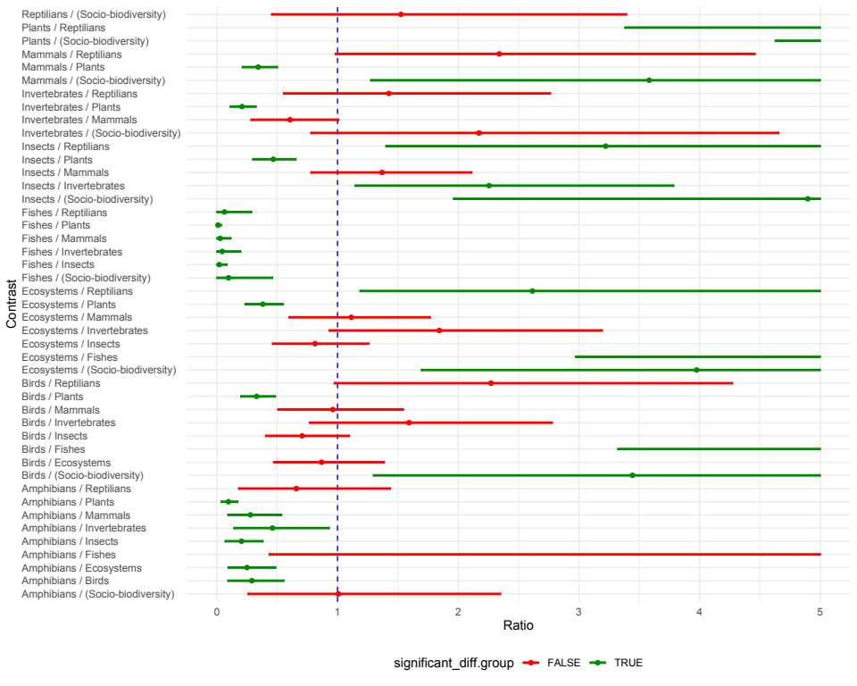
Fig. S4. Pairwise posterior contrasts in estimated publication counts among taxonomic groups from the additive Bayesian brms model for biomes and taxonomic groups. Green bars indicate contrasts clearly differentiated by the model, whereas red bars indicate contrasts not clearly differentiated.

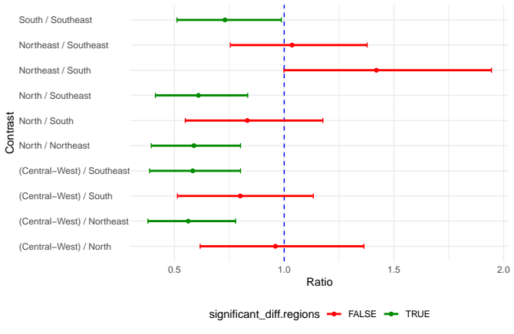
Fig. S5. Pairwise posterior contrasts in estimated publication counts among Brazilian geographic regions from the additive Bayesian brms model for regions and taxonomic groups. Green bars indicate contrasts clearly differentiated by the model, whereas red bars indicate contrasts not clearly differentiated.
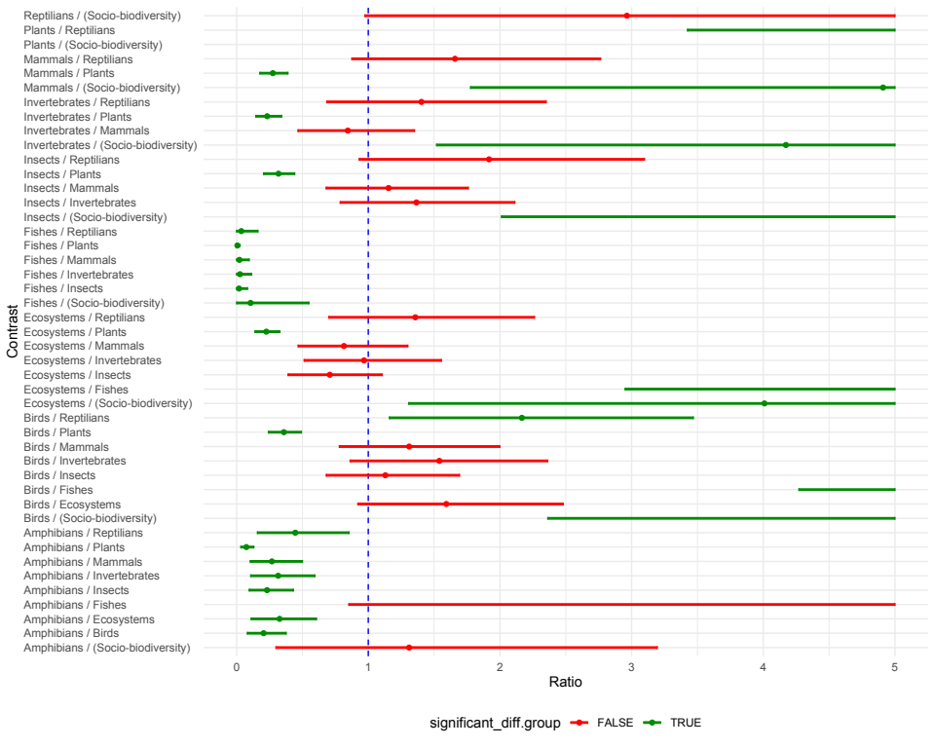
Fig. S6. Pairwise posterior contrasts in estimated publication counts among taxonomic groups from the additive Bayesian brms model for regions and taxonomic groups. Green bars indicate contrasts clearly differentiated by the model, whereas red bars indicate contrasts not clearly differentiated.
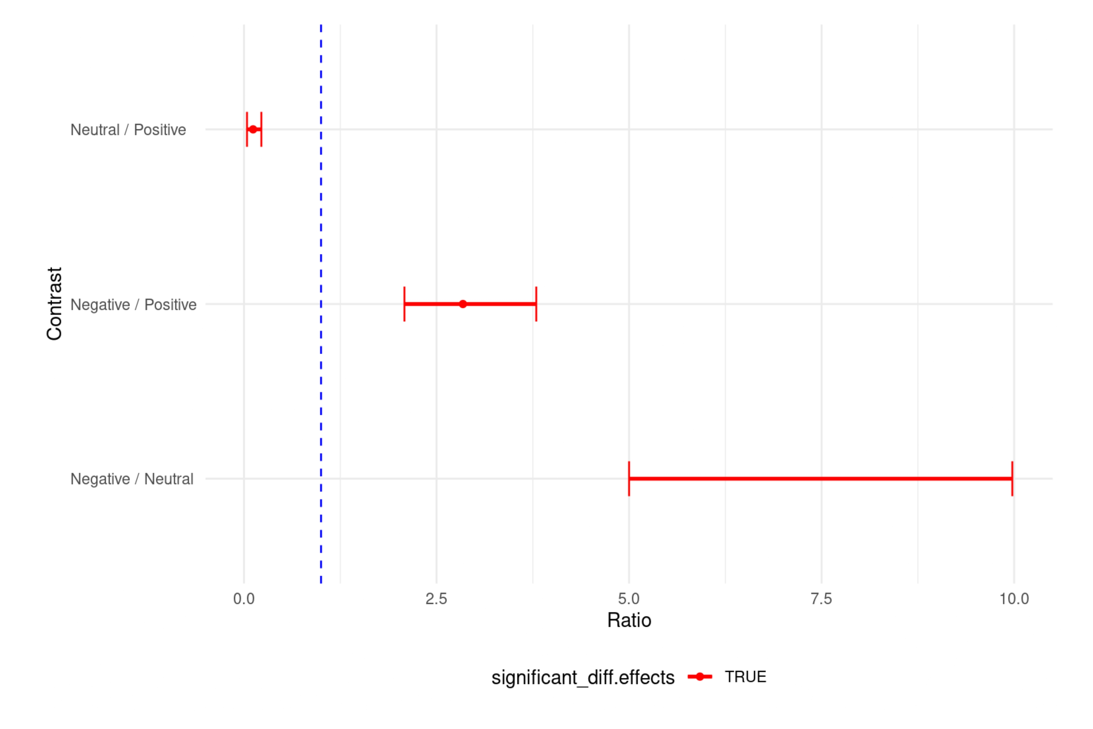
Fig. S7. Pairwise posterior contrasts in estimated publication counts among reported effect classes from the additive Bayesian brms model for effects and impact types. Red bars indicate contrasts not clearly differentiated by the model.
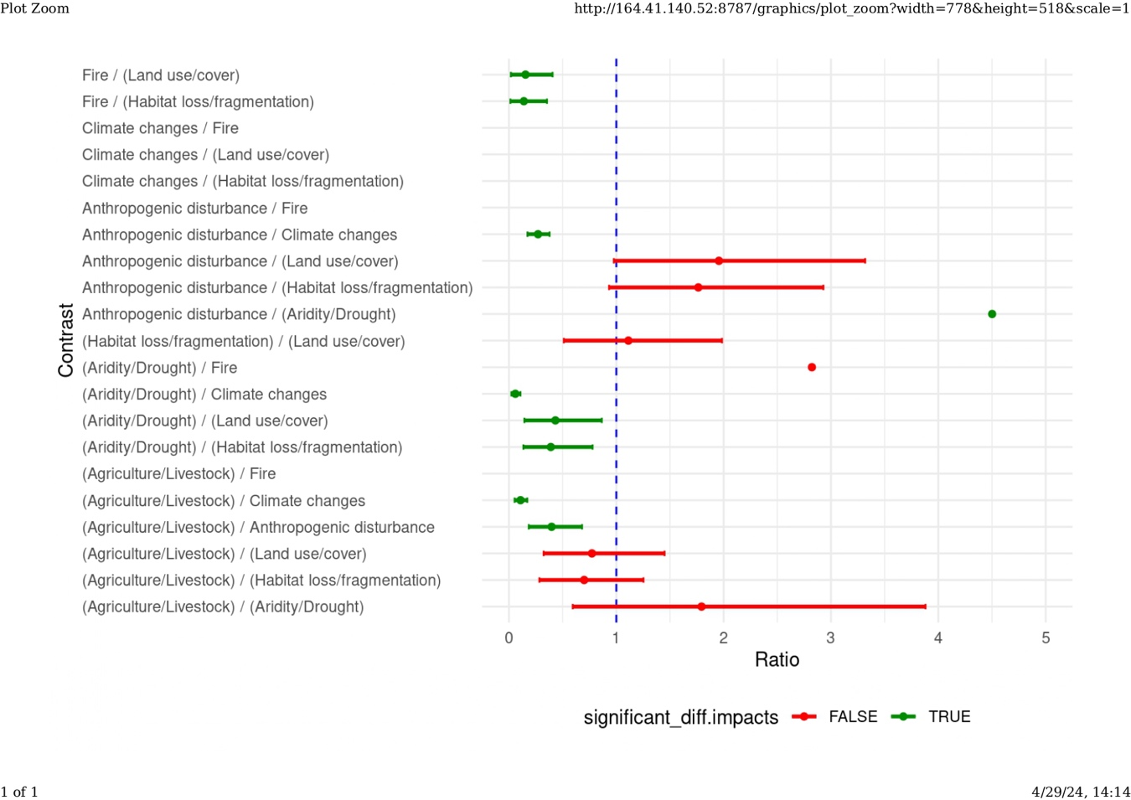
Fig. S8. Pairwise posterior contrasts in estimated publication counts among impact categories from the additive Bayesian brms model for effects and impact types. Green bars indicate contrasts clearly differentiated by the model, whereas red bars indicate contrasts not clearly differentiated.
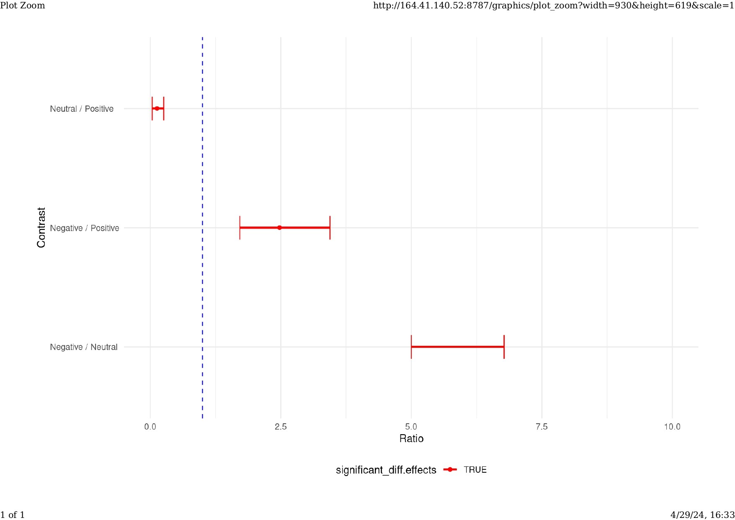
Fig. S9. Pairwise posterior contrasts in estimated publication counts among reported effect classes from the additive Bayesian brms model for effects and taxonomic groups. Green bars indicate contrasts clearly differentiated by the model, whereas red bars indicate contrasts not clearly differentiated.
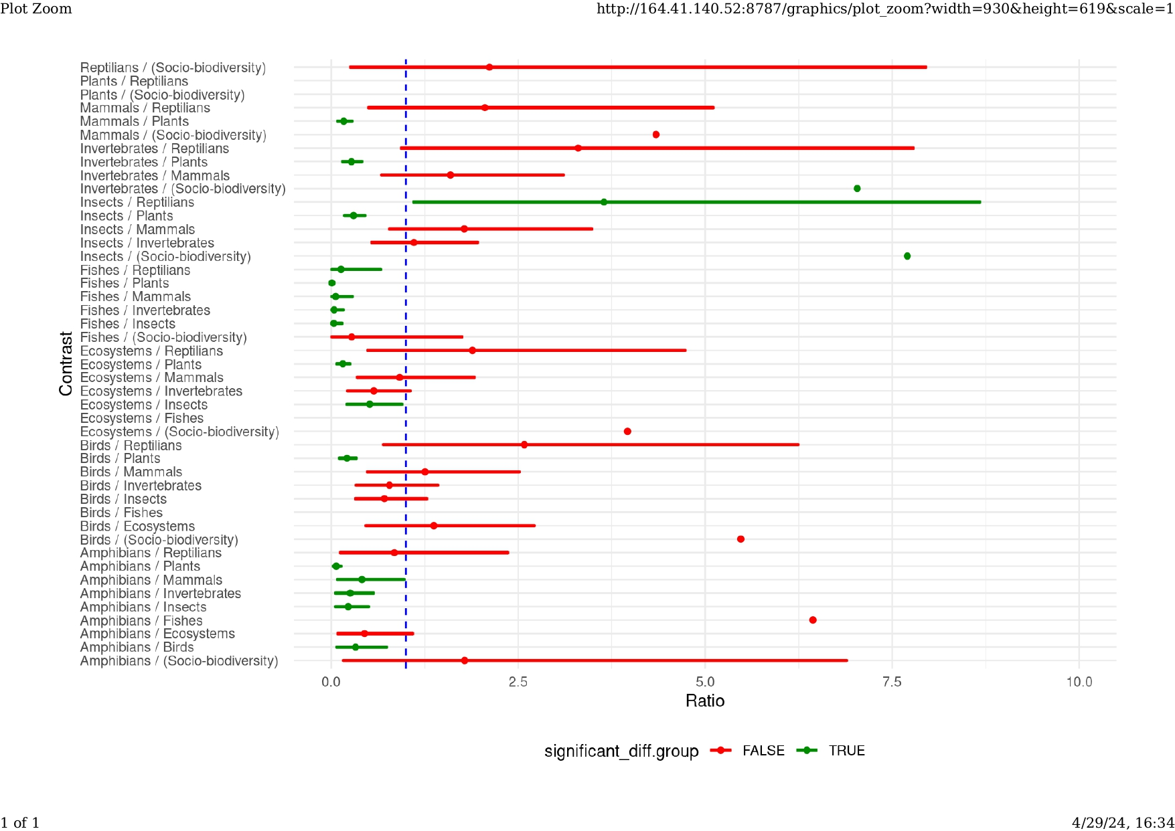
Fig. S10. Pairwise posterior contrasts in estimated publication counts among taxonomic groups from the additive Bayesian brms model for effects and taxonomic groups. Green bars indicate contrasts clearly differentiated by the model, whereas red bars indicate contrasts not clearly differentiated.

Table S4. Total number of known fauna and flora species, number of threatened species, number of publications on climate change and biodiversity in Brazil, and territorial extent by biome, taxonomic group, and Brazilian geographic region. Threatened species are additionally broken down by risk category (CR = critically endangered, EN = endangered, VU = vulnerable) for each taxonomic group (source: IBGE, 2024). For regions, the number of postgraduate programs and courses related to biodiversity is also shown (CAPES, 2024). For each factor, normality was assessed with the Shapiro test, and correlations with publication counts were evaluated using Pearson’s correlation coefficient (R), or Spearman’s rank correlation (*) when normality was not met; R² values are also reported. ** = non-significant. *** = invertebrates + insects.

Biomes | Fauna (all groups) |  | Flora (Plants) |  | Extension (km²) | Publications
Biomes | Total | Threatened | Total | Threatened | Extension (km²) | Publications
Atlantic Forest | 6.911 | 682 | 4,900 | 1.991 | 1,110,182 | 59
Cerrado | 5.209 | 375 | 2.176 | 755 | 2,036,448 | 45
Caatinga | 2.381 | 212 | 839 | 255 | 844,453 | 41
Amazonia | 6.721 | 234 | 1.625 | 288 | 4,196,943 | 33
Pampa | 1.761 | 118 | 424 | 121 | 176,496 | 23
Pantanal | 1.654 | 53 | 172 | 29 | 150,335 | 22
Coastal Marine | 2.286 | 171 | - | - | 3,600,000 | 12
Normal Distribution | Yes | Yes | Yes | No | Yes | Yes
Shapiro Test | W = 0.97  p = 0.93 | W = 0.86  p = 0.17 | W = 0.85  p = 0.17 | W = 0.76  p = 0.03 | W = 0.88  p = 0.23 | W = 0.97  p = 0.93
Correlation (R) | 0.72 | 0.87 | 0.91 | 0.94* | -0.17 | -
Coef. of Determination (R²) | 0.51 | 0.75 | 0.82 | 0.89 | 0.03** | -
Taxonomic group | Total | Threatened | Risk categories |  |  | Publications
Taxonomic group | Total | Threatened | CR | EN | VU | Publications
Flora (Plants) | 7.517 | 3.207 | 684 | 1.843 | 680 | 48
Invertebrates*** | 4.474 | 372 | 135 | 123 | 114 | 26
Birds | 1.911 | 256 | 34 | 82 | 140 | 12
Mammals | 731 | 102 | 11 | 43 | 48 | 10
Reptilians | 792 | 71 | 8 | 43 | 20 | 5
Amphibians | 1.095 | 59 | 34 | 10 | 15 | 3
Fishes | 4.936 | 393 | 136 | 126 | 131 | 2
Normal Distribution | Yes | No | No | No | No | No
Shapiro Test | W = 0.86  p = 0.16 | W = 0.56  p < 0.001 | W = 0.64  p = 0.001 | W = 0.51  p < 0.001 | W = 0.65  p = 0.001 | W = 0.81  p = 0.051
Correlation (R) | 0.76 | 0.46* | 0.31* | 0.45* | 0.89* | -
Coef. of Determination (R²) | 0.58 | 0.22 | 0.09 | 0.20 | 0.80 | -
Regions | Programs |  | Courses |  | Publications
Northeast | 31 |  | 49 |  | 78
Southeast | 50 |  | 89 |  | 76
South | 24 |  | 41 |  | 55
North | 16 |  | 27 |  | 46
Central-West | 15 |  | 24 |  | 46
Normal Distribution | Yes |  | Yes |  | Yes
Shapiro Test | W = 0.88, p = 0.32 |  | W = 0.86, p = 0.24 |  | W = 0.82, p = 0.11
Pearson Correlation (R) | 0.86 |  | 0.81 |  | -
Coef. of Determination (R²) | 0.74 |  | 0.66 |  | -

Table S5. Comparison of glmmTMB models used to select the most appropriate error distribution (Poisson, negative binomial 2, negative binomial 1, zero-truncated Poisson, zero-truncated negative binomial 2, or zero-truncated negative binomial 1) and, subsequently, the best-supported model structure (single fixed-effect or null model). Model fit was compared using the Akaike Information Criterion corrected for small sample size (AICc). The best-fitting models (lowest AICc) are highlighted in bold. “–” indicates convergence problems.

Global Models | Biological Aspects |  |  |  | Climatic Aspects |  |  |  | Coverage
Distribution selection | AICc | df |  | ΔAICc | AICc | df |  | ΔAICc | AICc | df |  | ΔAICc
Poisson | 300.5 | 9 |  | 0 | 231.6 | 6 |  | 0 | 168.9 | 6 |  | 0
Negative Binomial 2 | 302.9 | 10 |  | 2.4 | 234.1 | 7 |  | 2.5 | 171.3 | 7 |  | 2.4
Negative Binomial 1 | - | 10 |  | - | - | 7 |  | - | 171.3 | 7 |  | 2.4
Zero-truncated Poisson | 350,6 | 9 |  | 50.1 | 264.0 | 6 |  | 32.4 | 211.3 | 7 |  | 42.4
Zero-truncated Negative Binomial 2 | - | 10 |  | - | - | 7 |  | - | - | 8 |  | -
Zero-truncated Negative Binomial 1 | 353.1 | 10 |  | 52.5 | - | 7 |  | - | - | 8 |  | -
Model fit Selection | AICc | df |  | ΔAICc | AICc | df |  | ΔAICc | AICc | df |  | ΔAICc
Individual fixed effect model | 300.5 | 9 |  | 0 | 231.6 | 6 |  | 0 | 168.9 | 6 |  | 0
Null model | 365.8 | 3 |  | 65.3 | 339.0 | 3 |  | 107.4 | 286.8 | 3 |  | 117.9
Global Models | Ecosystem |  |  |  |  |  | Ecological level
Distribution selection | AICc |  | df |  | ΔAICc |  | AICc |  | df |  | ΔAICc
Poisson | 145.9 |  | 4 |  | 0 |  | 185.8 |  | 5 |  | 0
Negative Binomial 2 | 148.4 |  | 5 |  | 2.5 |  | 188.3 |  | 6 |  | 2.4
Negative Binomial 1 | 148.3 |  | 5 |  | 2.4 |  | 190.8 |  | 7 |  | 5.0
Zero-truncated Poisson | 175.4 |  | 5 |  | 29.6 |  | 220.5 |  | 6 |  | 34.7
Zero-truncated Negative Binomial 2 | 178.1 |  | 6 |  | 32.2 |  | 223.0 |  | 7 |  | 37.2
Zero-truncated Negative Binomial 1 | - |  | 6 |  | - |  | - |  | 7 |  | -
Model fit Selection | AICc |  | df |  | ΔAICc |  | AICc |  | df |  | ΔAICc
Individual fixed effect model | 145.9 |  | 4 |  | 0 |  | 185.8 |  | 5 |  | 0
Null model | 249.3 |  | 3 |  | 103.5 |  | 243.2 |  | 3 |  | 57.3

Table S6. Pairwise contrasts in estimated publication counts among factor levels from the individual glmmTMB models used for post hoc comparisons. Ratios, standard errors, z-ratios, and adjusted p-values are shown for comparisons among estimated marginal means. Groups were defined based on significant pairwise differences; letters are ordered from higher to lower publication counts (a > b > c > d > e).

Biological Aspects
Contrasts | Ratio | SE | Z-Ratio | P-value | Groups *
Demography / Distribution | 0.13 | 0.05 | -5.40 | < 0.001 | Distribution a
Demography / Diversity | 0.38 | 0.16 | -2.32 | 0.233 | Demography b
Demography / Extinction risk | 1.00 | 0.50 | 0.00 | 1.000 | Diversity b
Demography / Habitat suitability | 0.80 | 0.38 | -0.47 | 0.999 | Extinction risk b
Demography / Others | 0.31 | 0.12 | -2.92 | 0.055 | Habitat suitability b
Demography / Richness | 0.36 | 0.15 | -2.45 | 0.178 | Richness b
Distribution / Diversity | 2.90 | 0.73 | 4.21 | < 0.001 | Others b
Distribution / Extinction risk | 7.63 | 2.87 | 5.40 | < 0.001
Distribution / Habitat suitability | 6.10 | 2.08 | 5.30 | < 0.001
Distribution / Others | 2.35 | 0.55 | 3.64 | 0.005
Distribution / Richness | 2.77 | 0.69 | 4.10 | 0.001
Diversity / Extinction risk | 2.63 | 1.09 | 2.32 | 0.233
Diversity / Habitat suitability | 2.10 | 0.81 | 1.93 | 0.460
Diversity / Others | 0.81 | 0.24 | -0.73 | 0.991
Diversity / Richness | 0.95 | 0.29 | -0.15 | 1.000
Extinction risk / Habitat suitability | 0.80 | 0.38 | -0.47 | 0.999
Extinction risk / Others | 0.31 | 0.12 | -2.92 | 0.055
Extinction risk / Richness | 0.36 | 0.15 | -2.45 | 0.178
Habitat suitability / Others | 0.38 | 0.14 | -2.57 | 0.136
Habitat suitability / Richness | 0.45 | 0.17 | -2.07 | 0.372
Others / Richness | 1.18 | 0.34 | 0.58 | 0.997
Climatic Aspects
Contrasts | Ratio | SE | Z-Ratio | P-value | Groups *
Humidity / Others | 0.29 | 0.16 | -2.21 | 121,000 | Precipitation a
Humidity / Precipitation | 0.04 | 0.02 | -6.29 | < 0.001 | Temperature a
Humidity / Temperature | 0.04 | 0.02 | -6.27 | < 0.001 | Humidity b
Others / Precipitation | 0.14 | 0.04 | -6.85 | < 0.001 | Others b
Others / Temperature | 0.14 | 0.04 | -6.81 | < 0.001
Precipitation / Temperature | 1.01 | 0.14 | 0.07 | 1.000
Coverage
Contrasts | Ratio | SE | Z-Ratio | P-value | Groups *
Brazil / Global | 18.20 | 8.36 | 6.32 | < 0.001 | Brazil a
Brazil / Neotropical | 91.00 | 91.50 | 4.49 | < 0.001 | Global b
Brazil / (Pan-Americano) | 91.00 | 91.50 | 4.49 | < 0.001 | Neotropical b
Brazil / South America | 7.58 | 2.33 | 6.60 | < 0.001 | Pan-Americano b
Global / Neotropical | 5.00 | 5.48 | 1.47 | 0.583 | South America b
Global / (Pan-Americano) | 5.00 | 5.48 | 1.47 | 0.583
Global / South America | 0.42 | 0.22 | -1.64 | 0.469
Neotropical / (Pan-Americano) | 1.00 | 1.41 | 0.00 | 1.000
Neotropical / South America | 0.08 | 0.09 | -2.39 | 0.119
(Pan-Americano) / South America | 0.08 | 0.09 | -2.39 | 0.119
Ecosystem
Contrasts | Ratio | SE | Z-Ratio | P-value | Groups *
Aquatic / Marine | 0.56 | 0.31 | -1.05 | 0.543 | Terrestrial a
Aquatic / Terrestrial | 0.05 | 0.02 | -6.54 | < 0.001 | Aquatic b
Marine / Terrestrial | 0.09 | 0.03 | -6.92 | < 0.001 | Marine b
Ecological level
Contrasts | Ratio | SE | Z-Ratio | P-value | Groups *
Communities / Ecosystems | 6.87 | 2.60 | 5.09 | < 0.001 | Communities a
Communities / Populations | 1.22 | 0.25 | 1.00 | 0.750 | Populations a
Communities / Social | 18.33 | 10.87 | 4.91 | < 0.001 | Ecosystems b
Ecosystems / Populations | 0.18 | 0.07 | -4.50 | < 0.001 | Social b
Ecosystems / Social | 2.67 | 1.81 | 1.45 | 0.469
Populations / Social | 15.00 | 8.94 | 4.54 | < 0.001

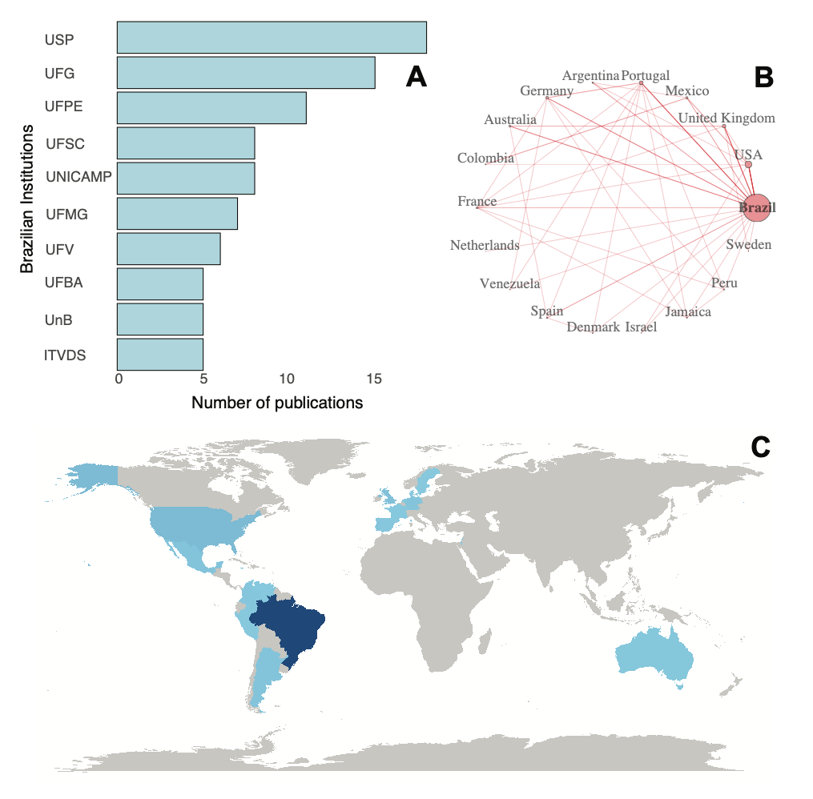
Fig. S11. (A) Most productive institutional affiliations. (B) International collaboration among countries. (C) Publication output by country.
REFERENCES
IBGE (2024). Sistema IBGE de recuperação automática: SIDRA. Tabela 9625 - Número de Espécies Da Fauna e Da Flora Brasileira Avaliadas Quanto Ao Risco de Extinção, Por Grupos Taxonômicos, Hábito Ou Forma de Vida, Tipo de Ambiente, Biomas e Sistema Costeiro-Marinho e Categorias de Risco. https://sidra.ibge.gov.br/tabela/9625#notas-tabela.
CAPES – Coordenação de Aperfeiçoamento de Pessoal de Nível Superior (2024). Cursos Graduação e Pós-Graduação Avaliados e Reconhecidos. Plataforma Sucupira. https://sucupira-v2.capes.gov.br/sucupira4/.
Kursa, M.B. & W. R. Rudnicki (2010). Feature Selection with the Boruta Package. Journal of Statistical Software, 36(11), 1-13. URL https://doi.org/10.18637/jss.v036.i11.

