Table S1 Plant species list in this study during 2017 - 2019

Functional group | Species name
Tall Grasses | Leymus chinensis
Tall Grasses | Agropyron cristatum
Tall Grasses | Stipa krylovii
Tall Grasses | Achnatherum sibiricum.
Tall Grasses | Setaria viridis
Tall Grasses | Elymus dahuricus L.
Tall Grasses | Leymus secalinus(Georgi)Tzvel.
Tall Grasses | Pennisetum centrasiaticum Tzvel.
Short Grasses | Carex korshinskyi
Short Grasses | Koeleria cristata(L.) Pers
Short Grasses | Poa subfastigiata trin
Short Grasses | Cleistogenes squarrosa
Forbs | Potentilla bifurca
Forbs | Artemisia frigida
Forbs | Potentilla tanacetifolia
Forbs | Potentilla acaulis
Forbs | Heteropappus altaicus
Forbs | Dianthus chinensis
Forbs | Geranium wilfordii
Forbs | Elsholtzia densa Benth.
Forbs | Iris tenuifolia
Forbs | Iris lacteal
Forbs | Serratula centauroides L.
Forbs | Artemisia dracunculus L.
Forbs | Artemisia argyi L.
Forbs | Bupleurum scorzonerifolium
Forbs | Cymbaria dahurica
Forbs | Phlomis umbrosa
Forbs | Ixeris chinensis
Forbs | Scorzonera austriaca
Forbs | Saposhnikovia divaricata
Forbs | Polygonum divaricatum L.
Forbs | Potentilla multifida L.
Forbs | Potentilla multicaulis Bge.
Forbs | Potentilla betonicaefolia poir.
Forbs | Gentiana dahurica
Forbs | Androsace alaschanica
Forbs | Sibbaldia procumbens Linn.
Forbs | Allium senescens
Forbs | Allium ramosum
Forbs | Allium tenuissimum
Forbs | Allium bidentatum
Forbs | Allium neriniflorum
Forbs | Astragalus galacties
Forbs | Astragalus scaberrimus
Forbs | Astragalus adsurgens
Forbs | Melilotoides ruthenica
Forbs | Gueldenstaedtia multiflora
Forbs | Thymus serpyllum L.
Forbs | Lespedeza davurica
Forbs | Kochia prostrata (L.) Schrad.
Forbs | Ephedra sinica Stapf
Forbs | Salsola collina L.
Forbs | Chenopodium aristatum
Forbs | Chenopodium glaucum
Forbs | Ceratoides latens (J. F. Gmel.) Reveal et Holmgren
Forbs | Gentiana squarrosa
Forbs | Thalictrum petaloideum
Forbs | Eriochloa villosa
Forbs | Artemisia scoparia Waldst. et Kit.
Forbs | Artemisia carvifolia
Forbs | Artemisia sieversiana L.
Forbs | Dontostemon dentatus Andrz.
Forbs | Polygonum aviculare L.
Forbs | Lappula myosotis v. Wolf.
Forbs | Polygonum convolvulus L.
Forbs | Fagopyrum tataricum
Forbs | Saussurea japonica
Forbs | Lepidium apetalum L.
Forbs | Melandrium apricum Roehl.
Forbs | Silene conoidea
Forbs | Androsace umbellata L.
Forbs | Chamaerhodos erecta
Forbs | Orostachys malacophylla (Pall.) Fisch.
Forbs | Amaranthus tricolor

Table S2 Results of mixed effect model with (historical) nitrogen addition (N) and water addition (W) as fixed factor and block as random factors on soil characteristics, plant stature and shallow BNPP. F-values were shown for N and W and Chi-Square values were shown for block.
Year | Source | TIN | Moisture | CWM_{stature} | BNPP_{0-10 cm}
2017 | N | 82.59*** | 19.60*** | 10.44** | 23.73***
 | W | 4.41* | 204.53*** | 30.56*** | 9.56**
 | N*W | 1.64 | 0.87 | 0.02 | 0.78
 | Block | 0.96 | 0.00 | 0.00 | 0.48
2018 | N | 6.71* | 7.72* | 2.90^ | 32.86***
 | W | 0.24 | 3.28^ | 21.22*** | 18.71***
 | N*W | 1.25 | 0.32 | 1.74 | 0.83
 | Block | 0.93 | 5.43* | 0.00 | 0.60
2019 | N | 4.86* | 17.81*** | 1.67 | 31.05***
 | W | 3.33^ | 74.74*** | 16.83*** | 13.00**
 | N*W | 1.15 | 0.15 | 2.13 | 0.80
 | Block | 1.57 | 0.00 | 0.00 | 0.59
Statistical significance is represented as: ***, p < 0.001; **, p < 0.01; *, p < 0.05; ^, 0.05 < p < 0.1, respectively

Table S3 Effects of (historical) nitrogen addition (N) and water addition (W) on plant cover, density and litter mass.
Year | Treatment | Cover  (%) | Density  (individuals m⁻²) | Litter mass  (g m⁻²)
2017 | Control | 65.14 ± 2.75 c | 198.71 ± 12.61 b | 17.12 ± 3.52 c
 | + N | 75.29 ± 2.56 b | 684.71 ± 137.11 a | 108.17 ± 23.36 ab
 | + W | 82.43 ± 2.74 ab | 265.57 ± 36.02 b | 80.02 ± 11.27 b
 | + NW | 87.86 ± 2.31 a | 359.57 ± 41.71 b | 143.11 ± 25.16 a
2018 | Control | 63.86 ± 1.37 b | 197.86 ± 14.08 b | 35.00 ± 10.49 c
 | + N | 72.71 ± 1.89 a | 416.71 ± 86.54 a | 123.20 ± 19.44 b
 | + W | 65.29 ± 1.43 b | 234.71 ± 32.57 b | 97.46 ± 10.68 b
 | + NW | 65.86 ± 3.00 b | 263.71 ± 37.87 b | 219.02 ± 34.38 a
2019 | Control | 74.00 ± 2.17 b | 261.17 ± 16.51 b | 15.66 ± 4.21 c
 | + N | 82.00 ± 2.25 a | 625.63 ± 120.66 a | 139.01 ± 27.94 ab
 | + W | 77.86 ± 1.94 ab | 439.42 ± 53.34 b | 101.52 ± 18.91 b
 | + NW | 77.71 ± 2.61 ab | 446.17 ± 78.86 ab | 190.67 ± 28.05 a
Results were presented as mean ± 1 standard error. Different lowercase letters indicate significant differences among different treatments at the level in each year of P < 0.05.
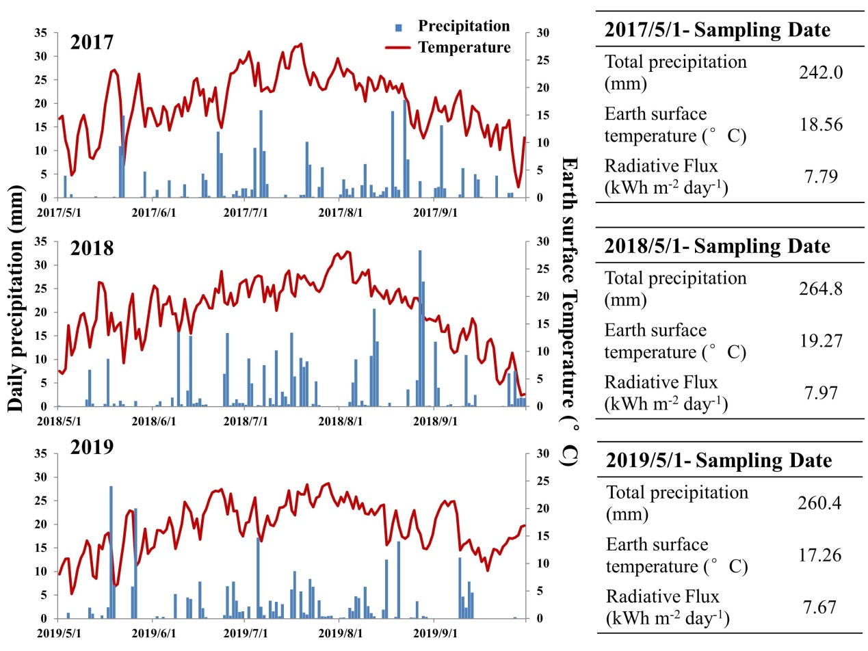
Fig.S1 Daily precipitation and earth surface temperature in growing seasons of sampling years.
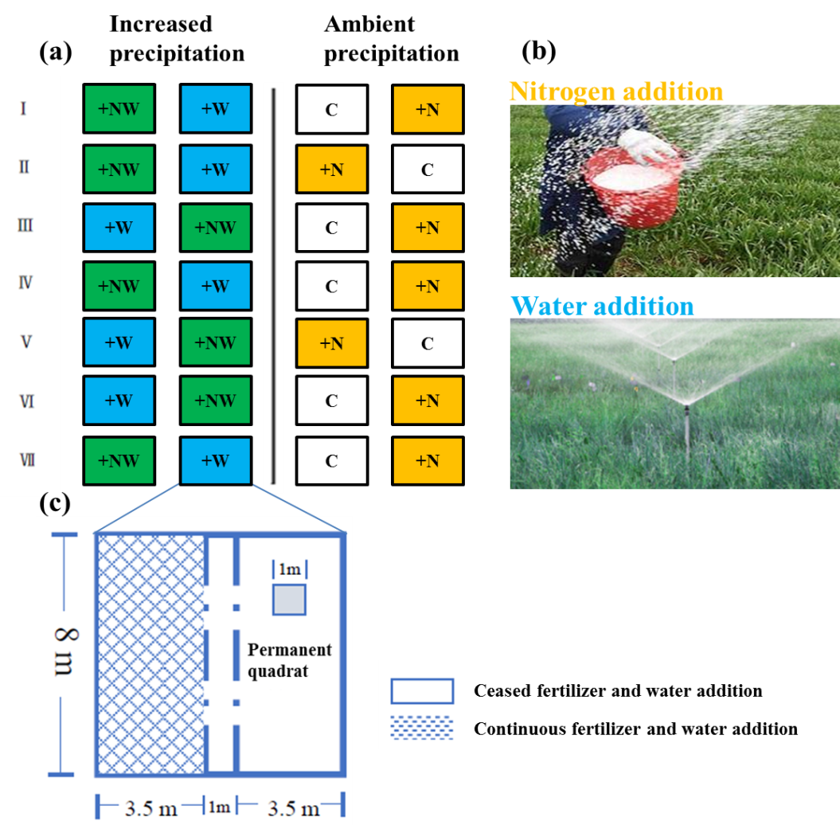
Fig. S2 Experimental design (a), nitrogen and water addition (b) and ceasing manipulation (c) in our study.

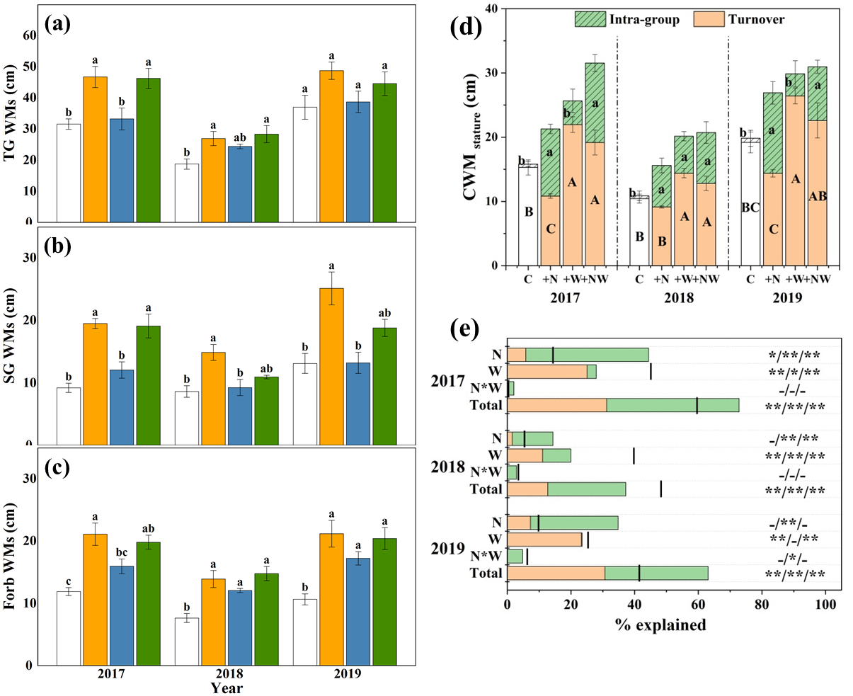
Fig. S3 Effects (2017) and legacy effects (2018-2019) of (historical) nitrogen addition (N) and water addition (W) on weighted mean stature of three functional groups (TG: tall grasses, a; SG: short grasses, b; Forbs, c). Decomposition of total variability in stature into intra-group and species turnover (d), and their parts explained by individual factors and the interactions in the experiment (e). Bar indicates the mean value (± 1 standard error) for each treatment. Different letters (in panels a-d) above bars indicate significant differences among different treatments at the level of P < 0.05. The interval in panel e between the column and the bar corresponds to the effects of covariation; The covariation is positive when the bar is above the column and negative when the bar crosses the column. The positioning of an * within the −/−/− graphic represents significance of the species turnover/intra-group variation /total variation, respectively.

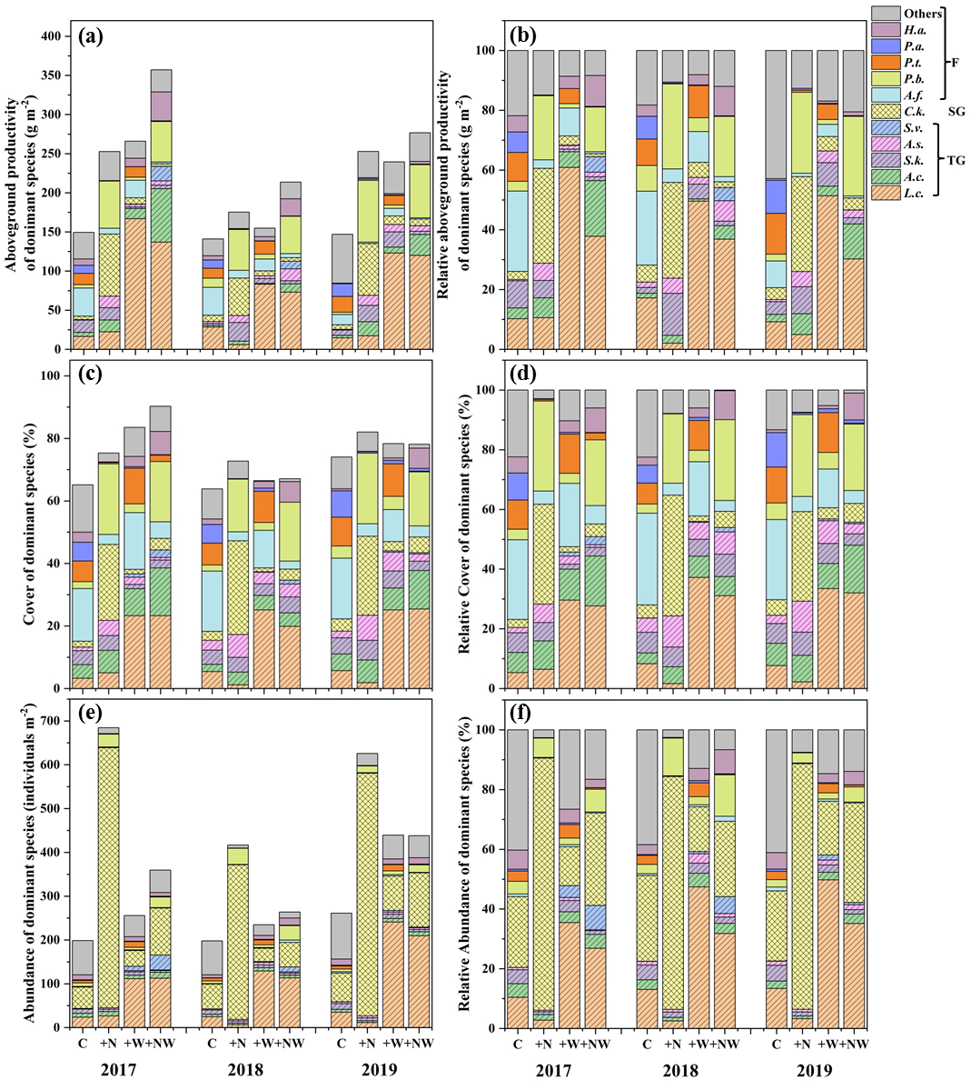
Fig. S4 Absolute and relative aboveground productivity (a, b), cover (c, d) and abundance (e, f) of dominant species from 2017 to 2019. TG: tall grasses (L.c.: Leymus chinensis; A.c.: Agropyron cristatum; S.k.: Stipa krylovii; A.s.: Achnatherum sibiricum; S.v.: Setaria viridis); SG: short grasses (C.k.: Carex korshinskyi); F: forbs (A.f.: Artemisia frigida; P.b.: Potentilla bifurca; P.t.: Potentilla tanacetifolia; P.a.: Potentilla acaulis; H.a.: Heteropappus altaicus).

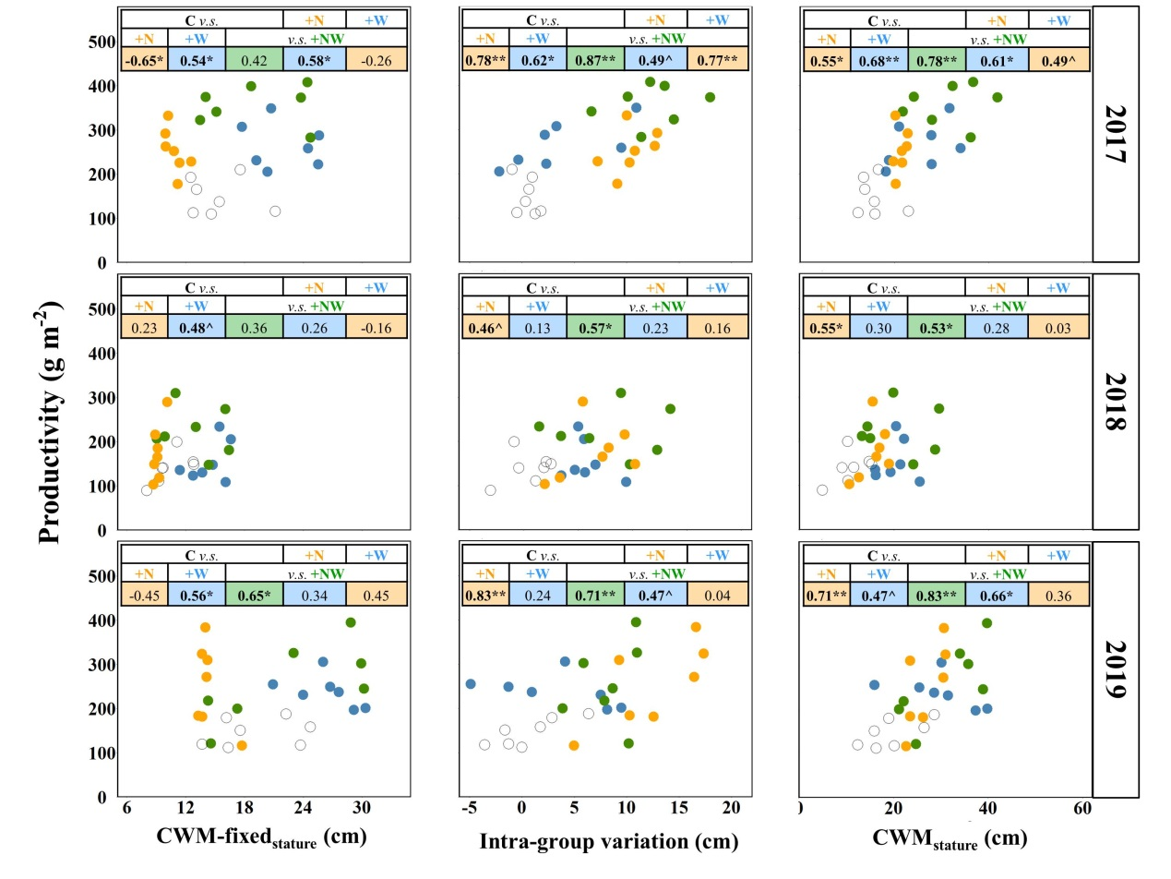
Fig. S5 The relationships of productivity at community level with community weighted mean stature and Inter- and Intra-group variability in stature. The correlations among data from each two treatments are calculated with the R values shown. Statistical significance is represented as: **, p < 0.01; *, p < 0.05; ^, 0.05 < p < 0.1, respectively.

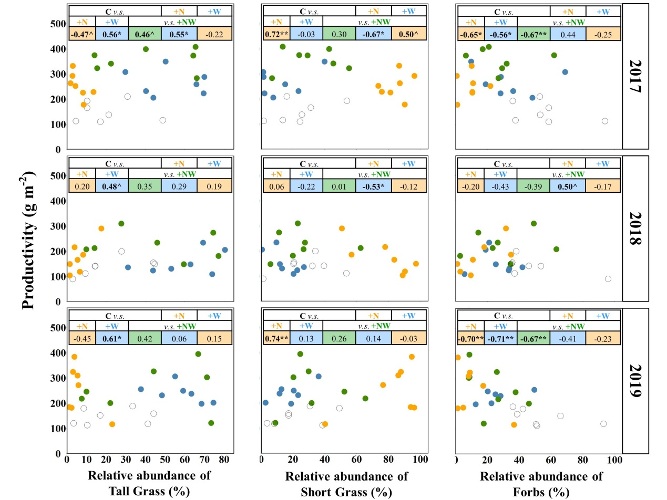
Fig. S6 The relationships of productivity at community level with the relative abundance of each functional group. The correlations among data from each two treatments are calculated with the R values shown. Statistical significance is represented as: **, p < 0.01; *, p < 0.05; ^, 0.05 < p < 0.1, respectively.

