Supporting Information

Structural comparison of Acinetobacter baumannii β-ketoacyl-acyl carrier protein reductases in fatty acid and aryl polyene biosynthesis

Woo Cheol Lee, Sungjae Choi, Ahjin Jang, Kkabi Son, Yangmee Kim

Supplementary Figure S1. Phylogenetic tree of strains GC1 and GC2.
Supplementary Figure S2. Genomic context of a FAS gene cluster including FabG among nosocomial pathogenic A. baumannii strains.
Supplementary Figure S3. Comparison of the genomic context for a representative strain of GC1 (A. baumannii AYE) and GC2 (A. baumannii ACICU).
Supplementary Figure S4. Size exclusion chromatography elution profile of AbApeQ.
Supplementary Table S1. PCR primers used in this study.
Supplementary Table S2. X-ray crystallography data collection and refinement statistics.

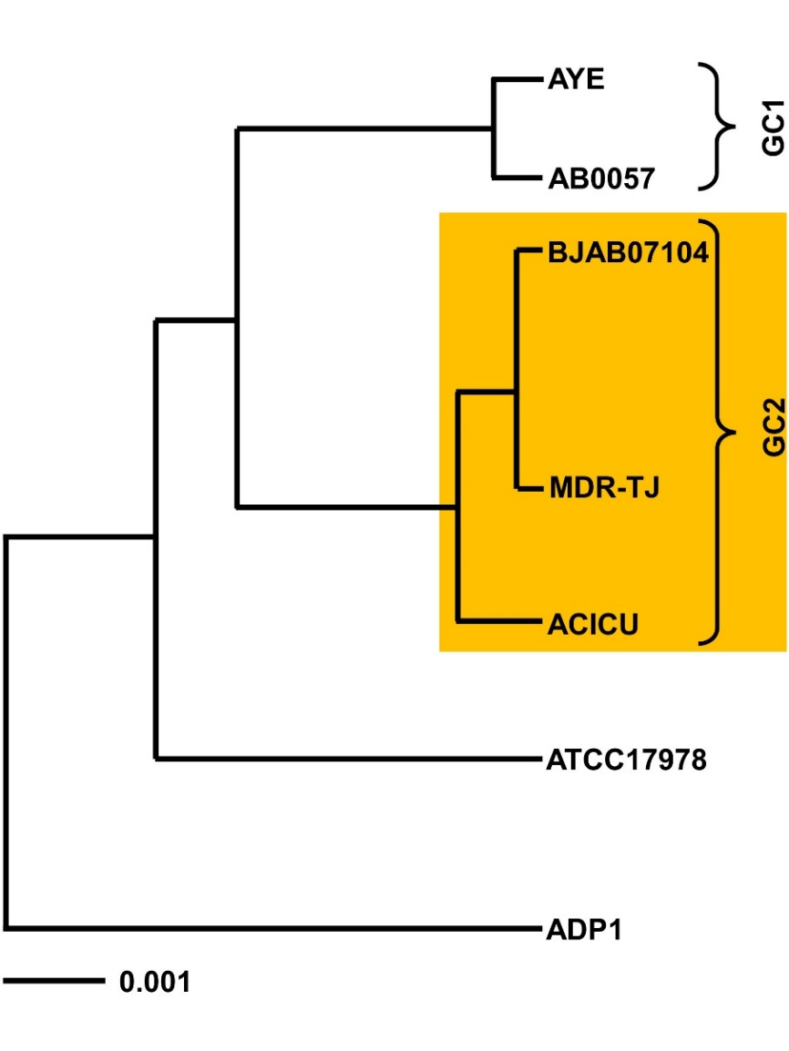

Supplementary Figure S1. Phylogenetic tree of strains GC1 and GC2. A. baumannii strains containing the APE BGC are highlighted in the orange box.

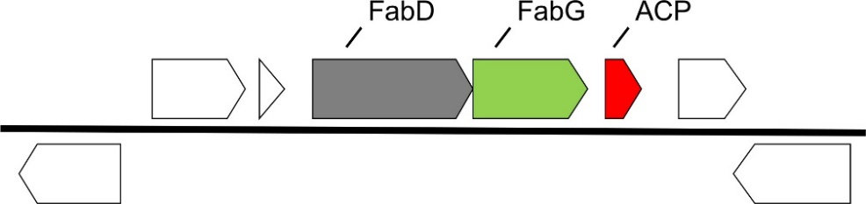

Supplementary Figure S2. Genomic context of a FAS gene cluster including FabG among nosocomial pathogenic A. baumannii strains.
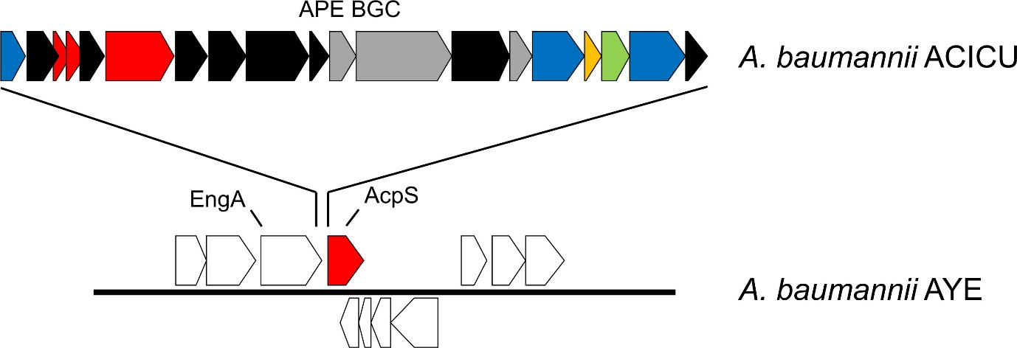

Supplementary Figure S3. Comparison of the genomic context for a representative strain of GC1 (A. baumannii AYE) and GC2 (A. baumannii ACICU). The color scheme is the same as that described in Figure 1.
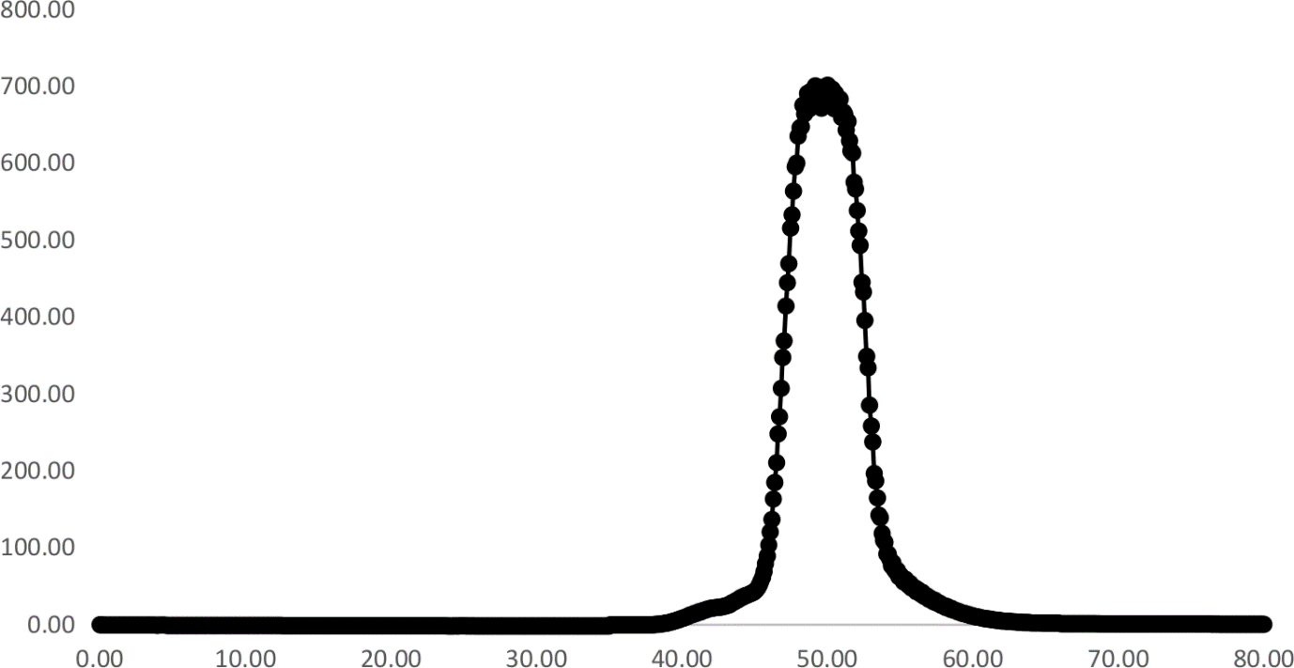

Supplementary Figure S4. Size exclusion chromatography of AbApeQ using a Superdex 75 10/300, prep. Grade column (GE Healthcare). The eluted volume of 50 mL corresponds to a molecular weight of ~80,000 kDa, which is the approximate tetrameric molecular weight of AbApeQ.

Protein | Primer | Sequence (5’-3’)
AbFabG | sense | CGCATATGACACAAGAACGCAAAGTTGC
AbFabG | antisense | CGCTCGAGTTAGGCCATGTATAAACCACC
AbApeQ | sense | CGCATATGACAAGACGAATTTTAGTAACG
AbApeQ | antisense | CGCTCGAGTCAGATGAGTCCTCCATTC
AbACP1 | sense | GCCCATGGATGAAGAGTTATCTTGAAATGAGC
AbACP1 | antisense | GCGGATCCTTATGACTTCTGTTGTGCTTC
AbACP2 | sense | GCCATATGTTATCTCAAGAGCAAGTATTAAC
AbACP2 | antisense | GCCTCGAGTCATTCAGCAGTCATGTTCTG
AbFabD | sense | CGCATATGATGTCTGCTAAACGTCTTGAACAAG
AbFabD | antisense | CGGGATCCTCATGCAATTTTTCCTTCTGCCAC
AbApeH | sense | CGGGATCCGTATTGCCATTTTCAGAAATTC
AbApeH | antisense | CGCTCGAGTTAATCCTCTACTTCTGTTTG
AbApeC | sense | CGCATATGGTAACACTACATCTTGCTCATTTAAC
AbApeC | antisense | CGCTCGAGTTAGCATTTGTTCCACCCAAATGCAG
AbApeK | sense | CGCATATGCATGCAGATGTAATCATTG
AbApeK | antisense | CGCTCGAGTCACGCATTCCTCTTCGGTTG
AbApeO | sense | CGGGATCCGAAACATTTACCTTCAGAAAA
AbApeO | antisense | CGCTCGAGTTAGGGCTTCACTCCAAAAACAAGAC
AbAcpS | sense | CGGGATCCGGTTCGGATTAATAAAATGAATAGTAAAC
AbAcpS | antisense | CGGTCGACTTAACGGTCAAGTGAATGAATCTG
AbApeQ L185F | sense | GTGTAGCTCCTGGATTTATCGAAACCGAAATG
AbApeQ L185F | antisense | CATTTCGGTTTCGATAAATCCAGGAGCTACAC
AbApeQ R148A | sense | GGAATTATGGGTAACGCTGGTCAGGTTAAC
AbApeQ R148A | antisense | GTTAACCTGACCAGCGTTACCCATAATTCC
AbApeQ R174A | sense | CTCGAATTGGCGAAGGCAAAAATTACTGTGAAC
AbApeQ R174A | antisense | GTTCACAGTAATTTTTGCCTTCGCCAATTCGAG

Supplementary Table S1. PCR primers used in this study. Restriction sites are underlined.

 | apo AbApeQ | AbApeQ-NADPH | apo AbFabG
Data collection
PDB ID | 7CAW | 7CAX | 7CAZ
Resolution (Å) | 1.88 | 1.85 | 1.79
Space group | P3₁21 | P2₁ | P2₁2₁2₁
Cell constants | a = b = 89.60,  c = 239.77 Å | a = 61.93, b = 90.02,  c = 97.78 (Å), β = 92.7° | a = 78.61, b = 100.04,  c = 120.17 Å
R_{merge} | 0.05 | 0.08 | 0.07
I/σI | 16.6 (5.5) | 9.4 (2.0) | 13.6 (2.1)
Redundancy | 2.83 | 1.9 | 4.62
Unique reflections | 165899 | 332397 | 88090
Completeness (%) | 94 | 96.4 | 98.2
Wilson B-factor | 16.4 | 22.8 | 19.8
Refinement
R-factor | 0.160 | 0.172 | 0.207
free-R | 0.191 | 0.199 | 0.229
RMSD
Bond lengths (Å) | 0.007 | 0.007 | 0.010
Bond angles (°) | 0.763 | 0.818 | 1.195
Overall B-factor | 17.0 | 25.0 | 29.0
Ramachandran plot
Favored (%) | 92.4 | 92.1 | 92.9
Allowed (%) | 7.6 | 7.9 | 6.6
Generously allowed (%) | 0 | 0 | 0.5
Disallowed (%) | 0 | 0 | 0

Supplementary Table S2. X-ray crystallography data collection and refinement statistics.
Note: Values in parentheses are of the outermost shells.

