Supplementary Information

Covariate Adjustment and Interpretation of Mortality Estimates in ADHD: A Systematic Review and Meta-analysis

Method S1. PRISMA 2020 checklist for this systematic review
Method S2. Protocol amendment
Method S3. Database search strategies and keywords
Result S1. Reasons for exclusion of studies at the full-text screening stage
Result S2. Summary of study-specific risk estimates for all-cause and cause-specific mortality
Result S3. Meta-analysis of the association between ADHD and mortality from external causes
Result S4. Meta-analysis of the association between ADHD and mortality from natural causes
Result S5. Meta-analysis of all-cause mortality associated with ADHD in females
Result S6. Meta-analysis of all-cause mortality associated with ADHD in males
Result S7. Meta-analysis of mortality from external causes associated with ADHD in females
Result S8. Meta-analysis of mortality from external causes associated with ADHD in males
Result S9. Summary of pooled and study-specific risk ratios for all-cause and cause-specific mortality associated with ADHD
Result S10. Leave-one-out sensitivity analysis of the association between ADHD and all-cause mortality
Result S11. Meta-analysis of all-cause mortality associated with ADHD by Newcastle–Ottawa Scale risk-of-bias subgroup
Result S12. Meta-analysis of all-cause mortality risk associated with ADHD by geographic region
Result S13. Sensitivity analysis excluding studies reporting SMR or OR estimates
Result S14. Methodological quality assessment of included studies using the Newcastle-Ottawa Scale
Result S15. Risk-of-bias assessment of included studies using the ROBINS-E tool
Result S16. Funnel plot and Egger’s test for publication bias in studies of ADHD and mortality
Result S17. GRADE evidence profile for the primary mortality outcomes

Method S1. PRISMA 2020 checklist for this systematic review
Section and Topic | Item # | Checklist item | Location where item is reported
TITLE
Title | 1 | Identify the report as a systematic review. | Title Page
ABSTRACT
Abstract | 2 | See the PRISMA 2020 for Abstracts checklist. | Abstract
INTRODUCTION
Rationale | 3 | Describe the rationale for the review in the context of existing knowledge. | Introduction, Paragraphs 1-3
Objectives | 4 | Provide an explicit statement of the objective(s) or question(s) the review addresses. | Introduction, Paragraphs 4
METHODS
Eligibility criteria | 5 | Specify the inclusion and exclusion criteria for the review and how studies were grouped for the syntheses. | Methods > Eligibility Criteria
Information sources | 6 | Specify all databases, registers, websites, organisations, reference lists and other sources searched or consulted to identify studies. Specify the date when each source was last searched or consulted. | Methods > Data Sources and Search Strategy
Search strategy | 7 | Present the full search strategies for all databases, registers and websites, including any filters and limits used. | Methods > Data Sources and Search Strategy
Selection process | 8 | Specify the methods used to decide whether a study met the inclusion criteria of the review, including how many reviewers screened each record and each report retrieved, whether they worked independently, and if applicable, details of automation tools used in the process. | Methods > Study Selection and Data Extraction
Data collection process | 9 | Specify the methods used to collect data from reports, including how many reviewers collected data from each report, whether they worked independently, any processes for obtaining or confirming data from study investigators, and if applicable, details of automation tools used in the process. | Methods > Study Selection and Data Extraction
Data items | 10a | List and define all outcomes for which data were sought. Specify whether all results that were compatible with each outcome domain in each study were sought (e.g. for all measures, time points, analyses), and if not, the methods used to decide which results to collect. | Methods > Eligibility Criteria and Estimand Framework; Methods > Evidence Mapping and Statistical Synthesis
Data items | 10b | List and define all other variables for which data were sought (e.g. participant and intervention characteristics, funding sources). Describe any assumptions made about any missing or unclear information. | Methods > Study Selection and Data Extraction
Study risk of bias assessment | 11 | Specify the methods used to assess risk of bias in the included studies, including details of the tool(s) used, how many reviewers assessed each study and whether they worked independently, and if applicable, details of automation tools used in the process. | Methods > Quality Assessment and Certainty of Evidence
Effect measures | 12 | Specify for each outcome the effect measure(s) (e.g. risk ratio, mean difference) used in the synthesis or presentation of results. | Methods > Evidence Mapping and Statistical Synthesis
Synthesis methods | 13a | Describe the processes used to decide which studies were eligible for each synthesis (e.g. tabulating the study intervention characteristics and comparing against the planned groups for each synthesis (item #5)). | Methods > Eligibility Criteria and Estimand Framework
Synthesis methods | 13b | Describe any methods required to prepare the data for presentation or synthesis, such as handling of missing summary statistics, or data conversions. | Methods > Eligibility Criteria and Estimand Framework
Synthesis methods | 13c | Describe any methods used to tabulate or visually display results of individual studies and syntheses. | Results > Tables 1-3; Figures 1-2; Supplementary Results S2-S17
Synthesis methods | 13d | Describe any methods used to synthesize results and provide a rationale for the choice(s). If meta-analysis was performed, describe the model(s), method(s) to identify the presence and extent of statistical heterogeneity, and software package(s) used. | Methods > Evidence Mapping and Statistical Synthesis
Synthesis methods | 13e | Describe any methods used to explore possible causes of heterogeneity among study results (e.g. subgroup analysis, meta-regression). | Methods > Evidence Mapping and Statistical Synthesis
Synthesis methods | 13f | Describe any sensitivity analyses conducted to assess robustness of the synthesized results. | Methods > Evidence Mapping and Statistical Synthesis
Reporting bias assessment | 14 | Describe any methods used to assess risk of bias due to missing results in a synthesis (arising from reporting biases). | Methods > Quality Assessment and Certainty of Evidence
Certainty assessment | 15 | Describe any methods used to assess certainty (or confidence) in the body of evidence for an outcome. | Methods > Quality Assessment and Certainty of Evidence
RESULTS
Study selection | 16a | Describe the results of the search and selection process, from the number of records identified in the search to the number of studies included in the review, ideally using a flow diagram. | Results > Study Selection
Study selection | 16b | Cite studies that might appear to meet the inclusion criteria, but which were excluded, and explain why they were excluded. | Results > Study Selection
Study characteristics | 17 | Cite each included study and present its characteristics. | Results > Study Characteristics
Risk of bias in studies | 18 | Present assessments of risk of bias for each included study. | Results > Risk of Bias and Certainty
Results of individual studies | 19 | For all outcomes, present, for each study: (a) summary statistics for each group (where appropriate) and (b) an effect estimate and its precision (e.g. confidence/credible interval), ideally using structured tables or plots. | Results > Forest Plot; Supplementary Table
Results of syntheses | 20a | For each synthesis, briefly summarise the characteristics and risk of bias among contributing studies. | Results > Study Characteristics and Adjustment Strategies; Results > Risk of Bias and Certainty
Results of syntheses | 20b | Present results of all statistical syntheses conducted. If meta-analysis was done, present for each the summary estimate and its precision (e.g. confidence/credible interval) and measures of statistical heterogeneity. If comparing groups, describe the direction of the effect. | Results > Primary Mortality Synthesis; Results > Cause-Specific Mortality
Results of syntheses | 20c | Present results of all investigations of possible causes of heterogeneity among study results. | Supplementary Results S11-S12
Results of syntheses | 20d | Present results of all sensitivity analyses conducted to assess the robustness of the synthesized results. | Results > Influence of Individual Studies; Results > Within-Study Changes Across Adjustment Strategies
Reporting biases | 21 | Present assessments of risk of bias due to missing results (arising from reporting biases) for each synthesis assessed. | Results > Risk of Bias and Certainty; Supplementary Result S16
Certainty of evidence | 22 | Present assessments of certainty (or confidence) in the body of evidence for each outcome assessed. | Results > Risk of Bias and Certainty; Supplementary Result S17
DISCUSSION
Discussion | 23a | Provide a general interpretation of the results in the context of other evidence. | Discussion > Paragraphs 1-3
Discussion | 23b | Discuss any limitations of the evidence included in the review. | Discussion > Paragraph 4 (Bias/Heterogeneity)
Discussion | 23c | Discuss any limitations of the review processes used. | Discussion > Limitations
Discussion | 23d | Discuss implications of the results for practice, policy, and future research. | Discussion > Paragraph 2 (Estimands) & Paragraph 4 (Future research) & Conclusion
OTHER INFORMATION
Registration and protocol | 24a | Provide registration information for the review, including register name and registration number, or state that the review was not registered. | Methods > Protocol and Registration
Registration and protocol | 24b | Indicate where the review protocol can be accessed, or state that a protocol was not prepared. | Methods > Protocol and Registration
Registration and protocol | 24c | Describe and explain any amendments to information provided at registration or in the protocol. | Methods > Protocol and Registration
Support | 25 | Describe sources of financial or non-financial support for the review, and the role of the funders or sponsors in the review. | Funding Section
Competing interests | 26 | Declare any competing interests of review authors. | Conflict of Interest Section
Availability of data, code and other materials | 27 | Report which of the following are publicly available and where they can be found: template data collection forms; data extracted from included studies; data used for all analyses; analytic code; any other materials used in the review. | Statements and Declarations > Data and code availability

Method S2. Protocol amendment
The original protocol followed a conventional approach of prioritizing the most fully adjusted estimate from each study and did not prespecify detailed consideration of the temporal or causal roles of individual covariates. During covariate extraction, we recognized that greater adjustment could represent different underlying contrasts across studies. The amendment was made before quantitative synthesis and was prompted by heterogeneity in covariate structures across studies, rather than by the direction or magnitude of the observed mortality associations.
We refined the estimate selection rule to prioritize the available estimate that most closely represented the overall association between recorded ADHD diagnosis and mortality, based on covariate composition. When only one model was reported, that estimate was retained; when sequential models were available, we favored models that avoided additional adjustment for potentially post-exposure or causally ambiguous domains when an alternative was available. Other amendments included use of ROBINS-E instead of ROBINS-I, addition of GRADE analyses, retention of geographic and risk-of-bias subgroup analyses, and omission of medication and age subgroup analyses because of insufficient data.
Method S3. Database search strategies and keywords
PubMed
("Attention Deficit Disorder with Hyperactivity"[Mesh] OR ADHD[tiab] OR "attention-deficit/hyperactivity"[tiab] OR "attention deficit hyperactivity"[tiab] OR "hyperkinetic"[tiab])
AND
("Mortality"[Mesh] OR mortality[tiab] OR death*[tiab] OR fatalit*[tiab] OR "all-cause"[tiab] OR "cause-specific"[tiab] OR "standardized mortality ratio"[tiab] OR SMR[tiab] OR survival[tiab])

Embase
('attention deficit hyperactivity disorder'/exp OR adhd:ti,ab OR 'attention-deficit/hyperactivity':ti,ab OR 'hyperkinetic':ti,ab)
AND
('mortality'/exp OR mortality:ti,ab OR death*:ti,ab OR fatalit*:ti,ab OR 'all-cause':ti,ab OR 'cause-specific':ti,ab OR 'standardized mortality ratio':ti,ab OR smr:ti,ab OR survival:ti,ab)

Web of Science (Core Collection)
TS=(ADHD OR "attention-deficit/hyperactivity" OR "attention deficit hyperactivity" OR hyperkinetic)
AND
TS=(mortality OR death* OR fatalit* OR "all-cause" OR "cause-specific" OR "standardized mortality ratio" OR SMR OR survival)

Result S1. Reasons for exclusion of studies at the full-text screening stage
Wrong study design ¹
Wrong publication type ²
Wrong study design ³
Wrong population ⁴
Wrong publication type ⁵
Repetition ⁶
Wrong outcome ⁷
Overlapping population ⁸: Excluded in favor of Chen et al. (2019), which used overlapping Taiwan National Health Insurance data and reported sequential adjustment models directly relevant to the estimand-aware review question.
Repetition ⁹: Excluded in favor of the 2022 follow-up (Helsinki perinatal risk cohort), which offers a longer observation period (age 46 vs. 40) and provides specific hazard ratios for mortality, whereas the 2015 study combined mortality with traffic/crime outcomes.
Wrong outcome ¹⁰
1. Cooper T, Piccinin A. HEALTH OUTCOMES AND RISK FOR MORTALITY IN OLDER ADULTS WITH ATTENTION DEFICIT/HYPERACTIVITY DISORDER SYMPTOMS. Innov Aging. 2024;8(Supplement_1):1202. https://doi.org/10.1093/geroni/igae098.3848
2. Weye N, Momen N, Christensen M, et al. S130. ALTERNATIVE METRICS TO QUANTIFY PREMATURE MORTALITY IN MENTAL DISORDERS. A POPULATION-BASED COHORT STUDY. Schizophr Bull. 2020;46(Supplement_1):S84-S85. https://doi.org/10.1093/schbul/sbaa031.196
3. Kothari A, Aparece JP, Del Toro Mijares R. Cardiovascular Risk Associated with the Treatment of Attention-Deficit/Hyperactivity Disorder in Adults. Curr Cardiol Rep. 2025;27(1):80. https://doi.org/10.1007/s11886-025-02223-w
4. Scott JG, Giørtz Pedersen M, Erskine HE, et al. Mortality in individuals with disruptive behavior disorders diagnosed by specialist services - A nationwide cohort study. Psychiatry Res. 2017;251:255-260. https://doi.org/10.1016/j.psychres.2017.02.029
5. 5th World Congress on ADHD: From Child to Adult Disorder 28-31 May 2015 · Glasgow · Scotland Editors: Manfred Gerlach, Würzburg, Germany Peter Riederer, Würzburg, Germany Luis A. Rohde, Porto Alegre, Brazil Andreas Warnke, Würzburg, Germany. Atten Deficit Hyperact Disord. 2015;7 Suppl 1:1-119. https://doi.org/10.1007/s12402-015-0169-y
6. London AS, Landes SD. Attention Deficit Hyperactivity Disorder and adult mortality. Prev Med. 2016;90:8-10. https://doi.org/10.1016/j.ypmed.2016.06.021
7. Silva D, Colvin L, Hagemann E, Stanley F, Bower C. Children diagnosed with attention deficit disorder and their hospitalisations: population data linkage study. Eur Child Adolesc Psychiatry. 2014;23(11):1043-1050. https://doi.org/10.1007/s00787-014-0545-8
8. Jeng JS, Huang HH, Chang WH, et al. Longitudinal study on all-cause and suicide mortality among individuals with attention deficit hyperactivity disorder. Eur Child Adolesc Psychiatry. 2025;34(3):1229-1238. https://doi.org/10.1007/s00787-024-02511-w
9. Koisaari T, Michelsson K, Holopainen JM, et al. Traffic and Criminal Behavior of Adults with Attention Deficit-Hyperactivity with a Prospective Follow-Up from Birth to the Age of 40 Years. Traffic Inj Prev. 2015;16(8):824-830. https://doi.org/10.1080/15389588.2015.1029068
10. Diallo FB, Pelletier É, Vasiliadis H, et al. Morbidities and mortality of diagnosed attention deficit hyperactivity disorder (ADHD) over the youth lifespan: A population‐based retrospective cohort study. Int J Methods Psychiatr Res. 2021;31(1):e1903. https://doi.org/10.1002/mpr.1903

Result S2. Summary of study-specific risk estimates for all-cause and cause-specific mortality
Author, year | Study design (country) Setting, coverage | Number of participants (sex) | Effect measure | Reported adjustment strategy and sequential-model role | Point estimates (95% confidence intervals)
Kuperman et al, 1988 | Retrospective cohort (United States); Inpatient, population-based | 110 patients with ADHD (20% girls and women) | SMR | Age, sex and calendar year | Cause-specific mortality: External causes (both): 0.79 (0.02-4.42)
Barkley et al, 2008; Barkley et al, 1990 | Retrospective cohort (United States); Outpatient, health services | 158 patients with ADHD (9% girls and women), and their parents | RR | None | All-cause mortality (both): 0.77 (0.13–4.51); cause-specific mortality – external causes (both): 1.54 (0.16–14.55)
Klein et al, 2012 | Prospective cohort (United States); Community, school-based | 207 patients with ADHD (0% girls and women) | RR | None | All-cause mortality: All-cause (men): 2.58 (0.96-6.96)
Barbaresi et al, 2013 | Prospective cohort (United States); Community, population-based | 367 patients with ADHD (28% girls and women) | SMR | Age and sex | All-cause mortality: All-cause (both): 1.88 (0.83-4.26). Cause specific mortality: External causes (both): 2.78 (1.12-6.90)
Dalsgaard et al, 2015 | Retrospective cohort (Denmark); Community, population-based | 32061 patients with ADHD (26% girls and women) | RR | Age, sex, calendar year, parental history of psychiatric disorders, maternal/paternal age, parental educational and employment status | All-cause mortality: All-cause (both): 2.07 (1.70-2.50); All-cause (men): 1.93 (1.55-2.38); All-cause (women): 3.01 (1.87-4.55). Cause specific mortality: Natural causes (both): 1.70 (1.11-2.47); Natural causes (men): 1.38 (0.82-2.16); Natural causes (women): 3.33 (1.51-6.24); External causes (both): 2.40 (1.81-3.13); External causes (men): 2.29 (1.69-3.04); External causes (women): 3.51 (1.50-6.85)
Hechtman et al, 2016 | Prospective cohort (United States); Community, school-based | 476 patients with ADHD (20% girls and women) | RR | Age and sex | All-cause mortality: All-cause (both): 5.06 (0.65-39.32). Cause specific mortality: External causes (both): 5.06 (0.65-39.32)
London and Landes, 2016 | Cohort study (United States); Community, population-based | 654 patients with ADHD (54% girls and women) | OR | Age, sex, race/ethnicity, foreign-born | All-cause mortality: All-cause (both): 1.78 (1.01-3.12)
Chen et al, 2019 | Retrospective cohort (Taiwan); Mixed, population-based | 275980 patients with ADHD (24% girls and women) | HR | Model 1 (used in the main analysis): matched design by sex and age; adjusted by residence, level of income, and outpatient visits past 1 year before the index date. | All-cause mortality: All-cause (both): 1.32 (1.22-1.43); All-cause (men): 1.26 (1.15-1.39); All-cause (women): 1.52 (1.28-1.79). Cause specific mortality: Natural causes (both): 1.14 (1.02-1.27); Natural causes (men): 1.09 (0.96-1.24); Natural causes (women): 1.28 (1.04-1.58); External causes (both): 1.63 (1.43 - 1.86); External causes (men): 1.46 (1.26 - 1.69); External causes (women): 2.15 (1.56 - 2.97)
 |  |  |  | Model 2 (more extensively adjusted): adjusted by model 1 and the presence of congenital anomaly, and mental comorbidities before the index date. | All-cause mortality: All-cause (both): 1.07 (1.00-1.17); All-cause (men): 1.04 (0.94-1.14); All-cause (women): 1.24 (1.04-1.48). Cause specific mortality: Natural causes (both): 0.91 (0.80-1.15); Natural causes (men): 0.83 (0.72-1.15); Natural causes (women): 1.03 (0.82-1.30); External causes (both): 1.51 (1.32-1.72); External causes (men): 1.45 (1.25-1.67); External causes (women): 1.82 (1.32-2.51)
Sun et al, 2019 | Prospective cohort (Sweden); Community, population-based | 86670 patients with ADHD (33% girls and women) | HR | Age (birth age, maternal age), sex, parental educational level, parental employment status, and birth weight | All-cause mortality: All-cause (both): 3.94 (3.51-4.43); All-cause (men): 4.63 (4.09-5.25); All-cause (women): 5.49 (4.46-6.76). Cause specific mortality: Natural causes (both): 2.47 (1.66-3.68); Natural causes (men): 1.76 (1.33-3.32); Natural causes (women): 2.70 (1.81-4.04); External causes (both): 6.48 (5.12-8.21); External causes (men): 5.01 (4.40-5.71); External causes (women): 7.11 (5.58-9.06)
Yeh et al, 2019 | Retrospective case-control (United States); Mixed, population-based | 4416 patients with ADHD (22% girls and women) | OR | Used in the main analysis: age, sex, insurance type, poverty level, and education | Cause specific mortality: External causes (both): 2.37 (1.79-3.15); External causes (men): 1.92 (1.38-2.67); External causes (women): 3.14 (1.80-5.50)
 |  |  |  | More extensively adjusted model: fully adjusted for age, insurance type, poverty level, education level, and all listed mental health conditions | Cause specific mortality: External causes (both): 0.88 (0.66-1.18); External causes (men): 0.67 (0.48-0.95); External causes (women): 0.86 (0.48-1.53)
Fitzgerald et al, 2019 | Retrospective cohort (Denmark); Community, population-based | 32540 patients with ADHD (31% girls and women) | IRR | Age, sex and calendar year | Cause specific mortality: External causes (both): 3.20 (2.29-4.47); External causes (men): 2.98 (2.06-4.30); External causes (women): 1.47 (0.66-3.27)
Schiavone et al, 2022 | Prospective cohort (Finland); Community; health services (maternity hospital) | 115 people with ADHD (29% girls and women) | HR | Sex | All-cause mortality (both): 2.15 (1.02–4.54); external causes (both): 2.82 (1.12–7.12)
Kim et al, 2025 | Retrospective cohort (South Korea); Community, general health screening program | 187 people with ADHD; NA for sex distribution | HR | Model 2 (used in the main analysis): adjusted for age, sex, and low income | All-cause (both) 1.67 (1.13, 2.46); External cause (both) 1.79 (0.25, 12.73)
 |  |  |  | Model 4 (more extensively adjusted): adjusted for age, sex, low income, Charlson comorbidity index, smoking, alcohol drinking, and regular physical activity. | All-cause (both) 1.39 (0.94, 2.05); All-cause (Male) 1.49 (0.93, 2.38); All-cause (Female) 1.29 (0.64, 2.57); External cause (both) 1.71 (0.24, 12.11); External cause (Female) 6.00 (0.85, 42.63)
 |  |  |  | Model 5 (more extensively adjusted): adjusted for age, sex, low income, Charlson comorbidity index, smoking, alcohol drinking, regular physical activity, and the other mental disorders | External cause (both) 0.97 (0.14, 6.88)
Bowden et al, 2025 | Retrospective cohort (New Zealand); Community; population-based | 25686 people with ADHD (23% girls and women) | HR | Sex, Age, Ethnicity, Social Deprivation, Urban or rural status, Birth year | All-cause mortality (both): 2.06 (1.67–2.54); men: 1.99 (1.58–2.50); women: 2.42 (1.47–3.99)
O’Nions et al, 2025 | Matched retrospective cohort (United Kingdom); community primary care; 2000-2019 | 30,039 adults with diagnosed ADHD (23,377 males; 6,662 females) and 300,390 comparison participants matched 1:10 by age, sex, and primary care practice | Mortality ratio | Matched on age, sex, and primary care practice; age-specific mortality rates estimated separately by sex using Poisson models with linear and quadratic age terms; no additional covariate adjustment. The combined-sex estimate was reconstructed by the review authors using fixed-effect inverse-variance pooling on the log-ratio scale. | All-cause mortality: combined derived 1.99 (1.78-2.23); males 1.89 (1.62-2.19); females 2.13 (1.79-2.53)
Abbreviations: ADHD, attention-deficit/hyperactivity disorder; SMR, standardized mortality ratio; RR, risk ratio; HR, hazard ratio; OR, odds ratio; IRR, incidence rate ratio; NA, not available

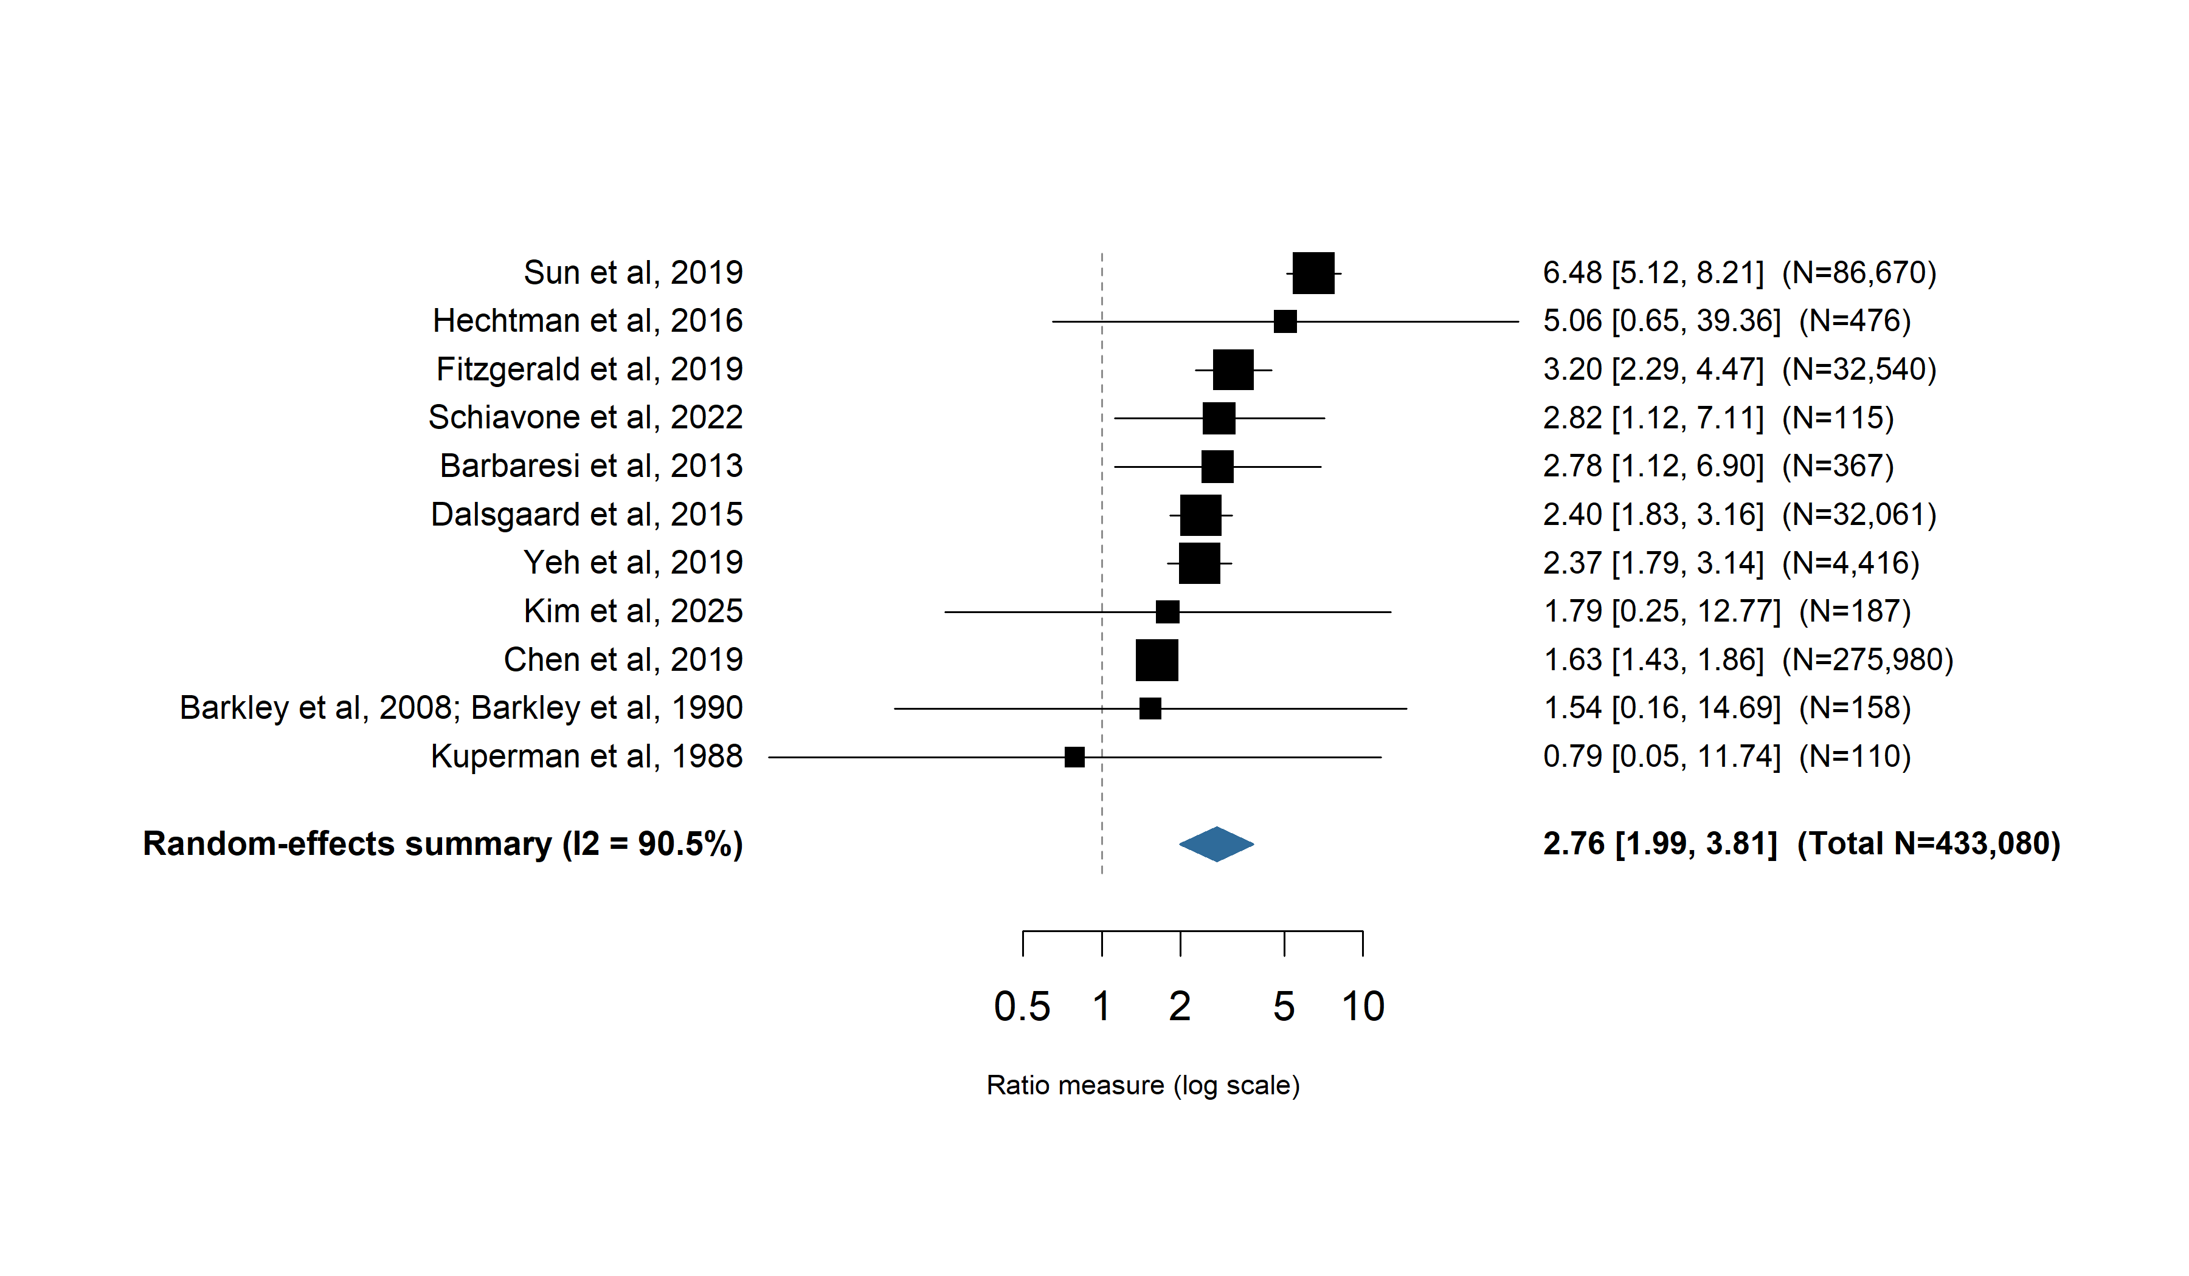
Result S3. Meta-analysis of the association between ADHD and mortality from external causes
Abbreviations: ADHD, attention-deficit/hyperactivity disorder; I², proportion of total variation due to between-study heterogeneity.

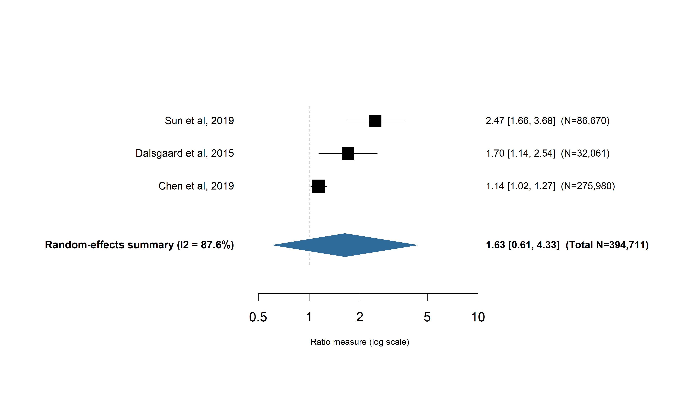
Result S4. Meta-analysis of the association between ADHD and mortality from natural causes
Abbreviations: ADHD, attention-deficit/hyperactivity disorder; I², proportion of total variation due to between-study heterogeneity.

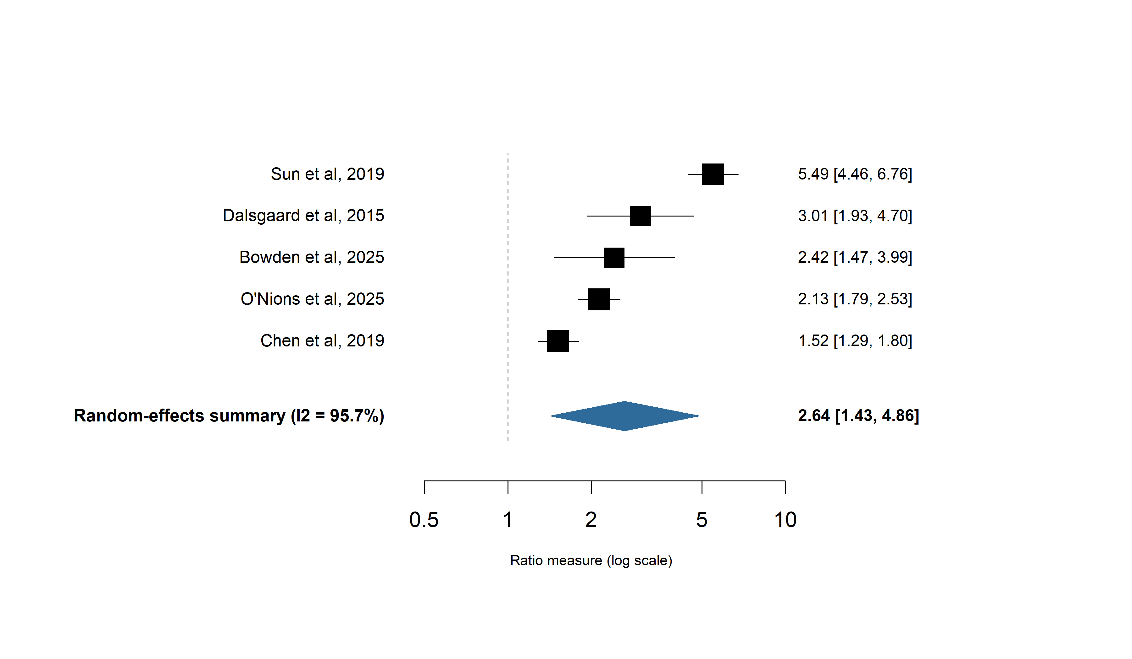
Result S5. Meta-analysis of all-cause mortality associated with ADHD in females
Abbreviations: ADHD, attention-deficit/hyperactivity disorder; I², proportion of total variation due to between-study heterogeneity.

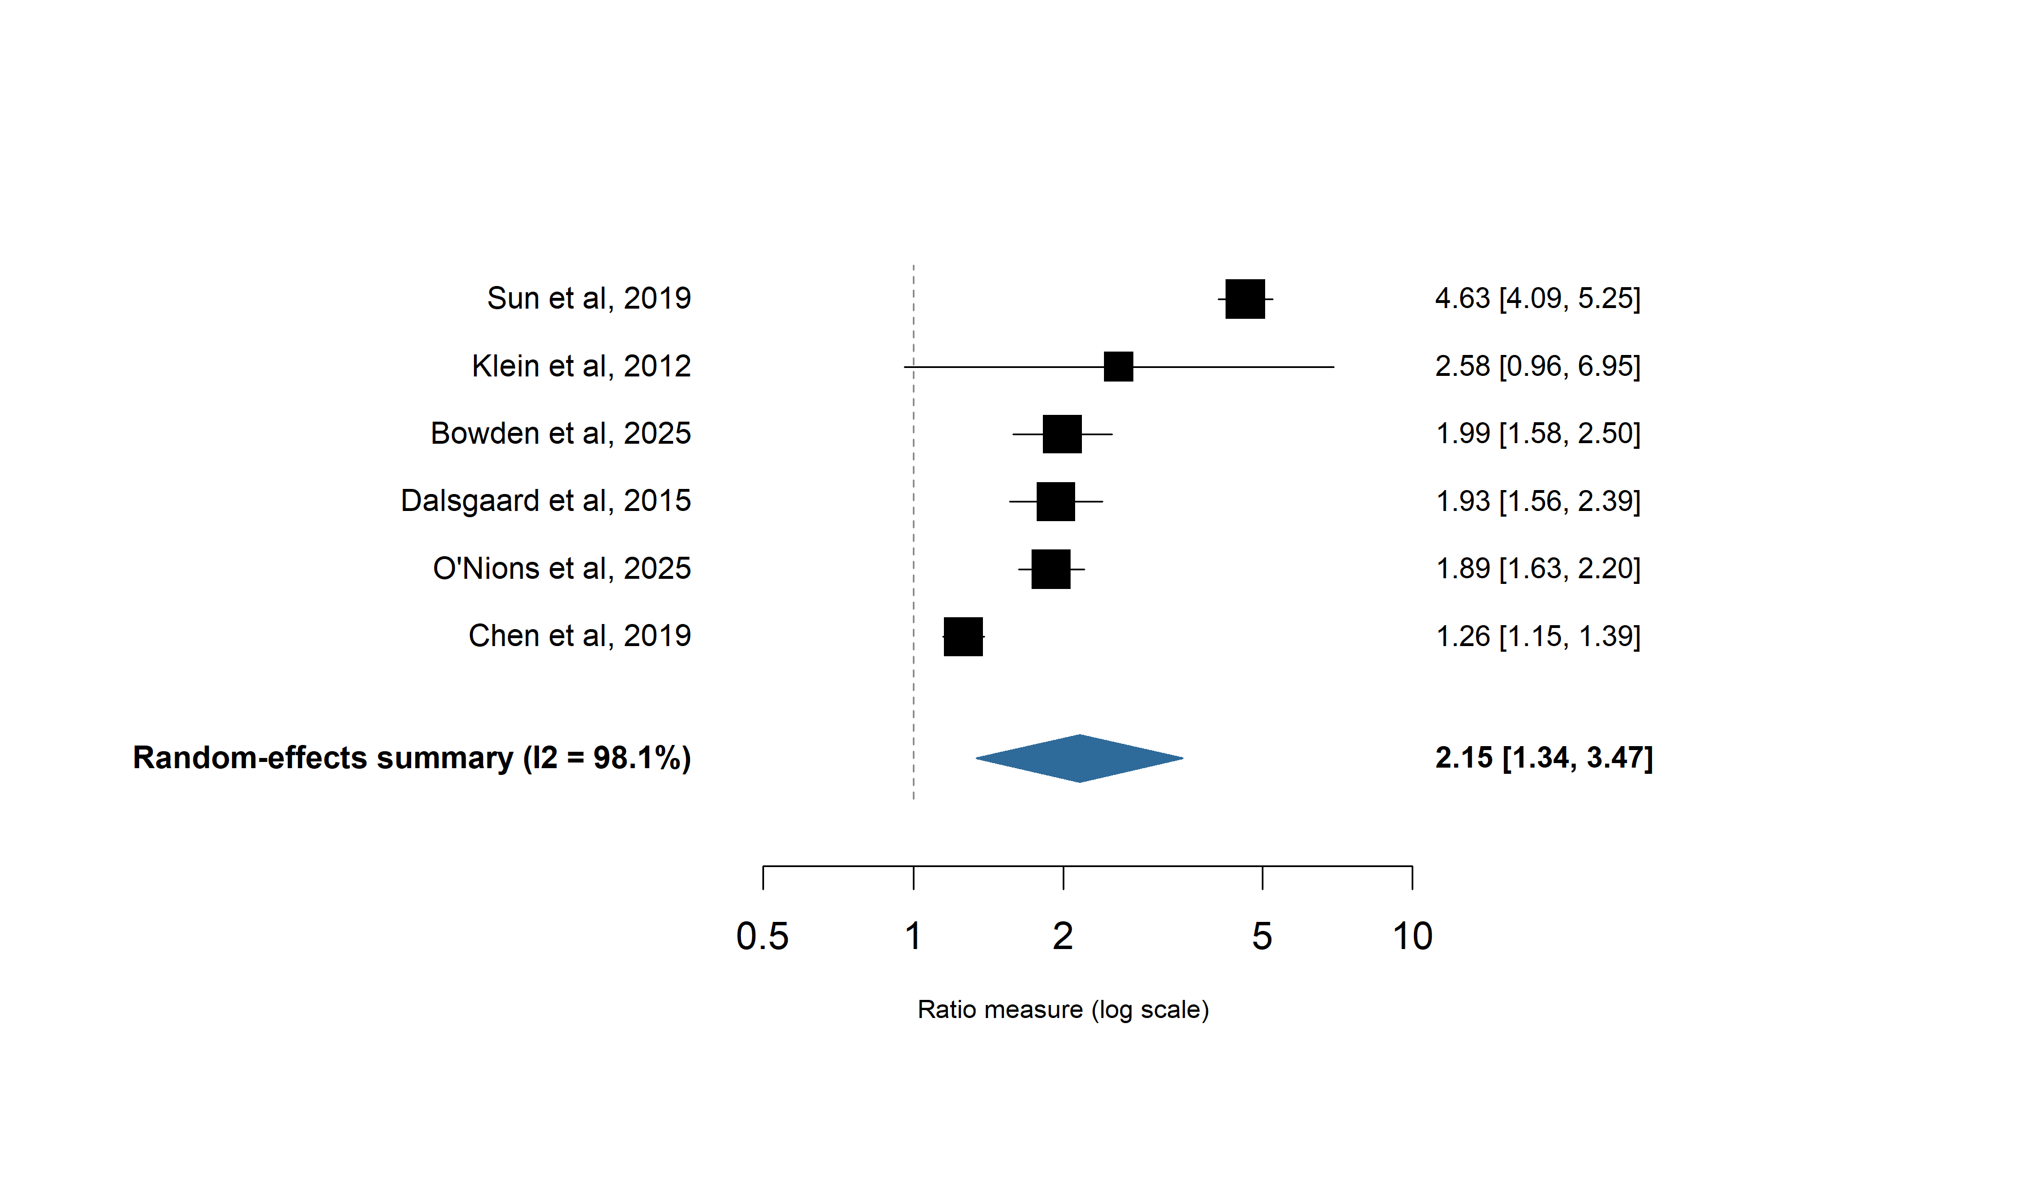
Result S6. Meta-analysis of all-cause mortality associated with ADHD in males
Abbreviations: ADHD, attention-deficit/hyperactivity disorder; I², proportion of total variation due to between-study heterogeneity.

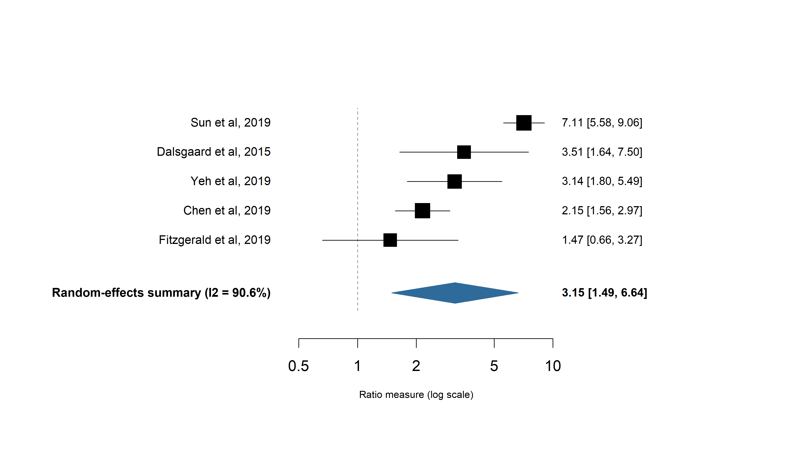
Result S7. Meta-analysis of mortality from external causes associated with ADHD in females
Abbreviations: ADHD, attention-deficit/hyperactivity disorder; I², proportion of total variation due to between-study heterogeneity.

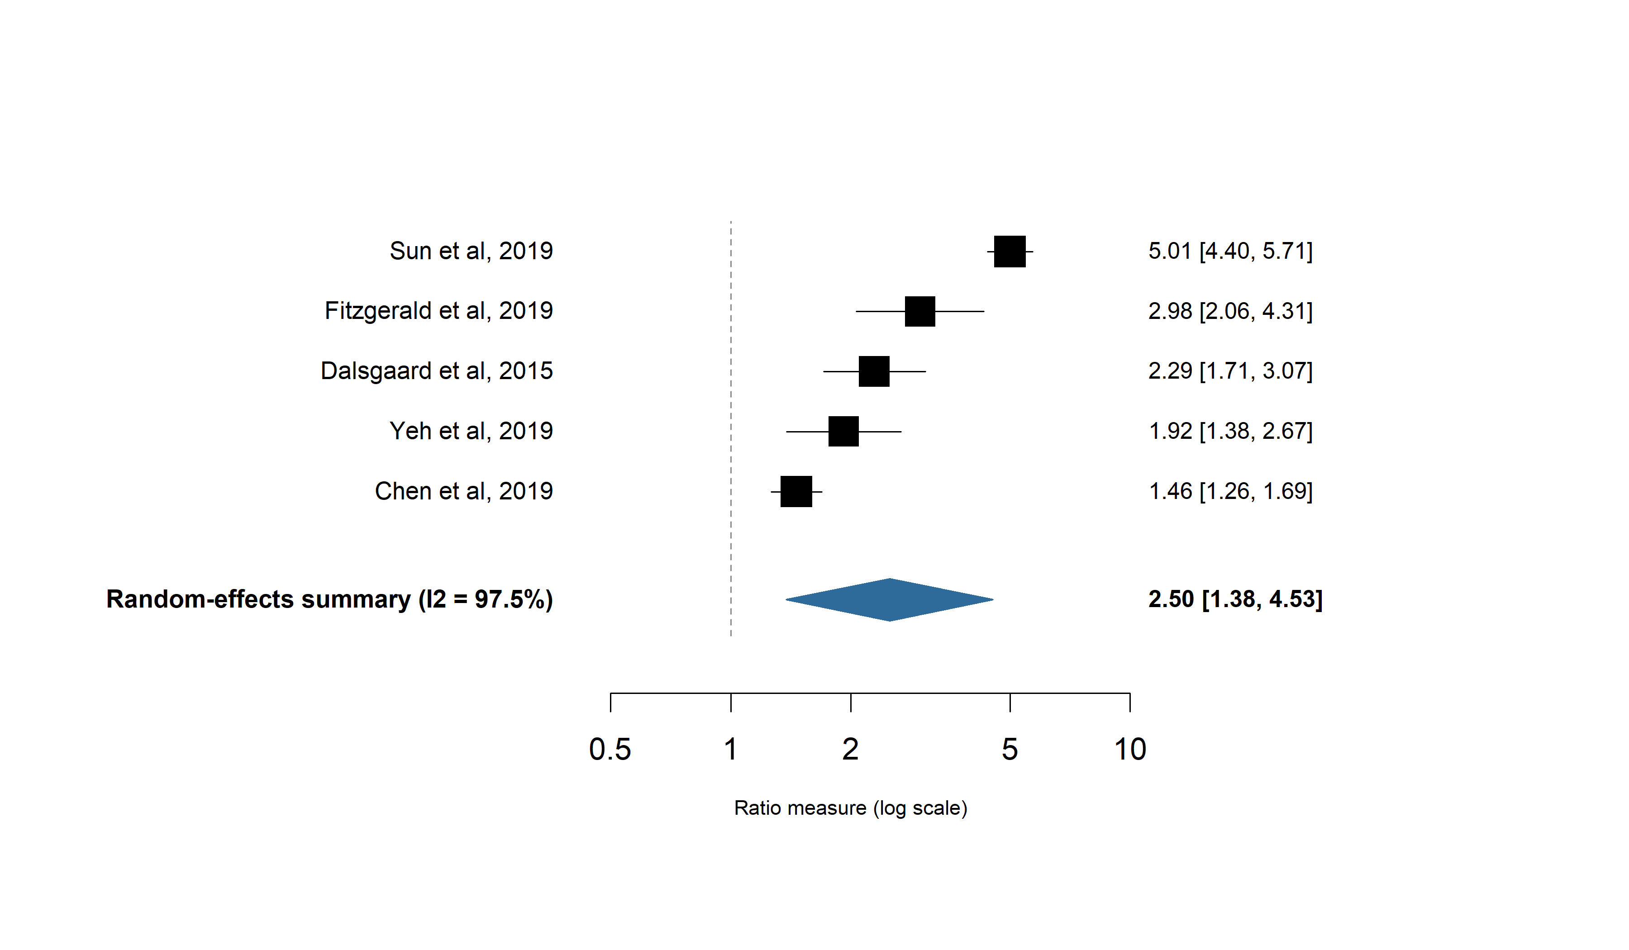
Result S8. Meta-analysis of mortality from external causes associated with ADHD in males
Abbreviations: ADHD, attention-deficit/hyperactivity disorder; I², proportion of total variation due to between-study heterogeneity.

Result S9. Summary of pooled and study-specific risk ratios for all-cause and cause-specific mortality associated with ADHD
Outcomes of interest | No. of studies | Participants with ADHD, No. | RR (95% CI) | I² | P value for heterogeneity
Primary outcome
All-cause mortality, both | 11 | 452393 | 2.02 (1.59-2.58) | 95.8 | <0.0001
Secondary outcomes
All-cause mortality, male | 6 | 450643 | 2.15 (1.34-3.47) | 98.1 | <0.0001
All-cause mortality, male, 95% prediction interval* | 6 | 450643 | 2.15 (0.56-8.33) | 98.1 | NA
All-cause mortality, female | 5 | 450436 | 2.64 (1.43-4.86) | 95.7 | <0.0001
All-cause mortality, female, 95% prediction interval* | 5 | 450436 | 2.64 (0.49-14.25) | 95.7 | NA
Natural causes, both | 3 | 394711 | 1.63 (0.61-4.33) | 87.6 | 0.0003
External causes, both | 11 | 433080 | 2.76 (1.99-3.81) | 90.5 | <0.0001
External causes, both, 95% prediction interval* | 11 | 433080 | 2.76 (0.98-7.72) | 90.5 | NA
External causes, male | 5 | 431667 | 2.50 (1.38-4.53) | 97.5 | <0.0001
External causes, male, 95% prediction interval* | 5 | 431667 | 2.50 (0.48-13.03) | 97.5 | NA
External causes, female | 5 | 431667 | 3.15 (1.49-6.64) | 90.6 | <0.0001
External causes, female, 95% prediction interval* | 5 | 431667 | 3.15 (0.44-22.39) | 90.6 | NA
Study-specific more extensively adjusted models
All-cause mortality, both | 2 | 276167 | Chen et al.: 1.07 (1.00-1.17); Kim et al.: 1.39 (0.94-2.05) | NA | NA
Natural causes, both | 1 | 275980 | 0.91 (0.80-1.15) | NA | NA
External causes, both | 3 | NA | Chen et al.: 1.51 (1.32-1.72); Yeh et al.: 0.88 (0.66-1.18); Kim et al.: 0.97 (0.14-6.88) | NA | NA
Sensitivity analyses
All-cause mortality, both, 95% prediction interval* | 11 | 452393 | 2.02 (0.94-4.35) | 95.8 | NA
All-cause mortality, both, excluding SMR/OR | 9 | 451372 | 2.06 (1.52-2.78) | 96.6 | <0.0001
Subgroup Analyses in primary outcome
NOS Risk of bias
Low risk | 8 | 451105 | 2.06 (1.55-2.73) | 97.0 | <0.0001
Moderate risk | 3 | 1288 | 1.77 (0.59-5.32) | 0 | 0.40
Country
Nordic | 3 | 118846 | 2.71 (1.06-6.97) | 93.9 | <0.0001
United States of America | 4 | 1655 | 1.80 (1.03-3.16) | 0 | 0.60
Asia-Pacific region | 3 | 301853 | 1.63 (0.90-2.94) | 87.4 | 0.0003
United Kingdom | 1 | 30039 | 1.99 (1.78-2.23) | NA | NA
For rows reporting mortality by sex (male, female), the participant count is the total ADHD cohort size of contributing studies, not a sex-specific denominator: most contributing studies (Dalsgaard, Chen, Sun, Bowden) reported only a combined-sex cohort size, which is repeated for both the male and female rows; O’Nions et al. is the only contributing study for which a true sex-specific denominator (23,377 males,6,662 females) was available. Abbreviations: ADHD, attention-deficit/hyperactivity disorder; RR, risk ratio; CI, confidence interval; I², proportion of total variation due to between-study heterogeneity; NOS, Newcastle–Ottawa Scale; SMR, standardized mortality ratio; OR, odds ratio.

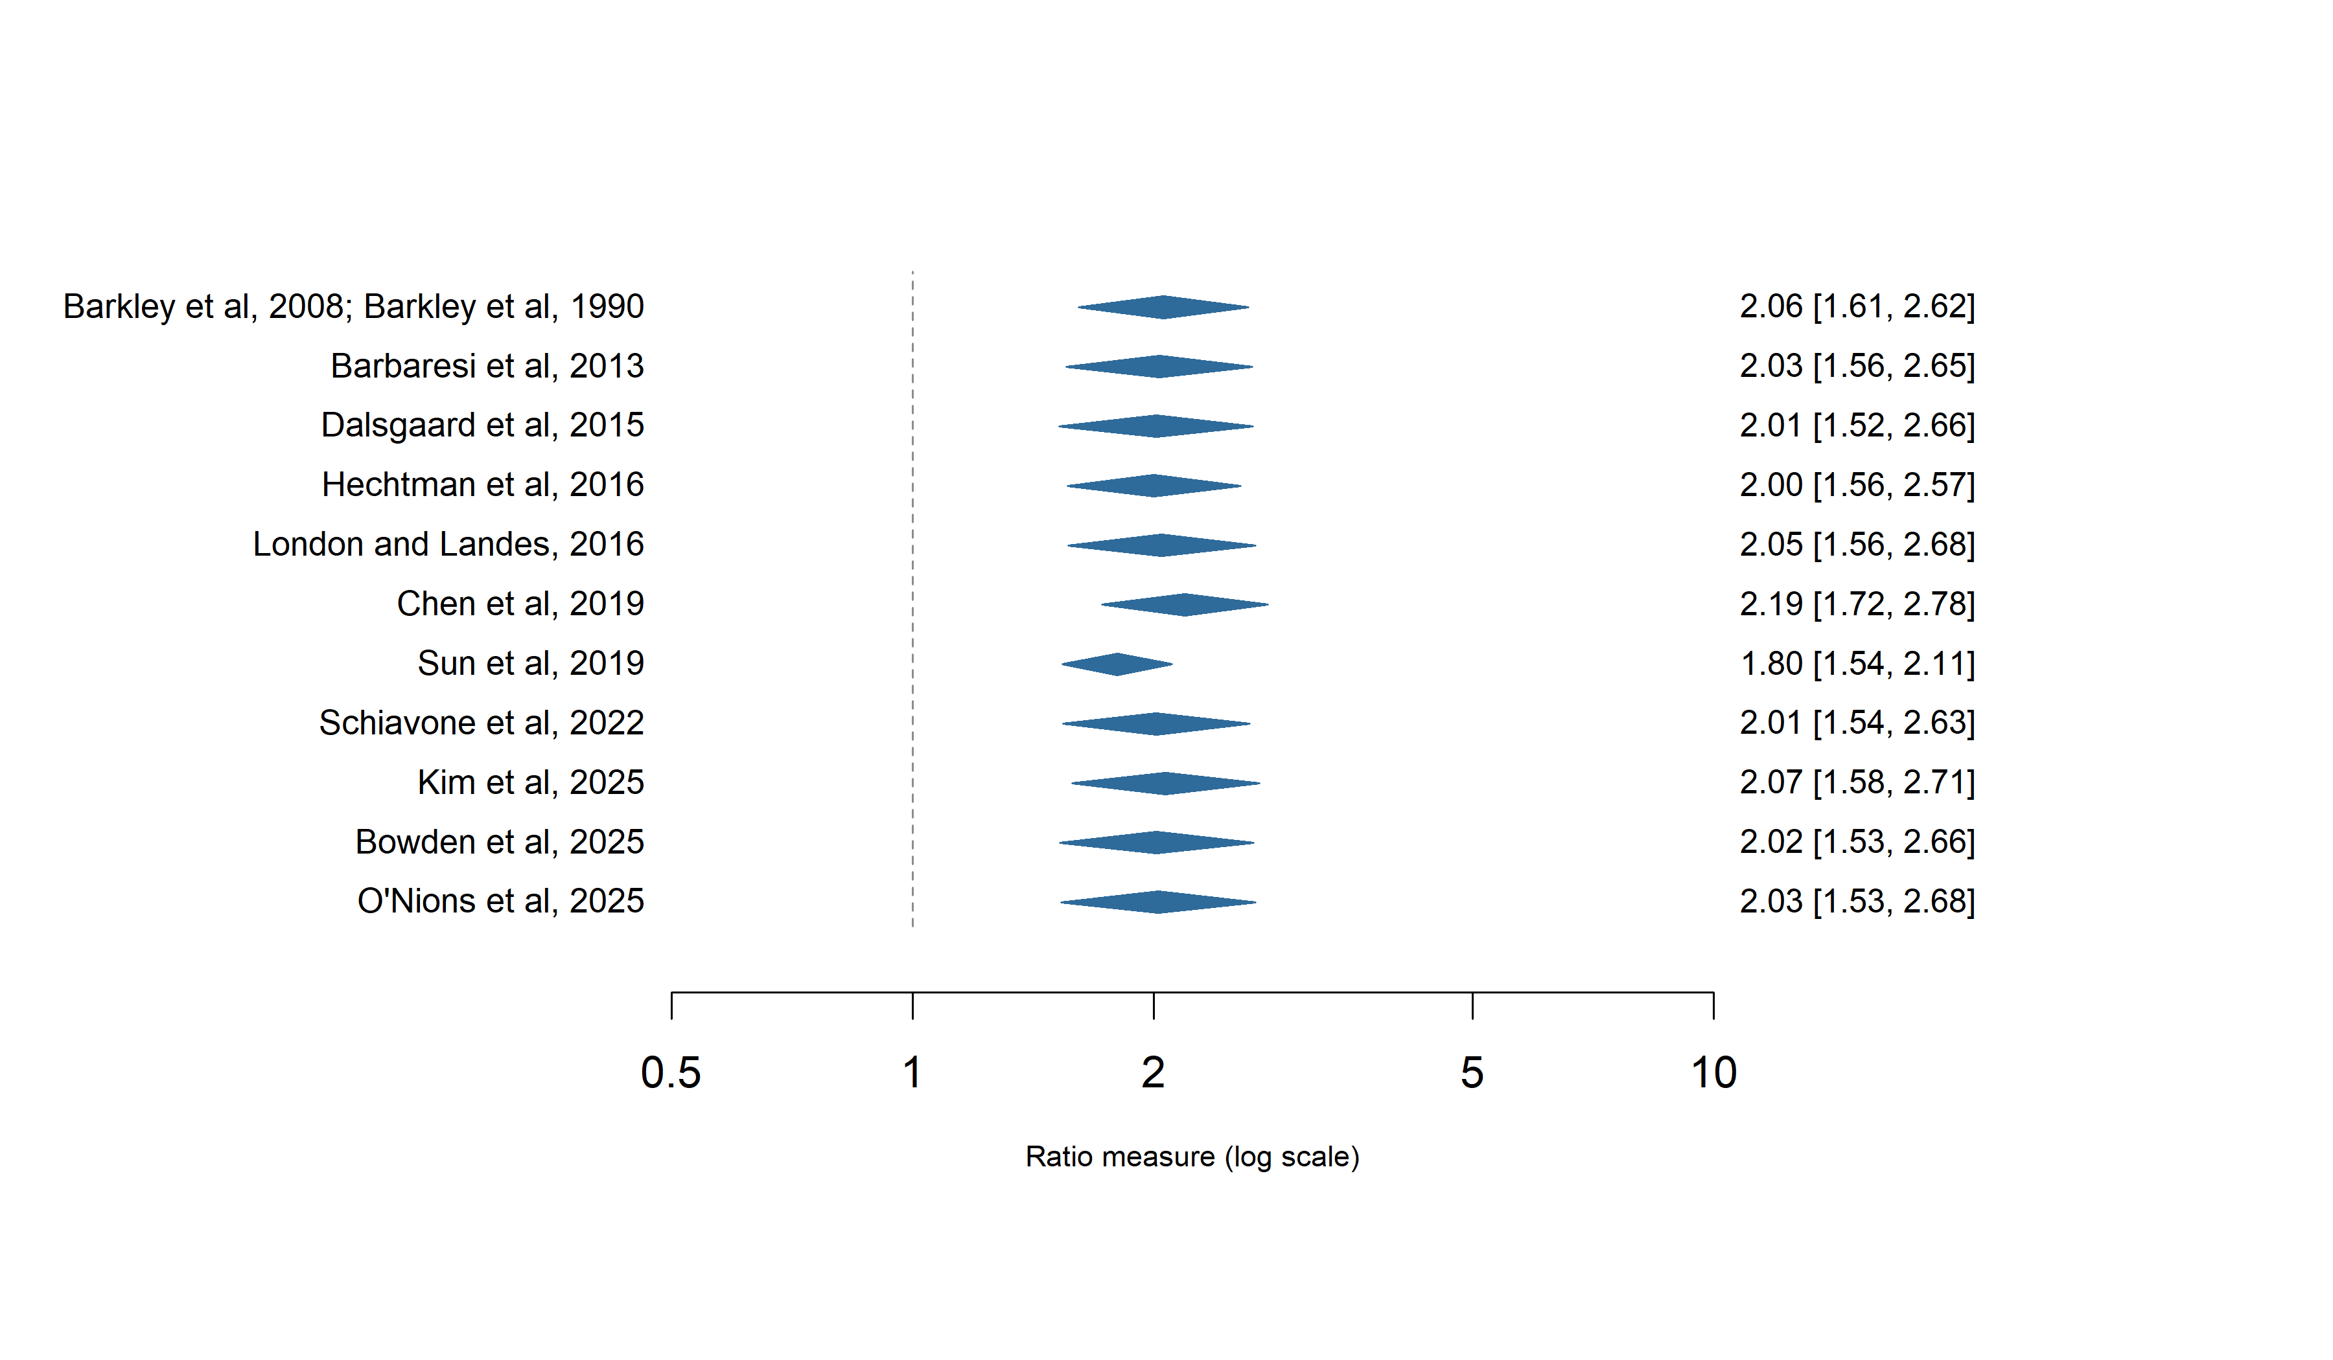
Result S10. Leave-one-out sensitivity analysis of the association between ADHD and all-cause mortality

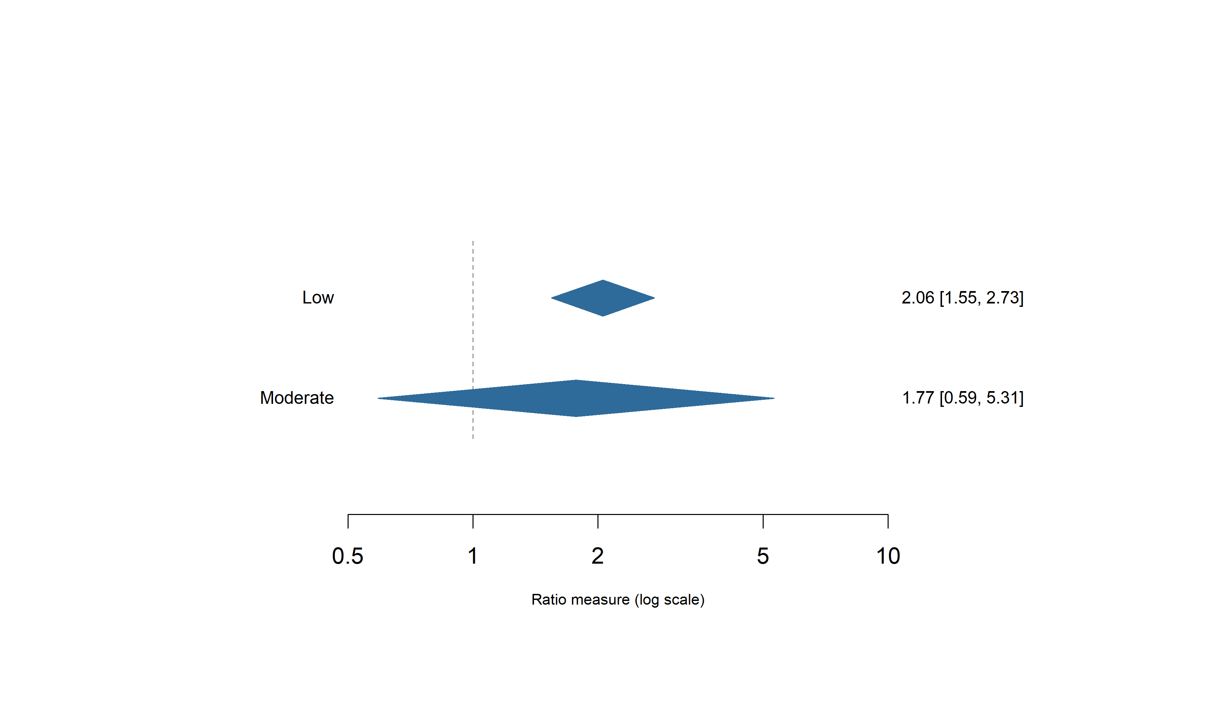
Result S11. Meta-analysis of all-cause mortality associated with ADHD by Newcastle–Ottawa Scale (NOS) risk-of-bias subgroup

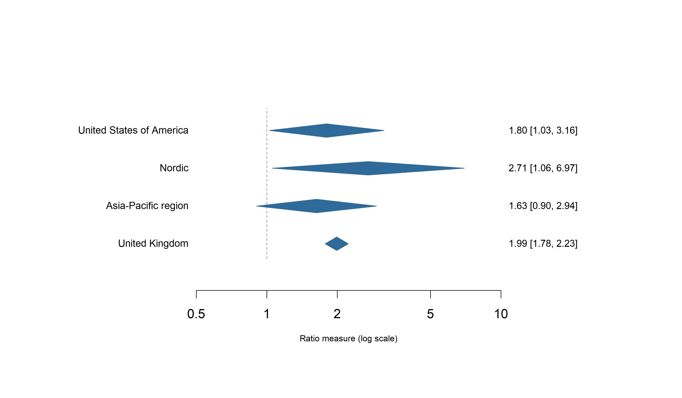
Result S12. Meta-analysis of all-cause mortality risk associated with ADHD by geographic region

Result S13. Sensitivity analysis excluding studies reporting SMR or OR estimates
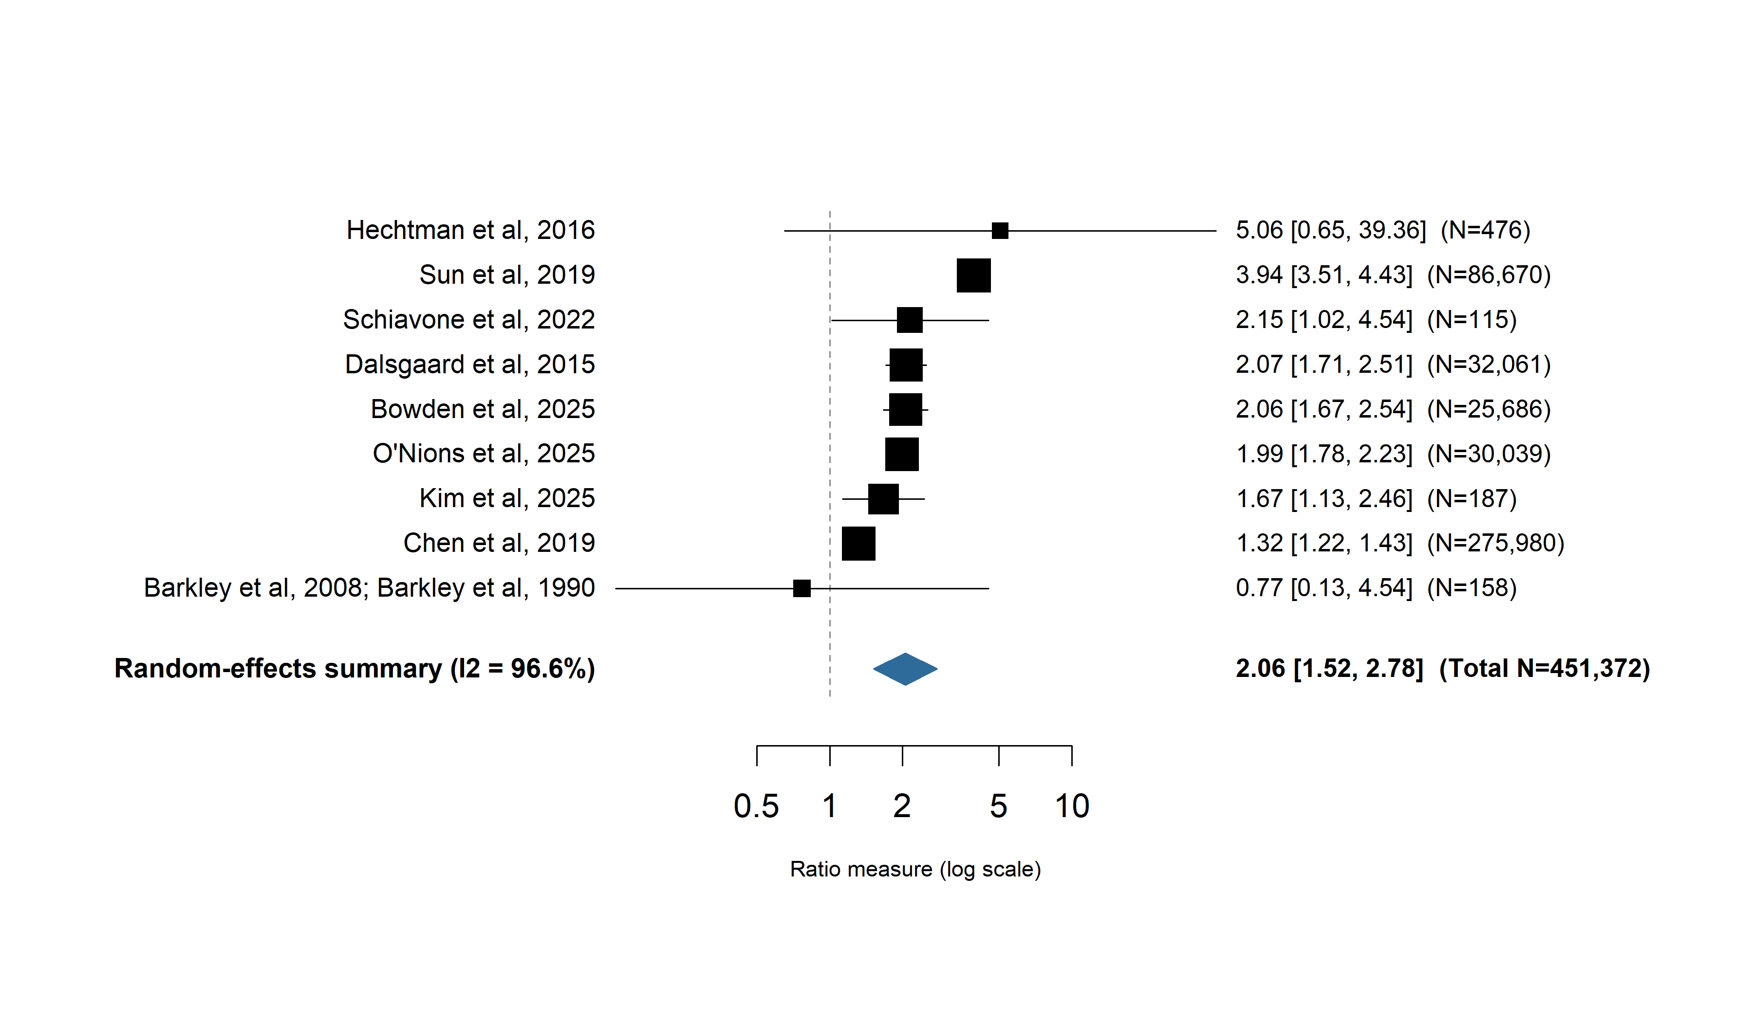
Abbreviations: ADHD, attention-deficit/hyperactivity disorder; SMR, standardized mortality ratio; OR, odds ratio; I², proportion of total variation due to between-study heterogeneity.
Result S14. Methodological quality assessment of included studies using the Newcastle-Ottawa Scale
Author, year | 1. Selection |  |  |  | 2. Comparability | 3. Outcome |  |  | Total score | Quality assessment risk of bias rating
 | 1.1 | 1.2 | 1.3 | 1.4 | 2.1 | 3.1 | 3.2 | 3.3
Kuperman et al, 1988 | * | * | * | * | * | * | * |  | 7 | Low Risk
Barkley et al, 2008; Barkley et al, 1990 | * | * |  |  | * |  | * | * | 4 | Moderate risk
Klein et al, 2012 | * | * |  |  | * |  | * | * | 4 | Moderate risk
Barbaresi et al, 2013 | * | * | * | * | ** | * | * | * | 8 | Low risk
Dalsgaard et al, 2015 | * | * | * | * | ** | * | * | * | 9 | Low risk
Hechtman et al, 2016 | * | * | * |  | * | * |  | * | 6 | Moderate risk
London and Landes, 2016 | * | * | * |  | * | * |  | * | 6 | Moderate risk
Chen et al, 2019 | * | * | * | * | ** | * | * | * | 9 | Low risk
Sun et al, 2019 | * | * | * | * | ** | * | * | * | 9 | Low risk
Yeh et al, 2019 | * | * | * |  | * | * |  |  | 5 | Moderate risk
Fitzgerald et al, 2019 | * | * | * | * | ** | * | * | * | 8 | Low risk
Schiavone et al, 2022 | * | * | * | * | * | * | * |  | 7 | Low risk
Kim et al, 2025 | * | * | * | * | ** | * | * | * | 9 | Low risk
Bowden et al, 2025 | * | * | * | * | ** | * | * | * | 9 | Low risk
O’Nions et al, 2025 | * | * | * | * | ** | * |  | * | 8 | Low risk

Result S15. Risk-of-bias assessment of included studies using the ROBINS-E tool
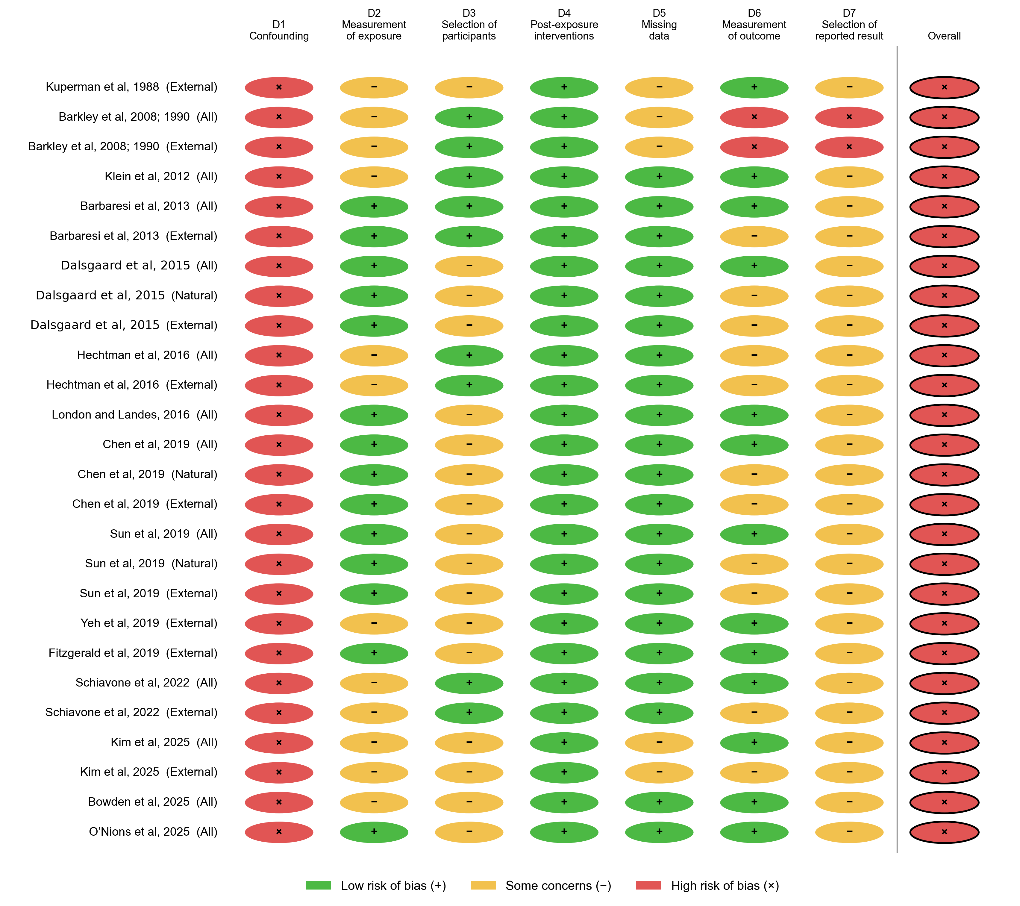

Result S16. Funnel plot and Egger’s test for publication bias in studies of ADHD and mortality
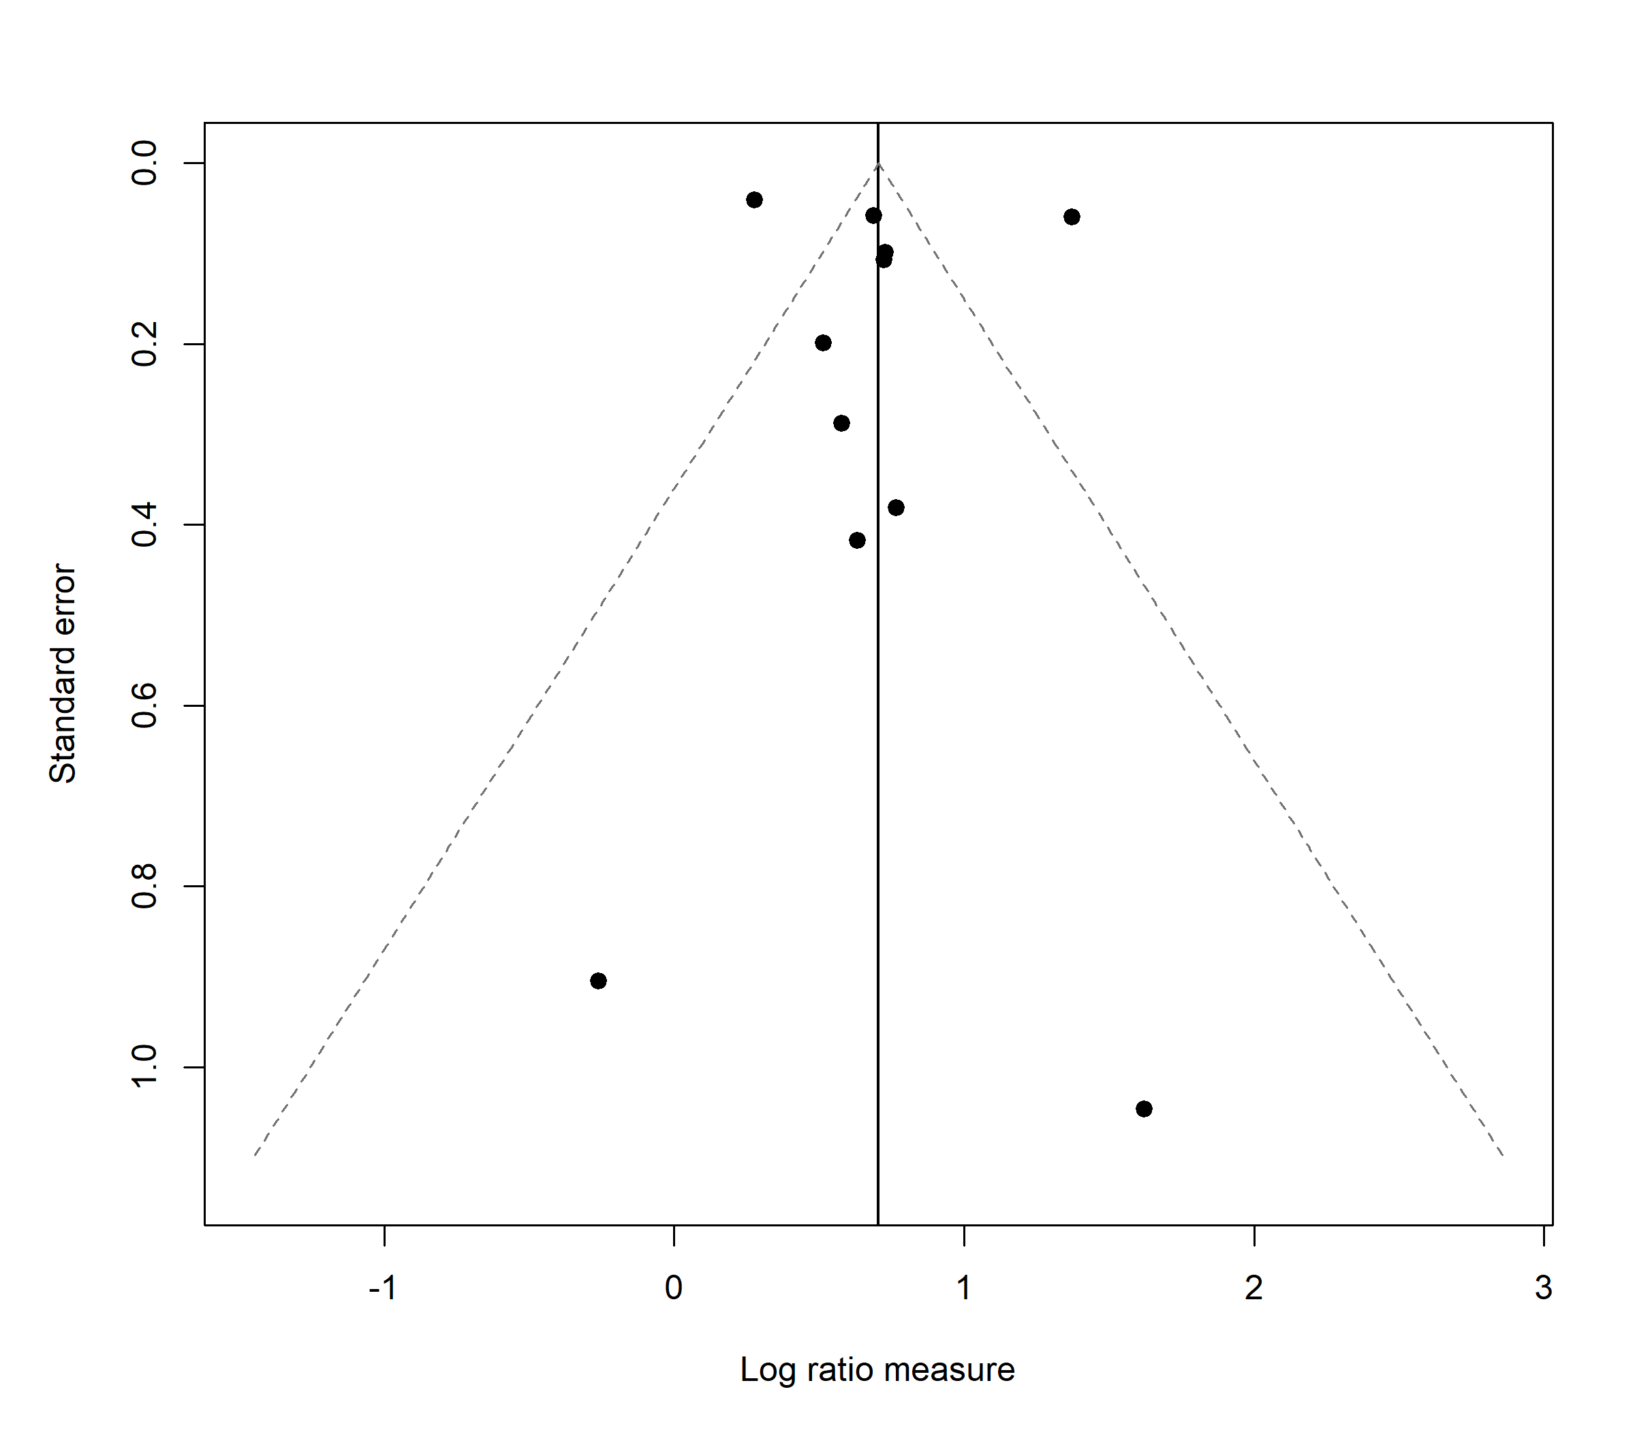
Egger’s regression test did not indicate funnel plot asymmetry (p = 0.707).
Result S17. GRADE evidence profile for the primary mortality outcomes
All outcomes began at low certainty, the GRADE starting point for a body of observational evidence, and were rated down for risk of bias (every contributing study was rated high risk of bias by ROBINS-E), inconsistency (I² = 87.6-95.8%; the 95% prediction interval for the primary all-cause synthesis crossed the null), and indirectness (adjustment strategies that could correspond to different target estimands, and differing target populations, across contributing studies). Natural-cause mortality was rated down an additional level for imprecision because its 95% confidence interval crossed the null and only three studies contributed. Because GRADE has no certainty level below “very low,” the additional downgrades did not change the final rating for any outcome.
Outcome | Risk of bias | Inconsistency | Indirectness | Imprecision | Publication bias | Overall certainty
All-cause mortality | Serious | Very serious | Serious | Not serious | Undetected | Very low
External-cause mortality | Serious | Serious | Serious | Not serious | Not assessed separately | Very low
Natural-cause mortality | Serious | Serious | Serious | Serious | Not assessed (too few studies) | Very low

