Supporting Information
Trilobatin combats copper overload-induced cognitive impairment by blocking FDX1-dependent cuproptosis and restoring mitochondrial dynamics
Guozhen Lan^{1†}, Wang Ran^{1†}, Zhishu Yang^{1†}, Fangqin Hou², Wenfang Zhang¹, Dongjing Liu¹, Nana Chen¹, Haibo Li², Jianmei Gao¹, Guohui Lu^{3*}, Yu Wei^{4*}
¹Key Laboratory of Basic Pharmacology of Ministry of Education and School of Pharmacy, Zunyi Medical University, Zunyi, Guizhou, China
²School of Chinese Medicine, Liaoning University of Traditional Chinese Medicine， Shenyang, Liaoning 110847, China
³School of Rehabilitation Medicine, Qilu Medical University, Zibo, Shandong 255300, China
⁴Department of Pharmacy, The Affiliated Hospital of Zunyi Medical University, Zunyi, Guizhou 563003, China
†These authors contributed equally to this work.
*Corresponding author: Prof. Guohui Lu, Prof. Yu Wei.
6 Xuefu West Road, Zunyi City, Guizhou Province, 563000, P. R. China
Tel: +86-851-286-423-03
Fax: +86-851-286-423-03
- mail: 690273268@qq.com

Supporting Results
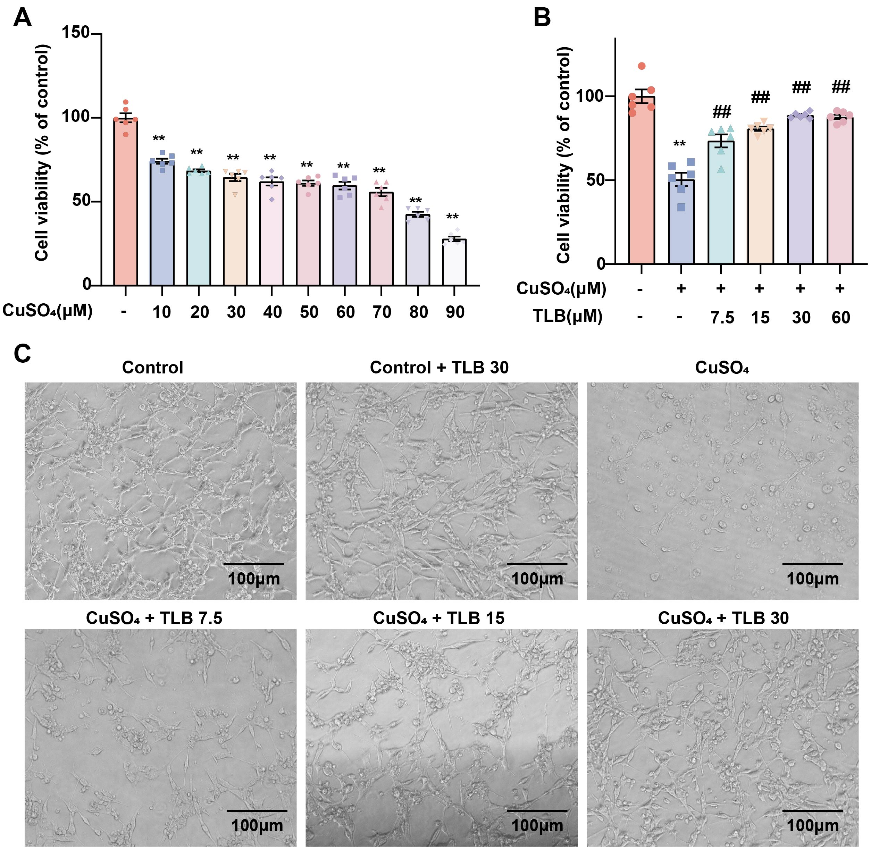
Figure S1. FDX1 Mediates the Protective Effects of Trilobatin Against CuSO₄-Induced Toxicity in HT22 Cells. (A) The effect of different CuSO4 concentration treatments for 24 hours on the viability of HT22 cells (n = 6). (B)The effect of different concentrations of TLB on the viability of HT22 cells (n = 6). (C) Morphology of cardiomyocytes was observed using a reverse-phase microscope (magnification: 200 times; scale bar = 100 μm). Data are expressed as mean ± SEM. **P < 0.01 vs. Control group; ##P < 0.01 vs. CuSO₄ group.
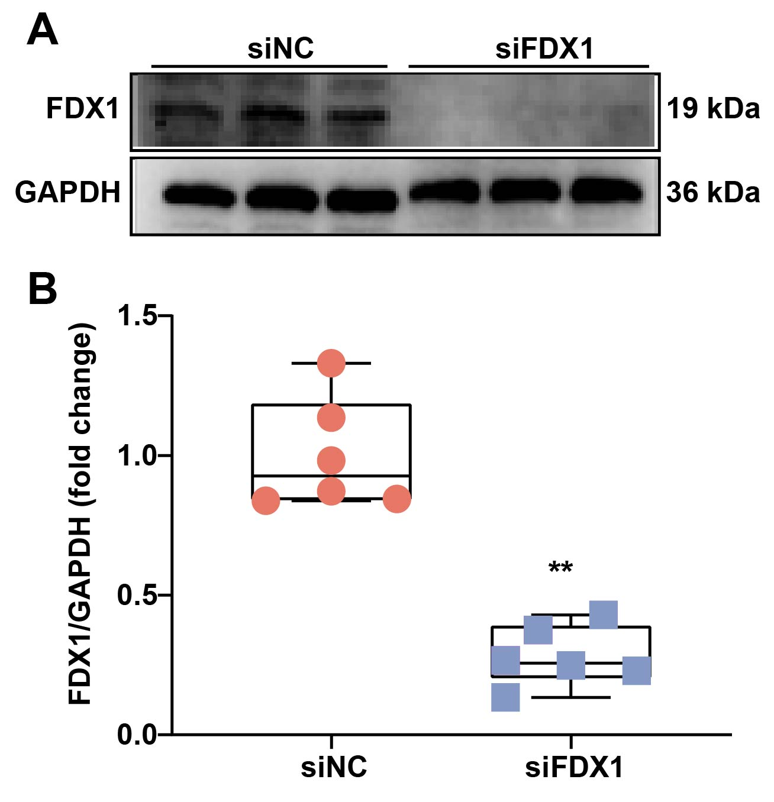
Figure S2. FDX1 Mediates the Protective Effects of Trilobatin Against CuSO₄-Induced Toxicity in HT22 Cells. (A)Representative immunoblot of FDX1 protein expression. (B) Quantification of FDX1 protein expression (n = 6). Data are expressed as mean ± SEM. **P < 0.01 vs. siNC group.
Uncropped raw Western blot images

Full-length unprocessed digital chemiluminescence scans of all western blot bands displayed in supplementary figures, with molecular weight markers annotated for reference
FDX1（19 kDa, n=6）
β-actin（42 kDa）
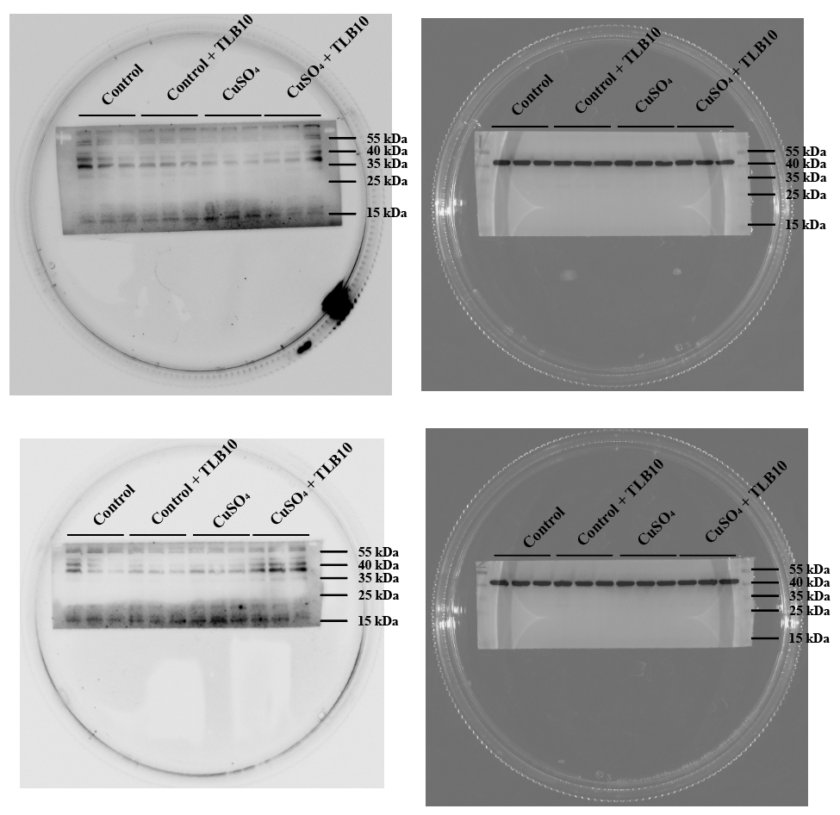
SLC31A1（35 kDa, n=6）
β-actin（42 kDa）
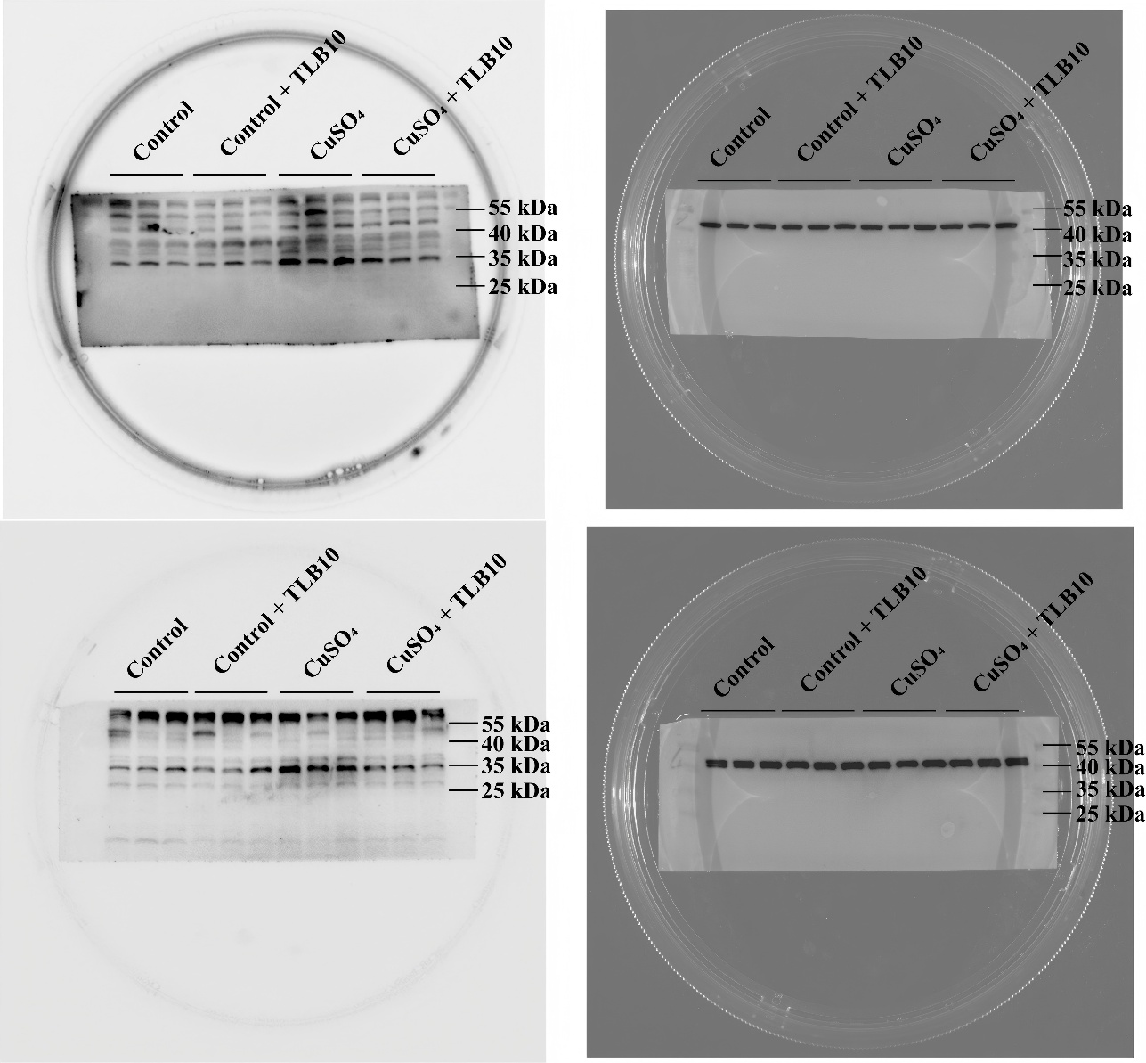
ATP7B（150 kDa, n=6）
（42 kDa）
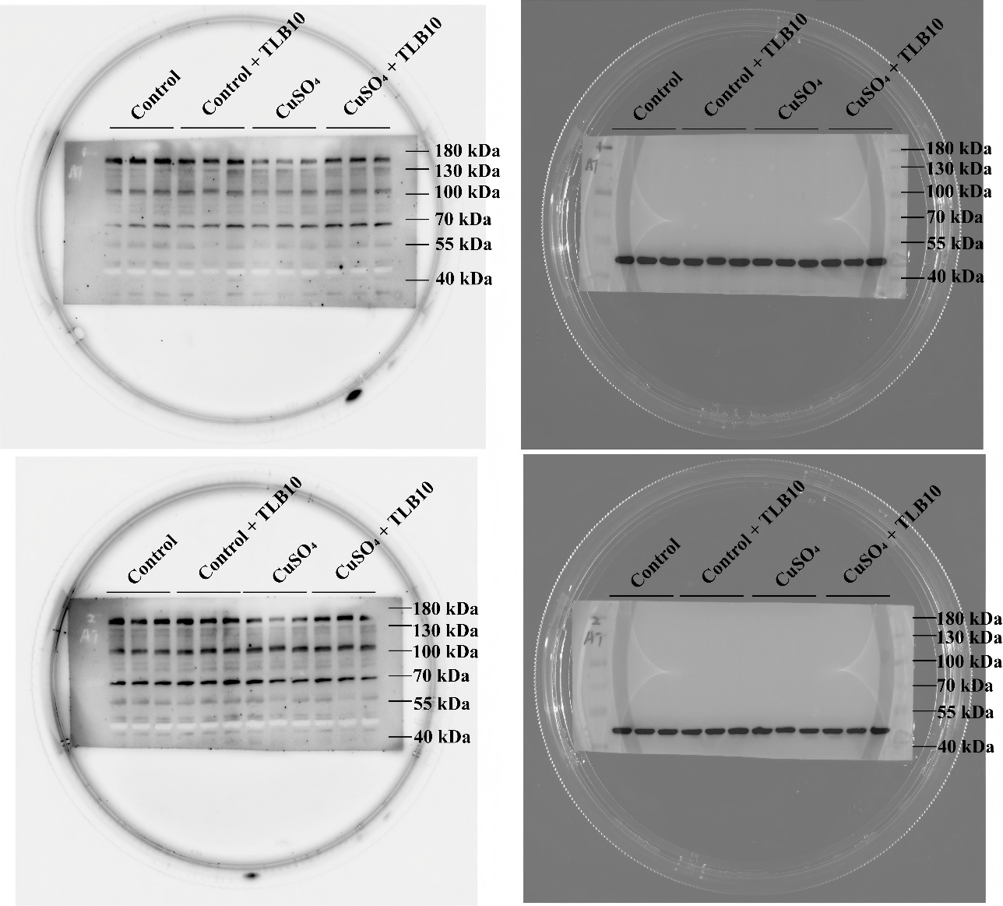
DLD（56 kDa, n=6）
β-actin（42 kDa）
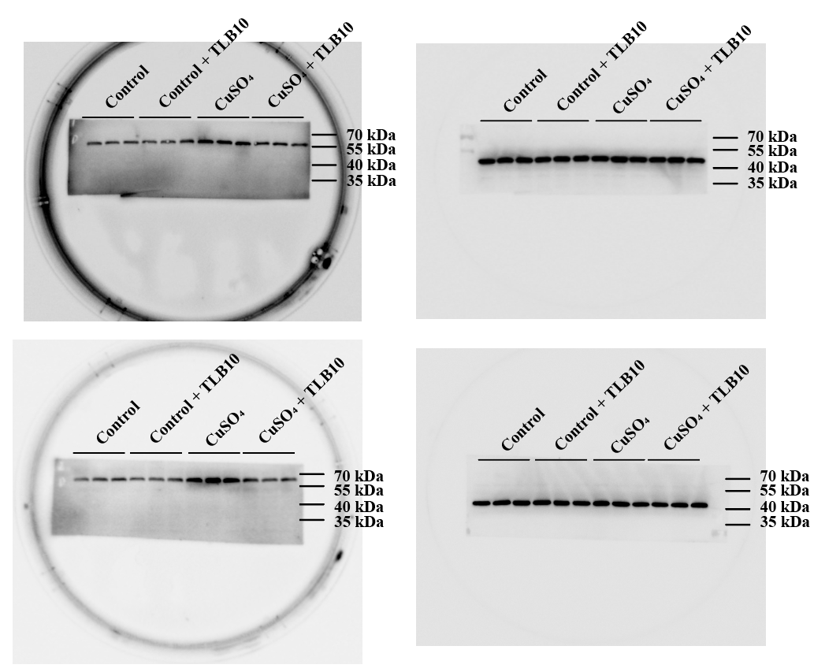
LIAS（42 kDa, n=6）
β-tubulin（50 kDa）
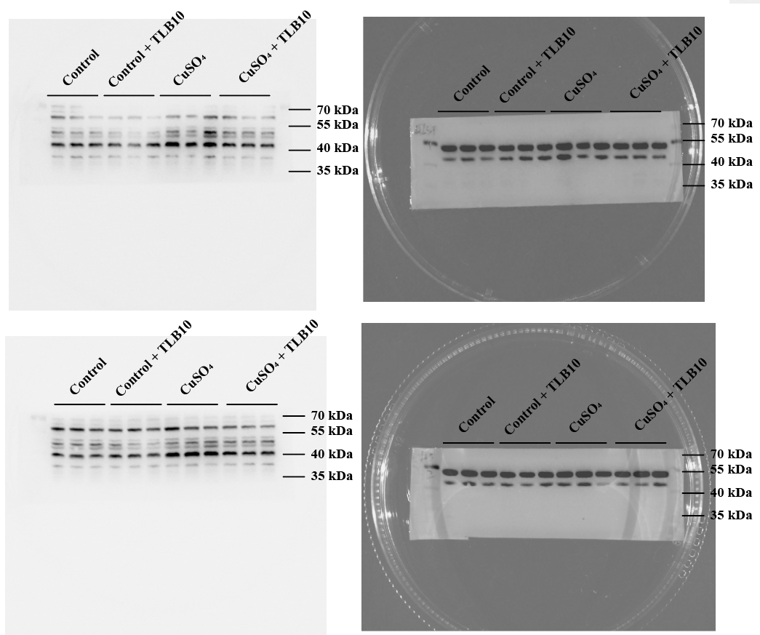
PDHA1（43 kDa, n=6）
β-tubulin（50 kDa）
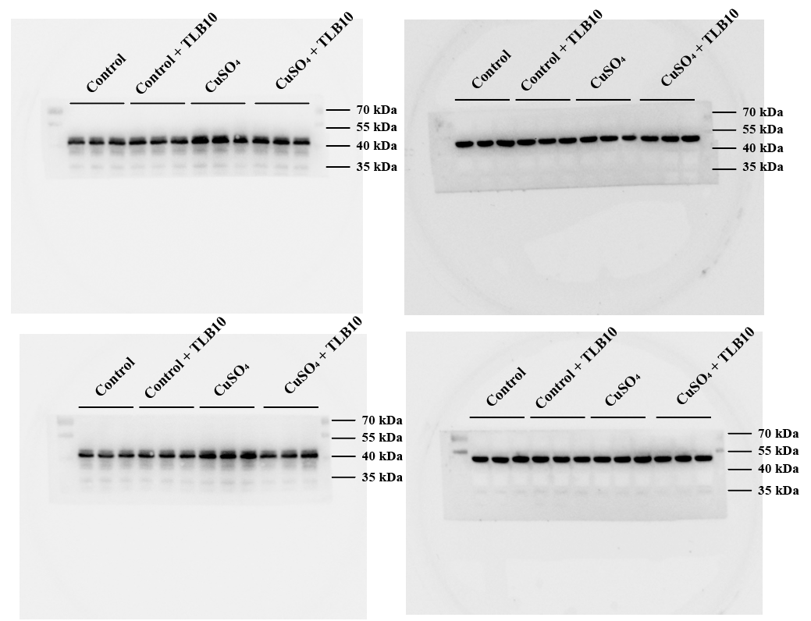
PDHB（35 kDa, n=6）
β-actin（42 kDa）
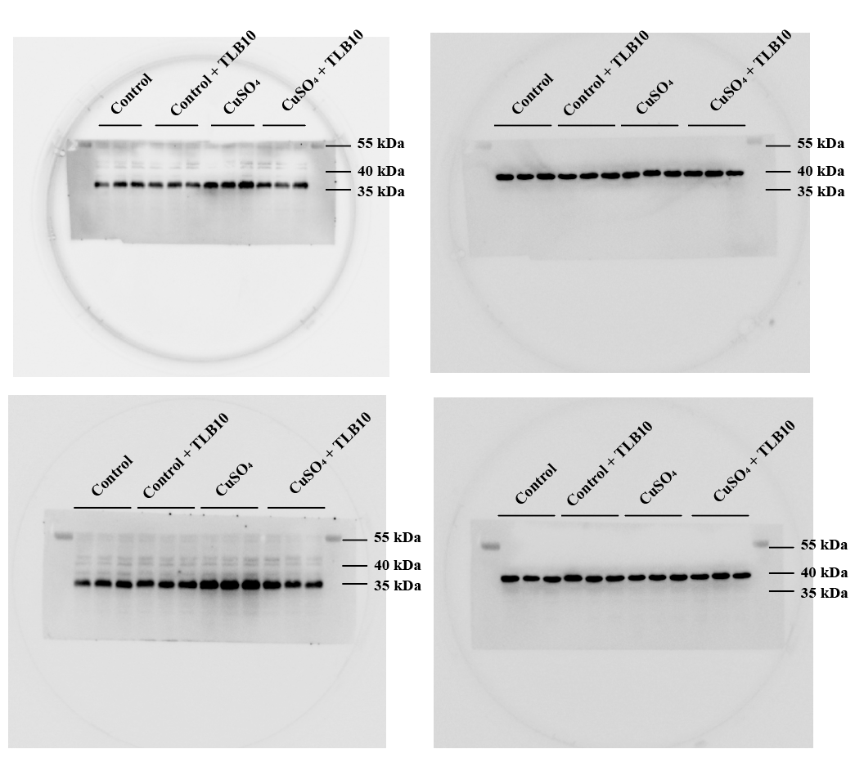
DLAT（69 kDa, n=6）
β-actin（42 kDa）
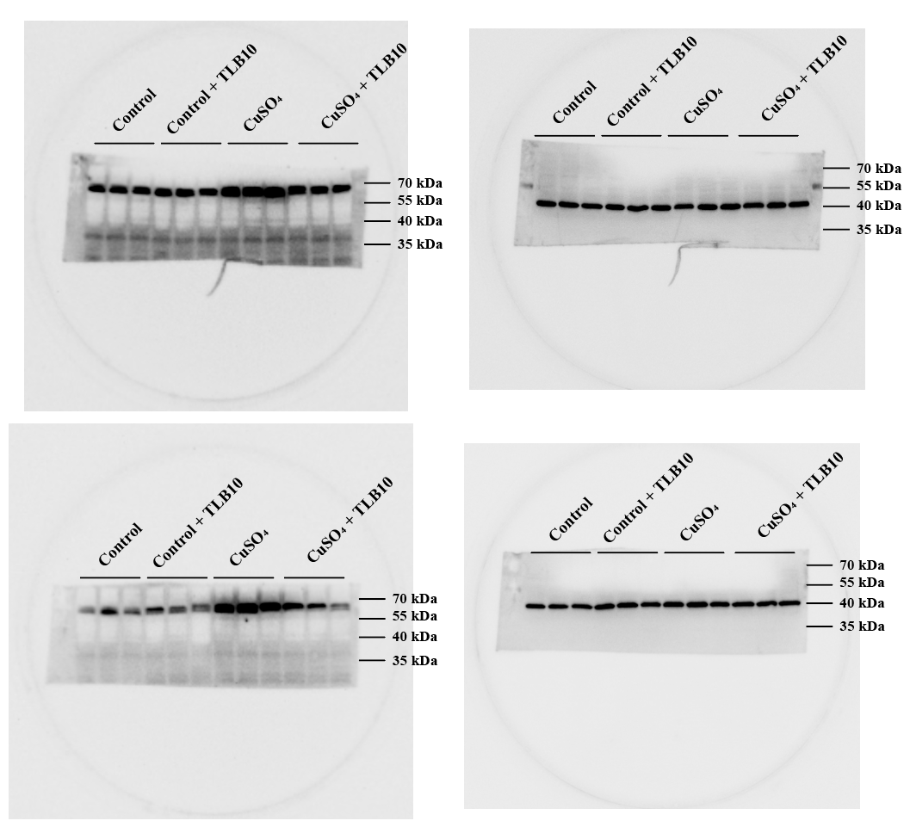
MTF1（81 kDa, n=6）
β-actin（42 kDa）
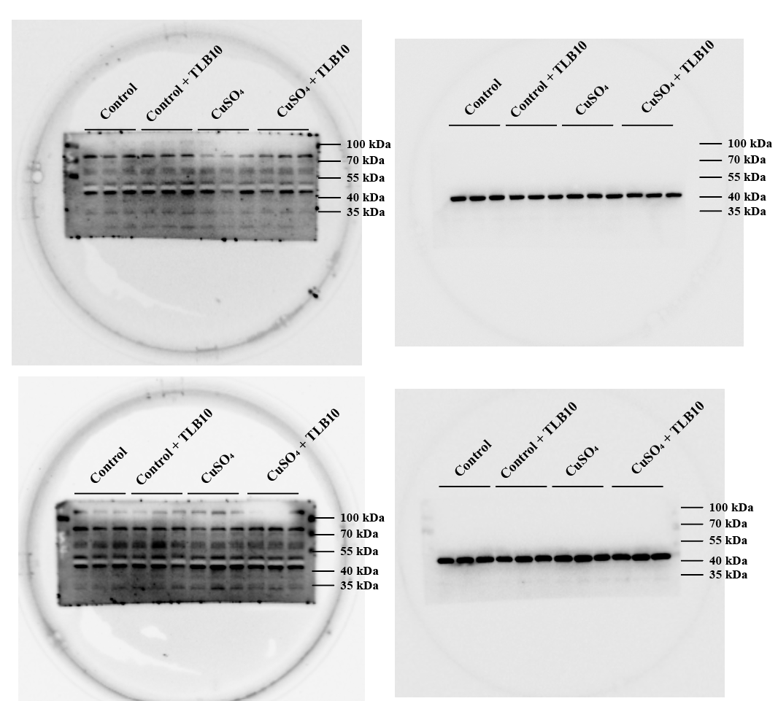
GLS（73 kDa, n=6）
β-actin（42 kDa）
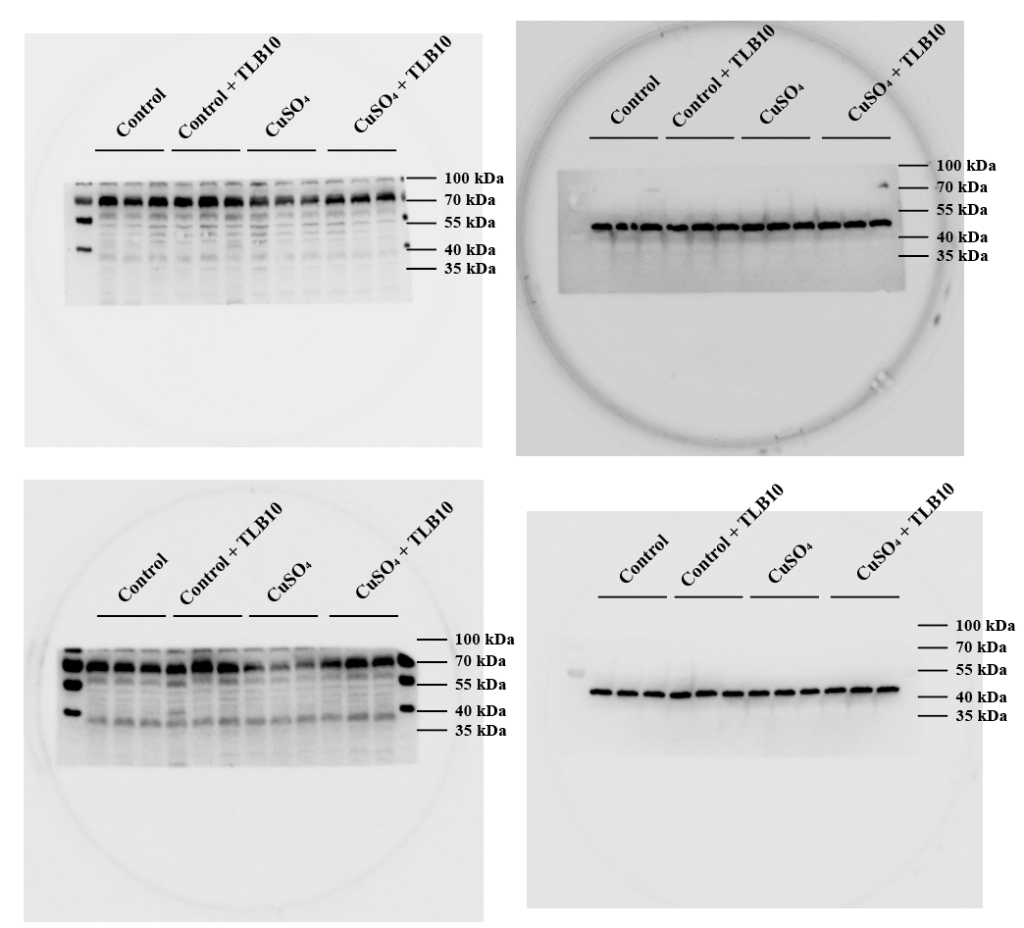
CDKN2A/p14ARF（17 kDa, n=6）
GAPDH（36 kDa）
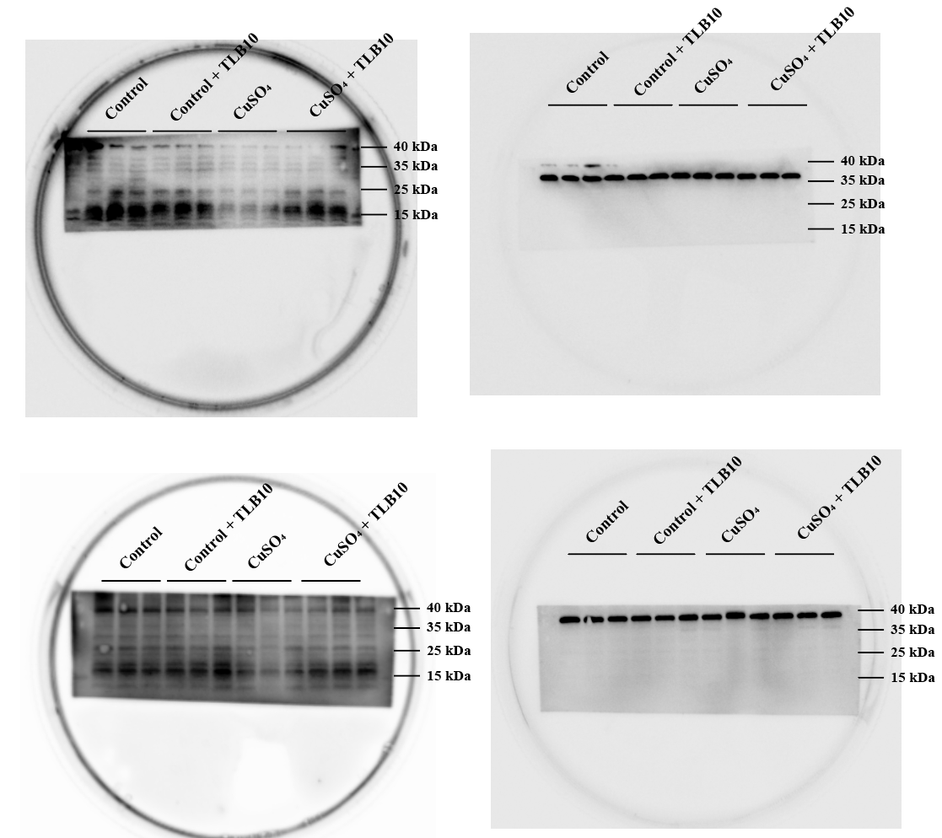
MFN1（84 kDa, n=6）
VDAC1（36 kDa）
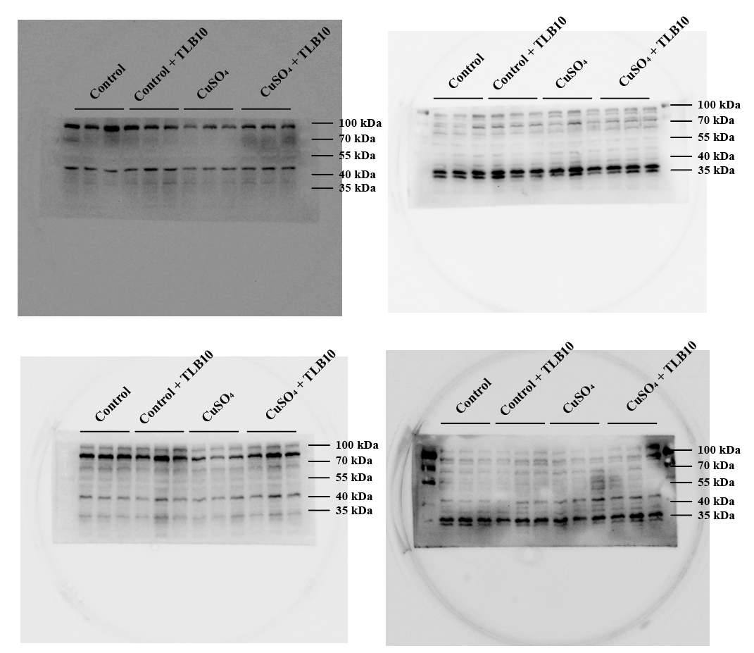
MFN2（80 kDa, n=6）
VDAC1（36 kDa）
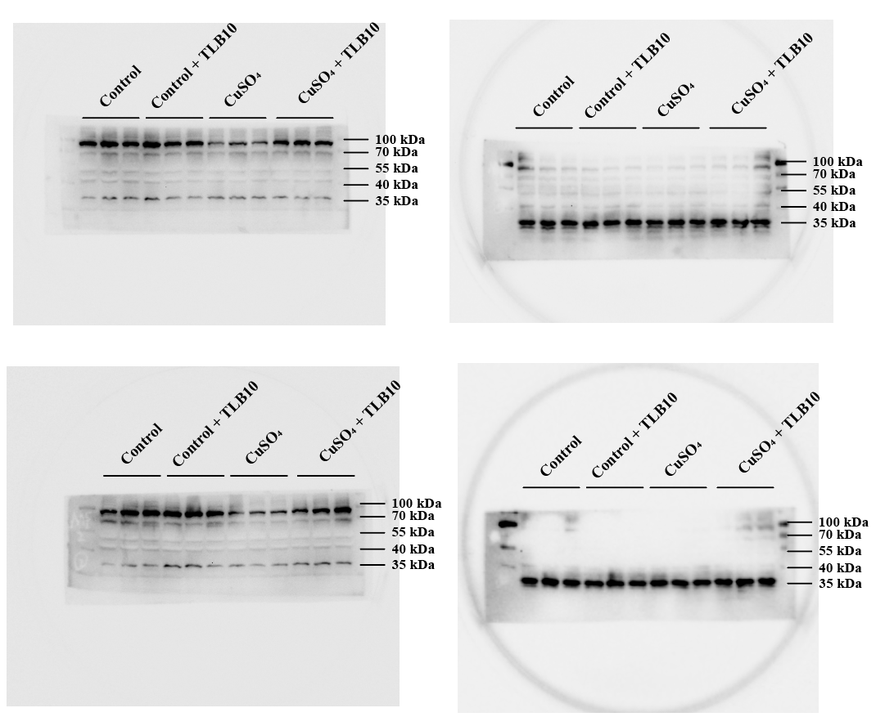
OPA1（100 kDa, n=6）
VDAC1（36 kDa）
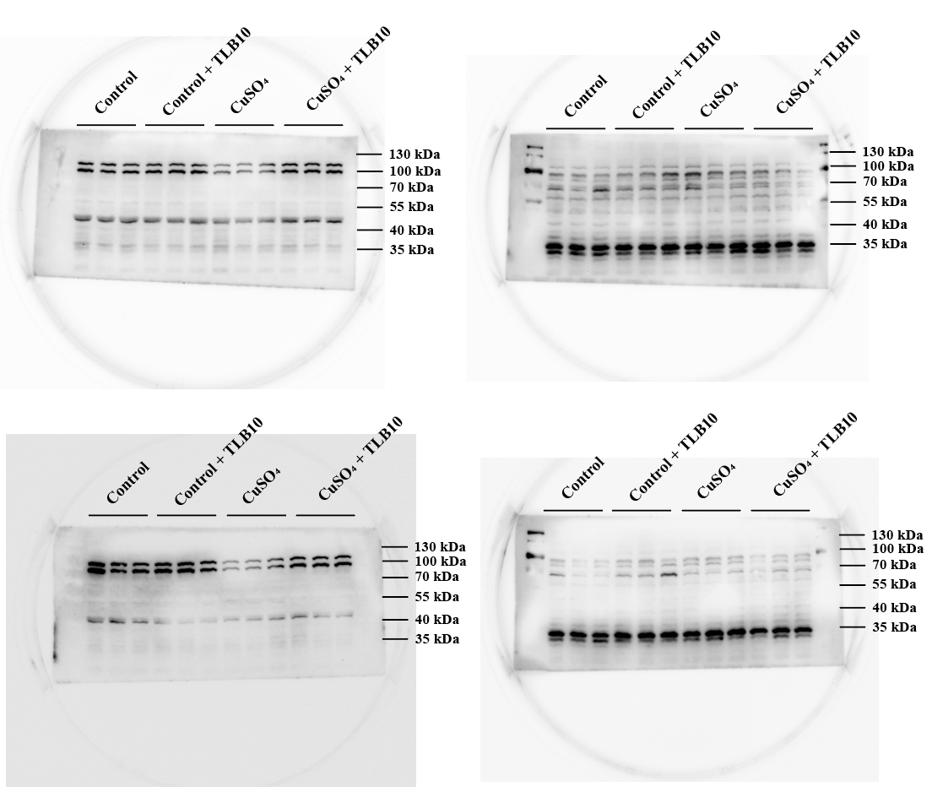
p-DRP1（83 kDa, n=6）;DRP1（82 kDa, n=6）
VDAC1（36 kDa）
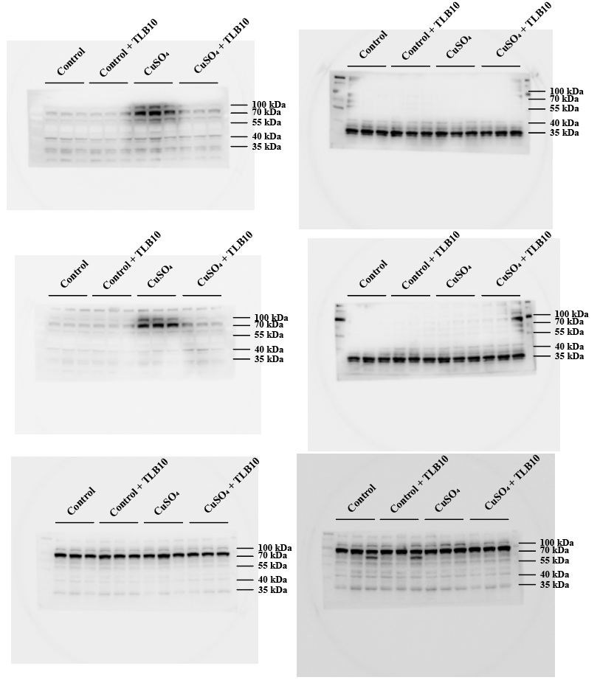
FIS1（17 kDa, n=6）
VDAC1（36 kDa）
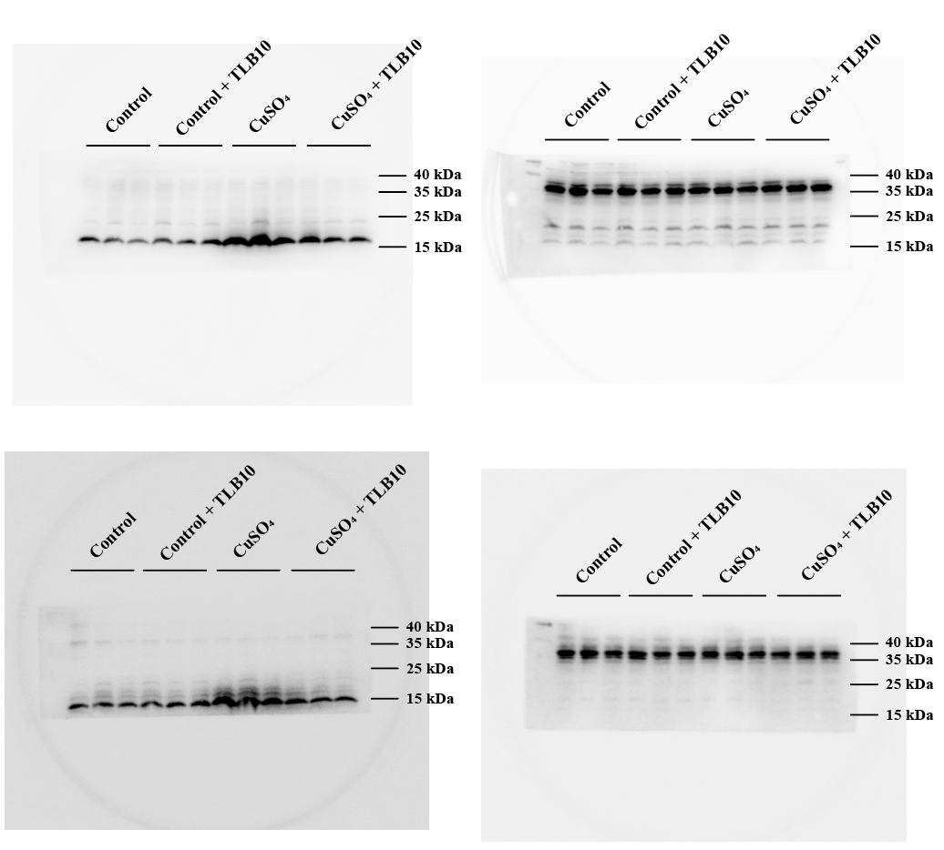
PINK1（65 kDa, n=6）
β-actin（42 kDa）
