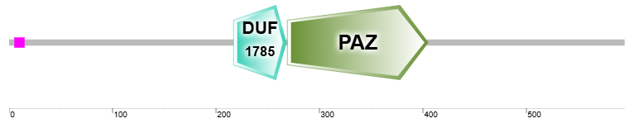
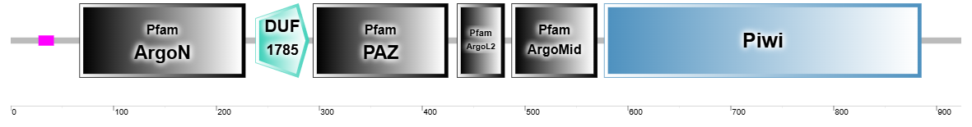
ARGONAUTE 4 (AGO4):

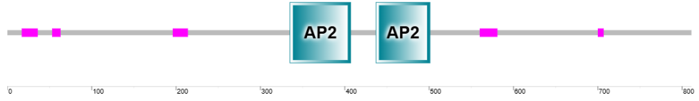
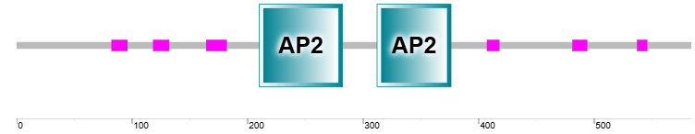
BABY BOOM (BBM):

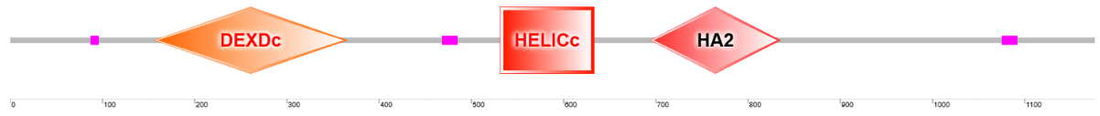
FASCIATED STEM 4 (FAS4):

MATERNAL EFFECT EMBRYO ARREST 29 (MEE29):
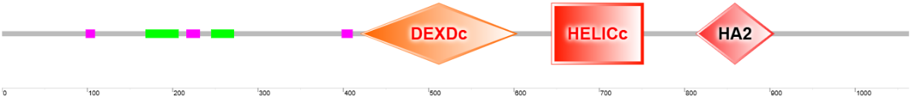
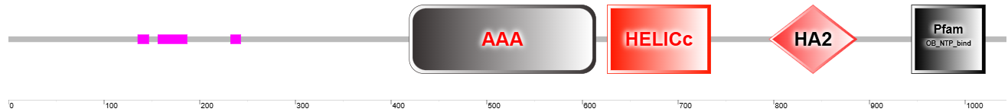

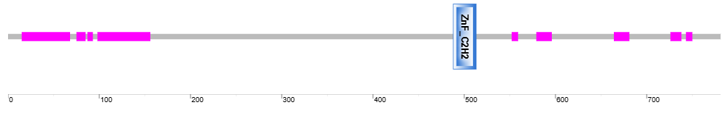
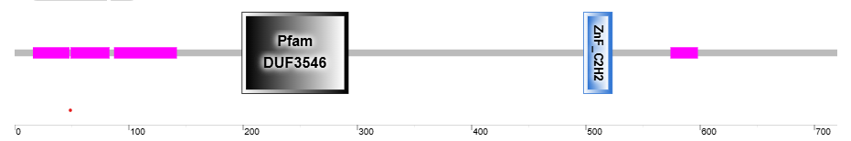
SERRATE (SE):

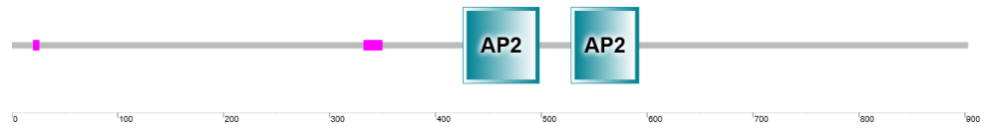
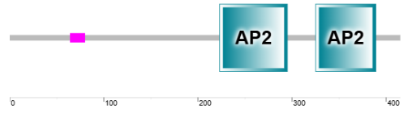
AP2-like ethylene-responsive transcription factor (AIL1):

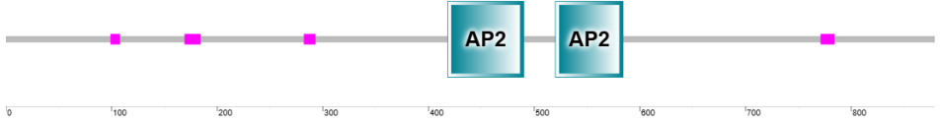
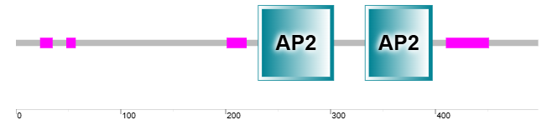
AP2-like ethylene-responsive transcription factor (AIL7):

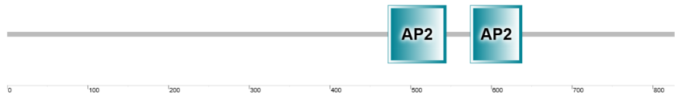
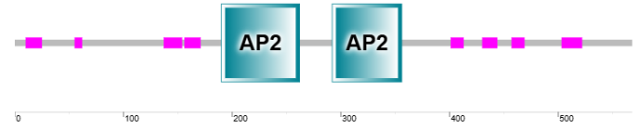
PLETHORA 2 (PLT2):

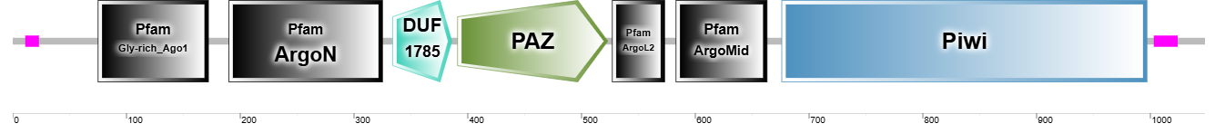
ARGONAUTE 1 (AGO1):

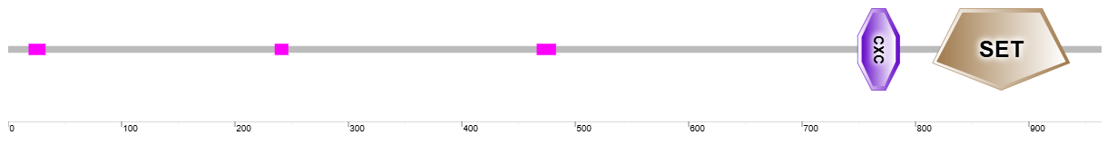
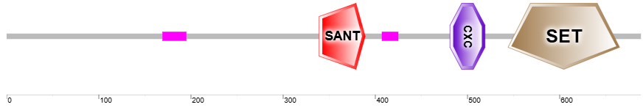
FERTILIZATION-INDEPENDENT SEED 1 (FIS1):

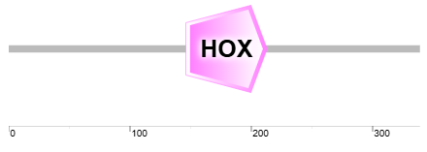
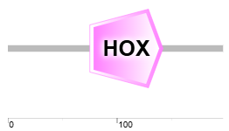
WUSCHEL-RELATED HOMEOBOX 13B (WOX13B):

DICER-LIKE 1 (DCL1):

Supplementary Figure 1. Amino acid domains of proteins from Dryopteris affinis gametophytes potentially involved in apomixis (top) and their corresponding homologues in Arabidopsis thaliana (bottom), as identified using SMART.

