Table S1. List reference sequences used in comparative chloroplast genome analysis, phylogenome analysis, gene structure, conserved motifs analysis, protein structure analysis, genetic diversity, Ka/Ks analysis.
No. | Speciment | Origin | Accession Number | Analysis Purpose
1 | Fragaria × ananassa ‘Benihoppe’ | China | NC_035961.1 | Comparative Genome, Structure, Motifs & 3D; Genetic diversity, Ka/Ks analysis
2 | Fragaria × ananassa ‘Royal Royce’ | Unknown | ON478194.1 | Comparative Genome, Structure, Motifs & 3D; Genetic diversity; Ka/Ks analysis
3 | Fragaria × ananassa ‘Camarosa’ | Unknown | ON478181.1 | Comparative Genome, Structure, Motifs & 3D; Genetic diversity; Ka/Ks analysis
4 | Fragaria chiloensis | Unknown | MW537844.1 | Comparative Genome, Structure, Motifs; Genetic diversity; Ka/Ks analysis
5 | Fragaria virginiana | USA | NC_019602.1 | Comparative Genome, Comparative Genome, Structure, Motifs; Genetic diversity; Ka/Ks analysis
6 | Fragaria vesca subsp. vesca | Unknown | NC_015206.1 | Structure, Motifs; Genetic diversity; Ka/Ks analysis
7 | Fragaria moschata | Unknown | MZ702811.1 | Structure, Motifs; Genetic diversity; Ka/Ks analysis
8 | Fragaria pentaphylla | Unknown | KY434061.1 | Structure, Motifs; Genetic diversity; Ka/Ks analysis
9 | Fragaria nilgerrensis | Unknown | MK560340.1 | Structure, Motifs; Genetic diversity; Ka/Ks analysis
10 | Rubus idaeus | China | OR972717.1 | Structure, Motifs;
11 | Fragaria orientalis | Unknown | NC_035501.1 | Ka/Ks analysis
12 | Fragaria viridis | Unknown | NC_048474.1 | Ka/Ks analysis
13 | Fragaria iinumae | Unknown | MW537854.1 | Ka/Ks analysis
14 | Fragaria tibetica | Unknown | NC_062835.1 | Ka/Ks analysis
15 | Fragaria mandshurica | Unknown | MK560339.1 | Ka/Ks analysis
16 | Fragaria iturupensis | Unknown | NC_062836.1 | Ka/Ks analysis
17 | Fragaria daltoniana | Unknown | MW537851.1 | Ka/Ks analysis
18 | Fragaria moupinensis | Unknown | OQ992645.1 | Ka/Ks analysis
19 | Fragaria gracilis | Unknown | NC_062837.1 | Ka/Ks analysis
20 | Drymocallis saviczii | Unknown | NC_050966.1 | Ka/Ks analysis
 | Malus domestica | China | MK434916.1 | Comparative Genome
21 | Dasiphora fruticosa | China | OQ992647.1 | Phylogenome
22 | Potentilla micrantha | Italy | PP541871.1 | Phylogenome
23 | Rosa chinensis | China | PV008704.1 | Phylogenome
24 | Rosa multiflora | USA | NC_039989.1 | Phylogenome
25 | Rosa roxburghii | Unknown | NC_032038 | Phylogenome
26 | Rubus occidentalis | China | OR972718.1 | Phylogenome
27 | Prunus avium | China | OP598110.1 | Phylogenome
28 | Prunus dulcis | Unknown | MT019559.1 | Phylogenome
29 | Prunus mume | China | MW759300.1 | Phylogenome
30 | Prunus persica | China | OL449945.1 | Phylogenome
31 | Cydonia oblonga | Unknown | KX499857.1 | Phylogenome
32 | Malus domestica | China | MK434916.1 | Phylogenome
33 | Pyrus x bretschneideri | South Korea | KX450881.2 | Phylogenome
34 | Pyrus communis | Unknown | NC_045336.1 | Phylogenome
35 | Amelanchier alnifolia | Unknown | NC_045314.1 | Phylogenome
36 | Sorbus aucuparia | Unknown | NC_052878.1 | Phylogenome
37 | Cercocarpus montanus | China | PP585285.1 | Phylogenome
38 | Chamaebatia foliolosa | China | NC_088512.1 | Phylogenome
39 | Dryas drummondii | China | NC_088514.1 | Phylogenome
40 | Dryas octopetala | China | PQ869155.1 | Phylogenome
41 | Purshia tridentata | China | PQ891887.1 | Phylogenome
42 | Artocarpus heterophyllus | China | MK303549.1 | Phylogenome
43 | Morus alba | China | MT577029.1 | Phylogenome
44 | Fragaria × ananassa ‘Mencir’ | Indonesia | This study (PZ351331.1) | Primary subject (all analyses)
Notes:
Comparative Genome= comparative chloroplast genome analysis
Structure & Motifs = gene structure and conserved motif analysis;
3D = direct comparative analysis for 3D protein structure modeling;
Genetic diversity = SNP and InDel analysis;
Ka/Ks analysis = selection pressure analysis
Phylogenome = Phylogenome analysis

Table S2. Quantity and quality assessment of high molecular weight genomic DNA.
NanoDrop Quantification
Sample | Concentration | A260/280 | A260/230
‘Mencir’ | 446,2 ng/ µL | 1,81 | 1,26
Qubit Quantification
Sample | Concentration
‘Mencir’ | 55,9 ng/ µL
Electrophoresis Gel (0,8%)
Sample | Result
‘Mencir’ | 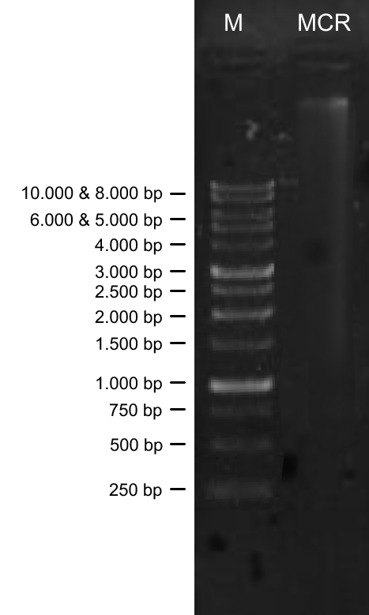
TapeStation
Sample | Result
‘Mencir’ | 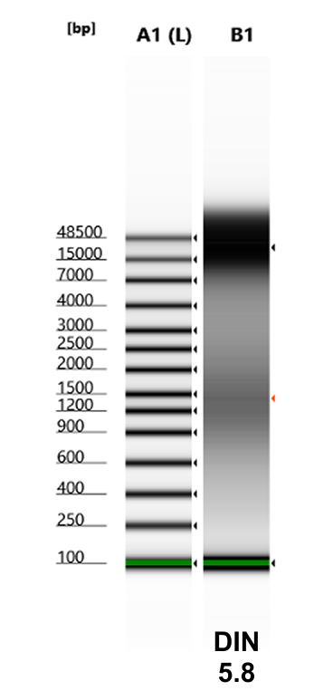

Table S3. Annotated gene list in the chloroplast genome of Fragaria × ananassa 'Mencir'.
Category | Group of Genes | Name of Genes
Photosynthesis | Subunits of photosystem I | psaA, psaB  psaC, psaI, psaJ,
Photosynthesis | Subunits of photosystem II | psbA, psbB, psbC, psbD, psbE, psbF, psbH, psbI, psbJ, psbK, psbL, psbM, psbN, psbT, psbZ
Photosynthesis | Subunits of cytochrome b/f complex | petA, petB, petD, petG, petL, petN
Photosynthesis | Subunits of ATP synthase | atpA, atpB, atpE, atpF, atpH, atpI
Photosynthesis | Large subunits of RubisCO | rbcl
Photosynthesis | Subunits of NADH dehydrogenase | ndhA, ndhB, ndhC, ndhD, ndhE, ndhF, ndhG, ndhH, ndhI, ndhJ, ndhK
Self-replication | Small subunit of ribosome (SSU) | rps2, rps3, rps4, rps7*, rps8, rps11, rps12*, rps14, rps15, rps16, rps18, rps19
Self-replication | Large subunit of ribosome (LSU) | rpl2*, rpl14, rpl16, rpl20, rpl22, rpl23*, rpl32, rpl33, rpl36
Self-replication | DNA dependent RNA polymerase | rpoA, rpoB, rpoC1, rpoC2
Self-replication | Ribosomal RNA (rRNA) | rrn16*, rrn23*, rrn4.5*, rrn5*,
Self-replication | Transfer RNAs (tRNA) | trnA-UGC, trnC-GCA, trnD-GUC, trnE-UUC, trnF-GAA, trnG-GCC, trnG-UCC, trnH-GUG, trnI-CAU, trnI-GAU, trnK-UUU, trnL-CAA, trnL-UAA, trnL-UAG, trnM-CAU, trnfM-CAU, trnN-GUU, trnP-UGG, trnQ-UUG, trnR-ACG, trnR-UCU, trnS-GCU, trnS-GGA, trnS-UGA, trnT-GGU, trnT-UGU, trnV-GAC, trnV-UAC, trnW-CCA, trnY-GUA
Other genes | ATP-dependent protease subunit p gene | clpP
Other genes | Maturase | matK
Other genes | c-type cytochrome synthesis gene | ccsA
Other genes | Translation initiation factor | infA
Other genes | Envelope membrane protein | cemA
Other genes | Subunit of acetyl-CoA-carboxylase | accD
Genes of unknown function | Conserved hypothetical chloroplast ORF | ycf1, ycf2, ycf3, ycf4
Notes: Duplicated genes are denoted by an asterisk (*); bolded genes indicate those not detected in some cultivars.
Table S4. GC Content Distribution Across Different Regions of the Chloroplast Genome
Genomic Region / Feature | GC Content (%)
Overall Average | 37.23
Inverted Repeat (IR) | 42.85
Large Single Copy (LSC) | 35.12
Small Single Copy (SSC) | 31.15
rRNA genes (within IR) | 53.53

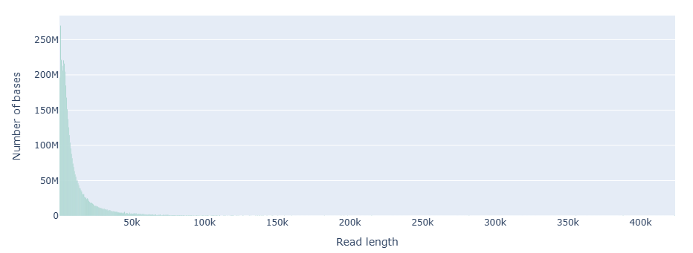
Figure S1. Weighted read length histogram.
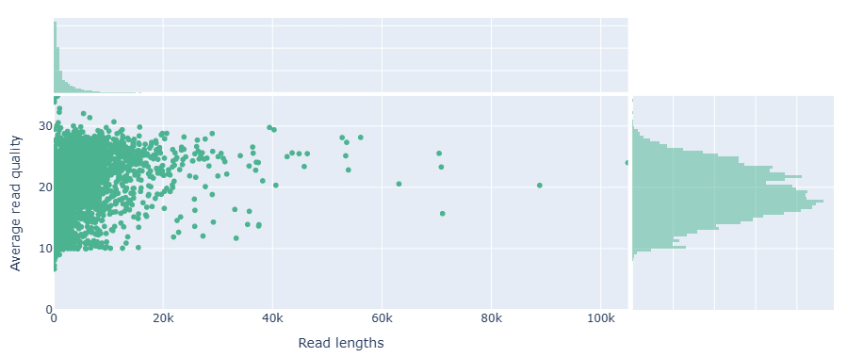
Figure S2. Read lengths vs Average read quality plot using dots.

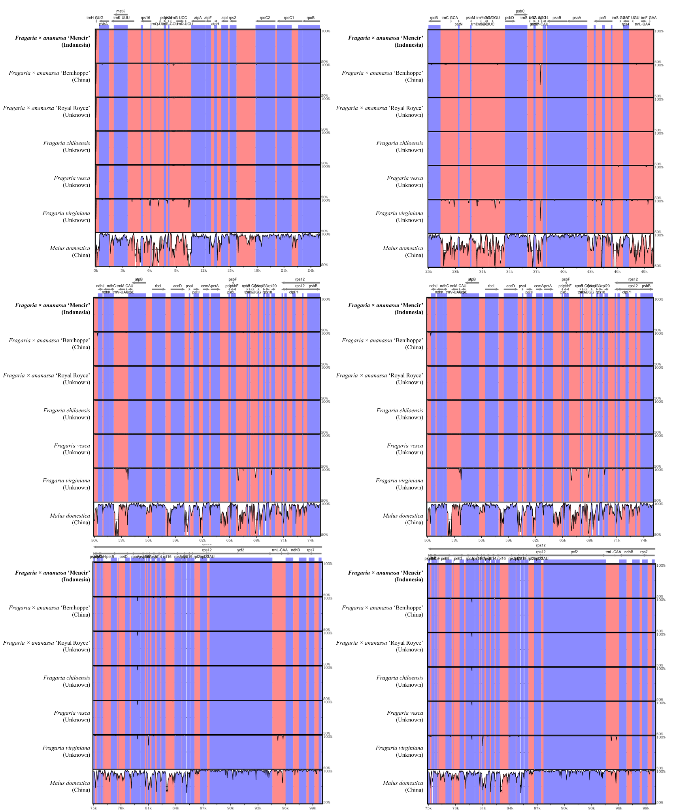
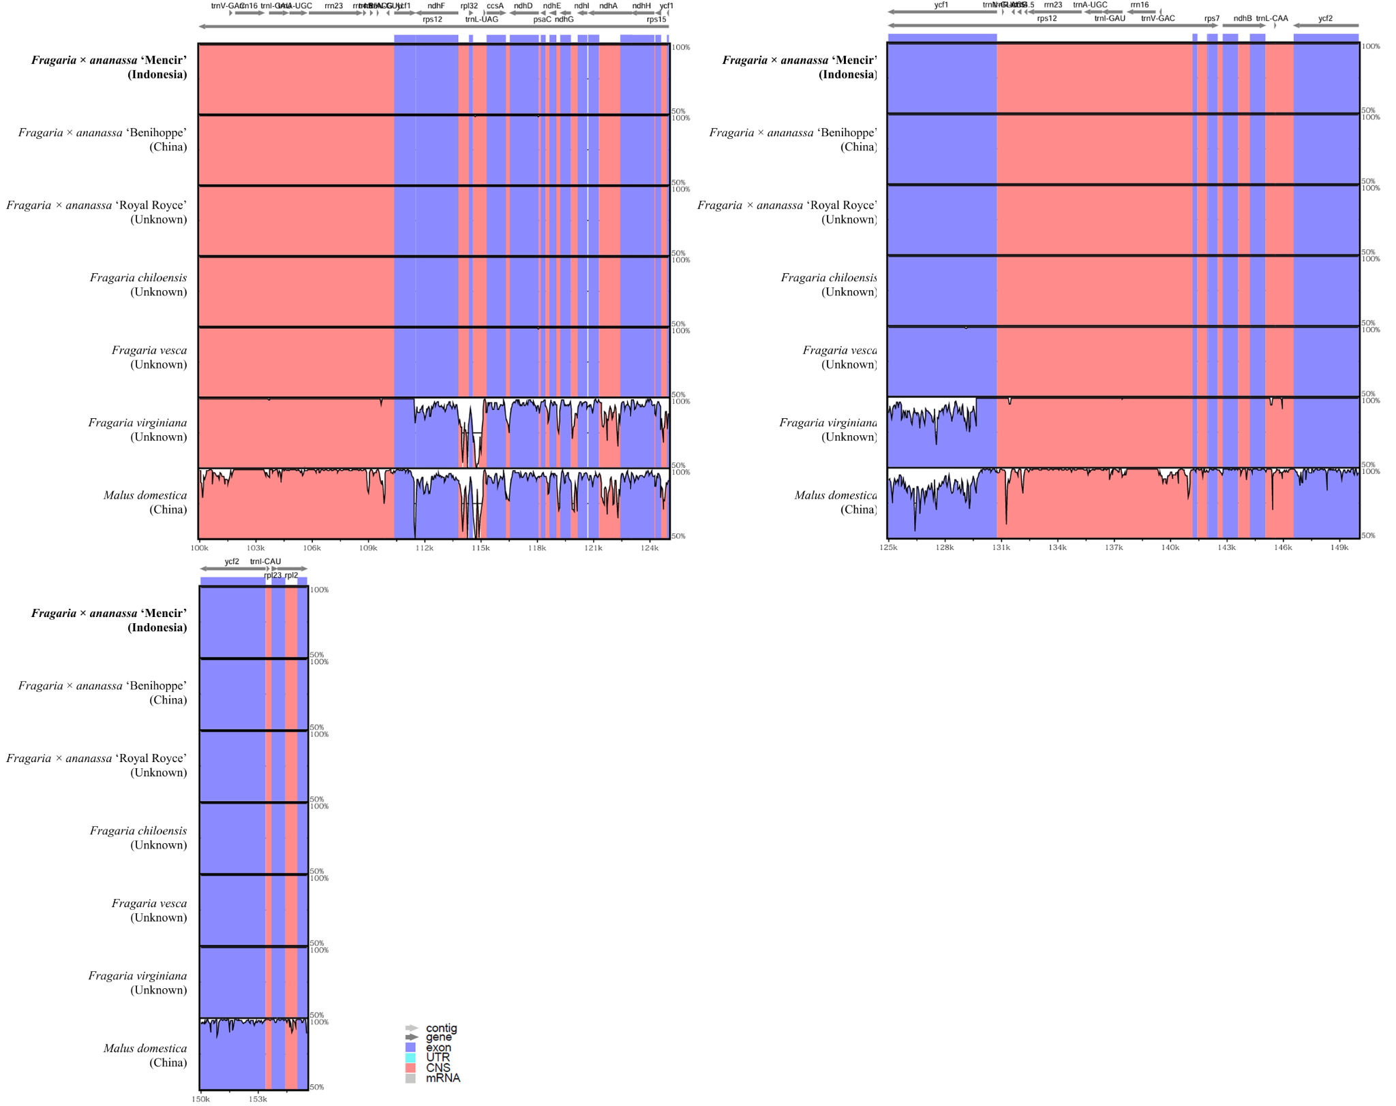
Figure S3. Comparative analysis of Fragaria chloroplast genome sequences and Malus domestica. Arrow orientation indicates gene transcription direction. Purple boxes denote exons and red boxes represent CNSs (conserved non-coding sequences).

