Supplementary Material For：
Cellulosic Paper-based membrane for oil-water separation enabled by pulp fiber refining and in-situ gelation
Decheng Gao, Yucheng Feng, Xiao Zhang, Shuying Wu and Fei Yang *
State Key Laboratory of Pulp and Paper Engineering, South China University of Technology, Guangzhou 510640, China;
* Corresponding author: Fei Yang: yangfei@scut.edu.cn

Supplementary Figures
The water layer on the surface of membranes
The membrane can easily absorb water and keep the water in the membrane for a period of time. It could repel oil droplets only when it was wetted. After the oil dropped on the surface, the cleaning effect can be achieved just by washing it with water. The gross of the hydration layer on the membranes can be clearly seen under light.
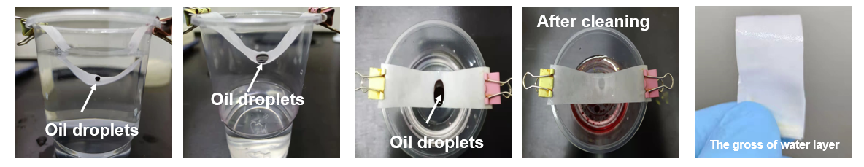
Fig.S1 the photograph of oil repellency and self-cleaning of membranes
The oil-water mixtures separation
The oil-water mixtures used a series of oil, including n-hexane, liquid paraffin, pump oil, petroleum ether, and xylene, and colored them with Oil Red O. Then mix them with water (20ml, 50% v/v), respectively. The separation process was carried out in two 2.8cm-in-diameter plastic pipes (driven by the gravity of mixtures). The separation efficiency (η) was determined by the Equation:
$$η=\frac{m1}{m2}×100\%$$
Where m₀ is the mass of water before separation, m₁ is the mass of water after separation.
The separation efficiencies for oil-water mixtures of the membranes (1-6) were shown in Fig.S2 (a). N-hexane/water mixture was taken as an example. All membranes had a separation efficiency of ＞99%, and the flux of M-2 was 276.92 L/m²·h. Meanwhile, the separation efficiency of M-2 for different oils was above 99% (Fig.S2 b). The separation efficiencies of the membranes were＞99% in 10 cycles (Fig.S2 c), indicating that the membranes had good adaptability. Furthermore, after separation, the oil phases would not pass through the membrane after standing for two hours (Fig.S2 d), indicating the excellent oil repellency of membranes.
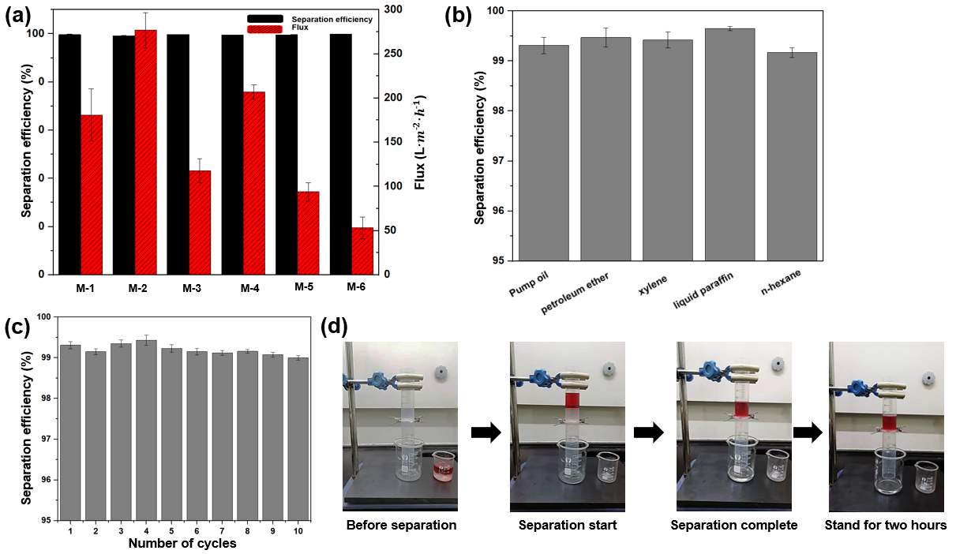
Fig.S2 (a) the separation efficiency and flux of membranes (1~6); (b) the separation efficiency for different oil-water mixtures of M-2; (c) the recycle numbers of M-2 for the example oil-water mixtures (N-hexane/water mixtures); (d) the photographs of separation process
The UV–vis absorbance curves of emulsion, Tween-80 aqueous solution, and the filtrate
As shown in Fig.S3, the emulsion and filtrate were scanned by UV-vis spectrum the range of 200-600nm. It could be found that the peak for toluene in 261nm were almost disappeared, leaving only the peak for tween-80 at 230nm. It confirms the purity of filtrate.
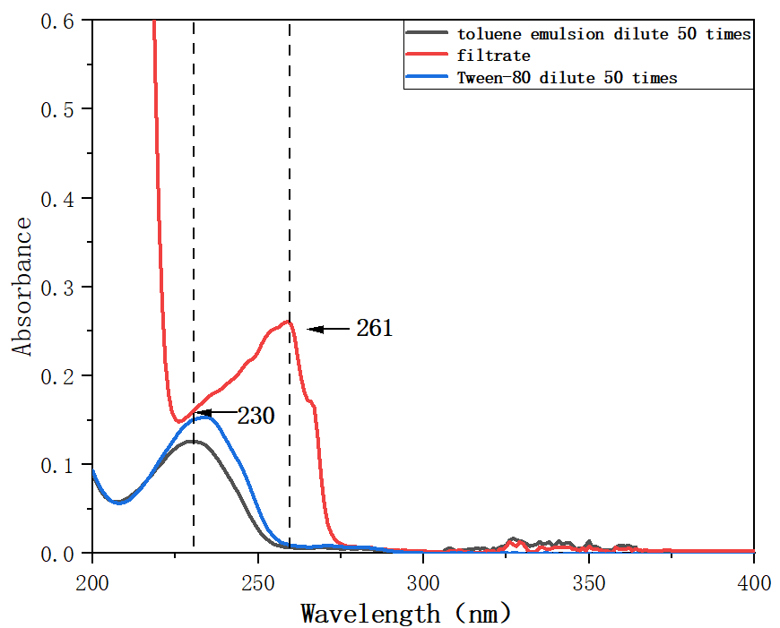
Fig.S3 UV–vis absorbance curves of emulsion, Tween-80 aqueous solution, and the filtrate
The FT-IR spectrum of membranes
Dry membranes were ground into powder and recorded the FTIR spectra from 400-4000cm⁻¹ on FTIR spectrometer (Nicolet Nexus 670: Nicolet Instrument Technologies, Inc, Madison WI, USA)
The FT-IR spectra of membranes were nearly consistent with paper substrate (Fig.S4). The board peaks from 3000cm⁻¹ to 3600⁻¹ were due to the stretching vibration of hydroxyl groups on cellulose fibers(Fan et al., 2015). The peak around 1060cm⁻¹ was attributed to the skeleton vibration of C-O-C pyranose(Kafy, Akther, Shishir, Kim, Yun & Kim, 2016). And the peak around 2900cm⁻¹ was the asymmetric stretching vibration of CH₂(Xi, Jiang, Lou, Dai & Wu, 2021). The peak around 1645cm⁻¹ was caused by water absorption of the cellulose in the membranes(Zhang, Yu, Liu, Teng & Yin, 2019). The peaks from 3000~3600 were higher with gelation, as a result of the cellulose macromolecule chain broken by NaOH/urea, indicating the -OH absorptivity was higher. In brief, the FT-IR spectra, suggested that there were no other chemical reactions occurring.
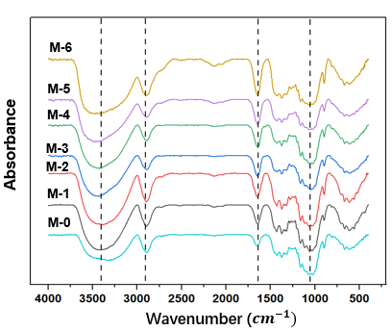
Fig.S4 the FT-IR spectrum of membranes from 400~4000cm⁻¹
The WAXD of paper and membranes
The crystalline structure of the membranes was investigated by using wide angle X-ray diffraction (Bruker D8 Advance, Germany).
The X-ray diffraction profiles of membranes at 15min pretreatment were shown in Fig.S5, and the untreated paper was the control group. The light absorbances of CNC-I occurs at 2θ=15°,16°and 22.5°.(Duchemin, Le Corre, Leray, Dufresne & Staiger, 2016). The peak around 16° was the peak in the amorphous regions, and the peak around 22.5° was the peak in the crystalline regions(Fan, Hu, Zhao, Liu & Lu, 2017). This showed that no significant changes in the crystalline region of the fibers in membranes, instead the swelling and gelation of fibers only appeared in the amorphous regions. At the same time, the crystalline structure of the cellulose was still CNC-I for the high dissolved concentration during processing. All these indicated that there were no other chemical reactions except gelation took place on the membranes during the process, and the skeleton structure of the fibers displayed no significant changes.
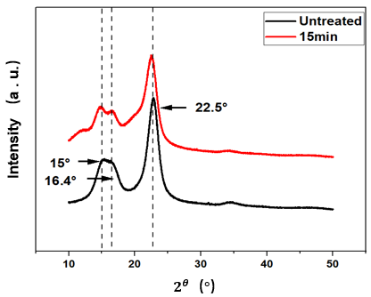
Fig.S5 WAXD of paper substrate and membranes

The water flux of paper and M-1, M-2
Table S1. The water flux of paper substrates, M-1 and M-2 at different beating degrees
SR(°) | Paper (L/m2·h) | M-1(L/m2·h) | M-2(L/m2·h)
10° | - | - | -
20° | 144.38±18.65 | 271.41±39.40 | 349.88±26.54
25° | 99.18±15.36 | 211.54±49.80 | 322.85±35.90
30° | 90.21±18.37 | 198.94±32.36 | 297.41±37.40
35° | 81.23±17.53 | 180.20±29.61 | 276.92±19.73
40° | 34.03±5.35 | 71.41±20.14 | 107.79±32.37
45° | 10.33±1.12 | 18.37±1.23 | 51.21±7.34
50° | 6.99±0.51 | 13.36±0.92 | 33.33±8.32

The morphology of pulps before and after refining
The Fiber analyzer (Morfi Compact, Techpap, French) was used to analyze the fiber morphology. The water retention properties were tested according to ISO 23714-2007.
The occurrence of fine fibrosis is the main reason for the change of pore structure of paper
Table.S2 The morphology of pulps
Beating degrees (°SR) | Fiber length (μm) | Fine fiber length ratio (%) | Fibrillation length ratio (%)
10°SR | 1.46 | 32.45 | 2.02
20°SR | 1.43 | 40.50 | 2.76
25°SR | 1.41 | 41.00 | 3.04
30°SR | 1.38 | 45.25 | 3.21
35°SR | 1.31 | 47.25 | 3.35
40°SR | 1.28 | 48.00 | 3.46
45°SR | 1.26 | 49.70 | 3.50
50°SR | 1.21 | 52.20 | 3.54

The water retention value of pulps before and after gelation
The water retention properties were tested according to ISO 23714-2007
Table.S3 the water retention value (WRV) of pulps before and after gelation
Beating degrees (°SR) | WRV before gelation (g/g) | WRV after gelation (g/g)
10°SR | 1.2771 | 1.1959
20°SR | 1.5786 | 1.4883
25°SR | 1.6508 | 1.5293
30°SR | 1.6603 | 1.5645
35°SR | 1.6780 | 1.5962
40°SR | 1.7013 | 1.6120
45°SR | 1.7083 | 1.6261
50°SR | 1.7288 | 1.6285

References
Kafy, A., Akther, A., Shishir, M. I. R., Kim, H. C., Yun, Y., & Kim, J. (2016). Cellulose nanocrystal/graphene oxide composite film as humidity sensor. Sensors and Actuators A: Physical, 247, 221-226.
Fan, J., Song, Y., Wang, S., Meng, J., Yang, G., Guo, X., Feng, L., & Jiang, L. (2015). Directly Coating Hydrogel on Filter Paper for Effective Oil-Water Separation in Highly Acidic, Alkaline, and Salty Environment. ADVANCED FUNCTIONAL MATERIALS, 25(33), 5368-5375.
Xi, J., Jiang, S., Lou, Y., Dai, H., & Wu, W. (2021). Underwater superoleophobic all-cellulose composite papers for the separation of emulsified oil. CELLULOSE, 28(7), 4357-4370.
Zhang, S., Yu, C., Liu, N., Teng, Y., & Yin, C. (2019). Preparation of transparent anti-pollution cellulose carbamate regenerated cellulose membrane with high separation ability. INTERNATIONAL JOURNAL OF BIOLOGICAL MACROMOLECULES, 139, 332-341.
Fan, T., Hu, R., Zhao, Z., Liu, Y., & Lu, M. (2017). Surface micro-dissolve method of imparting self-cleaning property to cotton fabrics in NaOH/urea aqueous solution. APPLIED SURFACE SCIENCE, 400, 524-529.
Duchemin, B., Le Corre, D., Leray, N., Dufresne, A., & Staiger, M. P. (2016). All-cellulose composites based on microfibrillated cellulose and filter paper via a NaOH-urea solvent system. CELLULOSE, 23(1), 593-609.

