Table S1. Educational level
Educational level | Dexmedetomidine group | Control group
Below high school | 18% | 21%
High school | 52% | 51%
University | 20% | 20%
Postgraduate | 10% | 8%
The distribution of educational level did not differ significantly between groups (P > 0.05).

Table S2. Pain severity according to PAINAD among participants with postoperative delirium
Pain severity | Dexmedetomidine group (n = 52) | Control group (n = 112) | P value
No pain (0 points) | 47 (90.4) | 28 (25.0)
Mild pain (1–3 points) | 5 (9.6) | 18 (16.1) | <0.001
Moderate pain (4–6 points) | 0 (0) | 66 (58.9)
No participants had PAINAD scores of 7–10. This was an exploratory post-randomization subgroup analysis.
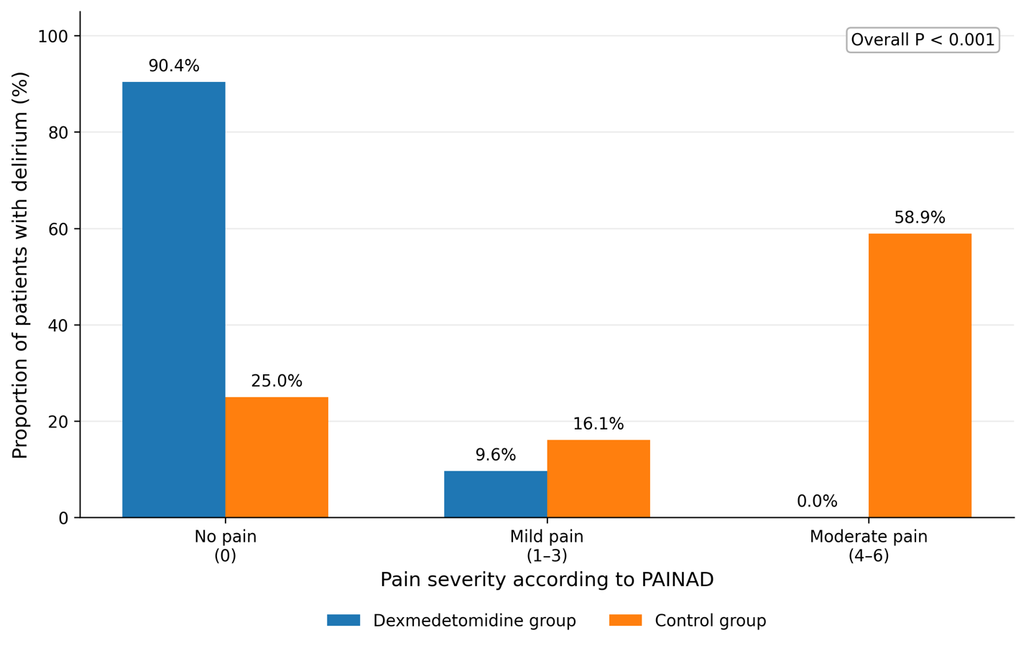
Figure S1. Distribution of pain severity according to PAINAD among participants who developed postoperative delirium.

