Additional file 1.
The reported MAE represents the intensity difference between the original 512 × 512 CT image and the same image after resizing to 256 × 256 pixels and subsequently restoring it to 512 × 512 pixels using linear interpolation. It therefore estimates the contribution of the resampling procedure to the measured HU difference.
Table S1: MAE introduced by image resampling from 512 × 512 to 256 × 256 and back to 512 × 512 pixels.
Peripheral | Eroded | Intersection | Patient | FOV
29.04 | 9.10 | 11.66 | Patient02 | Complete
31.16 | 11.32 | 13.65 | Patient05 | Complete
36.75 | 10.63 | 14.08 | Patient08 | Complete
42.02 | 11.31 | 14.97 | Patient01 | Truncated
35.93 | 9.72 | 13.34 | Patient02 | Truncated
39.04 | 13.20 | 16.85 | Patient03 | Truncated
35.78 | 10.25 | 13.43 | Patient04 | Truncated
38.61 | 12.34 | 15.79 | Patient05 | Truncated
36.29 | 13.33 | 17.02 | Patient06 | Truncated
33.39 | 14.61 | 16.93 | Patient07 | Truncated
38.52 | 15.23 | 18.31 | Patient08 | Truncated
45.98 | 12.01 | 16.83 | Patient09 | Truncated
32.40 | 15.42 | 17.90 | Patient10 | Truncated
43.37 | 9.79 | 14.25 | Patient11 | Truncated
43.53 | 12.95 | 17.33 | Patient12 | Truncated
37.45 | 12.08 | 15.49 | Mean | Both

A model-specific sCT body mask was additionally evaluated only in the sensitivity analysis to assess the effect of mask definition on the observed results.
Table S2: Sensitivity analysis of the evaluation-mask definition for Linear Correction: Dice similarity between the sCT-derived and constant masks and MAE calculated using the sCT-derived mask compared with the constant mask.
Peripheral Mask |  | Eroded Mask |  | Intersection Mask |  | Dice | Patient | FOV
Constant Mask | sCT Mask | Constant Mask | sCT Mask | Constant Mask | sCT Mask | Dice | Patient | FOV
191.02 | 186.25 | 89.21 | 88.85 | 100.25 | 99.17 | 98.85 | Patient_02 | Complete
173.24 | 169.39 | 79.31 | 78.97 | 89.38 | 88.69 | 99.17 | Patient_05 | Complete
207.88 | 202.82 | 76.70 | 76.53 | 91.79 | 91.04 | 99.09 | Patient_08 | Complete
210.65 | 201.95 | 99.48 | 98.93 | 111.77 | 110.41 | 99.31 | Patient_01 | Truncated
212.87 | 208.11 | 107.97 | 106.95 | 120.05 | 118.58 | 98.72 | Patient_02 | Truncated
170.87 | 167.75 | 91.27 | 90.71 | 100.58 | 99.79 | 99.18 | Patient_03 | Truncated
187.86 | 179.17 | 97.05 | 96.48 | 107.10 | 105.61 | 99.16 | Patient_04 | Truncated
181.17 | 178.97 | 87.93 | 87.81 | 98.80 | 98.41 | 99.04 | Patient_05 | Truncated
188.32 | 182.19 | 102.90 | 103.03 | 114.10 | 113.27 | 98.64 | Patient_06 | Truncated
188.64 | 179.77 | 80.37 | 79.58 | 92.51 | 90.81 | 98.93 | Patient_07 | Truncated
159.22 | 155.57 | 71.08 | 71.02 | 81.71 | 81.18 | 99.27 | Patient_08 | Truncated
200.21 | 197.02 | 134.03 | 134.02 | 142.52 | 142.14 | 99.04 | Patient_09 | Truncated
209.54 | 206.91 | 77.61 | 75.64 | 93.67 | 91.79 | 98.92 | Patient_10 | Truncated
237.73 | 226.03 | 131.66 | 130.80 | 144.18 | 142.32 | 98.82 | Patient_11 | Truncated
169.88 | 165.09 | 115.69 | 115.60 | 122.44 | 121.76 | 99.25 | Patient_12 | Truncated

Table S3: Sensitivity analysis of the evaluation-mask definition for PCC-cGAN: Dice similarity between the sCT-derived and constant masks and MAE calculated using the sCT-derived mask compared with the constant mask.
Peripheral Mask |  | Eroded Mask |  | Intersection Mask |  | Dice | Patient | FOV
Constant Mask | sCT Mask | Constant Mask | sCT Mask | Constant Mask | sCT Mask | Dice | Patient | FOV
192.27 | 196.43 | 70.80 | 71.17 | 83.98 | 84.71 | 98.38 | Patient_02 | Complete
184.03 | 186.88 | 66.06 | 66.20 | 78.70 | 78.99 | 98.52 | Patient_05 | Complete
187.75 | 195.73 | 66.00 | 66.54 | 80.00 | 81.18 | 98.47 | Patient_08 | Complete
215.45 | 241.47 | 75.24 | 77.63 | 90.73 | 94.94 | 98.52 | Patient_01 | Truncated
181.46 | 195.75 | 81.25 | 81.69 | 92.79 | 94.52 | 98.47 | Patient_02 | Truncated
165.39 | 167.69 | 76.82 | 77.30 | 87.19 | 87.78 | 98.47 | Patient_03 | Truncated
163.09 | 173.65 | 77.00 | 77.73 | 86.53 | 88.11 | 98.57 | Patient_04 | Truncated
155.87 | 157.39 | 74.61 | 74.59 | 84.09 | 84.21 | 98.35 | Patient_05 | Truncated
175.51 | 177.44 | 86.67 | 86.69 | 98.32 | 98.53 | 98.01 | Patient_06 | Truncated
161.62 | 171.14 | 72.17 | 71.93 | 82.20 | 83.09 | 98.65 | Patient_07 | Truncated
140.46 | 141.94 | 64.43 | 64.41 | 73.60 | 73.72 | 98.37 | Patient_08 | Truncated
183.22 | 192.50 | 98.12 | 99.32 | 109.04 | 110.55 | 97.99 | Patient_09 | Truncated
145.60 | 156.00 | 70.30 | 68.82 | 79.47 | 79.61 | 98.37 | Patient_10 | Truncated
226.53 | 245.42 | 97.74 | 98.51 | 112.95 | 115.38 | 98.28 | Patient_11 | Truncated
174.61 | 182.03 | 92.81 | 93.24 | 103.00 | 104.04 | 98.29 | Patient_12 | Truncated

Table S4: Sensitivity analysis of the evaluation-mask definition for ResUNet: Dice similarity between the sCT-derived and constant masks and MAE calculated using the sCT-derived mask compared with the constant mask.
Peripheral Mask |  | Eroded Mask |  | Intersection Mask |  | Dice | Patient | FOV
Constant Mask | sCT Mask | Constant Mask | sCT Mask | Constant Mask | sCT Mask | Dice | Patient | FOV
177.09 | 169.81 | 64.54 | 66.72 | 76.75 | 77.87 | 97.70 | Patient_02 | Complete
164.70 | 164.43 | 63.72 | 65.52 | 74.54 | 76.02 | 97.70 | Patient_05 | Complete
172.74 | 185.62 | 67.38 | 69.67 | 79.49 | 82.86 | 97.41 | Patient_08 | Complete
218.03 | 236.73 | 73.52 | 75.55 | 89.49 | 92.94 | 98.46 | Patient_01 | Truncated
171.19 | 174.95 | 74.95 | 76.13 | 86.03 | 87.49 | 98.30 | Patient_02 | Truncated
154.22 | 156.62 | 73.69 | 74.90 | 83.12 | 84.37 | 98.36 | Patient_03 | Truncated
160.18 | 161.28 | 73.27 | 75.46 | 82.89 | 84.88 | 98.25 | Patient_04 | Truncated
165.81 | 165.58 | 72.36 | 72.45 | 83.25 | 83.30 | 98.51 | Patient_05 | Truncated
157.54 | 156.58 | 83.21 | 83.87 | 92.96 | 93.43 | 97.74 | Patient_06 | Truncated
153.54 | 152.42 | 68.14 | 68.91 | 77.72 | 78.28 | 98.36 | Patient_07 | Truncated
138.09 | 138.91 | 61.66 | 61.84 | 70.87 | 71.14 | 98.42 | Patient_08 | Truncated
185.06 | 198.51 | 94.79 | 95.57 | 106.38 | 108.01 | 98.00 | Patient_09 | Truncated
140.48 | 143.15 | 67.90 | 67.18 | 76.74 | 76.58 | 98.18 | Patient_10 | Truncated
217.55 | 232.02 | 92.91 | 95.02 | 107.62 | 110.85 | 98.09 | Patient_11 | Truncated
184.44 | 184.86 | 89.77 | 91.53 | 101.56 | 102.94 | 98.11 | Patient_12 | Truncated

Localization of gamma failures. failures were classified according to the spatial dose gradient in the reference dose distribution, with 0.5 Gy/mm used as the threshold to distinguish high- and low-gradient regions.
Table S5: Percentage of failures in low and high gradient regions for 3%/3 mm criterion.
Percentage of failures in CBCT |  | Percentage of failures in sCT |  | Patient | FOV
high-gradient regions | low-gradient regions | high-gradient regions | low-gradient regions | Patient | FOV
62.6% | 37.4% | 54.8% | 45.2% | Patient02 | Complete
93.5% | 06.5% | 93.7% | 06.3% | Patient05 | Complete
72.6% | 27.4% | 63.7% | 36.3% | Patient08 | Complete
63.6% | 36.4% | 63.0% | 37.0% | Patient01 | Truncated
67.2% | 32.8% | 68.0% | 32.0% | Patient02 | Truncated
77.0% | 23.0% | 75.5% | 24.5% | Patient03 | Truncated
69.3% | 30.7% | 71.7% | 28.3% | Patient04 | Truncated
86.4% | 13.6% | 88.4% | 11.6% | Patient05 | Truncated
75.9% | 24.1% | 63.4% | 36.6% | Patient06 | Truncated
78.7% | 21.3% | 77.9% | 22.1% | Patient07 | Truncated
80.2% | 19.8% | 80.4% | 19.6% | Patient08 | Truncated
53.8% | 46.2% | 57.2% | 42.8% | Patient09 | Truncated
79.6% | 20.4% | 77.4% | 22.6% | Patient10 | Truncated
75.9% | 24.1% | 73.0% | 27.0% | Patient11 | Truncated
63.1% | 36.9% | 58.9% | 41.1% | Patient12 | Truncated

Table S6: Mean dose gradient at gamma failure and passing locations for sCT and CBCT across all test patients for 3%/3 mm criterion.
CBCT - Mean gradient [Gy/mm] |  | sCT - Mean gradient [Gy/mm] |  | Patient | FOV
Passes | Failures | Passes | Failures | Patient | FOV
1.13 | 3.03 | 1.18 | 2.69 | Patient02 | Complete
0.69 | 4.30 | 0.70 | 4.57 | Patient05 | Complete
1.27 | 4.04 | 1.32 | 3.62 | Patient08 | Complete
1.63 | 3.16 | 1.65 | 3.34 | Patient01 | Truncated
1.23 | 3.61 | 1.23 | 3.90 | Patient02 | Truncated
1.58 | 5.02 | 1.59 | 5.08 | Patient03 | Truncated
1.40 | 4.12 | 1.38 | 4.56 | Patient04 | Truncated
0.81 | 5.09 | 0.80 | 5.32 | Patient05 | Truncated
2.08 | 4.09 | 2.16 | 4.91 | Patient06 | Truncated
1.37 | 5.13 | 1.38 | 4.99 | Patient07 | Truncated
1.32 | 4.37 | 1.31 | 4.51 | Patient08 | Truncated
1.53 | 2.59 | 1.46 | 3.02 | Patient09 | Truncated
1.79 | 4.84 | 1.79 | 4.70 | Patient10 | Truncated
1.70 | 2.36 | 1.71 | 2.51 | Patient11 | Truncated
1.83 | 1.76 | 1.79 | 1.85 | Patient12 | Truncated

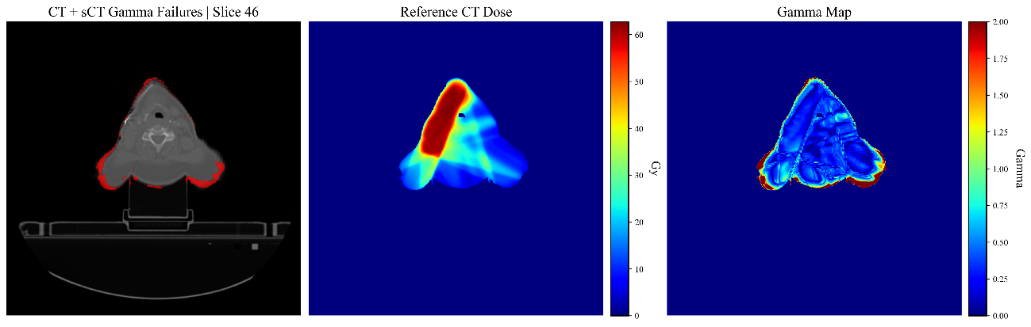
(a)
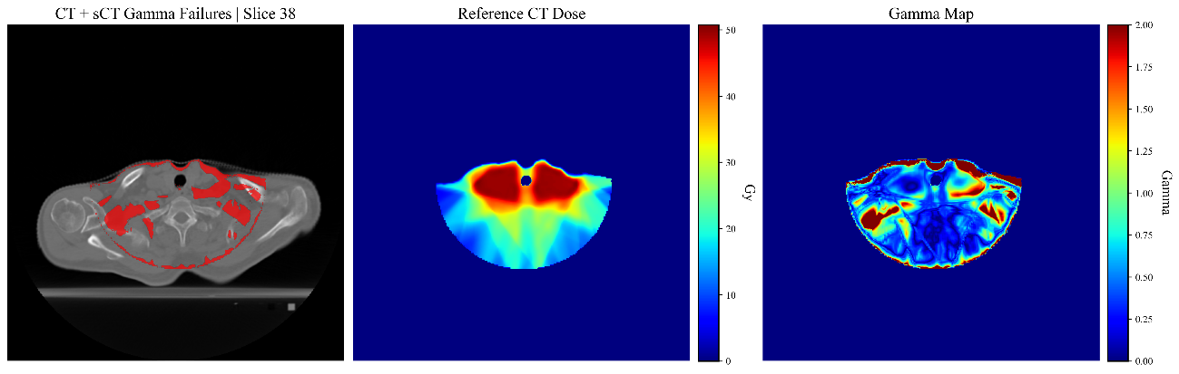
(b)
Figure S1: (a) and (b) illustrate the spatial localization of gamma failures for a representative slice for patient05 completed FOV and patienr02 truncated FOV, respectively. Images from left to right are: Reference CT image with sCT gamma failures overlaid in red (failures defined as voxels with gamma index > 1.0 at the 3%/3 mm criterion); (b) Reference CT dose distribution; (c) Gamma index map, where higher gamma values (warmer colors, approaching red) indicate greater disagreement between the sCT and reference dose distributions.

Positive percentage differences indicate overall improvement in gamma passing rate for sCT relative to CBCT, whereas negative values indicate better performance for CBCT.
Table S7. Organ-level gamma passing rate comparison between sCT and CBCT (# = number of).
Organ | # cases | sCT better in # cases |  | CBCT better in # cases |  | Percentage difference sum (sCT - CBCT)
Organ | # cases | 3%/3mm | 2%/2mm | 3%/3mm | 2%2mm | 3%/3mm | 2%2mm
Bone Mandible | 15 | 4 | 3 | 11 | 12 | -0.45 | -5.93
Brain | 13 | 5 | 5 | 6 | 7 | 3.12 | 3.26
Brainstem | 12 | 6 | 5 | 4 | 4 | 4.86 | -6.38
Oral Cavity | 15 | 7 | 10 | 4 | 4 | 11.95 | 20.04
Thyroid Gland | 14 | 9 | 7 | 4 | 5 | 60.93 | 44.96
Parotids | 15 | 5 | 5 | 6 | 10 | -3.68 | -8.98
Spinal Canal | 12 | 5 | 8 | 6 | 4 | 1.25 | 5.7

