Supplementary Materials

Supplementary Table 1. Comorbidities in the intubation task population.

 | Characteristic | VAP Pos  n = 524 | VAP Neg  n = 5602
Comorbidity | Intracranial Hemorrhage | 34 (6.49%) | 138 (2.46%)
Comorbidity | Sepsis | 11 (2.1%) | 144 (2.57%)
Comorbidity | Congestive Heart Failure | 8 (1.53%) | 128 (2.28%)
Comorbidity | Subarachnoid Hemorrhage | 14 (2.67%) | 57 (1.02%)
Comorbidity | Respiratory Failure | 10 (1.91%) | 47 (0.84%)
Comorbidity | Fever | 5 (0.95%) | 49 (0.87%)
Comorbidity | Respiratory Distress | 2 (0.38%) | 38 (0.68%)
Comorbidity | Shortness of Breath | 2 (0.38%) | 28 (0.5%)
Comorbidity | Renal Failure | 1 (0.19%) | 8 (0.14%)
Comorbidity | Cirrhosis | 0 (0%) | 6 (0.11%)
Comorbidity | Bacteremia | 0 (0%) | 3 (0.05%)

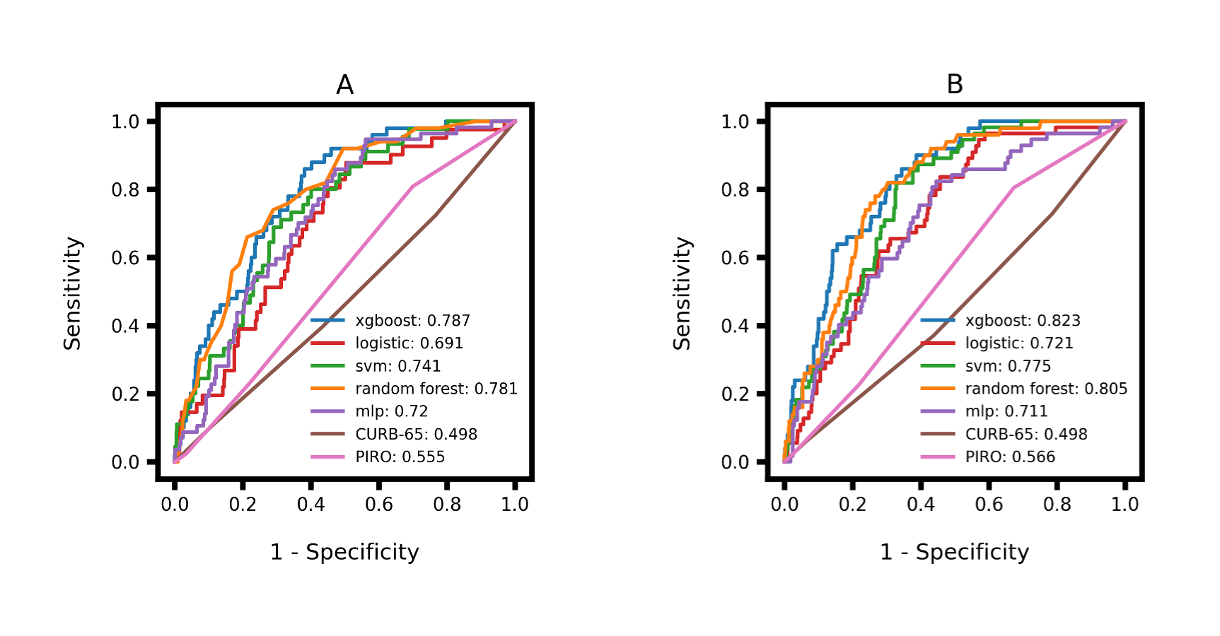Supplementary Figure 1. ROC curve comparison for intubation task models, with summary statistics calculated from the 12 (A) and 24 (B) hours of data preceding the time of prediction.

Supplementary Table 2: Figure legend interpretation for SHAP plots.
 | Figure Legend | Interpretation
Feature summary statistics | AVERAGE | The mean value for a given feature recorded over the data collection window
Feature summary statistics | FIRST | The first value for a given feature recorded during the data collection window
Feature summary statistics | LAST | The last value for a given feature collected before VAP predictions were generated
Feature summary statistics | MAX | The maximum value for a given feature recorded over the data collection window
Feature summary statistics | MEDIAN | The median value for a given feature recorded over the data collection window
Feature summary statistics | MIN | The minimum value for a given feature recorded over the data collection window
Features | Age | Patient age
Features | BUN | Blood Urea Nitrogen
Features | Creatinine | Creatinine measure
Features | DiasABP | Diastolic Arterial Blood Pressure
Features | GCS | Glasgow Coma Scale
Features | Hematocrit | Hematocrit measure
Features | HR | Heart Rate
Features | MV Hours | Total number of hours the patient had been mechanically ventilated at prediction time
Features | Onset Hour | The hour in the patient's stay at which VAP onset is first possible
Features | Platelets | Platelet count
Features | RespRate | Respiratory Rate
Features | SpO2 | Peripheral oxygen saturation (SpO₂)
Features | SysABP | Systolic Arterial Blood Pressure
Features | Temp | Patient temperature
Features | Urine | Urine output measurement
Features | WBC | White Blood Cell (WBC) count
Indicator and Count Features | Antibiotics Indicator | Indicator variable (Yes/No) for whether the patient had received antibiotics during their stay
Indicator and Count Features | ARDS indicator | Indicator variable (Yes/No) for whether the patient had received a diagnosis of acute respiratory distress syndrome (ARDS) by prediction time
Indicator and Count Features | Blood culture count | The count of the total number of blood cultures ordered by prediction time
Indicator and Count Features | Blood culture indicator | Indicator variable (Yes/No) for whether any blood culture orders had been placed by prediction time
Indicator and Count Features | Comorbidity Indicator | Indicator variable (Yes/No) for whether the patient had any of the following comorbidities: cirrhosis, congestive heart failure, fever, bacteremia, intracranial hemorrhage, renal failure, respiratory distress, respiratory failure, sepsis, subarachnoid hemorrhage, shortness of breath
Indicator and Count Features | Sputum Count | The count of the total number of sputum cultures ordered by prediction time
Indicator and Count Features | Sputum Indicator | Indicator variable (Yes/No) for whether any sputum culture orders had been placed by prediction time

Supplementary Figure 2: Logistic Regression Intubation Task

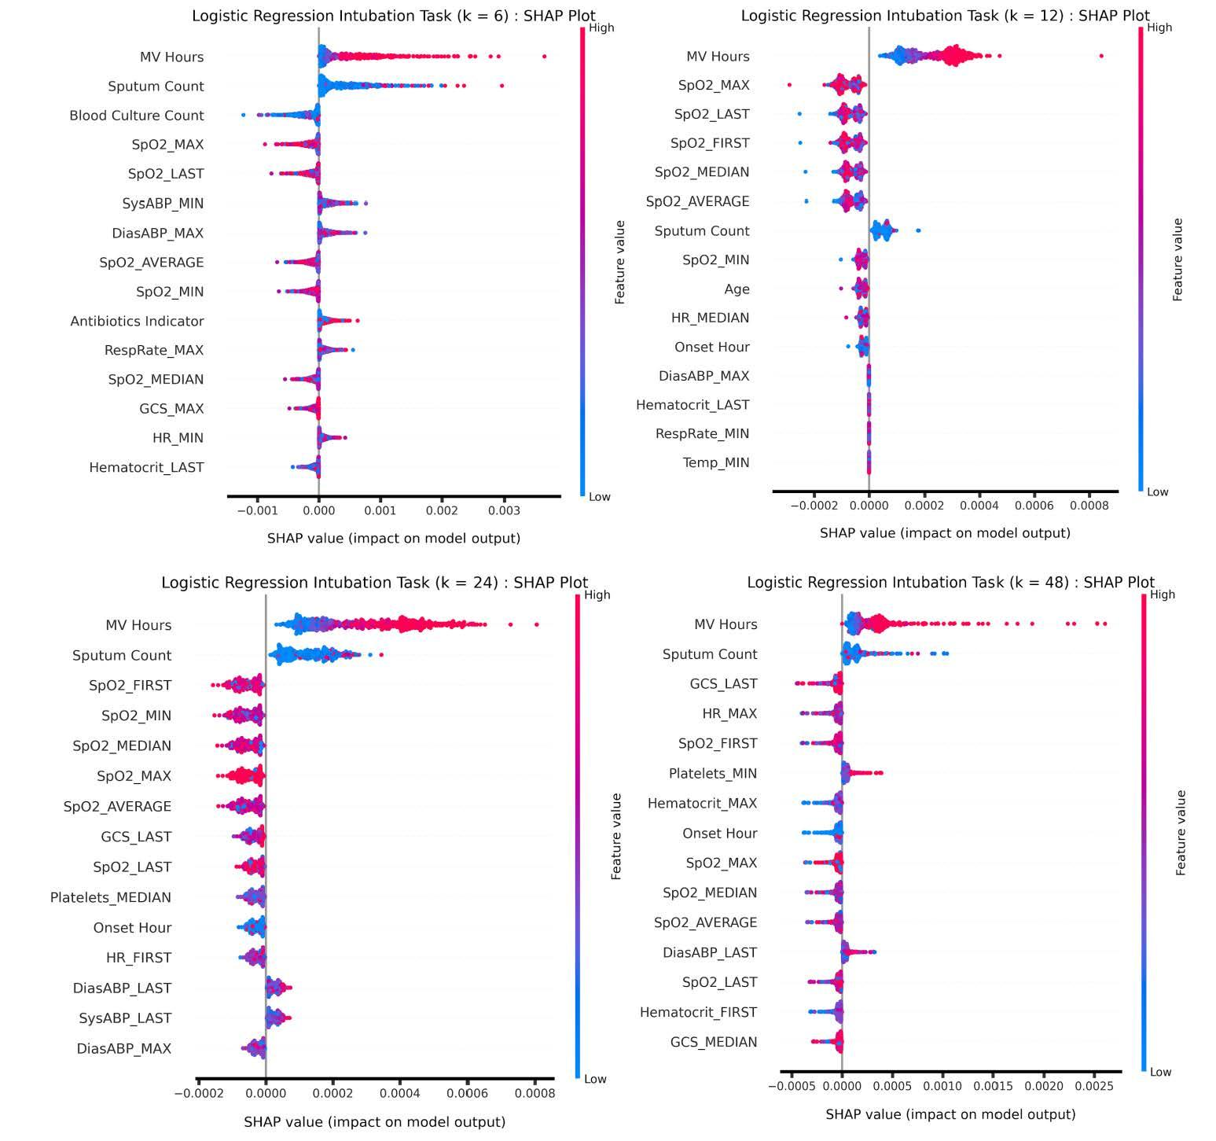
Supplementary Figure 2: Logistic Regression Intubation Task feature importance

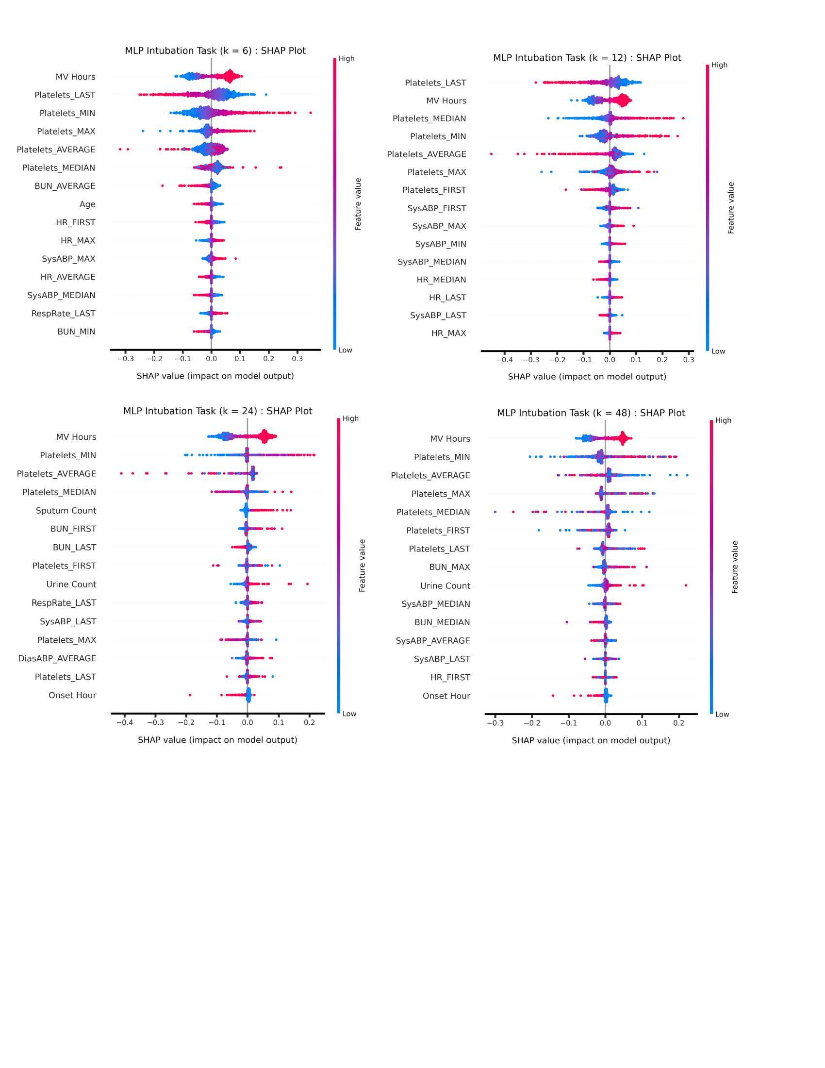

Supplementary Figure 3: MLP Intubation Task feature importance

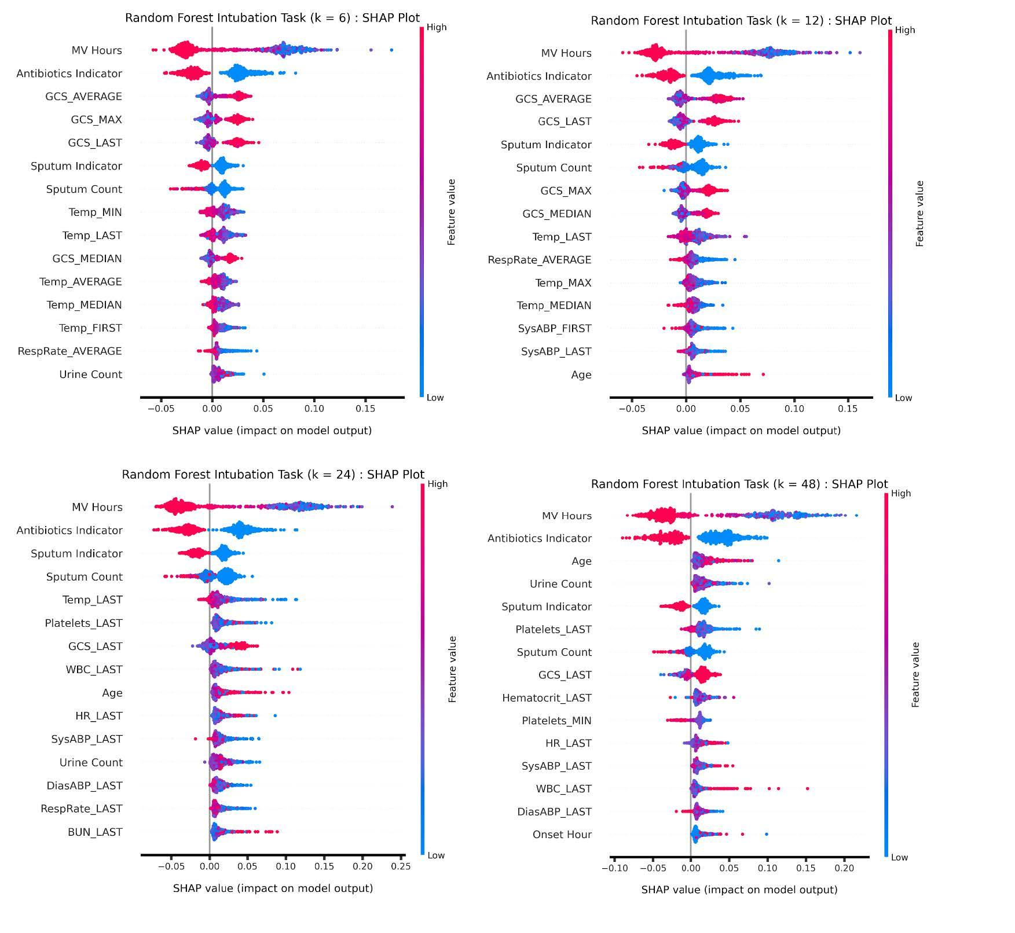
Supplementary Figure 4: Random Forest Intubation Task feature importance

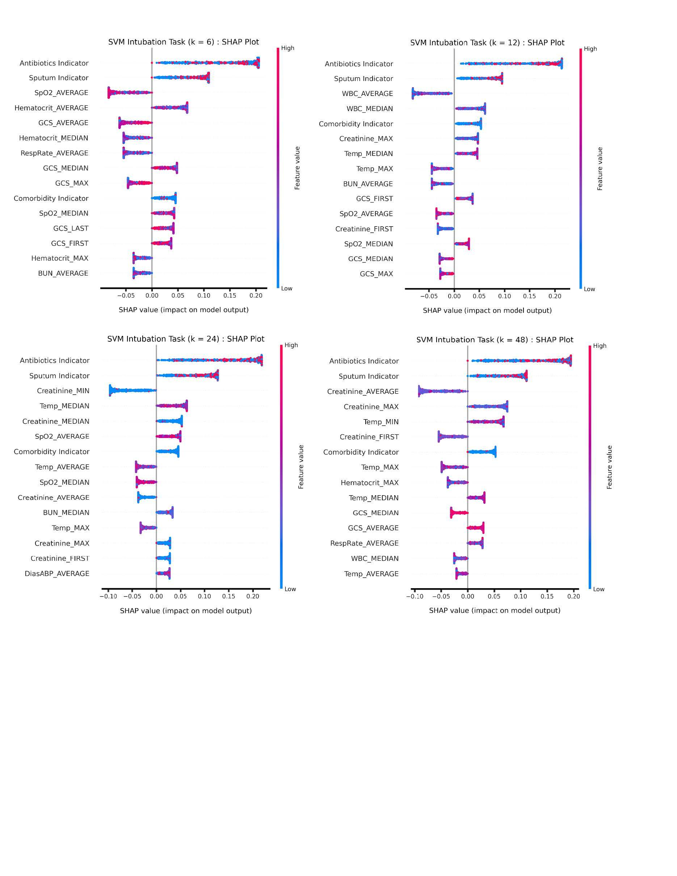
Supplementary Figure 5: SVM Intubation Task feature importance

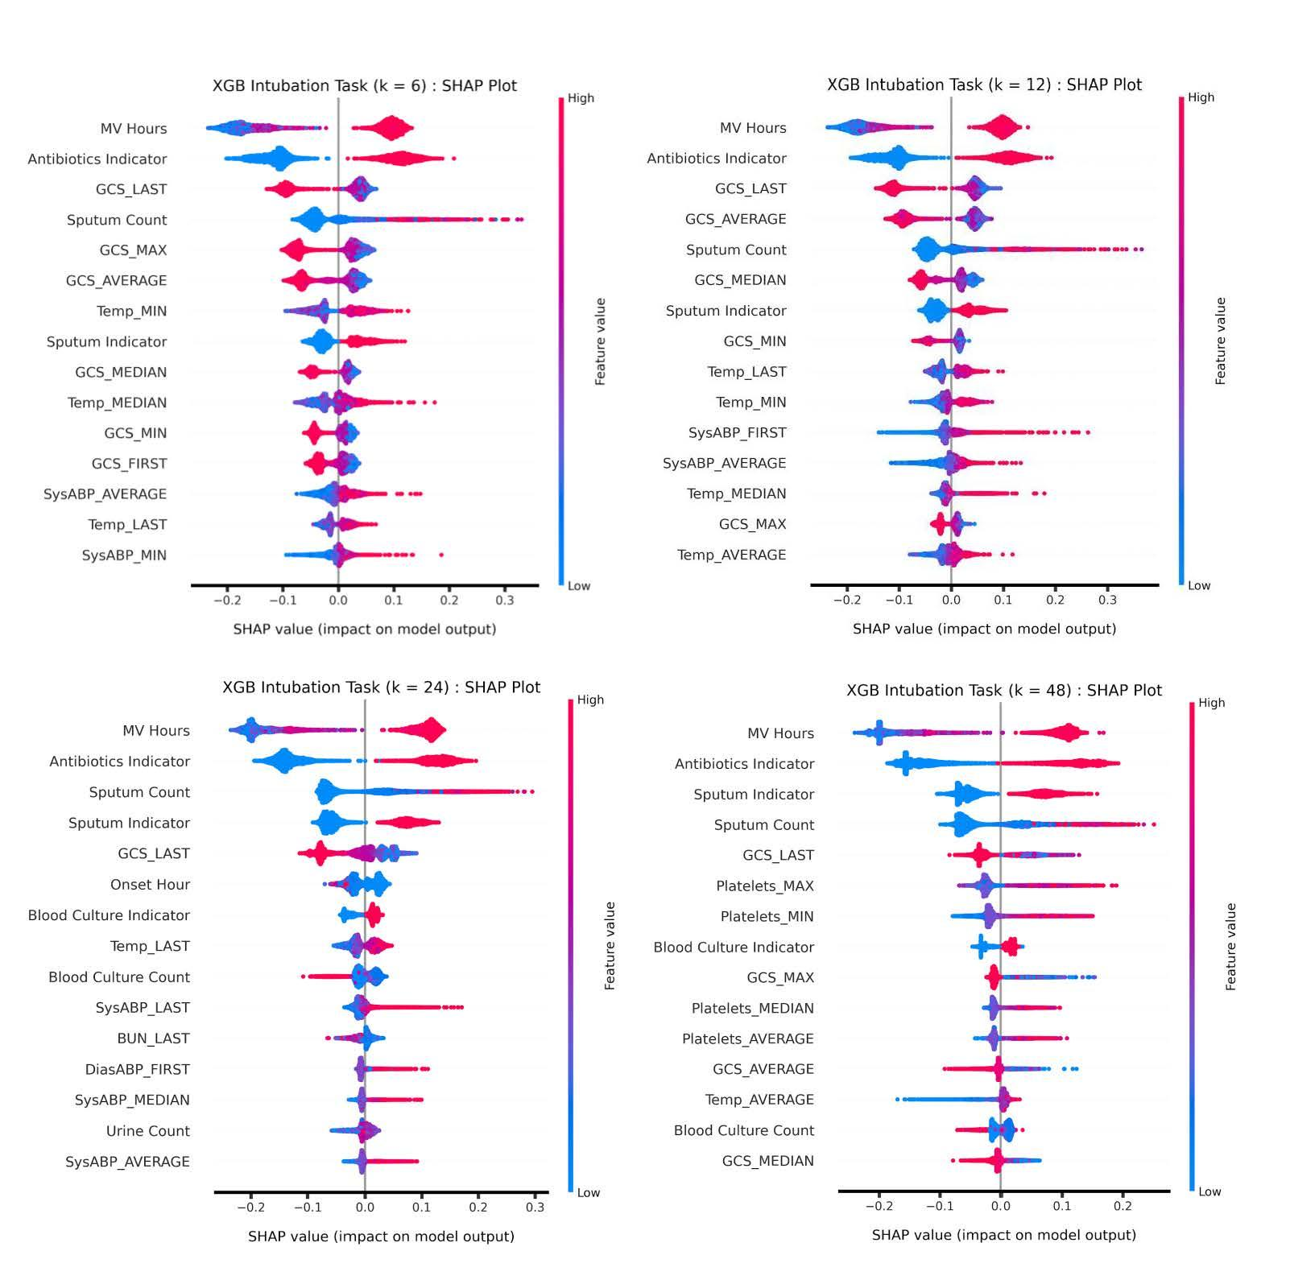
Supplementary Figure 6: XGBOOST Intubation Task feature importance
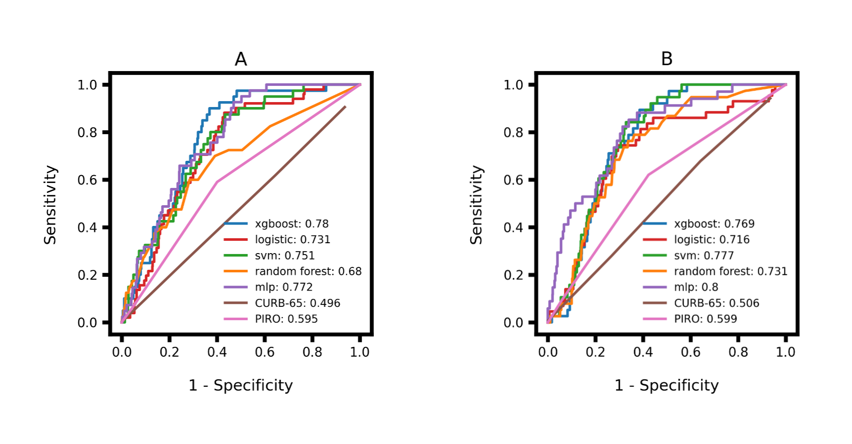
Supplementary Figure 7. ROC curve comparison for admission task models, with summary statistics calculated from the 12 (A) and 24 (B) hours of data preceding the time of prediction.

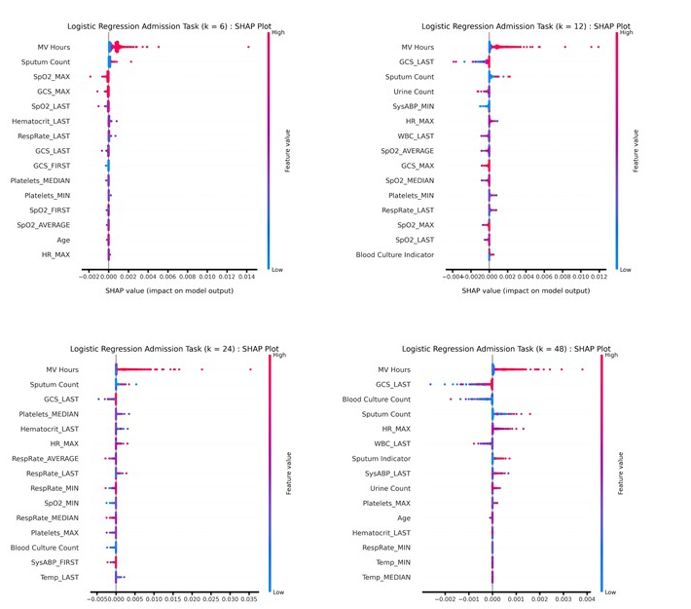
Supplementary Figure 8: Logistic Regression Admission Task feature importance

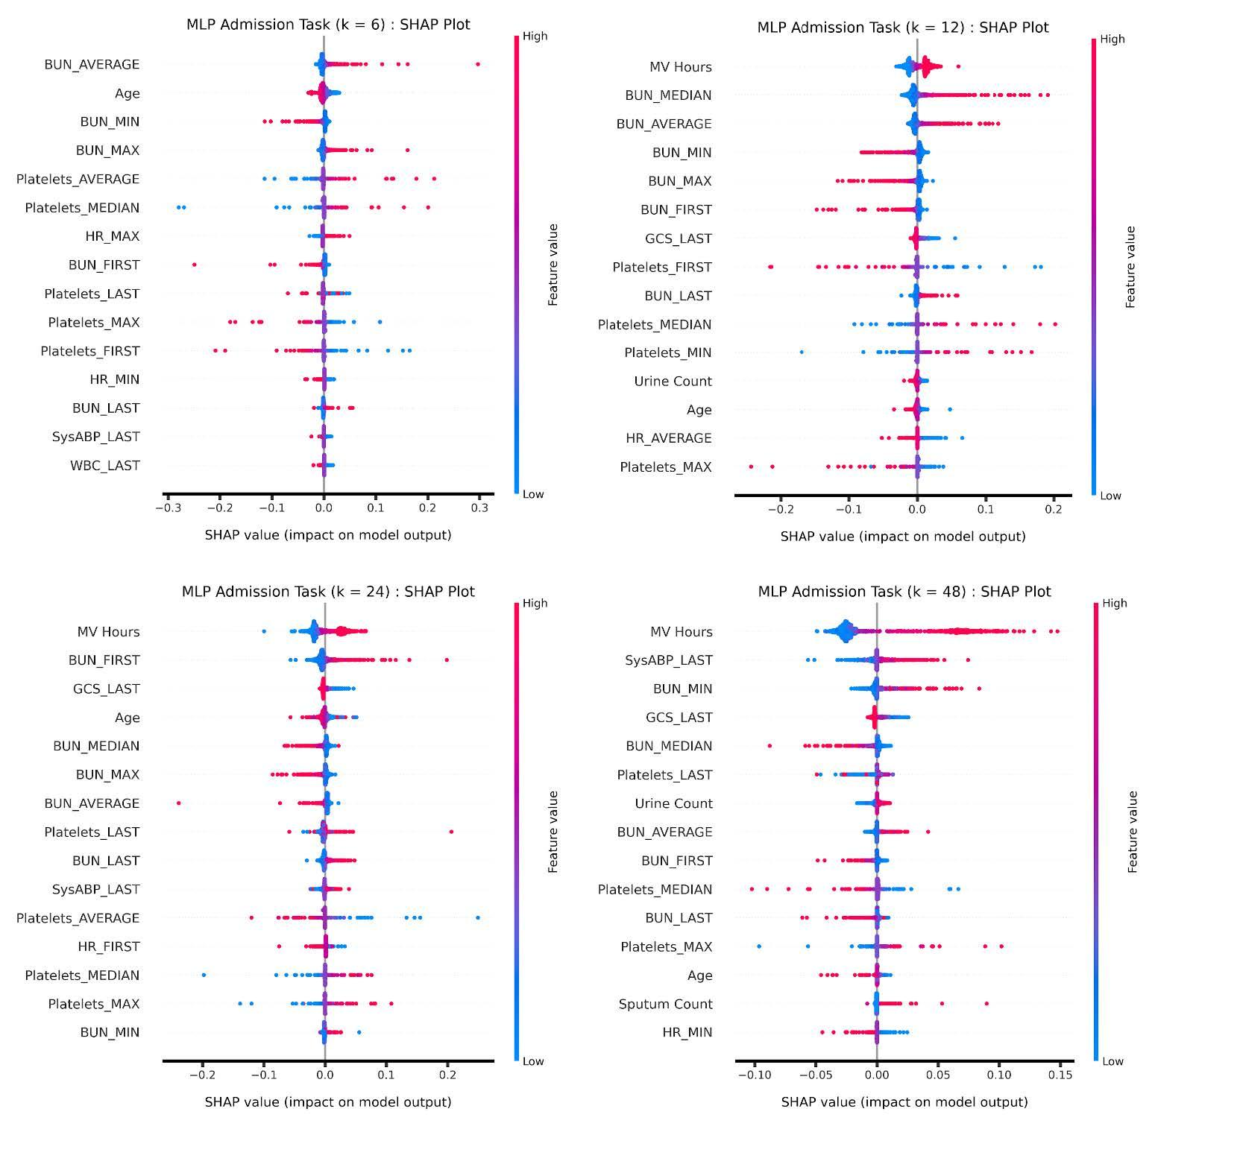
Supplementary Figure 9: MLP Admission Task feature importance

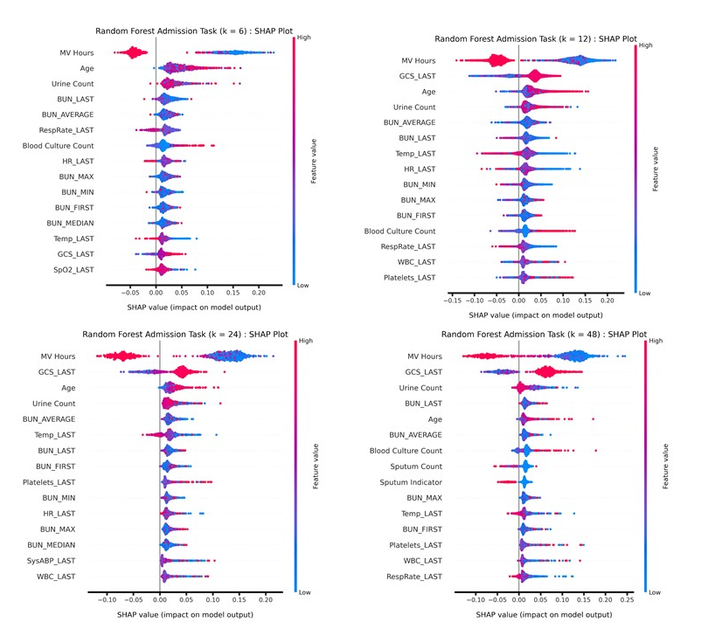

Supplementary Figure 10: Random Forest Admission Task feature importance

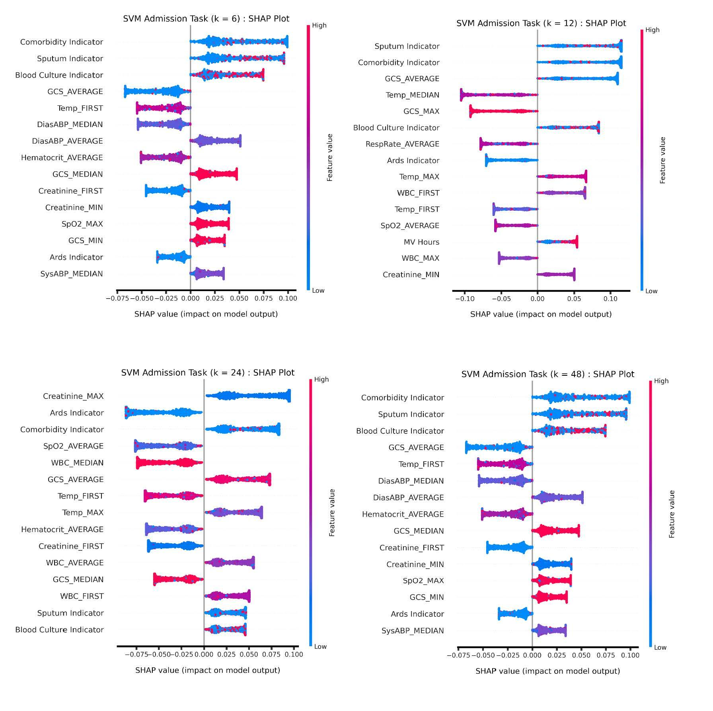
Supplementary Figure 11: SVM Admission Task feature importance

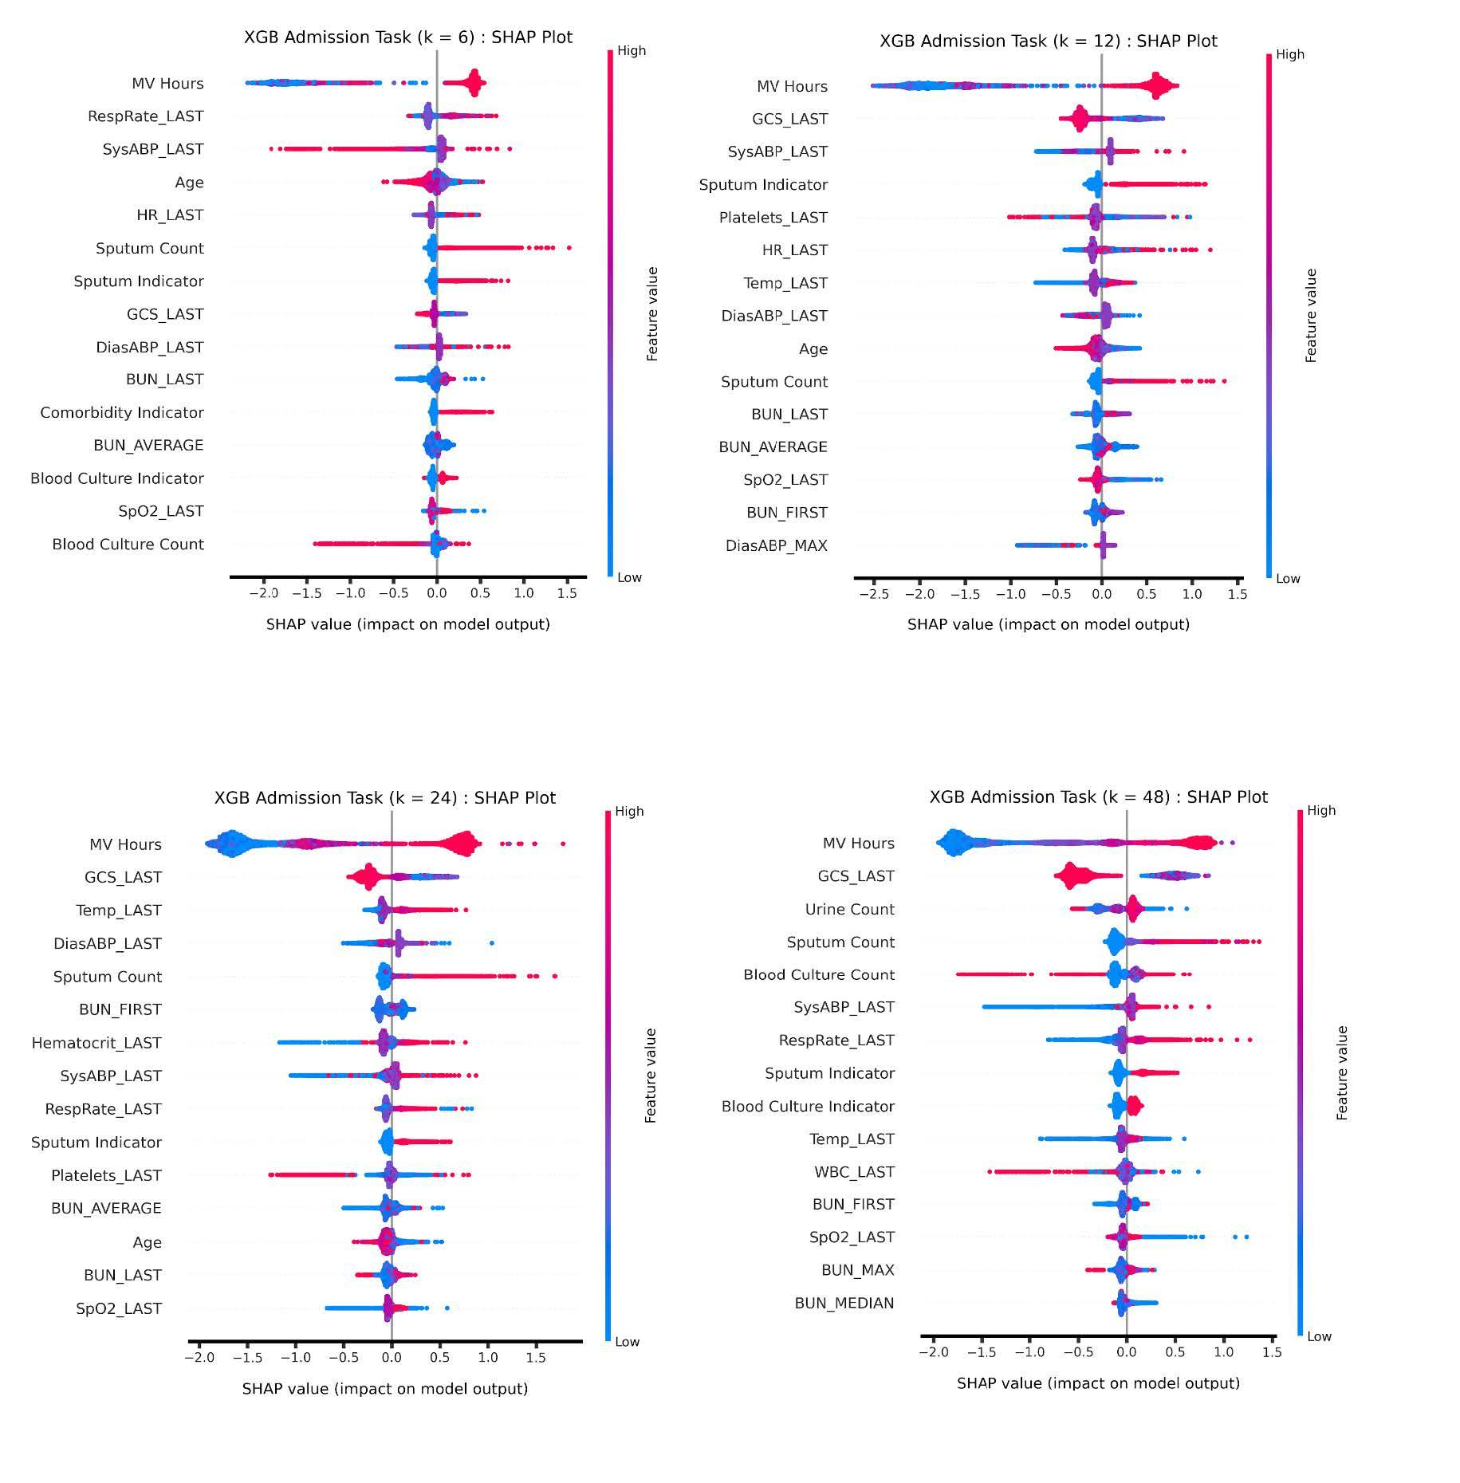
Supplementary Figure 12: XGBOOST Admission Task fe

