Supporting materials for

Protected areas enhance long-term carbon sequestration in China's forests
Contents of this file
Text S1 and S2
Figures S1 to S20

Abbreviation List
Abbreviation | Meaning
C | Carbon
PA | Protected area
PA_{out} | Match of protected area
SOC | Soil organic carbon
CD | Carbon density
CSR | Carbon sequestration rate
BC_{gain} | Difference in forest carbon density between PA and PA_{out}

Text S1. Detailed information on FCS model (methods, key parameters, validation and evaluation)
The Forest Carbon Sequestration (FCS) model was initially developed by He et al. in 2017 and later refined by Cai et al. ^{[1]}. It is designed to predict C sequestration in China's forest ecosystems under climate change scenarios, covering both forest biomass C pools and soil organic C pools ^{[1-5]}. The FCS model incorporates secondary succession theory through a stock-difference method, providing a specialized framework for simulating the complex C sequestration dynamics of forest ecosystems. The verification results are shown below in Figure S6~Figure S8.
During model application, the FCS model uses forest ecosystem baseline C density (CD, t C ha⁻¹) and climate data for predictive scenarios to predict the C sequestration potential of different C pools (e.g., biomass, litter, and soil) across different research periods (e.g., between 2020 to 2060).
1.1. Vegetation C cycling. Regarding vegetation biomass C sequestration, the classic view of ecology points out that the forest vegetation growth background has a huge impact on forest growth dynamics ^{[6, 7]}. The biomass C storage will reach a relative equilibrium in natural maturation ^{[8]}. The pattern of forest growth is modeled using the logistic equation, which captures the relationship between biomass and forest age in long term ^{[9, 10]}. By defining key growth equation parameters with climate effects, the model predicts forest biomass C sink dynamics under the nonlinear combined influences of forest age and climate ^{[11]}. Its definition is as follows:
（1）
Solving differential equations for Formula 1 to obtain Formula 2:
（2）
where B_{t0} represents the initial forest biomass (t ha⁻¹) at the moment t₀, t₀ and B_{t0} express the growth state of forests. In this study, we used remote sensing data for protected areas (PAs) and 3365 field surveys vegetation biomass measurements for matched control samples. B_{max} is the maximum vegetation biomass (t ha⁻¹) in mature forests, as calculated by Peng et al. ^{[12]}. Based on the results of path analysis, Peng et al. identified MAT and MAP as the most effective factors for predicting forest B_{max}. Vegetation biomass in mature forests was calculated with MAT and MAP using Formula 3 , as follows:
（3）
Where MAT and MAP is the mean annual temperature (°C) and mean annual precipitation (mm) for t corresponding years, were obtained from the National Climate Center.
v₀ is the intrinsic growth rate, represents the maximum growth rate under conditions where vegetative growth is unconstrained by environmental factors, nutrient availability, or disturbances. The Miami model identifies MAT and MAP as primary determinants of vegetation productivity ^{[13]}; consequently, we hypothesize that this model can be applied to estimate v₀ given known vegetation biomass, MAP, and MAT. Based on Liu's refinement of the Miami model ^{[14]}, we represent the resource competition effect in vegetation biomass growth as a variable coefficient to arrive at Formula 4:
（4）
where dB_{Miami} is the annual productivity estimated by the modified Miami model (t ha⁻¹ yr⁻¹), as expressed by Formula 5:
（5）
So, we derived that v₀ depends on both MAT and MAP ^{[15, 16]}. We obtained long-term (1961–2010) MAT and MAP data collected from 722 meteorological stations across China ^{[17]}. From the 3,365 investigated plots, we selected 501 plots located within approximately 10 km buffer zones of meteorological stations to develop a novel relationship among v₀, MAT, and MAP (Equation 6; R² = 0.50, RMSE = 0.07) ^{[1]}. As expressed by Formula 6:
（6）
For the prediction of forest soil organic C sequestration, two processes are incorporated: litter C cycling and soil C cycling.
1.2 Litter C cycling: Litter refers to the residual biomass shed from forest vegetation following phenological and climatic rhythmicity. The annual litter increment is calculated as the annual input (LPₜ) minus the amount decomposed (k₁ × Lₜ), as expressed by Formula 7:
（7）
By solving the differential equation, we obtain Formula 8:
（8）
where L_{t0} is the initial amount of litter (t ha⁻¹); B_{t} is the forest vegetation biomass (t ha⁻¹); ${\text{LP}}_{\text{t}}$ is the annual production of litter (t ha⁻¹ yr⁻¹), as followed:
（9）
where a_{i} is the biomass allocation coefficient among different organs; T_{i} is the turnover time of each organ (yr), with 1, 2, and 3 representing leaves, branches, and roots, respectively. The specific values of these parameters are referenced from the Biome-BGC model and the CEVSA model ^{[18, 19]}.
Different vegetation organs decompose at different rates, a variation primarily attributed to differences in their chemical stability. k₁ as shown in Formula 10
（10）
where ${\text{ ε}}_{\text{i}}$ is the relative humification rate of different litter types, assigned as ${\text{ ε}}_{\text{1}}$ = 1.0 (leaves), ${\text{ ε}}_{\text{2}}$ = 0.5 (stems), and ${\text{ ε}}_{\text{3}}$ = 2.0 (roots); AET refers to the annual actual evapotranspiration (mm yr⁻¹); while litter inputs follow a fixed mass ratio of leaves : stems : roots = 0.78 : 0.15 : 0.07.
1.3 Soil C cycling: The annual increment of soil organic C is quantified by the difference between its annual input (Iₜ) and decomposition (k₂ × Cₜ), as expressed in the Formula 11:
（11）
By solving the differential equation, we obtain Formula 12:
（12）
where C_{t0} (t ha⁻¹) is the soil organic C density at forest age t; I_{t} is the annual input of soil organic C (), where h is the humification coefficient set to 0.3 ^{[20]}; k₁ and L_{t} defined as in 1.2 Litter C cycling; k₂ is the decomposition rate of soil organic C (yr⁻¹). Differences in the chemical properties of various soil components result in corresponding variations in their decomposition rates. In the model, Soil organic C pool is partitioned into two pools: an active pool (easily decomposed humus, 98.5%) and an inert pool (refractory humus, 1.5%) ^{[20]}. The k₂ is derived from the Yasso model as follows ^{[15]}:
（13）
（14）
（15）
where${\text{k}}_{\text{2i }}$is the decomposition rate of humus;${\text{k}}_{\text{i0}}$is the decomposition rate of humus under standard conditions;${\text{ MAT}}_{\text{0}}$is the mean annual temperature under standard conditions (3.3°C);$\text{ D }$is dryness, determined as the difference of MAP and mean annual potential evapotranspiration;${\text{ D}}_{\text{0}}$is dryness under standard conditions (−32 mm); ${\text{s}}_{\text{i}}$ is a parameter; $\text{β}$ (0.105) and $\text{γ}$ (0.00274) are parameters quantifying the temperature and the drought effects; 1 is easily decomposed humus; 2 is refractory humus.

Text S2. Details of national-scale forest sampling and standardized field protocols
The field survey data utilized in this study were primarily derived from the Strategic Priority Research Program of the Chinese Academy of Sciences. Between 2011 and 2015, the project team implemented a standardized sampling protocol based on IPCC guidelines and systematic grid-based rules.
A total of 380 forest sampling areas were randomly selected across China, with 7 sampling sites established within each area, resulting in approximately 2,600 sites. At each site, three representative forest plots (1,000 m² each) with similar growth conditions were surveyed, totaling 7,800 plots nationwide. Within these plots, all trees with a diameter at breast height (DBH, measured at 1.3 m) ≥ 5 cm were measured. To characterize the understory vegetation (including shrubs, seedlings, and herbaceous plants), three 2 × 2 m² subplots were randomly positioned within each 1,000 m² plot, while one 1 × 1 m² quadrat was established for the collection and measurement of forest floor litter.
Comprehensive site-specific information was also recorded, including geographical coordinates, elevation, aspect, and slope; soil properties such as type, depth, gravel content, and bulk density; and vegetation attributes including origin (natural vs. plantation), community type, forest age, and canopy closure. Furthermore, the degree of anthropogenic disturbance was systematically documented for each site ^{[21, 22]}.
Based on the completeness of the data, this study selected 3,365 forest plots (Fig. S5), including data such as initial vegetation biomass, forest age, litter amount, and soil organic C content in the 0-20 cm layer.

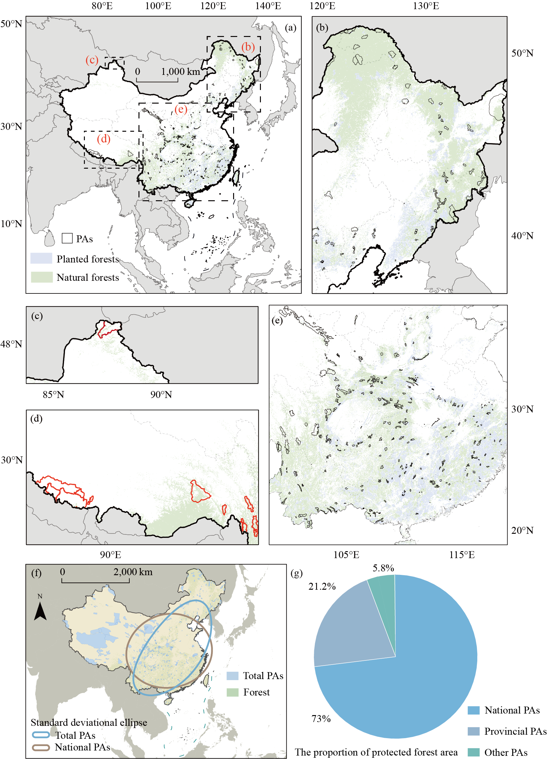
Supplementary Figure 1. Spatial distribution and ecological representativeness of protected areas (PAs) in China. (a) illustrates the geographic locations of protected areas (PAs) across the study area; (b-e) depict the spatial details and morphological characteristics of selected PAs; (f) demonstrates the spatial representativeness of national protected areas. The brown and blue standard deviational ellipses show the spatial aggregation and orientation of national PA and total PA in China within one standard deviation; (g) shows the proportion of China’s protected forests covered by PAs under different management levels.
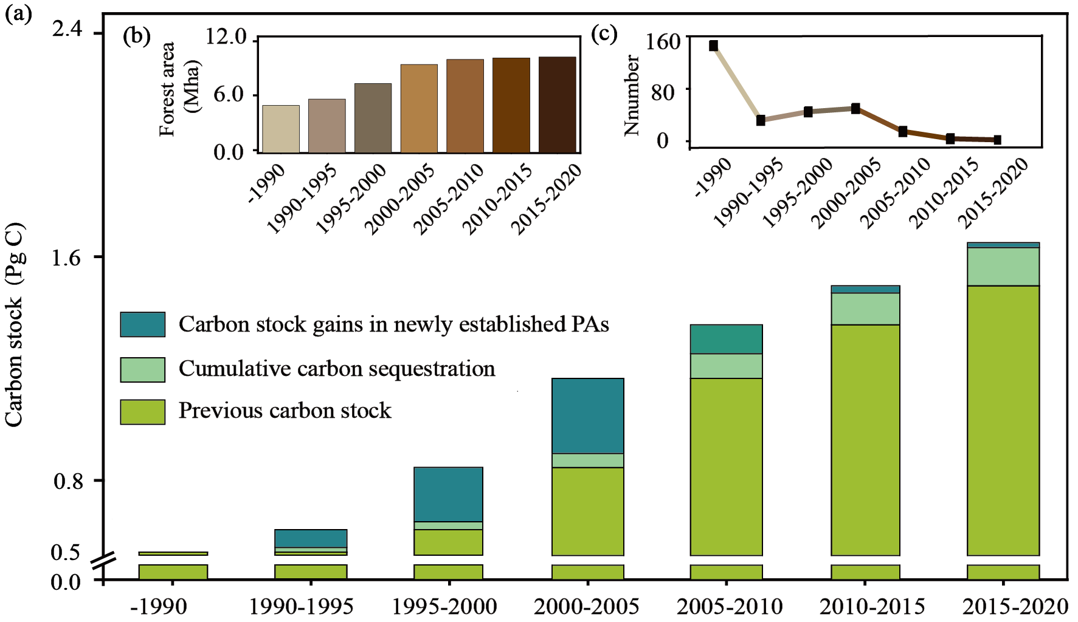
Supplementary Figure 2. Dynamics of 294 forest-type protected areas (PAs) construction and C sequestration from 1990 to 2020. Over the past 30 years (1990-2020), construction base of the PAs doubled and effectiveness of the construction is clear to see. Approximately 150 forest-type PAs have been established, protecting 5.17 Mha of forest, and the C sequestration rate of these PA is on an upward trend. (a) represents forest C stocks and growth dynamics in forest-type PAs in China over the past 30 years. (b) and (c) represent the expansion of forest area in China's forest-type PAs over the past 30 years through the establishment of new PAs, and the number of PAs established in each period, respectively.

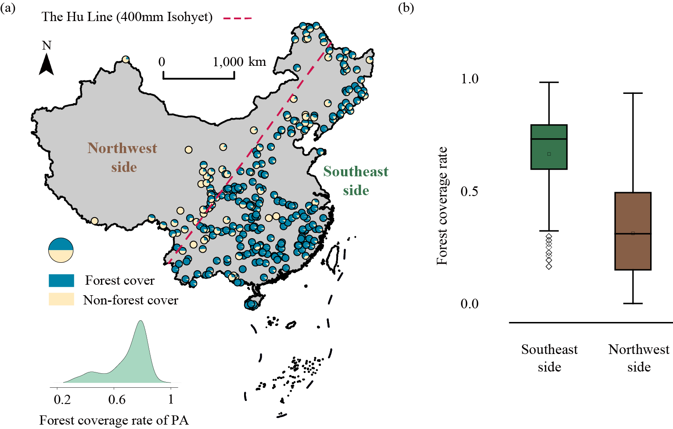
Supplementary Figure 3. Forest cover of 294 forest-type protected areas (PAs) in China in 2020. (a) illustrates the forest cover levels of 294 forest-type PAs across China. (b) displays the differences in forest cover between the PAs located on either side of the 400 mm annual precipitation isopleth.

Supplementary Figure 4. Comparison of C density (CD, t C ha⁻¹) differences between protected area (PA) and their provinces. (a) Comparisons were made in terms of forest vegetation, soil and ecosystems, with the bars representing the magnitude of the CD differences. No data are available for Jiangsu and Taiwan, and they are not included in the comparison. Green and brown denote CD of PA forest ecosystem exceeding and below CD of province forest. (b) Carbon sequestration gains from protected areas across China's provinces. Pie charts compare carbon sequestration gains in biomass and soil organic carbon pools.

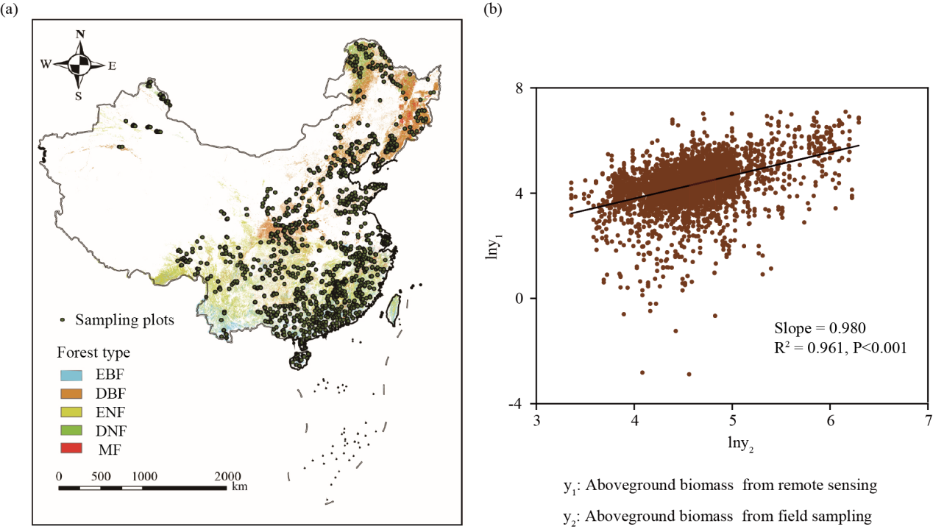
Supplementary Figure 5. Spatial distribution of 3365 field plots across China's forest ecosystems. (a) illustrates the representativeness of the field sampling plots. (b) shows the correlation between remote sensing data and field measurements. Comparative analysis demonstrates strong consistency between remote sensing and ground-measured data in forest aboveground biomass estimation.

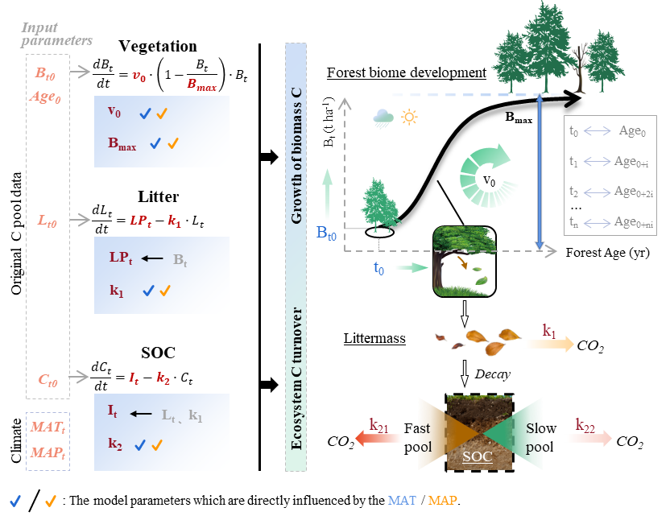
Supplementary Figure 6. Functional framework and key parameterization of the FCS model. The left panel illustrates three C cycling processes simulated by the FCS model. The corresponding equations, parameters, and input data for each process are also provided in this part. The C turnover rates are determined by temperature and precipitation, which in turn are used to predict future C stocks in climate scenarios. These climatic inputs enable the model to simulate forest C sequestration dynamics under various climate change scenarios. Moreover, initial C pool data (B_{t0}, L_{t0} and C_{t0}) enable the model to simulate future C stock growth across various forest stands. The model utilizes forest age as a primary driver to predict C stocks at different time points. This execution achieves the final projection of forest ecosystem C sinks, including biomass and soil C (0–100 cm). The right panel illustrates the primary C turnover processes within the FCS model and the associated temporal calculation logic. It depicts how biomass increments are allocated and cycled through different ecosystem compartments over time.

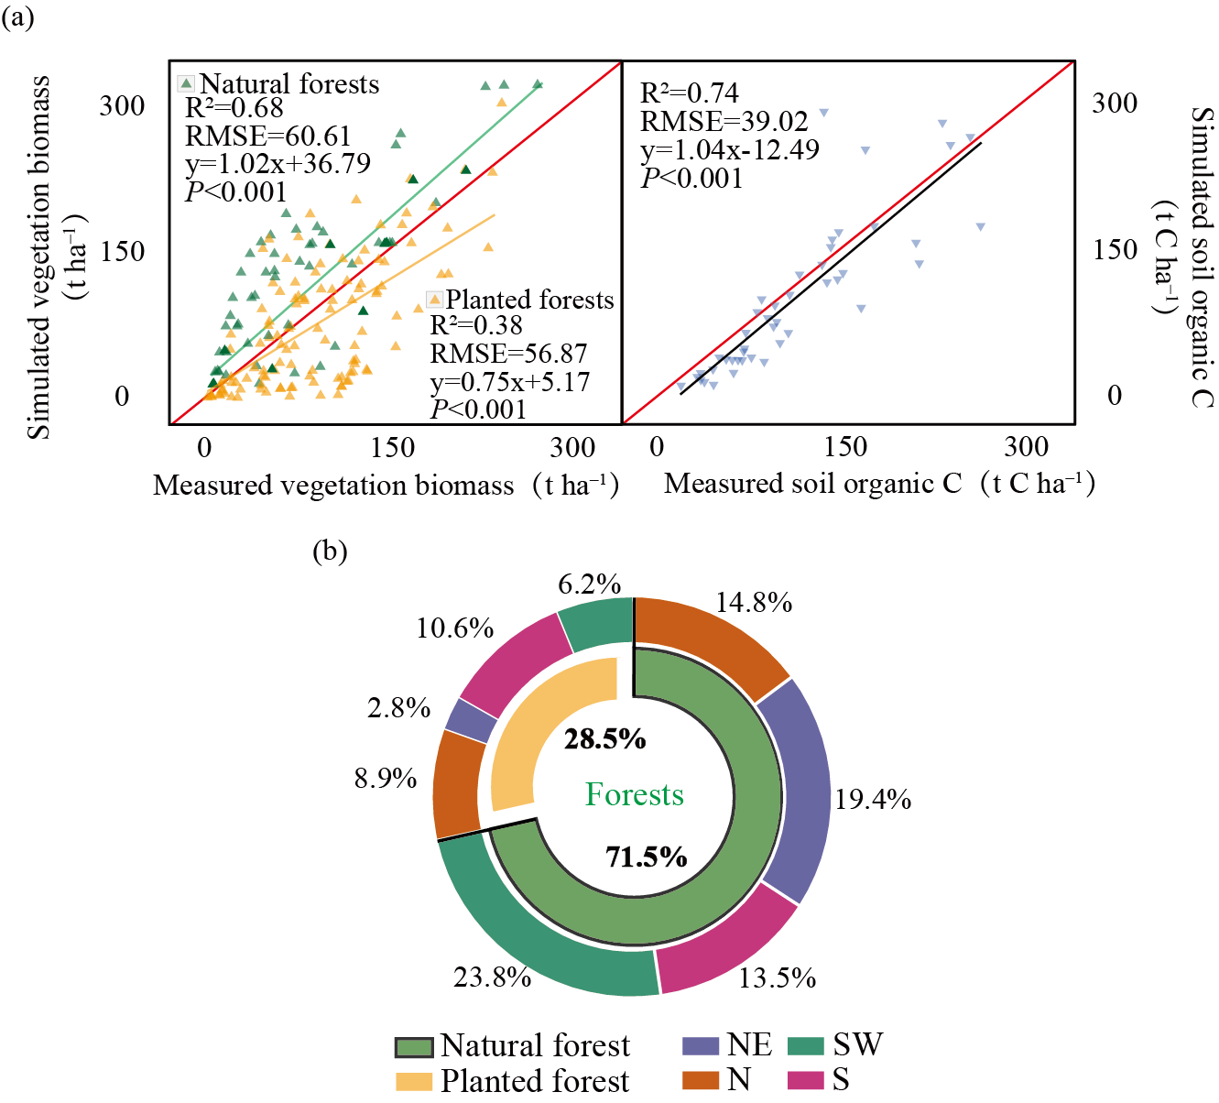
Supplementary Figure 7. FCS Validation of the FCS model using long-term datasets and forest type composition. (a) presents the validation results for natural forest biomass (t ha⁻¹), plantation biomass, and soil organic C density (t C ha⁻¹). The red lines represent the 1:1 reference lines. (b) illustrates the composition of forest origins across 294 PAs. This panel also shows their spatial distribution across four forest areas.

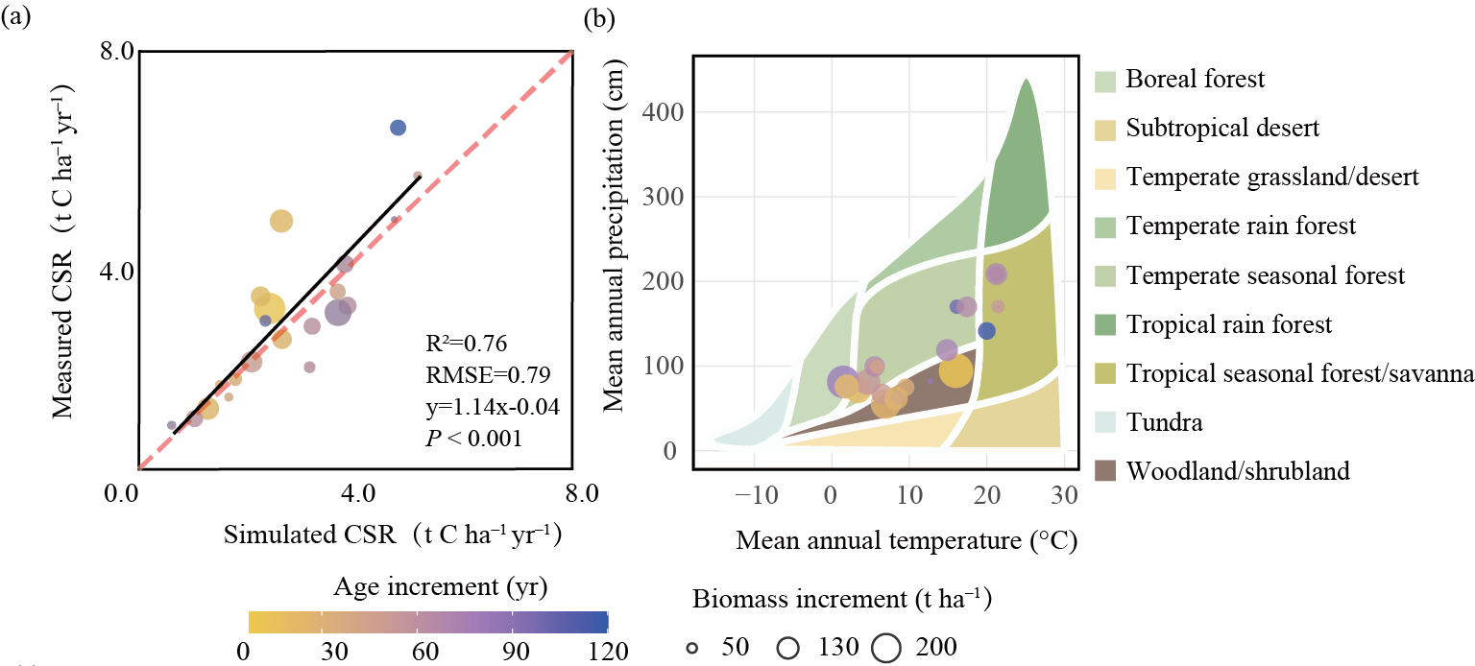
Supplementary Figure 8. Assessment of the FCS model performance in simulating forest C sequestration rate (CSR, t C ha⁻¹ yr⁻¹). (a) illustrates the validation results, where the red line represents the 1:1 reference line. (b) shows the spatial coverage of the collected succession datasets across major forest types in China. These comprehensive datasets ensure the high reliability of the model validation results.

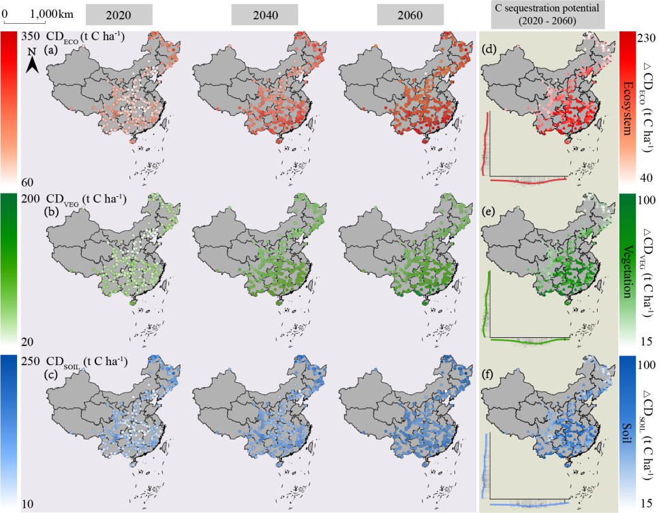
Supplementary Figure 9. Spatiotemporal pattern of C sequestration potential in China’s forest-type protected area (PA). Forest ecosystem (a) and (d), vegetation (b) and (e), soil (c) and (f) in these China PA. Panels d–f illustrate the variation in C sequestrations of different forest components along latitudinal and longitudinal gradients from 2020 to 2060.

Supplementary Figure 10. Comparison of the effects of climate factors on CSR2010–2020 in protected area (PA) forests in China. (a) Segmented linear regression equations for forest age (AGE) and C sequestration rate (CSR, t C ha⁻¹ yr⁻¹) were established for each forest area, and inflection points were selected using the “segmented” package in R software. The position of the red line indicates the inflection point, the shaded area represents the 95% confidence intervals, and the blue and gray circles represent the protected areas (PAs) that have not reached maturity and have reached maturity, respectively. (b) represent the structural equation models (SEM) illustrating the influence of mean annual temperature (MAT), mean annual precipitation (MAP), and forest age (AGE) on C sequestration rate (CSR) before and after forest maturity, respectively. (c) Comparison of the total impact of environmental factors on the CSR in forest PAs across the four major forest regions, both before and after forest maturity. The solid and dashed lines indicate significance levels with red representing positive effect and black indicating negative effects. Significance levels are *** P < 0.001, ** P < 0.01, * P < 0.05.

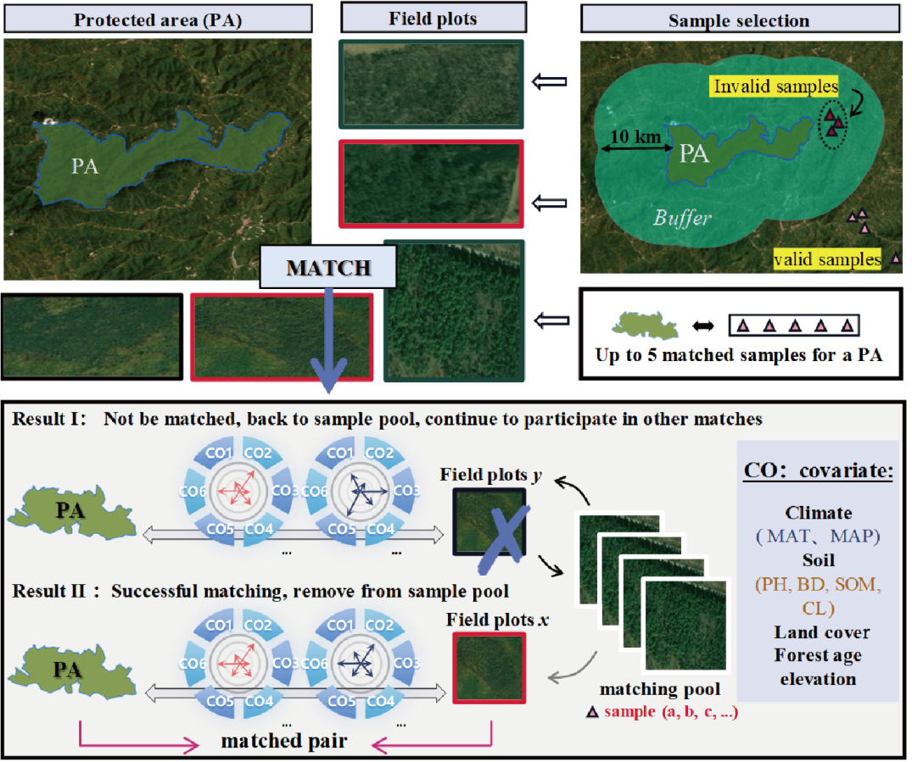
Supplementary Figure 11. Schematic diagram of propensity score matching (PSM) matching method in study. The PSM method was used to match the plot with the PA to achieve an effective comparison of C storage. The covariates used in the matching included forest age (AGE), mean annual temperature (MAT), mean annual precipitation (MAP), soil pH (PH), soil bulk density (BD), soil organic matter (SOM), elevation, soil texture (CL), and forest type (LC). Each sample involved in matching has a dichotomous result, which is matched or not matched. Each sample only supports the matching of one PA, and the sample that is not matched is eventually discarded. To avoid potential neighboring effects and spatial contamination, we excluded all sample plots located within a 10-km buffer zone surrounding the protected areas (PAs). This ensures that the control groups represent truly unprotected conditions unaffected by the proximity to conservation boundaries.

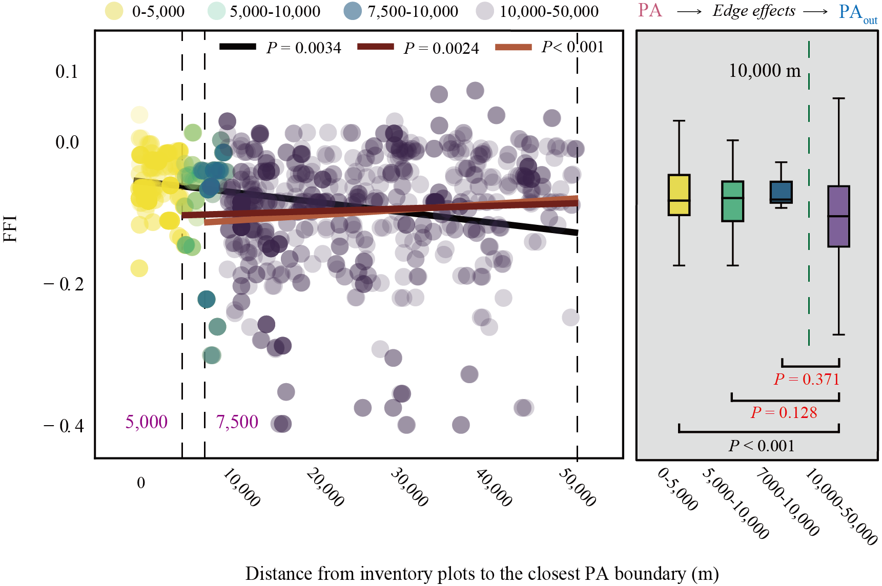
Supplementary Figure 12. Assessment of appropriate buffer distances based on the forest fragmentation index (FFI). Utilizing the nationwide forest fragmentation product developed by Ma et al., we quantified the spatial extent of edge effects. The scatter plot illustrates the spatial variation of FFI in relation to the Euclidean distance from the nearest PA boundary. The box plot displays the statistical discrepancies in FFI across different distance intervals.

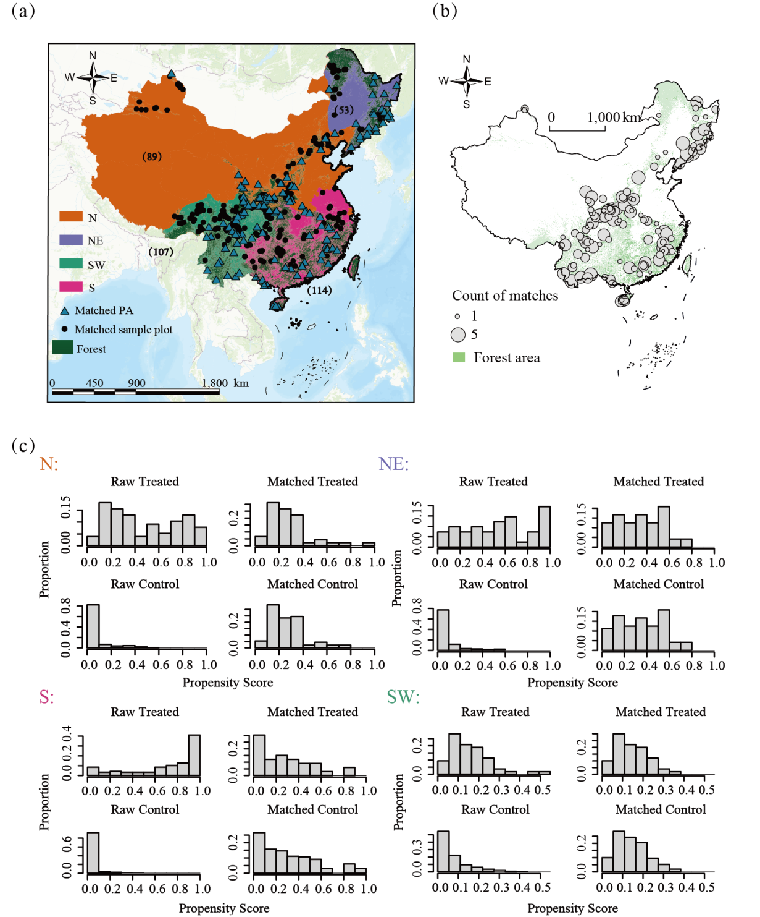
Supplementary Figure 13. Matching between protected areas (PAs) and sample plots outside PAs. A total of 393 pairs of matches were formed after matching by propensity score matching, of which 124 PAs received comparisons with effective matches. (a) Map of the distribution of matched sample plots and PAs. (b) Spatial distribution of the count of matches obtained for the PAs. (c) Histogram of propensity scores for the four forest areas. The conservative effect of PA is the treatment. Within each forest area, the raw group represents the score histogram of unmatched samples and the matched group represents the matched score histogram after matching. The similar distribution of propensity scores between the control and treatment groups after matching proves better matching work. The numbers in the (a) represent the count of matches within each forest area.

Supplementary Figure 14. Comparison of matching quality. (a) Spatial distribution of protected areas (PAs) and their corresponding statistical profiles under varying matching ratios (1:1 to 1:5). Figure (b) demonstrates that all matching results achieved high matching precision, characterized by a mean intra-pair standard deviation (SD) of < 0.02. Furthermore, the matching quality remained statistically indistinguishable across the various matching ratios, indicating the robustness of the matching results.

Supplementary Figure 15. An age-informed matching framework reduces the influence of forest growth on matching outcomes. (a) presents the correlation analysis between forest biomass and forest age based on remote sensing datasets. (b) illustrates the age distribution of protected areas (PAs) in the matched groups. (c) demonstrates that age-adjusted matching significantly reduced the intra-pair age divergence, where the whiskers represent the mean standard deviation (SD) of age within each matched pair across different matching methods.

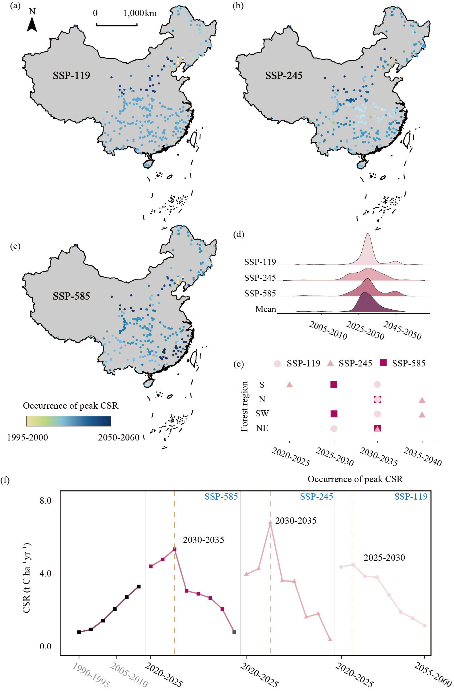
Supplementary Figure 16. Temporal variability of C sequestration rates (CSR) across diverse climate scenarios. Figures (a-c) illustrate the distribution of timing of peak CSR for 294 protected areas (PAs) under low-, intermediate-, and high-emission scenarios. (d) The ridgeline plots illustrate the probability density of timing of peak CSR across three SSP scenarios (SSP1-1.9, SSP2-4.5, and SSP5-8.5) and their multi-scenario mean, spanning from 2005 to 2060. Figure (e) represents the timing of peak CSR across the four forest areas in China under varying climate trajectories. Figure (f) shows the temporal dynamics of CSRs in the 294 forest-type PA over the projection period, under three climate scenarios.

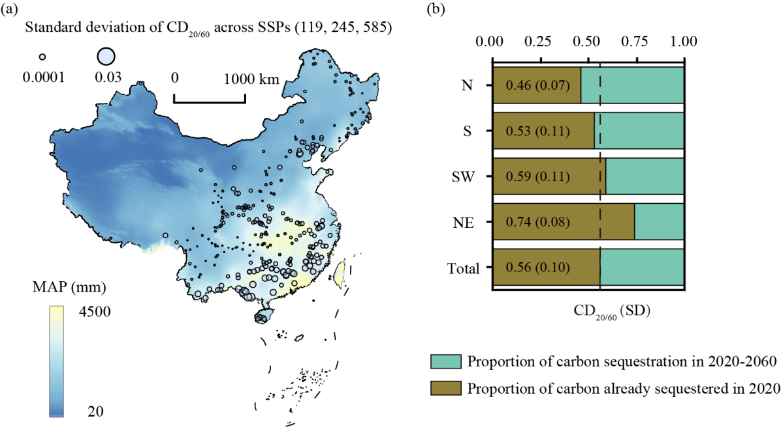
Supplementary Figure 17. Variation in relative C sequestration potential (CD_{20/60}) under three climate scenarios (SSP-1-1.9, SSP-2-4.5, and SSP-5-8.5). Figure (a) illustrates the spatial distribution patterns of relative C sequestration potential (CD_{20/60}) across different protected areas (PAs), analyzed in the context of spatial precipitation gradients. Figure (b) presents the assessment of relative C sequestration potential and its associated uncertainty for the four forest areas under three distinct climate scenarios. The values in parentheses denote the standard error (SE) of the CD_{20/60} projections across the three climate scenarios (SSP-1-1.9, SSP-2-4.5, and SSP-5-8.5).
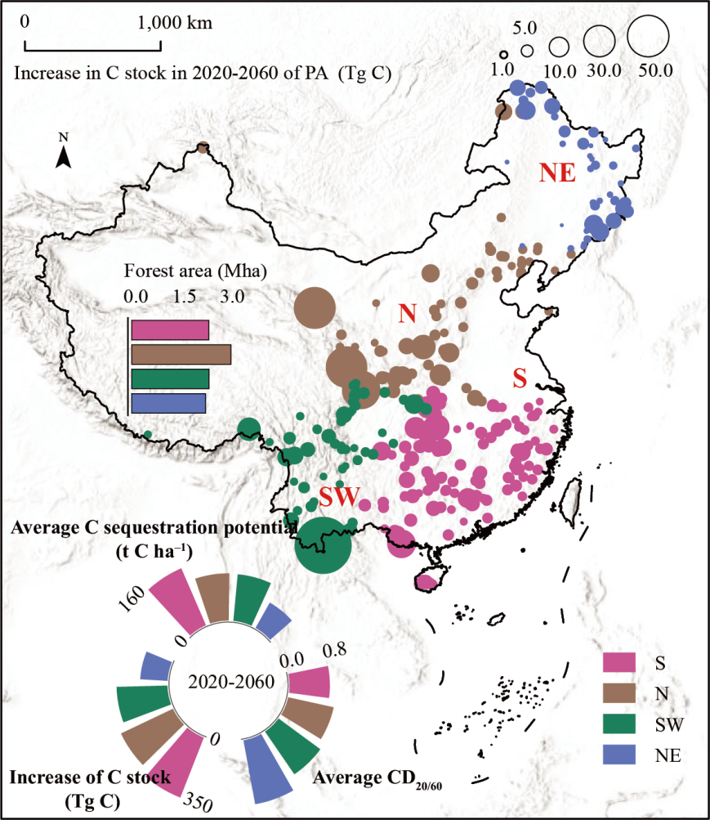
Supplementary Figure 18. C sequestration and C stock increase of 294 national forest-type protected areas (PAs) in China over the next 40 years. The size of the circles represents C stock increase (Tg C) of PA, while the color reflects the regional affiliation of each PA. Results are compared across four major forest areas to highlight regional disparities in sequestration capacity.

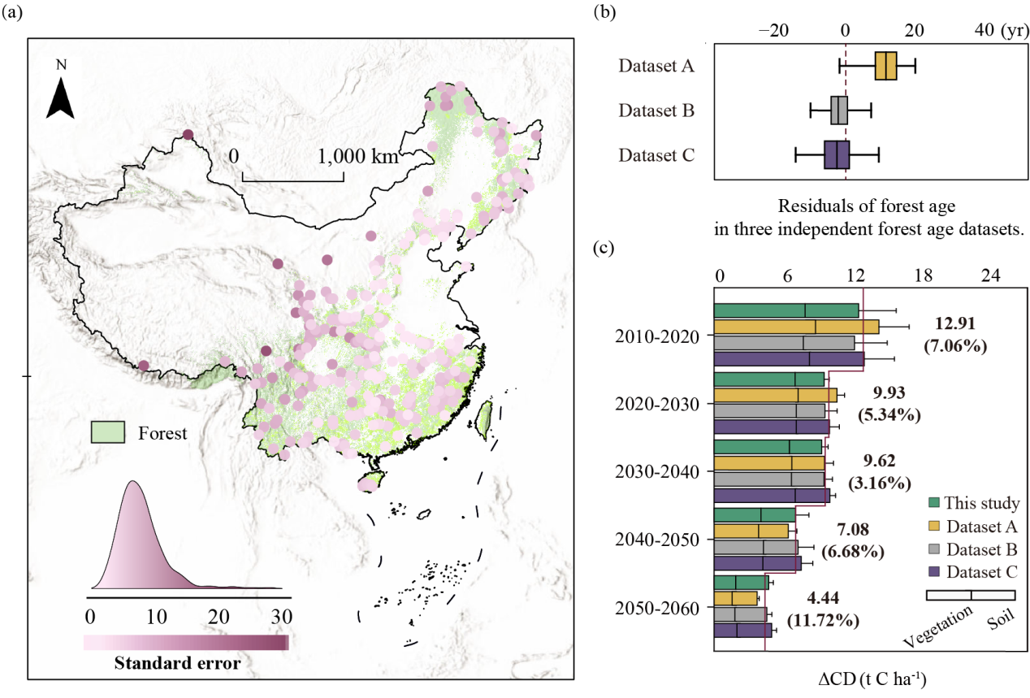
Supplementary Figure 19. The impact of uncertainty regarding the forest age on carbon sequestration gains (ΔCD) within protected areas (PAs). Figure (a) displays the distribution of standard errors across four stand-age datasets for 294 national forest-type PAs. Figure (b) compares the mean differences between the forest age datasets utilized in this study and three other independent datasets across 294 PAs. Figure (c) illustrates the uncertainty in evaluating the temporal dynamics of ΔCD derived from the four forest age datasets. The error bars represent the mean standard error of the assessment results across three climate scenarios. Numbers in parentheses indicate the coefficient of variation (CV, %) of the assessment results originating from the stand-age datasets for the period. (Dataset A: Besnard et al., 2024; Dataset B: Shang et al., 2025; Dataset C: Cheng et al., 2024).

Supplementary Figure 20. Spatial associations between species diversity and C sequestration in China's protected forests. (a) Distribution of China's forest protected areas across species-richness hotspots; (b) Joint spatial patterns of species richness and C sequestration rates in China's protected areas; (c) Density distribution of protected and national forests across species-richness classes; (d) Clustering patterns of C sequestration and species diversity across forest regions.

References
[1] Cai W x, He N p, Li M x, et al. Carbon sequestration of Chinese forests from 2010 to 2060: Spatiotemporal dynamics and its regulatory strategies. Science Bulletin, 2022, 67: 836-843
[2] Cai W x, He N p, Xu L, et al. Spatial-temporal variation of the carbon sequestration rate of afforestation in China: Implications for carbon trade and planning. Science of The Total Environment, 2023, 884: 163792
[3] Cai W x, Xu L, Li M x, et al. Imbalance of inter-provincial forest carbon sequestration rate from 2010 to 2060 in China and its regulation strategy. Journal of Geographical Sciences, 2023, 33: 3-17
[4] Cai W x, Xu L, Wen D, et al. The carbon sequestration potential of vegetation over the Tibetan Plateau. Renewable and Sustainable Energy Reviews, 2025, 207: 114937
[5] Xu L, He N p, Li M x, et al. Spatiotemporal dynamics of carbon sinks in China's terrestrial ecosystems from 2010 to 2060. Resources, Conservation and Recycling, 2024, 203: 107457
[6] Yu K, Chen H Y H, Gessler A, et al. Forest demography and biomass accumulation rates are associated with transient mean tree size vs. density scaling relations. PNAS Nexus, 2024, 3:
[7] Zhu J, Hu H, Tao S, et al. Carbon stocks and changes of dead organic matter in China's forests. Nature Communications, 2017, 8: 151
[8] Keith H, Mackey B G, Lindenmayer D B. Re-evaluation of forest biomass carbon stocks and lessons from the world's most carbon-dense forests. Proc Natl Acad Sci U S A, 2009, 106: 11635-11640
[9] Xu B, Guo Z, Piao S, et al. Biomass carbon stocks in China's forests between 2000 and 2050: a prediction based on forest biomass-age relationships. Sci China Life Sci, 2010, 53: 776-783
[10] Yang Y h, Luo Y q, Finzi A C. Carbon and nitrogen dynamics during forest stand development: a global synthesis. New Phytologist, 2011, 190: 977-989
[11] Liu Y c, Yu G r, Wang Q f, et al. How temperature, precipitation and stand age control the biomass carbon density of global mature forests. Global Ecology and Biogeography, 2014, 23: 323-333
[12] Peng B, Zhou Z y, Cai W x, et al. Maximum potential of vegetation carbon sink in Chinese forests. Science of The Total Environment, 2023, 905: 167325
[13] Lieth H. Primary production: Terrestrial ecosystems. Human Ecology, 1973, 1: 303-332
[14] Liu H J. The ecological application of Miami model. In: 1997
[15] Liski J, Palosuo T, Peltoniemi M, et al. Carbon and decomposition model Yasso for forest soils. Ecological Modelling, 2005, 189: 168-182
[16] Wen D, He N. Forest carbon storage along the north-south transect of eastern China: Spatial patterns, allocation, and influencing factors. Ecological Indicators, 2016, 61: 960-967
[17] He N p, Wen D, Zhu J x, et al. Vegetation carbon sequestration in Chinese forests from 2010 to 2050. Global Change Biology, 2017, 23: 1575-1584
[18] Hunt Jr E R, Running S W. Simulated Dry Matter Yields for Aspen and Spruce Stands in the North American Boreal Forest. Canadian Journal of Remote Sensing, 1992, 18: 126-133
[19] Cao M k, Woodward F I. Dynamic responses of terrestrial ecosystem carbon cycling to global climate change. Nature, 1998, 393: 249-252
[20] Foley J A. An equilibrium model of the terrestrial carbon budget. Tellus B: Chemical and Physical Meteorology, 1995, 47: 310-319
[21] Tang X l, Zhao X, Bai Y f, et al. Carbon pools in China’s terrestrial ecosystems: New estimates based on an intensive field survey. Proceedings of the National Academy of Sciences, 2018, 115: 4021-4026
[22] ECSP. Observation and investigation for carbon sequestration in terrestrial ecosystems by technical manual writing group of ecosystem carbon sequestration project[M]. Beijing:Science Press, 2015.

