Supplementary Material

MOF-derived S-scheme CuFe₂O₄/CuO/C heterojunctions with broad-spectrum response for efficient and stable tetracycline degradation

Liping Wang*, Ziyun Zhang, Chunyan Gao, Zhicong Li, Zhijuan Wang*, Yingchun Miao*

Corresponding author. wanglp_csu@163.com

Yunnan Key Laboratory of Crystalline Porous Organic Functional Materials, College of Chemistry and Materials Engineering, Qujing Normal University, Qujing, 655011, Yunnan Province, PR China

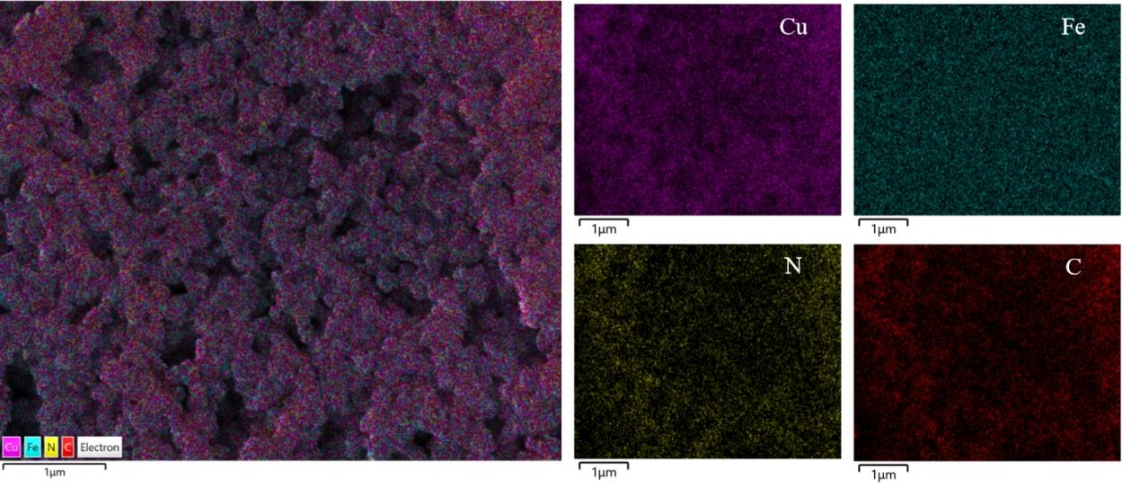
Fig. S1 Elemental mapping images of CuFe-PBA
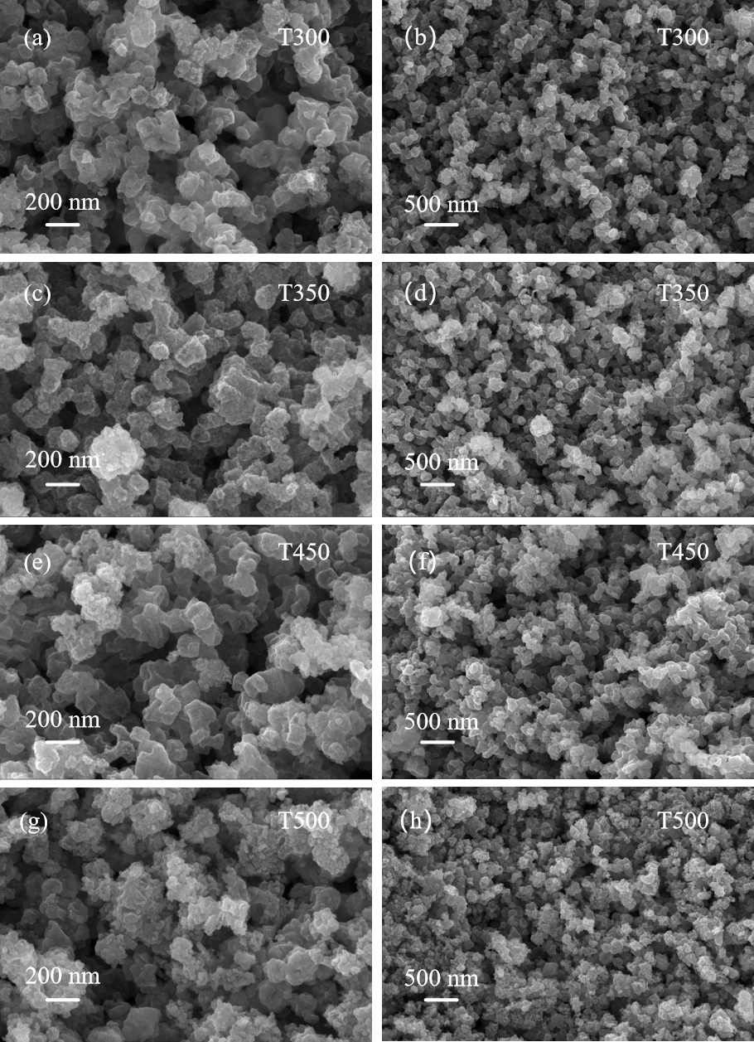
Fig. S2 SEM images of CuFe₂O₄/CuO/C composites
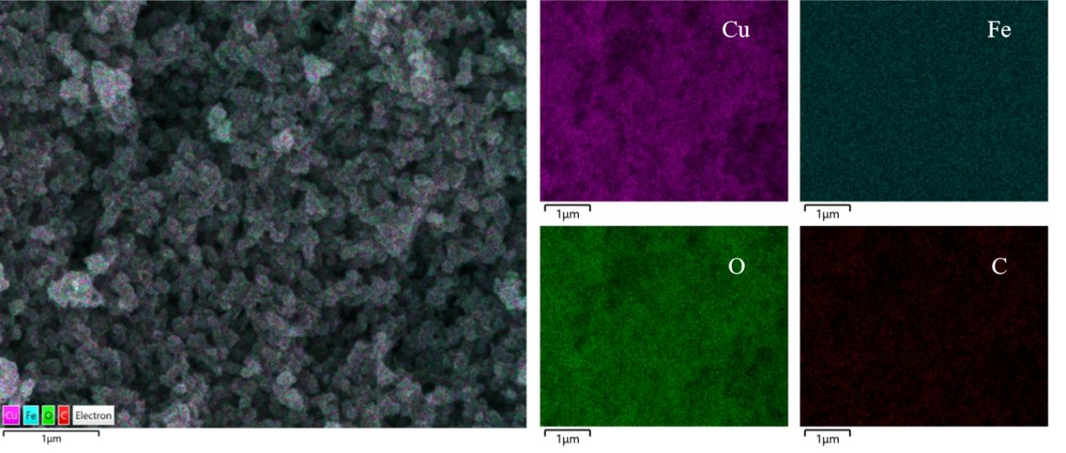
Fig. S3 Elemental mapping images of CuFe₂O₄/CuO/C synthesized at 400 ºC

Table S1 Relative amounts of different elements in CuFe₂O₄/CuO/C composites
Sample | Elements (wt%)
Sample | Cu | Fe | O | C
T300 | 43.58 | 30.07 | 20.56 | 5.80
T350 | 45.87 | 27.19 | 21.72 | 5.22
T400 | 41.23 | 34.62 | 19.82 | 4.34
T450 | 42.30 | 33.09 | 20.60 | 4.01
T500 | 42.99 | 33.19 | 19.94 | 3.68
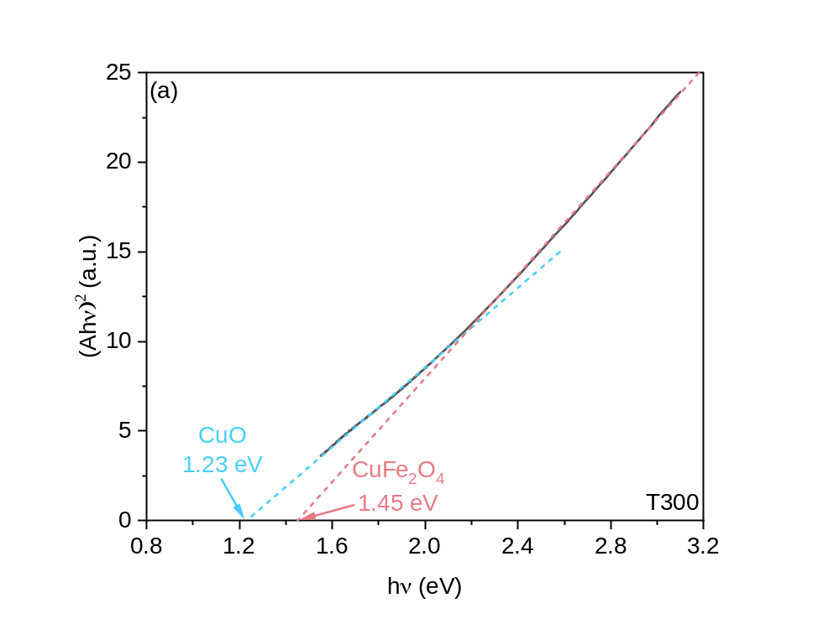
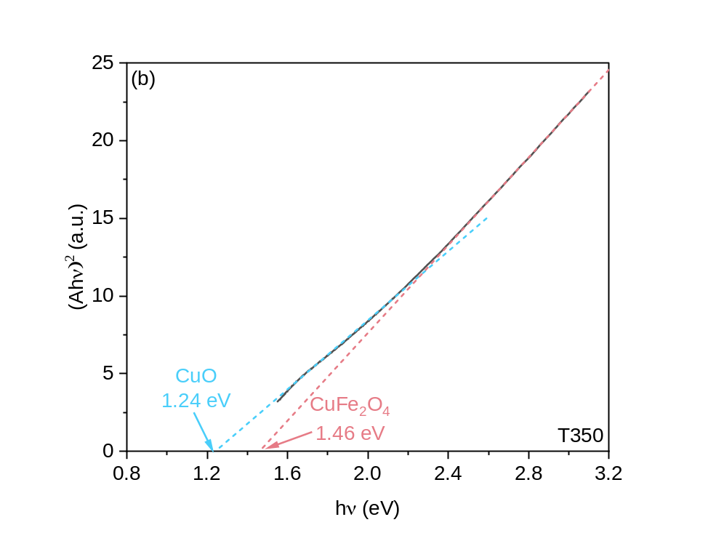
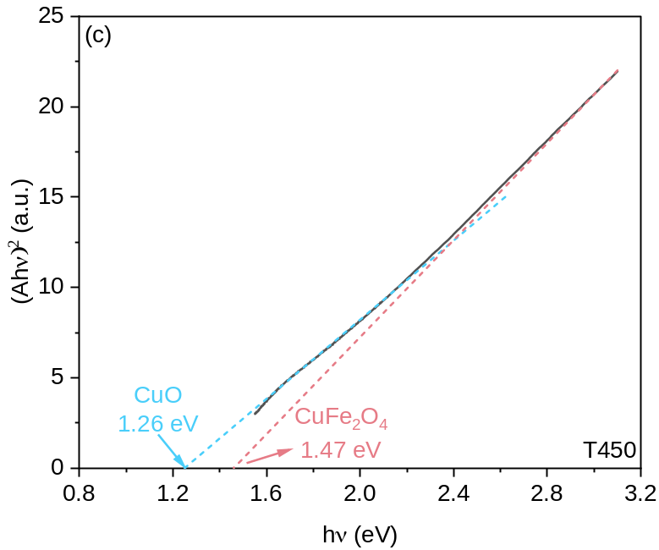
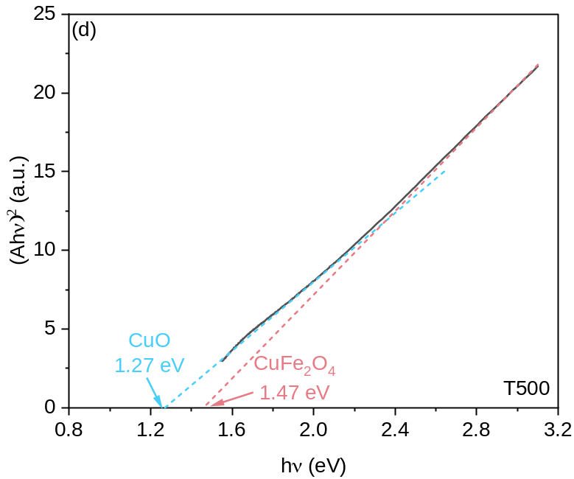
Fig. S4. Tuac plots of T300, T350, T450, and T500

Table S2 The CB and VB values of CuFe₂O₄/CuO/C composites
Sample  Semiconductor | CuFe₂O₄ |  | CuO
Sample  Semiconductor | CB (eV) | VB (eV) | CB (eV) | VB (eV)
T300 | -0.47 | 0.99 | 0.70 | 1.93
T350 | -0.47 | 0.99 | 0.69 | 1.93
T450 | -0.48 | 1.00 | 0.68 | 1.94
T500 | -0.48 | 1.00 | 0.68 | 1.95
Table S3 Calculation of CB and VB vs.vacuum
Semiconductor | CB vs. NHE (eV) | VB vs. NHE (eV) | CB vs. vacuum (eV) | VB vs. vacuum (eV)
p-type CuFe₂O₄ | -0.47 | 0.99 | E_{vac}=－4.5－E_{NHE}  E_{vac}=－4.03 | E_{vac}=－4.5－E_{NHE}  E_{vac}=－5.49
p-type CuO | 0.69 | 1.93 | E_{vac}=－4.5－E_{NHE}  E_{vac}=－5.19 | E_{vac}=－4.5－E_{NHE}  E_{vac}=－6.43
Table S4 Calculation of E_{f} and Φ
Semiconductor | E_{f} (eV) | Φ=E_{vac}-E_{f} (eV)
p-type CuFe₂O₄ | －5.29 | Φ=0－(－5.29)  Φ=5.29
p-type CuO | －6.23 | Φ=0－(－6.23)  Φ=6.23

Table S5 Degradation products table of tetracycline
NO. | R. Time | Formula | Calculated | Observed | Error  (ppm) | Structure
TC | 7.82 | C₂₂H₂₄N₂O₈ | 445.1605 | 445.1612 | 1.57 | 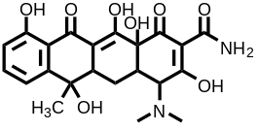
P1 | 7.47 | C₂₁H₂₂N₂O₈ | 431.1449 | 431.1457 | 1.86 | 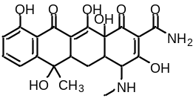
P2 | 7.37 | C₂₁H₂₀N₂O₇ | 413.1343 | 413.1352 | 2.18 | 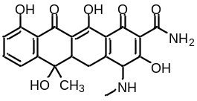
P3 | 9.78 | C₂₁H₂₀N₂O₇ | 413.1343 | 413.1352 | 2.18 | 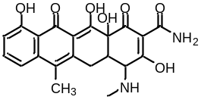
P4 | 6.32 | C₂₂H₂₄N₂O₉ | 461.1555 | 461.1567 | 2.60 | 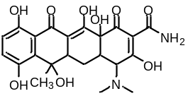
P5 | 6.14 | C21H22N2O10 | 463.1347 | 463.1357 | 2.16 | 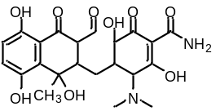
P6 | 8.01 | C₂₁H₂₄N₂O₇ | 417.1656 | 417.1664 | 1.92 | 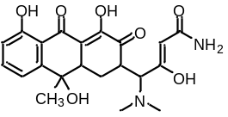
P7 | 7.76 | C₂₀H₂₂N₂O₇ | 403.1500 | 403.1512 | 2.98 | 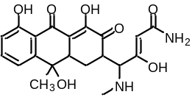
P8 | 7.14 | C₂₂H₂₄N₂O₉ | 461.1555 | 461.1565 | 2.17 | 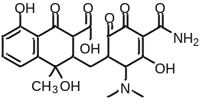
P9 | 3.71 | C₂₂H₂₄N₂O₁₀ | 477.1504 | 477.1516 | 2.51 | 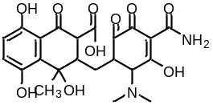
P10 | 6.31 | C₂₂H₂₆N₂O₁₀ | 479.1660 | 479.1670 | 2.09 | 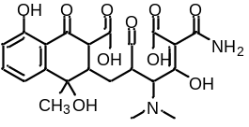
P11 | 5.35 | C₂₁H₂₄N₂O₈ | 433.1605 | 433.1618 | 3.00 | 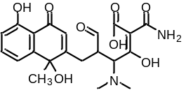
P12 | 7.47 | C₂₀H₂₂N₂O₇ | 403.1500 | 403.1509 | 2.23 | 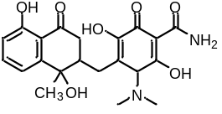
P13 | 7.44 | C₂₁H₂₄N₂O₇ | 417.1656 | 417.1665 | 2.16 | 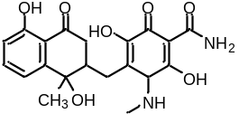
P14 | 7.71 | C₂₁H₂₂N₂O₆ | 399.1551 | 399.1561 | 2.51 | 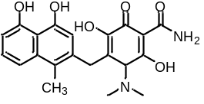

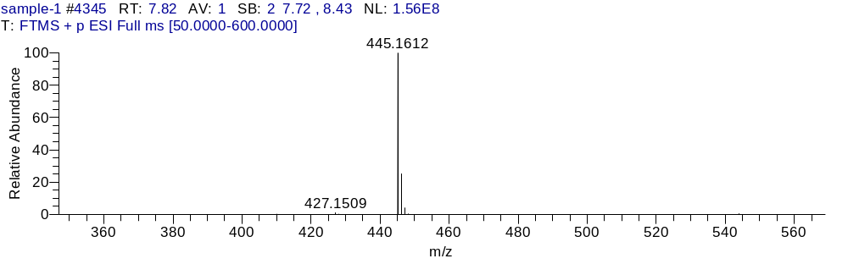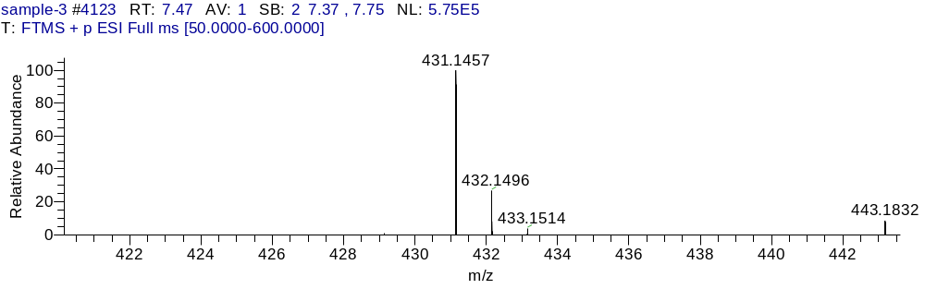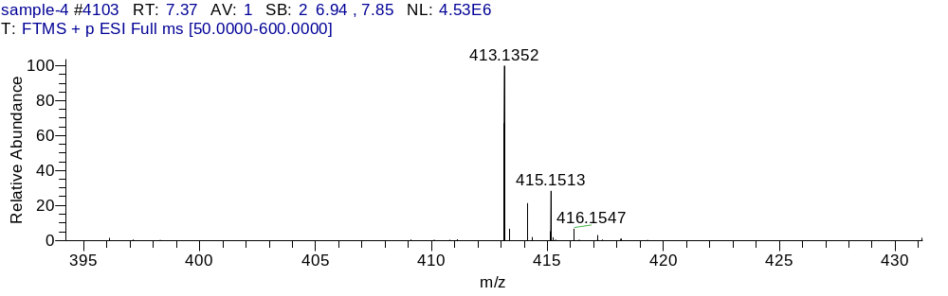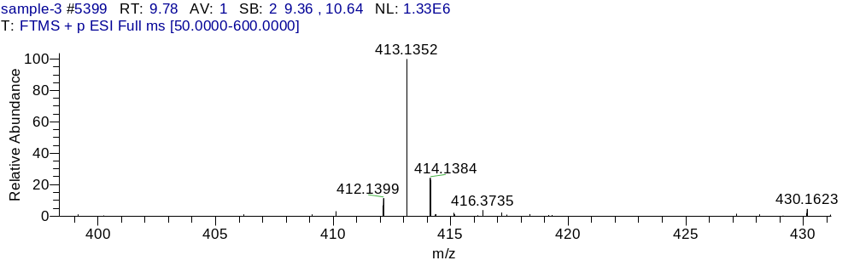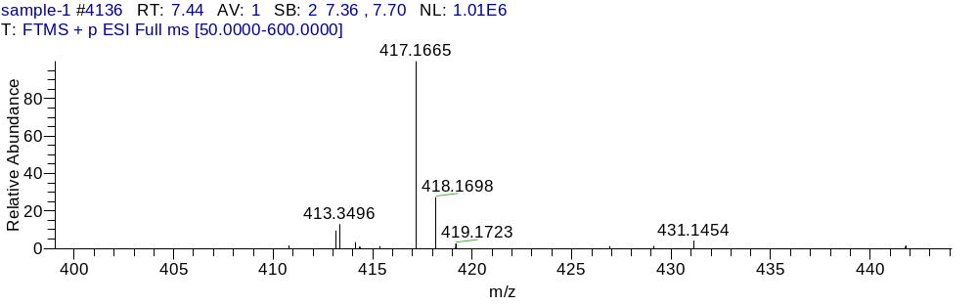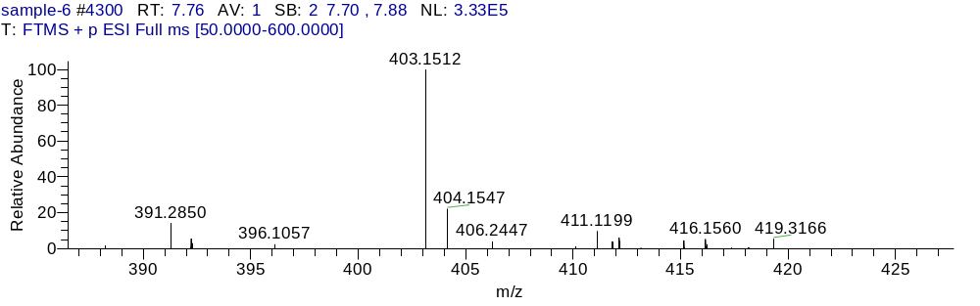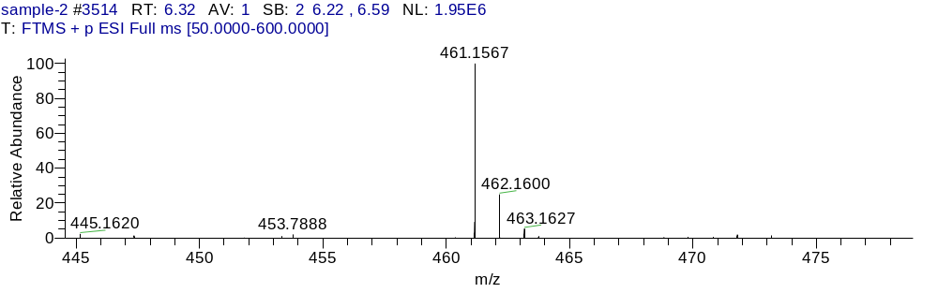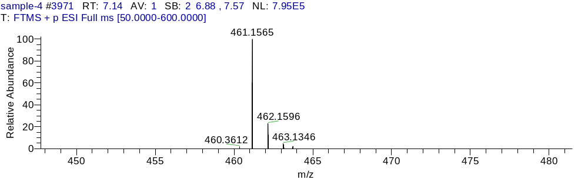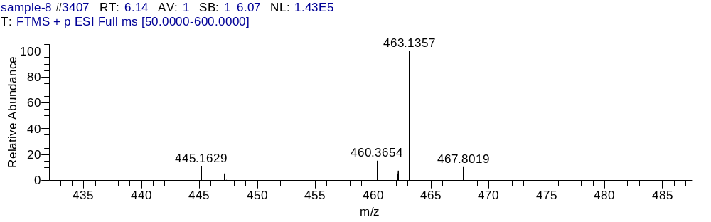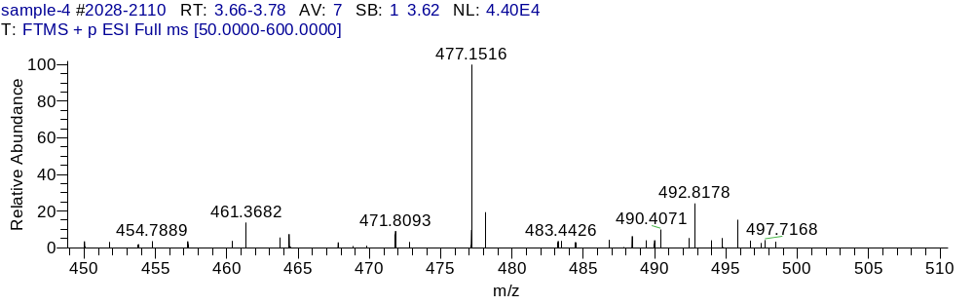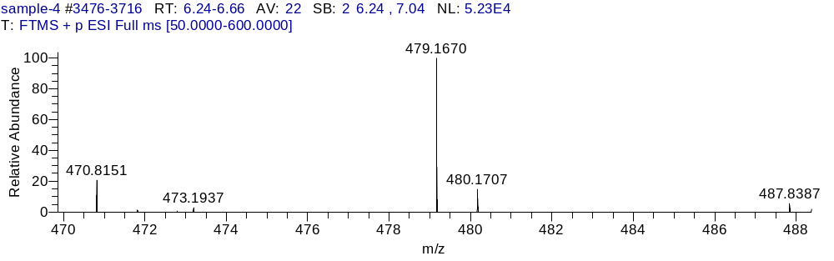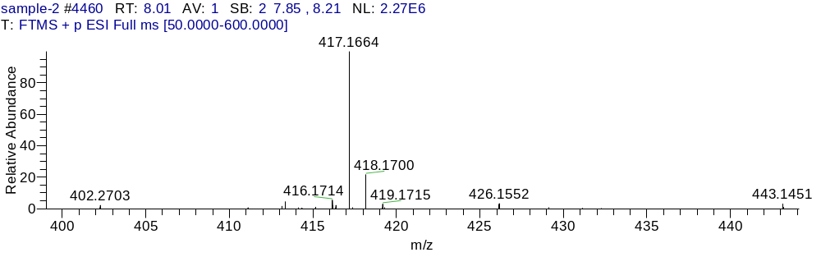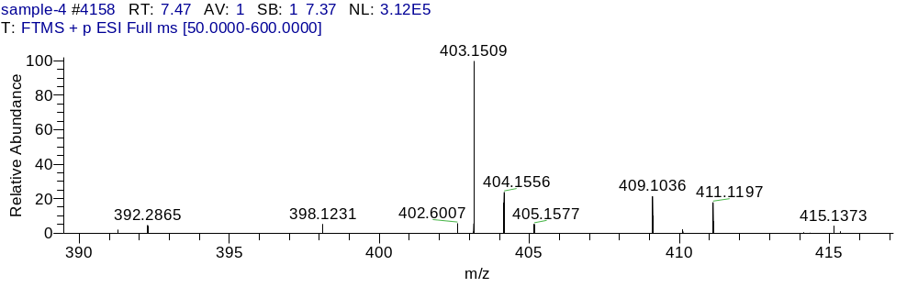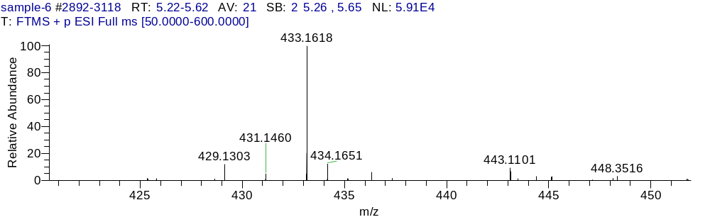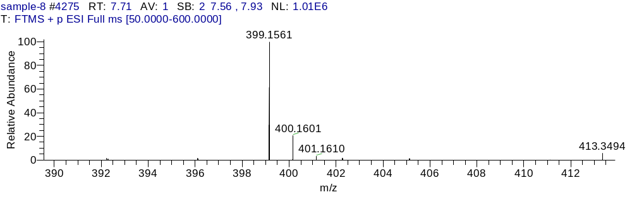
Fig.S5 Mass spectra of intermediates

