SUPPLEMENTARY INFORMATION
Figure S1. Mass reduction tool: (A) schematic, (B) photography in the field.
Table S1. Sample overview including sampling location, sample ID, sample type, region name, sediment layer depth and dry weight. Sample type ‘Composite’ is made of five increments in the same sampling grid, viz. five individual core samples mixed together. Region names (RI, RII and RIII) are indicated in Figure 1 in the main article. The dry weight [%] was determined in duplicates (asterisk indicates single measurement) by a service contractor following the standard method DS204:1980.
Sampling location | Sample ID | Sample type | Region name | Sediment layer [cm] | Dry weight [%]
Fortress Channel (FSK) | 1C0 | Composite |  | 0-30 | 54*
Fortress Channel (FSK) | 2C1 | Composite |  | 0-10 | 20*
Fortress Channel (FSK) | 2C2 | Composite |  | 10-20 | 43*
Fortress Channel (FSK) | 2C3 | Composite |  | 20-30 | 49*
Fortress Channel (FSK) | 3C0 | Composite |  | 0-30 | 45*
Fortress Channel (FSK) | 4C0 | Composite |  | 0-30 | 43-48
Fortress Channel (FSK) | 5C1 | Composite |  | 0-10 | 30-33
Fortress Channel (FSK) | 5C2 | Composite |  | 10-20 | 63-66
Fortress Channel (FSK) | 6S01 | Single |  | 0-30 | 55-70
Fortress Channel (FSK) | 6S02 | Single |  | 0-30 | 38-52
Fortress Channel (FSK) | 6S04 | Single |  | 0-30 | 36-37
Fortress Channel (FSK) | 6S05 | Single |  | 0-30 | 48-53
Fortress Channel (FSK) | 7C0 | Composite |  | 0-30 | 41-48
Fortress Channel (FSK) | 8S02 | Single |  | 0-30 | 24-37
Fortress Channel (FSK) | 8S03 | Single |  | 0-30 | 59-66
Fortress Channel (FSK) | 8S05 | Single |  | 0-30 | 46-61
Lake (UTM) | 1G | Composite | Close to FSK (RI) | 0-30 | 14-16
Lake (UTM) | 1F | Composite | Close to FSK (RI) | 0-30 | 20-22
Lake (UTM) | 11A | Composite | Close to a road (RII) | 0-30 | 17
Lake (UTM) | 12A | Composite | Close to a road (RII) | 0-30 | 18-19
Lake (UTM) | 1Q | Composite | Close to a road (RII) | 0-30 | 10-11
Lake (UTM) | 1R | Composite | Close to a road (RII) | 0-30 | 33
Lake (UTM) | 1S | Composite | Close to a road (RII) | 0-30 | 36-38
Lake (UTM) | 4T | Composite | Close to a road (RII) | 0-30 | 16-18
Lake (UTM) | 5S | Composite | Close to a road (RII) | 0-30 | 14-15
Lake (UTM) | 5T | Composite | Close to a road (RII) | 0-30 | 16-20
Lake (UTM) | 9B | Composite | Close to a road (RII) | 0-30 | 21*
Lake (UTM) | 9C | Composite | Close to a road (RII) | 0-30 | 20
Lake (UTM) | 1H | Composite | Centre of the lake (RIII) | 0-30 | 17-19
Lake (UTM) | 1J | Composite | Centre of the lake (RIII) | 0-30 | 12*
Lake (UTM) | 1L | Composite | Centre of the lake (RIII) | 0-30 | 13*
Lake (UTM) | 1N | Composite | Centre of the lake (RIII) | 0-30 | 14*
Lake (UTM) | 2H | Composite | Centre of the lake (RIII) | 0-30 | 22-25
Lake (UTM) | 4L | Composite | Centre of the lake (RIII) | 0-30 | 19*
Lake (UTM) | 5P | Composite | Centre of the lake (RIII) | 0-30 | 20*
Lake (UTM) | 6F | Composite | Centre of the lake (RIII) | 0-30 | 14*
Lake (UTM) | 6L | Composite | Centre of the lake (RIII) | 0-30 | 26*

Table S2. Spiking solutions and nominal concentrations.
Compound name | Monoisoto-pic mass [u] | Concentra-tion in spike [ppm] | Solvent | Supplier | Elution in standard (+) and facilitator sample (/+)
1H-Benzo(g)indole | 167.0735 | 38.25 | Ethanol | Sigma-Aldrich | +
2-Mercaptobenzothiazole | 166.9863 | 35.08 | Ethanol | Aldrich | +/+
2-Phenylphenol | 170.0732 | 38.87 | Ethanol | Fluka | +
Acridine | 179.0735 | 38.87 | Ethanol | Alfa Aesar | +
Amitriptyline | 278.1909 | 36.59 | Ethanol | Sigma | +
Carbamazepine | 236.0950 | 39.67 | Ethanol | Sigma | -
Carbazole | 167.0735 | 37.65 | Ethanol | Fluka | +
Isoquinoline | 129.0578 | 37.30 | Ethanol | Sigma-Aldrich | +
N,N-Diethylacetamide | 115.0997 | 37.91 | Ethanol | Aldrich | +
N-Ethylcarbazole | 195.1048 | 40.20 | Ethanol | Sigma-Aldrich | +
Pentachlorophenol | 263.8470 | 34.97 | Ethanol | Supelco | +
Pyrocatechol | 110.0368 | 37.54 | Ethanol | Fluka | -
Quinoxaline | 130.0531 | 45.98 | Ethanol | Sigma-Aldrich | +
Triclocarban | 313.9780 | 39.67 | Ethanol | Sigma-Aldrich | -
Triclosan | 287.9512 | 38.50 | Ethanol | Fluka | +
1-Adamantanecarboxylic acid | 180.1150 | 40.43 | Acetone | Aldrich | -
1-Hydroxy-2-naphthoic acid | 188.0473 | 36.38 | Acetone | Aldrich | -
1-Naphthoic acid | 172.0524 | 38.87 | Acetone | Alfa Aesar | -
2-Carboxycinnamic acid | 192.0423 | 36.21 | Acetone | Alfa Aesar | -
2-Naphthoic acid | 172.0524 | 34.87 | Acetone | Aldrich | -
3,3',5,5'-Tetrabromo-1,1'-biphenyl | 465.7203 | 39.08 | Acetone | Aldrich | +
4,4'-DDT | 351.9147 | 40.25 | Acetone | Fluka | +
4,4'-Dibromobiphenyl | 309.8993 | 39.45 | Acetone | Aldrich | +
4-Butylbenzoic acid | 178.0994 | 36.96 | Acetone | Aldrich | -
Acetophenone | 120.0575 | 34.65 | Acetone | Sigma-Aldrich | +
Anisole | 108.0575 | 41.58 | Acetone | Fluka | +
Benzo(a)pyrene | 252.09390 | 36.96 | Acetone | Sigma-Aldrich | -
Benzonitrile | 103.0422 | 42.30 | Acetone | Fluka | +
Bisphenol A | 228.1150 | 35.81 | Acetone | Sigma-Aldrich | +
Butylbenzene | 134.1096 | 38.12 | Acetone | Aldrich | +/+
Cyclohexanecarboxylic acid | 128.0837 | 42.88 | Acetone | Sigma-Aldrich | -
Cyclohexanepentanoic acid | 184.1463 | 37.92 | Acetone | Aldrich | -
DFTPP | 441.9969 | 37.65 | Acetone | Supelco | +
Dicyclohexylacetic acid | 224.1776 | 39.27 | Acetone | Aldrich | -
Diphenic acid | 242.0579 | 37.35 | Acetone | Aldrich | -
Estrone | 270.1620 | 39.27 | Acetone | Sigma-Aldrich | -
Ethylbenzene | 106.0783 | 41.58 | Acetone | Fluka | +/+
Fluoranthene | 202.0782 | 34.07 | Acetone | Sigma-Aldrich | +
Lauric acid | 200.1776 | 37.16 | Acetone | SAFC | -
Linoleic acid | 280.2402 | 36.96 | Acetone | Sigma | -
Linolenic acid | 278.2246 | 36.96 | Acetone | Sigma | -
Oleic acid | 282.2559 | 42.58 | Acetone | Sigma-Aldrich | -
Palmitoleic acid | 254.2246 | 39.07 | Acetone | Sigma | -
Perfluorooctanesulfonic acid | 537.8934 | 40.02 | Acetone | Aldrich | -
Perfluorooctanoic acid | 413.9737 | 40.88 | Acetone | Aldrich | -
Phthalic acid | 166.0266 | 39.47 | Acetone | Fluka | -
Progesterone | 314.2246 | 41.83 | Acetone | Fluka | -
Salicylic acid | 138.0317 | 36.38 | Acetone | Sigma-Aldrich | -
Testosterone | 288.2089 | 36.96 | Acetone | Fluka | -
Trans-chalcone | 208.0888 | 35.08 | Acetone | Aldrich | +
1,7-Dihydroxynaphthalene | 160.0524 | 29.34 | Methanol | Acros Organics | +
9,10-Anthraquinone | 208.0524 | 27.87 | Methanol | Sigma-Aldrich | +
9-Hydroxy-phenanthrene | 194.0732 | 28.38 | Methanol | Sigma-Aldrich | -
Dibenzofuran | 168.0575 | 27.44 | Methanol | Fluka | +/+
1,2,6,9-Tetramethylphenanthrene | 234.14085 | 1.00 | Isooctane | Chiron | +/+
1,2,6-Trimethylphenanthrene | 220.12520 | 1.25 | Isooctane | Chiron | +/+
1,3,6-Trimethylchrysene | 270.14084 | 1.00 | Isooctane | Chiron | -
1,4,6,7-Tetramethylnapthalene | 184.12520 | 1.00 | Isooctane | Alfa Aesar | +/+
1,7-Dimethylfluorene | 194.10954 | 1.25 | Isooctane | Alfa Aesar | +
1-Methylfluorene | 180.09390 | 1.02 | Isooctane | Fluka | +/+
1-Methylnaphthalene | 142.07825 | 1.12 | Isooctane | Fluka | +/+
1-Methylpyrene | 216.09390 | 1.00 | Isooctane | Sigma | +
2,3,5-Trimethylnapthalene | 170.10954 | 1.00 | Isooctane | Sigma-Aldrich | +/+
2,6-Dimethylnaphthalene | 156.09390 | 1.03 | Isooctane | Sigma-Aldrich | +/+
2-Methylnaphthalene | 142.07825 | 0.99 | Isooctane | Fluka | +/+
2-Methylphenanthrene | 192.09390 | 1.00 | Isooctane | Chem Service | +/+
2-Methylthianaphthene | 148.03467 | 1.16 | Isooctane | Aldrich | +
3,6-Dimethylphenanthrene | 206.10954 | 1.00 | Isooctane | Dr. Ehrenstorfer GmbH | +/+
3-Methylbenzothiophene | 148.03467 | 0.96 | Isooctane | Aldrich | +/+
4,5-Dimethylpyrene | 230.10954 | 1.00 | Isooctane | Alfa Aesar | +
4,6-Dimethyldibenzothiophene | 212.06596 | 1.01 | Isooctane | Aldrich | +/+
4-Ethyl-6-methyldibenzothiophene | 226.08162 | 1.00 | Isooctane | Alfa Aesar | +
4-Methylchrysene | 242.10954 | 1.06 | Isooctane | Community Bureau References (CBR) | -
4-Methyldibenzothiophene | 198.05032 | 1.00 | Isooctane | Sigma | +/+
6-Ethylchrysene | 256.12521 | 1.25 | Isooctane | Chiron | -
Acenaphthene | 154.07825 | 1.07 | Isooctane | Dr. Ehrenstorfer GmbH | +/+
Acenaphthene-d10 | 164.14102 | 2.54 | Isooctane | Cambridge Isotope Lab | +
Acenaphthylene | 152.06261 | 0.90 | Isooctane | Dr. Ehrenstorfer GmbH | +/+
Acenaphthylene-d8 | 160.11281 | 1.83 | Isooctane | Cambridge Isotope Lab | +
Anthracene | 178.07825 | 0.88 | Isooctane | Dr. Ehrenstorfer GmbH | +
Anthracene-d10 | 188.14102 | 2.58 | Isooctane | Cambridge Isotope Lab | +
Benz(a)anthracene | 228.09390 | 0.99 | Isooctane | Sigma-Aldrich | +
Benz(a)anthracene-d12 | 240.16922 | 1.87 | Isooctane | Cambridge Isotope Lab | +
Benzo(a)pyrene | 252.09390 | 1.14 | Isooctane | Sigma-Aldrich | -
Benzo(a)pyrene-d12 | 264.16922 | 1.94 | Isooctane | Cambridge Isotope Lab | -
Benzo(b)fluoranthene | 252.09390 | 1.03 | Isooctane | Sigma-Aldrich | -
Benzo(e)pyrene | 252.09390 | 0.87 | Isooctane | Dr. Ehrenstorfer GmbH | -
Benzo(g,h,i)perylene | 276.09390 | 1.12 | Isooctane | Dr. Ehrenstorfer GmbH | -
Benzo(g,h,i)perylene-d12 | 288.16922 | 2.06 | Isooctane | Dr. Ehrenstorfer GmbH | -
Benzo(k)fluoranthene | 252.09390 | 0.94 | Isooctane | Supelco | -
Benzo(k)fluoranthene-d12 | 264.16922 | 1.95 | Isooctane | Dr. Ehrenstorfer GmbH | -
Chrysene | 228.09390 | 0.88 | Isooctane | VWR Chemicals | +
Chrysene-d12 | 240.16922 | 1.78 | Isooctane | Cambridge Isotope Lab | +
Dibenzo(a,h)anthracene | 278.10956 | 0.88 | Isooctane | Dr. Ehrenstorfer GmbH | -
Dibenzothiophene | 184.03470 | 1.30 | Isooctane | Dr. Ehrenstorfer GmbH | +/+
Dibenzothiophene-d8 | 192.08489 | 2.29 | Isooctane | Cambridge Isotope Lab | +
Fluoranthene | 202.07825 | 1.09 | Isooctane | Sigma-Aldrich | +/+
Fluoranthene-d10 | 212.14102 | 1.99 | Isooctane | Bie & Berntsen Group | +
Fluorene | 166.07825 | 0.84 | Isooctane | Sigma-Aldrich | +/+
Fluorene-d10 | 176.14102 | 2.69 | Isooctane | Cambridge Isotope Lab | +
Indeno(1,2,3-c,d)pyrene | 276.09390 | 0.86 | Isooctane | Sigma-Aldrich | -
Indeno(1,2,3-c,d)pyrene-d12 | 288.16922 | 2.03 | Isooctane | Cambridge Isotope Lab | -
Naphthalene | 128.06261 | 1.05 | Isooctane | Dr. Ehrenstorfer GmbH | +/+
Naphthalene-d8 | 136.11281 | 2.01 | Isooctane | Cambridge Isotope Lab | +
Perylene | 252.09390 | 0.93 | Isooctane | Dr. Ehrenstorfer GmbH | -
Phenanthrene | 178.07825 | 0.98 | Isooctane | Dr. Ehrenstorfer GmbH | +/+
Phenanthrene-d10 | 188.14102 | 1.80 | Isooctane | Cambridge Isotope Lab | +
Pyrene | 202.07825 | 1.53 | Isooctane | Sigma-Aldrich | +/+
Pyrene-d10 | 212.14102 | 1.87 | Isooctane | Cambridge Isotope Lab | +

Table S3. AnQC for Utterslev Mose (UTM) and Fæstningskanalen (FSK).
AnQC_{UTM} | AnQC_{FSK}
UTM-1F | FSK-2C1
UTM-1F-RI | FSK-2C3
UTM-1J | FSK-3C0
UTM-1L | FSK-6S0-1
UTM-1S | FSK-6S0-5
UTM-12A | FSK-7C0
UTM-6F-RI | FSK-8S0-2
UTM-9B

Table S4. Mass-to-charge (m/z) channels excluded from the pixel-based analysis due to column bleeding and other non-chemical variation.
Min |  | Max
73.0200 |  | 73.0800
132.9700 |  | 133.0300
176.9700 |  | 177.0300
190.9700 |  | 191.0300
192.9700 |  | 193.0300
207.0200 |  | 207.1800
208.0200 |  | 208.0800
209.0200 |  | 209.0800
 | 248.9700 | 249.0300
 | 250.9700 | 251.0300
 | 252.9700 | 253.0300
264.9700 |  | 265.0300
266.9700 |  | 267.0300
281.0200 |  | 281.0800
282.0200 |  | 282.0800
283.0200 |  | 283.0800
312.9700 |  | 313.0300
327.0200 |  | 327.0800
328.0200 |  | 328.0800
329.0200 |  | 329.0800
343.0200 |  | 343.0800

Table S5. Parameters used in Unknowns Analysis (MassHunter B.07.00).
Parameter |  | Value
Resolution
RT window size factor |  | 25, 50, 100, 200
Extraction size window
Left m/z delta |  | 0.3 AMU
Right m/z delta |  | 0.7 AMU
Component shape
Sharpness threshold |  | 25%
Ion peaks & Library
 | Min # of ion peaks | 5
 | Max # of ion peaks to store | 15
 | Library | NIST®14 MS library
Compound identification
Max hit count |  | 1
Min match factor |  | 70%
Min MZ |  | 30
Ratio percentage uncertainty |  | 40
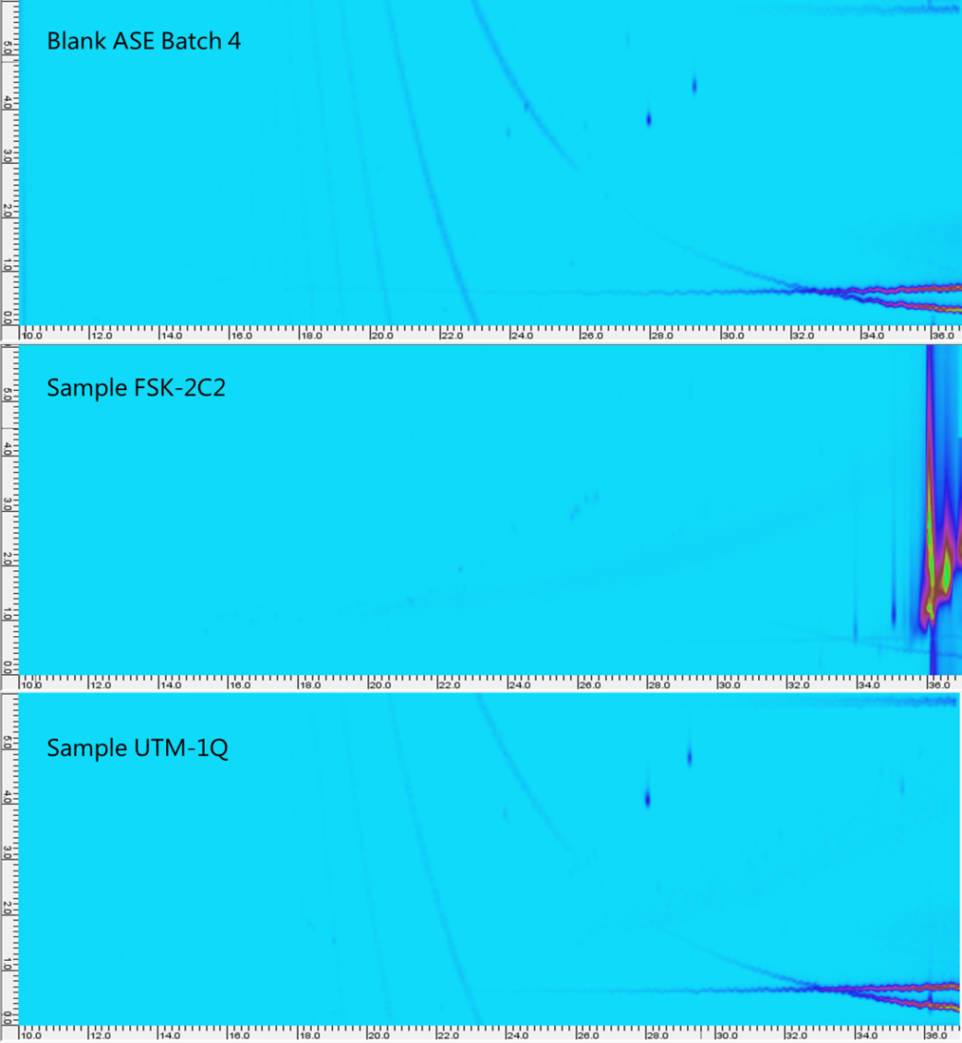
Figure S2. Extracted ion chromatograms of the typical phthalate ion 149.1±0.5 Da in an extraction blank (top chromatogram), an example fortress channel sample (middle) and an example lake sample (bottom).
Figure S3. Loading plots of PC1 (top) and PC2 (bottom) in the global model of both sampling sites.

Figure S4. Loading plot of FSK (local model). Left: PC3, right: PC4.
Figure S5. Score plot (PC2 vs. PC4) of UTM sampling site.
Table S6. First dimension retention times (¹D t_{R} in [min]) of n-alkanes C10-C26) to calculate the retention indices (RI) in Table 1. Identified in the summed extraction ion chromatogram (m/z 43.06, 57.07, 75.09 and 85.12).
Carbon number | Retention time ¹D t_{R} [min]
Carbon number | RefOil 1 | RefOil 2 | RefOil 3 | Florida mix 1 | Florida mix 2 | Average | Stdev
10 | 12.73 | 12.73 | 12.43 | 12.73 | 12.43 | 12.61 | 0.16
11 | 15.03 | 15.03 | 14.63 |  |  | 14.90 | 0.23
12 | 17.13 | 17.13 | 16.74 | 17.13 | 16.74 | 16.97 | 0.22
13 | 19.13 | 19.13 | 18.74 |  |  | 19.00 | 0.23
14 | 20.93 | 20.93 | 20.54 | 20.93 | 20.54 | 20.77 | 0.22
15 | 22.63 | 22.63 | 22.24 |  |  | 22.50 | 0.23
16 | 24.33 | 24.33 | 23.94 | 24.33 | 23.84 | 24.16 | 0.25
17 | 25.84 | 25.84 | 25.44 |  |  | 25.71 | 0.23
18 | 27.24 | 27.24 | 26.95 | 27.24 | 26.84 | 27.10 | 0.19
19 | 28.64 | 28.64 | 28.35 |  |  | 28.54 | 0.17
20 | 29.94 | 29.94 | 29.65 | 29.94 | 29.55 | 29.80 | 0.19
21 | 31.24 | 31.24 | 30.85 |  |  | 31.11 | 0.22
22 | 32.44 | 32.44 | 32.06 | 32.44 | 32.06 | 32.29 | 0.21
23 | 33.55 | 33.54 | 33.26 |  |  | 33.45 | 0.17
24 | 34.75 | 34.75 | 34.36 | 34.65 | 34.26 | 34.55 | 0.23
25 | 35.75 | 35.76 | 35.47 |  |  | 35.66 | 0.17
26 | 36.75 | 36.76 | 36.47 | 36.75 | 36.36 | 36.62 | 0.19

