Supplementary Information

Title:
Robust Non-Invasive Melanoma Early Detection Through Lightweight Self-Supervision and Lesion-Focused Representation Learning

Authors:
Chen-Hao Peng, Tzu-Kun Lo, Da-Chuan Cheng

Overview

This Supplementary Information provides additional figures and tables that support the main findings of the manuscript. It includes extended artifact-removal results, further visualization of DS-MAE pretraining, detailed robustness analysis under different blur levels and additional performance breakdowns across lesion categories.

Supplementary Figures and Tables

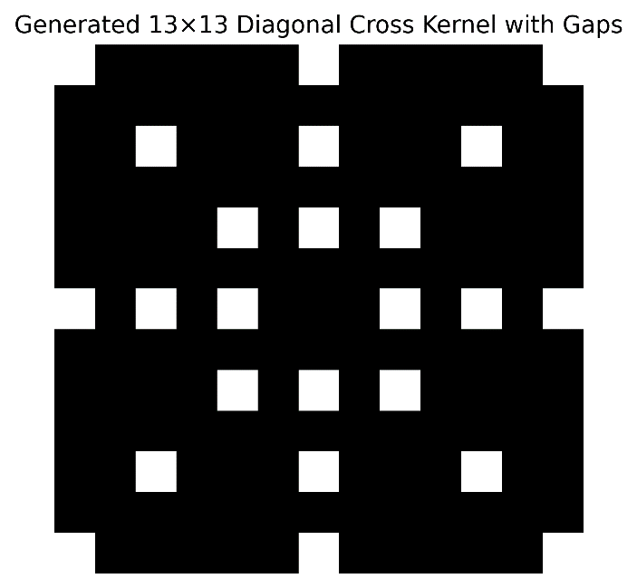
Supplementary Figure S1 | Generated 13×13 diagonal cross-shaped kernel with gaps
Figure S1. Generated 13×13 diagonal cross-shaped kernel with gaps, designed to enhance elongated structures for hair removal in dermoscopy images.
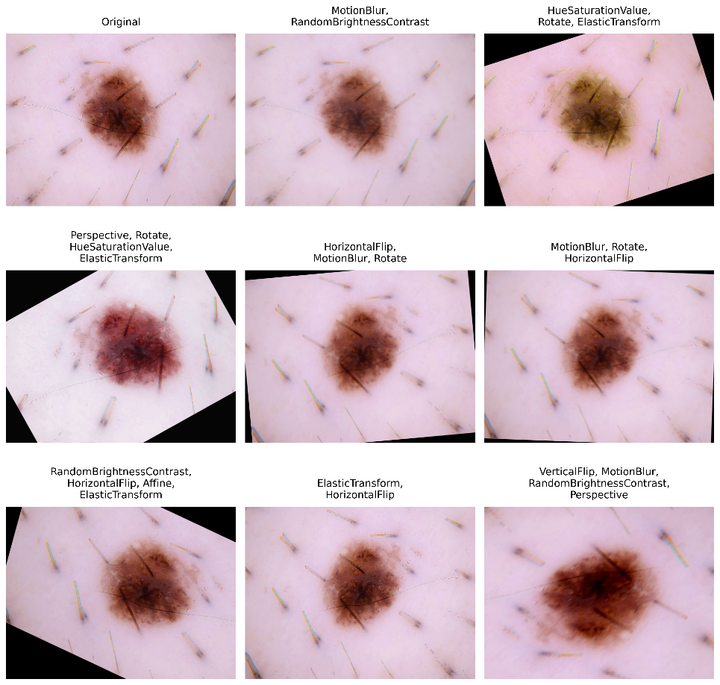
Supplementary Figure S2 | Generated augmentation
Figure S2. Original dermoscopy image (top-left) and augmented variants generated through different transformations, preserving lesion characteristics while enhancing data diversity.

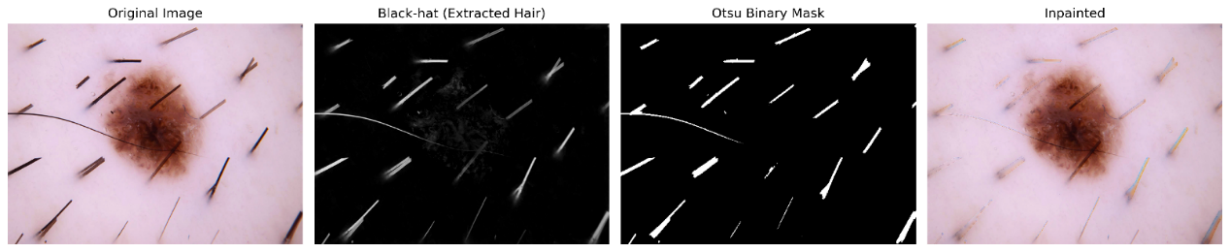
Supplementary Figure S3 | Additional examples of artifact removal.
Figure S3. Illustration of the hair-removal pipeline. From left to right: (1) original dermoscopic image, (2) initial hair response map obtained via black-hat morphological transformation, (3) refined binary hair mask after morphological closing, and (4) reconstructed image after bicubic inpainting, with hair artifacts substantially reduced while preserving lesion morphology and boundary integrity.

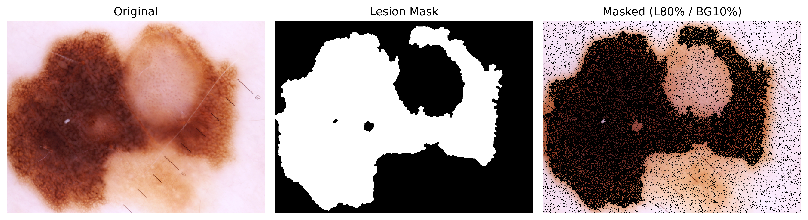
Supplementary Figure S4 | Reconstruction examples from DS-MAE pretraining.
Figure S4: Examples of input images with lesion-aware masking, corresponding model reconstructions and reconstruction error maps. DS-MAE masked 80% of pixels within the lesion region and 10% in the surrounding background. These results provide additional qualitative evidence that the model learned pathology-oriented features focused on lesion morphology and boundaries, as discussed in the Results section.

Table S1. Ablation study results for different training configurations.
Model | Accuracy | Balanced Accuracy | MCC | Jaccard Score | F1-score | Precision | OvO AUC
YOLOv11s + Preprocessing + Augmentation + DS-MAE + Pre-Trained on 4-Class + Shuffle Attention | 0.961 | 0.971 | 0.935 | 0.942 | 0.961 | 0.963 | 0.999
YOLOv11s + Preprocessing + Augmentation + DS-MAE + Pre-Trained on 4-Class | 0.939 | 0.956 | 0.902 | 0.890 | 0.940 | 0.943 | 0.998
YOLOv11s + Preprocessing + Augmentation + DS-MAE | 0.923 | 0.923 | 0.874 | 0.851 | 0.925 | 0.927 | 0.996
YOLOv11s + Preprocessing + Augmentation | 0.879 | 0.826 | 0.794 | 0.739 | 0.876 | 0.876 | 0.988
YOLOv11s + Preprocessing | 0.881 | 0.808 | 0.795 | 0.734 | 0.875 | 0.878 | 0.984
YOLOv11s (Baseline) | 0.880 | 0.785 | 0.794 | 0.706 | 0.876 | 0.877 | 0.981

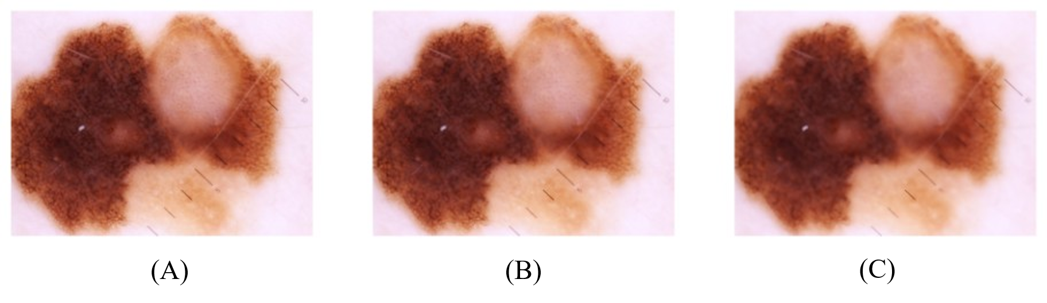
Supplementary Figure S5 | Image quality degradation to simulate mobile phone quality.
Figure S5. Simulated image degradation using bilateral filtering, illustrating the progressive loss of texture and contrast for robustness evaluation. From left to right: the original image, mild bilateral smoothing and strong bilateral smoothing, corresponding to the three image-quality conditions reported in Table 3 of the main text.

Table S2. Model complexity and inference efficiency of the proposed model and representative backbone architectures.
Model | Parameters (M) | FLOPs (G) | GPU Latency (ms) | GPU FPS | CPU Latency (ms) | CPU FPS
Proposed Model | 5.451 | 4.156 | 4.88 | 204.91 | 90 | 11.11
MobileViT V2 | 22.128 | 4.147 | 7.65 | 130.72 | 75.05 | 13.32
EfficientNet V2 B1 | 100.355 | 11.541 | 9.023 | 110.83 | 99.37 | 10.06
MobileNet V3 Large | 73.073 | 2.577 | 6.56 | 152.43 | 96 | 10.42
TinyViT | 28.497 | 19.726 | 12.943 | 77.261 | 201.812 | 4.955

