Supplementary Figure Description
Formulation Study of Theophylline & Antibiotic Combination Inhaler Powder
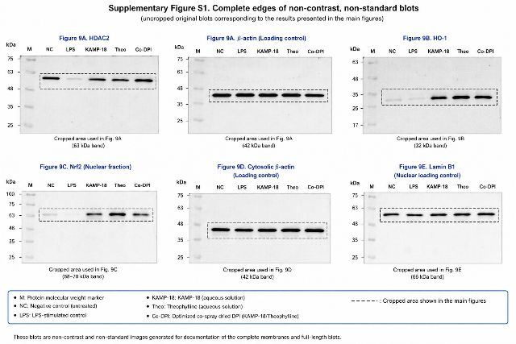
Supplementary Figure S1. Complete Edges of Non-Contrast, Non-Standard Blots
1. Overview
This figure presents the uncropped, full-length Western blot membranes corresponding to the protein expression data shown in Figure 9 (Panels A–E) of the study. Each blot displays the protein molecular weight marker alongside five experimental groups, with black dashed rectangles highlighting the cropped regions featured in the main text figures.
2. Panel Descriptions
Panel | Target Protein | Description / Fraction | Observed Band | Purpose / Significance
Figure 9A | HDAC2 | Histone Deacetylase 2 | ~ 53 kDa | Demonstrates expression levels of HDAC2 across treatment groups relative to control and LPS-stimulated conditions.
Figure 9A | β-actin | Loading control | ~ 42 kDa | Serves as a whole-cell / cytosolic internal loading control to confirm equal protein loading across lanes.
Figure 9B | HO-1 | Heme Oxygenase-1 | ~ 32 kDa | Evaluates antioxidant pathway activation (HO-1 expression) in response to treatments.
Figure 9C | Nrf2 | Nuclear fraction | ~ 58–70 kDa | Measures nuclear translocation of Nrf2 across treatment conditions.
Figure 9D | β-actin | Cytosolic loading control | ~ 42 kDa | Internal loading control for cytosolic protein fractions in Figure 9D.
Figure 9E | Lamin B1 | Nuclear loading control | ~ 66 kDa | Nuclear-specific loading control to ensure equal loading of nuclear protein extracts.

3. Experimental Groups & Lane Layout
Across all six panels, the lanes are loaded sequentially from left to right as follows:
- M: Protein molecular weight marker (kDa ladder)
- NC: Negative Control (untreated cells)
- LPS: Lipopolysaccharide-stimulated control
- KAMP-18: KAMP-18 aqueous solution
- Theo: Theophylline aqueous solution
- Co-DPI: Optimized co-spray-dried dry powder inhaler formulation (KAMP-18 / Theophylline combination)
4. Footnotes & Image Annotations
- Dashed Rectangles ( - - - ): Indicate the specific cropped band regions displayed in the main text figures (Figure 9A–E).
- Documentation Standard: These images are non-contrast and non-standardized full-length membrane blots generated for full compliance, documenting complete antibody specificity and membrane integrity.

