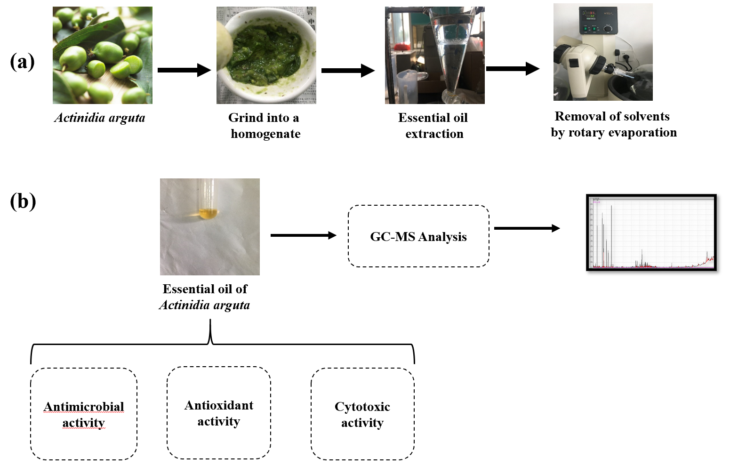

Preparation of Actinidia arguta essential oil (a) and schematic overview of the experiment (b)

