Table 1. Conceptual Differentiation of Complexity Suppression
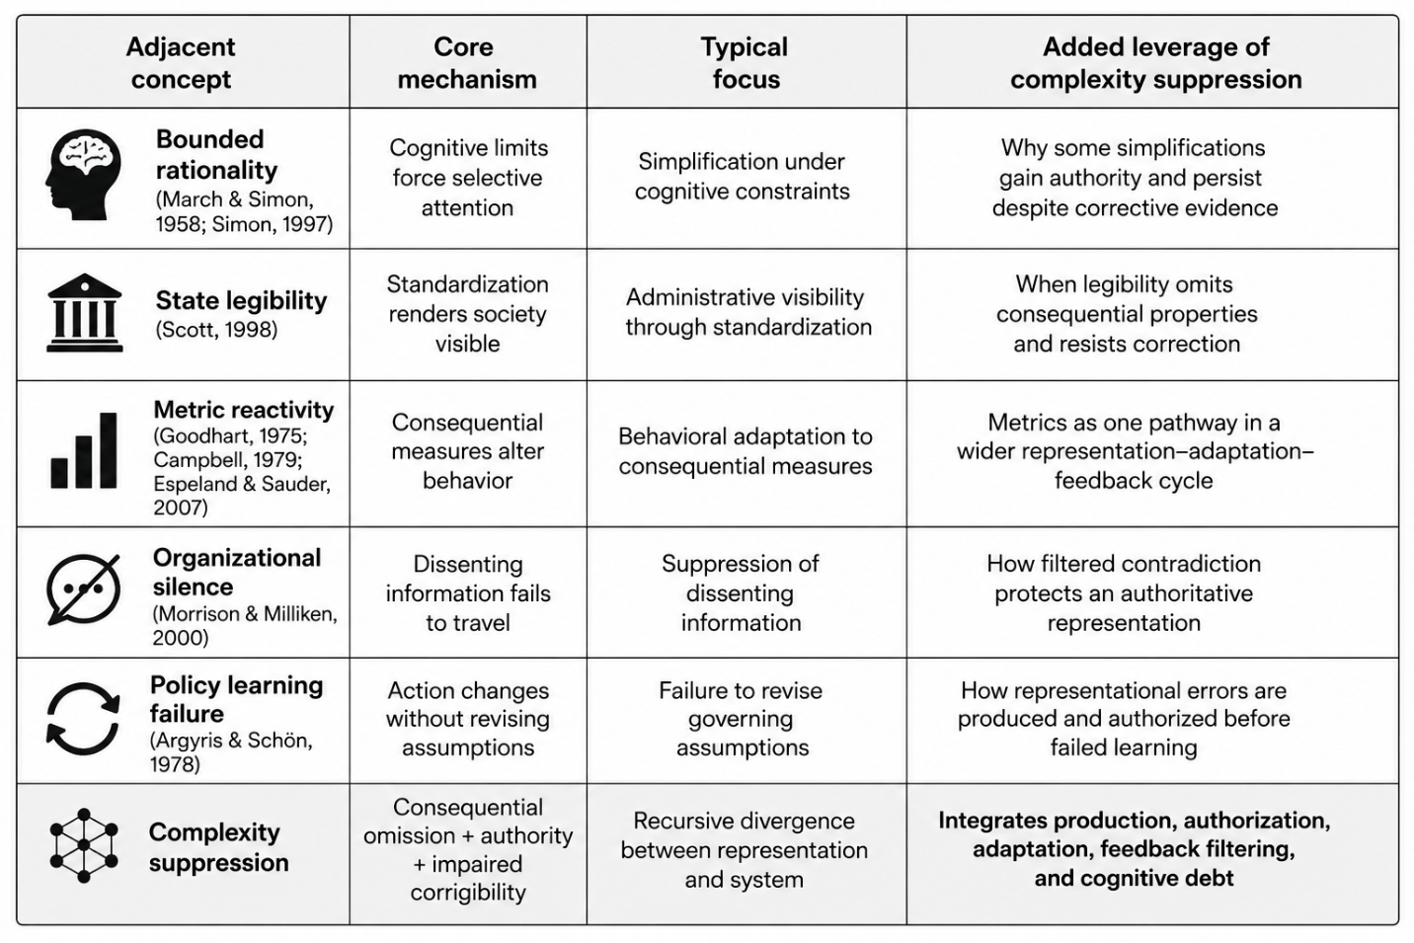
Table 2. Mechanisms of Complexity Suppression
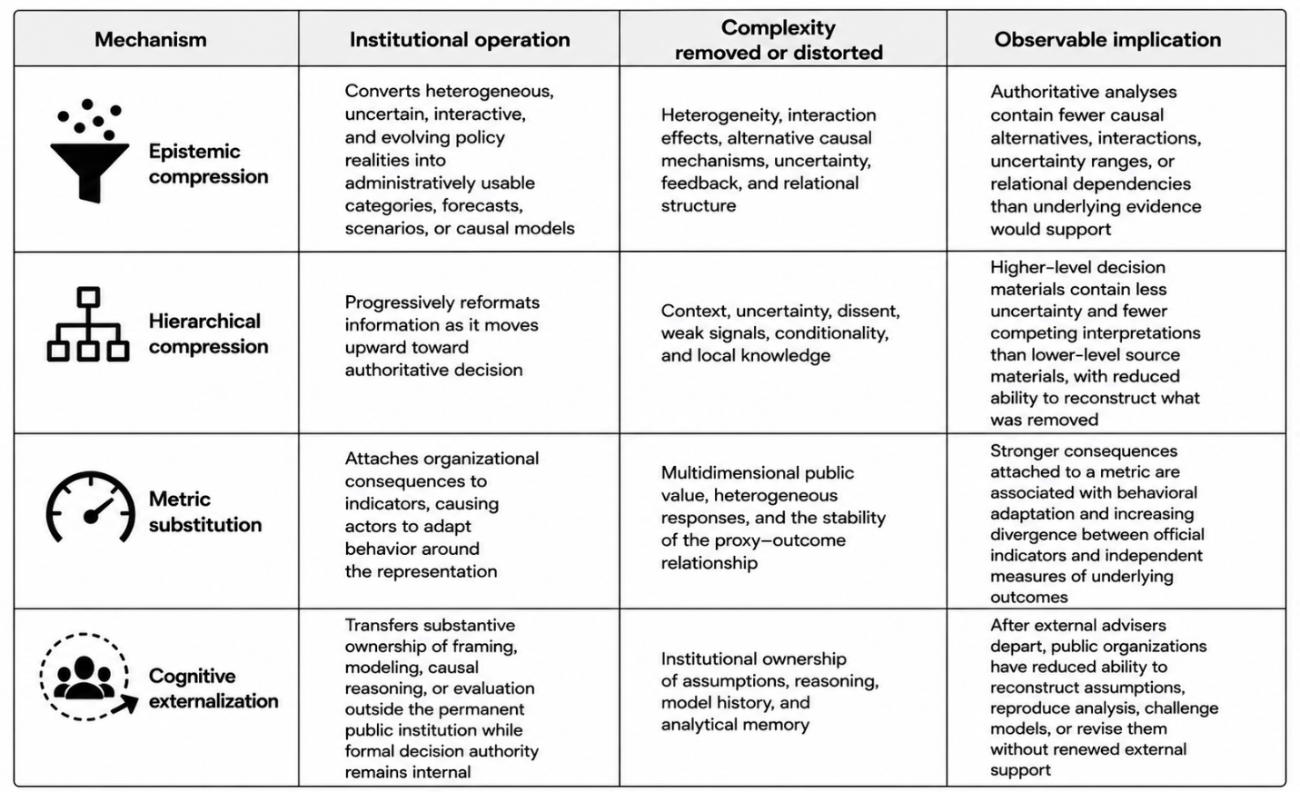
Table 3. Structured Comparison of the Two Illustrations
