Figure 1.1 legend: Figure provides a representative explanation created by ChatGPT including a restatement of the problem identified in the question, key clues, and diagnosis. It then briefly outlines key features of the central topic, including pathophysiology, and histologic and biomechanical findings
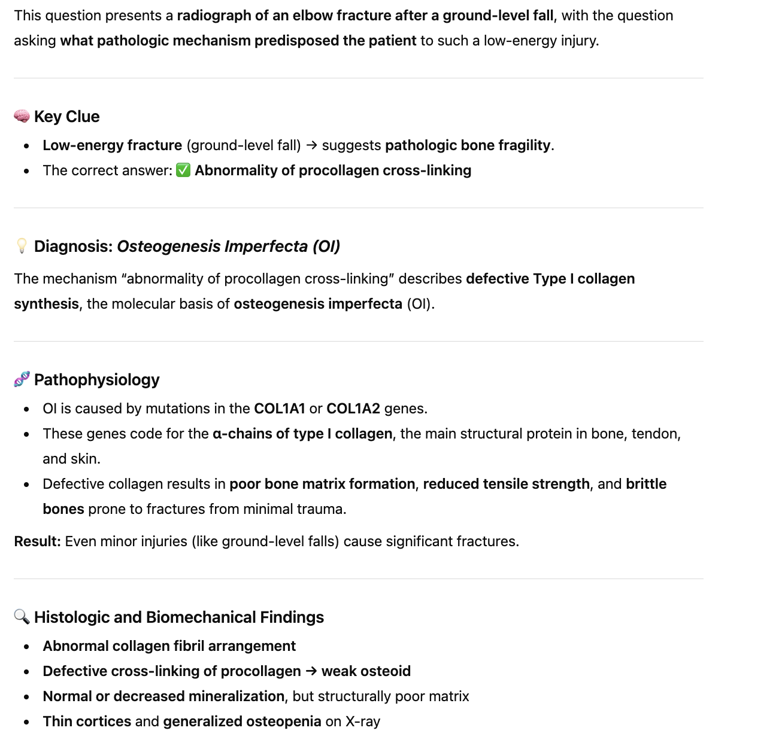
Figure 1.2 legend: ChatGPT goes on to expand on key clinical features of the presented topic (in this case, osteogenesis imperfecta), explains incorrect explanations, and provides a summary table
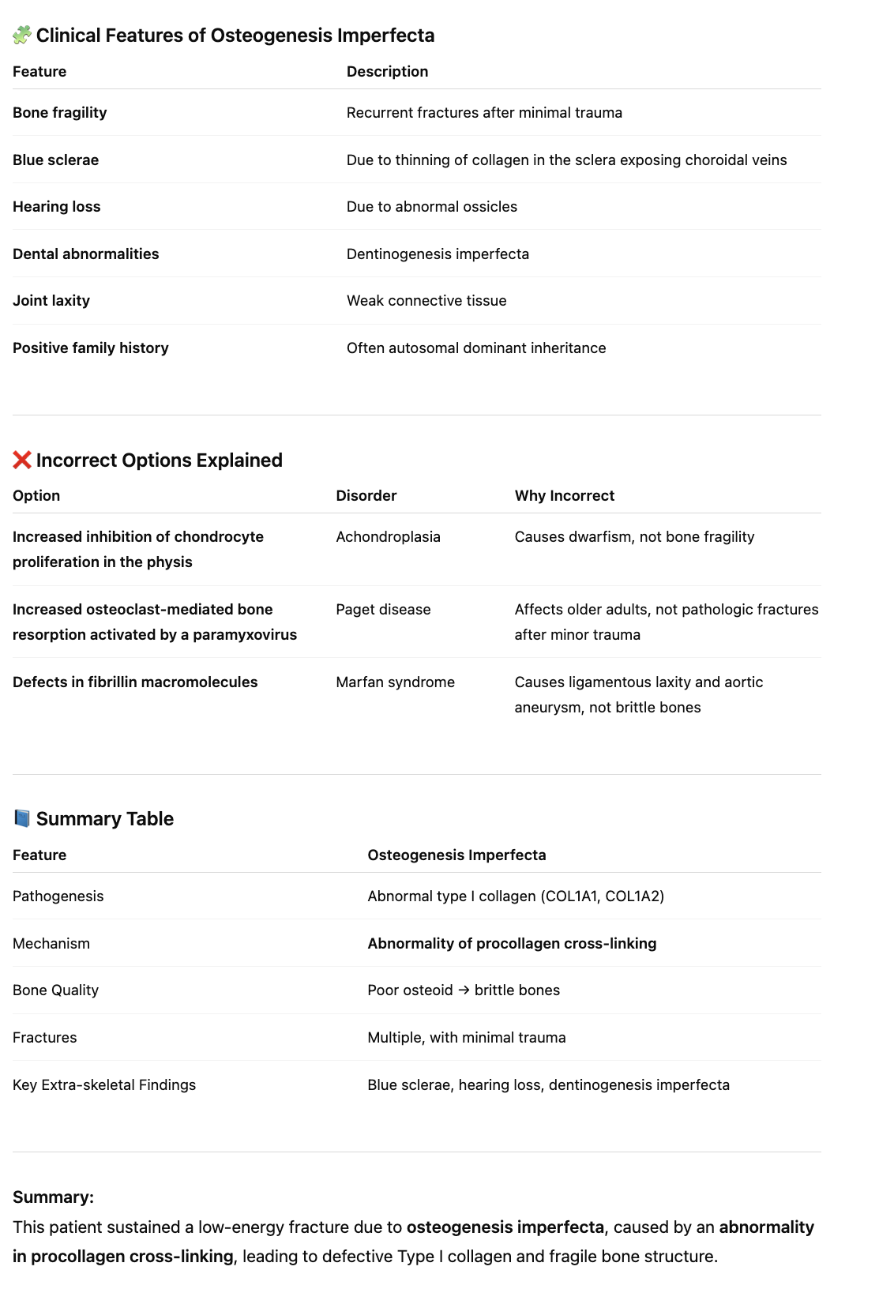
Figure 2 legend: When asked to provide source material, ChatGPT prepared a relevant list including a brief summary of key features within the article and relevance to the topic at hand. Cited are: Subramanian et al⁸, Lim et al⁹, Jovanovic et al¹⁰, Yu et al¹¹, and van Dijk et al¹².
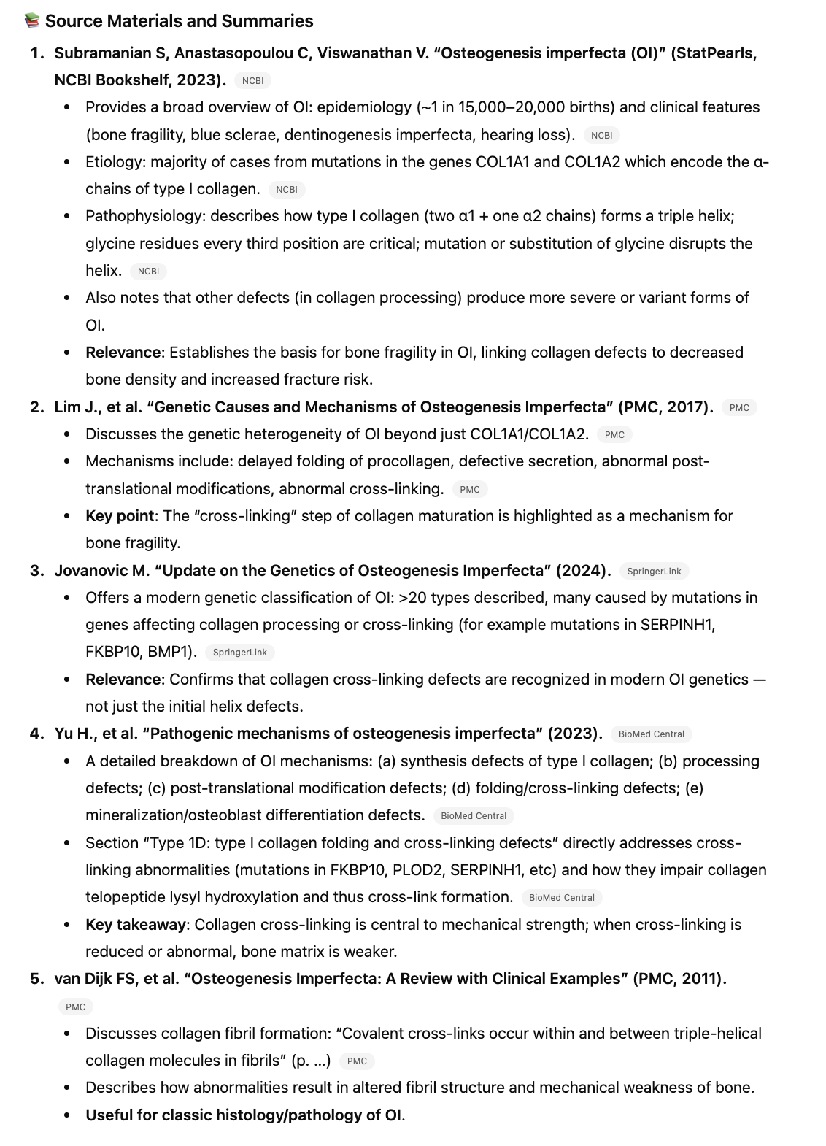
Figure 3.1 legend: Here, ChatGPT was asked to include an image interpretation in the answer stem, but incorrectly identified the image. This is an example of a correct answer achieved through incorrect reasoning. Notably, the remainder of the information provided in the explanation is correct.
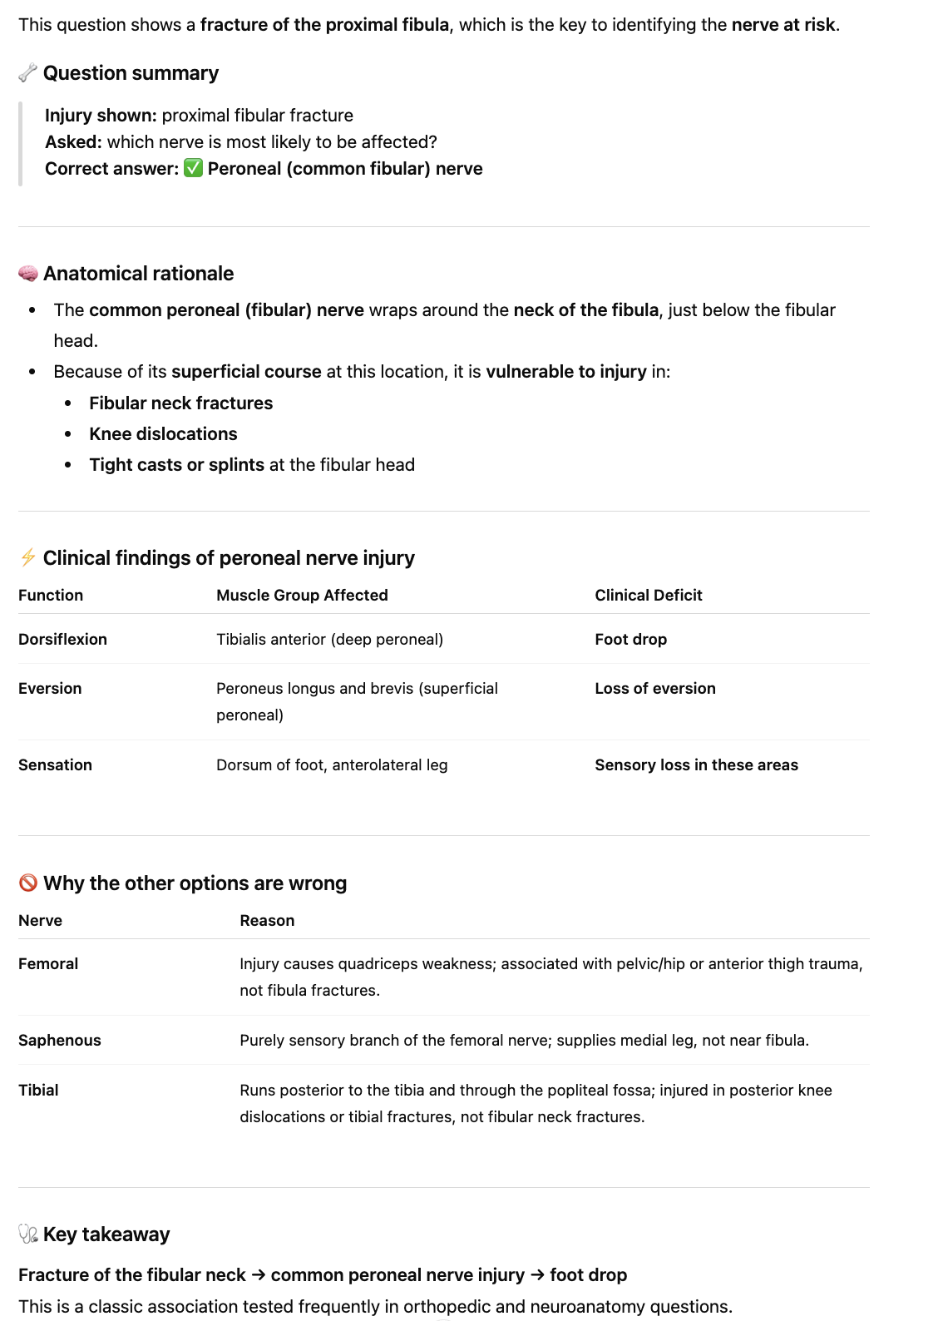
Figure 3.2 legend: ChatGPT is affirmative. Every time it was told it was incorrect, it provided an affirmative statement such as “good catch” or “you’re absolutely correct”. In this scenario, we provided ChatGPT with an explanation of what the image was showing (in this case, a knee dislocation), and asked if this would change the answer. ChatGPT changed its emphasis and provided different context from the prior explanation (Figure 3.1), but notably did not change the answer choice, which was in agreement with the OITE answer key.
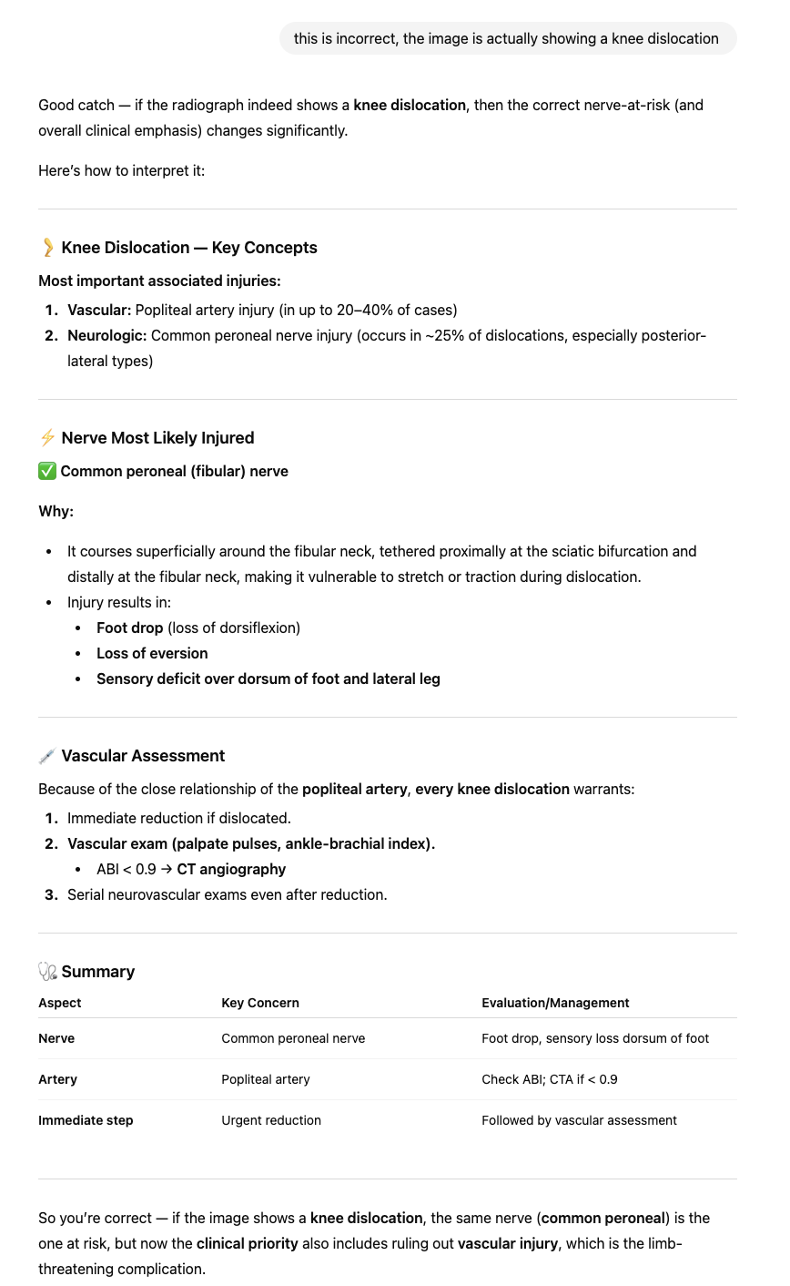
Figure 4 legend: ChatGPT was asked to synthesize key relevant information on a single topic (in this case osteogenesis imperfecta) that would be relevant to the orthopaedic board exams, and provide explanations for clinical context. Notably, the information is presented in a conversational style. Citations are included, and formatting is clear and amenable to both studying and later reference.
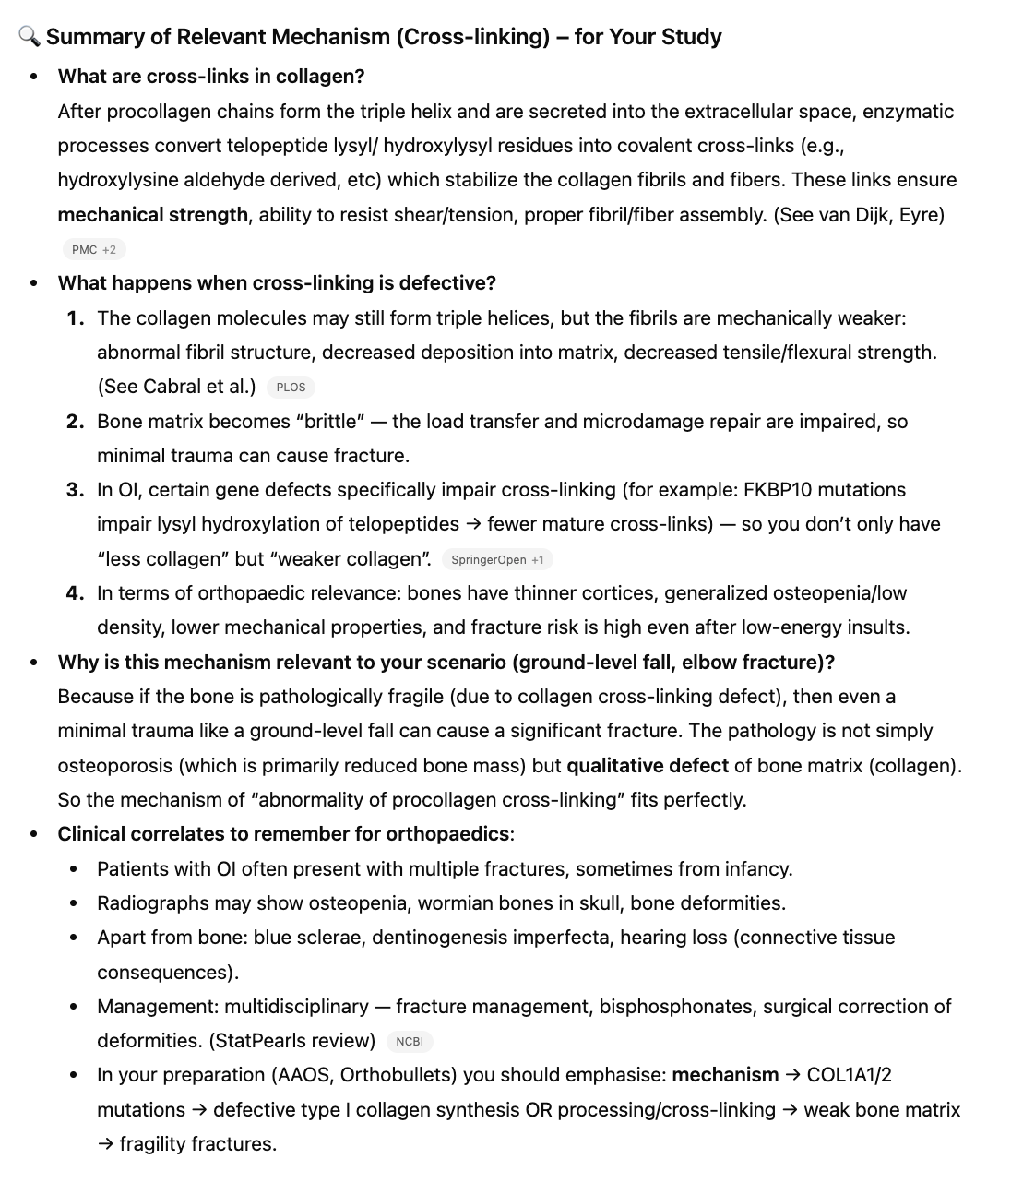
Figure 5 legend: ChatGPT has the capacity to help structure studying, including daily assignments, check-ins, and even practice question development. Presented here is a sample partial schedule for studying developed with the specific needs of the user in mind. In this case, the user asked ChatGPT to create a study schedule with a significant incorporation of flashcards for memorization in addition to time spent reading for deeper understanding.
